APPLYING PROJECT MANAGEMENT TECHNIQUES

Table of Contents

- Introduction and Background to Project………………………………………………………………….3
- Construction of Network Diagram and Gantt Chart with Critical path……………………...4
  - Network Diagram……………………………………………………………………………………………….4
  - Gantt Chart………………………………………………………………………………………………………...4
  - Critical Path………………………………………………………………………………………………………...4
- Role of Communication in Project Management……………………………………………………....5-6
- Application of PERT Analysis and Risk Management Techniques……………………………….6
  - PERT Analysis……………………………………………………………………………………………………...6
  - Risk Management………………………………………………………………………………………………...6-7
- Cost of Individual Activities and Total Project Cost……………………………………………………...8
- Application of Crash Costing Techniques……………………………………………………………………...9
- Consideration of Project Handover Issues…………………………………………………………………….10
- Conclusions………………………………………………………………………………………………………………….11
- References………………………………………………………………………………………………………………….12-15

1. Introduction and Background to Project
You make sure that a project stays on track and on budget while still reaching its goals. To do this, you need the right equipment and steps. It has always been crucial to make sure that the project's goals and objectives are in accordance with the organization's long-term goals (Kenny, 2003). People have varied notions about what it means to manage a project. Some people believe that it entails making plans, doing the work, checking on it, and finally finishing it. Schwalbe (2014) says that the ideal method to run a project is to make sure that everyone knows what they need to do, when they need to do it, and how to use the tools and materials they have. They should also be able to talk to each other and understand what the other person is saying. The Critical Path Method and Critical Chain Project Management are two more advanced ways to plan projects. When you build a tall skyscraper, use these. This project will be hard, however Building Information Modeling (Umar et al., 2024) is a good concept. A project might come up for a number of reasons, such as meeting a need or taking advantage of an opportunity. You have to finish each of these jobs by a certain date, and they get harder as you go. Because they are new, risky, and important to the organization, it's important to manage initiatives in a way that makes sense for them. Some things are easier to do than others (Kenny, 2003). When organizations work on initiatives, the most important thing is to make sure they last. They want to make the world a better place for everyone, which is why. To conduct a project that doesn't hurt the environment, you need to be in charge of a group of people, keep an eye out for probable problems with sustainability, and learn from your failures. The purpose is to finish the project so that it can deliver goods, services, and procedures that last a long period (Soares et al., 2024).
If you want to be a competent project manager, you need to know how to handle risks. You need to do things before and after to deal with risk well. Agile methodologies help you work with other people and find difficulties. Project managers may enhance their effectiveness by employing data-driven analytics to monitor hazards and address them promptly (Balasubramaniam et al., 2023).

2. Construction of Network Diagram and Gantt chart with Critical path
2.1 Network Diagram: A network diagram demonstrates how all the pieces of a project fit together and work together. Because of this, it's easy to discover the critical path, which tells you how long the project will take. You should write out what you need to do and how long it will take before you start working on it. You should additionally make a node for each job that needs to be done. Lastly, you need to use arrows to show how the nodes are connected to each other. The critical path is the longest way to get through the network. It informs you what you need to do right now, and if you don't do it, things will change (Olivieri et al., 2018; Hegazy and Menesi, 2010).

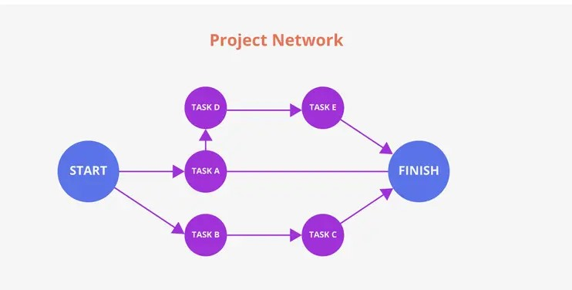
Figure: Network Diagram
2.2 Gantt Chart: A Gantt chart shows time, but a network diagram doesn’t. It shows actions as lines that cross each other. It tells you when things will start and end, how long they will last, and what you should do first. This makes it simple to keep track of everything and make modifications when necessary. You can make Gantt charts in Primavera, MS Project, and Excel (Poku and Arditi, 2006).
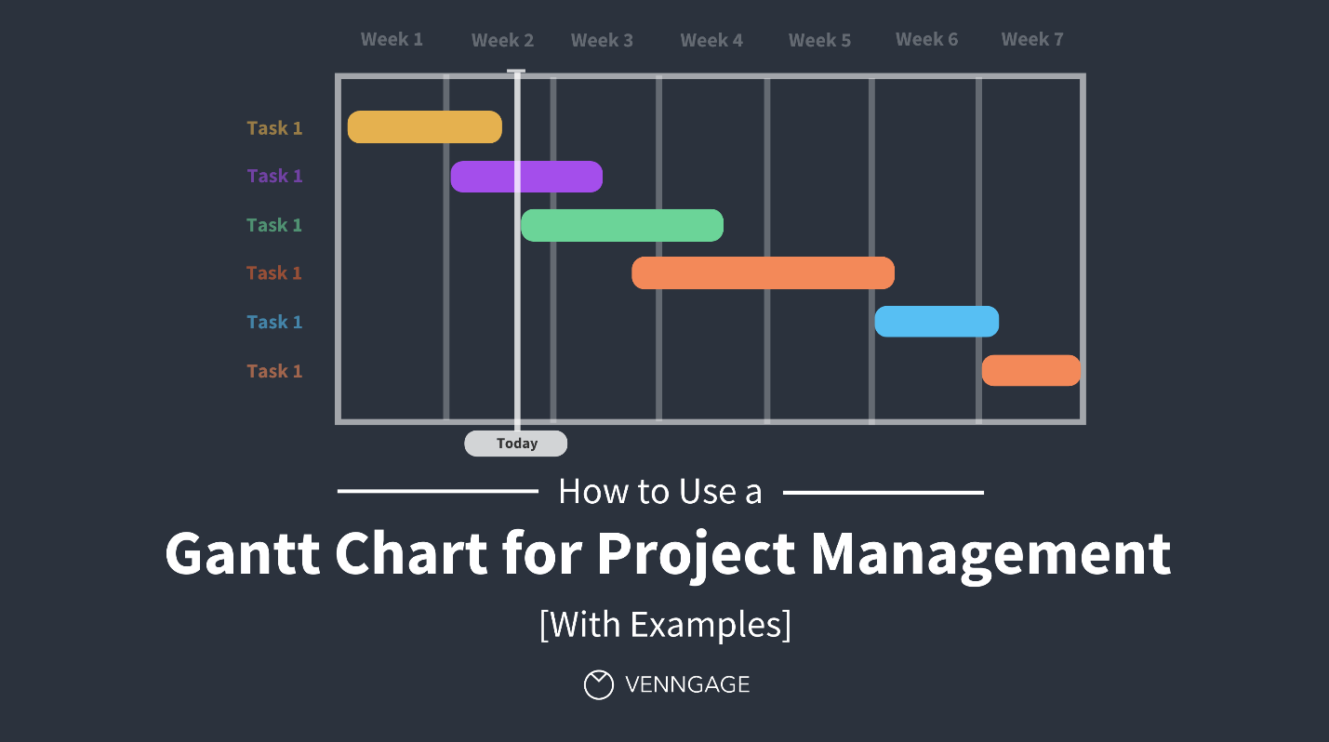
Figure: Gantt Chart
2.3 Critical Path: When you employ these tools, the Critical Path Method (CPM) is a wonderful way to keep track of your time. A lot of individuals use it to keep track of what has to be done on their buildings. The road that has the most jobs to do is the most significant one. It lets CPM know how long the job will take. It also searches for “float,” which is extra time for jobs that aren’t really vital. This makes it easy to keep track of plans, resources, and threats. A lot of people still use CPM, even though it has a lot of problems. Researchers are still working on making scheduling more accurate and better at leveraging the resources that are currently there (Olivieri et al., 2018; Kim and Garza, 2005; Jaafari, 1984). You need to know which tasks depend on which other tasks before you can use critical path analysis to construct Gantt charts and network diagrams. You can then pick the option you like most. This can help you estimate how long the job will take. This makes it easy to plan, keep track of, and finish building projects.
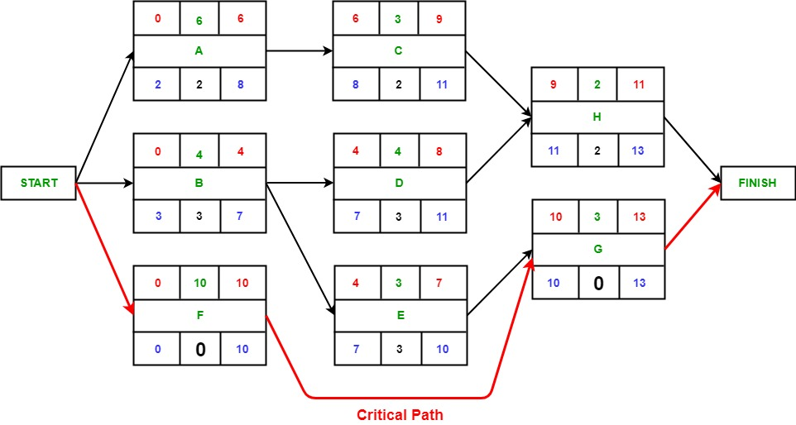
Figure: Critical Path

3. Role of Communication in Project Management
Good communication is important for running projects well since it affects how they are planned, done, and finished on time. If people want to be able to trust each other, make decisions, and work through problems, they need to talk to each other. In order to conclude the work, the project team needs to do all of these things. Research indicates that the efficacy of minor workplace modifications is predominantly influenced by the interpersonal relationships among colleagues. This is because it makes processes more flexible, which leads to better project and financial results (Obal et al., 2016). Businesses can talk to each other and share information using digital internal communication networks. Wuersch et al. (2022) assert that these systems encompass both social and technical components. First, you need to learn how to trust other people. After that, you need to improve at what you do. To make sure everyone is on the same page, find resources, and keep everyone up to date on how things are going, you should talk to clients, suppliers, and other relevant people who are working on the project. This helps keep good relationships going, which is important for getting help and getting the project approved. Talking to people inside and outside the company could have quite varied effects on different types of new ideas. People at the company need to talk to each other a lot for incremental innovation to work. Obal et al. (2016) assert that radical innovation necessitates the inclusion of individuals external to the organization. For project management to succeed, people need to be able to easily share information and work together. People still meet together, talk, and send emails to tell each other what they know. Some of the new project management tools and software that have revolutionized how people talk to each other are video conferencing, instant messaging, and design tools that let people work together. They let people talk to one other and do things at the same time (Ajiva et al., 2024). You can quickly make items and start businesses that may change as the market does using these technologies (Levitt, 2011). Researchers have underlined how important it is to make technologies that help individuals talk to each other better. If you don't think about what you say to people, things can turn very bad. Globerson and Zwikael (2002) say that this means companies should provide their personnel greater training and better tools to help them learn how to talk to each other. You may add communication to project management systems by using specialized software that enables you talk to people, plan activities, and share resources. This is especially true in the construction industry, where BIM and optimization technologies are growing more and more popular (Dasović et al., 2020). This will help you remember what happened. Toyin et al. (2024) say that these ICT solutions can make construction sites more efficient by making it easier for personnel to talk to each other and share information.

4. Application of PERT Analysis and Risk Management Techniques
4.1 PERST Analysis: Project managers usually utilize the Program Evaluation and Review Technique (PERT) to plan the work, keep track of how it's doing, and figure out how long it will take. It presents a project as a web of tasks that are all linked together and with time estimates that are based on chance. This helps managers calculate out how probable it is that the project will be done on schedule. The Polaris Fleet Ballistic Missile program was one of the first to use PERT. People used it to look at plans, see how changes to schedules would affect things, and measure progress in both qualitative and quantitative ways (Malcolm et al., 1959). If you have a lot to do and don't know how long each step will take, PERT is a useful approach to plan. Fuzzy PERT and other new methods use fuzzy set theory to deal with activity durations that aren't clear and can find more than one acceptable critical path. You can utilize them if PERT isn't working (Chen and Chang, 2001). You can utilize PERT models based on simulations to figure out which tasks are the most important and how changes to the schedule will effect them. This can help project managers find out what to do when they don't know what to do (Lu and Abourizk, 2000). You can make your schedule more accurate and use your resources better by using PERT with other scheduling tools. This makes constructing in general easier, but especially for towering buildings (Umar et al., 2024).
4.2 Risk Management: Risk management is all about finding, looking at, and dealing with the risks that come with a project. This means that the initiative is more likely to work. Using both proactive and reactive strategies is the best method to lower risk. You can find problems before they happen by using SWOT analysis and risk registers. A reactive strategy gives you answers that you may change and use over and over again to deal with problems that come up suddenly (Balasubramaniam et al., 2023). You can deal with emerging risks better when you can examine data in real time. The purpose of these strategies is to help people understand and cope with risks better. This is really crucial if you work in a difficult sector like digital or any other field where you could come across stuff you don't know about (Balasubramaniam et al., 2023). It is very important to find out what is wrong with how public sector and information systems perform as soon as possible, and even better, before they even start. Research indicates that a risk taxonomy and checklist might assist individuals in selecting appropriate activities and mitigating their risk. They achieve this by putting hazards into five groups: pre-project, customer, project management, technology, and development. As soon as you start a project, you should start to think about the risks (Zhou et al., 2008). Studies on risk management in public-private partnerships indicate that the primary components of the risk management framework encompass the identification, assessment, allocation, mitigation, treatment, and monitoring of risks. It emphasizes that risk monitoring and other essential components of the risk management lifecycle must be executed with greater diligence to ensure accuracy (Osei-Kyei et al., 2022).
Studies in certain areas, such as building supply chain management, reveal that people are competent at discovering and judging hazards. To completely solve the problems in the supply chain, more needs to be done to reduce risks and keep a watch on operations (Pham et al., 2022). Salesforce project delivery case studies illustrate that tailored risk management solutions can help with some of the issues that can come up during a project, including as risks to stakeholders, resources, and technology. They also show how important it is to have a clear approach for finding and getting rid of risks (Chinta et al., 2021). It's easier to work on projects in general if you know how to do PERT analysis and deal with hazards. This is because they show managers how to build solid plans when things aren't clear and how to prepare ready for problems before and after they happen. Because of this, the project takes longer and gets better results (Malcolm et al., 1959; Chen and Chang, 2001; Balasubramaniam et al., 2023).

5. Cost of Individual Activities and Total Project Cost
To set up your IT infrastructure, you need to buy the hardware and software, hire personnel, and teach them how to use everything. You need to buy networking equipment including servers, routers, switches, and connections to make the infrastructure better. Mare et al. (2014) say that all of these things demand hardware, which costs money. There are numerous various kinds of frameworks that stop piracy, and they all cost different amounts (Jiang et al., 2018). You hire IT experts to set up, install, and test both the software and the hardware. People refer to these as "costs of labor." Planning the workforce, cross-training, and making workers do extra work are all factors that will immediately raise costs. They also help make sure there are enough workers and that the budget isn't too high (Brusco and Johns, 1998; Sing et al., 2016). Finally, the cost of training includes the money needed to teach both technical staff and end users how to operate and care for the systems that have been constructed. Costs like hiring teachers, developing lesson plans, or getting ready for training could be included. Researchers have demonstrated their efficacy in engaging individuals in initiatives such as database systems (Mare et al., 2014).
Pay close attention to the prices and figures to find out how much each part costs. You need to know how much training you need, how much it will cost, how many pieces of hardware and types of licenses you need, how many hours you need to work, and how much those hours will cost. Sohn et al. (2020) predict that the costs of the project will be about the same as those of other projects to build up technical infrastructure. Cloud computing and open-source software that can expand with your organization can also help you save a lot of money on hardware and license fees. This means that users can choose from a wider range of PCs that cost less (Halligan et al., 2009). This in-depth cost study makes sure that the budgets are correct. This provides project managers time to figure out how much money they need and how to keep costs down while the work is going on.
6. Application of Crash Costing Techniques
When other people help, it's easier to get things done. This typically involves spending more money. The jobs along the main road are the most significant part of our plan. If you adjust the time frame, the full project's schedule will change right away. But this speedier pace could also help the company save money on things that aren't directly tied to it, like late fees, site fees, and equipment leases. This could help you get some of the more expensive items (Gerk and Qassim, 2008). When you're pouring concrete, building things, or testing systems while they're being produced, it's good to mess up. You will need to pay more to hire more people or buy more tools because you will have to do more work, get more resources (working faster could lead to blunders), and use more tools. You could make a mistake or have to do it all over again if you rush through it. Costs could go up since it might be harder to figure out how much the project will cost in the end (Ou-Yang and Chen, 2017). Knowing what you don't need will help you figure out how much time and money you require. Find the ones that cost the least for every hour you save. This kind of assignment will be easier for you if you use models that look at the advantages and cons of time, money, quality, and the environment. These algorithms can figure out the best approach to do each job and whether or not it's worth the risk to quality and the environment to speed things up (Banihashemi and Khalilzadeh, 2020).
7. Consideration of Project Handover Issues
During the handover phase, when the customer or organization formally takes over the finished project, a few important things could go wrong. Hospitals require the right forms and techniques to talk to each other to make handovers safer and more effective (Clarke and Persaud, 2011).
Another big difficulty is that the client or end user doesn't get enough training before or during the handoff. People often have problems using new systems correctly if they don't get enough training. This could cause problems, make people angry, or make them not want to use it. People who buy things need to know that the answer will help them. That's why every place requires its own technique to teach people and people should always talk to each other. Training is a key part of the handover plan since it keeps things the same and gets consumers ready (Clarke and Persaud, 2011). There is a lot of support for this. People still need support with technology even after the handover phase is finished. Clients often still require help with IT issues even after the project is done. This entails fixing issues, releasing new versions, and responding users' questions. It's really vital to help someone execute their job when you give them one. This means letting customers know when the help desk is open, what the service level agreements (SLAs) are, and how to obtain support if something goes wrong. This will make sure that the system runs well and those customers are delighted. You could have to wait longer for help if you don't show folks how to fix IT problems. In this case, the customer wouldn't be able to use the project as often as they wanted to. Researchers have examined numerous methods to assist individuals struggling with technology. Structured support and ongoing assessment are essential for addressing long-term requirements during the transition (Durand and Kishi, 1987; Clarke and Persaud, 2011).
8. Conclusions
The folks in charge of the project did an excellent job of planning, getting everyone involved, looking for problems, making modifications, and checking on the work often. Strategic frameworks for project management, especially in digital transformation, stress the need of knowing what stakeholders want, making the best use of resources, and keeping an eye on results to make projects more successful and efficient (Animashaun et al., 2024). As the project manager, you should keep an eye on the lessons learned and the sustainability risk registers that look at the whole life cycle. Soares et al. (2024) assert that these methodologies will extend the project's duration and enhance its efficacy. The study's findings emphasized the imperative of utilizing formal evaluation methodologies to avert the loss of growth possibilities (Pereira et al., 2021). Methodological rigor in the development of lessons learned, defined by a supportive atmosphere, rigorous methodology, and robust leadership, enhances the clarity and applicability of these lessons for future initiatives (Dagenais et al., 2025). It was challenging to maintain track of stakeholders and resources, which made it hard to change the plans for the project. It was easy to tweak and build better solutions that followed the guidelines. We found several good ways to apply agile in the future (Raharjo and Purwandari, 2020).
Cross-disciplinary collaboration was identified as an essential component for success, with tactics highlighting explicit objectives, shared comprehension, and cohesive communication channels enhancing the efficacy of planning and execution (Igbinenikaro et al., 2024). Digital transformation required the incorporation of advanced technologies and strategic alignment with organizational goals, underscoring the necessity for leadership commitment, risk management, and the fostering of an innovative culture to address challenges such as legacy system integration and resistance to change (Eyieyien et al., 2024).

References
Kenny, J. (2003). Effective Project Management for Strategic Innovation and Change in an Organizational Context. Project Management Journal, 34(1), 43–53. https://doi.org/10.1177/875697280303400106

Schwalbe, K. (2014). Introduction to Project Management (pp. 27–52). Auerbach. https://doi.org/10.1201/b16547-5

Umar, M., Okwandu, A., & Akande, D. (2024). Impact of effective schedule management on high-rise building projects. International Journal of Applied Research in Social Sciences, 6(7), 1371–1386. https://doi.org/10.51594/ijarss.v6i7.1298

Kenny, J. (2003). Effective Project Management for Strategic Innovation and Change in an Organizational Context. Project Management Journal, 34(1), 43–53. https://doi.org/10.1177/875697280303400106

Soares, I., Santos, J. M. R. C. A., & Fernandes, G. (2024). Sustainability in Project Management Practices. Sustainability, 16(10), 4275. https://doi.org/10.3390/su16104275

Balasubramaniam, V., Khair, M., Jain, Prof. (Dr.), Goel, O., & Mahadik, S. (2023). Effective Risk Mitigation Strategies in Digital Project Management. Innovative Research Thoughts, 9(1), 538–567. https://doi.org/10.36676/irt.v9.i1.1500

Obal, M., Kannan‐Narasimhan, R., & Ko, G. (2016). Whom Should We Talk to? Investigating the Varying Roles of Internal and External Relationship Quality on Radical and Incremental Innovation Performance. Journal of Product Innovation Management, 33(S1), 136–147. https://doi.org/10.1111/jpim.12340

Wuersch, L., Neher, A., & Peter, M. K. (2022). Digital internal communication: An interplay of socio‐technical elements. International Journal of Management Reviews, 25(3), 614–639. https://doi.org/10.1111/ijmr.12323

Obal, M., Kannan‐Narasimhan, R., & Ko, G. (2016). Whom Should We Talk to? Investigating the Varying Roles of Internal and External Relationship Quality on Radical and Incremental Innovation Performance. Journal of Product Innovation Management, 33(S1), 136–147. https://doi.org/10.1111/jpim.12340

Ajiva, O., Ejike, O., & Abhulimen, A. (2024). Advances in communication tools and techniques for enhancing collaboration among creative professionals. International Journal of Frontiers in Science and Technology Research, 7(1), 066–075. https://doi.org/10.53294/ijfstr.2024.7.1.0049

Levitt, R. E. (2011). Towards project management 2.0. Engineering Project Organization Journal, 1(3), 197–210. https://doi.org/10.1080/21573727.2011.609558

Globerson, S., & Zwikael, O. (2002). The Impact of the Project Manager on Project Management Planning Processes. Project Management Journal, 33(3), 58–64. https://doi.org/10.1177/875697280203300308

Dasović, B., Klanšek, U., & Galić, M. (2020). A Survey on Integration of Optimization and Project Management Tools for Sustainable Construction Scheduling. Sustainability, 12(8), 3405. https://doi.org/10.3390/su12083405

Toyin, J. O., Sattineni, A., Azhar, S., & Fasoyinu, A. A. (2024). Influence of Information and Communication Technology Application in Construction Jobsites: A Systematic Review and Bibliometric Analysis. Journal of Information Technology in Construction, 29, 444–479. https://doi.org/10.36680/j.itcon.2024.021

Malcolm, D. G., Roseboom, J. H., Clark, C. E., & Fazar, W. (1959). Application of a Technique for Research and Development Program Evaluation. Operations Research, 7(5), 646–669. https://doi.org/10.1287/opre.7.5.646

Chen, S.-M., & Chang, T.-H. (2001). Finding multiple possible critical paths using fuzzy PERT. IEEE Transactions on Systems, Man and Cybernetics, Part B (Cybernetics), 31(6), 930–937. https://doi.org/10.1109/3477.969496

Lu, M., & Abourizk, S. M. (2000). Simplified CPM/PERT Simulation Model. Journal of Construction Engineering and Management, 126(3), 219–226. https://doi.org/10.1061/(asce)0733-9364(2000)126:3(219)

Umar, M., Okwandu, A., & Akande, D. (2024). Impact of effective schedule management on high-rise building projects. International Journal of Applied Research in Social Sciences, 6(7), 1371–1386. https://doi.org/10.51594/ijarss.v6i7.1298

Balasubramaniam, V., Khair, M., Jain, Prof. (Dr. ), Goel, O., & Mahadik, S. (2023). Effective Risk Mitigation Strategies in Digital Project Management. Innovative Research Thoughts, 9(1), 538–567. https://doi.org/10.36676/irt.v9.i1.1500

Zhou, L., Vasconcelos, A., & Nunes, M. (2008). Supporting decision making in risk management through an evidence‐based information systems project risk checklist. Information Management &amp; Computer Security, 16(2), 166–186. https://doi.org/10.1108/09685220810879636

Osei-Kyei, R., Jin, X., Nnaji, C., Akomea-Frimpong, I., & Wuni, I. Y. (2022). Review of risk management studies in public-private partnerships: a scientometric analysis. International Journal of Construction Management, 23(14), 2419–2430. https://doi.org/10.1080/15623599.2022.2063013

Pham, H. T., Pham, T., Truong Quang, H., & Dang, C. N. (2022). Supply chain risk management research in construction: a systematic review. International Journal of Construction Management, 23(11), 1945–1955. https://doi.org/10.1080/15623599.2022.2029677

Chinta, U., Jain, S., & Aggarwal, A. (2021). Risk Management Strategies in Salesforce Project Delivery: A Case Study Approach. Innovative Research Thoughts, 7(3), 90–100. https://doi.org/10.36676/irt.v7.i3.1452

Mare, I., Hazelhurst, S., Kramer, B., & Klipin, M. (2014). The process of installing REDCap, a web based database supporting biomedical research: the first year. Applied Clinical Informatics, 5(4), 916–929. https://doi.org/10.4338/aci-2014-06-cr-0054

Jiang, B., Chen, P.-Y., & Mukhopadhyay, T. (2018). Software Licensing: Pay-Per-Use versus Perpetual. SSRN Electronic Journal. https://doi.org/10.2139/ssrn.1088570

Brusco, M. J., & Johns, T. R. (1998). Staffing a Multiskilled Workforce with Varying Levels of Productivity: An Analysis of Cross‐training Policies*. Decision Sciences, 29(2), 499–515. https://doi.org/10.1111/j.1540-5915.1998.tb01586.x

Mare, I., Hazelhurst, S., Kramer, B., & Klipin, M. (2014). The process of installing REDCap, a web based database supporting biomedical research: the first year. Applied Clinical Informatics, 5(4), 916–929. https://doi.org/10.4338/aci-2014-06-cr-0054

Sohn, H., Tucker, A., Ferguson, O., Gomes, I., & Dowdy, D. (2020). Costing the implementation of public health interventions in resource-limited settings: a conceptual framework. Implementation Science, 15(1). https://doi.org/10.1186/s13012-020-01047-2

Halligan, B. D., Geiger, J. F., Vallejos, A. K., Greene, A. S., & Twigger, S. N. (2009). Low cost, scalable proteomics data analysis using Amazon’s cloud computing services and open source search algorithms. Journal of Proteome Research, 8(6), 3148–3153. https://doi.org/10.1021/pr800970z

Gerk, J. E. V., & Qassim, R. Y. (2008). Project Acceleration via Activity Crashing, Overlapping, and Substitution. IEEE Transactions on Engineering Management, 55(4), 590–601. https://doi.org/10.1109/tem.2008.927786

Ou-Yang, C., & Chen, W.-L. (2017). Applying a risk assessment approach for cost analysis and decision-making: a case study for a basic design engineering project. Journal of the Chinese Institute of Engineers, 40(5), 378–390. https://doi.org/10.1080/02533839.2017.1335620

Banihashemi, S. A., & Khalilzadeh, M. (2020). Time-cost-quality-environmental impact trade-off resource-constrained project scheduling problem with DEA approach. Engineering, Construction and Architectural Management, 28(7), 1979–2004. https://doi.org/10.1108/ecam-05-2020-0350

Clarke, C. M., & Persaud, D. D. (2011). Leading Clinical Handover Improvement. Journal of Patient Safety, 7(1), 11–18. https://doi.org/10.1097/pts.0b013e31820c98a8

Clarke, C. M., & Persaud, D. D. (2011). Leading Clinical Handover Improvement. Journal of Patient Safety, 7(1), 11–18. https://doi.org/10.1097/pts.0b013e31820c98a8

Durand, V. M., & Kishi, G. (1987). Reducing Severe Behavior Problems among Persons with Dual Sensory Impairments: An Evaluation of a Technical Assistance Model. Journal of the Association for Persons with Severe Handicaps, 12(1), 2–10. https://doi.org/10.1177/154079698701200102

Animashaun, E., Familoni, B., & Onyebuchi, N. (2024). Strategic project management for digital transformations in public sector education systems. International Journal of Management &amp; Entrepreneurship Research, 6(6), 1813–1823. https://doi.org/10.51594/ijmer.v6i6.1167

Soares, I., Fernandes, G., & Santos, J. M. R. C. A. (2024). Sustainability in Project Management Practices. Sustainability, 16(10), 4275. https://doi.org/10.3390/su16104275

Pereira, J., Varajão, J., & Takagi, N. (2021). Evaluation of Information Systems Project Success – Insights from Practitioners. Information Systems Management, 39(2), 138–155. https://doi.org/10.1080/10580530.2021.1887982

Dagenais, C., Proulx, M., Hot, A., Mcsween-Cadieux, E., Villemin, R., Gautier, L., De Araujo Oliveira, S. R., Cloos, P., Traverson, L., Zinszer, K., & Ridde, V. (2025). How to formulate high-quality lessons learned: a rapid review. Global Health Action, 18(1). https://doi.org/10.1080/16549716.2025.2546691

Raharjo, T., & Purwandari, B. (2020). Agile Project Management Challenges and Mapping Solutions. 123–129. https://doi.org/10.1145/3378936.3378949

Igbinenikaro, O., Adekoya, O., & Etukudoh, E. (2024). FOSTERING CROSS-DISCIPLINARY COLLABORATION IN OFFSHORE PROJECTS: STRATEGIES AND BEST PRACTICES. International Journal of Management &amp; Entrepreneurship Research, 6(4), 1176–1189. https://doi.org/10.51594/ijmer.v6i4.1006

Eyieyien, O., Idemudia, C., Paul, P., & Ijomah, T. (2024). Strategic approaches for successful digital transformation in project management across industries. International Journal of Frontiers in Engineering and Technology Research, 7(1), 01–011. https://doi.org/10.53294/ijfetr.2024.7.1.0037

