

Module Code: ECAD5015

Assignment Title: Deepening Practice
ALN – Part 1 Journal
Student Name: Rosie Megrath
Student Number: 2205120
BA Primary Education (QTS)

AI Acknowledgement

I acknowledge the use of ChatGPT [https://chatgpt.com/] on 18th May 2025.
1. Who supports the use of visual aids in the classroom?
2. What barriers could I face when using visual aids in the classroom?
3. Put this reference list into alphabetical order

I confirm that I have not presented any AI generated text as my own work.
I confirm that I have copies of my drafts, notes, and other resources I used before and after the use of AI tools which I may be asked to provide in evidence.

Targets from previous module | How I have worked on these? | An example can be seen on…
Please check your use of Harvard referencing (e.g. Place title of paper in single quote, e.g. 'Students...of learning'; Place title of journal in italic, e.g. Principles of Policy and Practice; use of accessed date - p.10 Harvard Referencing Guidance | I have ensured to place the title of the references in italic | The reference list
Avoid over reliance on websites - try to use the recommended reading list and look for academic papers that have been peer reviewed. | I used more reliable sources, such as the Welsh Government and Estyn reports | The introduction
Ensure you avoid descriptive writing, aim to be critical and analytical by supporting your claims with relevant, academic sources. | I have made sure to be critical of my work by including barriers or limitations of each strategy (visual timetables and choice boards) | Barriers and limitations

Introduction
Inclusive education in Wales is underpinned by a comprehensive legislative and policy framework, designed to ensure that all learners, regardless of background, ability, or need, can access high-quality education. The Curriculum for Wales (Welsh Government, 2022) emphasises the vision of every learner as an ambitious, capable individual, promoting four core purposes that reflect the holistic development of each child. Central to this curriculum is a commitment to equity and inclusion, setting the expectation that schools adapt provision to meet the needs of every pupil, including those with Additional Learning Needs (ALN).
A significant shift in Welsh education policy was enacted through the Additional Learning Needs and Education Tribunal (Wales) Act 2018 and the ALNET (Wales) Act 2018, which together replaced the previous Special Educational Needs (SEN) system with a more flexible, person-centred approach. These Acts emphasise early intervention, collaboration, and the active participation of children and their families in planning and decision-making (Welsh Government, 2018). The legislation places a statutory duty on schools to identify and meet ALN, and ensures that the views, wishes, and feelings of the child are central to all processes—a principle that directly aligns with Article 12 of the United Nations Convention on the Rights of the Child (UNCRC), which states that every child has the right to express their views in matters affecting them (United Nations, 1989).
The Well-being of Future Generations (Wales) Act 2015 further reinforces the holistic, learner-centred ethos of Welsh education by requiring public bodies, including schools, to consider how their decisions impact the well-being of future generations. This Act advocates for a preventative, collaborative approach, focusing on long-term well-being, participation, and equality (Welsh Government, 2015). These principles are reflected in the expectation that schools nurture not only academic attainment but also emotional, social, and physical well-being, creating environments where every learner can thrive.
Theoretical models underpinning inclusive practice include Vygotsky’s social constructivism, which highlights the importance of social interaction, scaffolding, and differentiated support to facilitate learning for all pupils. Universal Design for Learning (UDL) offers a practical framework, advocating for proactive planning to address the diversity of learners by providing multiple means of engagement, representation, and expression (Rose & Meyer, 2002). UDL encourages teachers to remove barriers to learning, benefitting all pupils but especially those with ALN.
Estyn has consistently identified effective inclusive practice as being rooted in whole-school approaches, on-going staff development, and the use of evidence-based interventions. Recent Estyn reports (2023) highlight the importance of visual strategies, such as timetables and choice boards, in supporting routine, reducing anxiety, and empowering pupil voice in line with ALN reforms.
In summary, the theoretical and legislative context in Wales positions inclusive education as a collaborative, rights-based, and evidence-informed endeavour. Teachers are expected to draw on current research, reflect on their practice (Schön, 1983), and adapt provision to ensure that every pupil is seen, heard, and supported. The integration of visual timetables and choice boards exemplifies how theory, policy, and classroom practice converge to create truly inclusive learning environments.

Reflections and Practical Understanding
Creating an inclusive classroom involves deploying a range of strategies that address the diverse needs of all learners, with a particular focus on those with ALN. Two approaches that have proven highly effective within the context of the Curriculum for Wales are visual timetables and choice boards. Both support the principles of equity, participation, and learner well-being, which are embedded within the statutory and policy landscape in Wales (Welsh Government, 2022).

Visual Timetables in Practice
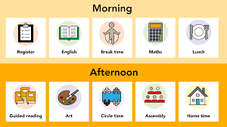Figure 1. Visual timetable for KS1 and KS2 (PlanBee, 2024)
Visual timetables are a well-established tool in supporting inclusivity, especially for pupils who may struggle with understanding or processing verbal information, such as those with autism spectrum condition (ASC) or communication difficulties (Moore, 2021). These timetables use images, symbols, or photographs to represent the day’s routine and transitions, offering predictability and reducing anxiety for pupils who benefit from structure.
During my PTE2 experience, the use of a large, clearly displayed visual timetable placed on a wall accessible to all, enabled all children to anticipate what was coming next. One pupil with ALN who previously showed signs of distress during transitions became noticeably calmer and more independent when able to check the timetable at any time. This supported the statutory requirement for person-centred practice outlined in the ALNET (Wales) Act 2018, as it placed the learner’s needs and voice at the centre of provision (Welsh Government, 2018).
Beyond pupils with diagnosed ALN, visual timetables benefitted all learners, promoting independence and a sense of security, in line with the Universal Design for Learning (UDL) framework (Rose & Meyer, 2002). Estyn (2023) also recognises visual supports as good practice, noting that they enhance routine and accessibility across mainstream settings.

Choice Boards in Practice
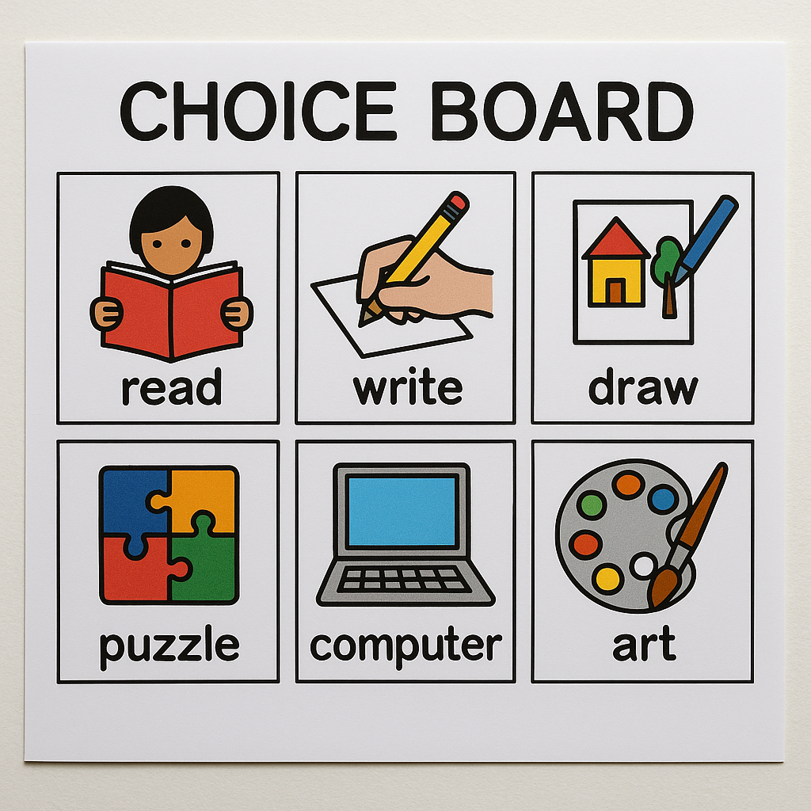Figure 2. OpenAI (2025)
Choice boards are another inclusive strategy, allowing pupils to make meaningful choices about aspects of their learning or routine. This approach aligns closely with UNCRC Article 12, which emphasises the right of every child to have a voice in matters that affect them (United Nations, 1989). In practice, choice boards can be as simple as a board offering two or three activities (e.g., “Would you like to read or draw?”) or more complex, such as selecting how to complete a task (e.g., writing, drawing, or using technology).
When implemented in my classroom, choice boards will encourage greater engagement and autonomy among pupils. For instance, a pupil with attention difficulties can become more motivated when allowed to choose the sequence of their tasks. Choice boards support differentiation, as pupils could select activities suited to their strengths and needs, promoting equity as called for by the Curriculum for Wales. Kennedy et al. (2019) found that offering choice increases motivation and reduces behavioural incidents, with improved focus and fewer disruptions during independent work.

Barriers and Limitations
Despite their benefits, both strategies present challenges. One significant barrier is the time and resources required to create and update visual supports, especially in busy classrooms with high staff workloads. It can be difficult to individualise timetables for multiple pupils or keep choice boards current and relevant.
There may also be staff resistance or a lack of confidence, particularly among teachers unfamiliar with these approaches or who perceive them as additional work. In some cases, pupils may become overly reliant on visual supports, potentially inhibiting flexibility if the timetable or choice board is unavailable.
Cultural and linguistic diversity presents further challenges. Visual supports must be sensitive to EAL learners and accurately reflect a range of backgrounds. Additionally, Estyn (2023) notes that the impact of such strategies can be limited if not implemented consistently across the school or adapted in line with ongoing feedback from pupils and staff.

Solutions and Recommendations
Addressing these barriers requires a whole-school, collaborative approach. Investing in staff training ensures teachers understand the rationale behind visual supports and feel confident in their use. Sharing resources and planning time within teams can reduce individual workload. Schools may also leverage digital tools, such as interactive whiteboard software, to make updating timetables and choice boards quicker and more engaging.
Involving pupils in designing their own visual supports not only aligns with the pupil voice requirements of the ALNET (Wales) Act 2018 and UNCRC Article 12 but also increases their relevance and effectiveness. Regularly reviewing these supports as part of the Additional Learning Needs planning cycle helps ensure they remain appropriate and impactful.
Ultimately, visual timetables and choice boards exemplify the practical application of inclusive pedagogy in Welsh classrooms. By addressing individual needs, promoting autonomy, and responding to policy requirements, they contribute to a learning environment where every pupil can participate fully and progress.

Link to Teaching Standards and Professional Development
Implementing visual timetables and choice boards directly supports the Professional Standards for Teaching and Leadership in Wales, particularly in the areas of pedagogy, collaboration, and professional learning. By planning and adapting lessons to include these strategies, teachers demonstrate their ability to meet the needs of diverse learners, reflecting the inclusive ethos of the Curriculum for Wales (Welsh Government, 2022). The use of visual supports and opportunities for pupil choice exemplifies a commitment to learner well-being, autonomy, and progression, which are key professional values and attributes.
Furthermore, these practices encourage collaborative working with teaching assistants, specialist staff, and families, as recommended by Estyn (2023) and the ALNET (Wales) Act 2018. Ongoing professional development is essential to stay informed about new resources and research on inclusive practice. Reflecting on the impact of these strategies encourages continual growth as a reflective practitioner (Schön, 1983). In future, engaging in further training, peer observation, and professional dialogue will help deepen understanding and ensure sustained high-quality, inclusive teaching in line with national expectations.

References
Estyn (2023) Supporting learners with additional learning needs in mainstream schools. Cardiff: Estyn. Available at: https://www.estyn.gov.wales/ (Accessed: 18 May 2025).
Kennedy, C. H., Cushing, L. S., & Itkonen, T. (2019) ‘Choice-making as an intervention strategy for students with additional learning needs’, Journal of Positive Behavior Interventions, 21(1), pp. 3–15.
Moore, A. (2021) ‘Visual timetables as a support for ALN learners in Wales’, British Journal of Special Education, 48(2), pp. 134–146.
OpenAI (2025) Choice board example [AI-generated image created by ChatGPT for student's assignment]. Created on 19 May 2025.
PlanBee. (2024). Visual timetable for KS1 and KS2. [Online image]. Available at: PlanBee [Accessed 19 May 2025].
Rose, D. H. and Meyer, A. (2002) Teaching every student in the digital age: Universal Design for Learning. Alexandria, VA: ASCD.
Schön, D. A. (1983) The reflective practitioner: How professionals think in action. New York: Basic Books.
United Nations (1989) Convention on the Rights of the Child. New York: United Nations. Available at: https://www.unicef.org.uk/what-we-do/un-convention-child-rights/ (Accessed: 18 May 2025).
Welsh Government (2015) Well-being of Future Generations (Wales) Act 2015. Available at: https://www.legislation.gov.uk/anaw/2015/2/contents (Accessed: 18 May 2025).
Welsh Government (2018) Additional Learning Needs and Education Tribunal (Wales) Act 2018. Available at: https://www.legislation.gov.uk/anaw/2018/2/contents (Accessed: 18 May 2025).
Welsh Government (2022) Curriculum for Wales. Cardiff: Welsh Government. Available at: https://hwb.gov.wales/curriculum-for-wales/ (Accessed: 18 May 2025).

