Hotel Panama the musical

The Writing process

We begun the writing process by brainstorming different show ideas one being a musical about finding yourself and also we had another idea about a thriller murder mystery, although quite early on everyone settles on a rough idea of a show about a run down hotel after Holly mentioned one of her favourite shows, “Benidorm” : a show about a hotel where a bunch of British tourists enjoy a holiday in Solana Resort in Benidorm. Wikipedia. (2021). Benidorm (British TV series). [online] Available at: https://en.wikipedia.org/wiki/Benidorm_(British_TV_series). Although to start I wasn't too happy with the decision which was my first faux pas in this process. But as it was a majority vote I was happy to settle on it and gave it a chance. From the get go ideas were flowing , there were talks about making a storyline up but keeping in theme of the famous characters and structure of benidorm storyline. We quickly decided after that we wanted to write our own characters to be able to know how to write characters which in my opinion was very valuable to know for future projects. My character i initially started with was named “Kandi Rosa” she was a bright and bubbly barmaid, who’s knowledgeable in everything to do with drinks and gossip, she is 21 years old from the manchester area. I chose to write this character the way I did was because I have been working behind bars for over a year in a successful nightclub , and how my childhood was influenced by Manchester as my dad is from Manchester. I had visited Manchester a lot and had relatives. So I thought to benefit acting as my character to put my knowledge to good use. But as characters were being made mine got cut. Which in reflection I should've fought for as I ended up with a character I didn't want to play.
When starting to write we wrote monologues. I wrote a really good one but because my boyfriend's car got broken into my notebook was stolen which set me back in the process. I enjoyed writing suspenseful and creepy monologues based on crime. I found these styles easier as I have studied criminology and know a lot of stories to do with the criminal world.
The first thing we learned about was story structure and based it off our lead character we had decided on named Debbie Presdee.
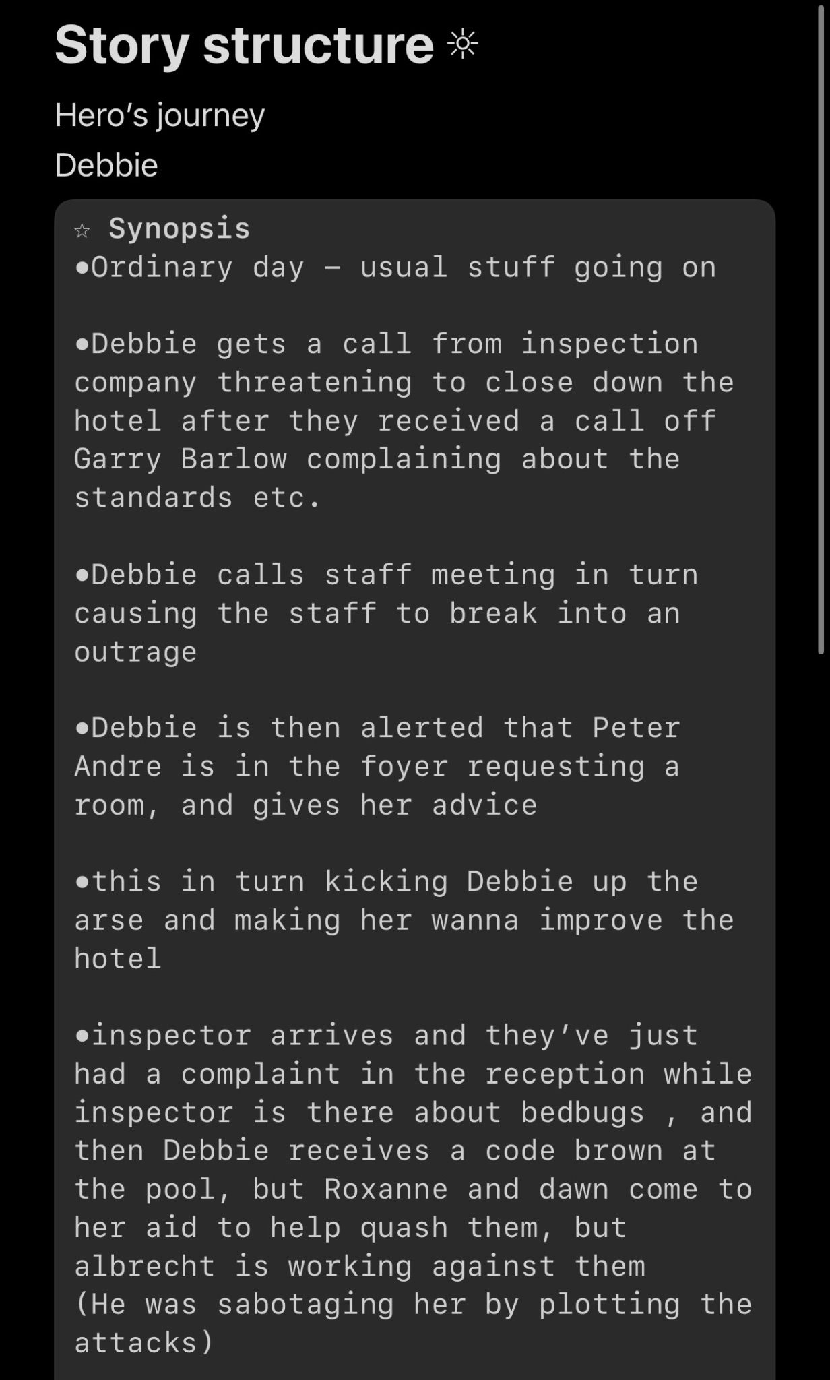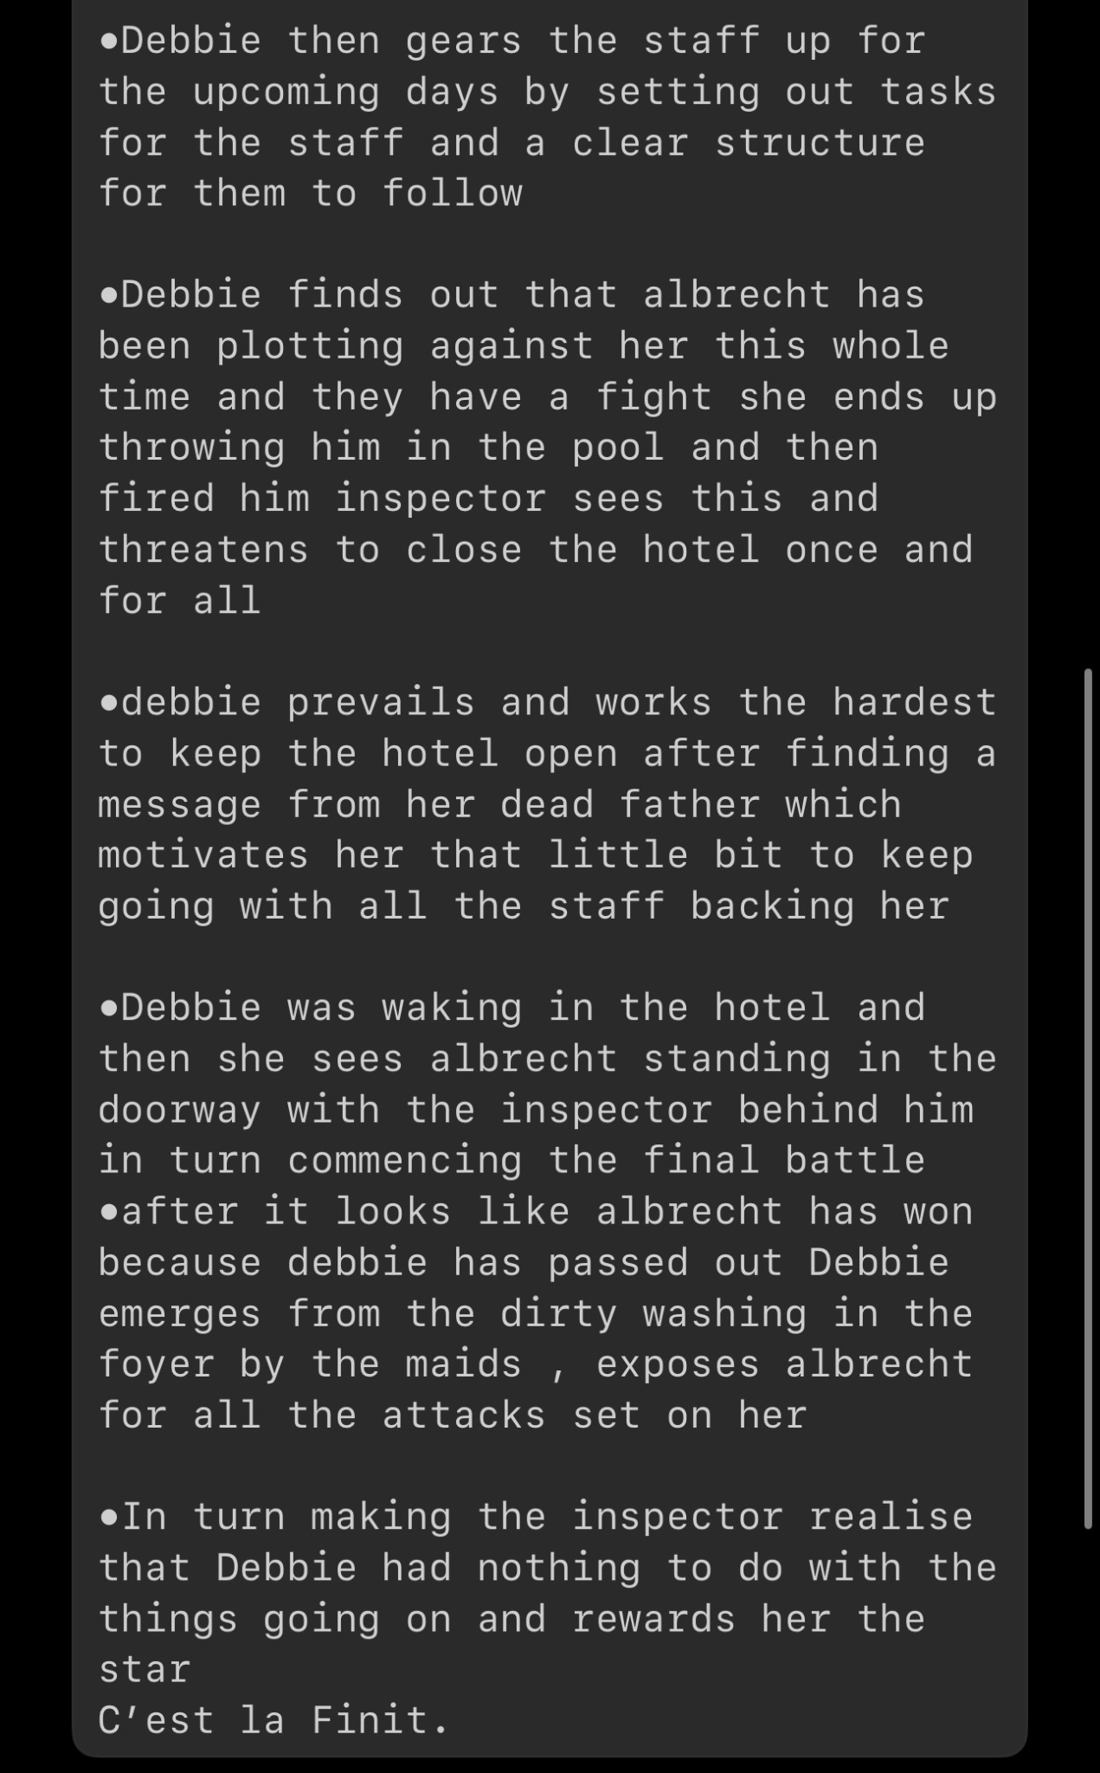
This is the hero’s journey structure we used to write the musical. I enjoyed using this structure as it was clear from start to finish and made it easy for me to follow and understand what the storyline needed to be successful and understandable.
The biggest problem i faced during the writing process was in fact the writing portion of the project, I am not confident in my writing abilities at all and it really knocked my confidence in the writing room, which looking back i shouldn't have let it happen but i was in a way intimidated by others skill and ability to write and my lack thereof. Once we decided on a storyline to follow we started fitting the characters into it , if we recap back to the character section of the writing process we know my character Kandi Rosa was cut therefore because of a classmate leaving university i was given their character, a child “Youtube” star who hunted ghosts with her brother. In all honesty I didn't like the character I was given, I felt the character was hard to write for as it is nothing at all like me , as I'm not a child and even though I believe in ghosts I tend to stay on the safe side and not agitate them so to put it. So from the get go that made the writing process a bit harder for me.
The first scene i wrote was scene 2 of the musical, which was the Busta Ghosts scene, a scene where we’re introduced to the characters Annie and Joshua who are 2 youtube “stars” (Annie aged 15, Josh aged 12) who found the hotel through a false advertisement online and had convinced their parents to go on holiday there (although we never see their parents)

‌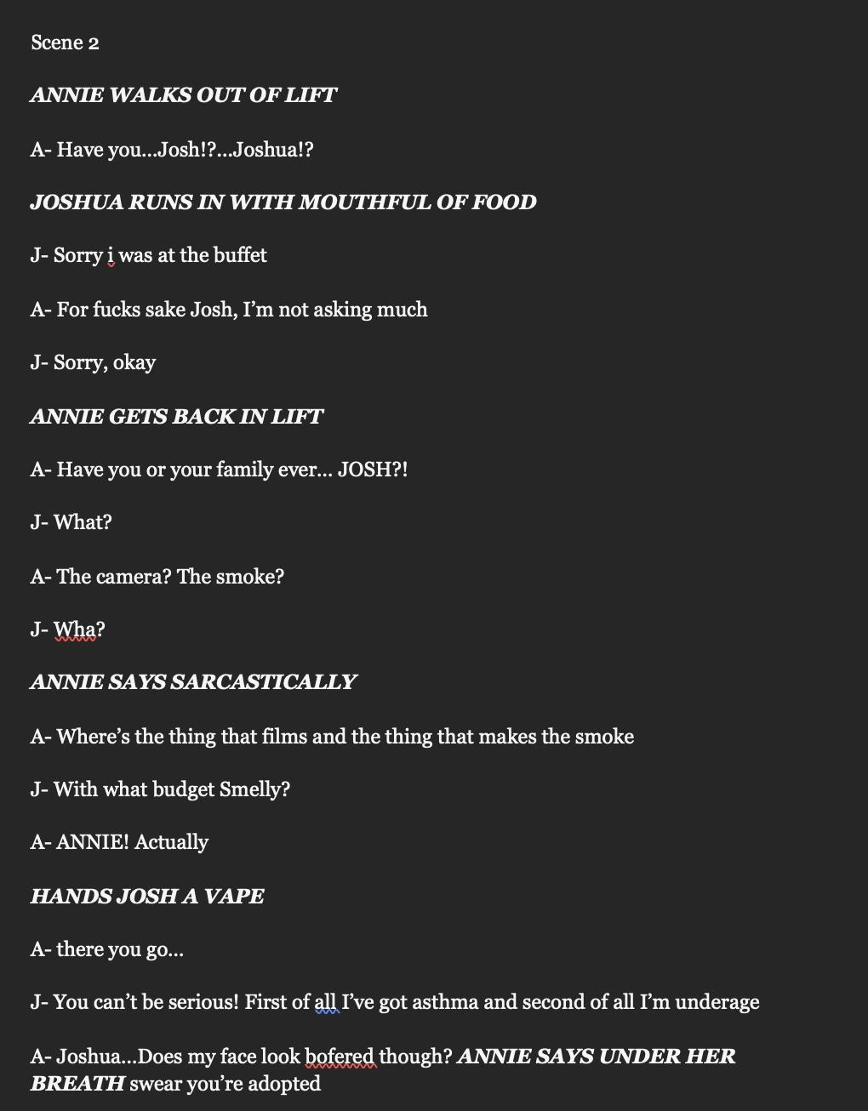
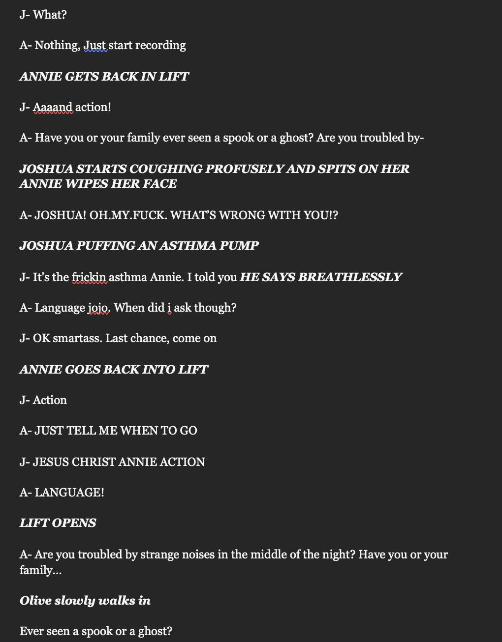
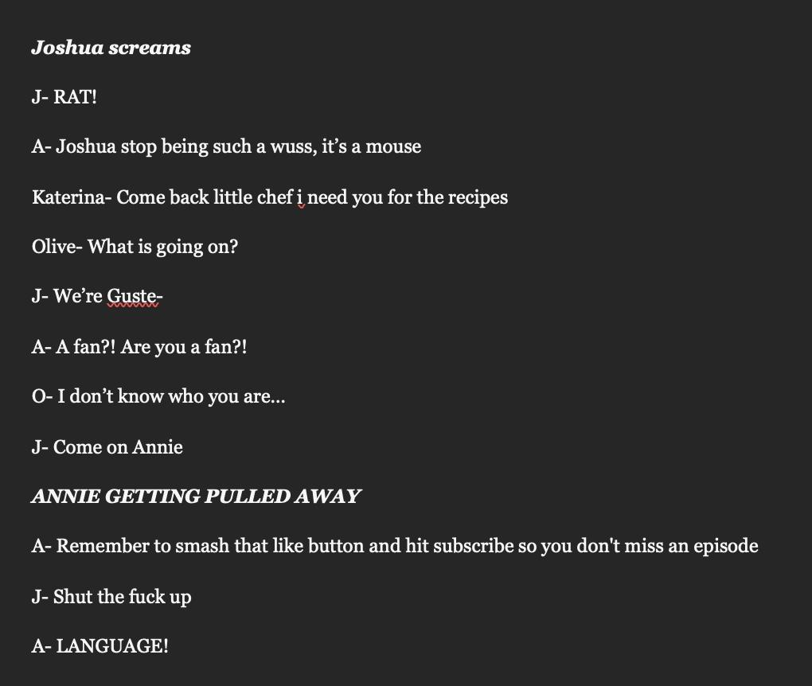

The first scene I wrote was incredibly long and was even longer to read through, as we were writing a comedy I had a hard time writing jokes in and trying to make it funny as I had to make sure the language and comedy was in touch with mine and Dyfans characters , being as we were children. That was the hardest challenge for me in this project as I’m not a child anymore and my sense of humour is more mature, but I’m glad I got handed the challenge as I know it would be a good learning experience for myself. After reading the scene and receiving feedback I realised I needed to make the scene shorter and more coherent to the fact me and Dyfan were children. My next steps were writing scene 5 and editing scene 2.
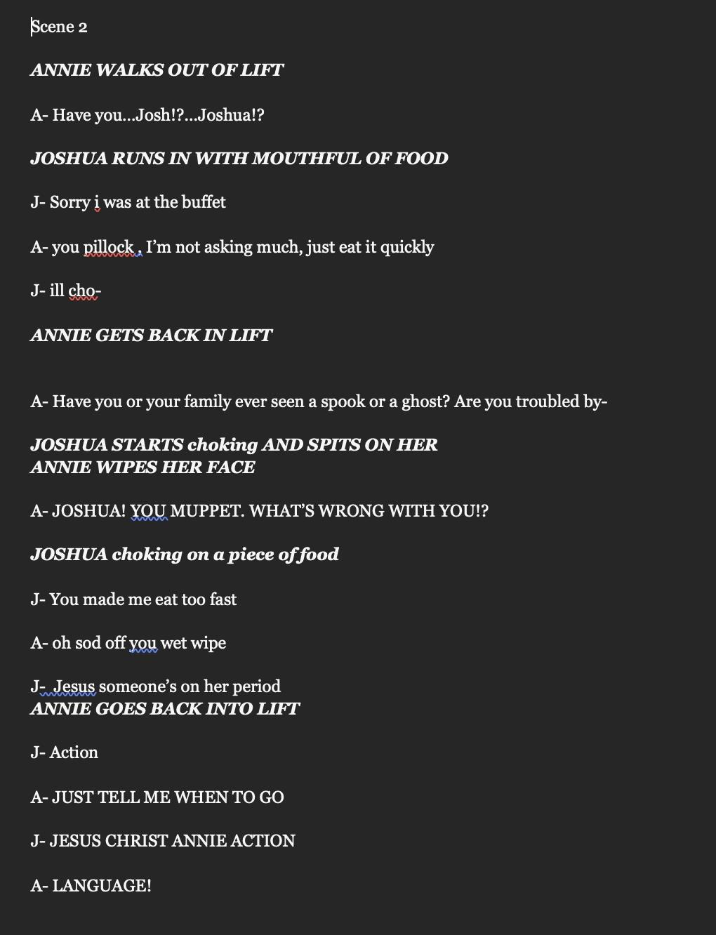
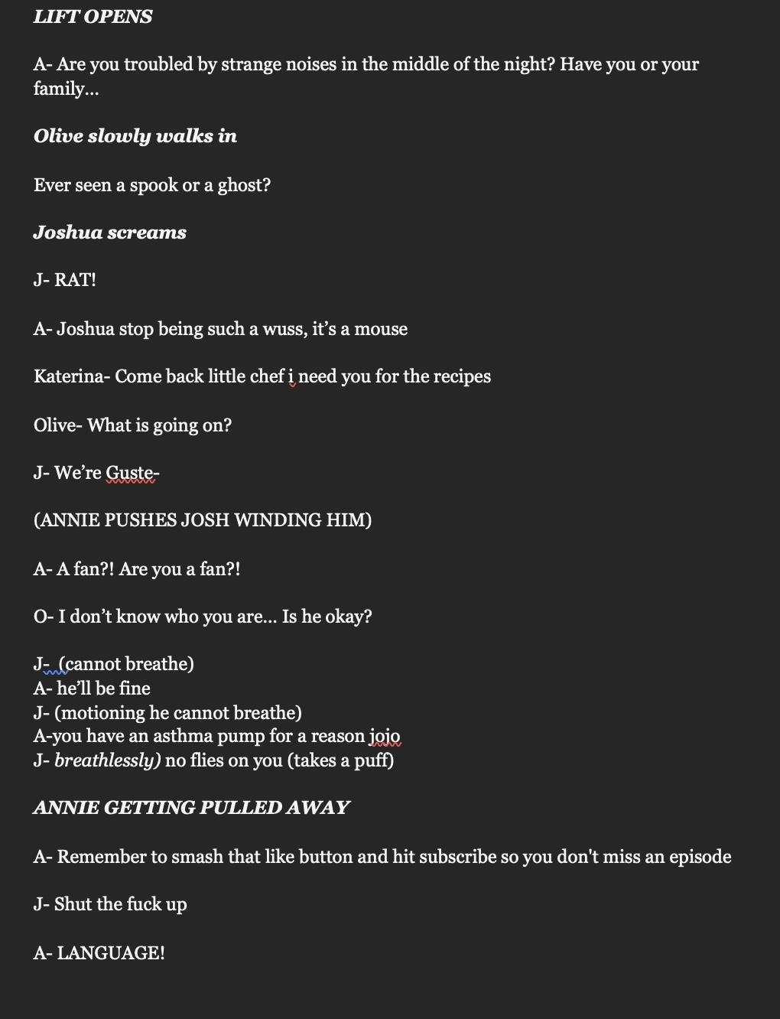
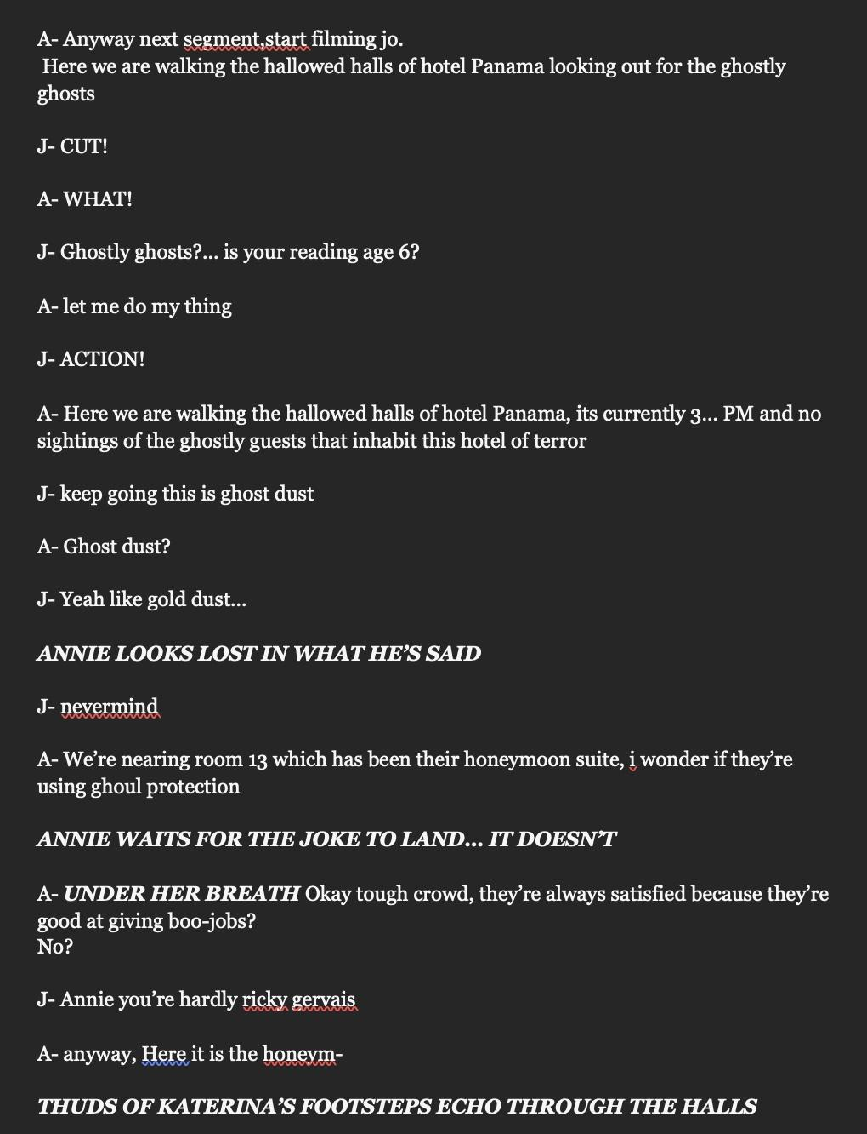
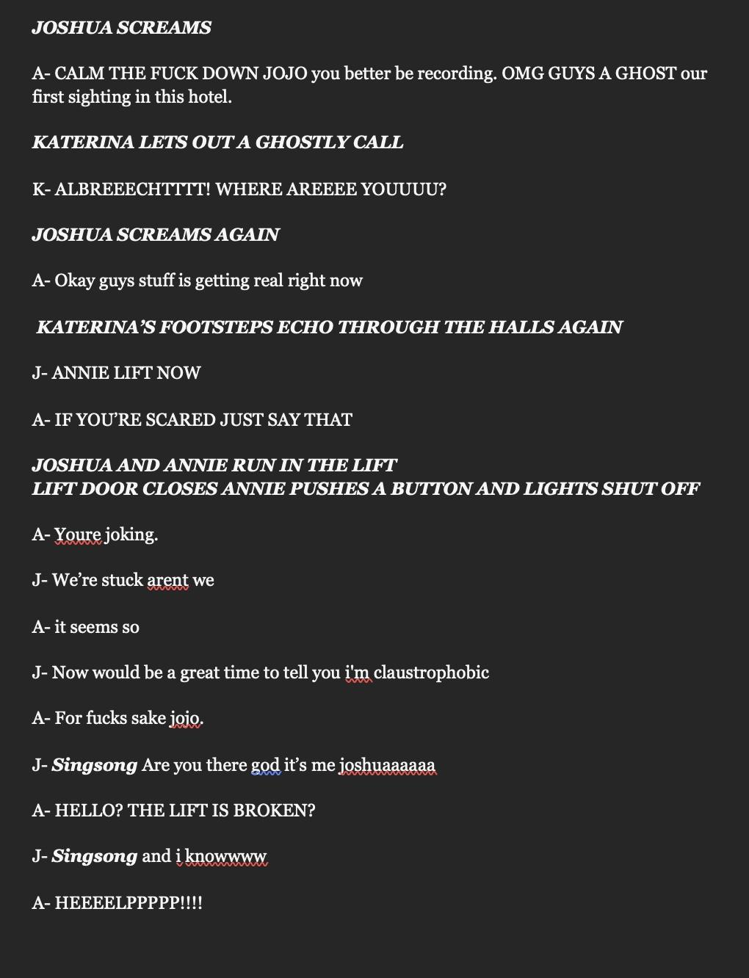

Although I do like this scene and how it's written , again it was far too long (somehow was longer than the first draft) . The jokes also were still not quite landing and that was a problem I needed to fix as Dyfan usually sat there while I wrote as he couldn't really be bothered. Because all the contextual points we thought we needed to discuss in the scene made it long so that was also another problem we needed to address. Llinos had also tasked us with writing scene 5 which was making me start to worry as I was worried about the content in our scenes.

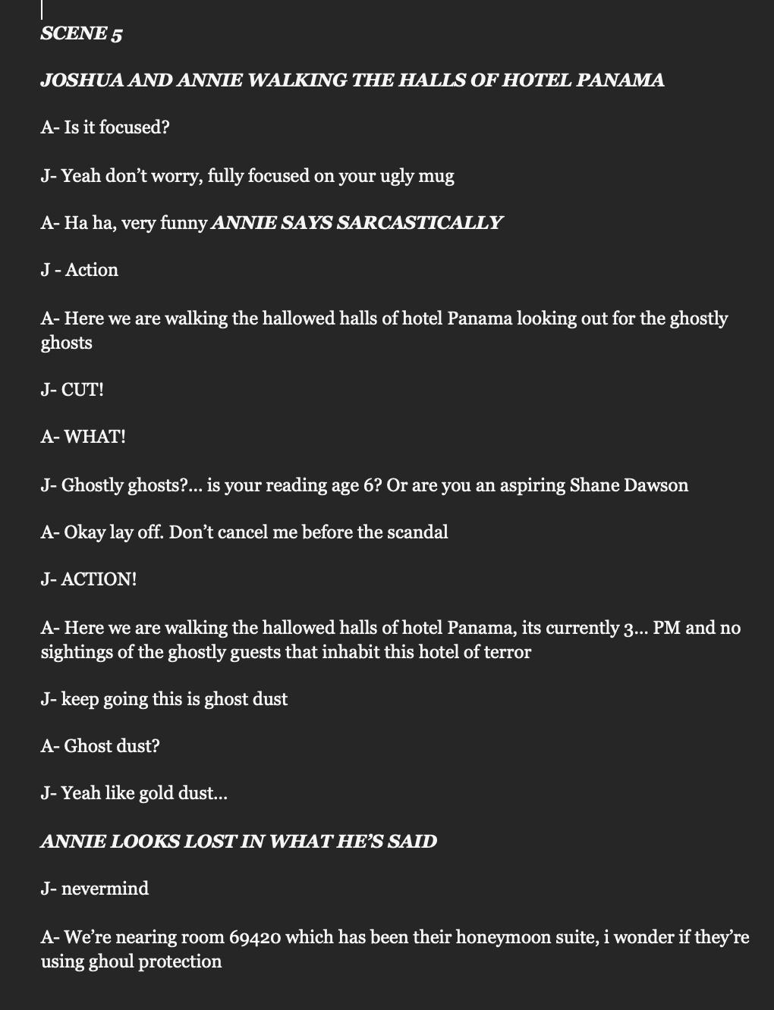
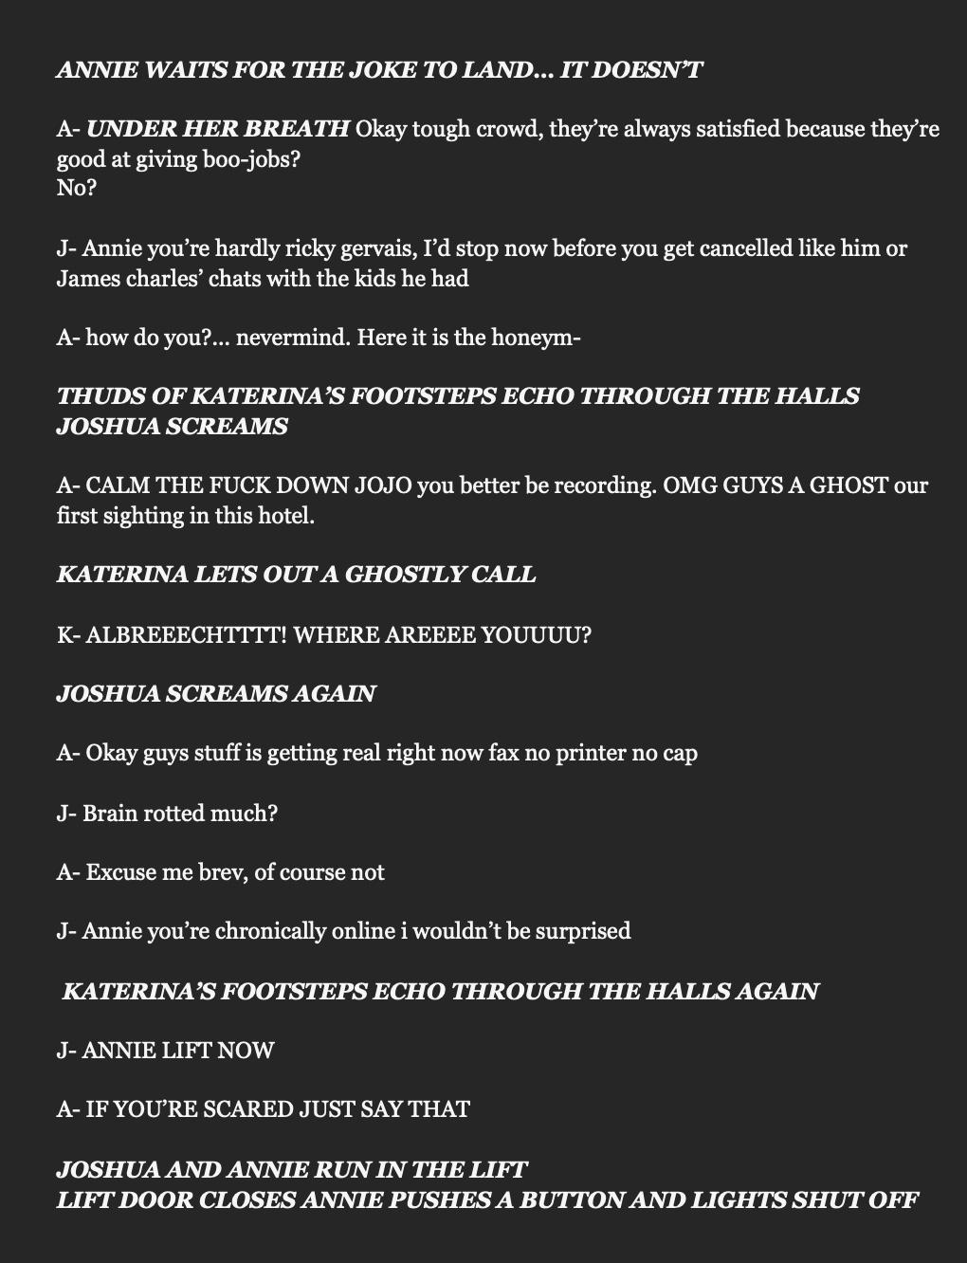
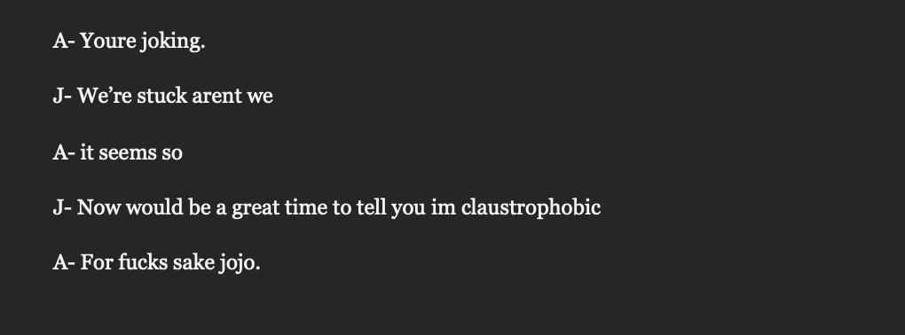
As you can read scene 5 wasn’t really needed and was a filler scene of sorts , with the way the musical was being written at a rapid pace we opted against scenes to fill time as the plot was way thicker than we thought it initially would be, therefore to combat this problem Llinos advised me to amalgamate scene 2 and 5 which was an amazing idea as themes and storyline spoken about in scene 5 didn't really matter when it came in the story and where. So we decided that was the proper way forward.
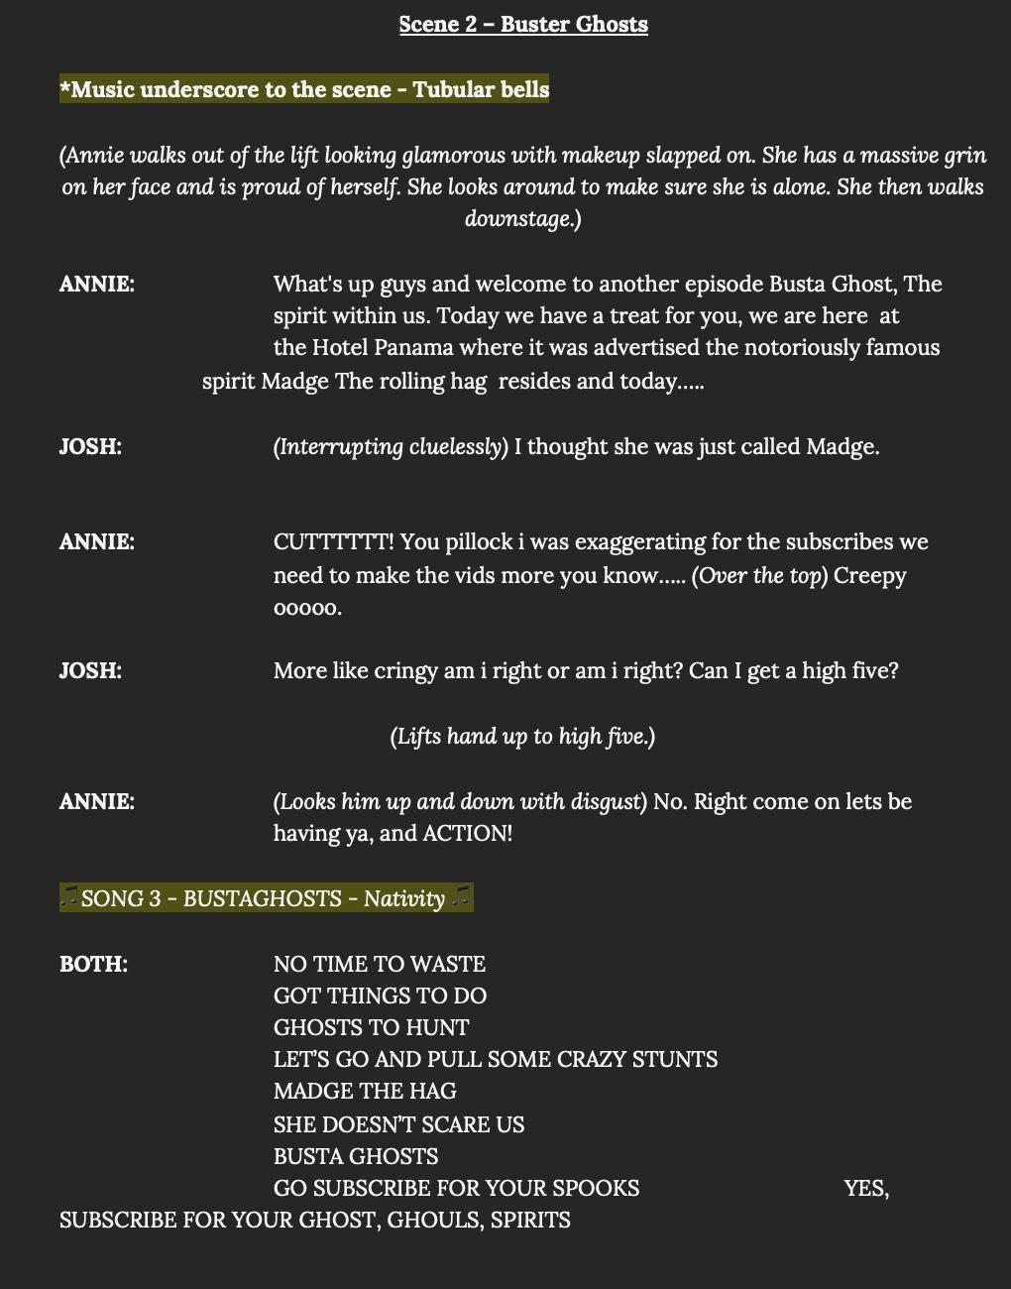
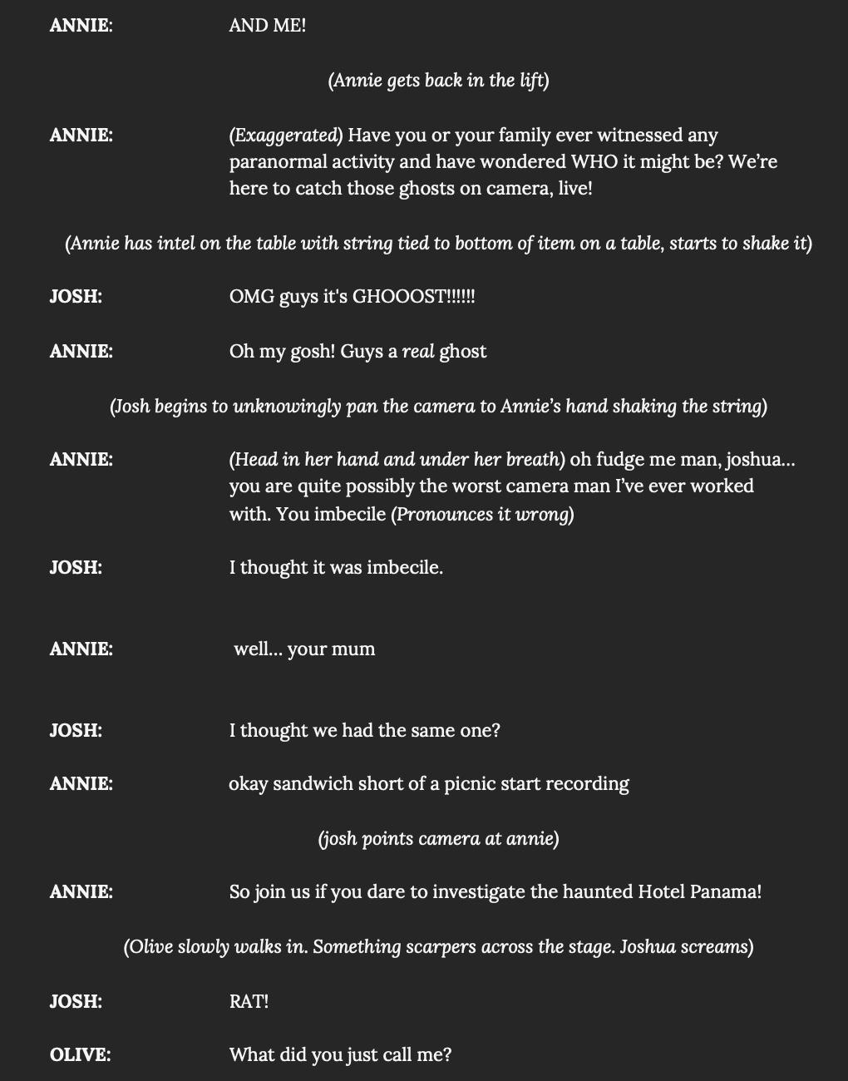
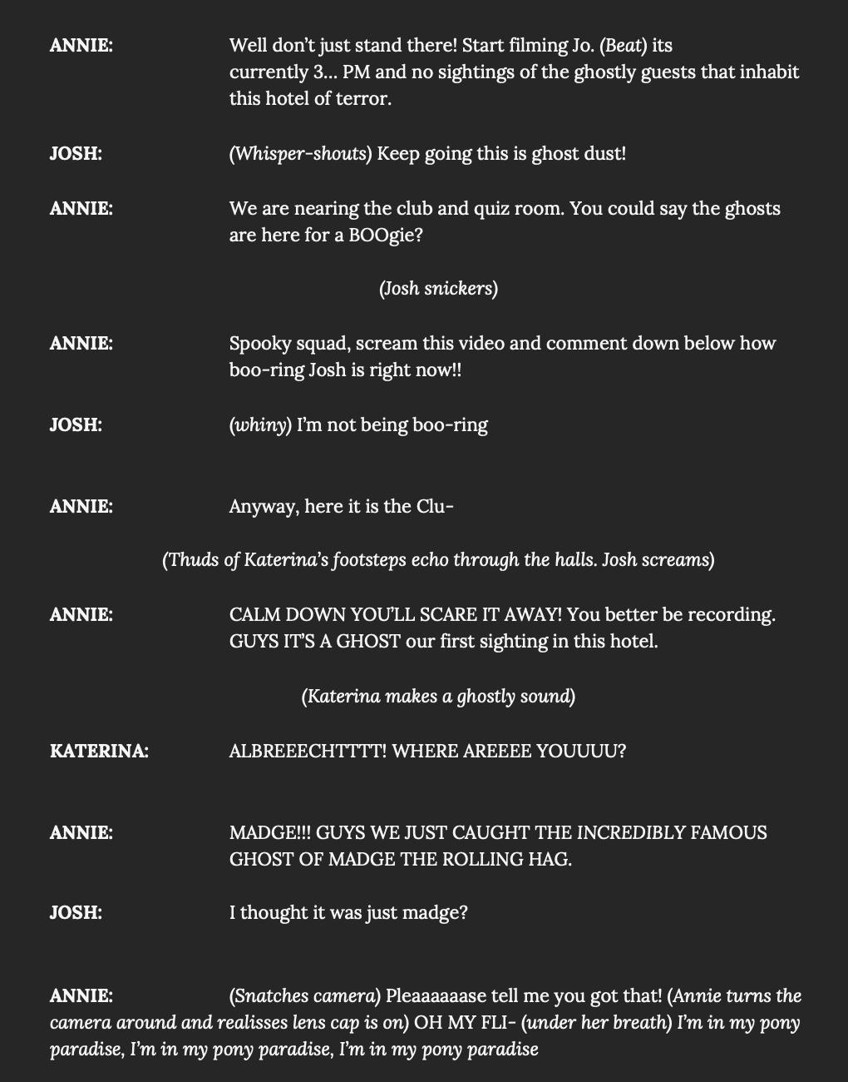
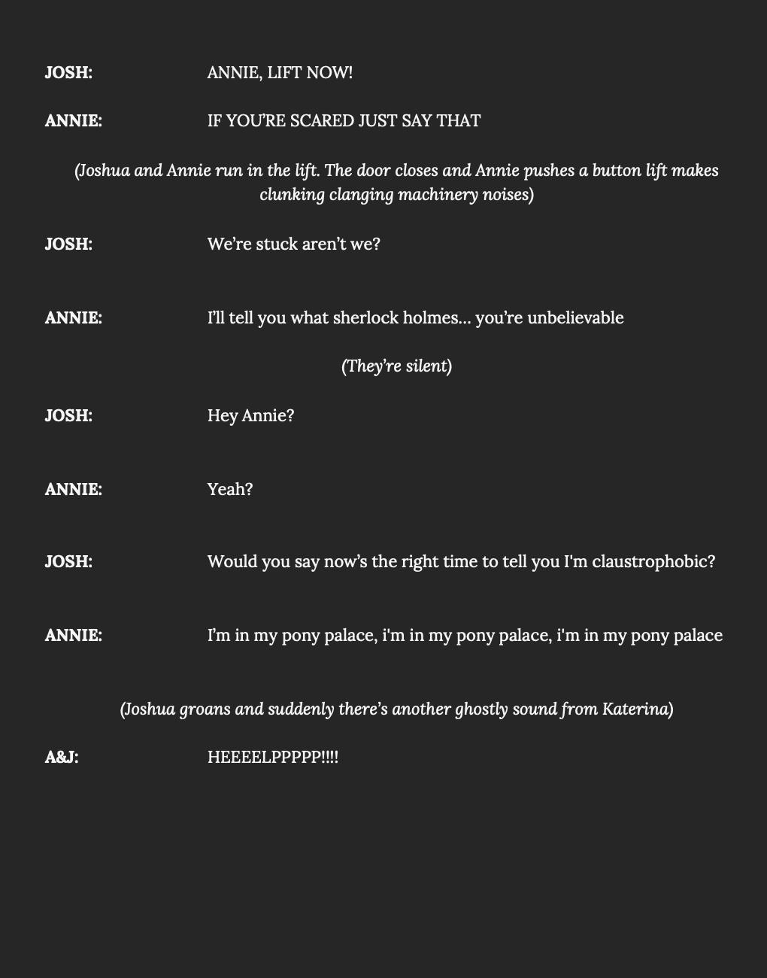

I seem to have lost the copies in between editing but here is the final scene, it initially had more of the original structure i had written but after reading it over and over again i decided to re-write the amalgamated scene as there was something off about it i couldn't quite place my finger on. I decided to write a song for my and dylan's characters as I thought our characters weren’t very featured in the show and that we needed more “air time” of sorts, this happened due to a couple reasons. One being i felt the project wasn’t very collaborative as the same people tended to take over in turn those people writing most of the show and also because i feel like i wasn’t being supported much by dyfan as he usually sat there and just let me write when in actuality i needed his help to write for his character as i didnt know which choices he had made for his character as he failed to either tell me or do exactly that. But in the end I’m happy with how the scene turned out. Writing isn't my strongest suit and I find it extremely hard to write down exactly what I'm thinking.
In reflection on the writing segment of the project i know i definitely would have done things a lot differently and looking back i wish i would’ve rose to the challenge instead of shutting myself off and panicking as i know writing isn't very strong for me, but i can’t not be proud of myself as it was a big hurdle for me to face , im mostly proud i was able to pull through and produce a scene on my own.

The rehearsal process

Startin the rehearsal process for me was very exciting as I feel I am better when I can visualise the scene in my head and act it out in the space which usually sparks ideas for the scene and how it’ll play out. I was also excited to work on a show with our director Angharad Lee, for research she is held to a very high standard and is well known and praised in the Welsh theatre scene. I was excited to work with such a talented director and gain that experience.

From the get go it was challenging as we had written a very chaotic show and Angharad's vision with the show was to make it as chaotic and stylised as we could. I had never done any heavily stylised theatre so i was apprehensive going in as i was unsure what was waiting for me but also ecstatic to be able to gain the experience and a different view of stylised theatre and how it worked for me, in turn allowing me to work on several techniques to improve myself as an actor.

I really enjoyed how we used the space in the show and how we were using techniques that we had learned in our acting classes, this being viewpoints and gridwork. There was a certain area of the stage that was allocated a different part of the hotel and how they’d stick to that grid. This method aided me in being able to focus more as I knew solidly where the scene was played in and where, as I'm usually quite bad with chaos as it just makes me lose focus, fast.

What I found enjoyable was how we used suitcases for the set. I believe it was an interesting vision which worked well and added to the chaos that we were portraying on stage. It was also a good opportunity to work alongside a moving set and it taught me valuable lessons on how to work with a moving set but also in a specific stylised way that added to the musical. It also taught me how to carry on even though there might be set malfunctions during a show.

In terms of myself in the rehearsal process, I believe I could've been more “in it” , because I'm not a big fan of the show and it’s naturesand my character not being my own. I sort of held back a bit and became detached during the rehearsal process. In turn making it harder for me to learn my dialogue and the songs, but in all fairness i do usually have a hard time learning lines as reading isn’t my strong point. This made me realise, in the industry there might be times where I'm in a show I don't particularly enjoy or I'm playing a character I don't enjoy but that doesn't mean I shouldn't give it any less effort etc. That lesson was very valuable and has heavily changed my mindset since. In terms of my and dyfans scenes I'm happy with the way they were directed, the stylistic choices seemed to be a good fit for our characters and made the scene more dynamic on stage and grabbed the audience's attention.

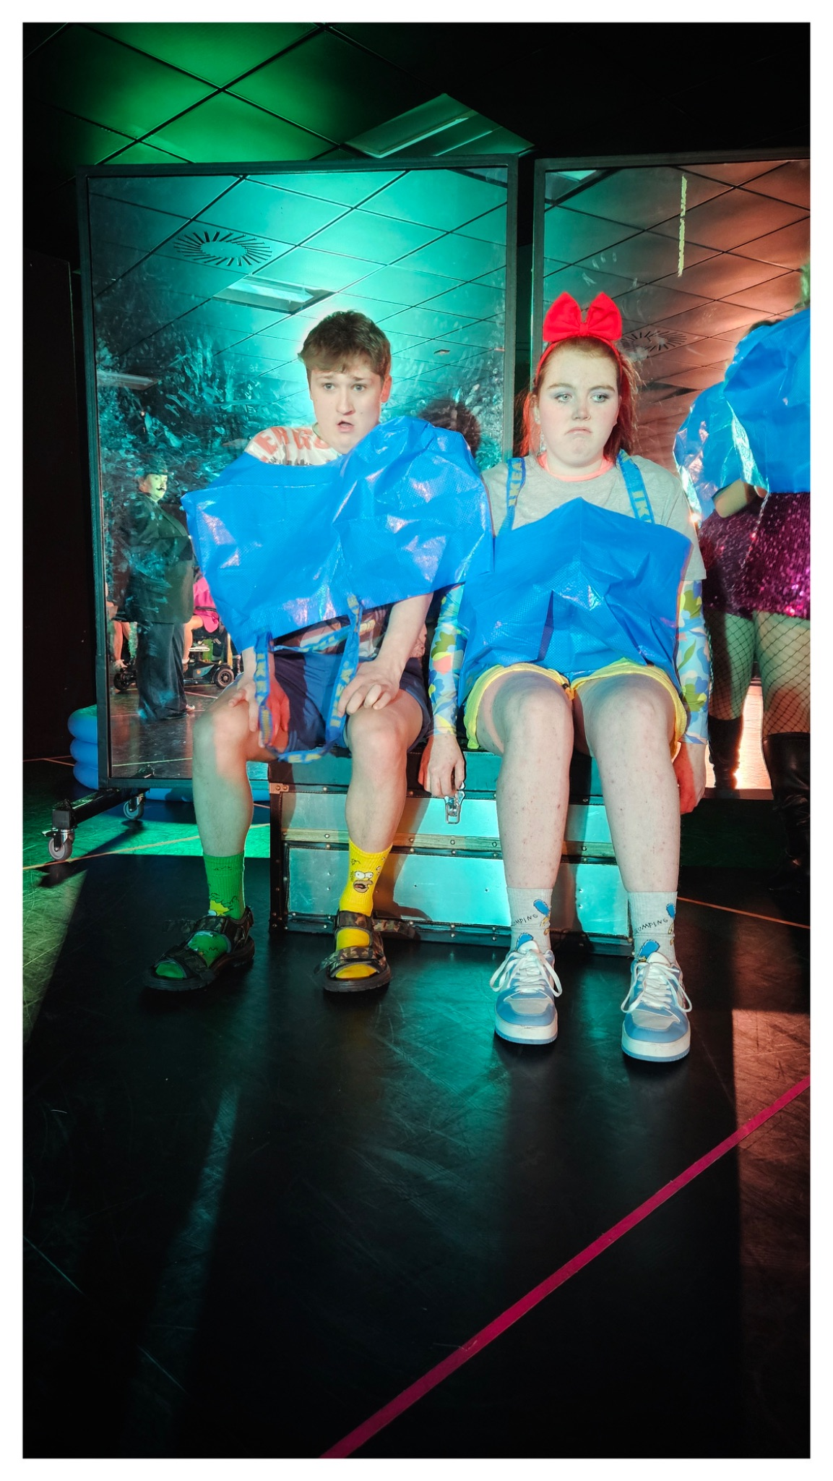

Conclusion

In conclusion I believe everything went well in the show , although we were all ill. The show sold out and the audience feedback was good and what we were wanting. From start to finish this project has been a big personal challenge for me but I have learnt so many valuable lessons I am now able to apply to my future acting with other projects. If I could reverse time , yes, there are several things I would do differently, such as stand up for my ideas and put my foot down, and also make sure the project was more collaborative. All things taken into account , for a first time writer I am overjoyed with the outcome and I'm extremely grateful for the lessons and experiences I've gained.

