Assignment one

Module Name: Business environment
Module code: LCBB405
Student Name: Ileana Cristina Greurus
Lecturer: Nadeem Mirza

Table of Contents
1.Introduction 3
1.1 History 3
2. Challenges faced by car industry 4
2.1 BMW's challenges and strategy 4
2.2 BMW Swot analysis (Strength, Weakness, Opportunity, Threats) 6
2.3 Pestle analysis of BMW 8
2.4 BMW 5 forces model 9
3.Conclusions 10
4.Bibliography 10

1.Introduction

“The UK automotive industry is a vital part of the UK economy worth more than £78.9 billion turnover and adding £15.3 billion value to the UK economy. With some 180,000 people employed directly in manufacturing and in excess of 864,000 across the wider automotive industry, it accounts for 13% of total UK export of goods, worth £44 billion, and invests £3 billion each year in automotive R&D”.
So, as we can see the automotive industry represent a huge part of the UK’s economy creating a lot of jobs and accumulating a lot of income for both UK government and the car manufacturers themselves.
“Like all industries, UK Automotive faces many opportunities and challenges. Tackling emissions and improving air quality, developing new technologies, addressing the skills shortage and ensuring that the vehicles on our roads are the safest possible are issues of extreme importance to the motor industry”.
The technological progress is faster than it seems, and alongside with-it new challenges emerge. Those challenges for some manufacturers turn to opportunities.
The car manufacturer that I have chosen is BMW which stands for Bayerische Motoren Werke. At its origin BMW is a German brand but it ‘s a very popular car in the UK Leading the luxury segment in UK (as well as in many other countries) one of every ten cars sold are BMW models. In the last year BMW was outsold only by Ford and Volkswagen making it one of the most successful brands in the UK.

1.1 History
The official founding date of the German motor vehicle manufacturer BMW is 7 March 1916, when an aircraft producer called Bayerische Flugzeugwerke was established. This company was renamed to Bayerische Motoren Werke in 1922.
BMW was established during the First World War to manufacture engines; in 1945, the company was still Germany’s leading manufacturer of aeroengines. Subsequently it diversified into what in 2000 were its main products, automobiles and motorcycles. By then BMW was one of Germany’s largest and most successful companies. But BMW’s Road to sustained success was a troubled one.
Like I previously said, BMW has started by making airplanes engines and since the Germany was highly involved in the second world war the demand for its services was huge. But at the end of World War 2 BMW was banned by the Allies from producing motorcycles or automobiles. During this ban, BMW used basic second-hand and salvaged equipment to make pots and pans, later expanding to other kitchen supplies and bicycles. Thankfully, the company gets a license to start manufacturing again and from March 26, 1946, on BMW was allowed to start making motorcycles again and later car engines.

2. Challenges faced by car industry
The car industry is booming currently but as in any other industry there are plenty of challenges to face. Some of these challenges might be governmental factors, demographic and economic factors, technology factors, and environmental and legal factors.
The entire business scenario is changing and companies are operating globally to reach customers all over the globe. The advancement in technology, increase in customers’ expectation and globalization are some of the challenges industries are facing today. Automobile industries, like other industries should take right decision at right time to perform better and remain competitive in market.

2.1 BMW's challenges and strategy
The BMW Group currently sees challenges in various areas, including political uncertainty, a cooling global economy (partly due to international trade conflicts), rising production costs to meet regulatory requirements, exchange rate effects and rising raw materials prices this had led to an increasing debt over the past years.
Also, as we see from their latest models it seems that BMW it's trying to establish a name in hybrid and electric cars industry which can be pretty challenging because they have to follow certain legislation and norms and they have to produce new technology to power their cars which means higher production costs.
The brands of BMW Group include BMW, MINI Cooper and Rolls Royce. Those 3 brands speak for themselves, MINI portraits itself as the perfect city car establishing a very deep connection with the customers from UK and not only.
Rolls Royce is an all-exclusive luxury brand. “Each and every Rolls-Royce motor car is hand-made, produced from the ground up at the brand's state-of-the-art manufacturing facility in Goodwood, England”
As we see BMW group’s offer can pretty much satisfy any buyer even though they only have 3 brands in their portfolio.
BMW has quite a clear strategy, conquer as much territory as possible, they are betting on their customers trust linked to the brand past success.

BMW debt level
BMW is currently facing a lot of challenges including an increasing debt over the years from 88B euros in 2016 to over 100B euros in 2022 according to their stock report. BMW is striving to become a significant player on the electric and autonomous vehicles’ market as well and its currently investing a lot of money implementing new technologies into their cars so they can offer a cost-effective alternative to the current offers on the market. The increasing debt can actually be overcome by the car manufacturer because their sales are constantly high “BMW sales reached a new all-time high of 2,213,795 units (+9.1%) last year, with the brand leading the global premium segment”
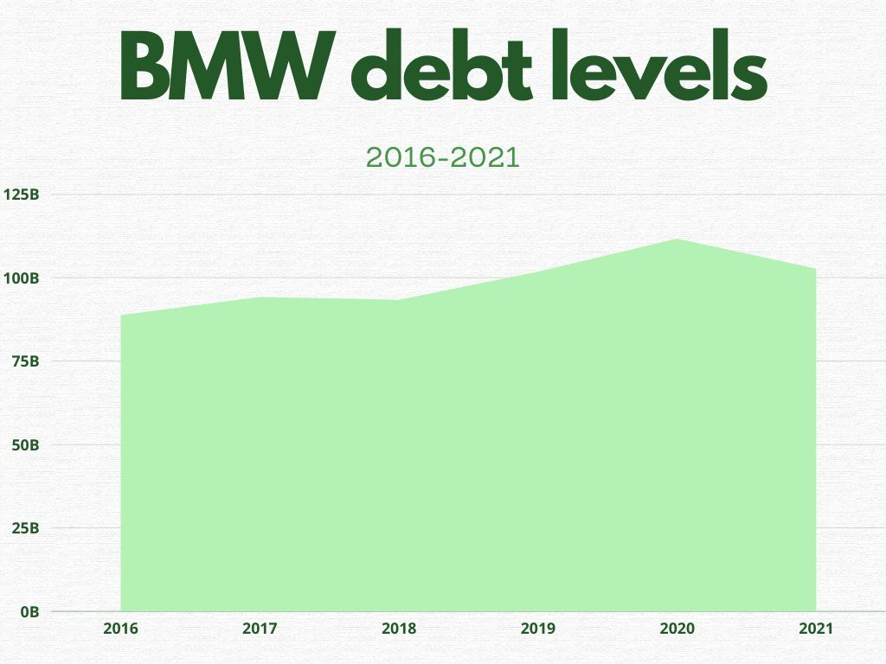
In this chart we can see that BMW had registered a debt increasing over the years.

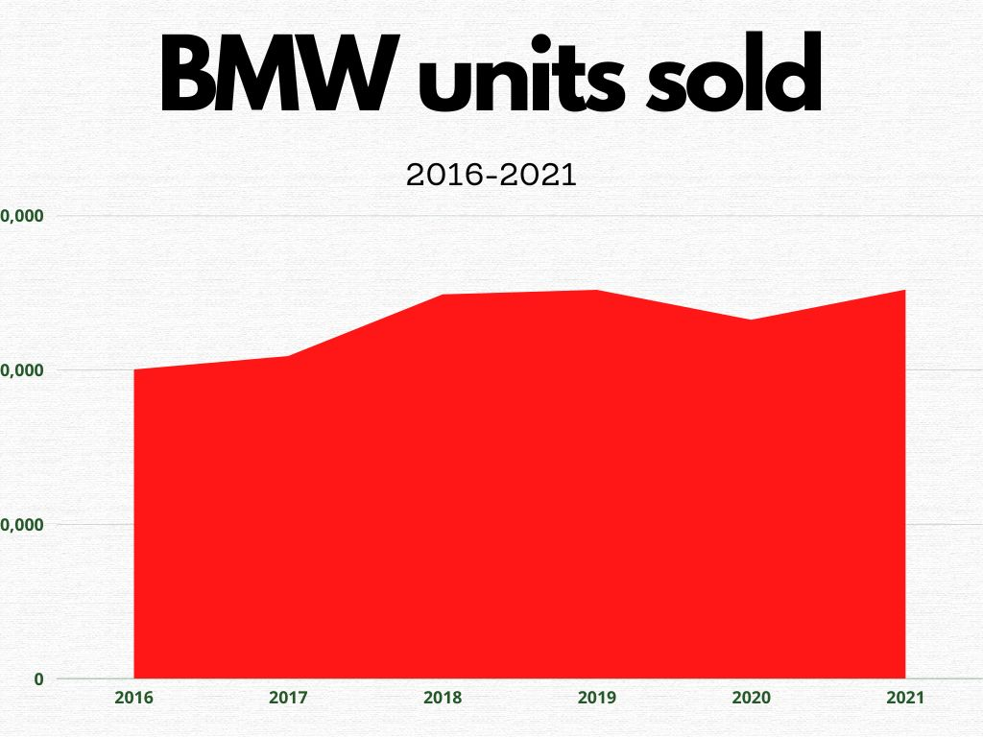
This chart shows us that BMW maintained a volume of sales of over 2.0M units.

BMW models released in the past years
Alongside with the quality of their products BMW high volume of sales is generated by the fact that they are offering a lot of diversity.
Their offer is improved every couple of years by introducing new models and upgrading their old models, a lot more often than their competitors. BMW has introduced in their offer a lot of alternatives such as full electric vehicles (BMW i3 in 2013) or full electric SUVs (BMW iX in 2022) also they are introducing new models so they can cover as much marketing demand as possible such as bigger SUVs (BMW x7 in 2021) or futuristic design coupes (BMW 8 series in 2019)

2.2 BMW Swot analysis (Strength, Weakness, Opportunity, Threats)
Strengths:
- One of the most valuable automotive brands in the world
- Successful partnership in China (China is the largest automotive market with 25.1 million units sold in 2015 alone. It is also the largest BMW’s automotive market. Every automaker strives to dominate Chinese automotive market, but few succeed).
- BMW was always a pioneer in technology implementing technologies such as: head-up display in 2005- a technology which creates a projection of speed and other indicators on the windscreen, 360 degrees camera system, xenon headlights etc.)
- Competence in hybrid and electric cars (BMW released its first electric vehicle BMW i3 in 2013. In 2014, BMW launched a new i8 plug-in hybrid vehicle, alongside with other numerous hybrid cars).
- Successful in Motorcycle industry.
Weaknesses:
- Poor automotive brand portfolio with little product differentiation (even though BMW group always had massive sells their portfolio only consist of mini, Rolls-Royce and BMW)
- Increasing debt (BMW’s debt is the highest in the company’s history. It has been growing significantly over the last five years and reached nearly €130 billion in 2015, this debt is caused by the ingestions in the new technology and electric cars)

Opportunities:
- High gas prices (nowadays we confront with a high raise of fuel cost, and this means a higher demand for smaller and economical vehicles that means that BMW's hybrid and electric car sells will grow exponentially)
- Demand for autonomous vehicles and new technology (currently numerous companies work to produce an autonomous vehicle including Tesla, google and Mercedes so, it seems that the autonomous vehicles will be in high demand very soon).
- Timing and frequency of new model releases (over the past years the customers' expectations has risen that’s why BMW has released new models constantly such as X7, I8, IX, 4series)
Threats:
- Increasing competition in the worldwide automotive market
- Uncertainty in the new fields they want to approach

2.3 Pestle analysis of BMW
BMW PESTLE Analysis examines the various external factors like political, economic, social, technological (PEST) which impacts its business along with legal & environmental factors. The PESTLE Analysis highlights the different extrinsic scenarios which impact the business of the brand.
- Political uncertainty across Europe, middle east and U.S markets
- Economical: debt has increased over the years, but the sells have minorly increased as well
- Social: preferences of environmental friendly vehicles targeting the young buyers.
- Technology: strong focus and spending on innovations and autonomous vehicles
- Legal: inconsistency in regulation regarding autonomous and electrical vehicles
- Environmental: focus on electrical and hybrid vehicles to have low to zero emissions.

5 FORCES ANALISYS
SUPPLIER
POWER
COMPETITIVE
RIVALRY
BUYER
POWER
THREAT OF
SUBSTITUTION
THREAT OF
NEW ENTRY
THREAT OF NEW ENTRY:
HIGH FOCUS ON AUTONOMOUS CARS
COMPETITIVE RIVALRY:
HAS BEEN THE WORLD'S BEST LUXURY CAR FOR MORE THAN A DECAD ON MORE CONTINENTS
FACING NEW RIVALS ON ELECTRIC CARS PLANE
BUYER POWER:
HAS REGISTRED A SELLS GROWTH CONSTANTLY IN THE PAST YEARS.
SUBSTITUTION:
FACING RIVALS AS SUCH AS TESLA AND GOOGLE FOR AUTONOMOUS CARS
SUPPLIER POWER:
SUCCESFULL PARTNERSHIP WITH CHINA
HAS MORE THAN 12000 SUPPLIERS OVER THE WORLD

2.4 BMW 5 forces model
Porter’s Five Forces Analysis of BMW covers the company’s competitive landscape as well as the factors affecting its sector. The analysis focuses on measuring the company’s position based on forces like threat of new entrants, threat of substitutes, bargaining power of buyers, bargaining power of suppliers and competitive rivalry.
- Threat of new entrants: the threat of new entrants can be nil to none, talking about the automobile industry and a company on the level of BMW, which has been relatively established in terms of research and sales, the only threat BMW is facing is in the electric and autonomous vehicles industry
- Threat of substitutes: Most of the people who shop in this segment do so to maintain a status symbol and class in society. They want to improve the quality of their living, and this product is not seen as a must-have but more as an experience so again the main threat BMW is facing is in the new segment they try to enter.
- Buyers power: Keeping the customers satisfied and maintaining the brand reputation by improving each customer touchpoint is crucial for a brand like BMW. There is an added requirement to constantly improve on the feedback given by the customers and keep on innovating so that the customer stays with the company. This require innovation and constantly improvement which can be very expensive this is reflected in the BMW current increasing debt.
- Barging power of suppliers: because of its brand reputation, BMW must maintain a standard of quality in all the raw materials it uses, and hence they carefully choose their suppliers. Due to their influence, they control the suppliers and their practices. The suppliers need to agree on the terms and conditions of the company and abide by their code of conduct to keep their relationship with the company. BMW deals with over 12000 suppliers across the globe, many of which are auto firms themselves, and hence BMW tries to collaborate with them and establish the standard process of operations.
- Competitive rivalry: BMW is trying to move towards a vision where it is selling luxury and helping save the environment with its production processes, thus making the customer feel more accomplished and satisfied.

3.Conclusions

Any car manufacturer is facing challenges such as: leal boundaries, production challenges, suppliers deficit, qualified personal, economical challenges and vicious competition.
BMW has faced difficult challenges over the years, since the very first beginning when they were banned from producing engines to more recent times when its facing a huge debt, but the history shows us that BMW somehow overcome most of its challenges. With a huge legacy, Leading the luxury segment in China, U.S and Europe, implementing new technologies and reaching new limits, BMW has all it takes to remain on top.

4.Bibliography

SMMT (2019) UK automotive: https://www.smmt.co.uk/industry-topics/uk-automotive/
SMMT (2019) Industry topics: https://www.smmt.co.uk/industry-topics/
Ovidius, J. strategic marketing insight, SWOT analysis of BMW: https://strategicmanagementinsight.com/swot-analyses/bmw-swot-analysis/
Simply Wall st (2022) Is BMW using to much debt?: https://simplywall.st/stocks/de/automobiles/etr-bmw/bayerische-motoren-werke-shares/news/is-bayerische-motoren-werke-etrbmw-using-too-much-debt-1
MBA skool team (2020) mba Skool: https://www.mbaskool.com/pestle-analysis/companies/18042-bmw.html#:~:text=BMW%20PESTLE%20Analysis%20examines%20the,the%20business%20of%20the%20brand.

https://www.smmt.co.uk/industry-topics/uk-automotive/
https://www.smmt.co.uk/industry-topics/
https://www.rollsroycepasadena.com/rolls-royce-information/rolls-royce-hand-made/#:~:text=Each%20and%20every%20Rolls%2DRoyce,manufacturing%20facility%20in%20Goodwood%2C%20England.
https://simplywall.st/stocks/de/automobiles/etr-bmw/bayerische-motoren-werke-shares#historical-debt
https://www.press.bmwgroup.com/global/article/detail/T0364013EN/electro-offensive-and-number-one-in-premium-segment:-bmw-group-posts-strong-sales-for-2021?language=en#:~:text=BMW%20sales%20reached%20a%20new,103%2C855%20units%20(%2B133.2%25).
https://strategicmanagementinsight.com/swot-analyses/bmw-swot-analysis/
https://www.mbaskool.com/pestle-analysis/companies/18042-bmw.html#:~:text=BMW%20PESTLE%20Analysis%20examines%20the,the%20business%20of%20the%20brand
The reason I have choose to use materials from outside the library is because the materials I found in the library about this brand are outdated and since this brand is evolving constantly I wanted to have accurate and updated information

