
SUPPORTING DOCUMENT FOR CASE STUDY
BMHP 5004 LEVEL 5

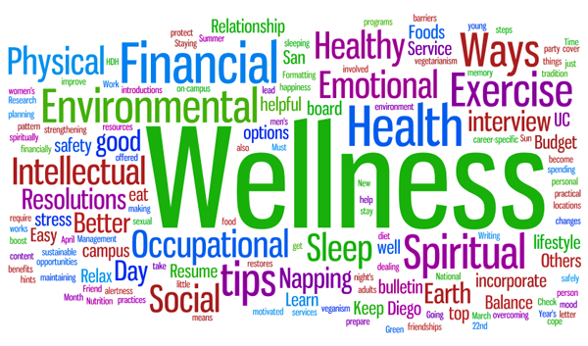
July 1, 2022
omeneke yusuf (2009232)
LECTURER: DR CRISFORD CHOGUGUDZA

INTRODUCTION
This paper is written in support of the case study A presentation. The case was about a family with three children who have multiple needs. They are known to the social services and have multidisciplinary professionals working with them
The Group A worked together by splitting the task among group members who took a topic each and wrote on it before the whole power point was compiled together for presentation. The task was not without its own constrains but all effort was made to make sure the issues were overcome.
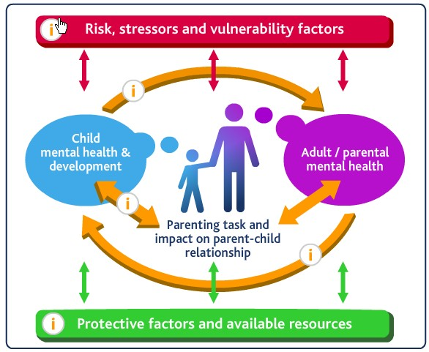
This Photo by Unknown Author is licensed under CC BY

Contents
CHILDREN, YOUNG PEOPLE AND FAMLY WELLBEING 3
FINDING OF CASE STUDY AND THE HEALTH AND SOCIAL CARE TEAM WORKING WITH THEM 3
CHILDREN ACT AND OTHER REGULATIONS 4
RECOMMENDATIONS 6
REFERENCES 7

CHILDREN, YOUNG PEOPLE AND FAMLY WELLBEING

The quality of an individual's relationship with their family has a significant impact on that person's overall health and happiness. Both the social support, in the form of affection, caring, and counsel, and the strain, in the form of being critical and demanding, that an individual receives from their family members may have an impact on the individual's overall health and wellbeing.
The family's and children's socioeconomic standing has a significant effect on overall welfare This can result in a variety of negative outcomes, including depression, substance addiction, and other mental health issues. When a family is socioeconomically disadvantaged, the parents are more likely to experience stress, which has a negative impact on the overall health of the family. If basic requirements are not met, both the parents and the children will have the a lot of troubles relating with each other
Wellbeing can be defined as the continuous existence of positive characteristics or attributes. The five main domains of children and family wellbeing are:

wellbeing was more dependent on their relationships with family and friends and feeling safe from social exclusion and bullying (Andresen, Bradshaw and Kosher, 2018). People who receive support from their family usually have high self-esteem which leads to better mental health. Socioeconomic status has a huge impact on the wellbeing of children and family.

FINDING OF CASE STUDY AND THE HEALTH AND SOCIAL CARE TEAM WORKING WITH THEM
The challenges that Family A in this case study encountered included marital violence, financial instability, failure to make rent payments, suspected parental alcohol problems, and parenting problems. Their unstable socioeconomic position was a contributing factor in the occurrence of these issues. People from lower socioeconomic classes are more likely to be involved in violent domestic situations. Having to deal with difficult financial circumstances can put a strain on the relationships between family members. Problems with housing and health are further exacerbated when there is a lack of financial stability. Family A may see considerable improvements to their situation if they are able to resolve their financial concerns (Pannilage Upali, 2017).

Because of all the problems and difficulties that are being faced by the family, there are certain organizations who are working with the family. The intervention of Connexon and educational workers, which is a group of educational services designed to assist with issues of absenteeism and disruptive behaviors in the classroom. Alcoholism is a problem that may be discussed with the help of experts who specialize in the field of alcohol or substance misuse. Children possess a different range of emotional and physical needs that need to be fulfilled.

CHILDREN ACT AND OTHER REGULATIONS
The health and social care staff adopt a structured intervention strategy to intervene in the child's best interest. This intervention process uses (CAF). This approach supports early intervention in child abuse and improves multiagency collaboration. Several laws have been passed to protect children and families. Social workers must capitalize on patients' strengths. Social workers assist patients to reach goals. Add rest at the lowest practical level to reduce escalation (Gloucestershire's Levels of Intervention Guidance, 2019).
Children and Social Act 2017 and Working Together to Safeguard Children 2018 have done this to help kids. This partnership examines childcare, executes a childcare plan, and assigns a worker to each child to manage services and care for their welfare.
This cooperation creates a team to monitor goals and meet partnership objectives (North Yorkshire Safeguarding Children, n.d.). The Children Act 1989" was passed to safeguard children from abuse and exploitation. This statute also allows authorities to investigate if they believe a child's exploitation or well-being is at risk. The Children Act 2004 was revised in 2004. If a child's welfare is compromised, the courts can interfere. Defining parental roles helps families maintain independence.
Children Act of 2004 established England's children commissioner. This legislation requires regulatory authorities, such as police, health care providers, and the youth justice system, to work to improve children's lives. In 2010, the new government evaluated children's social work and child protection practices to implement creative new policies and procedures to promote their well-being. New results were approved, and the new administration promised to implement them (Evans, 2013).

HUMAN RIGHT: The Human Rights Act of 1998 lays out the fundamental rights and liberties that are guaranteed to each person living in the United Kingdom. It does this by bringing the rights outlined in the European Convention on Human Rights (ECHR) into the domestic legal system of the United Kingdom. In the United Kingdom, the Human Rights Act became fully operational in October of the year 2000.
UNITED NATION CONVENTION ON CHILDEN RIGHT.
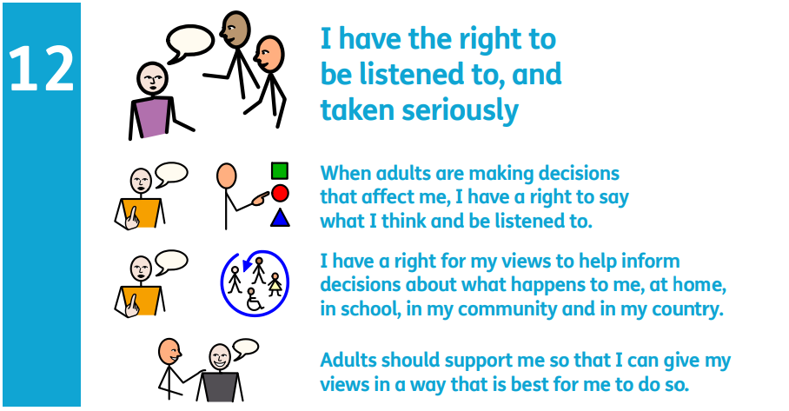
This Photo by Unknown Author is licensed under CC BY
The UNCRC said that every single child, regardless of their race or nationality, religion or language, ability or any other status, is entitled to certain rights. The Convention must be interpreted as a whole; all the rights are interconnected, and no single right surpasses the others in terms of relevance. The right to unwind and have fun (Article 31) and the right to express oneself freely (Article 13) are on equal in terms of importance with the right not to be subjected to physical or mental harm (Article 19) and the right to get an education (Article 20). (Article 28).
The Convention acknowledges only UNICEF as an organisation that is actively striving to benefit children. The Convention on the Rights of the Child is also the human rights convention that has the most countries who have ratified it. The United States is the only member state of the United Nations that has not ratified the Convention. In 1992, the Convention became legally binding in the United Kingdom.

RECOMMENDATIONS

Observing children and teens should be enhanced, and a positive attitude and prompt response should be emphasised.
Organizations and workers dealing with children and families should be trained to understand their vulnerabilities.
If timely aid had been given, the problem may not have been as bad. Adequate aid can prevent the issue from occurring. Social agencies and women's aid may have helped the family early on.
Roberts' seven-step crisis intervention approach analyses problems and suggests solutions (Lundy, 2011), A helpful parental trainer in schools can help parents learn more effective child-rearing approaches.

REFERENCES
- Andresen, S., Bradshaw, J. And Kosher, H. (2018). Young Children’s Perceptions Of Their Lives And Well-Being. Child Indicators Research, [Online] 12(1), Pp.1–7. Doi:10.1007/S12187-018-9551-6.accessed on 16/07/2022.
- Anon (2022) online Microsoft photo. by Unknown Author is licensed under CC BY-SA-NC.website uknown, accessedon 20/07/2022

- Ball, E., Batty, E. And Flint, J. (2015). Intensive Family Intervention and The Problem Figuration Of ‘Troubled Families’. Social Policy and Society, 15(2), Pp.263–274. Doi:10.1017/S1474746415000469.
- Blackburn, P. And Dwyer, K. (2016). A Bereavement Common Assessment Framework In Palliative Care: Informing Practice, Transforming Care. American Journal Of Hospice And Palliative Medicine®, 34(7), Pp.677–684. Doi:10.1177/1049909116647403.
- Digital Health and Care Wales. (2018). In The Community. [Online] Available At: Https://Dhcw.Nhs.Wales/Systems-And-Services/In-The-Community/ [Accessed 22 Jul. 2022].
- Equality And Human Rights Commission (2018). The Human Rights Act | Equality and Human Rights Commission. [Online] Equalityhumanrights.Com. Available At: Https://Www.Equalityhumanrights.Com/En/Human-Rights/Human-Rights-Act.accessed on 20/07/2022.
- Evans, M. (2013). Policy Guide: Children Act 1989 Amended 2004. [Online] Nursery World. Available At: Https://Www.Nurseryworld.Co.Uk/Features/Article/Policy-Guide-Children-Act-1989-Amended-2004.
- Gloucestershire’s Levels Of Intervention Guidance - Working Together To Provide Early Help, Targeted And Specialist Support For Children And Families In Gloucestershire. (2019). [Online] Available At: Https://Www.Gloucestershire.Gov.Uk/Media/2092076/Gloucestershire-Revised-Loi-Guidance-V4-Final-Gsce-Version-2019.Pdf [Accessed 6 Jul. 2022].
- Holden, K., Mcgregor, B., Thandi, P., Fresh, E., King, V. And Boyd, L.M. (2016). Factors Associated with Perceptions of Family Belonging Among Adolescents. Journal Of Marriage and Family, 78(4), Pp.1114–1130. Doi:10.1111/Jomf.12322.
- Lundy, C. (2011). Social Work, Social Justice & Human Rights : A Structural Approach To Practice. North York, Ont.: University Of Toronto Press.
- King, V. And Boyd, L.M. (2016). Factors Associated with Perceptions of Family Belonging Among Adolescents. Journal Of Marriage and Family, 78(4), Pp.1114–1130. Doi:10.1111/Jomf.12322.
- Monk, D. (2017). Thatcher’s Grandchildren? Politics And Childhood in The Twenty-First Century Edited by Stephen Wagg and Jane Pilcher, Basingstoke: Palgrave Macmillan, 2014. 352 Pp. Isbn: 978-1-137-28154-8 £65.00 Hardback. International Journal of Law in Context, 14(01), Pp.185–187. Doi: 10.1017/S1744552317000337.online version, accessed on 15/07/2022
- North Yorkshire Safeguarding Children (N.D.). Nyscp Home. [Online] North Yorkshire. Available At: Https://Www.Safeguardingchildren.Co.Uk/.accessedon 04/07/2022.
- Pannilage Upali (2017). Impact Of Family On Children’s Wellbeing. [Online] Researchgate. Available At: Https://Www.Researchgate.Net/Publication/320064189_Impact_Of_Family_On_Children.accessed on 19/07/2022.

- Roberts, A.R. And Ottens, A.J. (2005). The Seven-Stage Crisis Intervention Model: A Road Map To Goal Attainment, Problem Solving, And Crisis Resolution. Brief Treatment And Crisis Intervention, 5(4), Pp.329–339. Doi:10.1093/Brief-Treatment/Mhi030.
- Saxena, S., Ommeren, M. van and Saraceno, B. (2006). Mental health assistance to populations affected by disasters: World Health Organization’s role. International Review of Psychiatry, 18(3), pp.199–204. doi: 10.1080/09540260600655755.Accessed on 01/07/2022
- Stroud, P. (2019). Philippa Stroud: Now That We Can Measure Poverty, We Can Work Together to Tackle It. [Online] Conservative Home. Available At: Https://Conservativehome.Com/2019/05/23/Philippa-Stroud-Now-That-We-Can-Measure-Poverty-We-Can-Work-Together-To-Tackle-It/ [Accessed 22 Jul. 2022].
- Thomas, P.A., Liu, H. And Umberson, D. (2017). Family Relationships And Wellbeing. Innovation In Aging, [Online] 1(3), Pp.1–11. Doi:10.1093/Geroni/Igx025.Accessed on 26/06/2022
- UNICEF (1989). UN Convention on the Rights of the Child (UNCRC) - UNICEF UK. [online] UNICEF. Available at: https://www.unicef.org.uk/what-we-do/un-convention-child-rights/.accessed21/07/2022.

