

Certificate of Higher Education in Skills for the Workplace

Digital Skills and Research Methods

Lecturer: Anupam Mazumbar

Student: Shenses Maksud - 1605761

AN ANALYSIS OF IMPACT OF JOB STRESS ON THE PERFORMANCE OF DELIVERY MAN OF PIZZAHUT, UK

Table of Contents

Chapter 1: Introduction 6
Chapter 2: Literature review 9
Chapter 3: Research methodology 11
Chapter 4: Result analysis and discussion 15
4.1 Primary quantitative research method 15
4.2 Data analysis 21
Chapter 5: Conclusion and recommendations 22
Reference List 24
Appendices 26

Chapter 1: Introduction

1.1 Introduction
The current study is intending to demonstrate reasons of arising job stress in workplace and its impact on performance of delivery men of Pizza hut, UK.

1.2 Background of the research
In 2017, Pizza Hut has operating financial loss of £7.5 million (statista.com, 2018). Net earnings profit of the British private company has been reduced from £9.01 billion to £7.89million in year 2016 (statista.com, 2018). Along with that, pre-tax profit has been diminished from £7.9 million to £5.2 million in year 2016.

1.3 Research rationale
Pizza Hut has been experiencing lack of performance among the delivery men as they are feeling stressed because of excessive job pressure (glassdoor.co.uk, 2018). In case of meeting deadlines and coping with advance technological equipments as well as organizational culture, excessive work pressure is given on delivery men of Pizza hut, UK (influenced by Zeb and Rehman, 2015, p.121).

1.4 Problem statement
Job stress establishes inverse impact on performance of delivery men of Pizza hut, UK. As opined by Rahim (2017, p.213), job stress enhances the chances of employee burnout as well as turnover due to affecting negatively on mental condition of delivery men.

1.5 Aim
The aim of the research is to find out the impact of job stress on performance of delivery men of Pizza Hut, UK.

1.6 Research objectives
- To critically evaluate factors that influence job stress of delivery men of Pizza Hut UK
- To critically assess the impact of job stress of delivery men on organisational performance of Pizza hut UK
- To critically identify the impact of job stress on employee performance of delivery men of Pizza Hut UK
- To develop mitigation strategies for reducing job stress for delivery men of Pizza hut UK

1.7 Research questions
- Which are main factors of job stress of deliver men of Pizza hut UK?
- How job stress of deliverymen is influencing organisational performance of Pizza hut UK?
- How job stress is influencing performance of delivery men of Pizza hut UK?
- Which strategies can be adopted in Pizza hut UK to resolve job stress of deliverymen?

1.8 Significance
This study is intending to analyze the role of job stress on their performance of delivery men. This could facilitate the organisation to resolve such challenges.

1.9 Structure
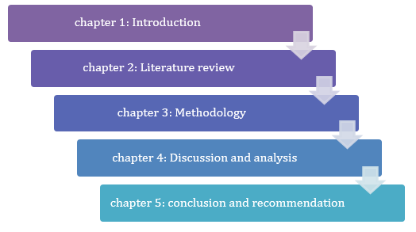

Figure 1.1: structure
(Source-influenced by Rahim, 2017, p.213)

1.10 Summary
It has described research aim along with research objectives and research questions.

Chapter 2: Literature review

2.1 Introduction
The current chapter critically analyzes sources of job stress and relationship between job stress and performance of delivery men of an organization. Along with that, it demonstrates impact of job stress on performance of delivery men with the aid of Lazarus theory of stress.

2.2 Conceptual framework
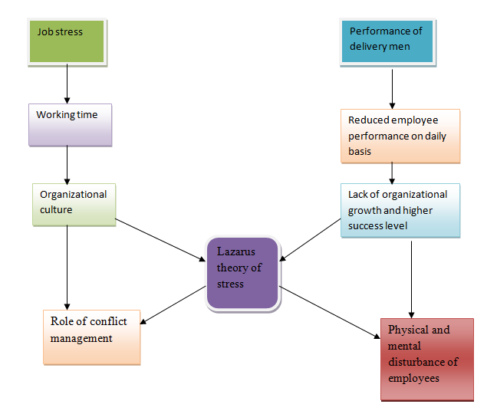

Figure 2.1: Conceptual framework
(Source: influenced by Desrumaux et al. 2015, p.181)

2.3 Critically analyzing sources of job stress and its impact
Job stress establishes inverse impact on performance of an organization. As per views of Banerjee and Mehta (2016, p.3), bad relationship between hierarchy and employees as well as role of conflict management are major reasons of arising job stress. Apart from that, long working hours, excessive workload and job insecurity are the other factors that influence job stress. As asserted by Desrumaux et al. (2015, p.181), job stress enhances the chances of employee burnout as well as turnover. Lu and Gursoy (2016, p.213) commented that, due to excessive working time and inadequate remuneration, physical and mental condition of employees are affected negatively.

2.4 Critically discussing relationship between job stress and job performance
Strong relationship exists between job stress and performance of employees due to affecting negatively on mental and physical condition. As per principles of Lazarus theory of stress, stress is the physical and mental disturbance of employees due to which they do not show enough interest in performing well for an organization. As opined by Menges et al. (2017, p.701), working time and bad relationship with hierarchy are two significant reasons of arising job stress. In the following context, Mullen et al. (2018, p.97) argued that organizational culture including roles and responsibility of employees sometime create job stress among delivery men.

Figure 2.2: Lazarus theory of stress
(Source: influenced by Mullen et al. 2018, p.97)

2.5 Critically describing impact of job stress on performance of delivery men
Performance of delivery men of an organization is mostly dependent upon level of stress. As opined by Nawaz and Ansari (2017, p.19), flexible working time and good organizational culture both allow employees to perform well. However, Petrou et al. (2018, p.1777) commented that effective organizational culture does not indicate higher performance of employees.

2.6 Literature gap
This study has described the factors of job stress and its impact. However, effective strategy to regulate job stress of employees without affecting organisational performance has not been mentioned in existing literary sources. Thus, this can be considered as gap in literature.

2.7 Summary
This chapter has discussed impact of job stress on performance of delivery men of an organization.

Chapter 3: Research methodology

3.1 Introduction
The current chapter demonstrates positivism philosophy as well as deductive approach and descriptive design. Along with that, it uses primary quantitative data collection method and follows ethical guidelines.

3.2 Research Onion
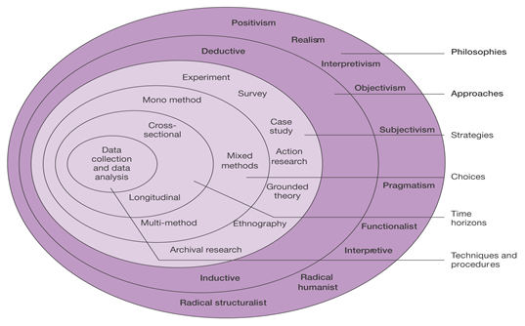

Figure 3.1: Research onion
(Source: influenced by Saunders et al. 2009, p.52)

3.3 Research philosophy
Researcher has chosen positivism philosophy for the purpose of gathering evidence based data and factual information regarding impact of job stress on delivery men of Pizza hut, UK (influenced by Sheikh, and Sultana, 2016, p.23).
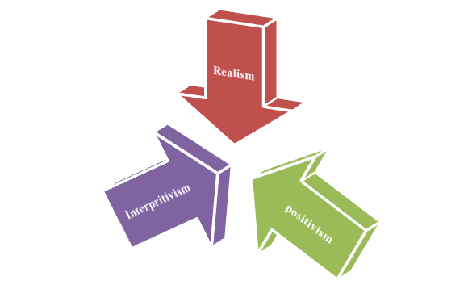

Figure 3.2: Research Philosophy
(Source: influenced by Sheikh, and Sultana, 2016, p.23)

3.4 Research approach
As the most preferred approach, researcher has selected deductive approach for understanding properly reasons behind creation of job stress. As opined by Tjora (2018, p.33), deductive approach assists in gathering specific information from a large amount of information. Moreover, it helps in at specific conclusion considering large amount of collected information (influenced by Tjora, 2018, p.33). Thus, this approach has facilitated the researcher to reach at the conclusion by analyzing all the accumulated data.
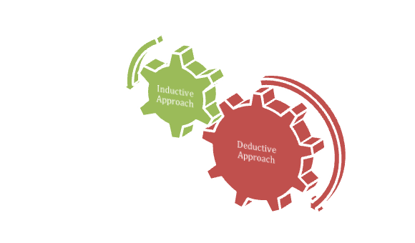

Figure 3.3: Research approach
(Source: influenced by influenced by Kothari, 2004, p.52)

3.5 Research design
Descriptive design has been followed in the following research due to describing information regarding factors influencing job stress and its impact on performance of delivery men of Pizza hut. As per views of Jagtap and Jagtap (2015, p.379), descriptive design assists in presenting informative data based on specific subject in a descriptive way.
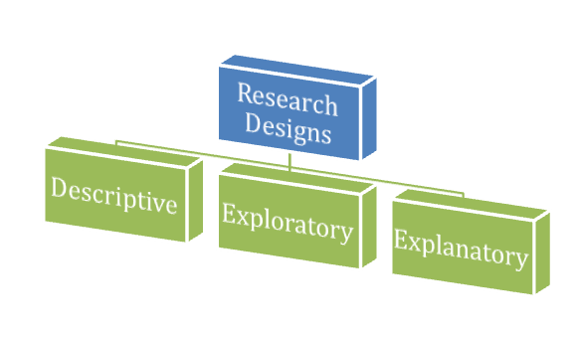

Figure 3.4: Research Designs
(Source: influenced by Jagtap and Jagtap, 2015, p.379)

3.6 Data collection methods
Primary quantitative data collection method including survey has been followed in the following research.

3.7 Sample size
Survey has been conducted among 50 delivery men in London area for the purpose of gathering information related to factors influencing job stress.

3.8 Sampling technique
Random non-probability sampling technique has been followed in order to conduct the research successfully.

3.9 Data analysis tool
In order to analyze data based on impact of job stress on performance of delivery men in Pizza hut, UK different data analysis tools such as MS excel has been used in this research.

3.9 Reliability and validity of data
All gathered data is reliable and valid due to conducting survey among delivery men of the company.

3.9 Research timeline
(Refer to appendix 2)

3.10 Ethical consideration
The researcher has maintained confidentiality of all collected data based on impact of job stress on employee performance of Pizza hut, UK. Along with that, different guidelines of Data protection Act 1998 have been followed in maintaining ethical approach (legislation.gov, 2018).

Chapter 4: Result analysis and discussion

4.1 Primary quantitative research method
Question 1: Do you think working hour and bad relationship with hierarchy are reasons of creating pressure on delivery men of Pizza hut?
Responses | Total respondent | No of Respondent | Percentage of Respondent
Agree | 50 | 18 | 36
Strongly agree | 50 | 14 | 28
Neutral | 50 | 2 | 4
Disagree | 50 | 10 | 20
Strongly disagree | 50 | 6 | 12

Table 4.1: Working timing and bad relationship with hierarchy are reasons of creating pressure on delivery men

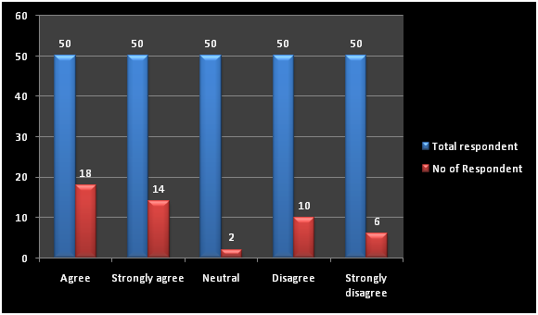

Figure 4.1: Graphical representation of question 1
Total percentage of agreed respondents is much higher than percentage of disagreed respondents. Due to which, certain decision based on working hour and bad relationship with hierarchy can be taken from the following result as a factor of job stress on employee performance.
Question 2: Do you think excessive work pressure is creating job stress among the delivery men of Pizza Hut?

Responses | Total respondent | No of Respondent | Percentage of Respondent
Agree | 50 | 12 | 24
Strongly agree | 50 | 13 | 26
Neutral | 50 | 4 | 8
Disagree | 50 | 12 | 24
Strongly disagree | 50 | 9 | 18

Table 4.2: Performance of delivery men depends upon level of stress

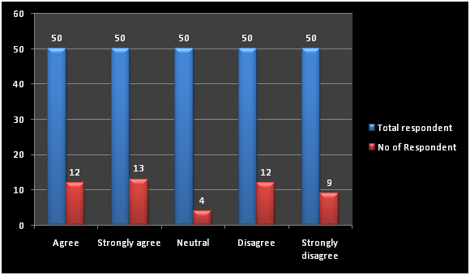

Figure 4.2: Graphical representation of question 2
Percentage of agreed respondents and disagreed respondents are almost equal. Due to which, it creates certain conflict regarding excessive work pressure. Therefore, final result based on work pressure as a major factor of job stress cannot be evaluated from the following result.
Question 3: Do you agree that job stress in Pizza Hut is influencing organisational performance?

Responses | Total respondent | No of Respondent | Percentage of Respondent
Agree | 50 | 14 | 28
Strongly agree | 50 | 17 | 34
Neutral | 50 | 4 | 8
Disagree | 50 | 8 | 16
Strongly disagree | 50 | 9 | 14

Table 4.3: Job stress impacts negatively on performance of delivery men

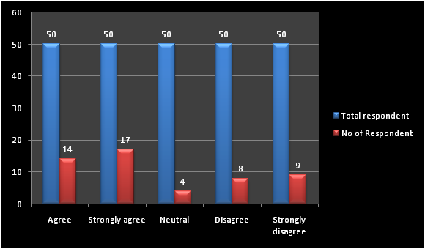

Figure 4.3: Graphical representation of question 3
Maximum percentage of agreed respondents has given their view in favour of the statement. Only 8% respondents have given their view against the information related to impact of job stress on performance of delivery men. Therefore, final decision can be taken on the basis of negative impact of job stress on performance of delivery men.
Question 4: How far do you agree that organisational culture is responsible for the job stress?

Responses | Total respondent | No of Respondent | Percentage of Respondent
Agree | 50 | 17 | 34
Strongly agree | 50 | 14 | 28
Neutral | 50 | 3 | 6
Disagree | 50 | 6 | 12
Strongly disagree | 50 | 10 | 20

Table 4.4: Organisational culture is responsible for the job stress

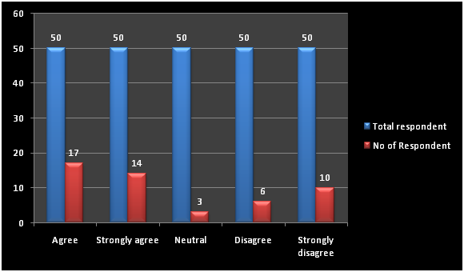

Figure 4.4: Graphical representation of question 4
Percentage of agreed respondents is higher than disagreed respondents. Therefore, final decision can be taken on the basis of organizational culture which is most influencing factor of job stress.
Question 5: Do you think tight schedule and job insecurity is creating stress among the employees of Pizza Hut UK?
Responses | Total respondent | No of Respondent | Percentage of Respondent
Agree | 50 | 14 | 28
Strongly agree | 50 | 15 | 30
Neutral | 50 | 3 | 6
Disagree | 50 | 8 | 16
Strongly disagree | 50 | 10 | 20

Table 5: Tight schedule and job insecurity is creating stress

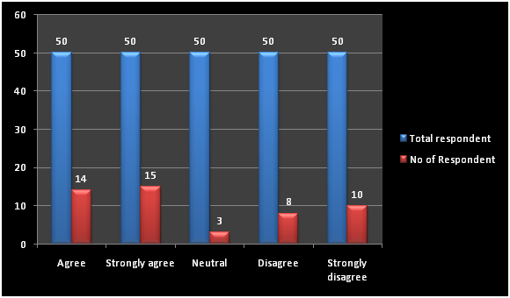

Figure 4.5: Graphical representation of question 5
Total percentage of agreed respondents is comparatively higher than disagreed respondents. Thus, it ensures positive result regarding tight schedule and job insecurity as significance factor of arising job stress.

4.2 Data analysis
Strict working time as well as bad relationship with hierarchy is major reasons of job stress among delivery men of Pizza hut, UK. In case of having higher stress among delivery men, organizational performance might be affected negatively. Along with that, flexible working time and good organizational culture both allow employees to perform well.

Chapter 5: Conclusion and recommendations

5.1 Conclusion
Thus, it can be concluded that higher job stress among delivery men is the reason of decreasing performance. Along with that, long working hours, excessive workload and job insecurity are the other factors that influence job stress.

5.2 Linking with objectives
Objective 1: to critically evaluate the factors that influence job stress of delivery men of Pizza Hut UK
This objective is linked with question 1 and 2 as well as question 4, question 5 of primary quantitative data analysis. It is clear that, excessive working hour and bad relationship with hierarchy are reasons of creating pressure on delivery men.
Objective 2: to critically assess the impact of job stress of delivery men on organisational performance of Pizza hut UK
This objective is linked with question 3 of primary quantitative data analysis. From this objective, it is clear that job stress affects negatively on organizational performance.
Objective 3: to critically identify the impact of job stress on performance of delivery men of Pizza Hut UK
This objective is linked with question 3 of primary quantitative data analysis. It is clear that, performance of delivery men is reduced significantly for higher job stress.

5.3 Recommendations
SMART recommendation

Specific | - To offer flexible job role to delivery men
Measurable | - With the measurement of employee performance and organizational growth
Attainable | - It can be attained by offering different schedule and decreasing exercise pressure
Realistic | - It is realistic as organizational growth rate and overall productivity are dependent upon this
Time | 2 month

Table 5.1: SMART recommendation 1

5.4 Future scope of the study
The current study has not described profession of delivery men and impact of job stress on growth of an organization. Therefore, further research can be conducted on profession of delivery men and impact of job stress on organizational success level.

Reference List
Banerjee, S. and Mehta, P., (2016). Determining the Antecedents of Job Stress and Their Impact on Job Performance: A Study Among Faculty Members. IUP Journal of Organizational Behavior, 15(2). pp.1-3
Desrumaux, P., Lapointe, D., Sima, M.N., Boudrias, J.S., Savoie, A. and Brunet, L., (2015). The impact of job demands, climate, and optimism on well-being and distress at work: What are the mediating effects of basic psychological need satisfaction?. Revue Européenne De Psychologie Appliquée/European Review of Applied Psychology, 65(4), pp.179-188.
glassdoor.co.uk (2018), Pizza Hut UK Employee Reviews about "long hours", Available At: https://www.glassdoor.co.uk/Reviews/Pizza-Hut-UK-long-hours-Reviews EI_IE36235.0,12_KH13,23.htm [Accessed on: 22/12/2018]
Jagtap, S. and Jagtap, S., (2015). Aesthetic design process: Descriptive design research and ways forward. In ICoRD’15–Research into Design Across Boundaries. 1 (10), pp. 375-385.
Kothari, C. R. (2004). Research methodology: Methods and techniques. New Age International: India
legislation.gov. (2018). Data collection Act 1998. Available at: https://www.legislation.gov.uk/ukpga/1998/29/contents [Accessed on: 04/12/18]
Lu, A.C.C. and Gursoy, D., (2016). Impact of job burnout on satisfaction and turnover intention: Do generational differences matter?. Journal of Hospitality & Tourism Research, 40(2), pp.210-235.
Menges, J.I., Tussing, D.V., Wihler, A. and Grant, A.M., (2017). When job performance is all relative: how family motivation energizes effort and compensates for intrinsic motivation. Academy of Management Journal, 60(2), pp.695-719.
Mullen, P.R., Malone, A., Denney, A. and Santa Dietz, S., (2018). Job stress, burnout, job satisfaction, and turnover intention among student affairs professionals. College Student Affairs Journal, 36(1), pp.94-108.
Nawaz, A. and Ansari, N., (2017). Impact of job stress on job performance with perceived organizational support as a moderator. Management Review, 1(2). pp.3-141

