Software Development

ACCA4017

Programs in C and Documentation

Harry Byrne
P133366

Part A
A1. A variable is a named location in memory that is used to hold a value that can be modified by the program. All variables must be declared before they can be used[1], this is usually done at the start of the program. The variable must have a type i.e. to specify the type of data it will contain for example the variable int stores integer values. Variables can be assigned at the start of a program which is useful for setting constants throughout a program.
A2. The for-loop is also referred to as a counting loop as it counts the amount of executions it needs to carry out. It is used when we know the number of executions needed in the loop. Below is a flowchart showing a for loop in sequence. It’s used to reduce the amount of coding needed for repeated tasks

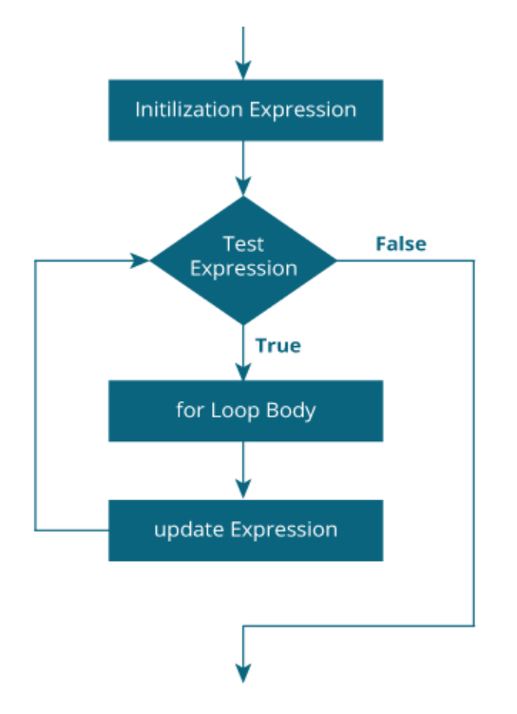

A3. An array is a list of variables of the same data type accessed under a common name. A one dimensional one is set out as a list and a 2 dimensional one is set out more like a table. In a programme any array is declared with [ ]. Each part within an array is called an element, due to the counting nature of C the first element is always counted as 0 as opposed to 1. They are useful for storing data when the order doesn’t matter, for example storing data on students, you could store their name and average scores in an array for each student, then using loops you could check the class scores average etc.

PART B

Exercise 1
Following the basic specification the pseudocode follows:
- Input age as integer
- Input height as float
- Input name as character
- Display on screen the inputted data.

Annotated Code
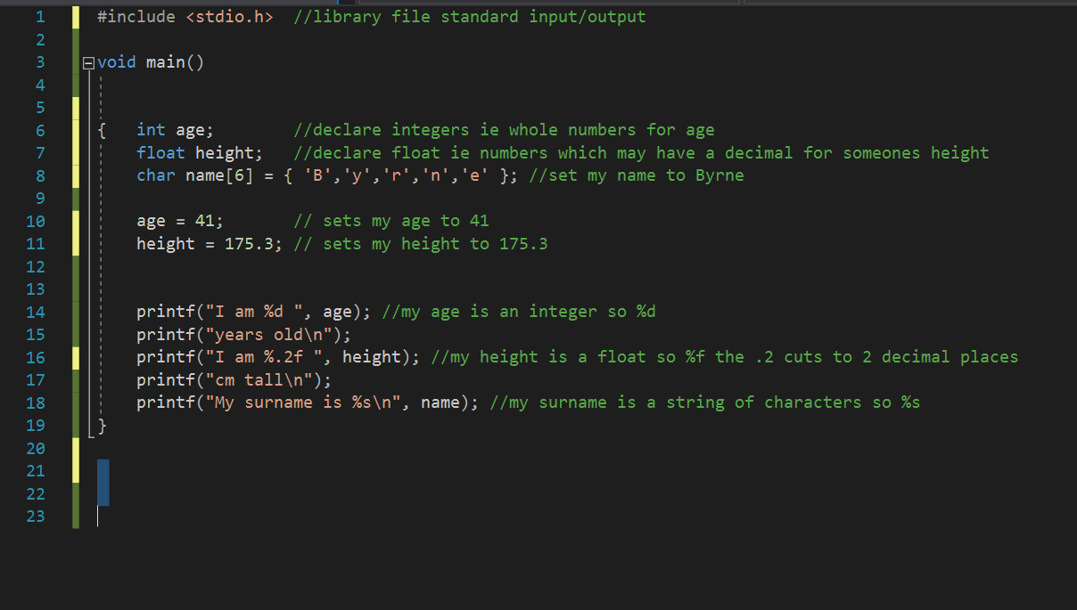

Testing
Program displayed information correctly.
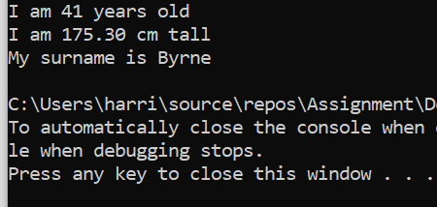
Extending the Specification
To make the program more user based it would be prudent to ask them to input their name, height and age then display that. Suitable pseudocode would be:
- Ask the user to enter their surname
- Store the surname in memory
- Ask the user to enter their height
- Store the height in memory
- Ask the user to enter their age
- Store the age in memory
- Show on screen the height, age and name along with relevant text

Annotated Code
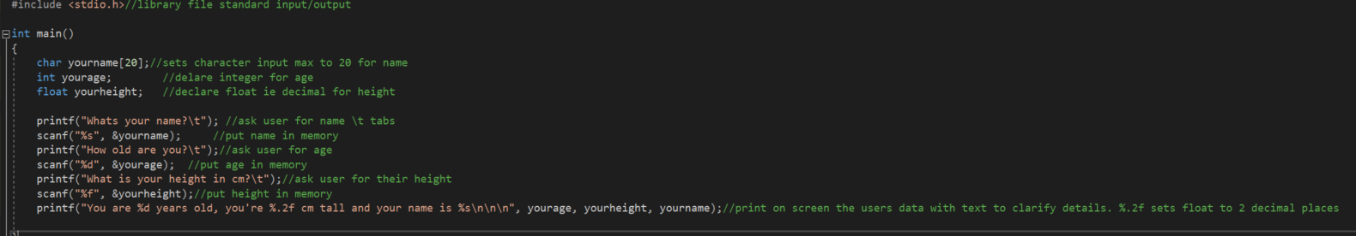

Testing
Following correct data format input the code was a success.
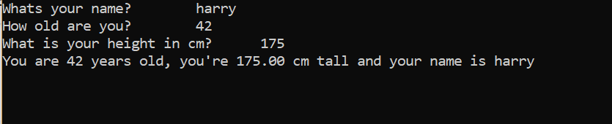

With incorrect data input format, the program failed.

Exercise 2
The pseudocode for this program needs to follow the following layout.
- User is asked to enter radius of circle
- Radius is stored into memory
- The area of the circle is worked out with Pi*r2
- The area is stored into memory
- User is asked to input height of the triangle
- Height is stored in memory
- User is asked to input length of triangle
- Length is stored in memory
- Area of triangle is worked out by base * height /2
- Area of triangle is stored in memory
- Area of circle – area of triangle is worked out to find out final figure needed
- Show on screen the area of final calculation

Annotated Code
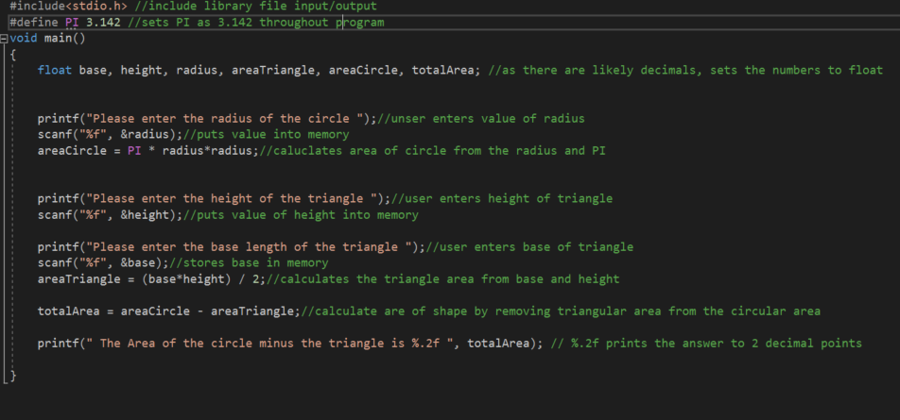

Testing
The results shown, show the input of whole numbers, program was deemed a pass.
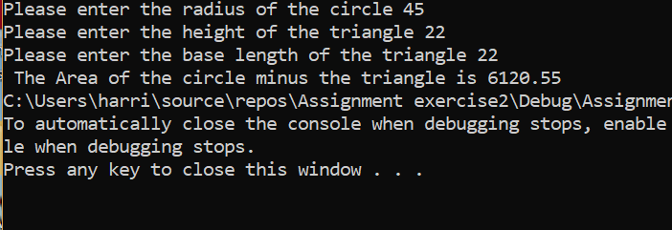

This time decimals were used. Once again program passed.
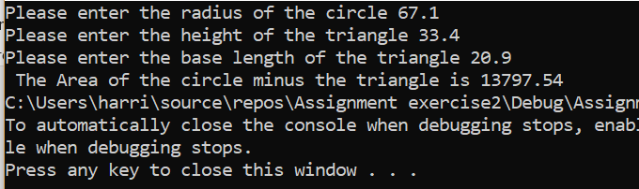

This time a letter was used. Program failed.
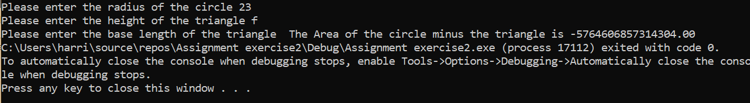

This time the inputted triangle was larger than the circle, this caused the output to be a negative number. It would have been prudent to enter a limit to the size of the triangle in relation to the size of the circle.
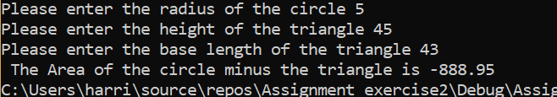

Exercise 3

The coding layout for this exercise needs to follow the basic layout of:
1. User is asked to enter the five different prices.
2. Five prices are stored in the array, would need to be stored as a float due to there being a high chance of decimal point being used.
3. The five prices need to be added together.
4. Display the total on screen.
5. Using the total already worked out multiply by 1.2 to get the total plus 20% tax value.
6. Display the total plus tax value on screen.

Annotated Code
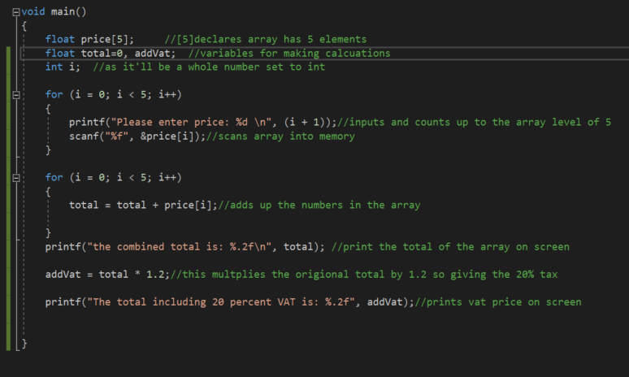

Testing
The results are as shown, for the first test whole numbers were used. As can be seen, the program worked correctly.
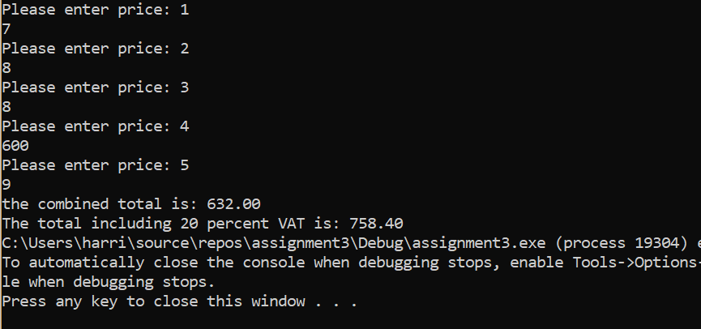

For the second test larger numbers with decimals were used. The correct answer was once again achieved.

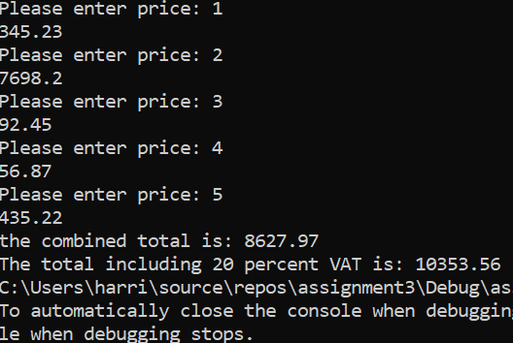

For the third test, a letter was inputted, the program failed.
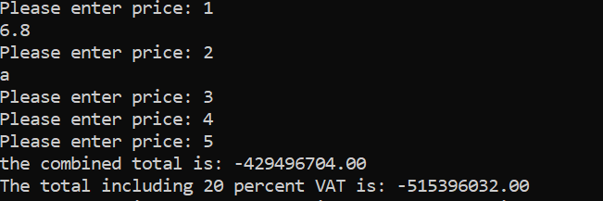

Exercise 4
The pseudocode for the fruit machine would follow the rough guideline:
- Set arrays for the winning combinations along with the points they are worth
- Ask the user if they’d like to play
- Program to pick 3 random numbers between 1 and 5
- Display numbers picked
- Check numbers against arrays to see if they are a winning combination

References
[1] H. Schildt, C/C++ Programmer’s Reference. 2003.

