
Module Code: BMSW4004

Assignment Title: Problem Solving and Decision Making
Student Name:
Student ID:

Lecturer Name:

Introduction:
Problem solving and decision making is a very important part of any company or organization. When a company or organization is run by many people and there is a decision to be made; Then there may be various kinds of problems or influence on decision making. In that case, problem solving or decision making is an effective means. Solving problems as quickly as possible and making effective decisions creates a favorable position for the company or organization. In this, employees do not lose interest in working or get bored, they enjoy working. In an employee-friendly organization, their work progress depends on the working environment. There may be various problems in an organization from time to time such as salary deficiency, non-payment of salary on time, poor working environment, time discrimination etc. If these problems are not solved quickly, the company faces losses. So, it is important to solve problems or take good decisions even in adverse environment. Child and Co. is one of the companies of UK. We will talk more about the problem in workplace and more about decision making.

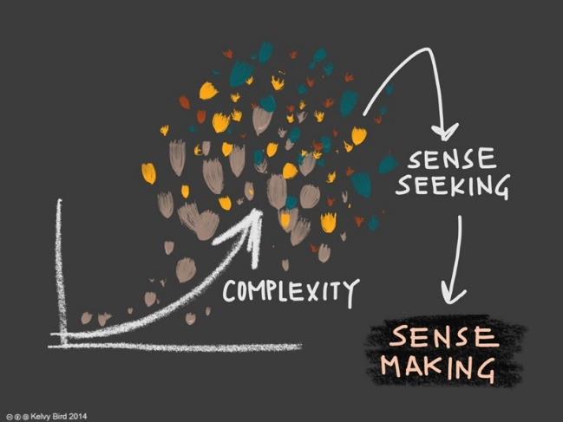
Between hard and simple problems, it is important to consider the scope of the problem, whether the company has enough resources to solve the problem, what are the possible solutions to solve the problem, or whether there is a better solution that would be better for everyone. Situational awareness is very important in solving common problems (Baumberger-Henry, 2017). In this case, it is necessary to keep in mind the solution in terms of reality. Moreover, there are strategic reasons for taking action considering possible outcomes.
There are various types of complications in the workplace. Which are identified as complications to everyone. One of them is the complications related to salaries and allowances. Salaries and allowances affect the personal life of an employee. Employees are happy that they can live in some comfort if they are paid a fair number of allowances along with the salary. As a result, they get pleasure from working for the company. Loyalty to work. Another of the complex problems in the workplace is the lack of working environment in the workplace (Feudtner, 2020). Working environment is very important for every company. If there is no work environment, employees lose their interest. Moreover, it is important to have a bond between everyone as a working environment (Weitzman and Weitzman, 2020). As a result of the internal environment, the good and bad effects of work emerge. There may be a communication breakdown between problems within the company. There is no alternative to maintaining communication between everyone on a daily basis to improve the quality of the company. Technology can be used to solve problems in the workplace. That's why it can be a good decision to discuss the issues with the staff. Another complicated problem can be in the workplace, health problems (Klein and Crandall, 2018). Health problems should be adequately assessed with good management. Otherwise, it may have adverse effects. Mental health issues are a well-known issue in today's workplaces. As a result, there is a possibility of having different types of effects in the workplace. Excessive worry, depression, depression, drug addiction etc. are major stakeholders of health problems (Marsiske and Margrett, 2018). Bias among employees is a complex issue because everyone has a goal to improve the business. Adapting behavioral characteristics to employees is very important. One of the main characteristics of the company may be to ensure that there is no conflict between the employees. Behavioral problems in the workplace have a huge negative impact. An example would be using social media instead of working at work. These problems make the mental state sick (Koppenjan et al., 2017).

The decision-making process is influential in solving identified problems. For example, the next step in identifying a problem is to adopt a nominal strategy. By doing this, the company can avoid some problems. For example, this decision can be taken to prevent pressure or dominance of a particular group (Thornton and Dumke, 2019).
With the help of Delphi technique, problems are solved even if they are not seen among the employees. However, there are obvious advantages and some disadvantages. This makes it more likely that officials or employees will accept the decision. The best course of action may not always be considered. In that case, the important responsibility of the manager is to take any decision that will have the best impact later. So that the decision-making of the employees in the workplace can have a good effect on it. Therefore, the advantage of problem identification is that the identified problem helps in making decisions or finding solutions. It requires decision-making at or near the maximum good according to the level of the problem (Baumberger-Henry, 2017).

An alternative solution can have a significant business impact on all areas of the company. If it fails to achieve the target, then the company will have to bear its responsibility or count the loss. Therefore, the most important solution in solving the problem may be to consider the management system seriously. Management system plays a role in all activities of a company right from floor selection to personnel. Another important solution is quality assurance. When the product reaches the customer, all the problems are solved if the quality of the product is good. Otherwise, both the product and the company have to post (Klein and Crandall, 2018).
Lack of trust is a big problem. In that case, developing trust and company character is an important issue. Because products largely depend on them.
Customer satisfaction is another important chapter. If the customer somehow loses interest, it is difficult to bring him back (Simon et al., 2019).
Moreover, waste management makes the customer interested in keeping the company's environment good and sustainable. In addition to solving the problem, the business becomes affordable and the business becomes profitable (Marsiske and Margrett, 2018).
Since every company has problems, the extent to which the problem has been solved can be understood by considering the company's dividend. Therefore, management system and quality assurance can be a good alternative solution.

Companies use some techniques in decision making. Techniques help to move the company to a profitable place. Some techniques can be explained. One of which is,
- Scientific Process: Scientific process is one of the most important problem-solving processes for working within a company. In this case, various questions have to be faced and solutions can be found as soon as the answers to the questions come forward. As a result, finding solution to the problem as well as great help in decision making (Thornton and Dumke, 2019). There are steps in this process through which the way is found. such as,
- Asking and answering questions
- Do enough research on the subject
- Gather enough information
- Try experimenting
- to observe
- Collect results and conclusion of method

- Trial and error: This method may seem difficult or messy, but it is a very profitable process. This method also has some additional benefits. To make this process successful, several things are analyzed to solve the problem (Feudtner, 2020). Trials are very useful in overcoming the failure of a company. Even the trial works as necessary to catch the problem.

- Differentiation between two solutions: By this process, the advantage of differentiating between two solutions is that the right decision comes forward very quickly (Koppenjan et al., 2017). In this case, more or less experientially, cost-effective or alternative ways of thinking etc. can be easily found. Such a process leads to better decisions for a company's decision making.

- Multi-voting: People inside the company can be asked to decide on any one, two or three of the issues. By doing this, based on everyone's opinion, the majority of opinions can bring something good. The one that comes up with the most alternative decision can be selected. As a result, it will be seen that the most alternative way will come forward (Klein and Crandall, 2018).

- Diagram Method: The most beneficial aspect of this method is that the number of mistakes is reduced very much in this method. As a result, the alternative solution method gives good results. In this case, any wrong decision can affect people, it has to be determined. Even the alternative approach that comes up this way helps keep the results of everything separate (Marsiske and Margrett, 2018).

- Decision Tree Method: More than one analysis results in the most necessary and useful means. As a result, if many results are kept side by side for alternative solutions, it is convenient to find the right or timely alternative solution (Taylor, 2018). As a result, it is understood what is necessary and what is unnecessary in the business.

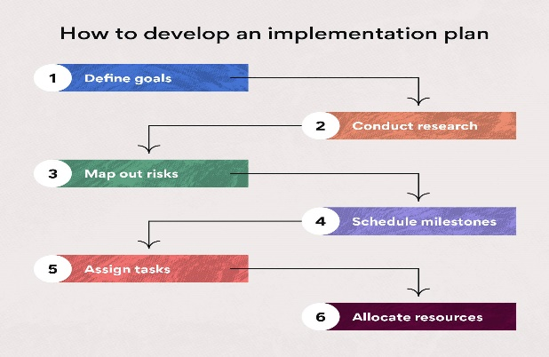
When the solution is in front of everyone, then it becomes necessary to implement the solution plan. By implementing the solution, the company creates several profitable conditions (Baumberger-Henry, 2017).
To implement the solution –
- Setting goals: Setting goals helps measure any work. If you set the goal, you can move towards the work easily. As a result, it is convenient for work.
- Research: An effective method for solving alternative solutions for the company using the knowledge gained through research. By doing this, various new information comes forward and the work becomes different (Koppenjan et al., 2017).
- Risk Mapping: In all types of work, the level of risk can be low or high. But the risk remains. By doing this, if the decision to take risk is made earlier, then it is possible to avoid or reduce the loss of the risk later.

Communicate with the stockholder is important. The company has different policies for communicating with its stakeholders. Stakeholders are communicated through some steps. Stakeholders collaborate directly and indirectly to implement the plan (Feudtner, 2020). So, after planning they are contacted. For example,
E-mail or Newsletter: This medium is considered as one of the popular mediums for effective communication (Simon et al., 2019). The advantage is that all the information of the company's accounts, budget etc. can be sent together through it. As a result, it becomes easier to understand from the stakeholders.
Automation Communication: This process ensures massive collaboration for the company (Sampson Jr et al.,2019). By this way a company can make communication with automatic system and also a company can able to update their information or database regularly. When company try to do something different as well as new, the stockholders play a vital role to do it. That’s why, they are some important people for doing well in business.
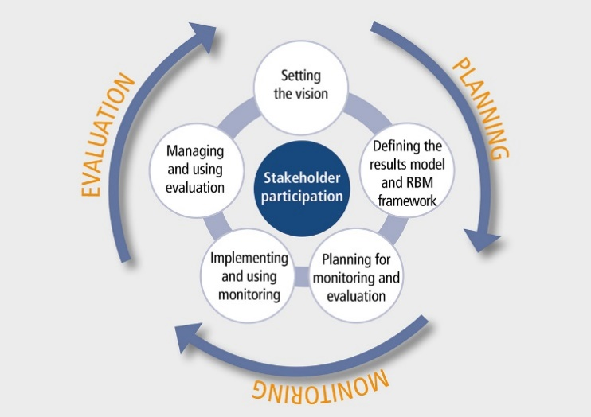
Monitoring and its review are the most effective means for a successful implementation (Klein and Crandall, 2018). This observation and monitoring acts as a kind of record which is preserved and remains for future. Stakeholder support can be sought to implement monitoring and review methods that every company should implement. This activity plays a direct role in solving the problems of a company successfully. Also helps as part of any new plan. By collecting information and monitoring through it, the company can collect reviews very easily (Feudtner, 2020). So, they can be able to find the way for developing. They also able to understand that, in which sector they have to work for developing.

Conclusion:
To improve, it is essential to have a monitoring cell in the company. By monitoring the activities of the officers or employees, it is possible to greatly advance the activities of the company. In this case, as it is convenient to identify the problem, it is also possible to take a good decision as a solution to the problem. The board of directors or the company's authorities may consider the level of the problem in making their decision. As a result, it is beneficial for the employees to find the working environment in the company. A company can have various problems. But there is a solution. The easier it is to find a way to solve a problem, the easier it is to make decisions.

Reference:
Baumberger-Henry, M., 2017. Cooperative learning and case study: does the combination improve students’ perception of problem-solving and decision making skills?. Nurse education today, 25(3), pp.238-246.
Feudtner, C., 2020. Collaborative communication in pediatric palliative care: a foundation for problem-solving and decision-making. Pediatric Clinics of North America, 54(5), pp.583-607.
Klein, G. and Crandall, B.W., 2018. The role of mental simulation in problem solving and decision making. In Local applications of the ecological approach to human-machine systems (pp. 324-358). CRC Press.
Koppenjan, J.F.M., Koppenjan, J. and Klijn, E.H., 2017. Managing uncertainties in networks: a network approach to problem solving and decision making. Psychology Press.
Marsiske, M. and Margrett, J.A., 2018. Everyday problem solving and decision making. Handbook of the psychology of aging, pp.315-342.
Sampson Jr, J.P., Lenz, J.G., Reardon, R.C. and Peterson, G.W., 2019. A cognitive information processing approach to employment problem solving and decision making. The Career Development Quarterly, 48(1), pp.3-18.
Simon, H.A., Dantzig, G.B., Hogarth, R., Plott, C.R., Raiffa, H., Schelling, T.C., Shepsle, K.A., Thaler, R., Tversky, A. and Winter, S., 2019. Decision making and problem solving. Interfaces, 17(5), pp.11-31.
Taylor, D.W., 2018. Decision making and problem solving. Handbook of organizations, 20, pp.48-86.
Thornton, W.J. and Dumke, H.A., 2019. Age differences in everyday problem-solving and decision-making effectiveness: a meta-analytic review. Psychology and aging, 20(1), p.85.
Weitzman, E.A. and Weitzman, P.F., 2020. Problem solving and decision making in conflict resolution.

