  Component One: Student Journal (learning log) 750 words +/- 10%  Contribution to Overall Module Assessment: 25% | Student No: | 2246646
 | Module Title: | Hotel Administration & Front Office Operations
 | Module Code: | BMIH4004
 | Lecturer: | Lisa Bassler

Introduction
This assignment is a reflective report that will be carried out using Gibbs' reflective cycle about my placement experience within the housekeeping department at the Hotel Novotel Milton Keynes, United Kingdom. Gibbs reflective cycle involves six different stages, and they are description, feelings, evaluation, analysis, conclusion and an action plan at the end (Crowe Associates, 2020).
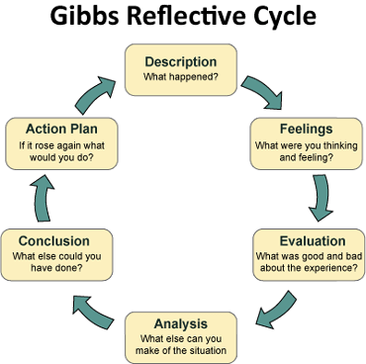
Figure 1: Gibbs’ Model of Reflection
(Source: Crowe Associates, 2020)

Description
I was appointed as a housekeeping staff at Hotel Novotel Milton Keynes, and the basic responsibilities and tasks were directly related to housekeeping activities and processes. Akbar (2021) suggested that usually, housekeeping responsibilities are related to overall cleanliness, keeping things in order, maintenance, good and positive behavioural approach, quick action, the safety of guests and ways of keeping the guests satisfied with various services like quick replies, good communication, problem – solving nature and fast services. In short, I was responsible for making the rooms clean and fresh whilst also looking after the complaints and grievances of the new guests and working accordingly to satisfy them.
My responsibilities lied in cleaning the rooms as well as answering to ad-hoc requirements from the guests. There were approximately seven employees working under me, and they were always ready to serve the guests who needed help at any point in time. Managing my team members, communicating effectively with the guests and acting, as a leader within the housekeeping were also my duties and responsibilities. I received good feedback regarding my communication skills and I realised the importance of effective communication and professionalism in enhancing guest satisfaction levels.

Feelings
Initially, I realised that I needed to work more effectively on time management and team management skills because there were moments when I was unable to manage my team accordingly. To meet all the needs and requirements of the guests, I sometimes got puzzled and the guests even complained about the timing of the services. I was also emotional when the guests praised and congratulated me on my hard work and dedication.
Many guests who were checking in or out did not have that much patience, but I realised that through experiences, I will gather the required skills and tactics to manage the issues and challenges mentioned above.

Evaluation
My strengths were my behaviour, empathy and sincerity towards the tasks assigned to me. I am a hardworking individual and the areas of improvement were related to team management and time management. During certain situations, the guests came up with certain problems, which I solved quickly in the most appropriate manner and later realised that I possessed the skills related to problem – solving.

Analysis
Through this placement at Hotel Novotel Milton Keynes, I have gathered a thorough understanding of the front – office area's role in contributing to a positive and pleasant guest experience. Through interactions with different guests, I understood that customer service is all about good behaviour, a positive attitude, having problem–solving skills, an empathetic approach, being active always and lastly, managing conflicts appropriately.
Pham et al. (2020) suggested that a welcoming and pleasant hotel environment would attract guests more often and give them a very enjoyable experience. Moreover, I did not face any issues related to ethical and cultural considerations, which I may face in the future. I feel that respect for every individual, who belongs to different religions, cultures, beliefs and ethnicities, should exist along with the maintenance of equality.

Conclusion
I can conclude that through the above experience, I gathered a lot of knowledge on customer services, customer handling and other activities that contribute towards a positive customer experience. I also understood the importance of problem – solving skills, conflict management skills, team and time management skills and lastly, communication and behavioural skills.

Action Plan
To work on my time management skills, I need to go through books and articles on time management and consult my managers for the next 3 months' time. To team management I need to work on myself and go through videos and articles as well as to my managers to receive mentorship, which I think I will develop within 5 months from now.
Through the above reflection, I gained a lot of knowledge and skills related to the hotel industry and the front office area. I also realised that I need to work on my time management skills and team management skills for a better future in the context of my employment.

Component Two
Contribution to Overall Module Assessment: 25%
Trip Advisor Review Response 150 words +/-10%
Dear Irina,
We hope you are doing great.
Thank you so much for your time and effort in writing such a lovely and motivating review, in context to, your stay, at our Hotel Novotel Milton Keynes and we sincerely appreciate it. Firstly, we at the Hotel Novotel Milton Keynes are highly grateful to you for choosing us, as your preferred hotel. I will sincerely share the positive review with all our team members, as they will be highly motivated and continue to work hard in order to provide their services to high quality standards in the future.
Our operations manager has appreciated Jane, who is in charge of the reception. In fact, she has thanked you and she mentioned that your behaviour and approach were great and appreciable too, which I thought to include in my letter. This is to inform you that we train our employees every month on new and effective ways of keeping the hotel clean and lovely. We also try our best to maintain a very pleasant environment within the hotel to enhance guest experiences. We sincerely look forward to your visit again.
Many thanks,
Ioana Elisa Bucura
Housekeeping Department
Hotel Novotel Milton Keynes

Screen shot of referenced Trip Advisor review used:
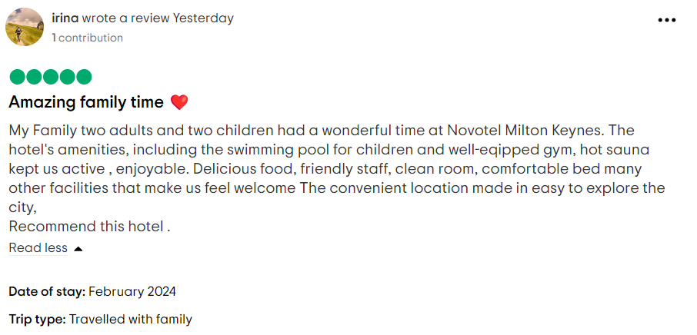

Figure 1: Screenshot of a Positive Review for Hotel Novotel Milton Keynes
(Source: Trip Advisor, 2024)

Letter of complaint response 500 words +/- 10%
Joanna Blake
558 Longford Road
Swansea, SA1 2AR
20th February, 2024

Dear Joanna,

We hope that you are doing great.
Firstly, I would like to sincerely thank you for choosing us, as your preferred organisation. Secondly, I would like to inform you that we are extremely sorry for all the inconveniences that you went through. I have read your complaint thoroughly and I can assure you that from next time, you will not have to face any issues related to your complaint.
I have escalated your complaint to the housekeeping department manager who is responsible for maintaining the cleanliness of the rooms. During your visit, there was a huge rush of guests and unluckily some of our housekeeping staff and workers were on leave. We never expected the rush at that time and thus, the issues related to dirty floors, stains on bedding and unclean bathrooms rose. I can ensure that from the next time, whenever we see such rushes, we will appoint zero – hour contracts for the housekeeping department, where the staff and workers will work for those rush hours. This will surely eradicate the issues that you have faced. We are thankful to you, as your feedback and complaint made us decide on the above. The housekeeping staff and workers who were working on the day of your visit will be informed about their below – standard services and strict actions will be taken by the management against them.
As far as the Wi-Fi services are concerned, we are installing high - range adaptors that are more reliable and at the same time, the internet speeds are high. From the next visit onwards, you will not complain about the Wi-Fi services and we can assure you of that. Sometimes, due to certain electrical and natural reasons, the Wi-Fi services are hampered but we try our best to resolve the issues, as soon as possible. Our systems manager has been informed about your complaint and the necessary actions have started to take place.
Regarding your complaint related to high noise – levels within the hotel, I would like to inform you that the guests who were staying at our hotel on that day belonged to the young group who were celebrating a birthday and unluckily, you got disturbed. After many requests, they did not listen and thus, it became an issue for not only you but also others who stayed beside their suite. We are extremely sorry about this and I have requested sound - free rooms, which will take some time to be implemented, as the cost is very high. We still assure you that from next time, if you complain about this issue, we will immediately transfer you to a better room so that you sleep peacefully.
Your terrible customer service experience was due to the first issue mentioned above, as most of the staff and workers related to the housekeeping were on leave. They were unresponsive and unhelpful because they got confused with the frequent services asked by many guests who stayed at the hotel. Please do consider visiting us again and I can assure you we will provide you with the best experiences and high quality customer service standards.

Sincerely,
Ioana Elisa Bucura
Housekeeping Department
Hotel Novotel Milton Keynes

Component Three:
Contribution to Overall Module Assessment: 50% (1000 words +/- 10%)
Writing in essay format

Key Skill 1 – Customer Service Skills

Garavan et al. (2021) mentioned that customer service skills, communication skills, organisational skills and problem solving skills are required for enhancing the operational standards in the context of individuals who work in front offices of hotels like the Hotel Novotel Milton Keynes.

As far as customer service skills are concerned, they involve various types of skills and techniques related to persuasive – speaking skills, empathy towards others, patience, positive and pleasant behavioural approach, self – control, enough field knowledge, high levels of confidence and lastly, a smiling and helpful attitude towards all guests and customers of the hotel. Sutherland et al. (2020) explained that the above factors will raise the levels of satisfaction, perception and loyalty within the consumer's minds and this will benefit the organisational performance and reputation within the industry.
Radisson Hotels, Hyatt Hotels, Taj Hotels and Shangri – La Hotels front office workers or employees possess these skills and therefore, their reputation is very high in the market. These hotels provide frequent training and development sessions, through which their front office employees and staff become more efficient and effective in handling the different services to the end consumers. The hotel industry has been facing high levels of competition in recent times and therefore, the above – mentioned consumer service skills are necessary and important for the development of a hotel's competitive advantage and increased market share within the global market. Lavee and Pindek (2020) suggested that each front office employee should be respectful towards each consumer and at the same time treat them with equality, unbiasedness and gratitude, as these factors matter a lot in the context of guests and consumers within the hotel industry.

Key Skill 2 – Communication Skills

It is highly important to possess communication skills, especially for individuals, employees and workers who deal with the end consumers and guests at the hotel's front office. Coffelt and Smith (2020) explained that communication skills include a proper understanding of what the customers have to say, empathy towards the guests, patience, respect towards guests and being a good listener. Communication is one of the most important factors that lead to success in the context of hospitality organisations like the Hotel Novotel Milton Keynes.
Communication with guests and customers tends to make them more loyal towards the organisation and at the same time, good bonding with front office employees and the customers helps to reduce the number of negative feedbacks and complaints. Employees who work for Radisson Hotels and Hyatt Hotels have very good communications skills and therefore, their reputation and brand loyalty is one of the highest within the hospitality industry in the UK. Cui (2021) further argued that the various organisations within the hotel and hospitality industry should provide training and development sessions towards front - office employees and workers to enhance and improve their communication skills after specific intervals of time.

Key Skill 3 – Organisational Skills

Organisational skills are equally important for the employees and workers who work in the front office, as this is directly linked to the organisational performance, productivity and business performance of hospitality organisations like Hotel Novotel Milton Keynes. Kopp et al. (2020) suggested that these skills involve team management skills, multitasking skills, time management skills to meet deadlines, decision – making skills, strategic planning skills, change management skills, prioritising tasks and activities and lastly, implementation of strategies for employee motivation and morale.
In Radisson Hotels, Shangri – La Hotels, Hyatt Hotels and IHG Hotels, the employees are trained with the above - mentioned organisational skills to maintain industry standards and develop competitive advantages. Multi – tasking skills are required because the guest rush can take place anytime and thus, the front office employees should be prepared for the same. It has been seen that when the rush in hotels rises, the complaints and issues related to the guests increase and this is due to the lack of readiness of the employees of the hotels. Fettes et al. (2020) further explained that, as the hotel industry is related to the hospitality industry, it is highly necessary to take effective care of educating the employees with organisational skills.

Key Skill 4 – Problem Solving Skills

This is a type of skill, which cannot be learnt or possessed all the time, as this skill pre – exist within an individual. The main elements that shape the problem - solving skills of an employee or individuals are clear analysis, effective communication skills, high emotional – intelligence, high levels of innovation and creativity, teamworking skills, resilience and adaptability (Training Express, 2020). There are different steps to problem - solving and are mentioned in the image below.
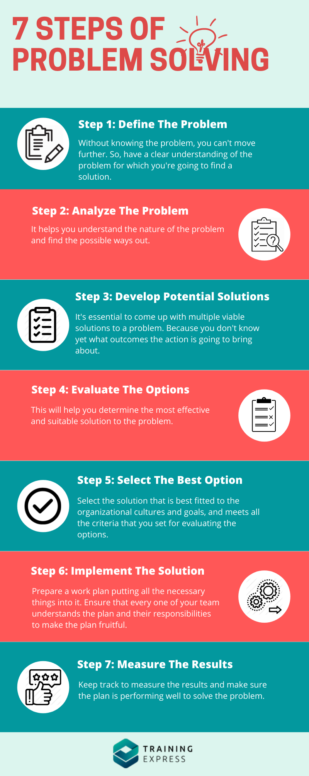
Figure 3: Problem – Solving Stages
(Source: Training Express, 2020)
Halttunen et al. (2023) suggested that there are mainly four different types of problem solvers and they are creative problem solvers, theoretical problem solvers, analytical problem solvers and lastly, practical problem solvers. In the context of problem solving skills, employees who are good at problem – solving are also very effective in the context of conflict management. It has been seen that employees with a good and effective problem – solving skills, have good communication skills and interpersonal skills.
Through effective training and development sessions, the skills of each employee who manages the hotel's front office should be improved and enhanced. These directly affect and influence the guests and the customer's experience at the hotel.
These front office employees should have very good behaviour, pleasant and respectful approach, ethical and unbiased thinking and lastly, should have a very good level of communication. During the present times, the competition levels of the hotel and hospitality industry are high and therefore, the above – mentioned skills should be applied for the development of competitive advantage within the market.

Reference List
Akbar, M.F. (2021) ‘Performance Appraisal Design In The Grand Mutiara Hotel Housekeeping Division Using BARS Assessment Model’, International Journal of Innovation in Enterprise System, 5(01), pp.65-77. Available at: https://doi.org/10.25124/ijies.v5i01.89
Coffelt, T.A. and Smith, F.L. (2020) ‘Exemplary and unacceptable workplace communication skills’, Business and Professional Communication Quarterly, 83(4), pp.365-384. Available at: https://doi.org/10.1177/23294906209464
Crowe (2019) Gibbs Reflective Cycle | Crowe Associates. [online] Crowe Associates. Available at: https://www.crowe-associates.co.uk/coaching-tools/gibbs-reflective-cycle/.
Cui, Y. (2021) ‘The role of emotional intelligence in workplace transparency and open communication’, Aggression and Violent Behavior, p.101602. Available at: https://doi.org/10.1016/j.avb.2021.101602
Fettes, T., Evans, K. and Kashefpakdel, E. (2020) ‘Putting skills to work: it’s not so much the what, or even the why, but how…’, Journal of Education and Work, 33(2), pp.184-196. Available at: https://doi.org/10.1080/13639080.2020.1737320
Garavan, T., McCarthy, A., Lai, Y., Murphy, K., Sheehan, M. and Carbery, R. (2021) ‘Training and organisational performance: A meta‐analysis of temporal, institutional and organisational context moderators’, Human Resource Management Journal, 31(1), pp.93-119. Available at https://doi.org/10.1111/1748-8583.12284
Halttunen, T., Dragin-Jensen, C., Kylänpää, C. and Karkov, A. (2023) ‘Collaborative problem solving: A pedagogy for workplace relevance’, Nordic Journal of Vocational Education and Training, 13(2), pp.45-73. Available at: https://doi.org/10.3384/njvet.2242-458X.2313245
Kopp, T., Kinkel, S., Schäfer, T., Kieslinger, B. and Brown, A.J. (2020) ‘Measuring the impact of learning at the workplace on organisational performance’, International Journal of Productivity and Performance Management, 69(7), pp.1455-1474. Available at: https://doi.org/10.1108/IJPPM-12-2018-0443
Lavee, E. and Pindek, S. (2020) ‘The costs of customer service citizenship behaviors: A qualitative study’, Frontiers in Psychology, 11, p.460. Available at: https://doi.org/10.3389/fpsyg.2020.00460
Pham, N.T., Thanh, T.V., Tučková, Z. and Thuy, V.T.N. (2020) ‘The role of green human resource management in driving hotel’s environmental performance: Interaction and mediation analysis’, International Journal of Hospitality Management, 88, p.102392. Available at: https://doi.org/10.1016/j.ijhm.2019.102392
Sutherland, K., Freberg, K., Driver, C. and Khattab, U. (2020) ‘Public relations and customer service: Employer perspectives of social media proficiency’, Public Relations Review, 46(4), p.101954. Available at: https://doi.org/10.1016/j.pubrev.2020.101954
Training Express (2020) 7 Steps to Improve Your Problem - Solving Skills. [online] Training Express. Available at: https://trainingexpress.org.uk/7-steps-to-improve-your-problem-solving-skills/.
Trip Advisor (2024). NOVOTEL MILTON KEYNES (United Kingdom) - Hotel Reviews, Photos, Rate Comparison. [online] Tripadvisor. Available at: https://www.tripadvisor.in/Hotel_Review-g187055-d254722-Reviews-Novotel_Milton_Keynes-Milton_Keynes_Buckinghamshire_England.html [Accessed 22 Feb. 2024].

