Hallstatt Burial and the Changes in Social Status
Wenjing Yu 1804905 HPAH6009

Content
Hallstatt culture and graves 2
Details of Chieftain’s Burial 3
Social Status 4
Funerary Evidence Itself 9
Bibliography 10

Hallstatt culture and graves
Hallstatt Culture (1100 BC - 450 BC) is named after the site of Hallstatt Village near Salzburg, Austria. It is mainly distributed in Yugoslavia, Austria, western Poland, France and other places. This culture is later than Urnfield culture and earlier than La Tène culture. It can be divided into four periods. Period A and B are from 1000 BC to 750 BC. They actually include the contents of Urnfield culture. Therefore, Hallstatt culture in recent studies only refers to its C and D periods, and its age is generally from 750 to 450 BC. ^{[1]}
This culture was recognized as the first stage of Celtic iron culture. Its age span is quite large, and its distribution range covers Germany, Austria, western Poland, France and other countries.
During this period, iron swords with bell handle and curved upward handle were popular, as well as various kinds of axes, knives, arrowheads and spearheads. In addition, bronze ware, fine pottery and small ornaments made of glass, amber and ivory were also produced. The tombs are cremated and buried with straight limbs.
Chiefs, and upper clan figures are often buried in four-wheeled chariots after their deaths. The bodies are placed in the chariots in the chambers of the wooden locust tombs. The funerary objects include weapons, harnesses, ornaments, etc.
In the early period, there were Urnfield culture and late Bronze Age. Later, iron ware became popular, and iron heavy swords and wing axes appeared. It can be seen from the ruins that the iron smelting industry has taken on a considerable scale, and many smelting furnaces, castings and slags have been found. ^{[2]}Pottery production skills are quite excellent, mostly geometric decoration and plain surface. Burial mounds were popular; chariot burials appeared in the late period, in which the deceased were placed in chariots and buried with weapons, ornaments and horses, believed to be mainly tribal leaders or other upper class figures. Many Greek arts and crafts were also found in the tombs during this period, which showed that there were trade contacts between Celtics and the Greek civilized world. In addition, many fortified fortresses are also included in the Hallstatt cultural sites, with wooden shacks or adobe walls, and lookouts and gates. It can be inferred that the war between different societies may have been more frequent at that time.

Details of Chieftain’s Burial
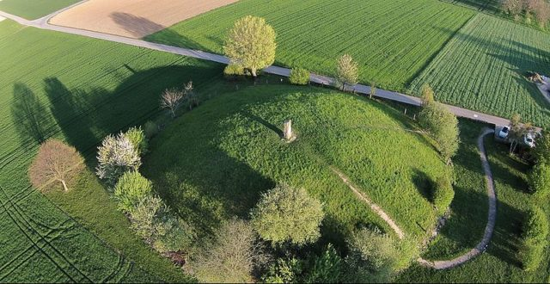
The Hochdorf Chieftain's Grave is a richly-furnished Celtic burial chamber near Hochdorf an der Enz (municipality of Eberdingen) in Baden-Württemberg, Germany, dating from 530 BC in the Hallstatt culture period. It was discovered in 1968 by an amateur archaeologist and excavated in 1978/79. By then, the originally 20 ft (6 m) high burial mound covering the grave, which is about 200 ft (60 m) in diameter, had shrunk to about 3 ft (1 m) height and was hardly discernible due to centuries of erosion and agricultural use.
Regarded as the “Tutankhamun of the Celts“.
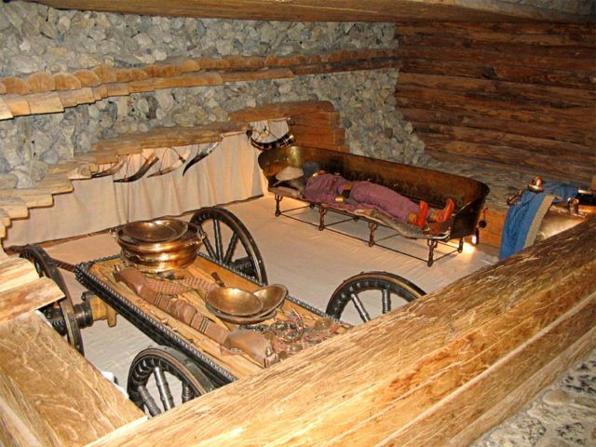
A man, roughly 40 years of age and 6 ft 2 in (187 cm) tall, was laid out on an exceptionally richly decorated 9 ft (275 cm) bronze recliner with eight wheels inside the burial chamber. Judging by other objects found there, this man probably had been a Celtic chieftain: He had been buried with a gold-plated torc on his neck, a bracelet on his right arm, a hat made of birch bark, a gold-plated dagger made of bronze and iron, rich clothing, amber jewelry, a razor knife, a nail clipper, a comb, fishing hooks, arrows, and most notably, thin embossed gold plaques which were on his now-disintegrated shoes. At the foot of the couch was a large cauldron decorated with three lions around the brim. This cauldron was originally filled with about 100 gallons (400 l) of mead. The east side of the tomb contained an iron-plated wooden four-wheeled wagon holding a set of bronze dishes—along with the drinking horns found on the walls enough to serve nine people. ^{[3]}
Reconstruction of the Celtic Grave in the museum.

Social Status
Before comparing tombs in Hallstatt, I would like to divide Hallstatt's tombs into three categories. The first category belongs to the noble single tomb, which is also the luxury tomb of the supreme power, for example, the chieftain’s grave I mentioned above. The second category belongs to the general tomb, which can be seen that the owner of the tomb is more powerful. The third type is a common tomb in which the owner of the tomb is a civilian or a lower status. And the second and third category can be the factors of a cemetery which not only shows the lower social status from those wealthy individual graves but the structure of the whole society as well.
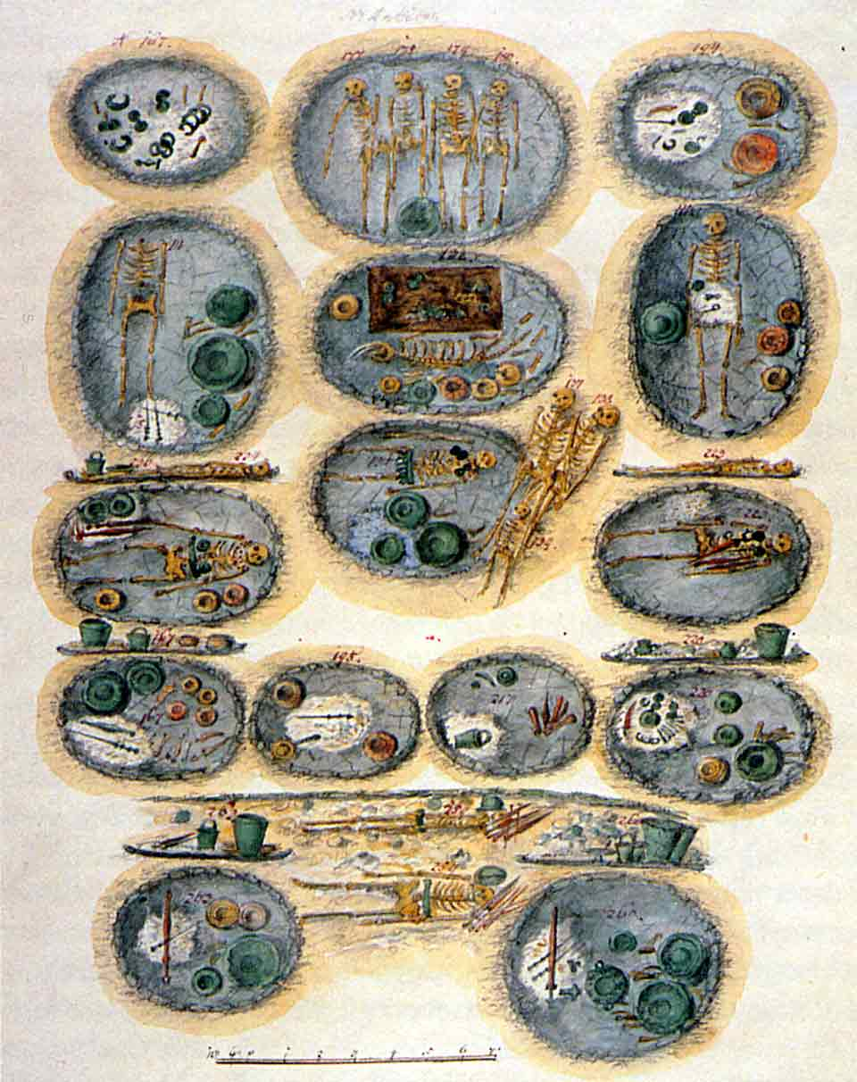
I think there are two main points in how to distinguish the tombs of people with higher status: first, the shape and structure of the tombs. Ordinary tombs are mostly cremated tombs or straight-limbed burial tombs. But at the same time, there are still limb-bending burials. The curvature of limbs may also be a reflection of social status. For example, leaders at the top of society can enjoy direct limb burial, while ordinary people need to serve leaders, so they can only use bending limbs to bury, to reflect their status, is a form of submission. In addition, from a personal point of view, cremation tombs should also belong to some of the more powerful people. The reason is that this kind of burial is more complex than ordinary burial, and the establishment of high mounds needs to occupy a certain space, but also requires the corresponding human resources, which makes it easier for slightly powerful people to build such burials.
Multi-person tombs at Hallstatt burial site
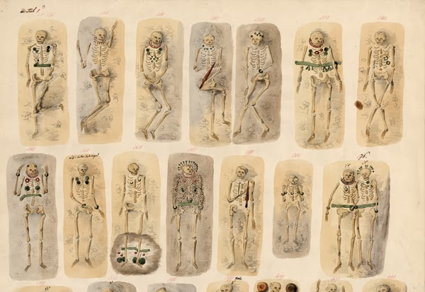
Apart from the two types of tombs above, we also need to pay attention to the multi-person tombs. Most of these burials are joint burials, but there are also many accompanying burials. If it is a joint grave, then it is necessary to consider whether it is a joint family grave, such as husband and wife, father and son, mother and son, or a simple upper and lower level grave in terms of rights and status. How to judge the social status of the owner of a tomb in a multi-person tomb is a little more difficult than the first two, but the simplest way is to make a comprehensive judgement by combining the funerary objects mentioned in the second point.
Part of 27 graves found at Hallstatt burial site
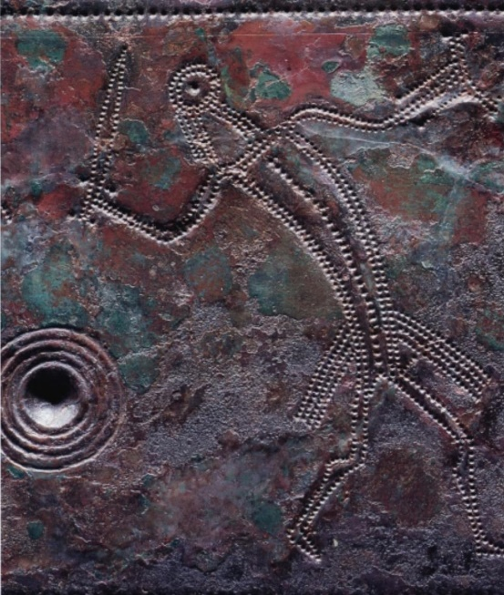
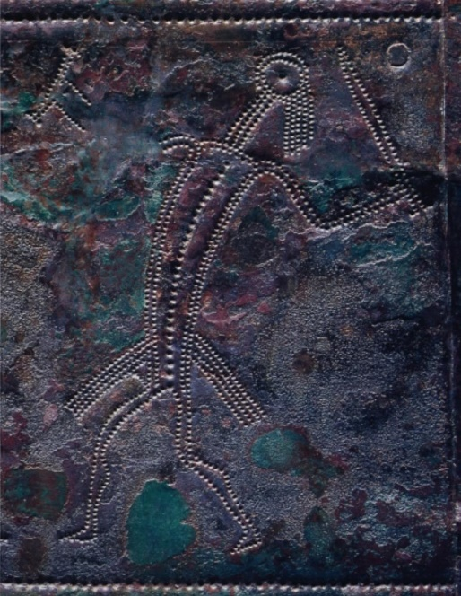
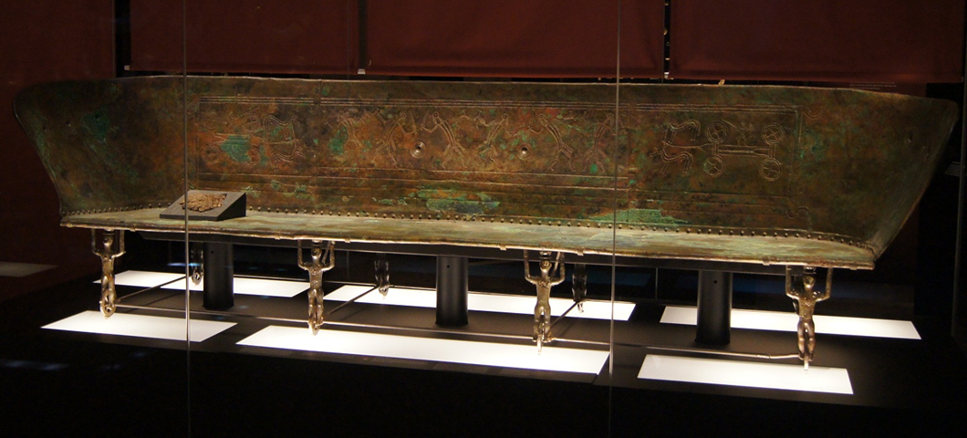
Secondly, the social status of the grave owner can be judged by the placement, quantity and quality of the burial objects. There are various opinions about the development stage and nature of Celtic society in the field of history and archaeology. Some believe that “Celtic society is a typical society in the period of disintegration of primitive commune system and transition to class system”. ^{[4]} Others think that “Celtic society is a classic example of military democracy”. ^{[5]} Others think that “Celtic society is an acceptable one. A rudiment of a country can be found”, ^{[6]} or "even a pre-existing country". ^{[7]} But, whatever which one is right, the conclusion above is not difficult to draw, if the early Celtic nation has formed a certain scale of cities, and has a certain degree of management, with relevant regulations and laws, then the top managers will certainly enjoy more exquisite and luxurious living conditions, and of course with better tombs. For example, the chieftain’s grave I mentioned earlier, although it has been stolen, still leaves behind rich burials such as gold, bronze and ornaments, and even "among the fragments of the deceased's clothes are gold ornaments". ^{[8]} Here take the bench on which Chieftain lies as an example. It has carvings of four-wheeled chariots and other battle scenes. The characters on the base ride on the unicycle with their hands lifted upwards to support the whole bench. The backboard and the base are exquisite and at the same time embody the dignity of the leader or the Royal family. It should also be mentioned here that the hilt of a dagger unearthed in Chieftain's tomb also shows the character's gesture of lifting his hands upward, the daggers that largely replaced swords in chief's graves in the west were probably not serious weapons, but badges of rank, and used at the table which is likely to be another factor in judging the status of the owner of the tomb. ^{[9]}
Details of the bench
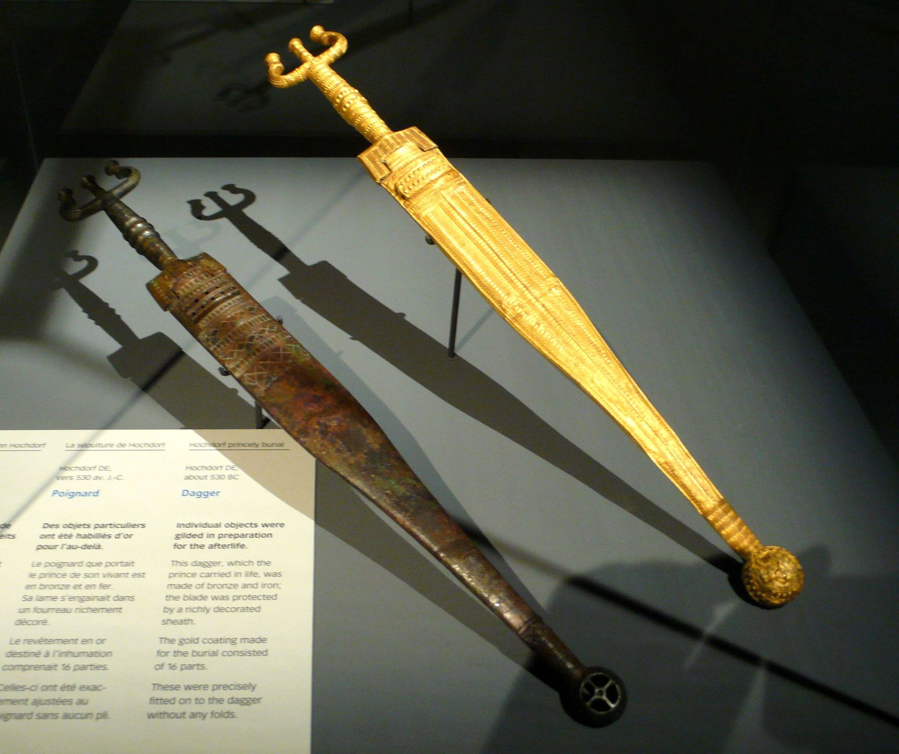
Dagger with gold foil
What’s more, we need to mention that in Hallstatt culture, chariot burial belongs to the later stage of the culture of that period, and only appears in senior leaders or other upper class figures. From this, we can preliminarily judge that as long as there are chariots in the funerary objects, whether early four-wheeled chariots or two-wheeled chariots in the middle and late stages, the social status of the grave owner must be not low.
From the late Hallstatt culture to the early La Tène culture, abundant funerary objects were found in five areas including Earl of Upper Rhine Territory of Germany-West Austria, Man River Region of France, Central France, Rhine-Sal-Mosol Region of Germany, and the upper reaches of the Rhine River. These funerary objects are exquisite and magnificent, showing the different status of the owner of the tomb and members of the general clan. Precious ornaments and wine utensils show the noble and luxurious life of the clan. In contrast, in the public cemetery at Hallstatt site, members of the clan are buried, with very few burials and no gold, silver ornaments or imports from the Mediterranean. Before the 2nd century BC, most of the necklaces in burials with rich funerals were gold, while the necklaces of ordinary clan members were mostly bronze and iron. "The collar has become a symbol of one's wealth and social behavior". ^{[10]} It can be seen that there are differences between the poor and the rich in Celtic clan society, and more wealth has been accumulated in the hands of clan aristocracy. ^{[11]}

Funerary Evidence Itself
Burial in the history of human civilization is a very special kind of existence, it is not only a relic of human material life, but also a reflection of the spiritual world, not only about the birth, but also about death. It is only formally the place where the body of the deceased is placed, but it essentially embodies the human attitude towards death, as well as the historical background, cultural and artistic traditions and religious beliefs associated with it.
Burial, as a part of ancient funeral rituals, as a relic embodying the ideas and behavior patterns of the ancients, its significance is not only in the history of mending or proof. Burial is not only an underground building, it is in the specific funeral behavior, according to certain ideas and behavior patterns and the place to hold funerals. The architectural form of the tomb, the image configuration, the type, quantity and display mode of the funerals all follow certain social norms, reflect the attitude of the owner and builder of the tomb towards death, and contain the etiquette system and belief customs of the specific society. So, we cannot focus only on the external form of the tomb, not just on the judgment of the age, nature and rank of the tomb, but should reveal the social significance embodied in the tomb in a deeper depth.
In order to reveal the social significance of burial, we cannot separate the various elements of the tomb, because "the tomb is not only a building shell, but architecture, murals, sculptures, utensils, decorations and even inscriptions, such as a variety of artistic and visual forms of the complex." Tombs should be regarded as an organic whole, focusing more on the links between the various elements of the tomb, between tombs and tombs, and between regions and regions. Placing tombs at the height of the history of human civilization, revealing the symbolism of funeral behavior according to the remains of tombs, establishing the relationship between tombs and ancient society, revealing the etiquette system, belief customs, and the family, filial piety, universe, hierarchy and other concepts associated with the tombs. The ultimate goal of burial research is to restore social life, including the spiritual world of the ancients, not just as a complement to historical research.

Bibliography
[1] Philip L. Kohl (1996). Nationalism, Politics and the Practice of Archaeology. p. 134.
[2] Megaw, R. and Megaw, V. (1990). Celtic Art. London: Thames and Hudson, pp.25-30; 39-47.
[3] En.wikipedia.org. (2019). Hochdorf Chieftain's Grave. [online] Available at: https://en.wikipedia.org/wiki/Hochdorf_Chieftain%27s_Grave.
[4] Munget, A. (1974). Western European Archaeology · Bronze Iron Age. Moscow, p.277.
[5] Ко́свен, М. (1955). Outline of Primitive Culture History. p.234.
[6] Sabo, M. (1971). Celtic Heritage in Hungary. Budapest, p.24.
[7] Daniel, G. (1977). Archaeological Encyclopedia. New York, p.50.
[8] Bill, O. (1980). Celtic Burial Treasures. The National Geographic Magazine, 157.
[9] Megaw, R. and Megaw, V. (1990). Celtic Art. London: Thames and Hudson, pp.40.
[10] Munget, A. (1974). Western European Archaeology · Bronze Iron Age. Moscow, p.236.
[11] Zhan, T. (1990). An Analysis of Celtic Social Structure. JOURNAL OF HANGZHOU UNIVERSITY, 20(1), p.96.

