

MODULE CODE: LCHS7000
MODULE NAME: SOCIAL EPIDEMIOLOGY AND PUBLIC HEALTH DEVELOPMENT
LECTURE’S NAME: ITSE OLAOYE
ASSIGNMENT TITLE: COMPONENT 2 ANALYTICAL REPORT
STUDENT NAME: VARSHINI VELMURUGAN
STUDENT ID: 2531984

TASK 1
ETHNICITY AND HEALTH INEQUALITIES IN THE UK
1. Introduction
Ethnicity refers to shared cultural identity, ancestry, language, and traditions that distinguish population groups. Health inequalities are avoidable, unjustifiable, and systematic health differences between groups (Cluley et al., 2025). In the UK, ethnic minority groups face disproportionately poor health outcomes relative to White British groups. These differences are not purely biological but are largely determined by social factors such as poverty, discrimination, and access to health care. For example, Black women are four times more likely to die from pregnancy or childbirth, and ethnic minorities are up to two times more likely to die from COVID-19 (Samarasekera, 2022). This demonstrates that ethnicity is a critical health determinant that needs to be addressed with public health strategies (Russo et al., 2024).
2. Underlying Factors and Context
1. Increased Cardiovascular Disease
Ethnic minority groups in the UK are disproportionately affected by cardiovascular disease (CVD), with South Asians having about 40% higher rates of death from coronary heart disease than the general population (Harding and Balarajan, 2000). This is due to genetic factors, increased rates of diabetes and socioeconomic determinants, including reduced access to health services. This indicates that health outcomes are influenced by structural inequities, such as late diagnosis and a lack of culturally sensitive health care (Bamford et al., 2020). This can be addressed through targeted screening, culturally sensitive health education and access to primary health care.
2. Greater Prevalence of Type 2 Diabetes
Type 2 diabetes is significantly more prevalent among ethnic minority populations, with South Asian and Black groups in the UK being 2–4 times more likely to develop the condition compared to White populations (Aizawa, 2018). Moreover, according to the Office for National Statistics, the proportion of deaths caused by diabetes is highest among the Bangladeshi (over 40%) and Pakistani (over 30%) populations, with lower proportions among White British (ONS, 2023). This is due to the interplay between ethnicity and socioeconomic status, including restricted access to affordable, healthy foods, safe environments, and health services. These inequalities affect disease management and outcomes. This can be tackled through early detection and community-based lifestyle modification interventions, as well as culturally sensitive dietary advice.
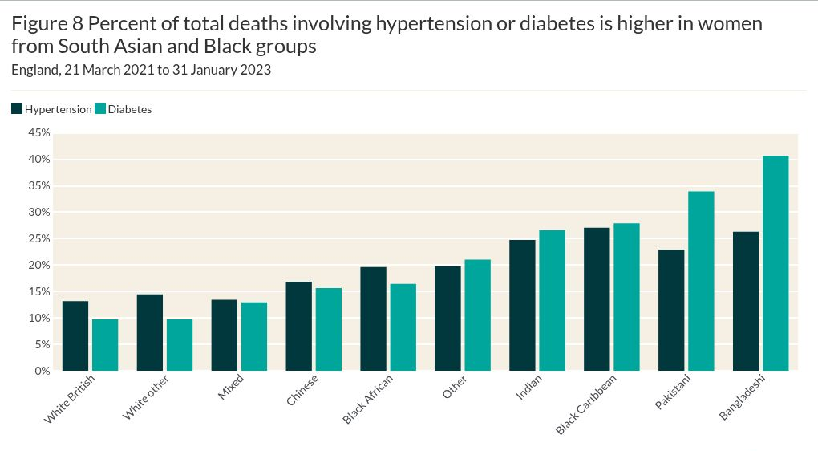
Figure 1: Proportion of all deaths due to hypertension or diabetes by ethnic group in England (Office for National Statistics, 2023)
This graph shows greater rates of deaths associated with hypertension and diabetes among South Asian and Black ethnic groups compared with White British, indicating ethnic health inequalities in England.
3. Mental Health Inequalities
Ethnic minority groups in the UK experience significant mental health inequalities. Black people are 8 times more likely to be subject to a community treatment order than White people, and the rate of anxiety disorders in some ethnic communities is over 40%, compared with 24.75% of White British people (Edge and MacKian, 2010). These inequalities result from structural factors including discrimination, marginalisation and institutional racism in mental health services. Cultural stigma and lack of trust in healthcare systems further reduce help-seeking behaviour (Bamford et al., 2020). To reduce these disparities, it is important to have culturally responsive mental health services, greater community involvement and anti-discrimination policies (Cluley et al., 2025).
4. Poverty and Socioeconomic Inequality
Socioeconomic inequality contributes significantly to health inequalities among UK ethnic minority groups. Poverty is disproportionately high among ethnic minority households, with some groups having poverty levels greater than 40%, compared to 20% among White British (Russo et al., 2024). This limits access to healthcare and healthy living conditions. Socioeconomic status thus is a key driver of health, compounding ethnic inequalities. Health interventions without tackling poverty may be ineffective. To address these inequalities, there needs to be better access to education and work, support for income and the expansion of social prescribing schemes (Rabiee, 2015).
5. Barriers to Health Care Access
Many ethnic minority groups in the UK face barriers to accessing healthcare services. Research shows ethnic minorities are less likely to use preventive health services and more likely to delay seeking medical advice, leading to worse health outcomes (Edge and MacKian, 2010). Language barriers, cultural differences, and experiences of discrimination hinder effective communication between patients and healthcare providers. To improve access, it is important to provide interpreter services, cultural-sensitive training for health care workers, and ensure policies are inclusive and deal with the needs of all populations (Russo et al., 2024).
6. Housing and Living Conditions
Housing inequalities play a large role in health inequalities because ethnic minority groups in the UK are more likely to live in crowded conditions. For example, 24% of households from the Bangladeshi community and 18% of Pakistani households live in overcrowded conditions, compared to 2% of White British households (ONS, 2021). This can lead to higher rates of infectious diseases and mental health problems. Further, infant mortality rates are around 7 per 1,000 births among Pakistani populations, compared to 3.5 per 1,000 births among White British (ONS, 2021). This shows the complex interaction between environmental and structural factors and ethnicity that lead to poor health outcomes. These problems can be tackled through better housing policies, community investment, and public health interventions. The prevalence of ethnic health inequalities across different conditions is highlighted in Figure 2.
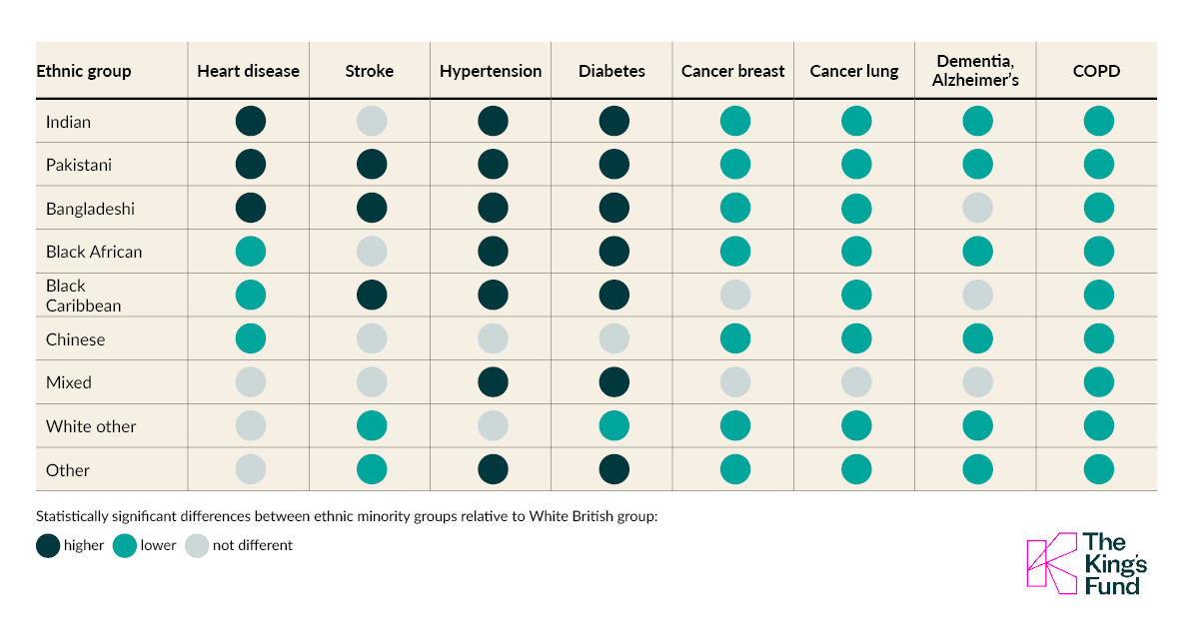
Figure 2: Health inequalities across ethnic groups in England, compared with the White British population (The King's Fund, Office for National Statistics)
This shows the extent of ethnic health inequalities across a range of conditions, confirming the contribution of structural and socioeconomic factors.
3. National Response to Reduce Health Inequalities
The UK government has put in place various initiatives to reduce ethnic health inequalities. The NHS Long Term Plan seeks to address inequalities by preventing and diagnosing conditions earlier for at-risk communities and increasing access to health services (Bamford et al., 2020). Programs like the Race Disparity Unit are also critical in tracking inequalities and generating evidence to inform targeted public health efforts in the UK. Moreover, digital health programs have been implemented to target at-risk groups through data-driven interventions (Samarasekera, 2022), enhancing service provision and health care access. Yet, despite these initiatives, the ongoing disparities suggest that structural and socioeconomic determinants such as poverty and discrimination continue to constrain responses in the UK.
4. Organisation Supporting Ethnic Minority Health
The Race Equality Foundation is a crucial organisation in the UK that works to reduce health inequalities through research, policy and the delivery of culturally sensitive health services (Bamford et al., 2020). It promotes awareness of the social determinants of health and facilitates community-based approaches to improve health for ethnic minorities. Its main objective is to eliminate inequalities and improve access to healthcare. It does so by engaging in advocacy and research dissemination, working with public health agencies to inform national health policy and improve culturally sensitive service delivery (Hale and Viner, 2013). This is crucial for addressing systemic challenges and improving equitable and effective healthcare.
5. Conclusion
In the UK, ethnic inequalities in health are multifaceted and influenced by social, economic and structural determinants. Rates of chronic disease, mental health problems and poor housing are more prevalent among ethnic minority groups. These health inequalities are not natural but are affected by systemic factors that can be changed through interventions, policy and community mobilisation. Understanding the underlying causes of inequality is crucial for improving health outcomes and promoting health equity for all.

TASK 2
THE EPIDEMIOLOGY OF TYPE 2 DIABETES IN TOWER HAMLETS
1. Introduction
Type 2 diabetes mellitus (T2DM) is a metabolic condition marked by insulin resistance and high blood glucose levels. It is a global burden, with more than 537 million adults living with the condition (World Health Organization, 2023; International Diabetes Federation, 2021). In the UK, over 4.3 million people are living with diabetes and rates are rising (Diabetes UK, 2024). Previous estimates also show a steady rise in prevalence among the population (Diabetes UK, 2023).
Tower Hamlets, an inner London borough, has a relatively high prevalence of T2DM, reflecting high levels of socioeconomic disadvantage and a high proportion of South Asian people. Data shows a high prevalence in this region, due to structural and ethnic inequalities (Chowdhury and Huda, 2016). This report critically examines epidemiological methods for detecting, measuring, and controlling T2DM in Tower Hamlets.

2. Public Health Measures (Prevention, Protection and Promotion)
Public health approaches to Type 2 diabetes (T2DM) involve prevention, protection and promotion, creating a public health strategy for diabetes in Tower Hamlets.
(a) Prevention:
Screening programmes, including NHS Health Checks, aim to identify high-risk individuals early. Screening enhances diagnosis but is unevenly taken up in deprived groups (Bashir, 2026). Public Health England (2019) outlines the increasing prevalence of T2DM and the importance of early detection. Risk assessment tools and community screening have been implemented to target high-risk individuals, including South Asians. However, screening programmes may fail to capture undiagnosed cases among populations with limited healthcare access, reducing effectiveness.

(b) Protection:
Treatment is based on NICE (2023) guidelines, including medication, monitoring and prevention of complications. England's National Diabetes Audit indicates improvements in processes (NHS Digital, 2023; NHS England, 2024). Data from Tower Hamlets shows integrated primary care has improved care (Chowdhury and Huda, 2016). Regular monitoring of HbA1c is crucial, but variations in testing and compliance can influence results (Sacks, Kirkman and Little, 2024).
(c) Promotion:
Health promotion programs promote healthier behaviours through better nutrition and exercise. Culturally sensitive interventions have improved engagement with ethnic minority communities (Abu and Llahana, 2025). However, behaviour change is difficult in disadvantaged communities. Poverty, food insecurity and poor access to healthy environments continue to hinder the sustained effects of these strategies.
Despite these efforts, continuing inequalities suggest health system interventions are not enough. Many programmes focus on changing individual behaviour, ignoring systemic issues like housing, work and schooling. Failure to tackle these determinants may result in persistent health inequalities. So, a multifaceted approach that links health care with broader social policy is needed to sustainably reduce diabetes inequalities (Mallik et al., 2026).
3. Determinants and Risk Factors
The risk of type 2 diabetes mellitus (T2DM) in Tower Hamlets is a complex interplay of biological, behavioural and social factors. South Asians are at higher risk due to metabolic predisposition including insulin resistance and abdominal obesity (Sattar and Gill, 2015). Comparative epidemiological studies also show significant differences in cardiovascular and metabolic risk across ethnic groups, corroborating the impact of ethnicity on disease prevalence (Tillin et al., 2013). Longitudinal studies also show increased morbidity and mortality in South Asian populations, suggesting sustained ethnic disparities (Mather et al., 1998).
Lifestyle factors, including unhealthy diet, low physical activity and obesity, play a significant role in disease development, with obesity recognised as a major driver of increasing T2DM prevalence in England (Malone and Hansen, 2019). But these health behaviours are shaped by broader social determinants, such as poverty, food insecurity and an absence of healthy environments, which restrict behavioural choices (Shiue, 2015). These factors are especially prevalent in Tower Hamlets, compounding health risks. There is also evidence showing a rising trend of T2DM among younger people in East London, which suggests an earlier onset of the disease and increasing burden over time (Balasanthiran et al, 2012).
These studies show that T2DM cannot simply be regarded as an outcome of individual behaviour but also needs to be considered in the context of structural issues that influence risk factors and health outcomes.
4. Identification of At-Risk Populations
In Tower Hamlets, around 10% of adults are living with Type 2 diabetes, with the prevalence being much higher in the Bangladeshi community (Chowdhury and Huda, 2016). Thus, epidemiological data demonstrate that Tower Hamlets is among the highest in London for diabetes prevalence. This is the result of the interaction of various factors including ethnicity, deprivation and environmental risk factors in this South Asian community. This is reflected in Figure 1, which shows that diabetes prevalence in Tower Hamlets has consistently been higher than in London and England.
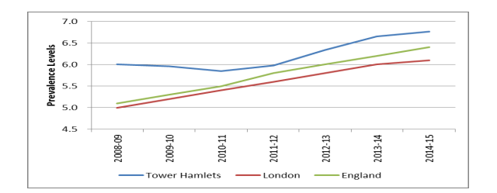
Figure 1: Type 2 diabetes prevalence in Tower Hamlets, London, and England over time, with consistently higher rates in Tower Hamlets (Tower Hamlets Council, 2015).
Health needs assessments and local epidemiological research have provided evidence for vulnerable populations and resource allocation. Risk factors include low-income households, older persons, and ethnic minorities, especially South Asians (Gujral and Burden, 1993). Recent research also points to disparities in access to care, diagnosis, and treatment, suggesting that disadvantaged groups have a greater burden of the disease and poorer management (Mallik et al., 2026).
However, reliance on broad ethnic categories may mask variability between subgroups, such as Bangladeshis, Indians, and Pakistanis. This hampers precision targeting strategies and potentially wastes resources. Thus, finer-scale local data is needed to effectively identify and respond to health inequalities in high-risk populations (Chowdhury and Huda, 2016).
5. Surveillance and Monitoring Systems
T2DM surveillance is supported by several surveillance systems, such as NHS Digital data, GP records, and the National Diabetes Audit. These offer detailed information about prevalence, incidence, and quality of care (NHS Digital, 2023; NHS England, 2024). WHO (2023) emphasises the importance of surveillance to guide public health policy, while IDF (2021) recognises the importance of global monitoring systems to identify trends and inform interventions.
Clinical monitoring systems, like HbA1c measurements, are essential for disease management as they allow early identification of poor glycaemic control (Balasanthiran et al., 2012). But inconsistencies in measurement, frequency of testing, and patient compliance can lead to inaccuracies and impact clinical decision-making (Sacks, Kirkman and Little, 2024). Further, local surveillance systems guide action by identifying at-risk populations in Tower Hamlets.
Surveillance systems can underestimate the number of undiagnosed cases, and do not reflect variability across ethnic subpopulations. Aggregation and delayed reporting may also reduce responsiveness, which hampers targeted public health measures.
6. Public Health Impact
T2DM causes significant health and economic burdens at individual and population level. Acute complications include fatigue, infections, and poor quality of life, and chronic complications include heart disease, renal failure, nerve damage and premature death (WHO, 2023). Furthermore, T2DM is a major risk factor for cardiovascular disease (CVD), which is one of the leading causes of death in affected populations, compounding the burden of T2DM in the long term (Sattar and Gill, 2015).
Diabetes has a considerable impact on healthcare systems with higher hospitalisations, long-term care costs and specialist services required. In Tower Hamlets, the burden is magnified due to higher prevalence and earlier disease onset. These trends are compounded by social determinants, such as deprivation and barriers to health care, which contribute to substandard management of the disease among disadvantaged groups (Frier et al., 2022).
The disparity in disease burden exacerbates existing health disparities, with high-risk populations being both more exposed to risk factors and having poorer health outcomes. This underscores the importance of holistic approaches that address medical and social aspects of the disease.
7. Intervention Programme and Evaluation
Community initiatives in Tower Hamlets include culturally sensitive strategies to enhance participation and outcomes in ethnic minority groups. Research indicates that culturally tailored self-management interventions are more effective in enhancing adherence, blood glucose levels and patient knowledge (Abu and Llahana, 2025). Such interventions are crucial in overcoming language barriers and cultural eating habits that impact disease management.
Staff development, especially for practice nurses, has improved service delivery and the capacity of primary care services, allowing for more individualised and ongoing support (Blunt and Griffin, 2013). Furthermore, large-scale initiatives in North East London aim to improve diabetes care by tackling inequalities through integrated service delivery models that enhance the coordination of care (Mallik et al., 2026).
These approaches show increases in patient activation and health outcomes, especially in high-risk groups. But their success is often hampered by factors including poor long-term engagement, limited resources and persistent social determinants. Further, although culturally sensitive interventions enhance immediate outcomes, their long-term effectiveness requires tackling broader issues such as poverty, housing, and access to healthy living environments (Shiue, 2015). Without such improvements, the effectiveness of intervention programs may continue to be limited and unable to reduce health inequalities.
8. Strengths and Weaknesses of Epidemiological Approaches
Strengths:
Epidemiological approaches have the advantage of using high-quality, large, national data, like the National Diabetes Audit, to study the prevalence, incidence, and consequences of diseases in populations. These data support the development of evidence-based interventions and inform public health policy. Moreover, the provision of primary care services in regions such as Tower Hamlets allows for early diagnosis, ongoing monitoring, and management of disease, which has a positive impact on patient outcomes (Chowdhury and Huda, 2016).
Weaknesses:
However, epidemiological data can be limited by underdiagnosis, especially in marginalised and disadvantaged groups, which can underestimate disease burden. Aggregated ethnic categorisations may mask important sub-group differences, limiting the specificity of intervention programs. Also, reporting lags and a lack of real-time monitoring hinder timely response to changing patterns.
Epidemiological strategies are critical for the prevention and control of T2DM, but their potential is limited without parallel social and structural interventions to reduce health inequalities.
9. Conclusion
The incidence of type 2 diabetes in Tower Hamlets is the result of biological, behavioural and structural factors. Epidemiological approaches offer important evidence for disease control, but have limited impact on structural and systemic determinants of health inequalities. Epidemiological insights need to be complemented with structural interventions addressing deprivation, inequalities and resource allocation in future public health strategies. Only a comprehensive strategy that links epidemiological data with structural policy changes will lead to a long-term reduction in health inequalities due to Type 2 diabetes.
REFERENCES
Abu, S., & Llahana, S. (2025). Factors influencing the uptake of culturally tailored diabetes self-management education and support programmes among ethnic minority patients with type 2 diabetes: A systematic review. Primary Care Diabetes, 19(2), 103–110. https://doi.org/10.1016/j.pcd.2025.01.010
Aizawa, T. (2018). Inequality in the treatment of diabetes and hypertension across residency status in China. Ethnicity & Health, 1–18. https://doi.org/10.1080/13557858.2018.1539220
Balasanthiran, A., O’Shea, T., Moodambail, A., Woodcock, T., Poots, A., Stacey, M., & Vijayaraghavan, S. (2012). Type 2 diabetes in children and young adults in East London: An alarmingly high prevalence. Practical Diabetes, 29(5), 193–198a. https://doi.org/10.1002/pdi.1689
Bamford, J., Klabbers, G., Curran, E., Rosato, M., & Leavey, G. (2020). Social capital and mental health among Black and minority ethnic groups in the UK. Journal of Immigrant and Minority Health, 23(3), 502–510. https://doi.org/10.1007/s10903-020-01043-0
Bashir, T. (2026). Screening programmes for diabetes in the UK. Practice Nursing, 37(3), 98–102. https://doi.org/10.12968/pnur.2026.0019
Blunt, C., & Griffin, R. (2013). Evaluating the effectiveness of a practice nurse development programme in Tower Hamlets, London. Journal of Nursing Education and Practice, 3(10). https://doi.org/10.5430/jnep.v3n10p110
Chowdhury, T. A., & Huda, B. (2016). A decade of change in diabetes services in a deprived multiethnic inner city area: Diabetes in Tower Hamlets. British Journal of Diabetes, 16(4), 188. https://doi.org/10.15277/bjd.2016.108
Cluley, V., Vanhoutte, B., Banerjee, J., & Pickard, S. (2025). The relationship between frailty, ethnicity and health inequality – A scoping review. Journal of Global Ageing, 1–45. https://doi.org/10.1332/29767202Y2024D000000020
Diabetes UK. (2023). Diabetes prevalence 2023. https://www.diabetes.org.uk
Diabetes UK. (2024). Diabetes statistics: Prevalence 2024. https://www.diabetes.org.uk
Edge, D., & MacKian, S. C. (2010). Ethnicity and mental health encounters in primary care: Help-seeking and help-giving for perinatal depression among Black Caribbean women in the UK. Ethnicity & Health, 15(1), 93–111. https://doi.org/10.1080/13557850903418836
Gujral, J. S., & Burden, M. L. (1993). An introduction to diabetes and healthy eating for people with diabetes. Practical Diabetes International, 10(3), 121. https://doi.org/10.1002/pdi.1960100319
Hale, D. R., & Viner, R. M. (2013). Risk behaviour and gender, socioeconomic status and ethnicity: Exploring a key component of health inequality in adolescence. Journal of Adolescent Health, 52(2), S97–S98. https://doi.org/10.1016/j.jadohealth.2012.10.230
Harding, S., & Balarajan, R. (2000). Limiting long-term illness among Black Caribbeans, Black Africans, Indians, Pakistanis, Bangladeshis and Chinese born in the UK. Ethnicity & Health, 5(1), 41–46. https://doi.org/10.1080/13557850050007338
International Diabetes Federation. (2021). IDF Diabetes Atlas (10th ed.). International Diabetes Federation.
Mallik, R., Marples, O., Vijayaraghavan, S., Garrett, C., Chowdhury, T. A., Anderson, J. V., & Huda, M. S. (2026). Addressing inequalities in access and care in type 1 diabetes – The North-East London Type 1 Diabetes Transformation (NATALIE) project. Primary Care Diabetes. https://doi.org/10.1016/j.pcd.2026.02.006
Malone, J. I., & Hansen, B. C. (2019). Does obesity cause type 2 diabetes mellitus (T2DM)? Or is it the opposite? Pediatric Diabetes, 20(1), 5–9. https://doi.org/10.1111/pedi.12787
Mather, H. M., Chaturvedi, N., & Fuller, J. H. (1998). Mortality and morbidity from diabetes in South Asians and Europeans: 11-year follow-up of the Southall Diabetes Survey, London, UK. Diabetic Medicine, 15(1), 53–59. https://doi.org/10.1002/(SICI)1096-9136(199801)15:1 (doi.org in Bing)<53::AID-DIA521>3.0.CO;2-V
National Institute for Health and Care Excellence. (2023). Type 2 diabetes in adults: Management (NG28). https://www.nice.org.uk/guidance/ng28
NHS Digital. (2023). National Diabetes Audit 2021–22: Care processes and treatment targets. https://digital.nhs.uk
NHS England. (2024). National diabetes audit and prevalence report. https://www.england.nhs.uk
Office for National Statistics. (2021). Child and infant mortality in England and Wales: 2020. https://www.ons.gov.uk
Office for National Statistics. (2023). Deaths involving diabetes and hypertension by ethnic group, England. https://www.ons.gov.uk
Office for National Statistics. (2024). Health inequalities by built-up area and ethnic group, England: March 2021 to May 2023. https://www.ons.gov.uk
Public Health England. (2020). Health matters: Preventing Type 2 diabetes. https://www.gov.uk
Rabiee, F. (2015). Redressing health inequality through social prescription programme in Birmingham, UK. European Journal of Public Health, 25(suppl_3). https://doi.org/10.1093/eurpub/ckv176.142
Russo, N., McGee, R., De Nardi, M., Borella, M., & Abram, R. (2024). Health inequality and economic disparities by race, ethnicity, and gender. SSRN Electronic Journal. https://doi.org/10.2139/ssrn.4964389
Samarasekera, U. (2022). UK digital health initiatives tackle racial inequality. The Lancet Digital Health. https://doi.org/10.1016/S2589-7500(22)00192-3
Sattar, N., & Gill, J. M. R. (2015). Type 2 diabetes in migrant South Asians: Mechanisms, mitigation, and management. The Lancet Diabetes & Endocrinology, 3(12), 1004–1016. https://doi.org/10.1016/S2213-8587(15)00326-5
Shiue, I. (2015). Impaired day-to-day activities worsened but diabetes control improved self-rated health: The UK diabetes survey, 2006. Diabetes & Metabolism, 41(6), 516–519. https://doi.org/10.1016/j.diabet.2015.10.002
The King’s Fund. (2023). Ethnic health inequalities in England. https://www.kingsfund.org.uk
Tillin, T., Hughes, A. D., Mayet, J., Whincup, P., Sattar, N., Forouhi, N. G., McKeigue, P. M., & Chaturvedi, N. (2013). The relationship between metabolic risk factors and incident cardiovascular disease in Europeans, South Asians, and African Caribbeans. Journal of the American College of Cardiology, 61(17), 1777–1786. https://doi.org/10.1016/j.jacc.2012.12.046
Tower Hamlets Council. (2015). Type 2 diabetes: Factsheet – Joint Strategic Needs Assessment. https://democracy.towerhamlets.gov.uk
World Health Organization. (2023). Diabetes fact sheet. https://www.who.int/news-room/fact-sheets/detail/diabetes
‌

‌
‌

‌

