Abdulkarim Patel
2432723
LCSH4003_BIRM
Introduction to health and social care
Debra Odeh
Name of assignment
27/09/2025

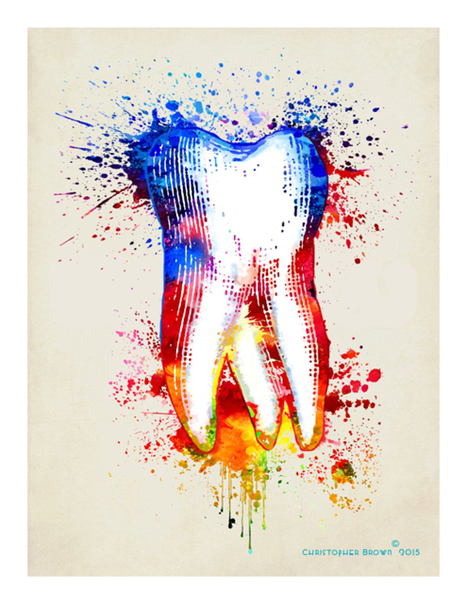

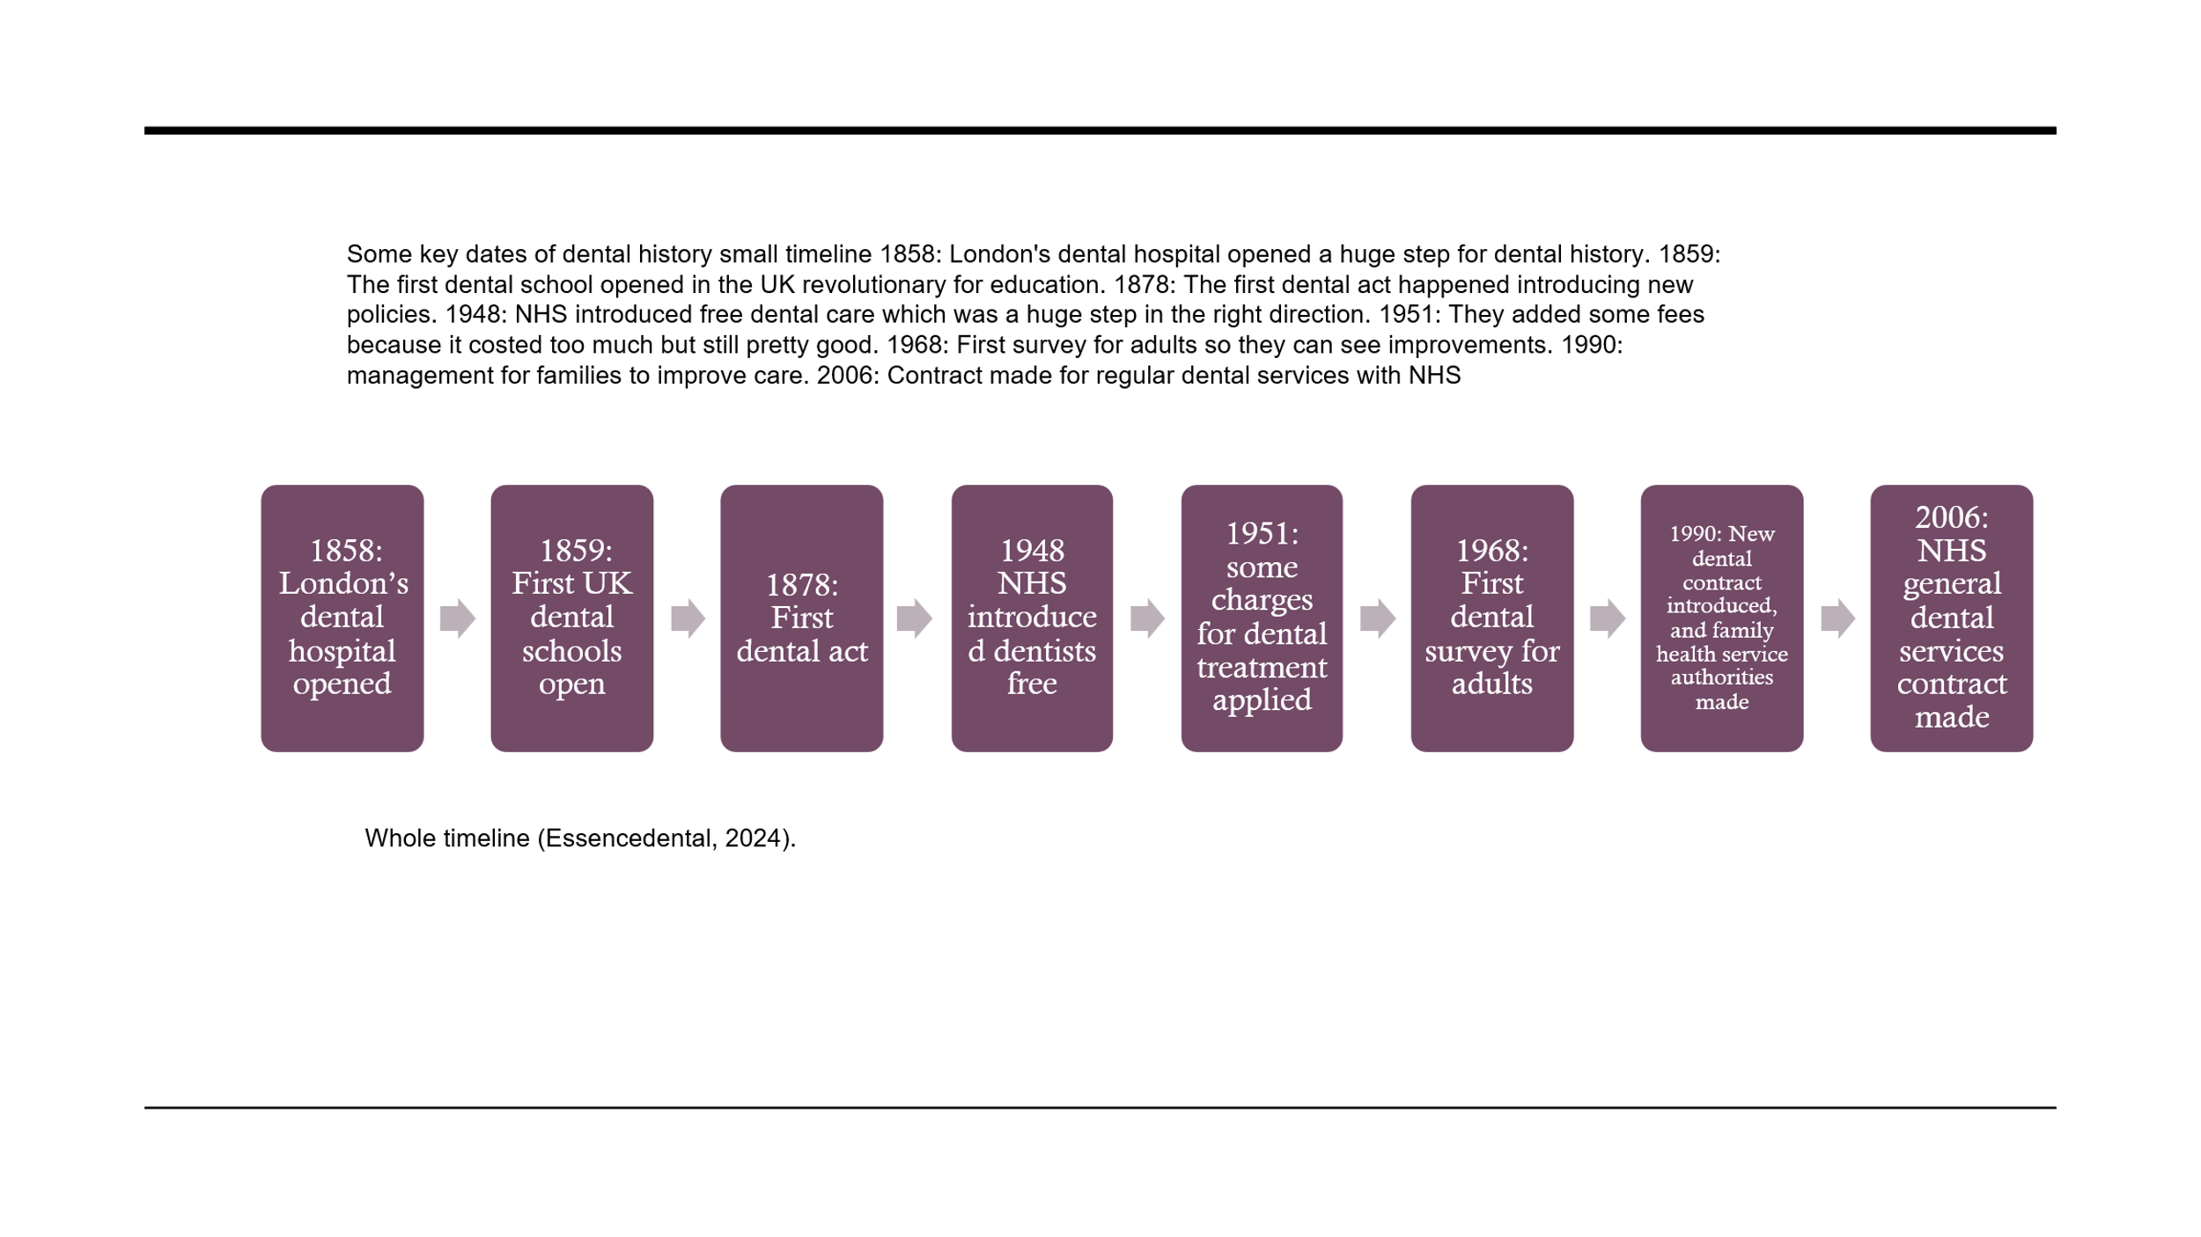
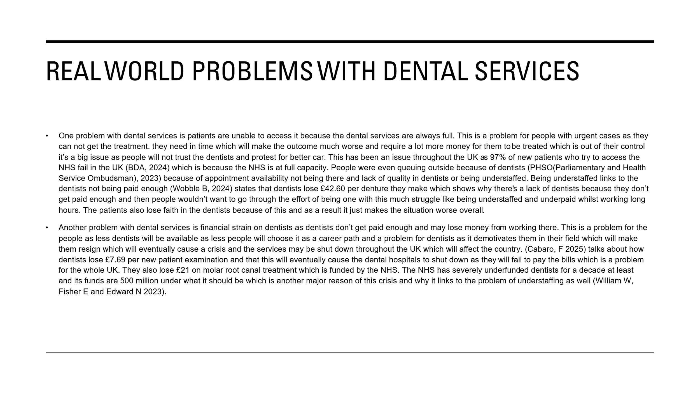
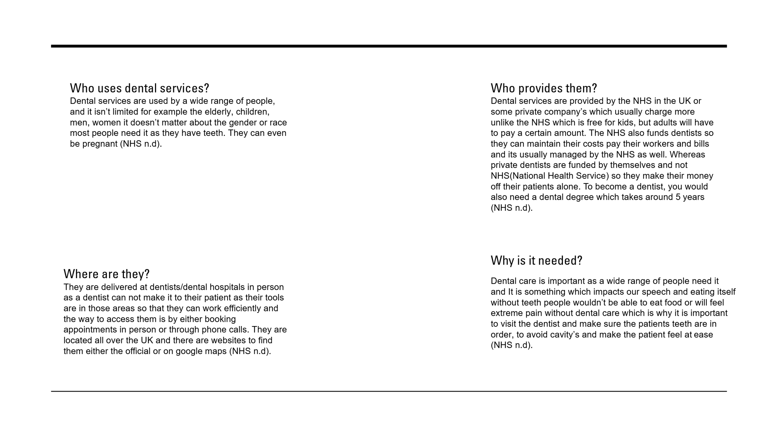

Task 2: Essay
The NHS (National healthcare service) is the centre of health care for UK it was born 1948 and it gave free healthcare to the public all over the UK and the UK was the first country in the west to give free healthcare because of the NHS. The events that led to the NHS was because of WW2 the number of deaths and injuries had a toll on the public, and the public needed healthcare to recover from the war, but it was too expensive (The National Archives, 2023). 5th July 1945 Clement Attlee won the general election for the labour party and was dedicated to make the NHS and Aneurin Bevan became the minister of health he was the person leading the campaign for free healthcare which led to the NHS eventually (M, clement 2023). that’s a bit of the past now ahead in 1952 the NHS couldn’t afford free healthcare for everyone, so they added a small fee for prescriptions, dental care and spectacles then in 1965 prescription charges are removed just to be readded in 1968 (N. Triggle 2015).

The main principle of the NHS is free healthcare, and it has expanded significantly to reach where it is today, and the government and prime minister have the highest control of it standing at the top the prime minister’s job decide how much money the NHS receive and where the funding come from e.g. tax and dental services charges or prescription charges, The government also control the NHS on a national level and have the highest authority (NHS England 2022). Second in command is the Department of Health and social care and its job is to control finances and monitor the performance of the NHS. They also get to control the future of the NHS and decide its policies and what is going to happen with it, they assist the government with their goals e.g. covid, another department on par with this one is the department for education which is responsible for children services and it works with the Department of Health and social care (NHS England 2022). Then under that is the NHS England which also runs on a national scale, this controls the NHS nationally it leads the whole of England, and its responsibility is about performance of the NHS also the funding and how the NHS is delivered which is the last national controller of the NHS (NHS England 2022).
Now its going to be regional control which is on a lower scale the NHS regional teams job is to operate the NHS financially and make sure it’s up to standard in the region it controls there are 7 regional teams that all control a region each they also work with the integrated care system to find ways to improve and check their performance (NHS England 2022). Integrated care partnerships is a local and regional they work with the NHS and make sure they aren’t going to compete with the NHS and focus on developing healthcare instead of futile things (NHS England 2022). Finally on a local level there are service providers and primary care networks which deliver the care from the NHS e.g. hospital services or dental services and more, they are close to home and can be visited often by the public and is the easiest way to access the NHS for a local checkup (NHS England 2022).
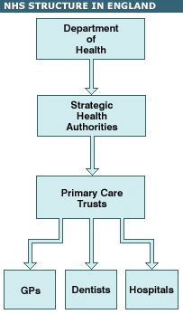
This is a diagram explaining the structure I’ve talked about (BBC news, n.d).

The NHS is funded by National insurance contributions and tax and a little amount of it is provided by the charges they give patients for glasses or dental issues, and it has a high budget of around £153 billion from 2022-23 (Sanctuary personnel 2020).

References:
Jackson, C (2023) NHS dentistry explained Available at: https://healthwatchnorthumberland.co.uk/nhs-dentistry-explained/#:~:text=NHS%20dentistry%20provides%20treatment%20that%20is%20clinically%20necessary,NHS%20contribution%20to%20dentistry%20was%20about%20%C2%A32.3%20billion. (accessed 16th September 2025)
British Dental Association (2024) Dentists: 97% of new patients unable to access NHS care Available at: https://www.bda.org/media-centre/dentists-97-of-new-patients-unable-to-access-nhs-care/ (accessed 11th October 2025)
PHSO (2023) Dental complaints on the rise Available at: https://www.ombudsman.org.uk/news-and-blog/news/dental-complaints-rise (accessed 11th October 2025)
Wobble, B (2025) The UK dentistry crisis Available at: https://thebritishtribune.com/2025/04/23/the-uk-dentistry-crisis-in-2024-the-decline-of-nhs-dental-services/ (accessed 12th October 2025)
Cabaro, F (2025) English dentists quit NHS as fees fail to meet expenses Available at: https://parliamentnews.co.uk/english-dentists-quit-nhs-as-fees-fail-to-meet-expenses (accessed 12th October 2025)
Boji, S (2021) A HISTORY OF DENTISTRY IN UK Available at: https://boundaryimplantcentre.co.uk/resources/dental-news/a-history-of-dentistry-in-the-uk/ (Accessed 12th October 2025)
Essence dental (2024) The Fascinating History of Dentistry: From Ancient Times to Modern Clinics Available at: https://www.essencedental.co.uk/the-history-of-dentistry/Care (Accessed 12th October 2025)
William W, Fisher E and Edwards N (2023) Bold action or slow decay Available at: https://www.nuffieldtrust.org.uk/research/bold-action-or-slow-decay-the-state-of-nhs-dentistry-and-future-policy-actions (Accessed 12th October 2025)
NHS (n.d) Milestone of the NHS Available at: https://www.england.nhs.uk/about/nhs-history/ (Accessed 12th October 2025)
NHS (n.d) Dentists Available at: https://www.nhs.uk/nhs-services/dentists/ (accessed 18th October 2025)
Clement, M (2023) The founding of the NHS: 75 years on Available at:https://history.blog.gov.uk/2023/07/13/the-founding-of-the-nhs-75-years-on/ (accessed 19th October 2025)
The National Archives (n.d) The foundation of the NHS Available at: https://www.nationalarchives.gov.uk/explore-the-collection/stories/the-foundation-of-the-nhs/ (accessed 19th October 2025)
Triggle, N (2015) Why not introduce more NHS charges? Available at: https://www.bbc.co.uk/news/health-31797770 (accessed 19th October 2025)
NHS England (2022) structure of the NHS Available at: https://www.england.nhs.uk/long-read/structure-of-the-nhs/ (accessed 19th October 2025)
Sanctuary Personnel (2020) How is the NHS funded? https://www.sanctuarypersonnel.com/blog/2020/04/how-is-the-nhs-funded/ (accessed 19th October 2025)
BBC news (n.d) State of the NHS http://news.bbc.co.uk/1/shared/spl/hi/guides/456900/456959/html/nn1page1.stm (accessed 19th October 2025)

