Introduction:
Christine Holgate, Group CEO and MD of Australia Post stated in the Accenture/United Nations CEO report “ Driving change and advancing the SDGs is not about spending more money — rather, changing how we spend money and shifting how we earn it.” (2019).
Is the mere existence of a sustainability strategy within our business enough to dictate success, and at what cost to our business? The aim of this report is firstly to examine our current sustainability strategy. This will be done by analyzing our existing trajectory against the 4 principles of sustainability to ascertain if this strategy is leading us in the right direction. Once this has been ascertained, we will then assess if our company may generate greater impact in terms of sustainability through appropriate adaptation of the existing strategy and increased coordination of our resources. This will be done by means of:
- SWOT analysis
- Positioning the company through its strengths and weaknesses to meet any challenges it may be facing
- Investigating the business case for sustainability and propositions for creating shared value
- Stakeholder strategy mapping
The outcomes from this report should provide us with a solid base for realigning our company with a sustainable business strategy that centers on the 3 Ps – Profit, People, and Planet.
The Conditions of Success for Sustainability:
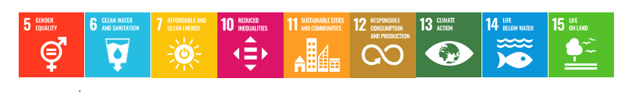
TTC, and subsequently each of its brands, has targeted 9 of the 17 Sustainable Development Goals (SDGs) (TTC 2020) within its strategy.
Diagram 1
To assess whether we have a strategy in place that enables us to operate as a sustainable company, we will briefly analyze our existing strategies in achieving these SDGs against the below listed and reworked 4 principles for Sustainability (Broman, Holmberg, et al. 2000).
Within our strategy we are ensuring that...:
- ...we do not systematically subject nature to increasing concentrations of substances extracted from the earth's crust.
Contributing targeted SDGs: 7, 12
Existing Implementations:
- Adjustment of sailing schedules to minimize fuel consumption.
- Renewable source of shore power used where possible.
- Maximising amount of people traveling within any given vehicle.
Challenges/ lack of implementation:
- BioFuel or electric vehicles are not in use but under consideration.
- Renewable shore power does not exist in all locations we operate.
- 2020 implementation of sustainability reporting software for data collection, analysis, and target setting.

- ...we do not systematically subject nature to increasing concentrations of substances produced by our extended operations
Contributing targeted SDGs: 6,7,11,12,13,14
Existing Implementations:
- Contractual requirement of EURO 6 rating for all vehicles used by our partners and vendors.
- High standard of maintenance and technology onboard ships.
- TTC has committed to being carbon neutral by 2050.
- Technological upgrades on all ships that no waste released into rivers.
Challenges/ lack of implementation:
- Reliance on supply chain cooperation.
- Lack of accurate measurement and target setting.
- Existing technology in all locations.

- ...we do not systematically subject nature to increasing degradation by physical means
Contributing targeted SDGs: 6,11,12,14,15
Existing Implementations:
- Complete removal of plastic water bottles, straws, and plastic single-use room amenities across the operation.
- Remaining Single-use items assessment in progress.
- 2020 paperless system implementation across ships.
- For each guest that selects e-documents, one tree is planted.
- Sustainably sourced fish is purchased.
- Appropriate Recycling implemented across the fleet.
- Respectful implementation of world heritage sites within itineraries
- Removal of unethical animal interactions.
Challenges/ lack of implementation:
- Lack of accurate measurement and target setting.
- Recycling facilities not available in all locations.

- ...we do not subject people to conditions that systematically undermine their capacity to meet their needs
Contributing targeted SDGs: 5,6,10,11,12,13
Existing Implementations:
- Increased sustainability educational opportunities for guests and employees.
- Balance of gender ratio across mid-level managers.
- Fair pay across company-owned operations.
- Support and funding of organizations promoting equal opportunity and fair work conditions.
- Widening network of itineraries to lesser-explored locations.
- Widening network of local community support.
Challenges/ lack of implementation:
- Unfair pay/conditions through certain chartered partner companies
- Low balance of gender equality in upper-level management
- Limited knowledge of the entire supply chain

It may be said that as we are at the beginning of this journey, we have made noticeable progress towards becoming a sustainable organization. We have comparably made further progress in principles 3 and 4, than in principles 1 and 2, where it becomes evident that our business is highly reliant on existent and future technologies and infrastructures. Our largest barriers faced would be lack of reporting, which will enable us to be more accurate in understanding our current footprint across our organization, as well as setting realistic timeframes and monitoring progress made, thereby creating an efficient enabling strategy to reach our set goals.

A Deeper Analysis:
To have a deeper understanding of our current strengths and weaknesses, as well as opportunities and threats, a SWOT analysis has been conducted, and outcomes may be seen below (Diagram 2).

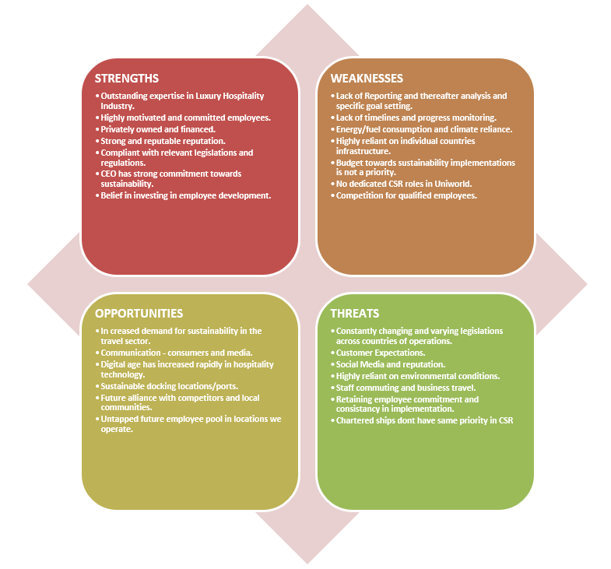

Diagram 2
Positioning the organisation through its strengths and weaknesses to meet these challenges
Based on this, below in Table 1 are some recommendations for each opportunity and threat listed in the above SWOT analysis and how we may meet these challenges according to our strengths and weaknesses.

Opportunity Challenge: | S O Strategy: |  | W O Strategy:
Increased demand for sustainability in the travel sector. |  | Using existing expertise to further expand sustainable tour options. | Implementation of reporting software enables progress monitoring and realistic timeframes. A CSR specific budget needs to be finalized to meet this expanding demand.
Communication - consumers and media. |  | Maximize use of motivated employees to promote initiatives in place and utilize expertise in Luxury travel to "redefine" sustainable luxury through these channels. | Integrate our sustainability measures into our recruitment/ employee strategy to meet requirements of future employee pools.
Digital age has increased rapidly in hospitality technology. |  | Investing in digital CSR training for employees to increase impact. | Investment in digital Food waste measurement system will boost lack of reporting and monitoring.
Sustainable docking locations/ports. |  | Private company investment in infrastructure can generate income from competitors. | Green energy access while docked decreases our fuel usage and emissions.
Future alliance with competitors and local communities. |  | Strong reputation in the industry and compliance with legislation gives us optimum positioning to initiate this alliance to maximise industry contribution. | Would create increased pressure to influence and lobby for better infrastructure in all locations.
Untapped future employee pool in locations we operate. |  | Expanding our investments in training outside of existing employees by initiating Internship programs in hospitality and sailing. | Through an internship program this would allow us to shape and train future employees and alleviate the lack of qualified employees.
Threat Challenge: |  | S T Strategy: | W T Strategy:
Constantly changing and varying legislation across countries of operations. |  | Enforcing „strictest” legislations across all areas of operation by using our strong knowledge of existing legislation throughout. | Implementation of CSR roles will monitor changing legislations and react accordingly.
Customer Expectations. |  | Further investment in employee development increases quality of product and sustainability output to meet expectations. | Allocating a budget to sustainable implementations and having a dedicated CSR task force to analyze data collected, company can become transparent with CSR initiatives and meet customer expectation.
Social Media and reputation. |  | Harnessing our CEO's CSR commitment in external communications of our challenges faced to encourage input/build trust via social media. | By ensuring accurate reporting we decrease risk potential.
Highly reliant on environmental conditions. |  | Using our company reputation to influence supply chain towards same 2050 carbon-neutral goal. | Minimizing our impact on Climate Change and ensuring continuous growth in CSR implementations we contribute towards minimizing extreme conditions.
Staff commuting and business travel. |  | Through increased awareness/training of travel impact, highly motivated employees will consider environmental risk of chosen travel method. | Dedicated CSR team can integrate sustainable travel policy for all employees.
Retaining employee commitment and consistency in implementation. |  | Harnessing motivated employees to further drive commitment within teams. | Hiring should be based on values of future employees, including CSR values.
Chartered ships don't have same priority in CSR |  | Implement strong CSR training programs onboard these ships and to partner companies. | Lobby together with Charter Partner owners to influence infrastructure improvement in these locations.
Table 1
The Business Case for Sustainability and creating Shared Value:
According to the Accenture/United Nations CEO Report, where over 1000 Executives across 21 industries and 99 countries were asked to give their input regarding sustainability within business, 55% of these business leaders say that they are „facing a key trade-off: pressure to operate under extreme cost-consciousness versus investing in longer-term strategic objectives which are at the heart of sustainability” (2019). However, the amount of CEOs who listed “no clear link to business value” as a barrier to sustainability has dropped from 37% in 2013 to 26% now in this latest report (2019). This tendency shows a definite increase in the realisation that the implementation of a sustainability strategy does not dictate a loss for companies, but rather the potential for decreased costs and increased profit when sustainability is successfully embedded within the company strategy.
There are intangible benefits that often arise when sustainability is integrated within an existing business strategy, and it is often hard to quantify these positive outcomes, in particular when they are not being measured and analyzed (Kreiss, Nasr et al. 2016). These intangible benefits should not, however, be ignored, as evidence points to the fact that these benefits can add more value and significantly outweigh those of tangible benefits that we have been able to measure and base our decisions on until now (Kashmanian, Keenan et al. 2010).
Here below are several intangible benefits (Whelan, Fink 2016), which have a positive impact across the three pillars of a sustainable business, and demonstrate the potential gains in further integrating sustainability as an underlying key factor within our strategy.
Improved Financial Performance through increased operating efficiency:
Through capital investments and innovative partnerships, and by reevaluating our current operations and working processes across our fleet, office, and supply chain, we stand to decrease costs significantly in the long run.
- The Sheraton Santa Fe Hotel in Mexico City has managed to reduce its energy usage by 26%, water consumption by 39% and its carbon emissions by 35% between 2008 and 2015. They did this by investing in green technology such as LED lighting, motion sensors, water reducers on their taps, solar panels, recycling soapy water and collecting rainwater for use. Not only are they successful in decreasing their footprint, The Starwood chain is projecting a saving of US$1 billion across their hotels within ten years due to initiatives such as these (O'Neill 2015).
- In a report conducted on behalf of Champions 12.3 , where they analyzed and collected data on food waste management of 114 restaurants across 12 countries which underwent a food waste reduction program, the following most significant outcomes were compiled (Clowes, Hanson et al. 2019):
- Within the 3 year study, it was found that the average benefit-cost ratio for food waste reduction was 7:1.
- Within the first year of this program being implemented, 76% of these 114 restaurants had already zeroed their initial investment.
- The average sight saved 2% of their associated costs during this implementation.

Increased stakeholder engagement to further drive competitive edge, customer loyalty and Innovation:
Businesses have been seen to be responsible for their negative impact on the environment and within communities, and companies have been accused of solely focusing on maximising profit at the expense of other stakeholders (Porter, Kramer 2006). This stems from the tendency of businesses to focus on their short term gains, as opposed to the customer needs and external influences which would lead to their long term success (Porter, Kramer 2019). By incorporating shared value for all stakeholders into all aspects of our strategy, we stand to increase innovation and growth by widening our information source and perspective, thereby increasing our company reputation and making us the primary choice of brand for consumers within our industry of river cruising.
When it comes to consumer decision making within the Tourism Industry, sustainability is a primary influencer. According to the 2019 survey conducted by Booking.com, 71% of travelers expect travel companies to offer more choices in sustainable travel (Ariel 2019). In a report conducted by McKinsey & Company, 66% of consumers surveyed stated they were willing to pay more for a sustainable product. Interestingly enough, this was more evident across the younger age groups, whereby 73% of Millenials said that they were willing to pay more (CREST 2019).
These examples of surveys conducted to emphasize the need for us to incorporate all stakeholders needs within our strategy to increase our competitive advantage against other river cruise companies, to grow our customer base and increase profits in the long term, taking into account the shift of changing requirements of the younger generations, who represent our future market.
Improvement of Risk Management
By further strengthening our Risk management within our strategy to incorporate the potential impact across our business, our employees and customers, as well as the surrounding environments and communities within which we operate, we stand to increase shared value for all of our stakeholders and minimize the possibility of protecting one of these stakeholders at the expense of others, thereby increasing our longevity in the future (Fatemi, Luft 2002).
Our industry is highly dependent upon weather conditions and the impacts of climate change. The sailing season of 2018 is a perfect example of this, where we as a company suffered heavy financial loss due an unprecedented change in expected weather conditions, resulting in an adverse effect on the water levels of the rivers upon which we sail, which rendered us unable to operate over an extended period. It is this very same vulnerability that we face that needs to become our driving force in our contribution towards combatting climate change (Franzoni, Pelizzari 2016). Through minimizing our impact on climate change we are actively contributing towards ensuring continued profit and growth in the long-term, reliable employment for our employees, meeting the sustainability demands required by current and future customers, as well as continued support in the communities in which we sail and minimized impact on the environment where we travel.
Employee Engagement, Wellbeing and Retention
The embedding of sustainability within our organization has many positive aspects when it comes to our employees. According to the 2016 Cone Communications Study, 76% of Millenials take a company’s environmental and social impact into account before accepting a job offer, and 64% will not accept a job if the company does not demonstrate strong sustainability practices (CONE 2016) This is particularly relevant as Millenials begin to represent our predominant workforce, and if we build our reputation as a sustainable company it leads to a greater pool of qualified candidates which we may hire from. For existing employees, the integration of a strong sustainability strategy leads to a significant increase in employee satisfaction, and retention rates increase while sick leave decreases, which results in decreased costs for our business (Whelan, Fink 2016).

Stakeholder Consideration
To ensure our strategy creates shared value across all stakeholders, and is prioritized according to how we may achieve maximum impact, Diagram 3 below illustrates our summarized strategy according to each of our stakeholders.
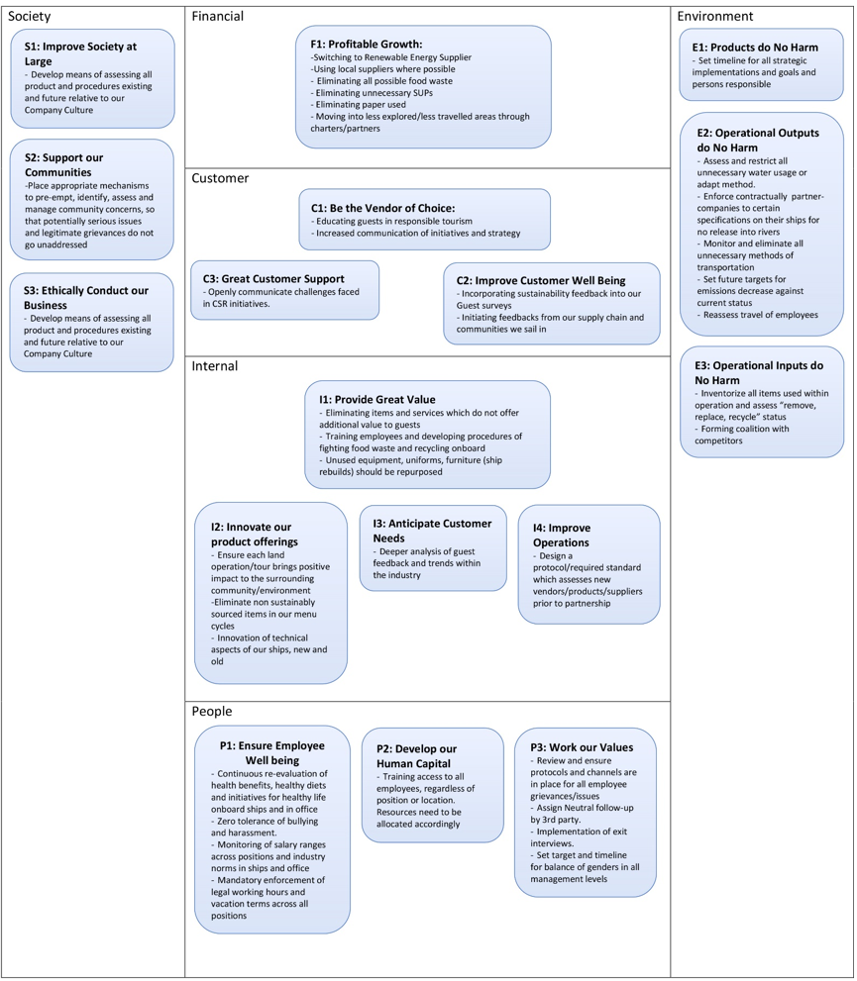
Diagram 3

Outcome and Recommendations
It has been determined that our existing strategy is aligned with being a sustainable company at present time, and that sustainability in itself can and should increase profit for the business, however at the same time it should add value for all stakeholders, and it should be measured and regularly reassessed.
To set a new trajectory for our company, I put forward the following recommendations as pictured below in Diagram 4. This diagram is our „strategic management scorecard” and illustrates our stakeholders and strategic goals, the aligned SDGs and Future-Fit goals which are being targeted against the contributing Key Future-Fit Indicators (KFIs), as well as the justification as to how they bring value to our business. Each of these KFIs has been evaluated on a scale of 1 to 3 by nine of our mid to upper-level management and averaged out according to our current status quo versus the intentioned potential impact, or target state, in the future (Future-Fit Foundation 2019).
I reason that if we work according to this newly balanced strategy, we are ensuring that we remain a brand which is valued by its customers and employees, and the communities where we operate, as well as a brand which does no harm to the environment and maximizes profit, ensuring the balance of Profit, People and Planet, and the longevity of this company.
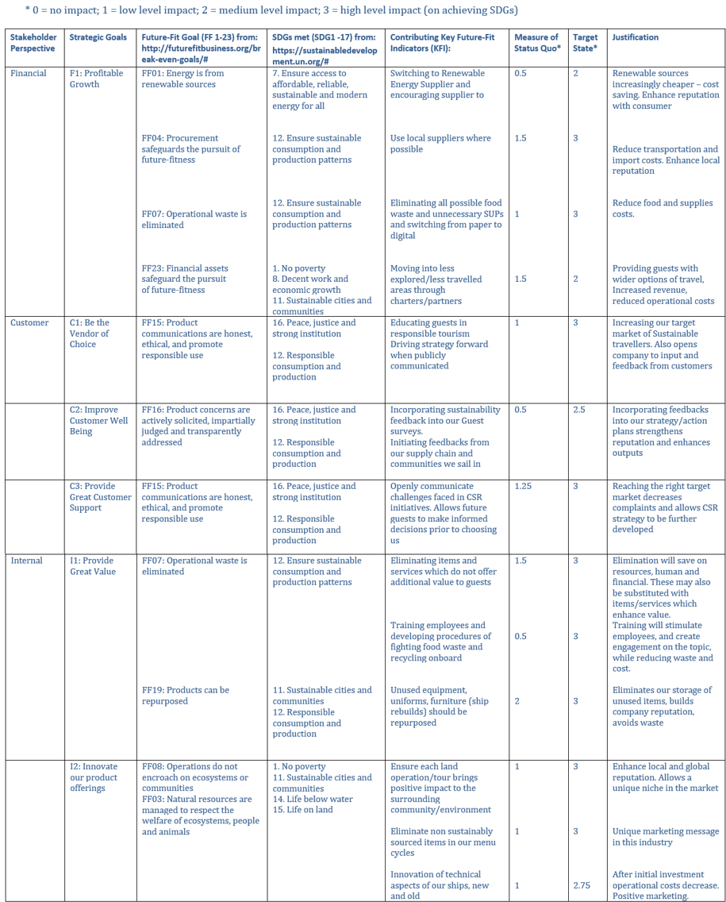
Diagram 4

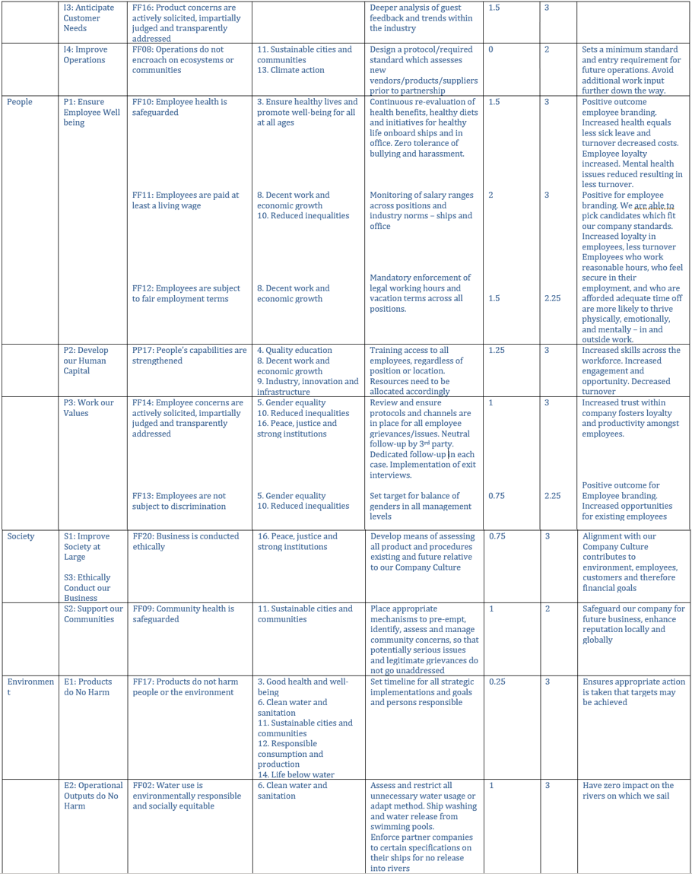
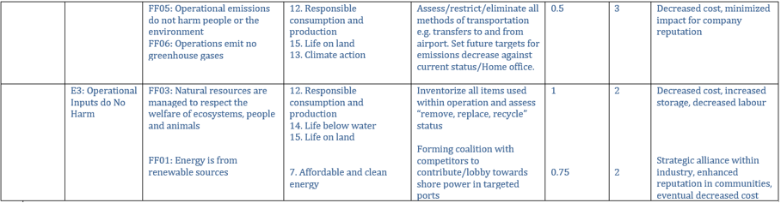

References
ACCENTURE, UNITED NATIONS, 2019. The United Nations Global Compact —Accenture Strategy CEO Study on Sustainability 2019. Available: https://www.accenture.com/_acnmedia/PDF-109/Accenture-UNGC-CEO-Study.pdf#zoom=40 [Apr 16, 2020].
ARIEL, R., -04-25T00:14:56+00:00, 2019-last update, Global Travelers prefer eco-friendly accommodation: Booking.com Sustainable Travel Report 2019. Available: https://www.gstcouncil.org/booking-com-sustainable-travel-report-2019/ [Apr 18, 2020].
BROMAN, G., HOLMBERG, J. and ROBÖRT, K., 2000. Simplicity without reduction: Thinking upstream towards the sustainable society. Interfaces, 30(3), pp. 13-25.
CLOWES, A., HANSON, C. and SWANNELL, R., 2019. The business case for reducing food loss and waste: restaurants. A report on behalf of Champions, 12.
CONE, 2016-last update, Research on Consumers, Millenials & CSR | Cone. Available: https://www.conecomm.com/research [Apr 18, 2020].
CREST, 2019. The Case for Responsible Travel: Trends & Statistics 2019. Available: https://www.responsibletravel.org/docs/CaseforResponsibleTravel_2019_Web.pdf [Apr 18, 2020].
FATEMI, A. and LUFT, C., 2002. Corporate risk management: costs and benefits. Global Finance Journal, 13(1), pp. 29-38.
FRANZONI, S. and PELIZZARI, C., 2016. Weather risk management in tourism industry. Symphonya.Emerging Issues in Management, (1), pp. 45-55.
FUTURE-FIT FOUNDATION, 2019. Explore the Benchmark. Future-Fit Foundation.
KASHMANIAN, R., KEENAN, C. and WELLS, R., 2010. Corporate environmental leadership: Drivers, characteristics, and examples. Environmental Quality Management, 19(4), pp. 1-20.
KREISS, C., NASR, N. and KASHMANIAN, R., 2016. Making the Business Case for Sustainability: How to Account for Intangible Benefits-A Case Study Approach. John Wiley & Sons, Inc.
O'NEILL, S., 2015. Starwood makes strong progress on sustainability goals | Green Hotelier.
PORTER, M.E. and KRAMER, M.R., 2019. Creating shared value. Managing sustainable business. Springer, pp. 323-346.
PORTER, M.E. and KRAMER, M.R., 2006. The link between competitive advantage and corporate social responsibility. Harvard business review, 84(12), pp. 78-92.
TTC, 2020-last update, The Travel Corporation. Available: https://ttc.com/ [Apr 18, 2020].
UNWTO, 2015. Tourism and the sustainable development goals. Available: https://www.unwto.org/tourism-in-2030-agenda [Apr 12, 2020].

WHELAN, T. and FINK, C., 2016. The comprehensive business case for sustainability. Harvard business review, 21, pp. 1-12.

