The Economic Suffering Due to the Plague of Covid-19: A Case Study of Sainsbury

Student Id: 1908539
Student Name: Ana Maria Moaca
Module Code: LCBB6000
Module Name: DISSERTATION
Module leader : Dr Anupam Mazumdar
Supervisor : Husam Alharahsheh
Table of Contents

Chapter 1: Introduction 2
Proposed aim, objectives, and research questions: 2
Chapter 2: Literature Review 4
Pandemic and Economic Stability in the UK 4
Pandemic and the Productivity of Sainsbury’s Operations 6
Pandemic and the Profits and Revenue of Sainsbury 6
Sainsbury after the Pandemic 8
Chapter 3: Methods and Methodology 9
Chapter 4: Key Findings and Discussion 14
Chapter 5: Conclusion and Recommendations 24
References 26
Appendix 29

Chapter 1: Introduction
The COVID-19 pandemic has impacted several businesses in the past two years within the economy of the UK and all around the globe. This impact has reverberated through several aspects of the external environment of these companies and resulted in huge losses (Schleper et al., 2021). The poor state of the country’s economy due to the rising inflation is also influenced by the COVID-19 pandemic. The retail industry of the UK contributes largely to the country’s economy through taxes. It also provides employment to more than 3 million individuals within the country and is one of the country’s largest private sector employers. According to the economic trends of 2020 in the UK, the retail industry contributes 5.2% to the country’s gross domestic product ().
This research project will study the impact of the COVID-19 pandemic on Sainsbury through its relationship with the economic stability within the UK. It will study the impact of the pandemic on the country’s economic status and its retail sector. It will discuss the influence of the pandemic on the operations of Sainsbury and its impact on the company’s finances.
Sainsbury is among the top three supermarket chains in the UK and comprises approximately 16% of the retail industry shares. The company was founded by John James and Mary Ann Sainsbury in 1869 and offers a range of products to its customers (about.sainsburys.co.uk, 2022). The company conducts its marketing and sales operations through its physical stores as well as its online shopping platform. The wide range of products offered by the company is marketed under different brand names including Argos, Nectar, Habitat, and more. The company owns more than 800 retail stores and approximately 600 supermarkets all over the country (about.sainsburys.co.uk, 2022). The mission of the company is to provide its customers with quality products and services to satisfy their needs. The company aims to acquire the top position in the UK’s retail industry.

Proposed aim, objectives, and research questions:
Aim: The aim of the research is to study and evaluate the impact of the pandemic on the economic growth of Sainsbury in the UK.
Objectives:
- To study the impact of the pandemic on the economic stability in the UK.
- To study the impact of the pandemic on the retail sector of the UK.
- To study the influence of the pandemic on the operations of SAINSBURY in the UK.
- To study the impact of the pandemic on Sainsbury’s finances and revenue.
- To discuss Sainsbury’s status after the pandemic.
Research questions:
- Has this pandemic adversely impacted the economic stability of the UK?
- How did the pandemic impact the retail sector in the UK?
- What was the impact of the pandemic on the productivity of SAINSBURY?
- What was the impact of the pandemic on Sainsbury’s profits and revenue?
- What is the status of Sainsbury after the pandemic?

Chapter 2: Literature Review

Pandemic and Economic Stability in the UK
The COVID-19 pandemic started in China and spread rapidly throughout the globe. It has since disrupted the various aspects of human life, including the economies of all the countries. The UK economy has also been disrupted due to the changes inflicted by the pandemic on the various markets. The national lockdown was imposed within the country to limit the spread of the virus and the pandemic (Nanda et al., 2021). This contributed to the downfall of several businesses in the country’s economy due to a lack of mobility of operations and a decrease in sales.
Fig 01: Rate of inflation in the UK.
(Source: Clark, 2022)
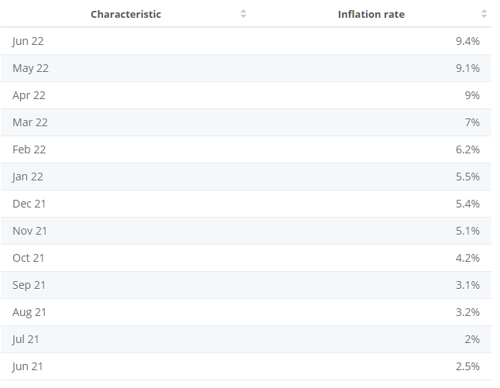
According to Harari et al. (2021), due to a surge in the cases of the COVID-19 virus, several restrictions were introduced within the country which influenced consumer behaviour and buying patterns. The rate of expenditure by individual households on products and services observed a steep decline with the progress of the pandemic. The inflation rate in the country rose from 5.1% in November 2021 to 9.4% in June 2022 (Clark, 2022). The GDP of the country declined in 2020 by 9.7%, which was the lowest since 1948. The GDP showed a slight recovery after the lockdown was lifted in 2021, however, it was still 0.5% less than that before the pandemic by the end of 2021.
Based on the study by Sayyida et al. (2021), it can be observed that the government's budget has also been disturbed as its expenditures have increased and the tax revenues have decreased during the pandemic. The government’s policies regarding support for businesses within the country have also caused more than £315 billion. As a response to this, the government has increased the tax rates. The government debt has also increased to around 95% of the country’s GDP (Boons et al., 2021). These sharp changes in the economic trends within the country are indicative of the permanent impact of the pandemic on the country’s economy.
Pandemic and the Retail Sector in the UK
According to Sopha et al. (2022), the retail sector of the UK comprises approximately 5.1% of the country’s GDP. The COVID-19 pandemic severely impacted the country’s economy and its various sectors including the retail industry. The restrictions imposed by the government like the national lockdown and social distancing norms led to a change in consumer behaviour and buying patterns. This negatively impacted the sales within the retail sector (de Palma et al., 2022). The physical stores of many retail companies were forced to shut down during the various phases of the national lockdown. Non-essential retail stores but mainly impacted due to the national lockdown as compared to the essential retail stores.
The research by Khaliq (2021) suggests that the total sale in the retail industry decreased by 1.9% in 2020. However, the cells of the online retail industry increased by 60% during the same. Customers started focusing on the purchase of essential goods only, resulting in an increase in the sale of food products. This also led to a decrease in the sales of non-food products by 23.8% in April 2020. Also, there was less or no availability of resources required by businesses to sustain their operations on normal levels (Fairlie and Fossen, 2022). This led to insufficiently stocked inventories, causing a disruption in the supply and demand curves. Many companies in the retail industry reported a shortage of essential goods and services. The overall sales of the online retail sector increased by 33.9% which is a record high. This rising trend was the result of an increase in the online expenditure of consumers (Filimonau et al., 2022). As compared to this, the in-store expenditure of the consumers decreased drastically during all four phases of the national lockdown.

Pandemic and the Productivity of Sainsbury’s Operations
The pandemic had a significant influence on the operations of Sainsbury as early as March of 2020. The company had to make several changes and its operations and management in order to ensure the safety of its customers as well as employees.
Grocery sales increased by 7.8% during the pandemic with an increase of 120% of sales through online orders. The company’s Argos business saw an increase of 10.9% in its sales, including an increase of 68% in its online sales (about.sainsburys.co.uk, 2022). During the lockdown, the fuel sales of the company decreased by 45%. The sales in the fashion section of the company saw a decrease of 8.5% which included a drop of 26.7% in just three months, from March to May 2020. Even though the sales of its food in Argos businesses were higher, most of its operations were disturbed as they were adjusted to ensure customer and employee safety. The company actively participated in supporting communities during the pandemic through several programs (Linsell, 2022). It lowered the prices of its food products to match the average customer expenditure rate. The company also implemented strategies to strengthen relationships with its suppliers true the innovation of 1900 new products.
The company made several changes to its structure in order to increase its capabilities of online sales. As a result, it has put approximately 1150 employees at risk of unemployment. It also turned to implementing technology within its several operations to increase its efficiency and sales during the pandemic (Linsell, 2022). This caused further threats to the employment status of its workers.

Pandemic and the Profits and Revenue of Sainsbury
The pandemic had an impact on the profits and revenues of all companies in the retail sector, lowering their financial resources considerably. Sainsbury alone faced an annual loss of £261 million during the pandemic. This was despite its high sales of food and Argos products in the essential products category. During the pandemic, many members of its staff had to take leaves of absence due to many reasons, including Covid-19 infections to self or family members (about.sainsburys.co.uk, 2022). This put them in dire need of financial assistance. The company spent approximately £485 million in payments of bonuses to its staff during the pandemic so as to help them recover and sustain themselves. Sainsbury also paid over £100 million in salaries through an increase in the pay rate. Also, the company’s restructuring costs impacted its profit margins by £423 million. This was largely due to the closing of almost 400 Argos stores (Linsell, 2022). This loss has been estimated to grow up to £617 million by the first half of 2021. The company’s expenditure on its operations during the pandemic was estimated to be approximately £200 million.
Fig 02: Sainsbury’s Profits.
(Source: Simpson, 2021)
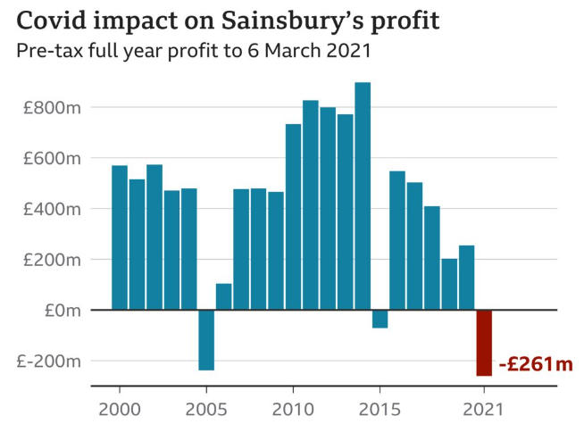
Lowering the buying price of its products further lowered the company’s profit margins. The online sales of the company’s products surged from a mere 8% to 11% within a year of the pandemic as the trend of online shopping increased with the progress of the lockdown. Combining the two important factors of increased sales and lowered prices, the profit margins of the company still dipped into the negative, causing serious implications for the company’s financial status (Burt and Maglaras, 2022). The discounts offered by the company’s rivals like Aldi also influenced its sales and profits considerably.

Sainsbury after the Pandemic
According to Filimonau et al. (2022) the consumers are returning to their normal routine and work from office cultures as the pandemic has slowed down with lower infection rates. This has lowered online sales as shoppers are turning back to stores for non-essential and essential products. As the impact of the pandemic on the company’s sales and profits was considerably high, its aftereffects are still very drastic for its business. The pandemic caused a shift in the curves of supply and demand (Akram et al., 2021). This created a shortage of resources. Combining the impact of the pandemic with the aftershocks of Brexit has skyrocketed the inflation rate in the country to a severe 9.4% in June 2022. The grocery sales eased by 2.4% in June 2022 as compared to those in 2021. Sales in Argos also decreased by 10.5% (Spyro, 2022).
According to Ogundijo et al. (2021), the changes in customer buying behaviour after the pandemic have influenced the company’s online sales which had increased during the lockdown. As the inflation rate is rising, consumers have been hugely impacted due to the high CPI which influences their buying behaviour even further. Consumers are crunched by the high living costs and are refraining from engaging in unnecessary expenditures like shopping for clothes or furniture, which are some of the important product sections in the company’s inventory (Pantano et al., 2020). The company has estimated its underlying profits to be approximately £630 to £690 million before tax for the year 2022. The company cited extreme pressures from its external environment and their uncertainties as the reason for this low-profit margin. The company’s profits were recorded to be £730 million last year, including £100 million in profits from increased grocery sales driven by the Covid-19 pandemic. The company’s stock also fell by 13% through the first half of 2022 (Linsell, 2022).
As a result of this, the company has been forced to lower its prices even further and cut down more than 2000 jobs. The company has also decided to integrate the operations of Sainsbury, Argos, and Habitat to save an approximate amount of £250 million in expenditure costs. Sainsbury is also engaging in increased pay rates for its employees to help them sustain the high living costs as a result of the inflation in the country (about.sainsburys.co.uk, 2022).

Chapter 3: Methods and Methodology
Research Philosophy
Research philosophies adapted for a research project can be described as the beliefs about the selection of methods for collecting, analysing, and interpreting data collected for conducting the research. The selection of the research philosophies is based on the nature of the collected data and the methods used for its assessment. There are different types of such philosophies, including interpretivism, realism, and positivism (Naidoo and Gasparatos, 2018). The research philosophy that was implemented for this case study of Sainsbury is that of Positivism. Positivism refers to viewing only the facts about a situation or topic of interest and is considered to be a trustworthy method of gaining information (Li et al., 2019). The topic of the case study is based on finding the social truth and the questions posed by the research are rare and specific to a certain component of the economy of the UK. The objectives of the research are focused on the social aspect of the company’s operations and revenue. This is why the philosophy of positivism is best suited for conducting this case study.
Research Paradigm
A research paradigm can be described as a framework of philosophical nature on which the approach to research is based. The research paradigm of a research project offers a guideline of beliefs, based on which the theories and practices applied in the research are approached for the completion of the project. It is focused on the epistemology, ontology, and methodology of the research (Li et al., 2019). The selection of the appropriate research paradigm is very important for obtaining the desired outcomes in a research project as they influence the approach taken toward the collection and interpretation of the data. This increases the quality and appropriateness of the research methodology. The research paradigm selected for this case study is social constructivism. Social constructivism is based on the context and nature of the accumulation and interpretation of the collected data (Patel and Patel, 2019). It helps in understanding the particulars of a specific situation. The data gathered through this belief and approach is rich in facts and dependable.
Research Approach
Research approach can be described as the methods of data assessment chosen for a certain research project. There are two types of research approaches, deductive and inductive methods of assessment. The deductive approach or reasoning methods can be described as the testing of the pre-existing theories with respect to a particular topic of discussion (Patel and Patel, 2019). Inductive reasoning can be described as the process of developing a completely new theory regarding a topic based on the data collected through the research process. The research process of this case study follows the deductive reasoning approach with the help of primary research tools. This approach to research was helpful in observing the patterns in the data through appropriate assessment methods for concluding the outcomes of the research.
Research Methodology
Research methodology helps in the description of the methods implemented by a researcher in conducting the various operations involved in the research process. It can also be described as a systematic and logical plan of action for obtaining answers to the questions posed by a research project (Naidoo and Gasparatos, 2018). Having an appropriate research plan helps the researcher to obtain reliable and valid outcomes and conclusions to the project for fulfilling its initial objectives and aims. It describes the nature and sources of the data to be collected for conducting research. It also helps in the identification of the appropriate methods of data analysis and interpretation. The research methodology used for this research project is the Experimental Methodology. This methodology helps in the identification of the relationship between two different variables in a given situation or circumstance (Li et al., 2019). In this case, it helped in understanding the relationship between the pandemic and the operations of Sainsbury, resulting in an impact on its profits and revenue. The approach to this methodology is through the collection of primary data.
Research Strategy
A research strategy can be described as a carefully planned course of action taken by the researcher for directing his or her efforts and thoughts appropriately. This helps in researcher in conducting the research in a systematic and logical way to obtain results that are detailed and of high quality (Li et al., 2019). The research strategy implemented for conducting this case study is the quantitative research strategy. The quantitative research strategy can be described as the method of research that emphasize the measurement of the factual data and information regarding the topic of discussion. This is achieved through the collection of statistical data which is collected through surveys and questionnaires which are primary methods of data collection (Patel and Patel, 2019). The data is then analysed in its numerical format with the use of computational techniques. This research strategy helped in the obtaining of appropriate and nearly accurate data through primary research tools and quantitative strategy of research.
Data Sampling Methods
Different data sources can be used for obtaining the data required for reaching certain outcomes when conducting a research project. These sources of data include primary and secondary sources (Naidoo and Gasparatos, 2018). Primary sources of data refer to the collection of information from individuals directly related to the topic or situation that is being discussed. The secondary sources of data include previous research projects, articles, journals, books, and other documents related to the topic of discussion. The data source selected for this research project is of the primary type. The use of appropriate data sampling techniques is important for obtaining accurate results from the research approach (Patel and Patel, 2019). The research will be conducted by gathering information from at least 10 participants through a survey. The survey questionnaire will be sent to the participants via email or text messaging.
Data Collection Tools
Data collection refers to the process of gathering information from the selected sources of data. Based on the nature of the research approach, there are three types of data collection tools. These include quantitative, qualitative, and mixed data collection (Li et al., 2019). The type of data collection approach used for this research project is quantitative data collection. The selected tool for this particular case study is a survey questionnaire using Google Forms. This will help in the collection of data directly from the primary sources of data. The data collected through secondary sources listed in the literature review will be subjected to quantitative analysis. This will provide accurate insights into the status of Sainsbury’s sales and profits to understand the impact of the pandemic on its operations. The data collected through Google Forms will be automatically grouped by the tool for ease of analysis.
Data Analysis and Interpretation
Data analysis refers to the process of segregating, structuring, compartmentalizing, and assessing the data that is collected for the research purpose. For the analysis of data, various methods and techniques are applied to the data set. These methods and techniques help in the description, condensation, illustration, and detailed evaluation of the collected information (Grover et al., 2018). different tools can be implemented for analysing and evaluating the data collected for this case study. The data analysis approach selected for the assessment of secondary data collected for this research project is that of the descriptive type which can be seen in the literature review. The data analysis of the primary data will be conducted using the sampling tool. Google forms provide an analytical summary of the data collected in the form of pie charts (Rashid et al., 2019). These are easy to interpret as the results and outcomes of the survey will be provided in percentages and statistics. This type of data analysis is that of the quantitative type.
Time Prospects of the Research
 | Apr | May | Jun | Jul | Aug | Sept | Oct
Reviewing the literature
Classifying the appropriate content
Assessment of the available material
Analysis of the secondary research
Concluding the research project
Drafting the final report.

Ethical Considerations
Ethical consideration when conducting a research project refers to the identification and understanding of various ethical standards the researchers are supposed to maintain during the process. Researchers should identify the ethical implications of the various processes and methods involved in the research, including methods of data collection, data handling, and the involvement of participants (Rashid et al., 2019). Based on the topic of discussion of the research project, there are different sets of rules and ethics that the researchers are expected to follow. These sets of standards and ethics guide the approach of the researchers in the selection of the research design, methods of data sampling, research methodology and more. Keeping in mind these ethical considerations will ensure the transparency of the collected data for increased accuracy of results (Grover et al., 2018). The implementation of ethical procedures will also ensure the reliability of the data sources. These standards also state that the participants in the study have consented to the study and are not forced in any way to contribute to its outcomes and conclusions. The participants of this case study about Sainsbury were made to fill out individual consent forms before the survey questionnaire was sent to them.

Chapter 4: Key Findings and Discussion
Six questions were prepared to understand the relation between the pandemic and the sales and profits of Sainsbury from the perspective of its customers. The Google form containing the questionnaire was sent to the known customers of Sainsbury through email or text messaging. Ten responses were received after which the accepting of responses was stopped to limit the data sample size. All the participants answered every question which ensured that the sample size for the collection of data related to every question was maintained at ten responses. The responses were received within 20 minutes of sending the google form links to the participants. This shows the efficiency of using Google forms for conducting surveys for limited-time case studies and research projects.
The questions and the responses to the survey were organized by the Google forms tool for easy access and assessment. The google form also provided auto-generated pie charts for recording the responses to every question through statistical representation. The questions, their options, and the recorded responses are provided below. The pie charts of data analysis and interpretation are also attached below. These are the key findings of the research project through the implementation of various methods as described in the research methodology. The conclusion of the project will be based on these results and findings.

- Did the Covid-19 pandemic impact your purchase behaviour when shopping with Sainsbury?
- Yes
- No
- Maybe
Responses:
Yes | 4
No | 3
Maybe | 3
Total | 10

Fig 03: Response Pie-chart generated through Google Forms for Question 1.
(Source: Author, 2022)
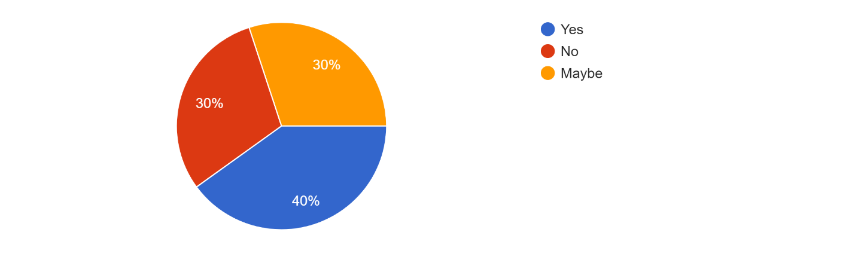

- Did you spend more or less than £100 in a month during the pandemic when shopping with Sainsbury?
- More than £100
- Less than £100
Responses:
More than £100 | 5
Less than £100 | 5
Total | 10

Fig 04: Response Pie-chart generated through Google Forms for Question 2.
(Source: Author, 2022)
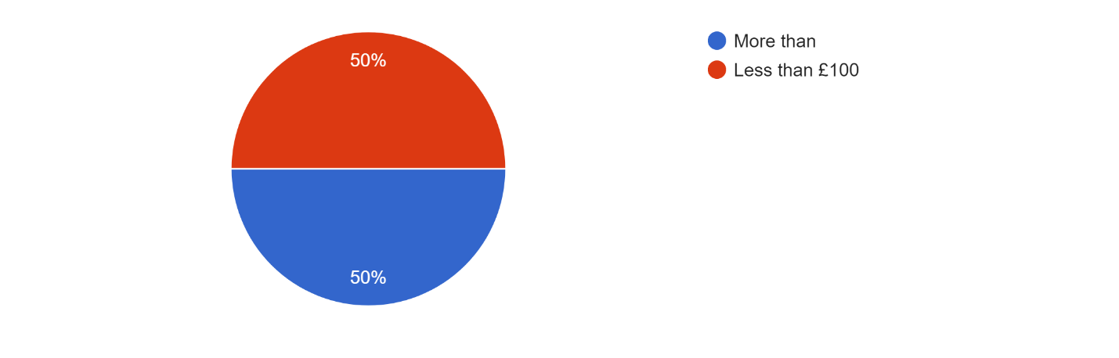

- Did you opt for any other online stores for buying goods?
- No, only Sainsbury.
- Yes, one other.
- More than one.
Responses:
No, only Sainsbury. | 3
Yes, one other. | 5
More than one. | 2
Total | 10

Fig 05: Response Pie-chart generated through Google Forms for Question 3.
(Source: Author, 2022)
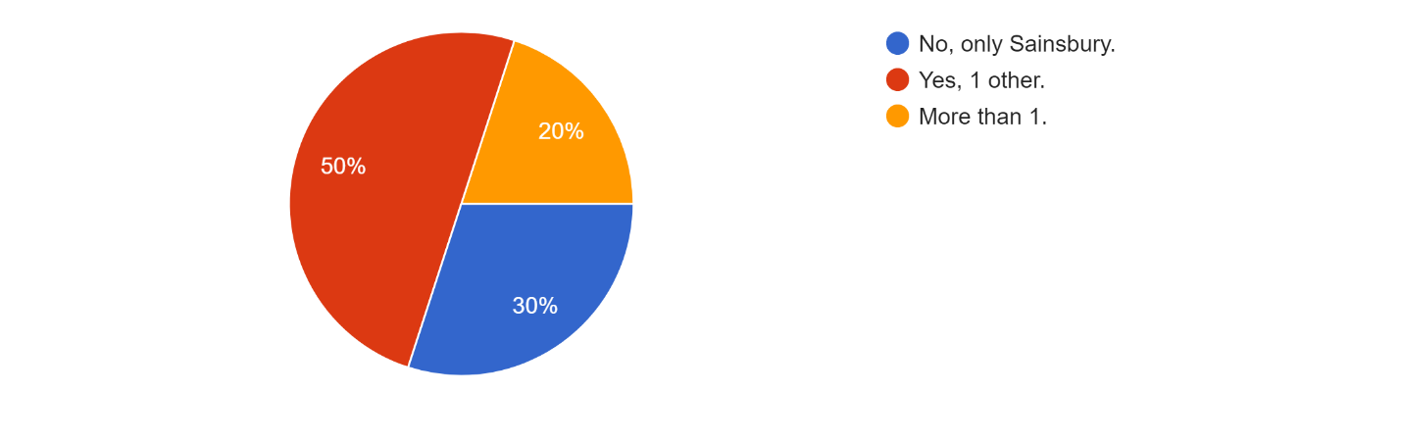

- Did you buy products related to fashion or furniture during the pandemic?
- No
- Yes
Responses:
No | 7
Yes | 3
Total | 10

Fig 06: Response Pie-chart generated through Google Forms for Question 4.
(Source: Author, 2022)
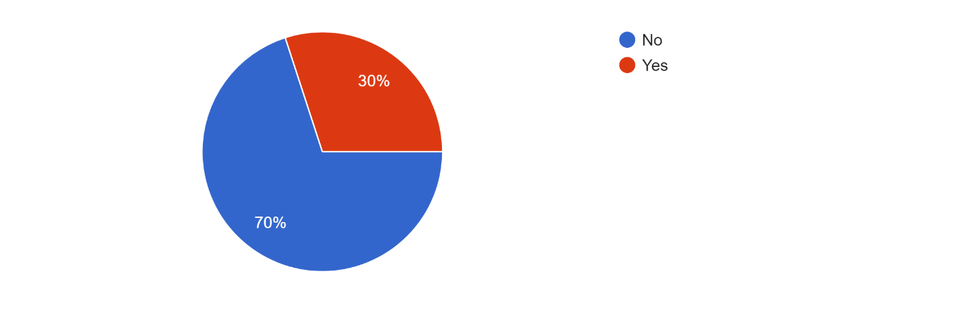

- How was your experience shopping with Sainsbury during the pandemic?
- Good
- Not good
- Okay
Responses:
Good | 4
Not good | 1
Okay | 5
Total | 10

Fig 07: Response Pie-chart generated through Google Forms for Question 5.
(Source: Author, 2022)
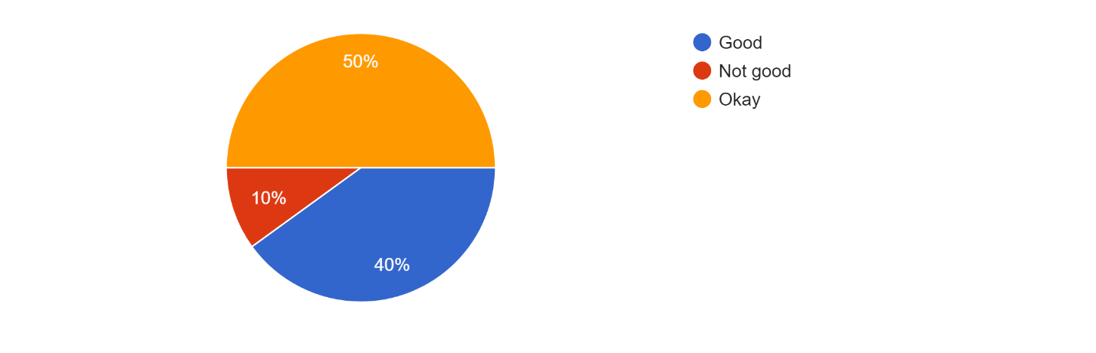

- As the pandemic is ending, will you continue to shop on Sainsbury's online shopping website or will you opt for shopping in physical stores?
- Online shopping
- Physical stores
- Both
Responses:
Online shopping | 4
Physical stores | 2
Both | 4
Total | 10

Fig 08: Response Pie-chart generated through Google Forms for Question 6.
(Source: Author, 2022)
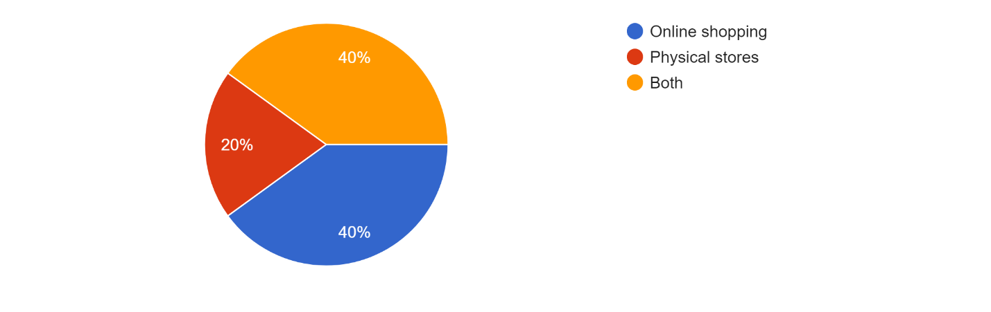

The findings of the survey were straightforward as they were in the form of statistics and graphical representations of the data provided clear answers to the questions of the case study. The results and findings of the survey questionnaire are discussed below for individual questions.
Question 1:
40% of the participants of the survey (the known customers of Sainsbury) believe that the Covid-19 pandemic has impacted their buying behaviour and changed their shopping patterns with Sainsbury, a retail supermarket chain and digital shopping platform. 30% of the consumers believe that the Covid-19 pandemic might have influenced their buying behaviour. This means that these customers believe that there are other factors that could also have influenced their shopping patterns. Further research is required in this area to determine the exact additional causes. The remaining 30% believe that the pandemic has had no impact on their buying behaviour and attitude toward shopping with Sainsbury. There is a possibility that this may be due to the difference between the financial income of these participants as compared to the others. Further research is required in this aspect to determine the exact reasons for this.
Question 2:
50% of the consumers stated that they spend more than £100 when shopping with Sainsbury in a month. This can be calculated to be an approximate amount of more than £1200 a year during the pandemic for a single customer. Although further research is required in this context to understand the financial background of these customers. Also, the products bought by these individual customers during their monthly shopping sprees should be taken into consideration to understand their spending on essential and non-essential products. The rest of the 50% of the customers reported that they spent less than £100 every month when shopping with the company, through its physical stores or online platform, during the peak period of the pandemic. These products are assumed to be essential products but further investigations can provide more information in this regard.
Question 3:
30% of the participants of the survey reported that they preferred to buy their products from Sainsbury only. This highlights the aspect of customer loyalty towards the company, its products, and the quality of service. The success of the company’s efforts toward keeping their customers satisfied and safe during the pandemic is visible through these statistics. However, the low number of customers who believe this is also indicative of the fact that there is still scope for the company to improve its customer service and efficiency of its strategies. 50% of the participants in the survey reported that they bought goods and products from one other online store. These statistics are evidence of the lack of variety of products or their availability in the inventory of the retail company. Also, it might point to the difference between the quality of products offered by Sainsbury and its competitors. Further investigation into this aspect of customer buying behaviour can help in determining the specific reasons behind it. This can help in increasing the efficiency of the research that can be conducted in the future for studying the accurate impact of the Covid-19 pandemic on the sales and profits of Sainsbury. The rest of the 20% of participants stated that they used more than one online store to shop for products and services. This can be attributed to the uncertainty of the social aspects and their impact on consumer buying behaviour.
Question 4:
70% of the participants reported that they did not buy products related to fashion or furniture during the pandemic. This means that most of the expenditure of these participants was focused on buying only essential products like food products and health-related items. Based on these statistics it can be concluded that the maximum sales of Sainsbury were that of its food on health-related goods while only a few were related to non-essential products. This is reflective of the consumer buying behaviour during the pandemic that focused on spending only on essential products and not on non-essential products. The remaining 30% of the participants stated that they did buy fashion or furniture-related products from Sainsbury during the pandemic. This trend in buying behaviour is very low as fashion and furniture-related products can be termed as non-essential products.
Question 5:
40% of the participants of the survey stated that their shopping experience with Sainsbury was good during the pandemic. These statistics are reflective of the company’s efforts to provide its customers with good service while ensuring their health and safety along with its employees. The quality of the products offered by Sainsbury along with its lowered prices is important factors that have helped sustain its sales even during the pandemic. 50% of the customers, however, reported that their shopping experience with Sainsbury was okay. These numbers can be indicative of the lack of strategic management on the part of the company to address the needs of its customers and provide quality service. It can be said that there is scope for improvement in the operations of Sainsbury. Only 10% of the customers who participated in the survey reported that their shopping experience with Sainsbury was not good during the pandemic. Further research can be conducted in this area using the same participants to understand the reason behind these numbers. There can be several reasons behind these statistics and can be studied to understand their relevance in answering the questions of the research project, and specifically, the impact of the COVID-19 pandemic on the sales and profits of Sainsbury.
Question 6:
40% of the participants of the survey stated that they will continue to shop on Sainsbury’s online shopping website rather than going to its physical stores. These responses by the participants are indicative of a major change or shift in the shopping preferences of consumers where they prefer shopping from online websites rather than going to physical stores. This change was inflicted by the pandemic and might continue to exist even after the pandemic ends. 20% of the participants reported that they prefer buying at physical stores rather than online shopping. The most probable reason for this can be the mistrust of consumers in technology and digital platforms in providing quality products and services that gave good value for money. However further research can be conducted in this area to gather more information regarding the same. 40% of the remaining participants of the survey stated that they prefer both, online shopping and buying from physical stores, even after the pandemic. This flexibility in the attitude towards shopping might be more specific regarding a certain type of product. For example, people prefer buying fashion from physical stores and grocery products can be bought from online platforms. Further research can be conducted in this area also to understand the exact reasons behind this flexibility in the attitude towards shopping preferences.

Chapter 5: Conclusion and Recommendations
The research project team that studying the impact of the COVID-19 pandemic on the sales and profits of Sainsbury. The literature review section of the research project addressed the impact of the COVID-19 pandemic on the economic stability in the UK. It also addressed the influence of the pandemic on the retail sector within the country. The impact of the pandemic on the productivity of Sainsbury’s operations including its sales was discussed in this research project. It also studied the impact of the pandemic on the profits and revenue of the company. A brief review of the status of this retail company after the pandemic was highlighted through a literature review.
The research philosophy adopted for this research project was that of positivism. The research paradigm implemented for this case study was that of social constructivism and the research approach was that of deductive reasoning through primary research. The research methodology implemented for this case study was the experimental methodology and the research strategy was that quantitative type. Google forms were effectively used for data sampling and provided satisfactory results along with tools for analyzing this data.
Based on the findings of the survey conducted for this case study, it can be said that the pandemic has impacted the sales and profits of Sainsbury. A change in the buying behaviour of customers during the COVID-19 pandemic played a crucial role in influencing this impact on the company. due to the rising inflation rate and consumer price index in the country, the buying capacity of customers has decreased drastically. Combining the COVID-19 pandemic and the rising inflation provided a sufficient boost to this shift in buying behaviour among the customers of Sainsbury. Also, people were more focused on fulfilling their primary and basic needs in terms of food products and other health-related products rather than spending on non-essential products like fashion and furniture. However, it can also be observed that customer loyalty towards the company is observed to be moderate before, during, and at the end of the pandemic. The business ethics and strategies for customer satisfaction of the company can be credited for this customer loyalty. Also, through this survey, it was observed that customers are more inclined toward shopping on digital platforms rather than visiting physical stores. This shift in shopping preferences is influenced by the COVID-19 pandemic and will continue to exist even after the pandemic ends.
In secondary research for this case study, it was observed that certain changes need to be made to the strategic management of Sainsbury to increase the efficiency of its operations. The areas that need improvement are several including its methods of procurement of resources from its suppliers, its marketing strategies, human resource policies, financial management, and more. Making changes to its current strategic management operations can help in balancing the impact of the pandemic and its growth into the future. The company needs to make certain changes to its structure. The leaders need to step forward and actively engage in its management operations to ensure their efficiency which is important for its growth and development and the future. The company’s leaders will be responsible for changing the company’s current status which has been highly impacted by the pandemic and increasing its productivity to earn profits.
Ask the consumers are shifting towards online shopping, Sainsbury needs to consider its options of shifting its operations entirely to its online platform. This will help increase its reach in the retail sector, increasing its customer base considerably. The company can also introduce innovative ways to integrate technology in its operations like its warehouse by following the example of Ocado, its biggest rival. Introducing new products can help to enrich its current product line and increase its popularity among the customers. The company needs to ensure that the quality of the products it offers should be high. Training its employees to handle technology-based equipment will ensure a boost in their employability skills. Further research needs to be conducted to identify several aspects of the company’s operations that have contributed to its losses during the pandemic. The company can adopt new strategies to recover its losses and regain its position within the retail industry. For this purpose, Sainsbury needs to clear its debts add provide sufficient dividends to stakeholders to ensure sufficient revenue for implementing these new strategies.

References
About.sainsburys. (2022). About us page on Sainsbury’s website (Online). Available at: https://www.about.sainsburys.co.uk/about-us. Last accessed on August 6, 2022.
Akram, U., Fülöp, M.T., Tiron-Tudor, A., Topor, D.I. and Căpușneanu, S., 2021. Impact of digitalization on customers’ well-being in the pandemic period: challenges and opportunities for the retail industry. International Journal of Environmental Research and Public Health, 18(14), p.7533.
Boons, F., Doherty, B., Köhler, J., Papachristos, G. and Wells, P. (2021). Disrupting transitions: Qualitatively modelling the impact of Covid-19 on UK food and mobility provision. Environmental innovation and societal transitions, 40, pp.1-19.
Burt, S. and Maglaras, G. (2022). Special issue on Covid-19 and retailing. The International Review of Retail, Distribution and Consumer Research, 32(2), pp.127-129.
Clark, D. (2022). CPI inflation rate in the UK 1989-2022 (Online). Available at: https://www.statista.com/statistics/306648/inflation-rate-consumer-price-index-cpi-united-kingdom-uk/. Last accessed on August 6, 2022.
de Palma, A., Vosough, S. and Liao, F., 2022. An overview of effects of COVID-19 on mobility and lifestyle: 18 months since the outbreak. Transportation Research Part A: Policy and Practice.
Fairlie, R. and Fossen, F.M. (2022). The early impacts of the COVID-19 pandemic on business sales. Small Business Economics, 58(4), pp.1853-1864.
Filimonau, V., Beer, S. and Ermolaev, V.A. (2022). The COVID-19 pandemic and food consumption at home and away: An exploratory study of English households. Socio-Economic Planning Sciences, 82, p.101125.
GROVER, V., CHIANG, R.H., LIANG, T.P. and ZHANG, D. (2018). Creating Strategic Business Value from Big Data Analytics: A Research Framework. Journal of Management Information Systems, 35(2), pp.388-423.
Harari, D., Keep, M., and Brien, P. (2021). Coronavirus: Economic impact (Online). Available at: https://commonslibrary.parliament.uk/research-briefings/cbp-8866/#:~:text=GDP%20declined%20by%209.7%25%20in,two%20months%20earlier%20in%20February. Last accessed on August 6, 2022.
Khaliq, M. (2021). Impact of the coronavirus (COVID-19) pandemic on retail sales in 2020 (Online). Available at: https://www.ons.gov.uk/economy/grossdomesticproductgdp/articles/impactofthecoronaviruscovid19pandemiconretailsalesin2020/2021-01-28. Last accessed on August 6, 2022.
Li, T., Higgins, J.P. and Deeks, J.J. (2019). Collecting data. Cochrane handbook for systematic reviews of interventions, pp.109-141.
Linsell, K. (2022). Sainsbury’s Warns of Lower Profit Amid Cost-of-Living Crisis (Online). Available at: https://www.bloomberg.com/news/articles/2022-04-28/sainsbury-warns-of-lower-profit-amid-cost-of-living-crisis. Last accessed on August 6, 2022.
Naidoo, M. and Gasparatos, A. (2018). Corporate environmental sustainability in the retail sector: Drivers, strategies and performance measurement. Journal of Cleaner Production, 203, p.125e142.
Nanda, A., Xu, Y. and Zhang, F. (2021). How would the COVID-19 pandemic reshape retail real estate and high streets through acceleration of E-commerce and digitalization?. Journal of Urban Management, 10(2), pp.110-124.
Ogundijo, D.A., Tas, A.A. and Onarinde, B.A. (2021). Exploring the impact of COVID-19 pandemic on eating and purchasing behaviours of people living in England. Nutrients, 13(5), p.1499.
Pantano, E., Pizzi, G., Scarpi, D. and Dennis, C. (2020). Competing during a pandemic? Retailers’ ups and downs during the COVID-19 outbreak. Journal of Business research, 116, pp.209-213.
Patel, M. and Patel, N. (2019). Exploring Research Methodology. International Journal of Research and Review, 6(3), pp.48-55.
Rashid, Y., Rashid, A., Warraich, M.A., Sabir, S.S. and Waseem, A. (2019). Case study method: A step-by-step guide for business researchers. International journal of qualitative methods, 18, p.1609406919862424.
Sayyida, S., Hartini, S., Gunawan, S. and Husin, S.N. (2021). The impact of the COVID-19 pandemic on retail consumer behavior. Aptisi Transactions on Management (ATM), 5(1), pp.79-88.
Schleper, M.C., Gold, S., Trautrims, A. and Baldock, D. (2021). Pandemic-induced knowledge gaps in operations and supply chain management: COVID-19’s impacts on retailing. International Journal of Operations & Production Management, 41(3), pp.193-205.
Simpson, E. (2021). Sainsbury's: The cost of Covid has been high (Online). Available at: https://www.bbc.com/news/business-56912064. Last accessed on August 6, 2022.
Sopha, B.M., Arvianto, A. and Tjahjono, B. (2022). Survival strategies of traditional retailers during the COVID-19 pandemic: Some insights from a developing country. Journal of Industrial Engineering and Management, 15(2), pp.185-201.
Spyro, S. (2022). Sainsbury's sales fall after covid high (Online). Available at: https://www.express.co.uk/finance/city/1636357/sainsburys-sales-fall-covid-lockdown-high. Last accessed on August 6, 2022.

Appendix

