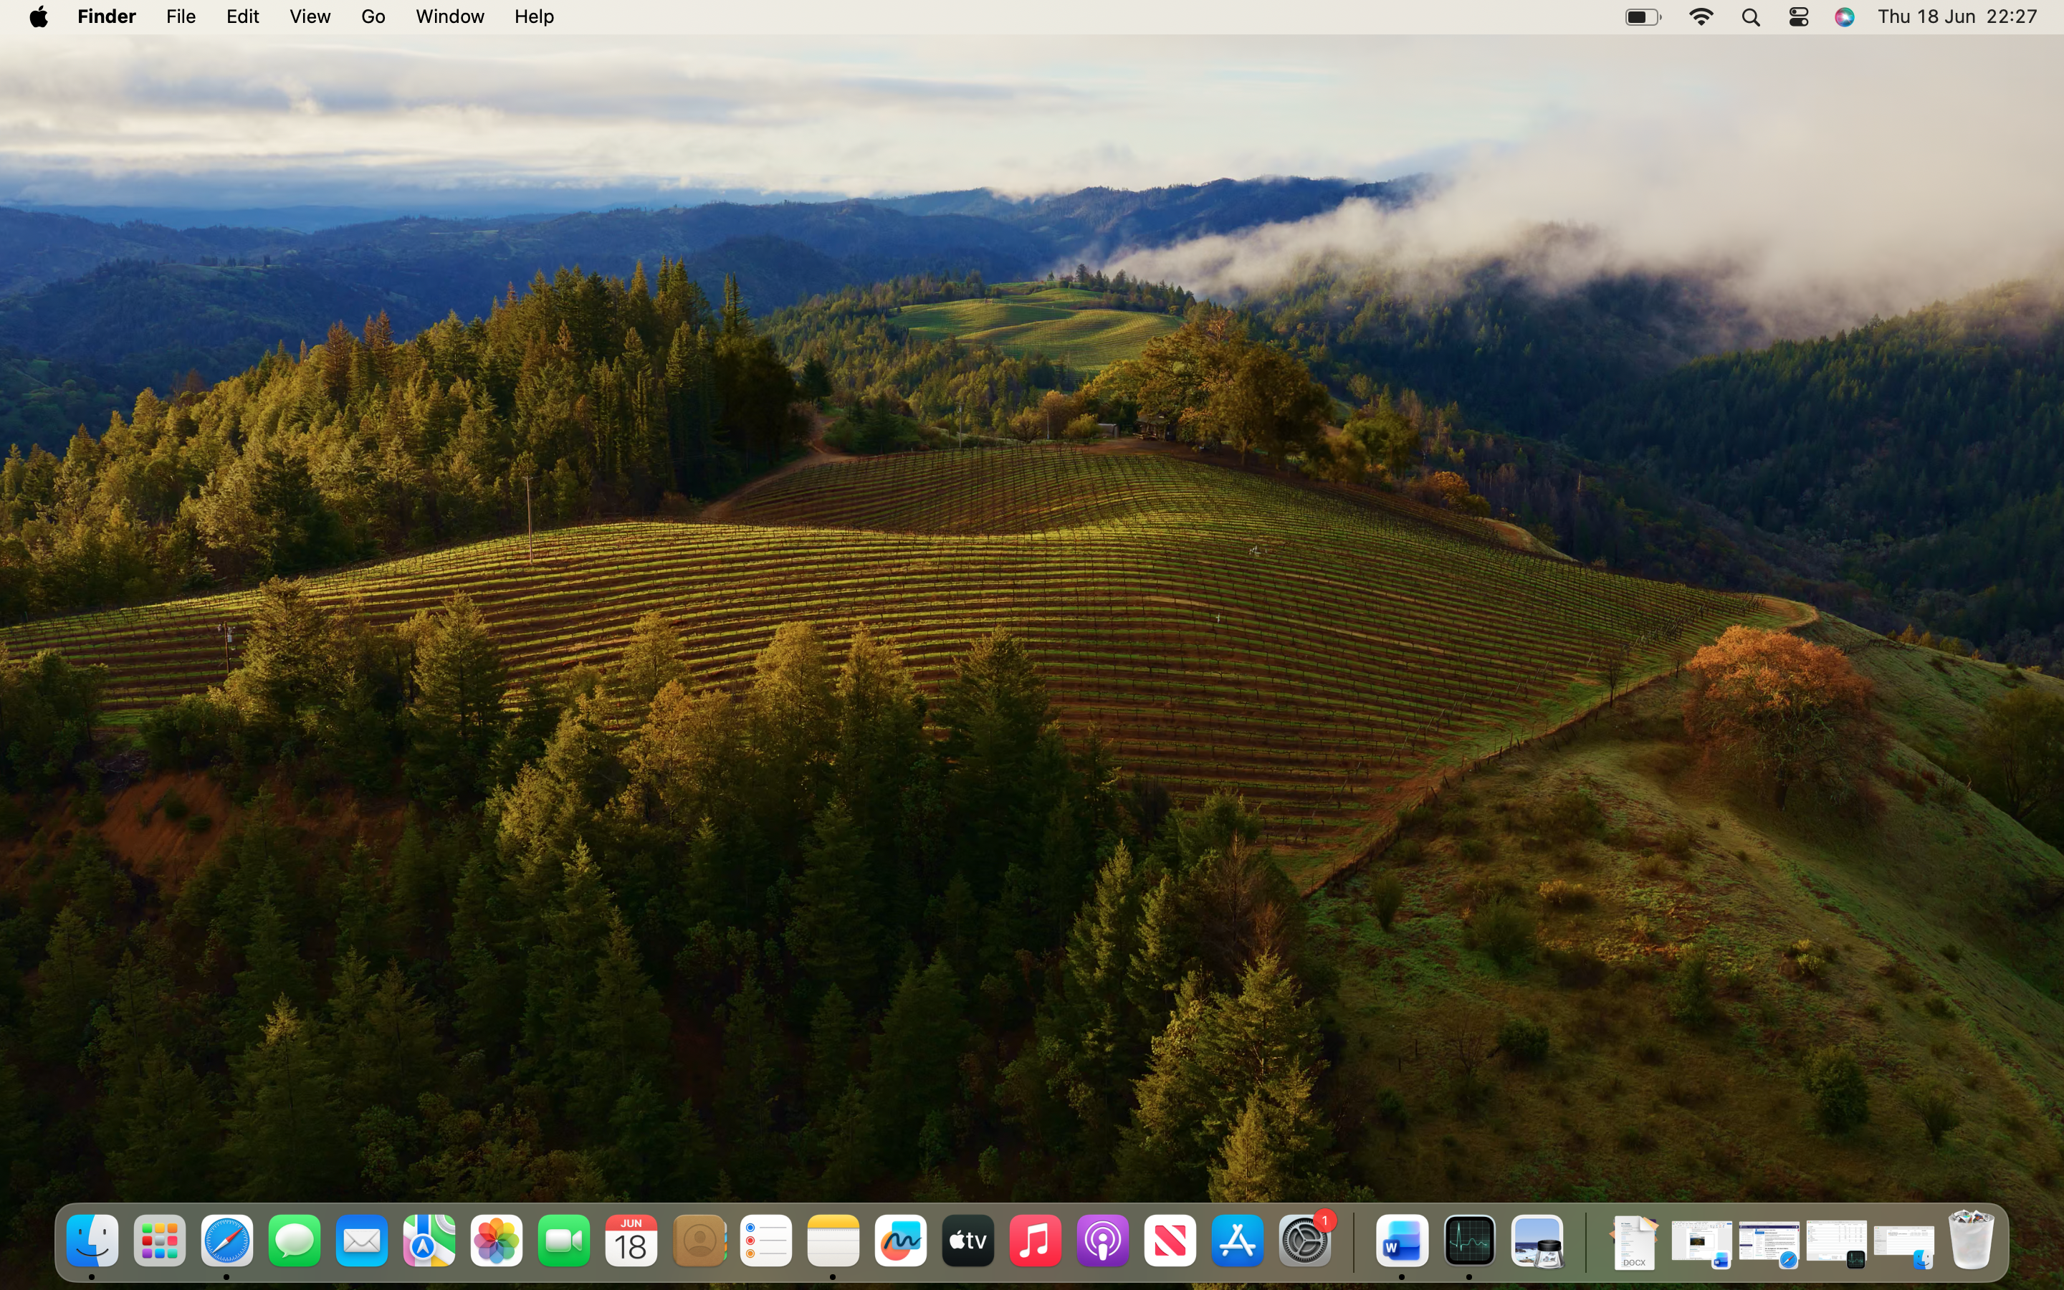
I am learning to use my Mac. Today, I learned how to take screenshots. This helps me a lot with my work. As I can now easily add pictures to my assignments. Next, I want to learn how to edit these pictures.

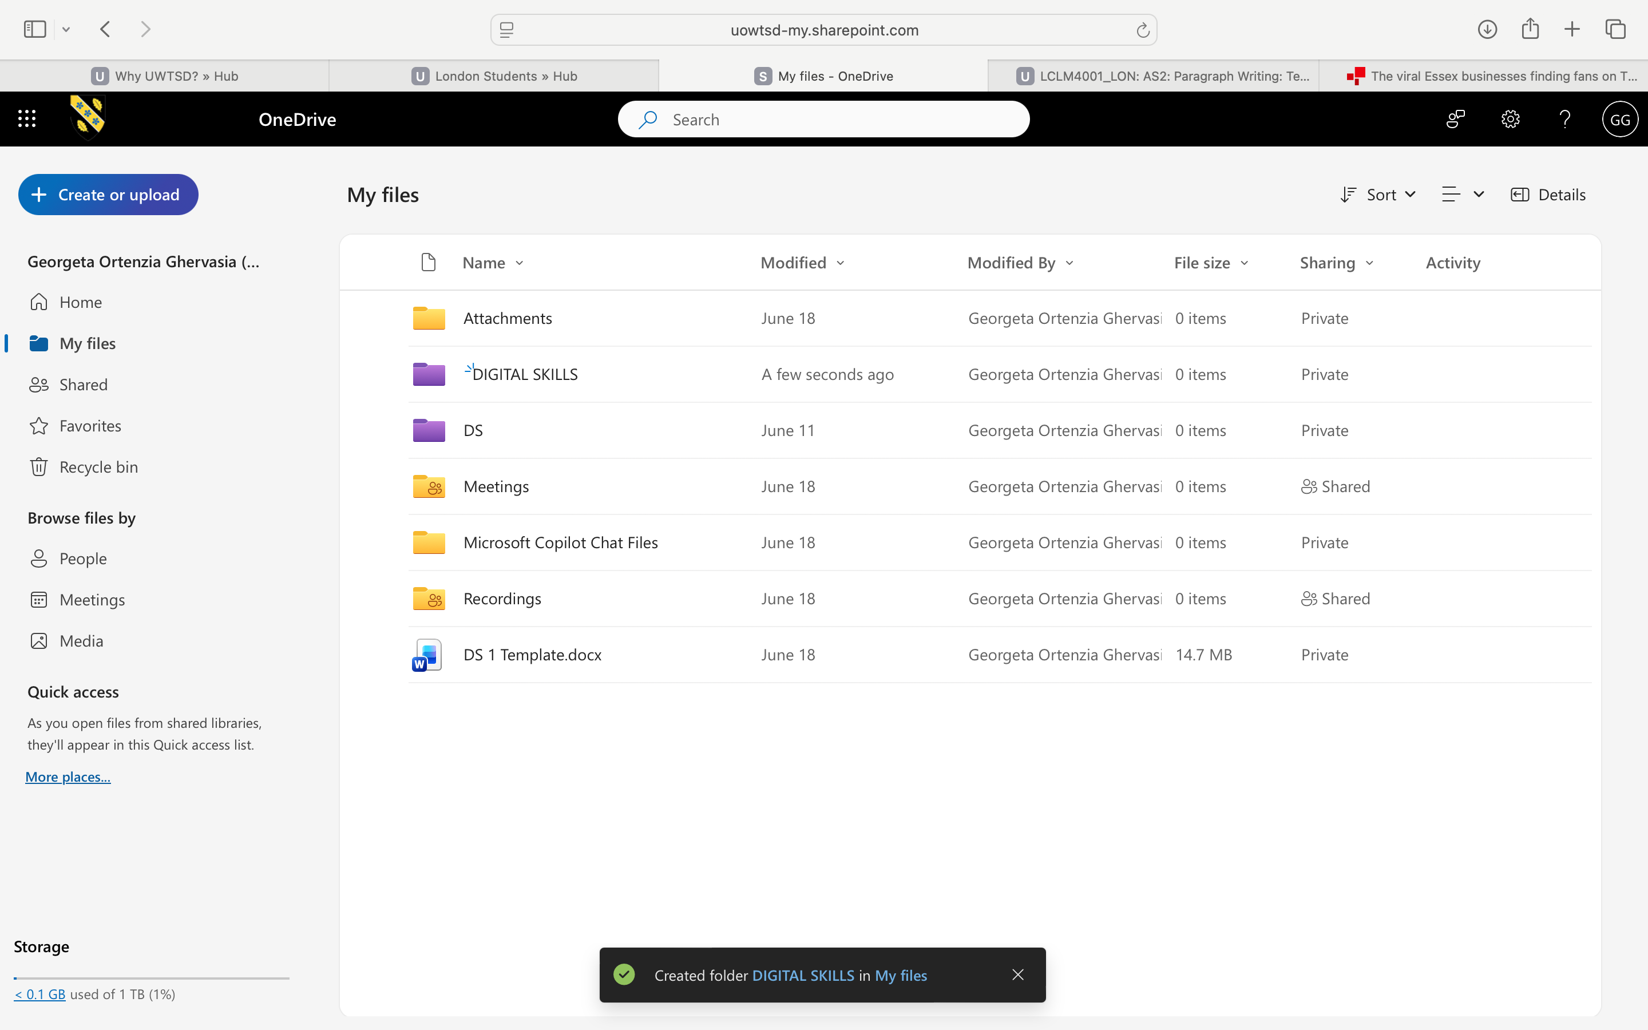
This picture shows how I organized the folder in One Drive to have access to them all the time.

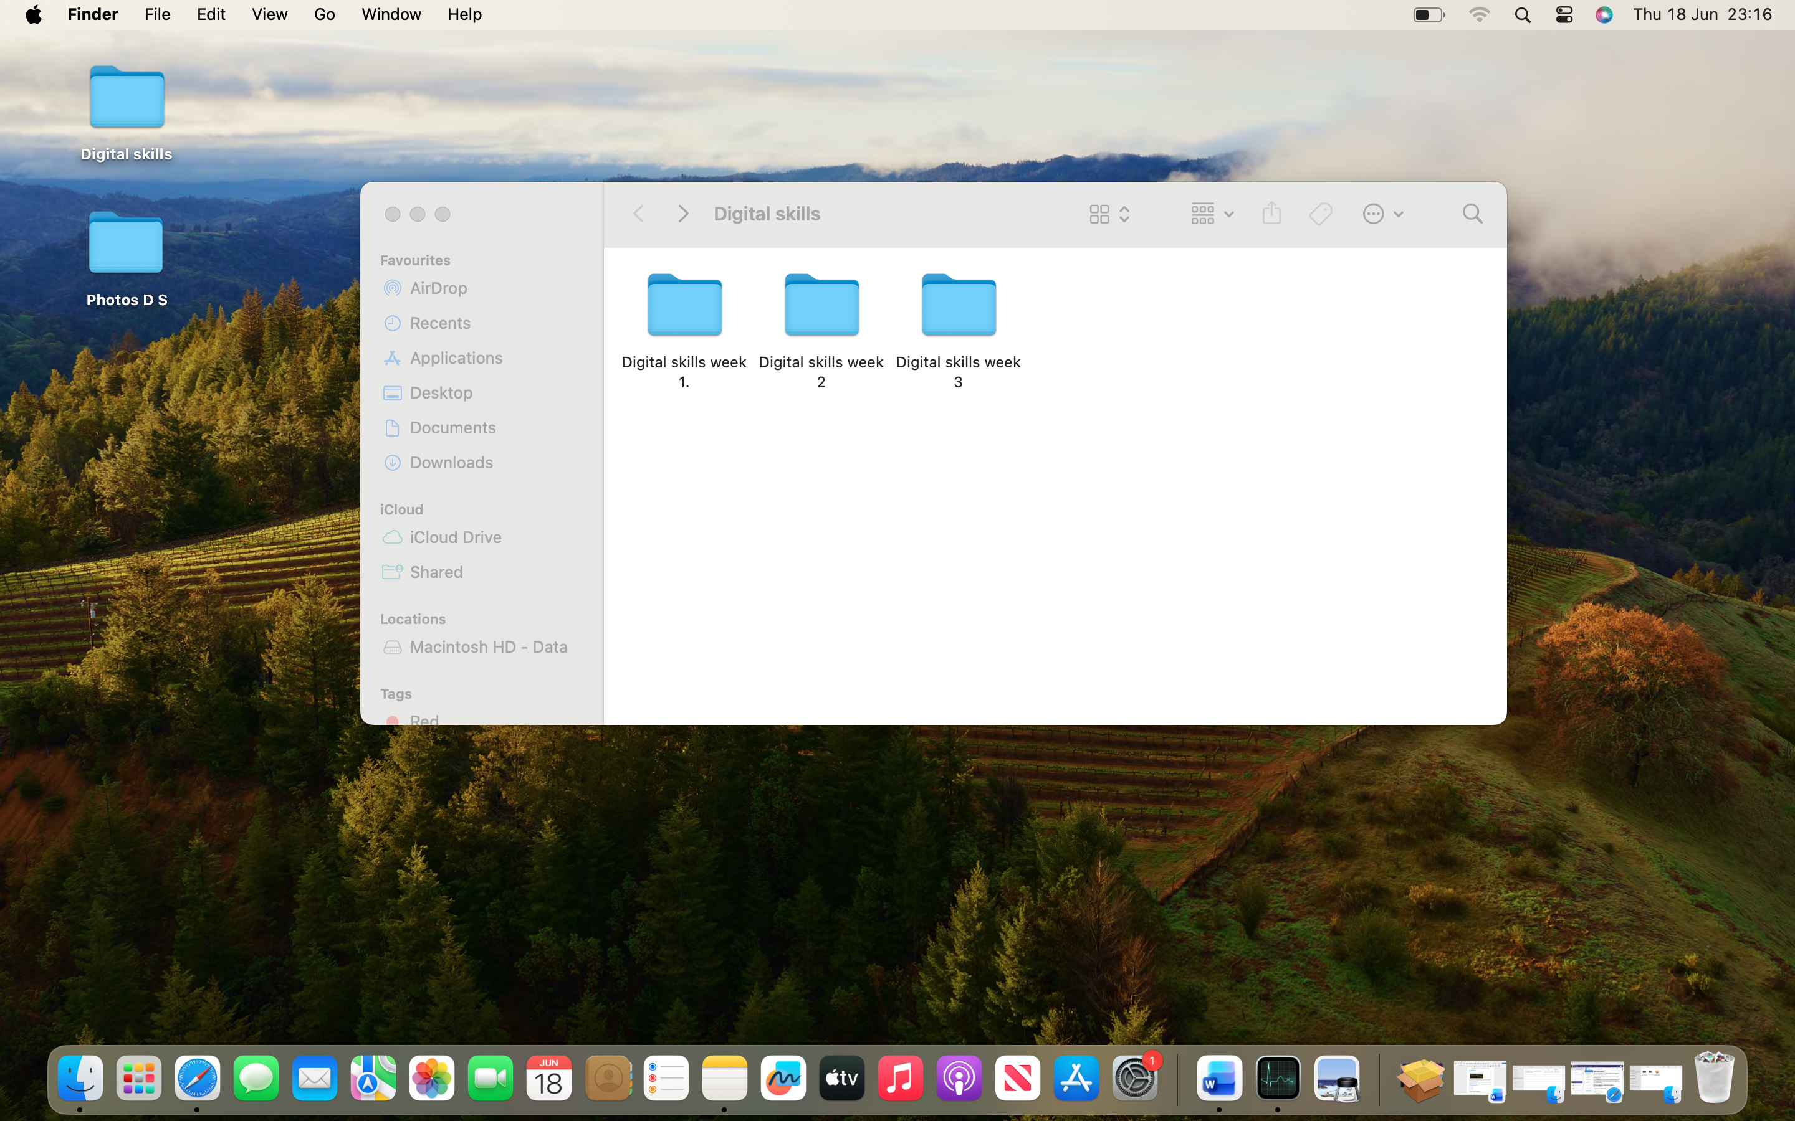
I keep my files organized in folders. This helps me find everything I need for my classes quickly.

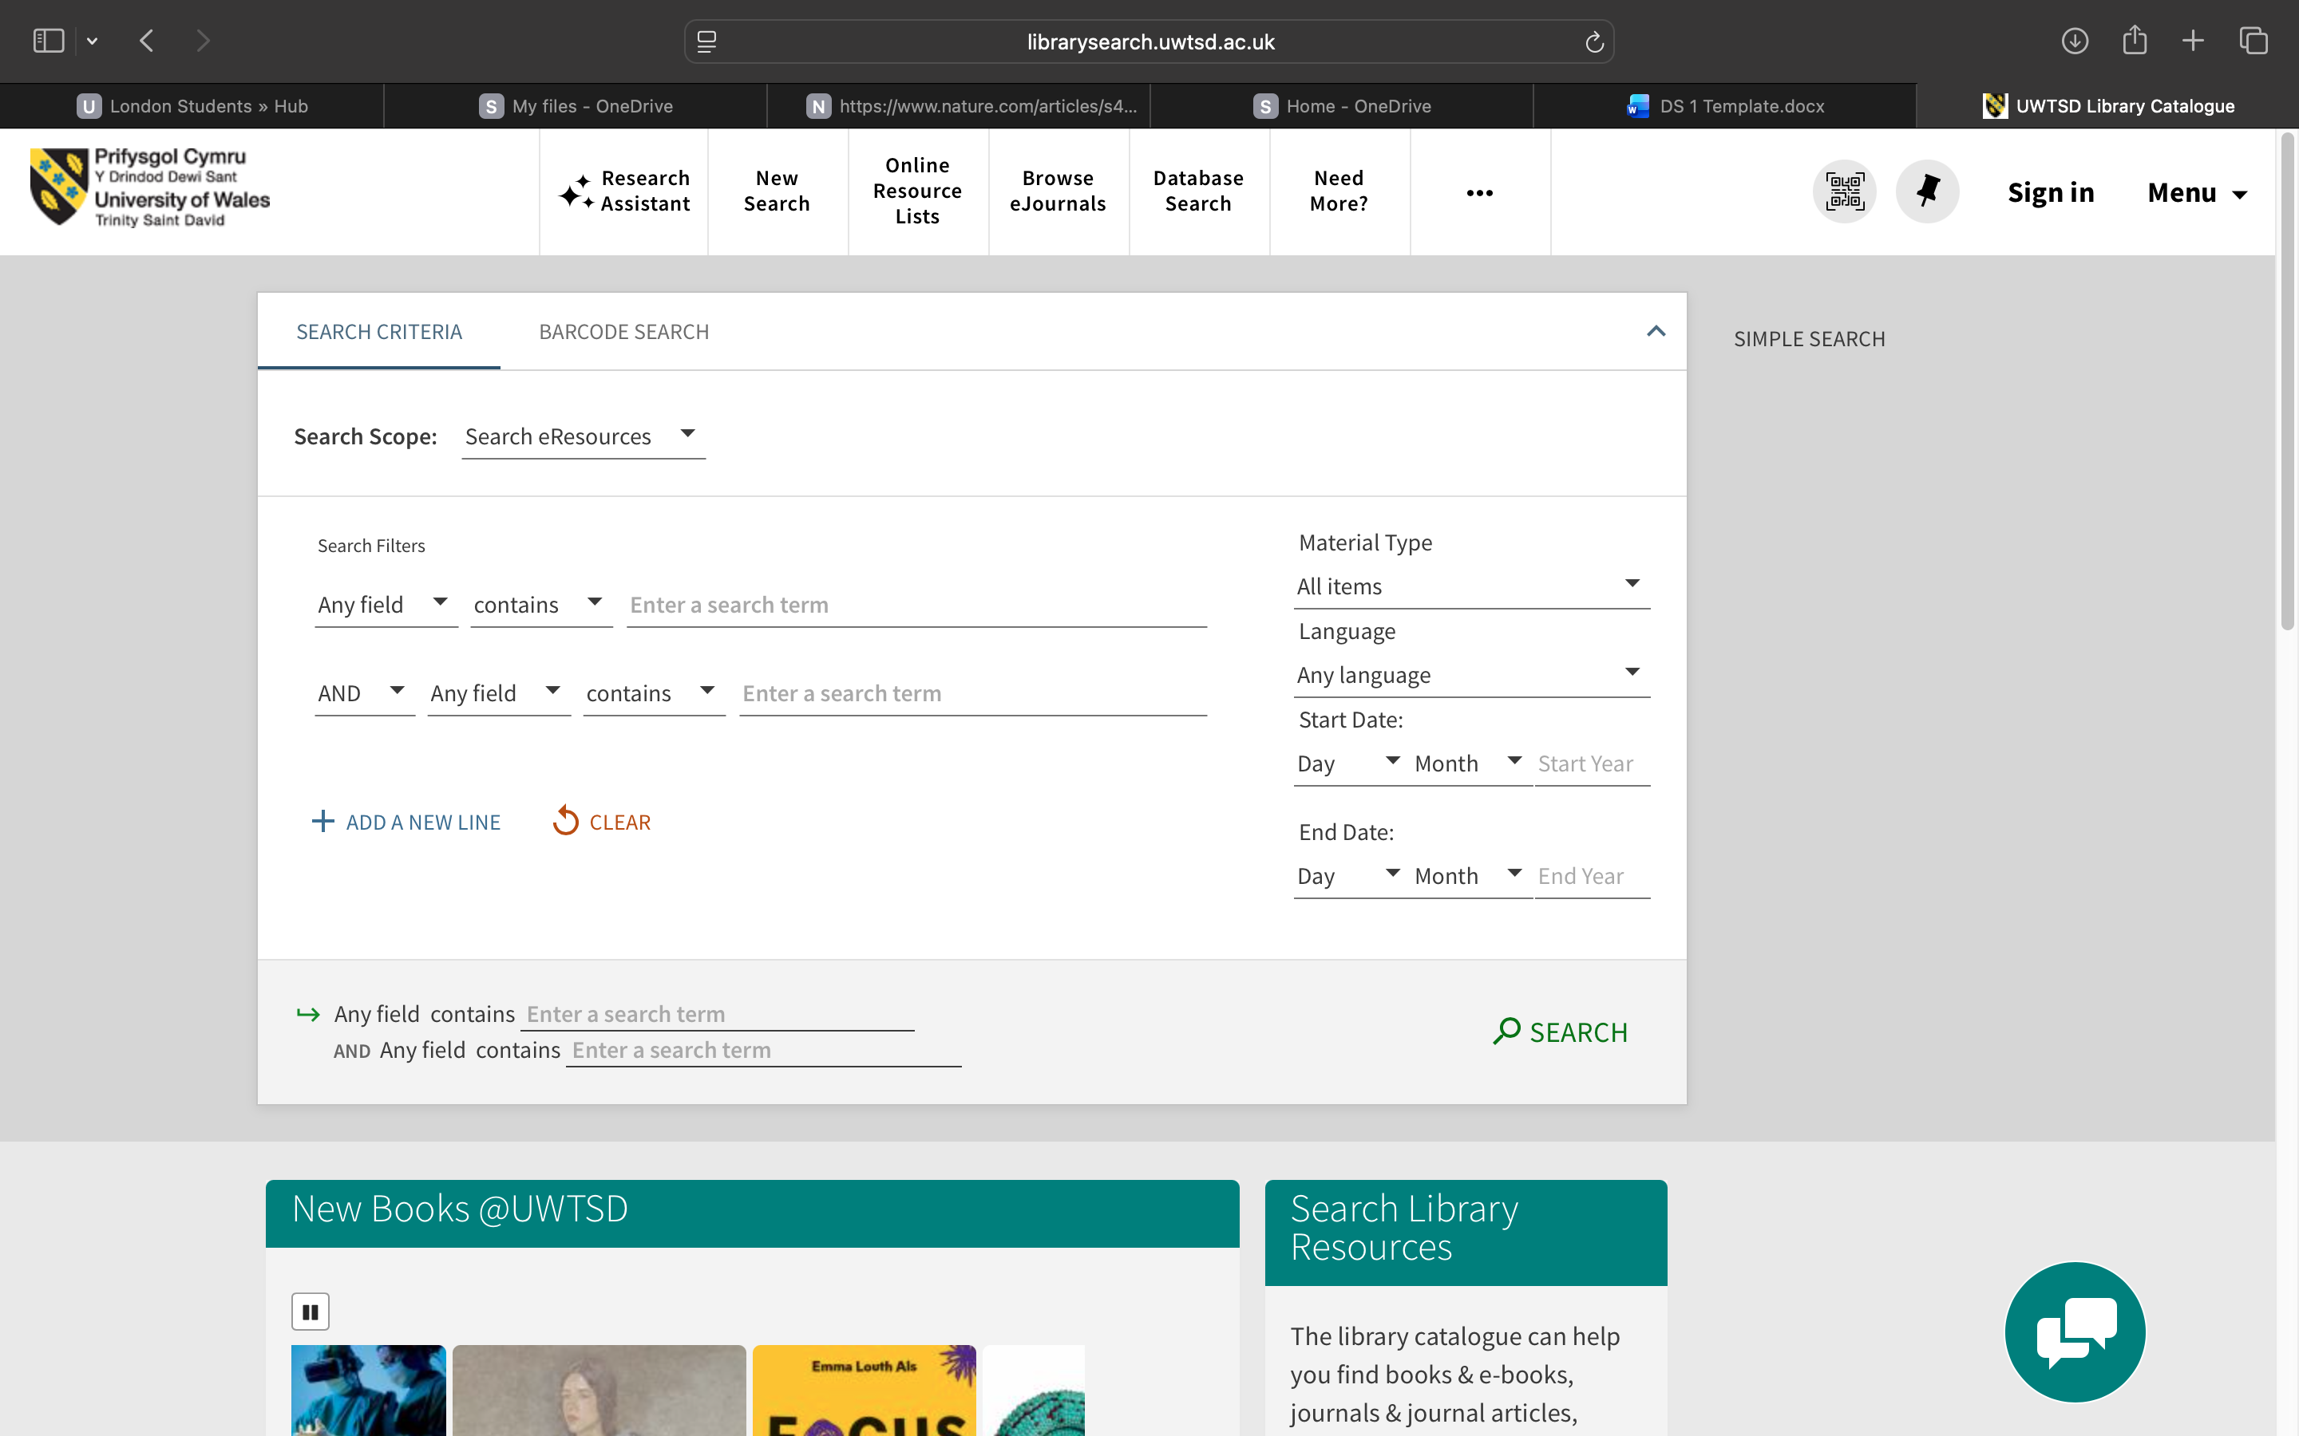
I learned how to use the advanced search tools in my university online library.
This screenshot shows how I can easily find specific books or articles I need.

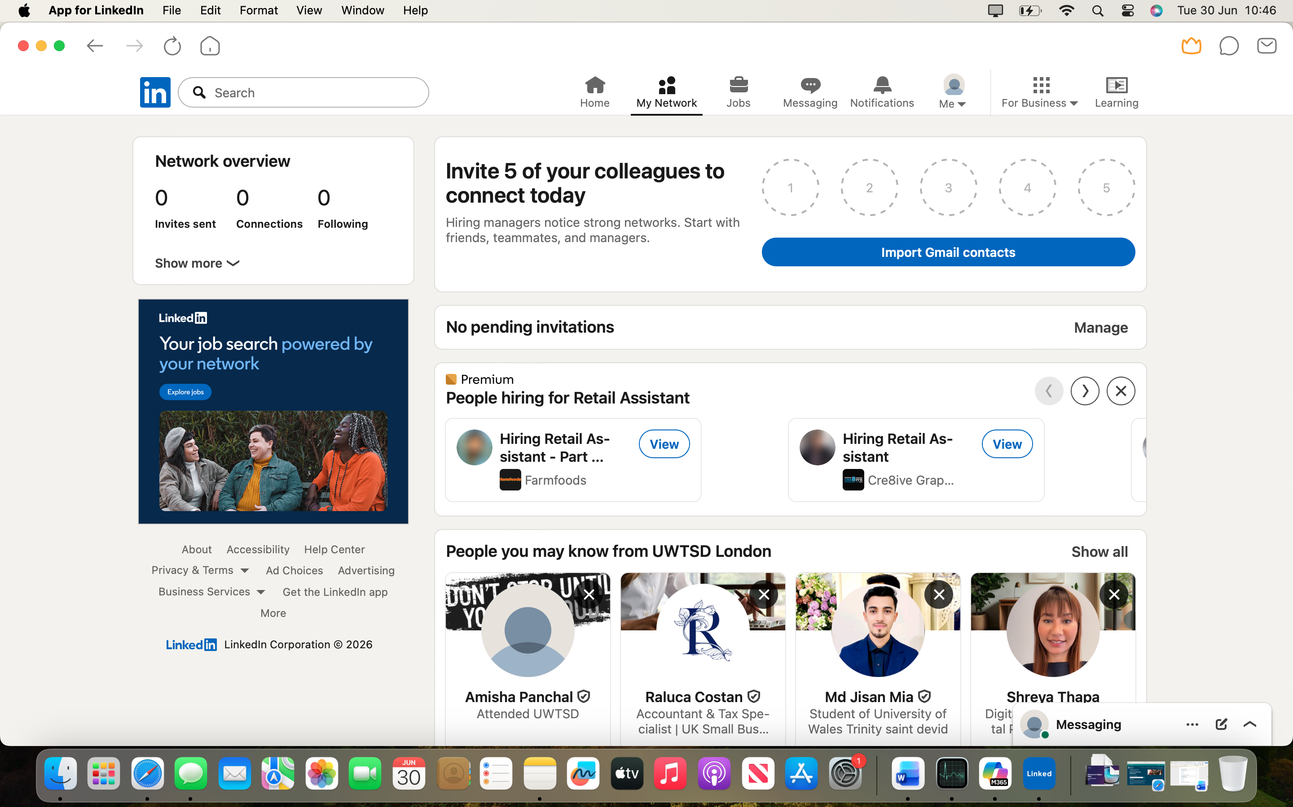
I am using LinkedIn to explore future jobs opportunities. As a student, I use this platform to take free professional courses offered to me.

Digital tools are essential for my schoolwork, making me feel confident when I search fort things online. Improving my computer skills is a main goal, although using new apps can sometime make me feel nervous. This module will help me learn more, as Digital skills are important for my future job.

