Knowledge and Information Management Skills for the Workplace
Table of Contents
Introduction 3
LO 1 4
(a) Explaining the relationship between data, information and knowledge 4
(b) Explaining the relationship between individual knowledge and organisational knowledge 6
(c) Applying analysis and modelling techniques to identify knowledge assets 8
(d) Evaluating actual and potential knowledge assets 10
LO 2 13
(a) Explaining what is required to create, store, apply and integrate knowledge 13
(b) Considering the importance of Intellectual Property rights 15
LO 3 16
(a) Explaining the contribution of knowledge assets have on an organisation 16
(b) Evaluating the knowledge requirements for the organisation 17
(c) Evaluating the organisation’s framework for enabling knowledge sharing 19
(d) Recommend improvements to the current framework 21
Conclusion 23
Reference 24

Introduction
The knowledge is a continuous process of development rather than just a resource to be utilised when needed. The individual and organisational knowledge sharing is a circular process form which both the individual and the organisation can be benefited. In this assignment, different aspects of knowledge sharing and management are discussed from the perspective of Balfour Beatty which is a UK based leading infrastructure group, established in 1909, with a mission of collective breadth of its technical competences and the depth of practical expertise.

LO 1

(a) Explaining the relationship between data, information and knowledge
Before explaining the relationship between data, information and knowledge, the specific definition of each is necessary which is given below-
Data: According to (Amine, 2012), data can be defined as the facts and figures which are composed together for a specific purpose and analysis.
Information: It can be defined as the transmitted facts and figures which is transported and characterised by precise sequences and procedures (Fox, 2019).
Knowledge: It refers to the combination of facts, data, information and the skills obtained over the time with the help of various academic procedures, experiences and expertise.
The relationships between data and information:
Generally, the data represents the facts which are being collected as a raw format whereas the information is the processed data using specific criteria according to the needs and requirements of the users. Therefore, the data can be regarded as the element or integral part of the information (Grant, 2019). For example, the marks obtained by a student in different subjects are data when they are considered separately, again when the result sheet is created using those data, that result sheet, its components like average, grade, grade point average etc. can be called as information.
The relationships between data, information and knowledge:
The relationship between data and information is discussed above which indicates that data and information are integral part of each other. However, the relationship between that part and knowledge is very crucial. Generally, different unorganised and raw data makes information after analysing and organising them appropriately and then many pieces of information creates knowledge base. Knowledge is the final output of various gathered information obtained thorough either theoretical or practical aspects of the subject matter, which can be acquired though continuous research and development (Dunn, 2019).
For example, the daily income of a person is a data, and the average of the collected daily income of a sample of people (e.g. 100) after using appropriate statistical tools and techniques can be regarded as information. Such sets of information over a particular period of time (e.g. 10 years) forms a specific knowledge that can be used for many purposes and further analysis.
Therefore, it is clear from the above discussion that, data, information and knowledge are closely related to one another. The unorganised form of data creates information after proper arrangement and different specific information can be used as knowledge after processing and analysing those pieces of information.

(b) Explaining the relationship between individual knowledge and organisational knowledge
The knowledge is a continuous process rather than just a resource (Spender, 2012). The terms of individual knowledge and organisational knowledge are entry point to explain the relationship between these two. The individual knowledge involves the acquired and observed facts, processed information, acquaintance, obtained experiences, developed expertise over the time etc. of an individual person (Grant, 2019). On the other hand, the organisational knowledge can be defined as the individual knowledge shared, managed and retained by all the members of the organisation as a whole (Grant, 2016).
The relationship between individual knowledge and organisational knowledge:
According to Spender (2012), an organisational knowledge rooted inside the organisational directions, procedures and guidelines that applies a restriction to the employees of that organisation. Therefore, the individuals are the entities who create and share the related information and knowledge with the organisation and the organisation is the entity that makes these gathered and shared knowledge usable, the organisation ensures the utilisation of them.
Hedlund and Nonaka (2014) argue on the provided approach of Spender (2012) and they think that, the above-mentioned approach largely depends on the interaction between the individuals and organisations. They also emphasise that, the usefulness of the individual knowledge and organisational knowledge will be subject to the contribution of the individual shared knowledge along with the quality of those knowledges (Hedlund and Nonaka, 2014).
The creativity and integrity of the individual contributes towards the generation of the organisational knowledge i.e. collective knowledge (Spender, 2012). On the other hand, the organisational knowledge is the learning processes that instructs the members of the organisation to master the related process or routines as the cognitive entity. Hedlund and Nonaka (2014) believe that organisational knowledge can be very versatile but it can be fragile as well because it is developed through the simultaneous development by the individuals’ knowledges.
For example, in Balfour Beatty, the knowledge and experiences gathered by the individual both in this organisation and their previous workplace can be shared and preserved in the organisation as a part of knowledge management process and then such accumulated knowledges are properly sorted, categorised and stored for the purpose of value addition to the organisations and the entire community as a whole. The individuals work in this organisation can also be benefited from that gathered organisational knowledge as well. Therefore, it can be concluded that, the individual knowledge and organisational knowledge are the integral parts of each other, and development of both are as the parts of circular process.

(c) Applying analysis and modelling techniques to identify knowledge assets
The knowledge assets comprise the gathered intellectual properties and resources of any organisation which can be preserved by the organisation and its members in the form of information, expertise, experiences, ideas, capacities, visions, cognitive skills, technical skills etc. (Debowski, 2010). The knowledge assets can be identified using various different models, tools and techniques.
Identifying the knowledge assets:
Among various related models, tools and techniques, ASHEN model is one of the most popular models or techniques. Snowden (2000) developed the ASHEN model that emphases on the application of the systems of narrative which is basically focuses on the organic approach to the knowledge management.
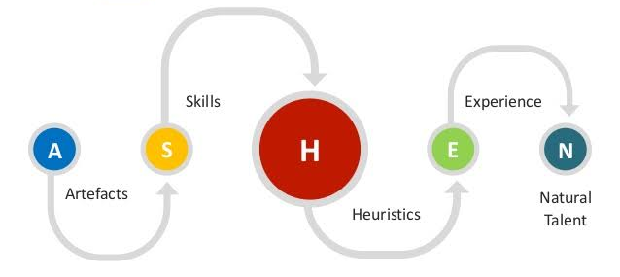
Figure: The ASHEN model
Source: Snowden (2000)
The ASHEN model can be used to instruct the users the ways of locating, identifying, sharing and utilising the knowledge. This model consists of the below areas-
- Artefacts: It includes all the existing or current explicit knowledge which are preserved in the organisation. For instance, in Balfour Beatty, it includes the knowledge of operating the required machineries used for the construction work.
- Skills: It involves the things for which tangible procedures can be defined and the way of their acquisition. Here, skills are the capability of the constructing the infrastructures which is acquired though a long-term continuous development and improvement process.
- Heuristics: It includes the capabilities of making the decision quickly, effectively and efficiently, even though the ultimate outcome is unknown (Grant, 2019). For instance, having a cost-effective way of construction because of research and development in Balfour Beatty.
- Experience: It is regarded as the most precious asset that an organisation can have because it is something which can be obtained over a long period of time. In case of Balfour Beatty, the experience of doing the construction work can be categorised here.
- Natural Talent: It involves the inborn ability which cannot be imitated or replace very easily and it shows how exclusive the knowledge asset is (Lehaney, 2014). For instance, the leadership skills, forecasting the future economic condition of the economy, the decision-making skills of the strategic decision makers of Balfour Beatty can be regarded as the natural talents which cannot be produced or shifted to the other.
Generally, these factors are combined together to make an ideal question of ASHEN model to identify the knowledge assets because in the context of a large organisation like Balfour Beatty, it is more meaningful to put together all these factors and evaluate the knowledge assets, its requirements, evaluation, improvements and preservations.

(d) Evaluating actual and potential knowledge assets
The knowledge assets encompass the accumulated intellectual properties and resources of any organisation (Amine, 2012). The knowledge assets can be categorised in many ways. The actual and potential knowledge assets are categorised and evaluated below as per the requirements-
Evaluation of the actual and potential knowledge assets:
The evaluations have been made under four broad categories and their sub-categories under which the actual knowledge assets are evaluated first and then the potential knowledge assets are evaluated.
1. Experimental knowledge assets: These involve the implicit knowledge gained though the common experiences. For instance-
Skills and expertise of the individuals: This is the core actual knowledge asset that makes the company one of the biggest in the UK construction industry (Grant, 2019). For the sustainable future in the long run, continuous improvement of these is must as a part of potential knowledge assets.
Care, love and trust: These are the implicit knowledge assets that grow gradually inside the members of the organisation. Balfour Beatty acquired the love and trust of the general people by practising these inside the employees towards the organisation.
Energy and passion: These are basically the embedded quality of the employees which are tested at the time of recruitment of them. Energy and passion for work provides a huge support and intension of the employees to share and utilise the knowledge for the betterment of the organisation.

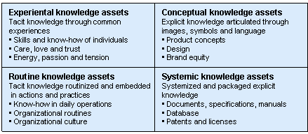
Figure: Different categories of knowledge assets
Source: (Geytere, 2019)
2. Conceptual knowledge assets: These involve the explicit knowledge acquired though the images, symbols and language. For instance-
Product concepts: This involves the capacity to do the work what is offers. Balfour Beatty offers different types of infrastructure works all over the country (Mcinerney and Day, 2014). It also expects that, in the next few years, it will acquire some huge construction contracts from the Government.
Design: In the arena of infrastructure development, the potential impacts on the environment is one of the major concerns. In this connection, Balfour Beatty offers eco-friendly way of construction work, with minimum level of carbon emission and sight restoration to its prior condition.
Brand equity: This is regarded as one of the major knowledge assets of Balfour Beatty that has been being growing since long and makes the company as one of the market leaders in the industry.
3. Routine knowledge assets: These involve the implicit knowledge acquired in the forms of routinised and surrounded operations and practices. For instance-
Expertise in daily operations: This includes the basic knowledge of the employees as per their individual roles for which they have been hired (Spender, 2012). All the employees are recruited after examining their capabilities and required skills.
Organisational culture and work environment: The growth and sharing of the knowledge largely depends on the organisational culture and work environment. In Balfour Beatty, these are knowledge sharing friendly that enriches the knowledge base of the organisation as whole continuously.
4. Systematic knowledge assets: These involve the explicit knowledge acquired in the forms of systemised and packaged way: For instance-
Documents, specifications and manuals: It includes the knowledge gathered, retained and utilised in the regular manner in daily operations indicating that how and in which way the required task will be done (Dunn, 2019).
Database: It involves all the database regarding the core operations, required expertise, experiences, employee management, market analysis, economy forecasting etc. which is must for retaining the leadership in the industry.
Contracts, patents and licenses: For the construction organisation like Balfour Beatty, various contracts, patents and licenses play a crucial role to sustain the market because these are the core assets through which the organisation makes money. The more these assets owned by an organisation, the potential it will have in the future and the more successful it will be in the future.
For instance, in September 2019, Balfour Beatty and VINCI SYSTRA joint venture has won the HS2 construction contract £1 billion for the Old Oak Common station (Dunn, 2019). Again, Balfour Beatty believes that, the 5-year IT partnership with Fujitsu will reinforce its knowledge sharing competences to boost end-to-end offerings to the customers (Fox, 2019). This is a good example of how the actual knowledge assets contribute the organisation in the present time and will be a potential asset in the near future that provides a competitive edge over the others.

LO 2

(a) Explaining what is required to create, store, apply and integrate knowledge
While the information can be regarded as static base of data, the knowledge is the non-stop process of creating, preserving, applying, integrating and improving continuously. Here the knowledge denotes both the individual and organisational knowledge. The requirements and ways of creating, storing, applying and integrating the knowledge are explained below from the viewpoint of Balfour Beatty.
Creating knowledge: Knowledge can be created through the exercise, teamwork, association, interaction, learning, converting, analysing and sharing them (Grant, 2019). It is reinforced by different pertinent information, data, experiences, expertise, observation and enquiry which can expand the decision-making capabilities and act as the building blocks in knowledge generation.
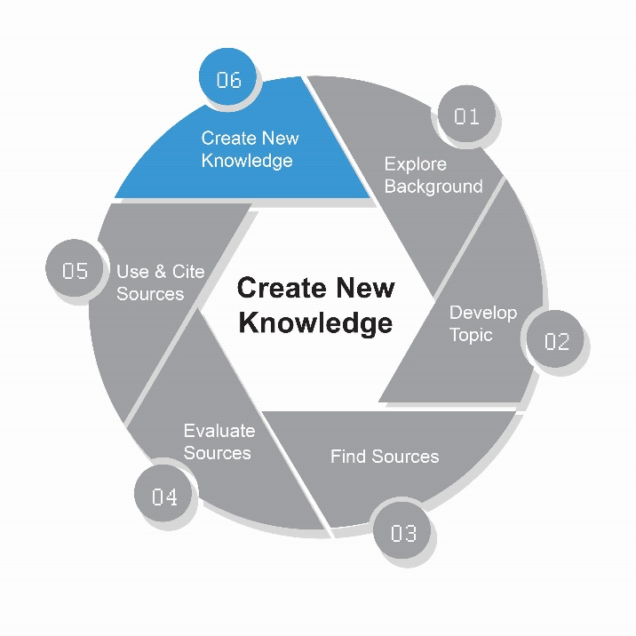
Figure: Process of creating knowledge
Source: (Grant, 2019)
For creating the knowledge base, the above process can be followed by the organisation. But due to unique operational activities and characteristics of each organisation, customised process of creating the knowledge is followed by most of the organisations and by Balfour Beatty as well.
Storing knowledge: The created knowledge needs to be stored properly so that the potential personnel and organisation can be benefited from them. Knowledge can be stored in the form of ‘knowledge repository’ that comprises different documents, results, intelligences, analysis and databases (Geytere, 2019). In Balfour Beatty, knowledge is stored in the form of various instructions manuals, research and analysis of the market and economy, database related to the customers and their specific requirements, the potential demand and trend analysis in the near future.
Applying knowledge: In order to be benefited from the acquired and stored knowledge, it must be applied in the appropriate manners. To apply the knowledge properly, the systematic approach should be followed. For instance, at first the specific problem should be identified, different alternative potential solutions from the stored knowledge should be identified then and they should be analysed critically, and lastly the most appropriate one should be chosen for application (Debowski, 2010). Now the appropriate knowledge will be applied in appropriate scenario and appropriate manners. Utmost care should be taken at the beginning, in the middle and at the end of the application process to check whether any alternation is required or not.
Integrating knowledge: Integration of knowledge involves synthesizing, inaugurating, reshaping, analysing multiple knowledges in order to make a common knowledge base, form or model from which the value of the organisation as a whole can be maximised. In this process, the new information needs to be incorporated, merged and integrated into the existing knowledges, information and database (Fox, 2019). Different mathematical, statistical and analytical tools and techniques are required for this process. In Balfour Beatty, it is generally done by various software considering different scenario and simulation analysis.
Therefore, in order to utilise the individual and organisational knowledges, an organisation must focus on all these four broad areas of knowledge management. If any of these is ignored, the outcome of such process may be questionable that may affect the decision-making process in the long run sustainability. So, quality knowledge should be created and stored appropriately, the bunches of knowledges should be accumulated and integrated appropriately and then it should be applied appropriately considering the time, cost and manners.

(b) Considering the importance of Intellectual Property rights
The intellectual property rights can be defined as the rights of the individual or organisation over the creation of the mind, intelligence and brain (Wiig, 2012). It is recognised all over the world because it has huge impacts on the overall value addition to the humanity.
The intellectual property rights provide an inducement to the person who creates the intellectual property so that they can be motivated for future works. It can be regarded as the recognition of the work of the individuals because some people take the recognition as the motivation, nothing else. Since, the individuals work hard for creating the knowledge, they spend money, take the risks, so through such rights the rewards are entitled to the appropriate persons who deserve it (Lehaney, 2014).
The intellectual property rights make available of the original products, services or offerings. It is very crucial for the ensuring the economic growth of the organisation and the country as a whole, especially for the advancement of the information technologies in this era.
The intellectual property rights not only benefit the creator of the intellectual property but also the consumers of them because they can enjoy the authentic products or services at reasonable considerations. It also ensures the security, reliability, and effectiveness of the procurement decision made by the consumers.

LO 3

(a) Explaining the contribution of knowledge assets have on an organisation
The knowledge assets comprise both the individual knowledges and organisational knowledge. For the sustainability in the long run and competitive advantages, an organisation must utilise and develop its knowledge assets. The contribution of the knowledge assets from the context of Balfour Beatty is explained below.
Contribution of patents, copyright and trademarks: Balfour Beatty has a registered patent under the category of 'Hydraulic Engineering; Foundations; Soil Shifting' and another 14 trademarks under the category of ‘Building and repairs' (Balfour Beatty, 2019). These contribute the most to the organisation for obtaining different heavy construction contracts. For example, Ground Engineering of this organisation is regarded as one of the foremost specialist geo-technical contractors that offers advanced piling and ground development.
Contribution of design rights: Balfour Beatty is well-known for its innovative and distinctive design. For instance, the King Sheet Piling (KSP) is a retaining wall system designed exclusively by Balfour Beatty which saves the cost of steels by 35% to 40% (Balfour Beatty, 2019). Therefore, the efficient designs contribute more to the organisation by cutting the costs of constructions. According to Balfour Beatty, such design saved about £1.2 billion in two major projects.
Contribution of database rights: The database of an organisation is the storehouse of all the knowledge, experiences and expertise gathered over the years. The database of Balfour Beatty consists of research and analysis, development, experiences and expertise gathered for a long period of time. It contributes directly to the value creation of the organisation and it is also utilised for creating new knowledge or further analysis.
Contribution of expertise: For a construction organisation like Balfour Beatty, the expertise is the primary value creation tools. Balfour Beatty has a number of recognised related expertise and Building Information Modelling (BIM) is one of them. BIM is used to produce and manage crucial information about the concerned infrastructures which has used in 35 projects already and has been using for another 60 projects (Balfour Beatty, 2019). Another area of expertise is the railway project and recently a £65 million contract has been awarded to this organisation to operate across the ‘South of England, Anglia and the London North Western (LNW)’ rail route.

(b) Evaluating the knowledge requirements for the organisation
The organisational knowledge involves the accumulated knowledge and expertise possessed by the members of the organisation. The knowledge requirements in an organisation is discussed below from the perspective of Balfour Beatty.
Practical know-how:
This involves the basic knowledge requirements by the related personnel for their specific and particular roles (Grant, 2019). In Balfour Beatty, different employees have different roles in different departments like accounts and finance, human resource management, administration, communication and affairs, technical and engineering, research and development etc.
Tacit knowledge:
It involves the cognitive ability and sense that is unique and less prone to replacement. For instance, the creativity of the personnel in Balfour Beatty.
Situated knowledge:
It indicates the technical knowledge that enables the concerned personnel to identify the arising problems and potential and appropriate solutions to them.
Dispersed knowledge:
The common knowledge like mission, vision, objectives and values of the organisation like Balfour Beatty should be clear to all the employees. It emphasises on the ultimate objective of maximising the value creation (Fox, 2019).
Knowledge of expertise:
For an infrastructure organisation like Balfour Beatty, possession of the key expertise in the relative fields is the main value creation driver. Continuous research and development are required here to maximise the value addition and minimise the costs.
General knowledge:
It involves the general or fundamental knowledge requirements of the employees in an organisation. For Balfour Beatty, it includes the general education, communication skills, contracts presentation skills, gesture and posture of the employees etc.
Organisational culture:
In the modern era of leadership and management practices, organisational culture influences the knowledge requirements and creation in the organisation (Amine, 2012). The supportive organisational culture encourages the sharing and gathering the knowledge obtained by the individuals.
Since each and every organisation is different from the other in terms of operations, size, objectives, values and culture, the knowledge requirement will be different for each of them (Hedlund and Nonaka, 2014). However, form the perspective of Balfour Beatty, the major knowledge requirements are mentioned above which may vary from organisation to organisation.

(c) Evaluating the organisation’s framework for enabling knowledge sharing
The organisational knowledge sharing and development is a continuous process though which new knowledge and opportunities are created. Different organisational knowledge sharing frameworks are used in different organisation (Wiig, 2012). As a diversified and vast organisation, Balfour Beatty maintains its own and customised framework of knowledge sharing. It has a separate segment for career development for all the employees, from the apprentice to the experts.
But for the purpose of evaluation as per the requirements, the conceptual framework of knowledge sharing is applied from the perspective of Balfour Beatty.
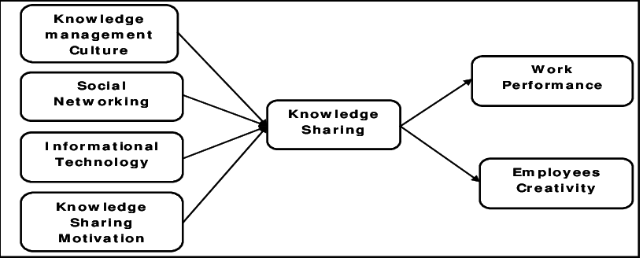
Figure: Conceptual framework of knowledge sharing
Source: (Geytere, 2019)
Factors influencing knowledge sharing:
There are four factors that affect the knowledge sharing which are evaluated below from the viewpoint of Balfour Beatty-
- Knowledge management culture: Knowledge sharing largely affected by the knowledge management culture of an organisation (Lehaney, 2014). In an organisation like Balfour Beatty, the knowledge management culture is very common because of the creative nature of each new construction contract.
- Social networking: The organisational knowledge is enriched by the shared knowledge of the individuals and again the individuals are benefited from the organisational knowledge. So, for the purpose of knowledge management, networking among the people inside and outside of Balfour Beatty is encouraged to gather experience, expertise and learning.
- Information technology: In this golden era of the development of information technologies, the roles of it in the process of knowledge sharing cannot be ignored (Hedlund and Nonaka, 2014). In Balfour Beatty, there is a common portal for the employees for sharing their experiences, training, learning and knowledge.
- Knowledge sharing motivation: It comprises the reasons for which the knowledge will be shared. So, motivation for sharing the knowledge is crucial for this. In Balfour Beatty, such motivation is provided with though financial and non-financial incentives, recognition and rewards for the shared knowledge, preservation and application of the shared knowledge act as the motivation.
Outcome of knowledge sharing:
According to the conceptual framework, the result of knowledge sharing affects the work performance and employees’ creativity.
- Work performance: It involves the comparison the performance of the employees before and after the knowledge sharing program (Fox, 2019). In Balfour Beatty after implementing the knowledge obtained from the knowledge sharing process, the performance and efficiencies of the employees must be increased.
- Employees’ creativity: The obtained knowledge not only facilitates the employee performance and efficiencies but also enables them to utilise that obtained knowledge to innovate new ways of doing the work, in more efficient ways.
According to Nirali Singh, Head of Knowledge Management and Innovation at Balfour Beatty, the organisation follows and maintains its own framework for knowledge sharing and knowledge management that aligns with Balfour Beatty’s long-term strategic objectives.

(d) Recommend improvements to the current framework
For sustaining in the competitive market, an organisation should maximise the value creation though the continuous improvement in terms of innovation, skills, research, development and knowledge (Lehaney, 2014). As one of the largest construction companies in UK, Balfour Beatty already maintains its own framework for knowledge sharing and knowledge management. But there are some scope of improvement using different tools and techniques.
For improving the overall scenario and optimise the value creation, Balfour Beatty can follow the PRINCE2 since it has the capable employees including Nirali Singh, Head of Knowledge Management and Innovation, for its implementations. Such improvement process can be regarded as the ‘Project’ and the processes need to be followed are as follows-
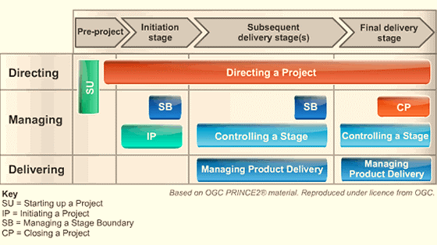
Figure: PRINCE2 Processes for improvement process
Source: (Prince2.com, 2019)
Directing a Project: Directing the project ranges from the starting to the closure which includes initiation, allocating the boundaries, ad hoc direction and closure of the project for improving the knowledge sharing process.
Controlling the project: This process includes monitoring and controlling mechanism for the activities being initiated related to the improvement of the knowledge sharing. It includes authorising appropriate task to appropriate person to be done, collecting the changing information, observing the changes being occurred, reviewing the overall situation, reporting to the responsible persons and taking necessary action when required (Dunn, 2019).
Managing project outcome: The responsible person should ensure that the project outcome meets the objectives set at the initiation of the improvement process.
The specific areas where Balfour Beatty can improve its knowledge sharing and management process include-
Individual’s basic skills: The organisation should focus on the recruitment process and select the best candidates based on the quality they have, the passion and energy towards this sector, their long-term planning with the organisation, their passion and hunger for learning.
The technical skills and expertise: Balfour Beatty should provide an unrestricted platform for sharing knowledge by ensuring proper accumulation, retention, processing, development and application of the shared knowledge (Lehaney, 2014).
Preserving intellectual rights: Though Balfour Beatty is already aware of its property rights and has appropriate policy on that, the organisation should ensure maximum control on all of its knowledge assets.
Investing more in research and development: For the improvement of knowledge sharing and management process, investing more in the research and development is required because without these, the knowledge sharing and management process may not be effective as much as it should be (Grant, 2019).
It can be concluded that, the improvement process of knowledge sharing and management process should be an emerging process which can be changed with the requirements of time, and it should not static. The approach of the employees also should be open minded for never-stop learning and accepting the changes when required.

Conclusion
Balfour Beatty has been shaping the world with its new technologies, innovation, research and development for over a century. Knowledge sharing and management lies behind such long-term progress over the years. In a world with more versatility, uncertainty, competitiveness and easy access to the knowledge base, a continuous improvement process in terms of skills, capabilities and expertise are must through the knowledge sharing and management process. Thus, each organisation should prepare itself for facing any upcoming challenges and uncertainties in order to meet the sustainable long-term strategic objectives.

Reference
Amine, M. (2012). Knowledge management: a personal knowledge network perspective. Journal of Knowledge Management, 16(5), pp.829-844.
Debowski, S. (2010). Knowledge management. New Delhi: Willey India.
Dunn, V. (2019). Balfour Beatty awarded £65 million Network Rail seasonal treatment contract. [online] Balfour Beatty plc. Available at: https://www.balfourbeatty.com/news/balfour-beatty-awarded-65-million-network-rail-seasonal-treatment-contract/ [Accessed 31 Dec. 2019].
Dunn, V. (2019). Balfour Beatty VINCI SYSTRA joint venture awarded HS2 construction management contract for c. £1 billion Old Oak Common station. [online] VINCI. Available at: https://www.vinci.com/vinci.nsf/en/press-releases/pages/20190917-1745.htm [Accessed 31 Dec. 2019].
Fox, L. (2019). Innovative IT partnership will strengthen knowledge sharing capabilities to boost end-to-end offering to clients. [online] Balfour Beatty plc. Available at: https://www.balfourbeatty.com/news/innovative-it-partnership-will-strengthen-knowledge-sharing-capabilities-to-boost-end-to-end-offering-to-clients/ [Accessed 31 Dec. 2019].
Gebert, H., Geib, M., Kolbe, L. and Brenner, W. (2013). Knowledge‐enabled customer relationship management: integrating customer relationship management and knowledge management concepts [1]. Journal of Knowledge Management, 7(5), pp.107-123.
Geytere, T. (2019). ALL about Nonaka and Takeuchi's SECI Model - 12manage. [online] 12manage.com. Available at: https://www.12manage.com/methods_nonaka_seci.html [Accessed 31 Dec. 2019].
Grant, R. M. (2016) ‘Toward a Knowledge-based Theory of the Firm’, Strategic Management
Hedlund, G. and Nonaka, I. (2014) ‘A Model of Knowledge Management and the N-form Corporation’,
Lehaney, B. (2014). Beyond knowledge management. Hershey, Pa.: IGI Global (701 E. Chocolate Avenue, Hershey, Pennsylvania, 17033, USA).
Mcinerney, C. and Day, R. (2017). Rethinking Knowledge Management. Dordrecht: Springer.
Prince2.com. (2019). PRINCE2 Information & PRINCE2 Courses for Project Managers provided by ILX Group | UK. [online] Available at: https://www.prince2.com/uk/prince2-processes [Accessed 31 Dec. 2019].
Saracevic, T. (2014). Information policy—A new area for information processing and management. Information Processing & Management, 22(6), p.i.
Spender, J. C. (2012) ‘Making Knowledge the Basis of a Dynamic Theory of the Firm’,
Wiig, K. (2012). Knowledge Management. Arlington, Tex.: Schema Press.

