This is the memory snapshots when the program is first launched and after loading all 3 objects:

There is a memory rise in-between those as to be expected as there is data loaded. When longer the program runs after all 3 objects being loaded the heap size and allocations stay the same. However, after a longer time they do drop by a small amount.
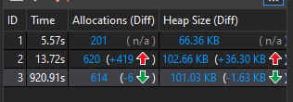
Straight after booting up After a minute
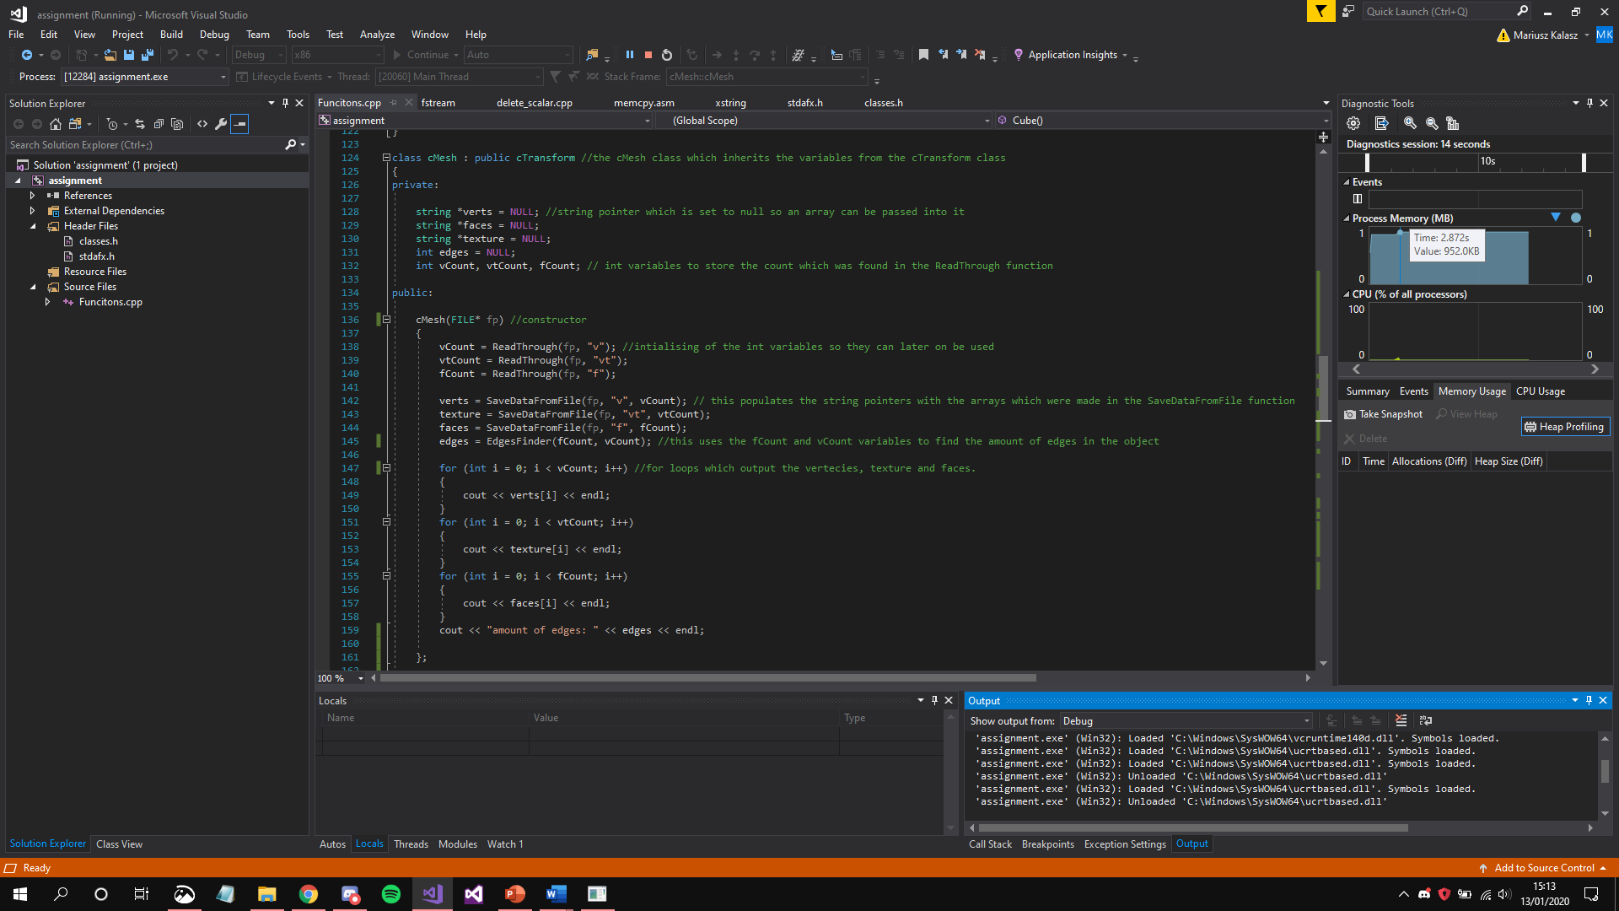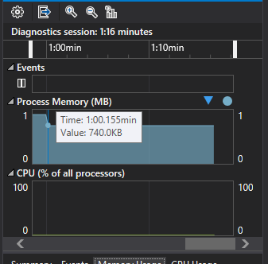
The required memory footprint is 952.0KB but then it does drop to 740.0KB, this is when all 3 objects have been loaded. This comes from the variables and arrays which are used throughout the code. The ones which are believed which use the most memory are the arrays of pointers, which can be found in the cMesh class, and the dataPoint array, which is found in the ReadThrough and SaveFromFile functions. The dataPoint array is a dynamic array so it will only use the amount of memory address which it needs, so there are no empty reserved memory addresses which in turn reduces the memory footprint. The arrays of pointers don’t have a set size, as they use the size of the array, which is being passed into them, so again no wasted memory. Another noteworthy variable is the buffer variable, which is a char of size 64, the variable is used to read the file and store the set of characters (or string) it is used in the ReadThrough and SaveFromFile functions to find the chars which are needed, as it does have a set size it can’t be really controlled on how much memory is used but that can be controlled by changing its size to a lowest possible value.
However, majority of variables and arrays use the string storage class which uses a good amount of the memory so a future improvement would be changing those to chars. Another possible improvement would be a way to clear all the arrays and variables when the program closes, this more takes hold with the dataPoint array and the variables as the arrays of pointers get cleared after the application closes, but dataPoint still has data stored in it same with the variables so that again takes up unneeded memory.
From the author’s understanding it is important to decrease the memory footprint of the scene, as if it has a too high of a memory footprint for example as high as the PC RAM it will crash the PC, this is an extremity of it but it is a good idea to keep the scene’s memory low as it will render the scene faster as well with less lag. So the methods of reducing the memory footprint will affect the scene loading majorly in how quick it will load up and how stable that will be [1], but also if the memory gets too out of hand it can crash the program or even the PC so by keeping the memory footprint low it will drop the chance of that happening.

Bibliography

[1] | M. McDunnigan, "How does a video card affect render time?," Chron, [Online]. Available: https://smallbusiness.chron.com/video-card-affect-render-time-71284.html. [Accessed 13 January 2019].

