A Critical Evaluation of the Role and Outcomes of Digital Innovation in Self-Directed Learning
Module Code: ecpt5006
Sophie Mccallum (1907466)
2023
Table of Contents
Introduction 2
Role of creativity in digital innovation 2
Selection and Justification of appropriate teaching tools/resources 3
Application of the chosen learning tools 5
Evaluation and Reflection 13
The Feedback 13
Lesson Plan 16
References 18

Introduction

This assignment will explore and critically evaluate the role that digital innovation plays within the development of both teaching and learning on the BA Film & TV course, by means of designing and evaluating teaching tools and illustrating a critical awareness of the amalgamation between digital innovation and professional practice.
To graduate from the Film & TV course requires knowledge and experience in both theory and practice, as filmmaking is not only a technical skill but supplemented with a “rational, intellectual capacity” (Buckland, 2016), and understanding film in this way results in a “deep knowledge of how films are put together and why they are made in a particular way”. As filmmaking education requires hands-on learning to build the technical skills around equipment, this assignment will explore how digital technology can connect both theory and practice, and how it can be used to solidify learning when putting it to practice. Adult learning can arguably be characterised as “experimental, problem-based, immediate, and self-directed” (Tomei, 2010), so the objective of this assignment is to develop and put into practice a digital learning tool which can be used by students in their self-directed learning. In self-directed study, students don’t often access learning modules during the typical university hours (Jackson et al., 2018), so the objective of this development and application of a digital tool is to provide students with a digital tool separate from the university’s platform but also only accessible to students. The chosen digital tool for this essay is a webpage created from scratch, with various videos and hyperlinks to aid in students’ self-directed learning. In doing this, it provides students with a means of study which is distinctive from the University’s module digital tools and hopefully resulting in a new and interesting way to partake in self-directed learning.

Role of creativity in digital innovation
Before applying creativity and pedagogy, one must first explore and understand the frameworks for diagnosing and improving digital innovation. Digital technology is unique in all aspects and can progress to many types of innovation processes which are ever-changing and hard to control and predict; to help navigate this constantly changing topic, a framework is needed to help measure and manage it. Nylén & Holmström (2015) identified some key areas worth taking into consideration, three of which are relevant to the chosen tool applied to the lesson – firstly, digital products (which, for the sake of this essay, is the digital tool used) should be both efficient and “provide a rich user experience”, which can then be measured based on “usability, aesthetics, and engagement”. Secondly, the value the digital tool creates for users (students) should be measured, by means of assessment. Thirdly, Nylén & Holmström (2015) discuss “digital evolution” which involves gathering information beneficial to identifying and utilising opportunities for innovation.
Effectively providing a rich user experience with a digital tool whilst still creating it as aesthetically pleasing and engaging can be challenging. It is argued that the standard belief is teaching should be constructed as a “technology” rather than an art; Muijs & Reynolds (2001) in their introduction to Effective Teaching – Evidence and Practice suggest that the view of teaching as an art is responsible for the deficiency of exceptional teachers in schools. In addition to this, they categorise the devotion of attention to “personal factors and qualities” as an idiosyncratic and difficult method to influence students and inadequate by educational policies. Admittedly, their Muijs & Reynolds (2001) aversion to creativity in teaching is mainly in regard to the humanities sector, but this can be taken into account whilst tackling the amalgamation of theory and practice in Film & TV. The focus on personal factors and qualities is arguably beneficial to the ‘art’ of teaching, as highlighted in Vygotsky’s Zone of Proximal Development, which refers to the “range of abilities an individual can perform with the guidance of an expert, but cannot yet perform on their own” (Cherry, 2023). Based on a learner’s skillset, Cherry splits the stages of the Zone of Proximal Development into three distinct categories; tasks a learner cannot do with assistance, tasks they can do with assistance, and tasks they can do without assistance. As a rule of thumb, one should not assume any student has specific prior knowledge, nor should it be assumed the readiness of said student. The focus on individual development is crucial and is done through relationship building (van der Linde & Goede, 2022), which, if done correctly, can lead to each student developing into an “autonomous, self-directed, lifelong learner, who takes ownership of their own success”. So contrary to Muijs & Reynolds (2001), dedicating focus towards “personal factors and qualities” will contribute to educational policies by encouraging students and providing an appropriate level of support according to each individual skill level, that incites motivation and self-learning.
The second key area that Nylén & Holmström (2015) suggest considering before applying digital innovation is the ability to measure the value of said digital tool through means of assessment. This also ties in with Vygotsky’s theory as the value of the digital tool can differ depending on which category of the Zone of Proximal Development each student falls under. Students who partake in self-directed learning reported higher course satisfaction, motivation, and performance (Roth, Ogrin, & Schmitz, 2016), which was measured through formative assessment in the form of feedback. When measuring the value of a digital tool by means of student feedback, Fanshawe et al., (2020) suggest that it can be used to “develop the self-regulating skills and attitudes that students require in their employment beyond higher education”, this in turn complies with the key area that Nylén & Holmström (2015) state is important when developing a digital tool. Receiving feedback from students is a type of self-formative assessment on the teacher’s progress, which is a means of enhancing their learning (Omorogiuwa, 2012) rather than viewing their students’ results at the end of a module to reflect on their teaching. This allows teachers to discover the strengths and weaknesses of their students and their experiences during the lessons. Receiving feedback from students personally instead of just viewing their grades gives the teacher a more in-depth view of how successful they are in teaching.
The third key area of the framework suggests that the digital tool’s capability for change should be considered whilst applying it to a lesson. Digital innovation is not only technological, it is also about “leveraging technology for maximum benefit”, and most importantly, it should be noted that digital innovation is an iterative process, with the opportunity for continuous learning (Digital innovation, 2019). This goes hand in hand with the second key area, therefore it can be said that in order for a digital tool to be valuable it should be receptive to change and adaptation; continuous improvement on the digital tool can have a positive impact on innovation as it encourages essential and incremental innovation which then creates a culture of “experimentation and risk” (Lizarelli, de Toledo and Alliprandini, 2021). As stated in the evaluation of the second key area, the value of the digital tool can be measured through its effectiveness by means of formative assessment. This also allows for teachers to change and adapt their digital tool based on their students’ needs and suggestions. If a student feels they have not properly comprehended a topic, the teacher can use this to ensure their digital tool is adjustable and can be altered as studying progresses. It is a teacher’s responsibility to recognise all students’ abilities to develop the knowledge that is “essential to the development of sound educational policies and practices” (Cook-Sather, 2002). By allowing the input of student perspectives, the opportunity to improve practice and student experience is increased, therefore fulfilling the framework set by Nylén & Holmström (2015).

Selection and Justification of appropriate teaching tools/resources

The above led me to the decision of developing interactive content for the students, in the form of a webpage created specifically to be used to enhance their practical experience. Those who actively participate with online interactive content enhance their learning process and make it more memorable, as it can provide them with a more immersive and personalised experience (Storyly, 2023). The importance of interactive learning to students has been proven through studies to be crucial to their relationship and influence in online learning (Kyei-Blankson et al., 2016). It was found that students perceive “learner-content interaction” to be more important and beneficial to their learning and progress compared to “learner-learner interaction”. Online interactive learning enables Film and TV students to access content when they are out filming on location (e.g., filming away from university grounds and/or without any university staff present), the webpage can be an effective tool to independently solidify learning as it is a means of self-directed studying and assessment. The webpage provides students with a way to test and validate their skills and knowledge as they can use it when they are unsure of certain aspects in their practice. This is a controlled environment where the information is already examined and referenced to be appropriate for their work.
Furthermore, the purpose in creating a webpage is to improve learning, retention, and personalised experience, as online interactive content encourages learners to partake in problem solving, and decision-making. It can also be tailored to each specialism within film (cinematography, directors, etc.), which in turn enhances the students’ experiences and makes the module content more relevant and valuable to their learning (Oladokun, 2023).
When deciding on creating a webpage for the Film and TV students, the framework I used to decide was the Technology Integration Matrix (Florida Center for Instructional Technology, 2019), hereby known as TIM. The TIM framework outlines the five characteristics of meaningful learning environments and five levels of technology integration, and how they associate with each other on a matrix of twenty five cells. The “Authentic” level of technology integration was the most suitable to the environment the students work in, this is a tool that links “learning activities to the world beyond the instructional setting” and would not focus on working on decontextualised assignments fits in with their practical requirements of filming in locations away from the university grounds. After choosing the “Authentic” level of technology integration, I had to consider what learning environment would be most beneficial to the students. Out of the five levels of learning environments presented to us in the TIM framework, I had decided that the “Infusion” level would be most appropriate to the students in their development and transition into the film industry, without overwhelming or discouraging them. As Cherry (2023) states, a “more knowledgeable other” is someone who has a higher level of knowledge than the learner and can provide them with instruction to guide them through their learning process. Whilst out filming on location the students are working independently, it is unlikely that a “more knowledgeable other” will be present. It is therefore important to consider the implications of each aspect of the TIM framework and choose the one best for students to work independently without overwhelming and discouraging them from any potential self-directed learning. In the “Infusion” level, the learning context is provided by the teacher and students have the freedom to choose which tools they use.
The Authentic Learning, Infusion Level allows students to choose which tools they need to complete tasks and activities that have a “meaningful context beyond the instructional setting” (Florida Center for Instructional Technology, 2019). In order for this selection to work, students must be comfortable with the chosen technology tools and feel confident that they are able to apply these tools to their practice. I took this into consideration when developing my webpage and provided various videos and hyperlinks which direct them to useful websites that they can use in their self-directed learning. In doing this, the risk of students using incorrect or outdated sources for their learning is greatly reduced.
In this Authentic Learning, Infusion Level, the teacher should encourage students to “make connections to the world outside of the instructional setting” (Florida Center for Instructional Technology, 2019), in the form of choosing and using technology tools. The learning context provided by the teacher should be regularly used by students to assist them in choosing suitable content based on their individual needs. I recently held a lecture where I introduced the students to the webpage and used it to enhance my teaching. I demonstrated the various videos and useful hyperlinks and informed the students that once they are given the webpage URL, they will have constant access to it and can even use it on their own independent films outside of the university. As stated previously, Film and TV students not only need knowledge of theory but also essential practical experience, and this proposed webpage will provide them with the tools to expand and develop their skills and experience in their own self-directed learning.
Finally, the TIM framework takes the setting of a projectinto account, this should provide not only technological tools, but “ongoing, independent access to a broad range of information, data, and source materials beyond the instructional setting” (Florida Center for Instructional Technology, 2019). The webpage I created covers the basics of film language used on set, various lenses available for use along with visuals of what picture they create, features on a camera, the importance of logging shots, and more. These are small but very vital aspects of filming and are often overlooked. So whilst students are focusing on their modules and the various pieces they need to include, the webpage offers them a quick, simple, and easy solution to quickly refresh and solidify their learning whilst on set.

Application of the chosen learning tools
In this section I have included screenshots of webpage I had developed and introduced to the Film and TV first and second year students, annotated to explain the use of each section. All students were encouraged to use this webpage to aid them in other modules and independent projects, they were also provided with this hyperlink to access the webpage:
https://new.express.adobe.com/webpage/38Bz5CTPGNKtL

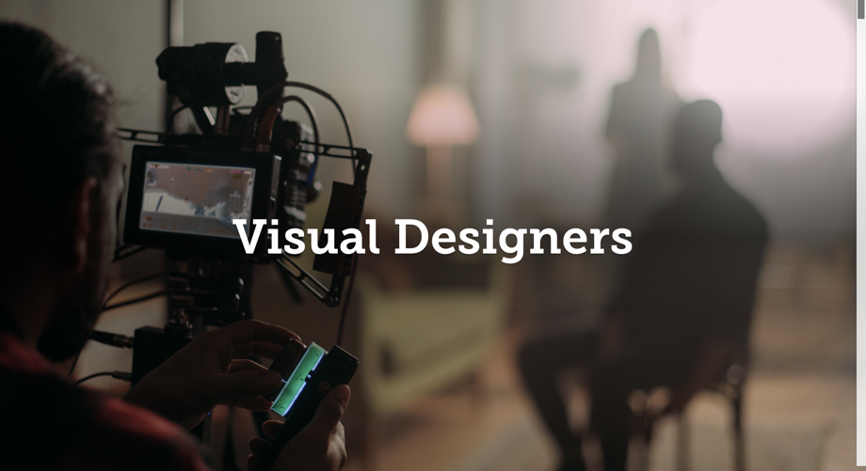
Pictures 1 and 2 show the initial images that students will see when opening the webpage. I used simple but relevant, engaging and interesting photos to adhere to the aesthetic standard that must be met when creating a successful digital tool.

1.
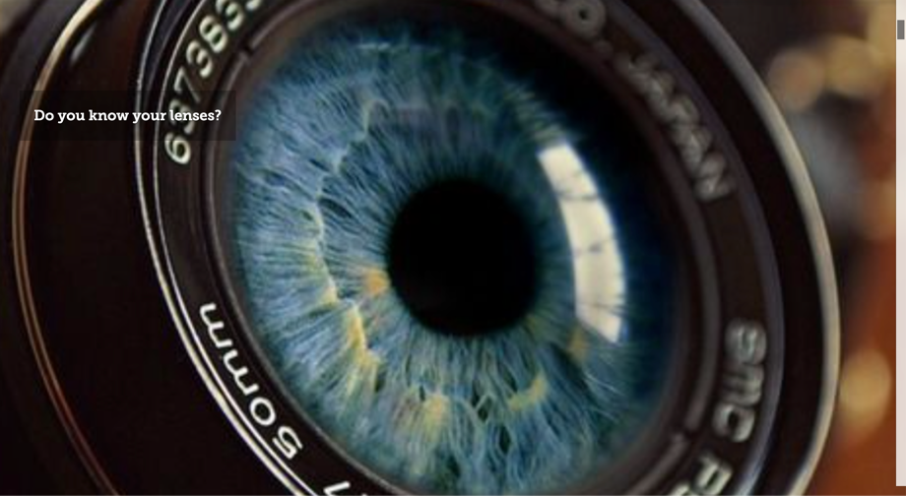

2.
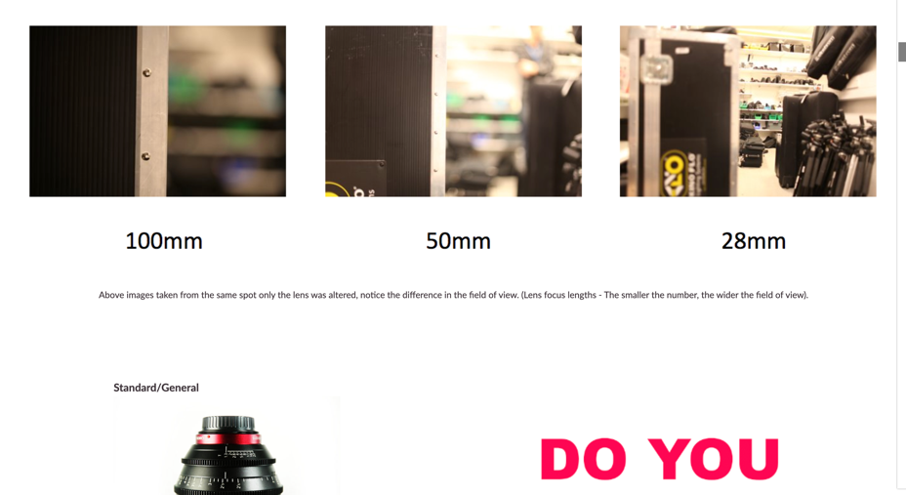
Picture 3 shows a brief introduction to the different effect of various lenses. This can provide a quick refresh for students who need a visual reminder of what effect each lens provides.s For example, new and inexperienced filmmakers may find it hard to memorise that a 100mm lens is a more ‘zoomed in’ lens, and the 28mm lens is wider and allows you to view more.

3.
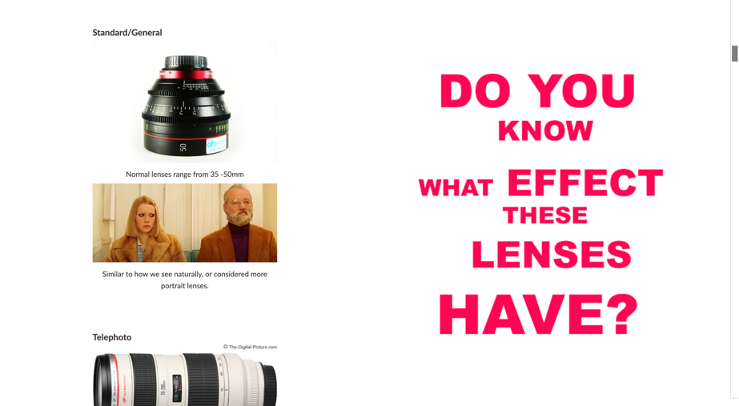
Pictures 4, 5, 6, and 7 show that the webpage provides an in-depth visual of what each lens is and what effect they have. It’s important to note that the lenses shown here are all available at the University’s Film and TV stores for students to book out and use.
Pictures of scenes from films have been used to increase interest. Picture 6 also shows that I have included a video example of a particular lens being used – more specifically a lens which is less commonly used in standard films. This is to provide an even more in-depth visual of this lens and its potential.

4.
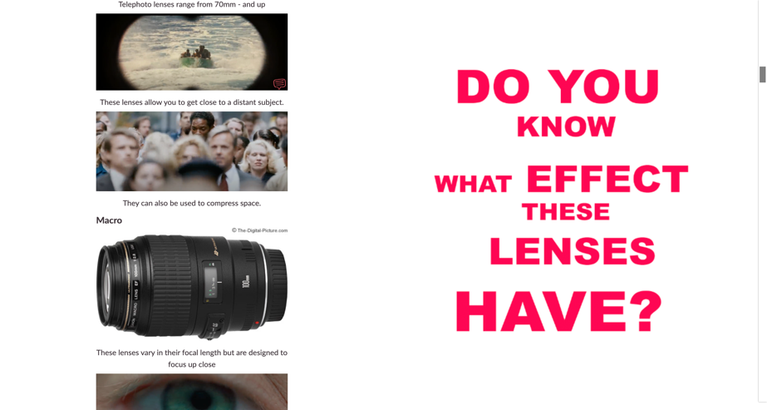
5.
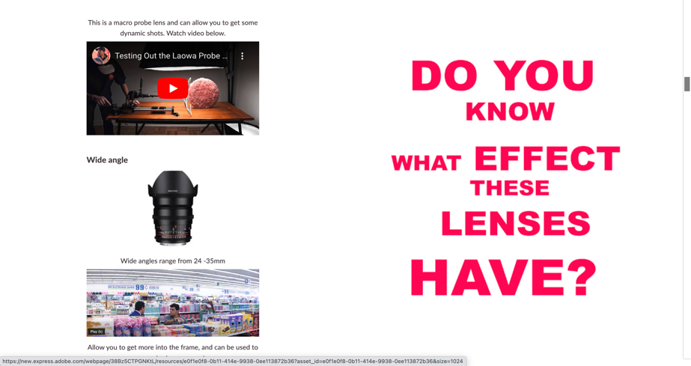

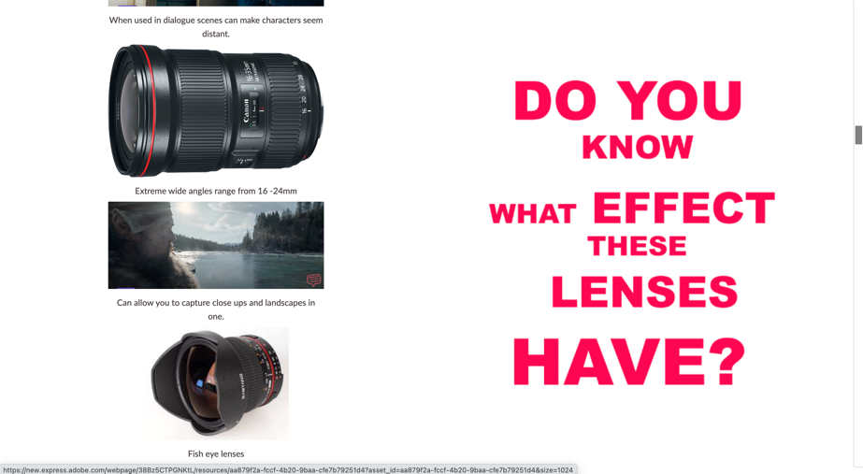
6.

7.
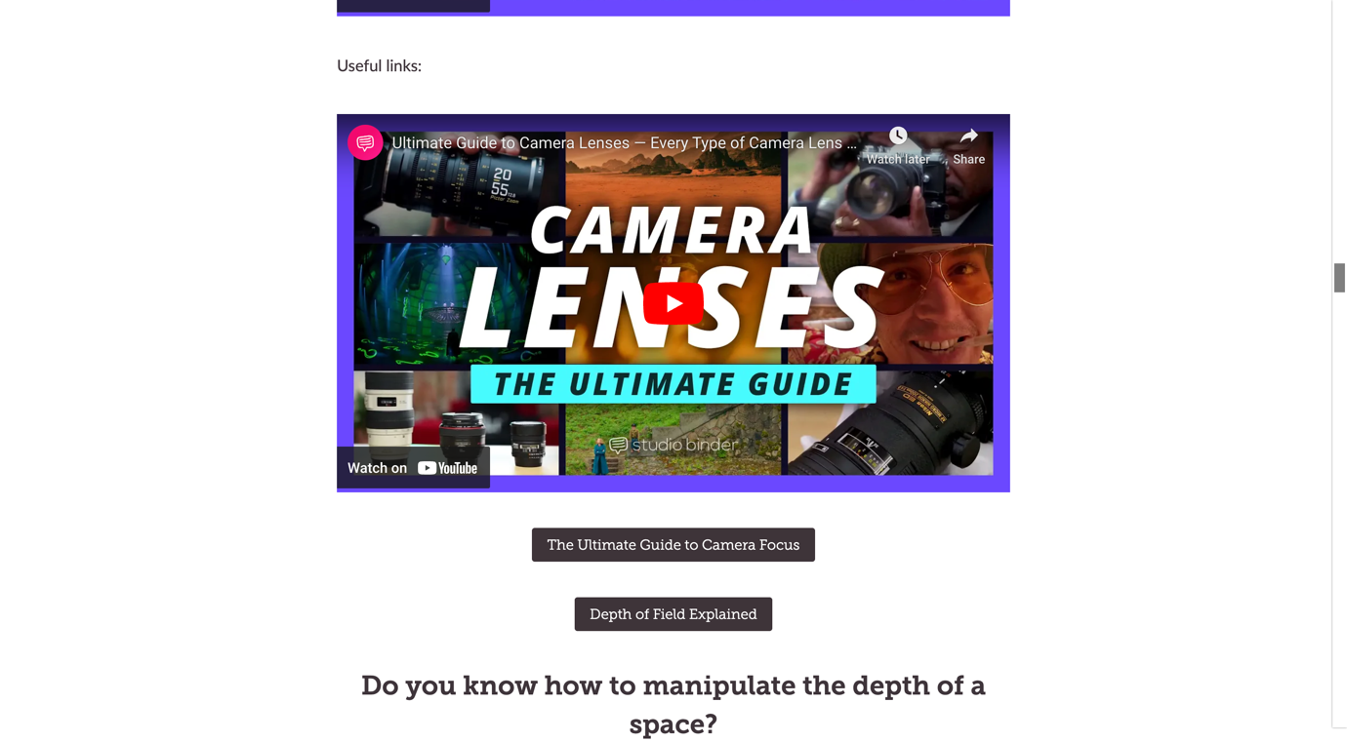
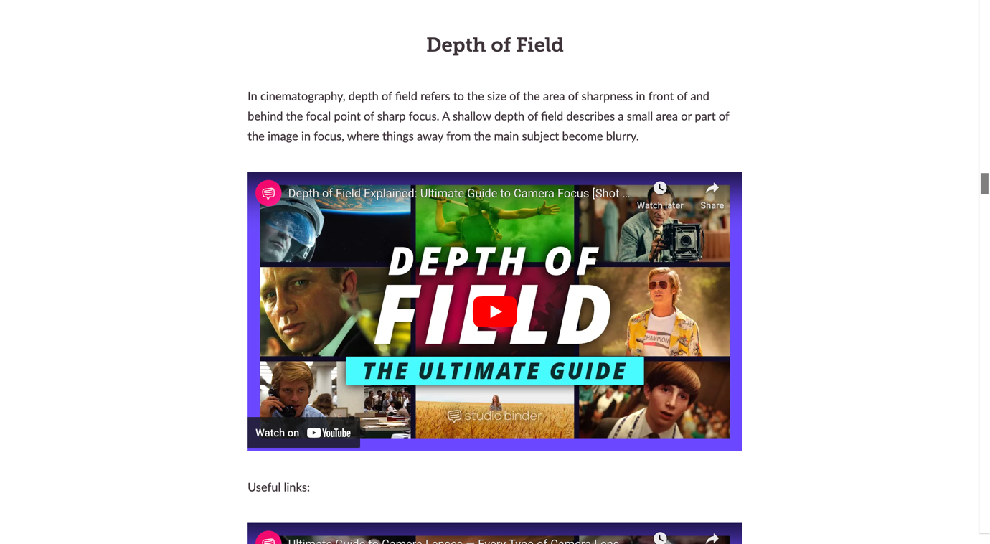
Picture 8 displays the video I have included in the webpage which explains the depth of field to students. This video and all others have been screened and confirmed that it provides information that is within the guidelines of the Film and TV standard.
8.
I created a section specifically for students to explore on their own accord, which can be seen here in picture 9. This section was not covered during the lesson, but students were informed of what it is and what it is there for, along with being encouraged to use this section to help guide them in future.
9.
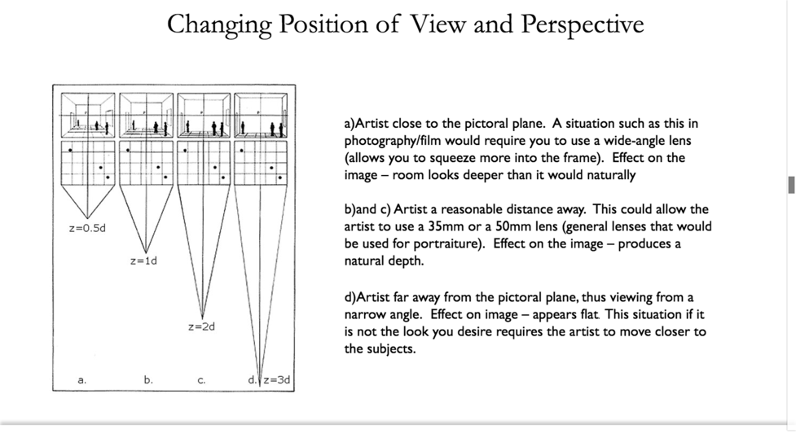

10.
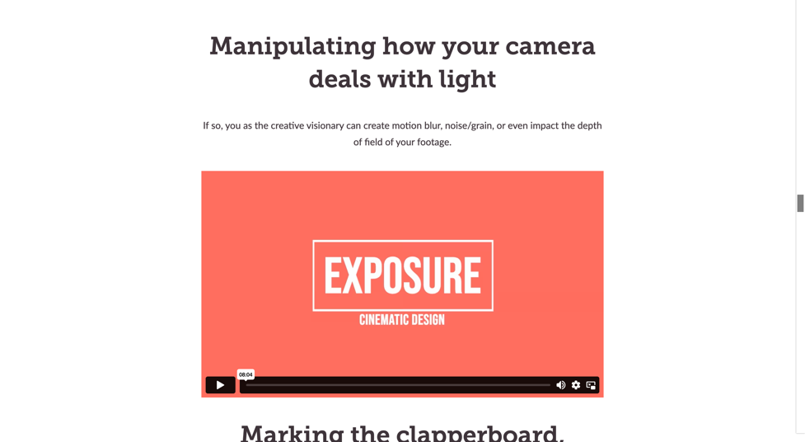
Picture 10 shows a graph I had included which gives a simple visual of how space can be manipulated – this can be useful for students who when on set are uncertain of which position or lens to use.
Picture 11 is an informative video on lighting.
Picture 12 covers the clapperboard, which is annotated to explain each individual section. Students can use this whilst filming on location to check and reaffirm that they have marked it correctly.

11.
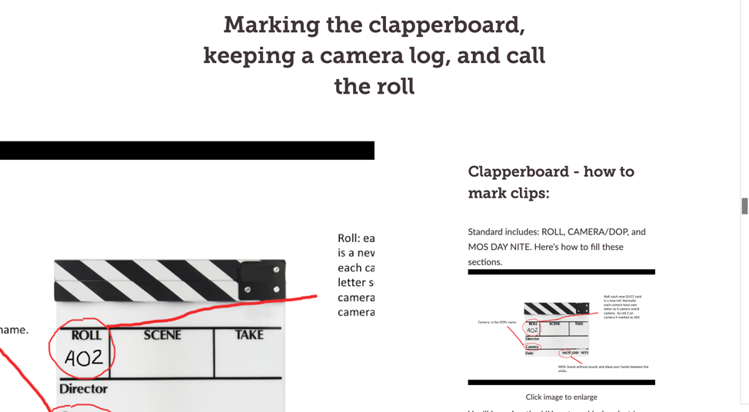

12.

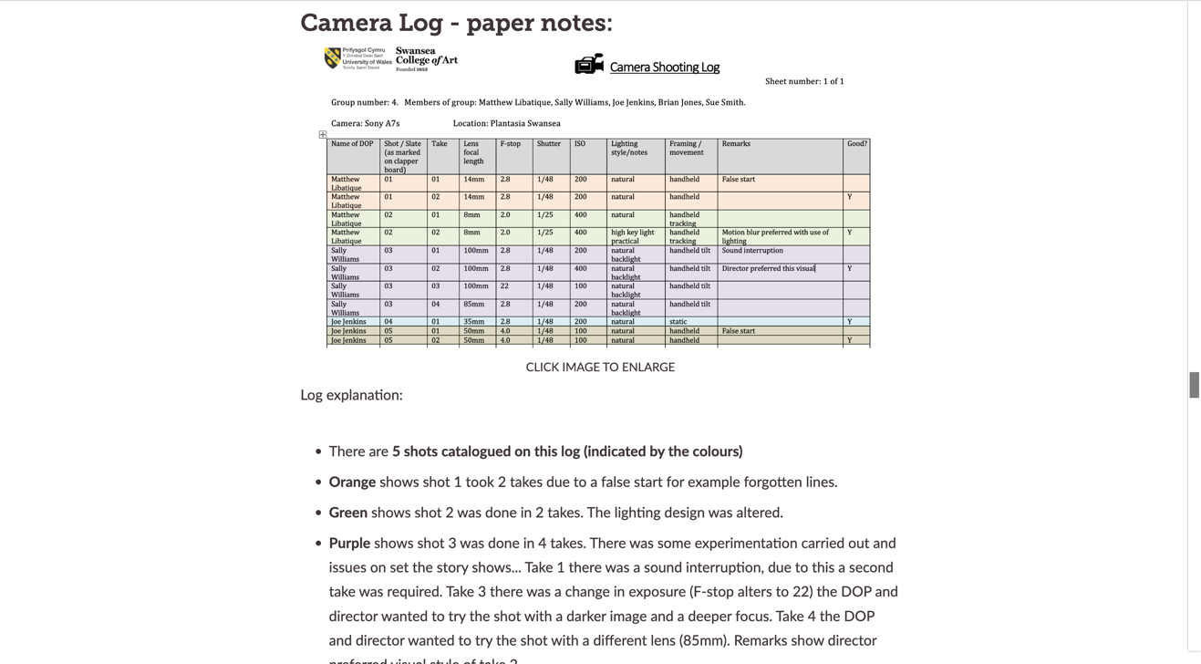

Picture 13 is an example of a completed camera log, more specifically the one that is provided to students from UWTSD. It was more appropriate to use the UWTSD camera log as all logs can differ, and students will be using the UWTSD provided template for the duration of their course.
13.

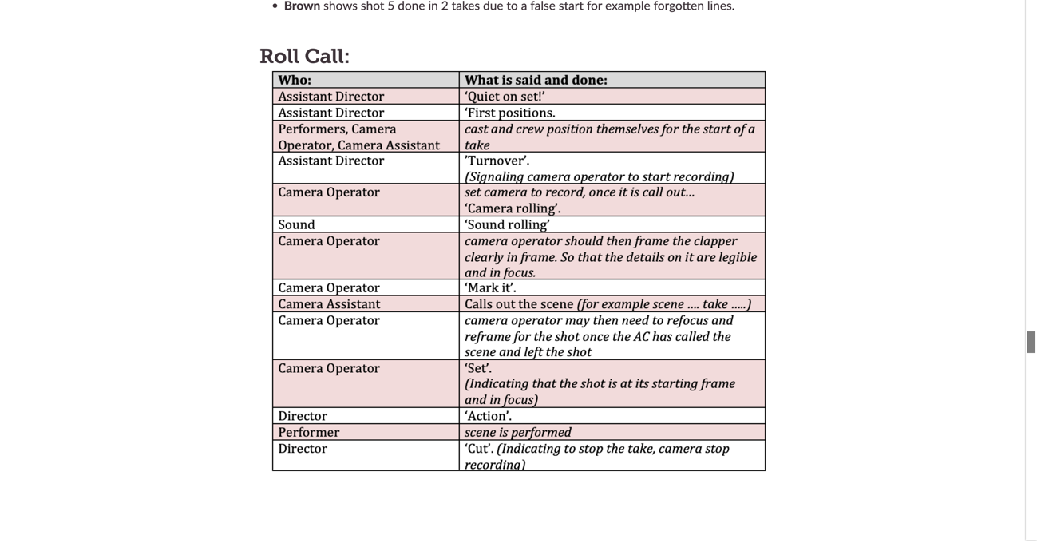

Picture 14 shows that the students have been provided with the correct use and order of language and statements that are used while filming on set. Students can look back at this before beginning their film to refresh themselves on what each individual role needs to say.
14.

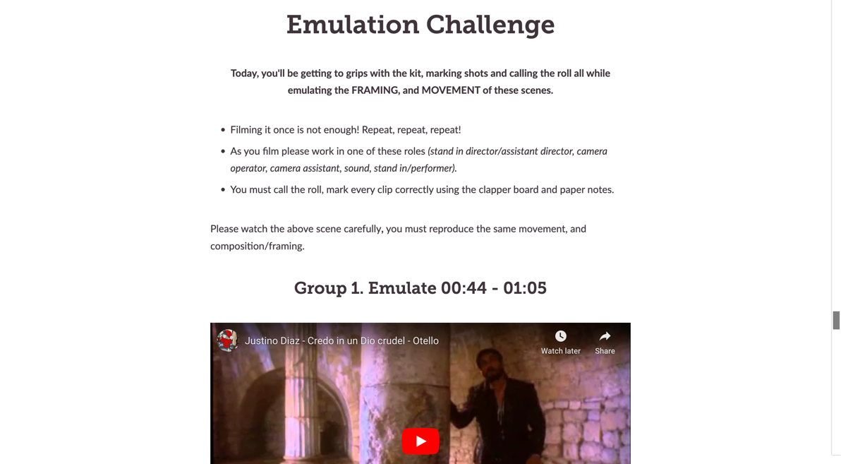

The emulation challenge shown here in pictures 15 and 16 provides students with an in depth explanation of what the challenge is, what students need to do, what they must consider while emulating these scenes, and even offers them a higher difficulty option of the same emulation goal. In doing this, it is delivering a task that can be completed by students of different expertise, ensuring that students are neither overwhelmed with a difficult to complete task or underwhelmed with a task which does not challenge them.
15.
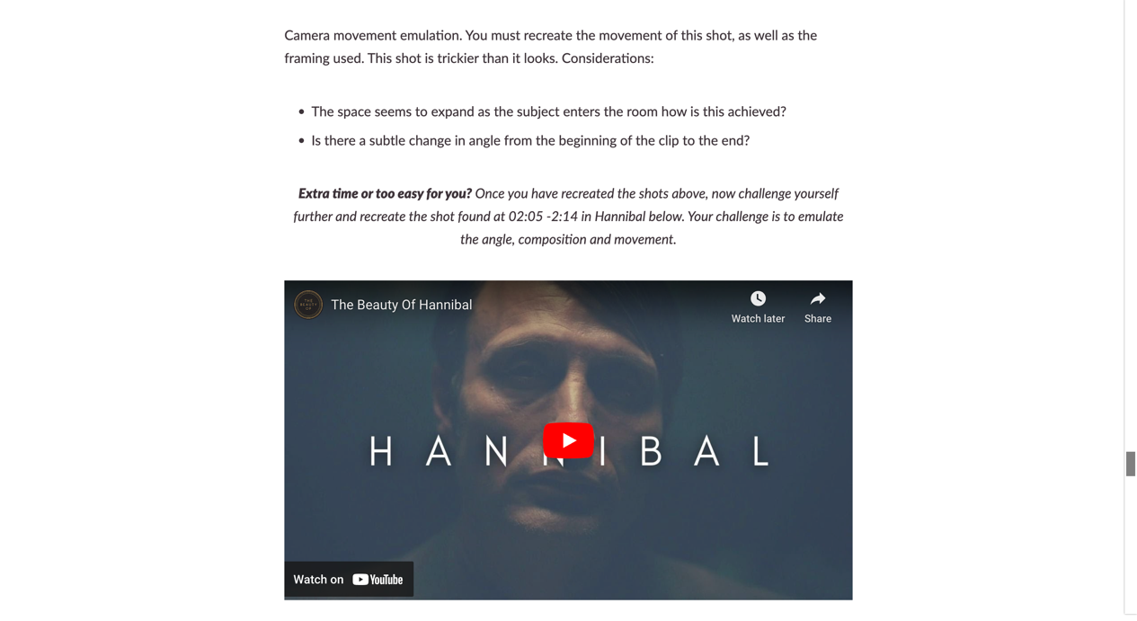
16.

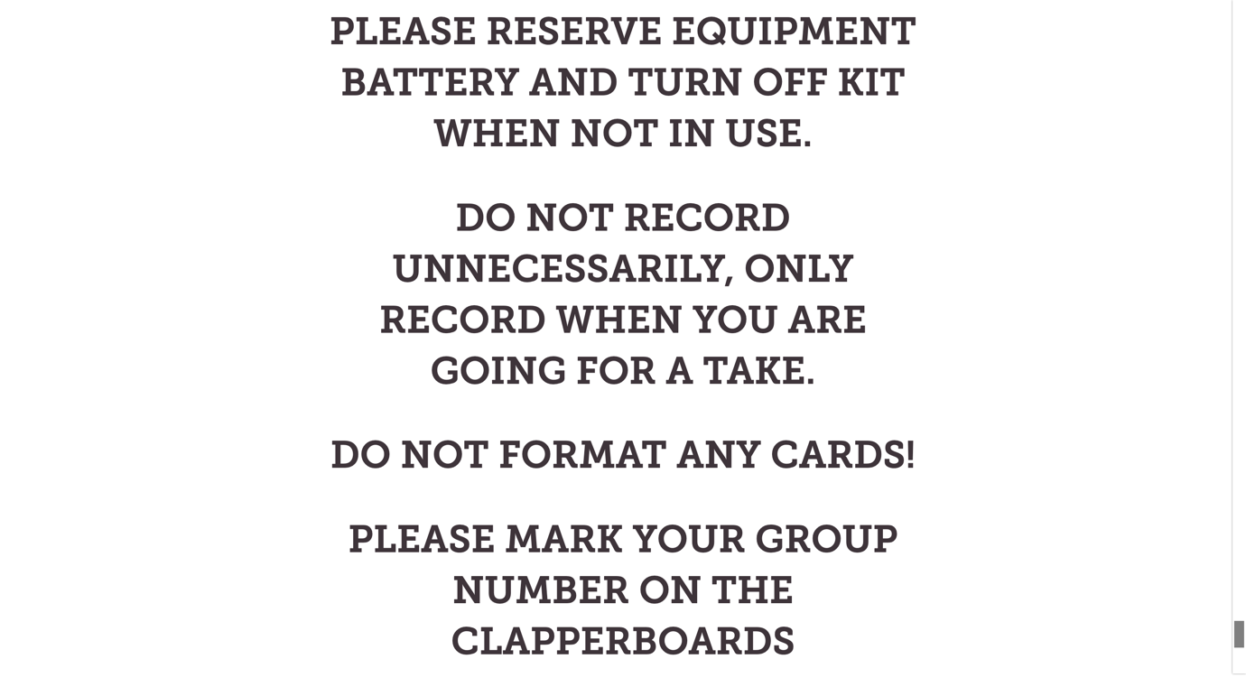
Finally, picture 17 is the end of the webpage, this is a reminder to students to take care of and respect the equipment. It directly translates to working in the film industry and is an important message for students to be aware of and take on board.
17.

*Please note that the videos shown in pictures 8, 9, 11, 15, and 16 all play within the webpage. This means that students do not have to click a link and leave the webpage in order to watch the video. This shows the creation of a convenient tool, as students can quickly play the videos and select which part they need to watch, and they can also scroll to other areas of the webpage to cross-reference what is being stated in the video. My aim here is for students to solidify learning and understanding in their self-directed study.

Evaluation and Reflection
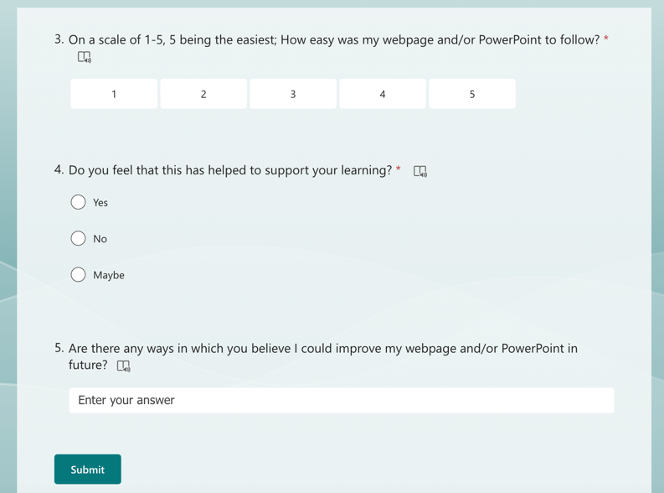
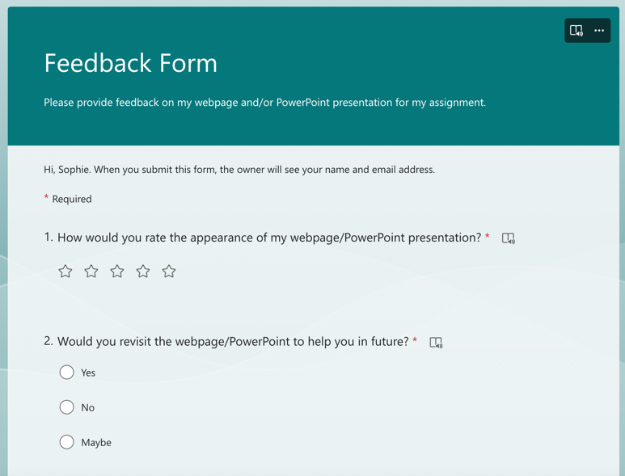
The chosen digital tool for this module and its purpose differs from the typical or standard digital tool, as it encourages and enhances self-directed learning and self-directed study. However, I have also created a Feedback Form on Microsoft Forms as a way of assessing my own performance and that of the webpage through the students’ experiences and view on my work. As Nylén & Holmström (2015) stated, the efficiency of a digital tool can be measured through “usability, aesthetics, and engagement”, and this is what I have based my feedback forms on, to ensure that my webpage fits into their framework. Below are screenshots of the desktop and mobile version of the feedback form:
The desktop version of the Feedback Forms
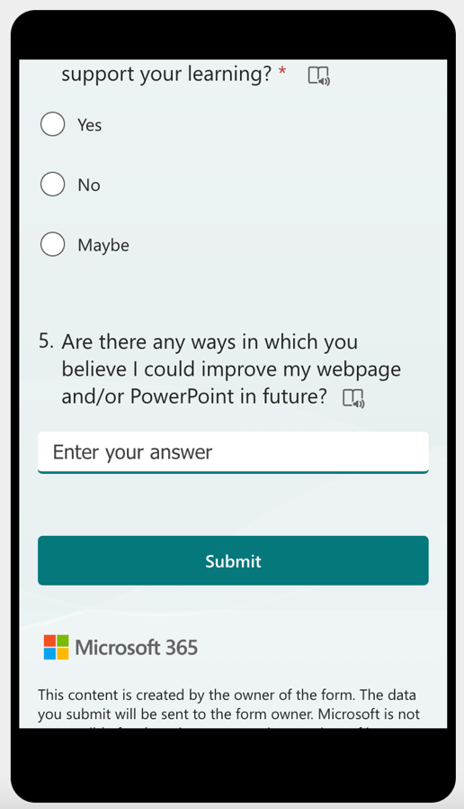
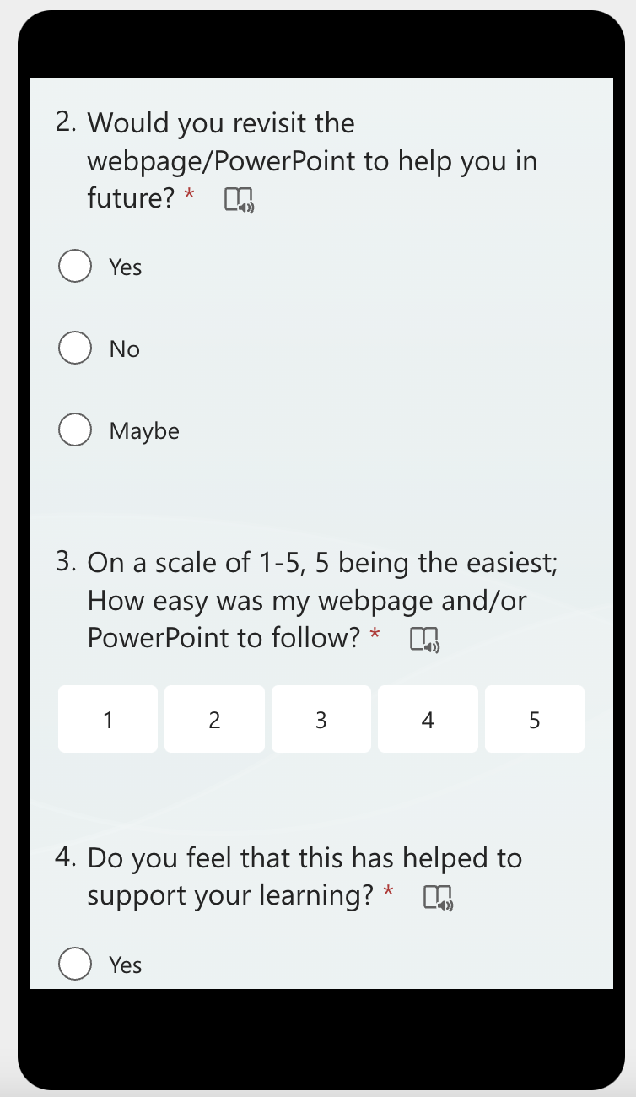
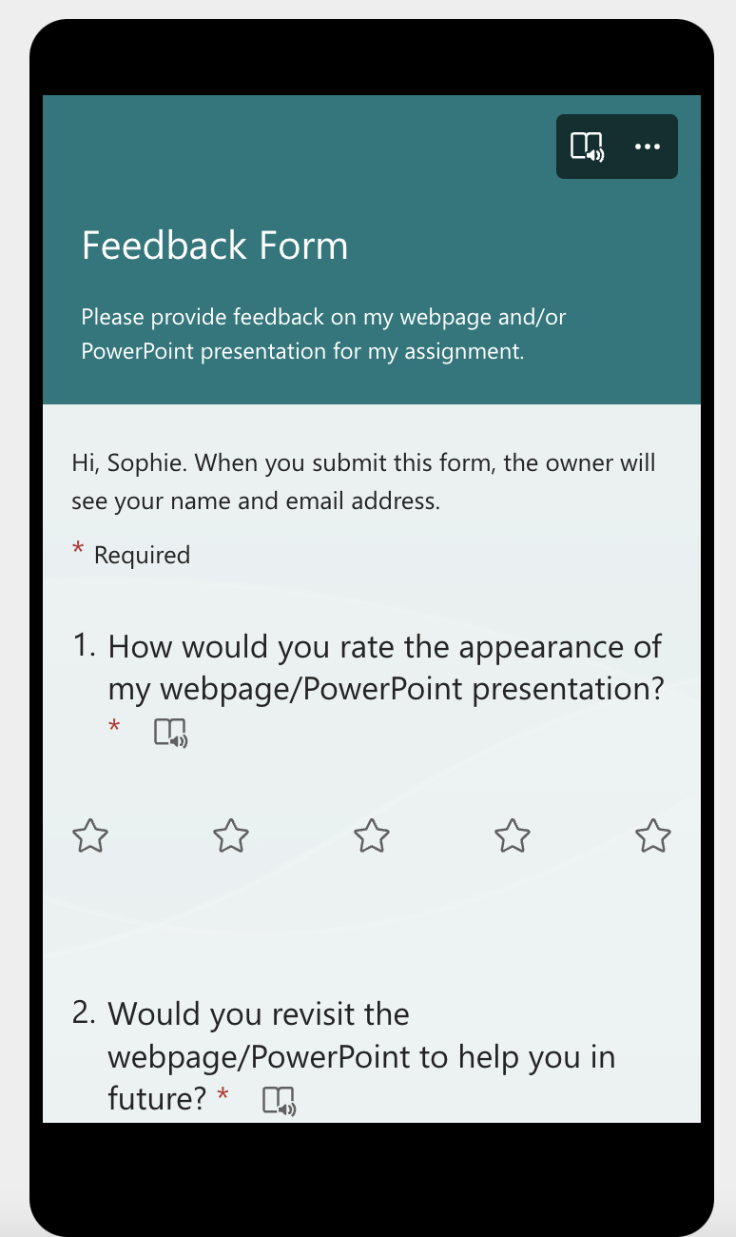
The mobile version of the Feedback Forms

The Feedback
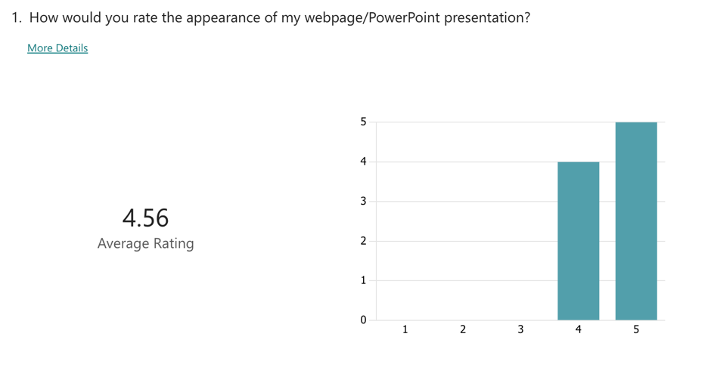
Below are the responses to the feedback forms:

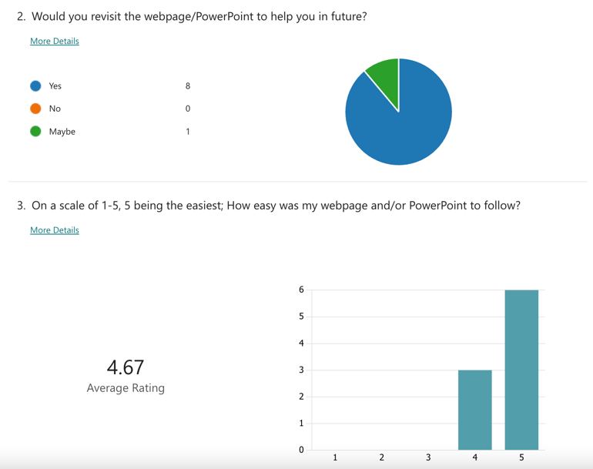
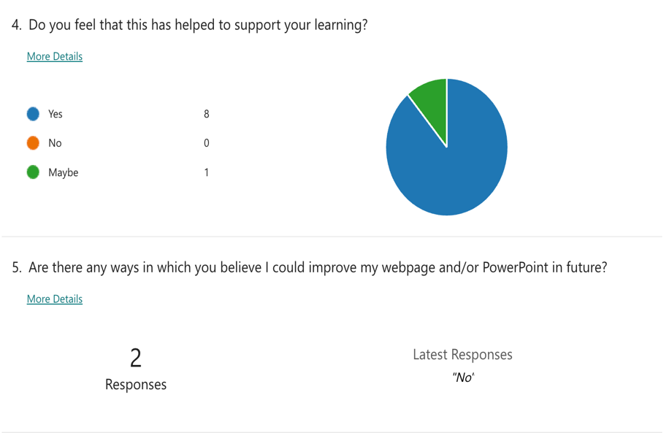
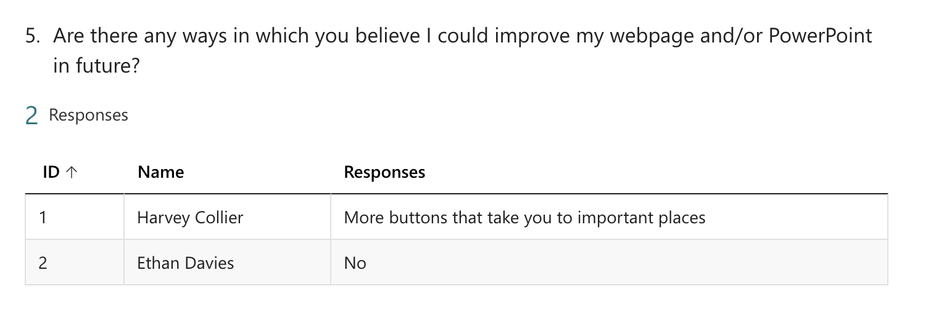
Student feedback indicates that the webpage was successful in terms of usability and aesthetics. The appearance of my webpage received a score of 4.56 out of 5, signifying that all students who completed the survey found the design to be satisfactory at the least. The usability of the webpage was measured by whether the students would revisit to help them in future; 8 out of 9 said that they would, with 1 voting that they might revisit. This shows that the webpage has met the engagement aspect of the framework. The usability aspect was also met, evident by the response to how easy the webpage was to follow, which received a response of 4.67 out of 5, meaning that the framework I used to build my webpage was effective. Students also responded in favour of the belief that the website has supported their learning.
The first four questions were mandatory to answer, however I provided a fifth question which was optional for students to suggest ways in which I could improve my webpage. Out of two responses, only one was useable (as the other was simply “no”), and the student stated, “more buttons that take you to important places”. I have made the assumption that this is in regard to the hyperlinks I had provided in the webpage, that leads students to useful websites which have been checked, are reliable, and meet the correct standards. In retrospect, I had limited time, so I was only able to choose specific topics which I felt students had less experience and knowledge in. Going forward, I will be expanding the self-directed study section of the webpage, adding more relevant and useful hyperlinks and videos. The webpage can be continuously edited while it is active, so over the course of my studies as a student teacher or indefinitely, I can keep adding more information for the students who will always have access to this webpage as long as they have the URL.
Upon reflection and evaluating the feedback, I believe my application of a digital tool to aid self-directed learning was successful. The nature of the tool means that it can be continuously updated to meet the needs of not only each individual student but the changing industry standards.

Lesson Plan
Below is the lesson plan I had created before holding the lesson and introducing students to the webpage. Whilst creating this I had made sure I had taken all desired outcomes into consideration, ensuring all outcomes and aims truly reflected my intention to guide students towards self-directed learning which will be beneficial in building their career as filmmakers.
Topic: Visual Design |  | Class: Year 1 & 2 BA Film and TV
Date: 13/11/23 | Length of lesson: 2 hours |  | Number of students: 13
Resources required:
Computer and projector.
Aim of Lesson:
To teach and refresh students’ knowledge on lenses and their uses, depth of field and how space is manipulated, marking the clapper board, keeping a camera log and language used on set.
For students to use the above in their emulation exercises, where they emulate chosen scenes from different films.
To encourage students to revisit the webpage in their emulation exercises and in future projects in the form of self-directed learning.
Learning Outcomes – The Learners Should Be Able To:
- Learners should be able to understand the effects each lens has and use this knowledge to identify which lens they need to emulate specific scenes given to them.
- Learners should have a basic understanding of the language used on set and put this into practice in their emulation exercises, other modules, and their own projects.
- Learners should be able to properly log both camera and audio logs and understand the importance of this
- Learners should know how to manipulate the depth of space in a film and when it is appropriate to do so.
Previous student knowledge required for the session:
No previous knowledge required, some hands-on experience with the camera is preferred.
Anticipated difficulties (if applicable):
Internet connectivity issues or lack of mobile data can hinder on their filming schedule.
Students who either don’t have a mobile device or theirs is temporarily unavailable won’t be able to visit the page on their own accord.
Students who can only use a computer or laptop may not be able to visit the webpage due to inconvenience whilst on set.
Professional Standards (where are these being met within the session)
In this session I met various standards from the Professional Standards Framework (2023):
K4 – Appropriate use of digital and/or other technologies, and resources for learning. I have provided the students with a webpage that they can access on their mobile phones whilst on location.
A1 – Design and plan learning activities and/or programmes. I have designed emulation activities for the students to enhance their skills and solidify their learning when put into practice.

Assessment Strategies: when and how are they included within the lesson?
Formative assessment will take place throughout the lesson, through means of strategic questioning (encouraging further thinking through “how” and “why” questions), discussions, and analysing students’ work throughout by looking through what they’ve filmed so far and how it compares to their emulation task.

Informal reflection (to be completed after the session)

The session overall went well – the students were engaged during the lesson and answered questions. The students had revisited the webpage during their emulation exercises to refresh their memory, but also as a way of self-assessment as they had used the webpage to check if their methods were correct.

Update – students had used the webpage during their trip to Lampeter on 23rd November 2023 where they were working in independent crews without the help of a lecturer. This solidifies the notion that the webpage is useful to students, and I have been successful in creating a means to enhance self-directed learning.

References
Buckland, W. (2016) The film critic between theory and practice; (or: What every film critic needs to know), Film Criticism. Available at: https://quod.lib.umich.edu/f/fc/13761232.0040.106/--film-critic-between-theory-and-practice-or-what-every-film?rgn=main%3Bview (Accessed: 28 November 2023).
Cook-Sather, A. (2002) “Authorizing Students’ Perspectives: Toward Trust, Dialogue, and Change in Education.” Thousand Oaks, CA: American Educational Research Association, 31, pp. 3–14.
Digital innovation (2019) WalkMe - Digital Adoption Platform. Available at: https://www.walkme.com/glossary/digital-innovation/ (Accessed: December 7, 2023).
Fanshawe, M., Delaney, N. and Powell, A. (2020) ‘Utilizing instantaneous feedback to promote self-regulated learning in online higher education courses’, Technology-Enhanced Formative Assessment Practices in Higher Education, pp. 41–59. doi:10.4018/978-1-7998-0426-0.ch003.
Florida Center for Instructional Technology (June 01, 2019) The Technology Integration Matrix. Available at: https://fcit.usf.edu/matrix/matrix/ (Accessed: 04 December 2023).
Jackson, T.H. et al. (2018) ‘Self‐directed digital learning: When do dental students study?’, Journal of Dental Education, 82(4), pp. 373–378. doi:10.21815/jde.018.040.
Kendra Cherry, Mse. (2023a) How Vygotsky defined the zone of proximal development, Verywell Mind. Available at: https://www.verywellmind.com/what-is-the-zone-of-proximal-development-2796034 (Accessed: 01 December 2023).
Kyei-Blankson, L., Ntuli, E. and Donnelly, H. (2016) ‘Establishing the importance of interaction and presence to student learning in online environments’, World Journal of Educational Research, 3(1), p. 48. doi:10.22158/wjer.v3n1p48.
Lizarelli, F. L., de Toledo, J. C. and Alliprandini, D. H. (2021) ‘Relationship between continuous improvement and innovation performance: an empirical study in Brazilian manufacturing companies,’ Total quality management & business excellence, 32(9–10), pp. 981–1004. doi: 10.1080/14783363.2019.1653178.
Muijs, D. and Reynolds, D. (2001) Effective teaching: Evidence and practice. London: Paul Chapman Publishing.
Nylén, D. and Holmström, J. (2015) ‘Digital Innovation Strategy: A framework for diagnosing and improving digital product and Service Innovation’, Business Horizons, 58(1), pp. 57–67. doi:10.1016/j.bushor.2014.09.001.
Oladokun, S. (2023) Harnessing Interactive Content: Why Use Interactive content and what are the benefits?, LinkedIn. Available at: https://www.linkedin.com/pulse/harnessing-interactive-content-why-use-what-benefits-sunday-oladokun/ (Accessed: 04 December 2023).
Omorogiuwa, K. O. (2012) “Benefits and challenges of feedback in formative assessment of distance learners.” Available at: https://uir.unisa.ac.za/handle/10500/8558 (Accessed: December 7, 2023).
Roth A. Ogrin S. Schmitz B. (2016). Assessing self-regulated learning in higher education: A systematic literature review of self-report instruments.Educational Assessment, Evaluation and Accountability, 28(3), 225–250. 10.1007/s11092-015-9229-2
Tomei L. A. (2010). Designing Instruction for the Traditional, Adult, and Distance Learner: A New Engine for Technology-Based Teaching. IGI Global. 10.4018/978-1-60566-824-6
van der Linde, S. and Goede, R. (2022) ‘The Art of Teaching Professional Practice: An Action Research Methodology Inspired by Ulrich’s Systems Concepts’, Systemic Practice and Action Research, 36(2), pp. 203–237. doi:10.1007/s11213-022-09608-w.
What is interactive content? how to use interactive content? (2023) Storyly. Available at: https://www.storyly.io/glossary/interactive-content#:~:text=Interactive%20content%20is%20important%20because,and%20make%20it%20more%20memorable. (Accessed: 03 December 2023).

