Research on Corporate Social Responsibility: Case Study on Toyota Motor Corporation

Course name: 21st Century Business and Societal Ethics

Course ID: BMDM7008

Student Name: Bowen Yu

Student ID: 2008848

7479 Words for Main Contents
Table of Contents
1.0 Introduction 1
2.0 Deontology and Stakeholder Theory 3
2.1 Deontology in Corporate Social Responsibility 3
2.2 Stakeholder Theory and Mendelow Matrix 4
3.0 Typical Cases and Analysis of Toyota Motor Corporation's Corporate Social Responsibility 7
3.1 Internal Driving Forces of Toyota Motor Corporation’s Corporate Social Responsibility 7
3.2 External Actions of Toyota Motor Corporation’s Corporate Social Responsibility 10
3.2.1 Traffic Safety 11
3.2.2 Improving the environment: Toyota Environmental Challenge 2050 12
3.2.3 Public welfare activities and natural disaster assistance 13
3.3 Difficulties in Corporate Social Responsibility: The Negative Case of Toyota Motor Corporation’s Corporate Social Responsibility 14
3.3.1 Toyota Motor Corporation's Large-scale Car Recall in 2009 14
3.3.2 Follow-up issues of Toyota Motor Corporation's large-scale vehicle recall 16
3.3.3 Differential treatment of large-scale vehicle recalls by Toyota Motor Corporation 16
3.4 Reflection 17
4.0 CSR Future Development of Toyota Motor Corporation and Automakers 18
5.0 References 21
Appendix 26
Appendix1: Toyota Philosophy 26
Appendix2: Toyota Code of Conduct 2018 28
Appendix3: Toyota Human Rights Policy 32
Appendix4: Traffic Safety Activities of Toyota 37
Appendix5: Toyota Environmental Challenge 2050 43
Appendix6: Social Contribution and Disaster Rescue 44

1.0 Introduction
Generally, the corporate social responsibility of modern society is produced after the Second World War, especially in the 1960s when the development of corporate social responsibility was very rapid. Socially, social responsibilities such as the civil rights activities, female rights, consumer rights, and the development of environmental awareness have largely developed the corporate social responsibility. In the 1970s, state-level institutions for social responsibility, consumers and equality were established, which led to great progress in corporate social responsibility. In the 1990s, corporate social responsibility began to develop globally, that is, globalization and institutionalization.(Carroll, 2015) The development of corporate social responsibility has become a global concept with the interaction of thought and action. The scope of corporate social responsibility is not only to help companies abide by basic ethics and obtain benefits, it includes factors such as ethics, charity, law, etc., to improve social expectations of corporate stakeholders and modern organizations, and continue to be in the global market.(Carroll, 2015. Lindgreen and Swaen, 2010)

It should be noted that corporate social responsibility is a relatively subjective concept, so it lacks a generally accepted definition. In order to have a clear concept of corporate social responsibility, different scholars have put forward different views.(Carroll, 2015. Grigoris, 2016. Fitch, 1976.) On the one hand, corporate social responsibility specifies that a company's responsibility is to any group or individual that may affect or be affected by the achievement of the organization's goals. On the other hand, under this framework, corporate social responsibility also points out that companies need to conduct business activities under standards that meet or exceed the expectations of ethics, law, business and the general society. The main drivers for organizations to take corporate social responsibility measures are: internal organizational factors, competitor actions, investor organizations, consumers, government regulators and so on.(Grigoris, 2016) Generally, organizations adopting corporate social responsibility policies should not expect to gain benefits or rewards by adopting corporate social responsibility policies, but some corporate social responsibility policies have obvious benefits, including but not limited to:

- Improve organizational finances and performance.(Grigoris, 2016)

- Attract new employees, motivate existing employees, and reduce employee turnover.(Grigoris, 2016)

- Improve corporate social responsibility.(Grigoris, 2016)

- Strengthen the company's reputation in society.(Grigoris, 2016)

- Get more capital.(Grigoris, 2016)

An obvious feature is that due to the diversity of corporate stakeholder groups, their requirements for corporate social responsibility will continue to change. For example, some stakeholder groups will require companies to carry out corporate social responsibility actions in multiple aspects. However, some stakeholder groups only require companies to carry out detailed corporate social responsibility actions in one aspect.(Lindgreen and Swaen,2010. Schooley, 2021) This phenomenon has led to a very broad and complex concept of corporate social responsibility. However, so far, the importance of corporate social responsibility has not been reduced because of its complexity. On the contrary, many enterprises, especially large enterprises, have included corporate social responsibility in the obligations and responsibilities of corporate development. This situation is not only due to the development of social responsibility awareness, but also can be reasonably explained by deontology knowledge. Simply put, deontology is concerned with human actions, not the consequences of human actions.(Bcampus,2022. BBC,2014.) Deontology emphasizes ethics, and ethics are obligations. Deontological people live in a world of rigorous morality and moral rules, and they think doing the right things because it is right and not doing the wrong things because they are wrong. For example: helping others because helping others is right. Don't kill, because killing is wrong. It is clear that there is a certain chemistry associated with associating deontology with corporate social responsibility. The view advocated by deontology emphasizes on the individual, it constrains individual behavior, and advocates correct individual morality and obligations. It can also help companies implement corporate social responsibility strategies for individuals, such as proposing corporate social responsibility principles, constraining and improving corporate employees and overall quality. Or help corporate employees realize the importance of responsibilities and obligations in society and enterprises through rules and regulations, so as to generate a positive corporate atmosphere and environment and enhance corporate social responsibility awareness..(Bcampus,2022.)

Through the above discussion, it’s clear to discover the importance, complexity of corporate social responsibility, as well as the ideological role played by deontology in corporate social responsibility. Therefore, this report will firstly introduce the deontology in corporate social responsibility, including its history, development, characteristics and application, and analyze the promoting role of stakeholder theory in corporate social responsibility. After that, this report will take Toyota Motor Corporation, the world's largest auto manufacturer and the leader of organizational management, as a case to analyze the importance and application of corporate social responsibility in society. At the end, this report will analyze the development path of corporate social responsibility in the future and give an evaluation.

2.0 Deontology and Stakeholder Theory

2.1 Deontology in Corporate Social Responsibility
The "father" of deontology, the famous philosopher Immanuel Kant, believed that people could develop a coherent system of morality and ethics through the use of reason.(Chakrabarty and Erin. 2013, Freeman and Werhane,2008.) This moral ethics concerns the correctness of a person's actions and the motives for his actions. Simply put, deontology aims to critique people's actions and motives, rather than focusing on the consequences of their actions. (Chakrabarty and Erin. 2013, Freeman and Werhane,2008.Bcampus,2022.) Kant stated in his "absolute imperative" that the behavior of some things has an objective necessity in itself, and has nothing to do with other purposes. An absolute imperative is not the basis of action, it is the purpose of action itself. The absolute imperative is executed without regard to any other intent and purpose, nor does it vary depending on any particular situation.(Bcampus,2022.BBC,2014.) Putting Kant's absolute imperative in the deontological framework, it can be understood as: under deontology, if a person is doing a morally correct action, then he is doing a good thing, because it is good in itself and is It is unconditional, inevitable, and it needs to be followed.(Freeman and Werhane,2008.) For example: honesty is a good thing from the root, then people have the obligation to be honest and trustworthy unconditionally, and abide by morals and ethics. Therefore, from the point of view described above, deontological ethics teaches that something is right or wrong in itself, regardless of its consequences. People have a responsibility and obligation to do the right thing, even if the outcome is bad. In this sense, deontologists will insist on doing what is morally right, and will maximize behavior that makes those things better.

If the above ethical and moral code of conduct is reversed, that is, deontologists need to think about this action before taking action to evaluate whether it is correct and positive. Generally, they will think about the following questions:

- Is this action correct or incorrect? (Freeman and Werhane,2008. Micewsk and Troy, 2007)

- Is this action acceptable to other rational people?(Freeman and Werhane,2008. Micewsk and Troy, 2007)

- Is this action universal? In other words, does it apply to other similar situations?(Freeman and Werhane,2008. Micewsk and Troy, 2007)

- Does this action respect the dignity of others? Or at least not denigrate the dignity of others?(Freeman and Werhane,2008. Micewsk and Troy, 2007)
Kant's deontology gives a criterion for evaluating morality. It can not only assess people's code of conduct, but also reflect social ethics, social regulations and laws. As mentioned above, the right and wrong proposed by Kant's deontology are not the right and wrong of their results, but that their actions conform or violate the moral code of conduct. Deontology, on the other hand, includes all people through absolute imperative, and sets up moral and ethical behaviors, so as to obtain the most beautiful humanities and society.(Freeman and Werhane,2008. Micewsk and Troy, 2007)

If deontology is combined with corporate social responsibility, it can be well found that Kant's absolute imperative and deontology can create a good ethical and moral framework for individuals in a business. At the same time, the moral ethics emphasized by deontology can serve as the driving force for the moral behavior of individuals in an organization. Individuals in an organization should act on the basis of conscientious ethics, so as to demonstrate the conscientious moral character of the organization as a whole. Beyond the individual, deontological principles will drive organizations to do what is good for society, reflecting the good morals inherent in organizations, i.e. demonstrating their corporate social responsibility.(Freeman and Werhane,2008. Micewsk and Troy, 2007)

2.2 Stakeholder Theory and Mendelow Matrix
In general, a stakeholder is anyone who can affect or be affected by an organization, strategy, or project. These personalities can be internal or external to the organization. (Donaldson and Preston, 1995. Mitchell, Agle and Wood, 1997. Johns and Wicks, 1999.) Mitchell, Agle, and Wood (1997) proposed that the stakeholder theory dates back to the early days of corporate social responsibility, and defined it as "corporate obligations to socially constituted groups other than shareholders that go beyond legal or contractual obligations On this basis, they ask: what are these groups, and how many of these groups does the company need to serve? How should their interests be balanced? How much should the company pay to distribute benefits and services?

Freeman (1984, 1990) mentioned that a stakeholder in an organization is any group or individual that can influence or be affected by the achievement of organizational goals, which has become the broadest definition of a stakeholder at present. The stakeholder theory is descriptive, describing the company as a competing interest group with intrinsic value. At the same time, stakeholder theory is also instrumental in that it establishes a framework for organizations to examine the links between the practice of stakeholder management and the achievement of various company goals. Stakeholder theory is also normative, pointing out that an organization's stakeholders are determined by the organization's interests and examining whether the company has any corresponding ability to create benefits. All interests have their own intrinsic value, and they are considered for their own sake. Finally, stakeholders are managerial and provide managers with advice, theoretical frameworks, and practical approaches.

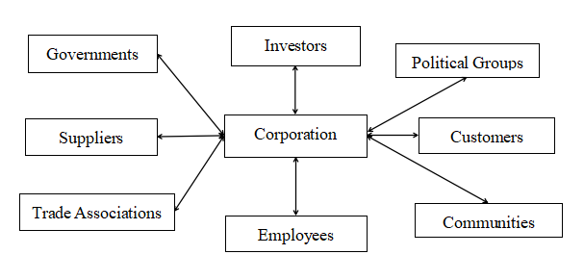
Figure1: Stakeholder Map. (Freeman,1984,1990. Donaldson and Preston, 1995.)

As can be seen from Figure 1, an organization's stakeholders are characterized by diversity and complexity. Due to the different areas that different organizations target, their key stakeholders also vary. Organizational managers therefore need to identify their organization's primary and secondary stakeholders, and be aware of their interests and drivers. Therefore, the mendelow matrix is one of the ways to help organizational managers identify their own stakeholders. medelow analyzes groups of stakeholders associated with an organization in terms of stakeholder power (ability to influence the organization's strategy or project resources) and stakeholder interest (the level of interest that stakeholders have in the organization's projects).(Olander and Landin, 2005)
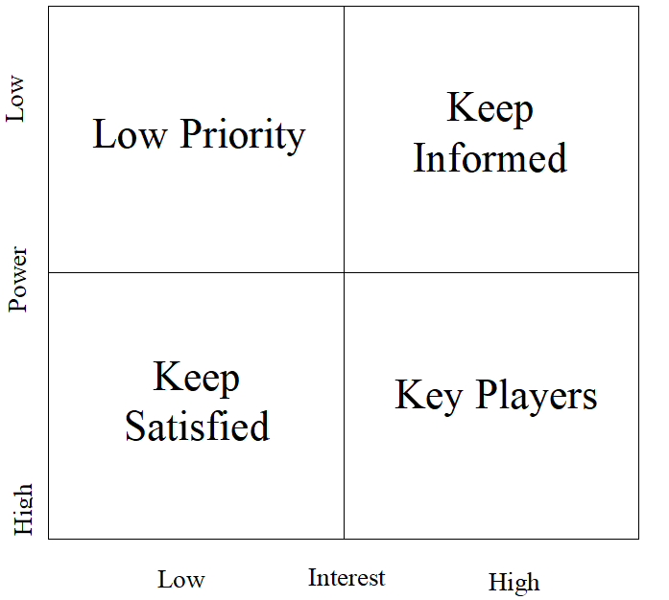
Figure2: Mendelow Matrix.(Olander and Landin, 2005. Oxford, 2018)

High Power, High Interest People: Fully attract these people and do the best to keep them satisfied. (Olander and Landin, 2005. Oxford, 2018)

High Power, Low Interest People: Try to keep them satisfied, but not let them get tired of organizational projects. (Olander and Landin, 2005. Oxford, 2018)

Low Power, High Interest People: Communicate fully with these people to ensure that no major situation arises, and get suggestions or ideas for project improvement from them. (Olander and Landin, 2005. Oxford, 2018)

Low Power, Less Interest People: Keep an eye out for changes in their level of interest and don't communicate too much. (Olander and Landin, 2005. Oxford, 2018)

Combining and applying stakeholder theory and the mendelow matrix, it is important to see that it helps organizational managers to understand, analyze, and manage the organization's primary and secondary stakeholders. In the next section, these theories will be applied in the case of Toyota Motor Corporation, combined with the deontological theory mentioned earlier, to analyze the corporate social responsibility issues arising from various events in Toyota Motor Corporation, and demonstrate Toyota Motor Corporation's efforts for corporate social responsibility.

3.0 Typical Cases and Analysis of Toyota Motor Corporation's Corporate Social Responsibility
In the previous part of the researchers have explained the characteristics of corporate social responsibility and the application principles of corporate social responsibility under the deontology. In order to better conduct business activities and promote the development of corporate social responsibility, organizations need to analyze the primary and secondary stakeholders, and have close contact with them.

A powerhouse in the automotive industry, Toyota Motor Corporation has become the largest company in Japan and the ninth largest company in the world, and the first automaker in the world to sell more than 10 million vehicles a year. Today, Toyota Motor Corporation not only has the world's leading sales results, but also its corporate philosophy, advanced technology research and development, and good corporate social responsibility and social contributions have been studied and studied by social scholars. (Toyota, 2021.)

Therefore, in this part, the researcher will take Toyota Motor Corporation as a case to analyze its internal and external actions related to corporate social responsibility since its establishment, combined with the principles of corporate social responsibility, deontology and Stakeholder content is analyzed and evaluated

3.1 Internal Driving Forces of Toyota Motor Corporation’s Corporate Social Responsibility
In the previous section, researcher mentioned the characteristics of deontology, that is, deontology is not just a system of morality and ethics, it also gives managers a standard for evaluating morality. It can not only assess the code of conduct of people, but also can reflect the rules and regulations and legal provisions. In other words, deontology can subconsciously turn other people into absolutely rational deontologists through prescriptive and moral frameworks through deontologists. Therefore, if researcher wants to evaluate Toyota Motor Corporation's current CSR actions, reseacher first needs to understand Toyota Motor Corporation's series of rules and regulations that help promote CSR, that is, the driving force within the organization, so as to better understand the current Toyota Motor Corporation. Outcomes of Corporate Social Responsibility.

To this day, Toyota Motor Corporation's corporate social responsibility has been integrated with the company's core philosophy, operating core and corporate guiding principles.(Toyota, 2021) After decades of development, Toyota's famous operating philosophy, the Toyota Way, has combined social responsibility and corporate operation into one, and proposed the latest corporate operating philosophy:

Toyota Motor Corporation will combine its own software, hardware and partners to create the unique value of Toyota Way(More detail can see in Appendix1). (Toyota, 2021)

Software: Toyota Motor Corporation will strive to improve society through a human-centered design philosophy that fully utilizes the imagination of its employees. Toyota Motor Corporation will understand the nature of work and operations through genchi genbutsu (real places and real things, which refers to understanding the situation by observing what actually happens when you work).(Toyota, 2021)

Hardware: Toyota Motor Corporation will create a physical platform for the mobility of people and things and a flexible system that changes with software.(Toyota, 2021)

Partners: Toyota Motor Corporation will unite partners, communities, customers and employees to expand organizational capabilities and create happiness for all.(Toyota, 2021)

As can be seen from Toyota Motor Corporation's current Toyota Way, Toyota Motor Corporation's current operating philosophy is not only to require employees to improve their work capabilities and create new organizational competitive advantages. Toyota Motor Corporation also requires organizational employees to bring positive work results to society.(Toyota, 2021) The most obvious point is that in Toyota Way, Toyota Motor Corporation asks to organize joint partners and bring happiness into society. From a deontological point of view, this is undoubtedly the use of organizational rules and regulations to formulate a good moral and ethical framework, and to influence organizational employees subconsciously, make "creating happiness" as a responsibility and obligation, and let all employees and managers to accept and improve their own moral ethics.

Not only that, Toyota Motor Corporation's Code of Conduct Manual(2018) also clearly states the behavioral requirements of the organization's employees and the service requirements for stakeholder groups. In Toyota Motor Corporation's Code of Conduct Manual, Toyota Motor Corporation stated: The company has established close ties with society and stakeholders. As a member of society, Toyota Motor Corporation is engaged in causes that contribute to society in an open and fair manner. Expand your business. Toyota Motor Corporation strives to become an organization trusted by the international community through aggressive public relations, investor relations and philanthropy. Toyota Motor Corporation should not forget its gratitude to its stakeholders, therefore, regardless of the occasion, Toyota Motor Corporation will strictly respond to illegal and criminal acts and any socially unacceptable behavior.
Toyota Motor Corporation also wants employees in the automotive business to realize the importance of traffic safety and to live a safe and happy life. Toyota Motor Corporation will always conduct its activities in a manner that does not cause unnecessary misunderstandings and work with humility, honesty and integrity. (More Detail can see Appendix2) (Toyota, 2018)

Toyota Motor Corporation's Code of Conduct further complements what Toyota's Toyota way says about the ethical framework and subconscious responsibilities and obligations. It points out the attitude of all employees of Toyota Motor Corporation towards their daily work, their attitude towards the company's stakeholders, and their responsibilities and obligations to contribute to society. For example, in related corporate communication activities, Toyota Motor Corporation has a code of conduct for fair, open, accurate and timely communication of facts: "Toyota Motor Corporation strives to communicate accurate and timely information to stakeholders through active public relations and open dialogue, Thereby enhancing the image and transparency of the company...Toyota Motor Corporation listens to and respects stakeholder criticism and suggestions...Toyota Motor Corporation will strive to build a positive relationship with stakeholders through open and fair communication." In terms of safety education, Toyota Motor Corporation's Code of Conduct Manual clearly states: In order to help create a safe society, Toyota Motor Corporation actively promotes traffic education activities for traffic safety in addition to the pursuit of safer vehicles. Not only the employees of Toyota Motor Corporation, but also the industry responsibility of Toyota Motor Corporation and even automakers, and actively respond in the whole society to raise the awareness of social traffic safety. (Toyota, 2018)

Regarding the illegal and uncivilized behaviors mentioned above, Toyota Motor Corporation actively participates in the interaction of crime prevention and the promotion of the construction of a safe society. Toyota Motor Corporation also cooperates with local communities to carry out disaster prevention activities and take practical actions to help communities when disasters occur.(Toyota, 2018)

Furthermore, as a large enterprise, the issues of religion, human rights and discrimination have always affected the development of social responsibility of the organization, and have had a serious negative impact on the normal business activities of the organization. In order to solve these problems and fundamentally make employees aware of the importance of human rights and social responsibility awareness, Toyota Motor Corporation issued the Toyota Human Rights Policy(Toyota,2021) to formulate a correct moral and ethical framework and guide employees to conduct correct religious, cultural and gender perception.(More detail can see in Appendix3) Toyota's Human Rights Policy reads: "The pursuit of the happiness of others other than oneself has always been the foundation of Toyota Motor Corporation... This spirit and pursuit remains in the hearts of everyone at Toyota Motor Corporation today... Toyota Motor Corporation will continue to To protect and improve the human rights of the company's employees, customers, and all those involved in Toyota Motor Corporation business activities... This policy is the highest-level human rights-related policy within Toyota Motor Corporation and is expected to be followed by all Toyota Motor Corporation employees." In the content of the policy, Toyota Motor Corporation detailed the content of the organization's human rights policy, which includes remediation of human rights issues, organization education and training, and stakeholder cooperation. These include, but are not limited to: Toyota Motor Corporation will take immediate corrective action if a human rights issue causes or contributes to an adverse impact on the business, and will continue to develop and operate practical remedial mechanisms. Toyota Motor Corporation provides appropriate education and training for all senior managers and employees and ensures that this policy is incorporated into the processes necessary to institutionalize human rights in the organization's activities.(Toyota,2021)

The above cases can prove that Toyota Motor Corporation is indeed carrying out relevant activities related to corporate social responsibility, including formulating various rules and regulations and establishing correct values and ethics. Toyota Motor Corporation's behavior can restrain and evaluate employees through the framework of rules and regulations from within the company, and through these ethical and moral frameworks, it can subconsciously influence employees and lead them to correct corporate values and ethics. Through this series of rules and regulations, managers of Toyota Motor Corporation can also evaluate whether the company is currently doing the right behavior, whether it promotes the development of corporate social responsibility, whether it respects corporate stakeholders, and whether it is through corporate rules and regulations. Whether the corporate social responsibility values of the company can be popularized to every employee and stakeholder. It is such a moral and ethical framework and corporate system that Toyota Motor Corporation has affirmed its corporate values and ethical concepts from the inside. It not only helps corporate employees find correct working methods and social and ethical standards, but also helps the company better communicate with them. The communication and exchange among the stakeholders of the enterprise further promoted the corporate social responsibility actions of Toyota Motor Corporation. In the next part, researcher will mainly describe the results of Toyota Motor Corporation's major corporate social responsibility actions in recent years, and further analyze the results of Toyota Motor Corporation's corporate social responsibility actions.

3.2 External Actions of Toyota Motor Corporation’s Corporate Social Responsibility
In this section, researcher will illustrate typical CSR cases of Toyota Motor Corporation, and further illustrate Toyota Motor Corporation's social responsibility actions and contributions to society.

3.2.1 Traffic Safety
As a car manufacturer, Toyota Motor Corporation's main stakeholder group is the car buyer group. Therefore, Toyota Motor Corporation's primary social responsibility is to emphasize and promote social traffic safety. Toyota Motor Corporation addresses traffic safety by integrating people, vehicles, and the transportation environment. Since its inception, Toyota Motor Corporation has been conducting educational activities targeting stakeholder groups such as drivers and pedestrians to raise awareness of traffic safety. Toyota Motor Corporation has been upgrading or developing new traffic safety education programs, which have been implemented simultaneously in overseas branches in recent years(More detail can see in Appendix4).(Toyota, 2019) These traffic safety behaviors include:

Toyota Safety Education: Toyota Motor Corporation's traffic safety education covers all age groups. For teenagers and children, Toyota Motor Corporation has set up a traffic safety class for toddlers, and through Toyota Safety School, children in kindergartens and preschools are invited to the relevant facilities of Toyota Motor Corporation for traffic safety education. Children learn traffic safety rules through activities such as performances and traffic safety theaters, and reproduce various traffic environments through real-life simulations to help traffic education children and their guardians develop correct traffic safety awareness. Not only that, Toyota Motor Corporation cooperates with dealers nationwide every year to cooperate with the Japanese government's national traffic safety campaign. By distributing educational materials, Toyota Motor Corporation explained in an easy-to-understand manner the causes of traffic accidents among children and the correct awareness of traffic safety. (Toyota, 2019)

In addition to teens, Toyota Motor Corporation has come up with its own Safe Driving Program, which is available to the public and drivers within the organization. The content of this safe driving plan includes actual road driving, correct driving posture, vehicle movement and how to use various safety equipment and so on. This program was launched in the 1980s with the aim of reducing vehicle safety accidents and achieving the ultimate goal of eliminating traffic casualties completely. Not only that, but a vehicle-moving theme park in Odaiba, Japan, allows everyone to take a one-hour driving safety course. In this course, each driver is trained by a tailor-made safe driving instructor. In addition to the basic driving courses, it also provides the content of the elderly driving and experiencing automated equipment, allowing drivers to experience the various equipment of the vehicle more deeply and reducing the occurrence of accidents.(Toyota, 2019)

In addition to social contributions in Japan, Toyota Motor Corporation's social responsibilities also cover the international market and various subsidiaries. For example, in response to the poor traffic environment in Vietnam, Toyota Motor Corporation Vietnam has cooperated with the Traffic Bureau of the Ministry of Public Security of Vietnam to train the first batch of safe driving instructors since 2015. Toyota Motor Corporation selected trainees from the police and Toyota Motor Corporation Vietnam and received 18 months of training, which included safe driving skills and traffic safety awareness, as well as vehicle equipment use, the importance of child seats, and the dangers of drinking and driving sex and the severity of various traffic accidents. Not only that, in order to promote the improvement of the traffic environment, Toyota Motor Corporation donated cars to the Vietnam Police Department for the internal training of the police department. Until now, the police department of the Ministry of Public Security of Vietnam has trained 500 police officers every year, and a total of 2,000 people have completed the training content. (Toyota, 2019)

3.2.2 Improving the environment: Toyota Environmental Challenge 2050
Environmental problems due to vehicle emissions have always been the focus of society's attention. Therefore, Toyota Motor Corporation has been considering new ideas and technologies to deal with environmental problems. Toyota Motor Corporation established the Toyota Environmental Challenge 2050 plan in 2015 and set 2030 as an environmental challenge milestone so that everyone can face environmental issues and continue to address environmental challenges from a long-term perspective(More detail can see Appendix5).(Toyota, 2015,2019,2020)

By 2030, Toyota Motor Corporation plans to reduce carbon dioxide emissions by 25 percent or more from 2013 levels over the entire vehicle life cycle. With the support of infrastructure developers, governments and customers, the annual sales of electric vehicles exceed 5.5 million units. Compared to 2010, global average CO2 emissions from new vehicles are expected to be reduced by 35% or more. Compared to 2013, carbon dioxide emissions from factories around the world are expected to be reduced by 35%. At the same time, Toyota Motor Corporation will complete the establishment of a battery collection and recycling system worldwide, and build 30 model facilities for proper disposal of end-of-life vehicles.(Toyota, 2015,2019,2020)

Under such an environmental challenge project, Toyota Motor Corporation expects to completely eliminate all carbon dioxide emissions over the entire vehicle life cycle by 2050. Compared with 2010 levels, Toyota Motor Corporation's new vehicles will reduce global average carbon dioxide emissions by 90% by 2050, and global factories will achieve zero carbon dioxide emissions.(Toyota, 2015,2019,2020)

3.2.3 Public welfare activities and natural disaster assistance
In addition to Toyota Motor Corporation's main product areas, Toyota Motor Corporation covers social responsibilities to social welfare and natural disaster relief. For example, in 2017, Toyota Motor Corporation signed an agreement with Special Olympics International, and since 2018, it has become a global partner and actively focuses on people with disabilities in society. During the 2018 campaign, Toyota sent 30 cars and 104 volunteers to assist the event(More detail can see Appendix6).(Toyota, 2018,2020)

Toyota Motor Corporation participates in natural disaster recovery operations with a mission to protect human life and restore disaster areas, and provides vehicles to support disaster relief efforts. Toyota Motor Corporation also wants to donate to disaster relief organizations such as the Japan Red Cross, Japan's Central Welfare Fund and Japan Platform. Toyota's disaster relief efforts include supporting evacuees living in vehicles, supporting internal development of human resources, and dispatching volunteers to provide services.(Toyota, 2018,2020)

Countries where Toyota Motor Corporation has provided disaster relief efforts in recent years include, but are not limited to:

- October 2018: Indonesia Earthquake (Toyota, 2018,2020)

- February 2018: Earthquake in Eastern Taiwan (Toyota, 2018,2020)

- September 2017: Earthquake in south-central Mexico (Toyota, 2018,2020)

- October 2019: Typhoon No. 19 (Toyota, 2018,2020)

- September 2019: Typhoon No. 15 (Toyota, 2018,2020)

- April 2016: Kumamoto Earthquake in Kumamoto Prefecture, Japan (Toyota, 2018,2020)

From the above CSR actions of Toyota Motor Corporation, it is clear that the CSR actions of Toyota Motor Corporation are all related to the stakeholders of the company. For example, car drivers, pedestrians, relevant personnel in the automotive field, social organizations, government organizations, etc. As a large multinational company, Toyota Motor Corporation's social responsibility actions have covered the global region. It not only actively faces a series of future problems faced by the company, but also strives to solve emergencies and enhance its own reputation. In the first part, the researcher explained that corporate social responsibility under deontology enables people to find correct morals, values and ethics, and to judge whether the behavior of individuals and enterprises is correct and whether it can influence to society and others, thereby enhancing the moral ethic of the entire organization. Judging from the current case, Toyota Motor Corporation's corporate social responsibility is very correct. Under the active corporate social action, Toyota Motor Corporation not only has a huge corporate team, but also attracts more young people to join Toyota Motor Corporation for further development. Promoting enterprise development, but also creating huge profits and car sales for Toyota Motor Corporation, is the manifestation of correct corporate social responsibility and corporate ethical values.

However, the current case cannot prove that Toyota Motor Corporation has been doing the correct social responsibility actions. In the next section, researcher will present typical negative cases and analyze the difficulties and complexities of corporate social responsibility actions.

3.3 Difficulties in Corporate Social Responsibility: The Negative Case of Toyota Motor Corporation’s Corporate Social Responsibility
Toyota Motor Corporation has a positive corporate social responsibility awareness and social responsibility actions in various fields. However, not all actions have helped Toyota Motor Corporation promote its corporate social responsibility and help the company build positive relationships with stakeholders. In addition to positive corporate social responsibility actions, Toyota Motor Corporation also has catastrophic negative cases. In this part, researcher will take several typical negative events as examples to illustrate.

3.3.1 Toyota Motor Corporation's Large-scale Car Recall in 2009
In 2009, because a Lexus es350 sedan lost control and collided on the highway, the National Highway Traffic Safety Administration conducted an investigation and finally found that the all-weather floor mats used on different vehicles were inappropriate and caused the accelerator pedal to be stuck. so that the vehicle loses control. After the news was released, it attracted media attention and reported it. In late September 2009, Toyota Motor Corporation decided to recall the vehicles to fix the fatal flaw and warned customers of the dangers of using incorrect floor mats. The recall includes eight vehicles including the Lexus es350, Camry and Prius. During this phase, the number of recalled vehicle products reached 4.26 million units in the United States and 6.1 million units in Canada and elsewhere. The incident seriously affected Toyota's reputation as a high-quality company, and was under suspicion from the global media and consumers.(Toyota,2021)
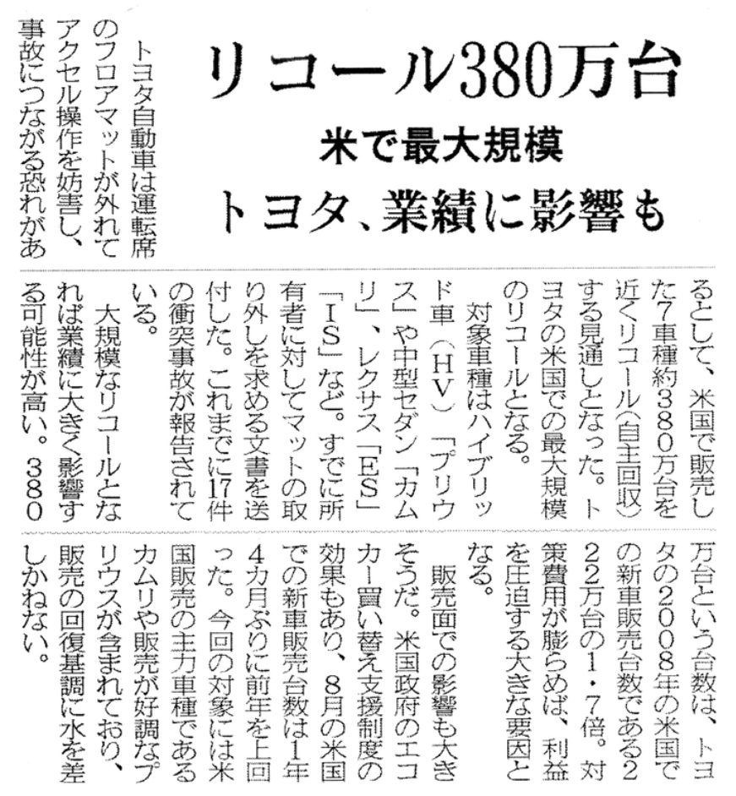
Picture1: News of Recall Situation from Toyota, shows that 3.8 million vehicle were recalled in U.S.(Toyota, 2021)

But this incident did not end. At the end of 2009, new problems appeared in Toyota's automobile products. The accelerator pedal of the vehicle could not or slowly return, which seriously affected the driving safety. Toyota Motor Corporation announced on January 21, 2010, that it recalled several flagship models including Corolla, rav4, and Camry in the United States. After that, the scope of the recall was expanded to the world, with a total of 4.44 million vehicles being recalled. In May 2009, the third-generation Prius had a problem with the abs control program, and Toyota Motor Corporation had to recall 440,000 vehicles worldwide on February 9, 2010 for repairs. (Toyota,2021)

3.3.2 Follow-up issues of Toyota Motor Corporation's large-scale vehicle recall
In response to the recall situation, Akio Toyoda, president of Toyota Motor Corporation, held a press conference in Nagoya City in 2020, announcing the establishment of a special global quality committee. Is to verify and improve product quality in the global market. (Toyota,2021)

In the U.S. market, as Toyota's vehicle incidents are still happening, the U.S. Congress decided to hold a public hearing, and at the hearing criticized a series of Toyota's product quality issues. President Akio Toyoda explained at the notary meeting and explained how Toyota responded. (Toyota,2021)

After that, Akio Toyoda flew from the United States to China in person, and held a press conference in Beijing, expressing his apology and instructions on follow-up measures to Toyota's customers. (Toyota,2021)

Judging from Toyota's actions in the recall situation, this appears to be a successful crisis rescue case. However, from the point of view of corporate social responsibility, especially from the perspective of corporate social responsibility under the deontological framework, this is undoubtedly a failed corporate social responsibility action. First of all, if Toyota Motor Corporation was going to make a proper and aggressive CSR move, then this mass recall shouldn't happen. In a deontological framework, this recall, including various auto parts issues, was "wrong" at the source, it shouldn't have happened, and it shouldn't have been in the automaker's products. The massive recall was inherently wrong, and it was not endorsed by any stakeholder: customers were suspicious of Toyota because of the recall. The government has held a hearing to criticize Toyota Motor Corp.'s product quality problems. The general public has begun to speculate about Toyota Motor Corporation. These actions have dealt a severe blow to Toyota Motor Corporation's corporate social responsibility. Therefore, even if Toyota Motor Corporation carried out a series of rescue operations after the recall, it cannot be the fact that this is a huge social responsibility failure.

3.3.3 Differential treatment of large-scale vehicle recalls by Toyota Motor Corporation
Toyota Motor Corporation has adopted different coping strategies in different countries and regions to resolve the recall incident, but this situation has resulted in the emphasis on the US market and the neglect of the large market in China. The most obvious bias is that Toyota Motor Corporation recalled about 6 million vehicles in the U.S. market and included 16 different models including the Camry and Prius. But Toyota Motor Corporation has only recalled 75,000 vehicles in the Chinese market, and only one model, the rav4. In the U.S. market, Toyota Motor Corporation provides door-to-door service to customers and subsidizes transportation costs for owners who drive back to the garage. However, in the Chinese market, Toyota Motor Corporation does not provide free door-to-door service, and requires car owners to drive to the sales store for repairs. Worst of all, Toyota Motor Corporation cannot guarantee the number of parts in the Chinese market, which results in owners having to drive the problem car several times to the repair shop for repairs.(Zhu, 2014)

It is obvious that Toyota Motor Corporation has adopted completely different strategies in the face of two different markets, China and the United States. Such a move to underestimate consumers in the Chinese market has greatly reduced the impression of consumers in the Chinese market on Toyota Motor Corporation. Such negative effects, coupled with the historical problems left by China and Japan, made Chinese market consumers feel disappointed or even hopeless about Toyota Motor Corporation for a time. Toyota Motor Corporation once again ignored the company's stakeholder group in this incident, and took almost irresponsible remedial actions against consumers in the Chinese market, making consumer groups and government departments feel chilled about the company's social responsibility. This situation was not until the government launched the relevant regulations of the "Consumer Rights Protection Law of the People's Republic of China", and Toyota was forced to take further compensation actions. Toyota's actions in China have proven to be extremely irresponsible and have disappointed Chinese stakeholder groups.

3.4 Reflection
Toyota's negative case isn't just a massive recall that began in 2009. To this day, Toyota Motor Corporation continues to have negative cases that surprise and disappoint stakeholders and society. In 2016, for example, Toyota Motor Corporate recalled 5.8 million vehicles worldwide for airbag problems.(BBC,2016) In 2018, Toyota Motor Corporation products once again aroused speculation in society after Kobe Steel, a raw material supplier to Toyota Motor Corp, admitted to falsifying the strength and quality of products sold to Toyota Motor Corp. (Toyota, 2018)This series of events can reflect the contradiction with Toyota Motor Corporation's internal and external corporate social responsibility and ethics. However, such contradictions can also highlight the difficulties of CSR and the complexity of implementation. Sheehy(2014) believes that one of the main reasons for the current difficulty in exercising corporate social responsibility is that management has too much power to measure and formulate freely. They can incorporate corporate social responsibility into management decisions and turn an organization's ethical behavior into organizational Intentional management measures, which create certain moral and ethical risks. Grigoris(2016) summarizes the difficulties of corporate social responsibility: The difficulties of corporate social responsibility mainly come from: 1. Lack of transparency. 2. Lack of consensus CSR standards or ineffective CSR standards. 3. Corporate social responsibility standards that do not meet the characteristics of the country. 4. The assessment of the dimension of corporate social responsibility is not sufficient. 5. Inappropriate selection of corporate social responsibility assessment criteria. Nowadays, almost all companies are promoting their own corporate social responsibility actions, which has become a globally recognized leading form for companies to actively participate in social responsibility construction and promote corporate change. However, it is precisely because corporate social responsibility has become the driving model of global business that it has developed a series of deviations. As pointed out by grigoris(2016), the evaluation of corporate social responsibility is different in different countries and regions. Therefore, Toyota Motor Corporation's differentiated treatment in the Chinese market is exactly the corporate social responsibility standard that does not meet the characteristics of the country and region. A huge disaster was caused by Toyota Motor Corporation's incorrect assessment of the latitude of regional CSR. This kind of behavior makes today's corporate social responsibility a formulaic phenomenon. Sheehy(2014) pointed out that the difficulty of corporate social responsibility comes from the vagueness and diversity of its definition. Today, if a 10 billion-dollar company donates ten dollar, it can also be called corporate social responsibility. Likewise, Toyota's global remediation plan in the wake of the massive recall could be included in Toyota's corporate social responsibility actions. But as mentioned in the first and second parts, although corporate social responsibility is a relatively subjective perception, its origin comes from the ideology of social progress and the positive phenomenon of social progress. It also comes from a correct ethical and moral framework, and a subconscious mind of integrity. Therefore, even if there are all kinds of difficulties in corporate social responsibility today, even the world's top company such as Toyota Motor Corporation has a huge disaster, it cannot prevent correct, honest and positive corporate social responsibility actions and concepts from reaching the organization. action concept and core. Therefore, in the next section, the researcher will further elaborate on the future development of current CSR.

4.0 CSR Future Development of Toyota Motor Corporation and Automakers
The promotion of corporate social responsibility is contradictory in the case of Toyota Motor Corporation. On the one hand, Toyota Motor Corporation has a relatively complete corporate social responsibility theory, action principle, moral and ethical framework and many successful social responsibility actions. But on the other hand, Toyota Motor Corporation still had a catastrophic corporate crisis despite having a well-established CSR framework. In the last part, researcher mentioned the difficulties related to the development of corporate social responsibility, which also affects the future development of corporate social responsibility. Strandberg (2002) believes that the current corporate social responsibility has become the main business scope of enterprises, but its development is relatively slow. The main reason for this situation is the inconsistency between the corporate social responsibility statement and the corporate social responsibility action, that is, the company will choose to protect its own interests and selectively ignore some social responsibilities.(Garriga and Mele, 2004) This situation can be concluded in the previous section in which Toyota Motor Corporation treats customers in the Chinese and American markets differently. Not only that, the current corporate social responsibility lacks a certain driving force (such as clear legal provisions), and today’s corporate social responsibility is still a huge subject with a subjective nature, which makes it impossible for companies to take collective actions to promote corporate social responsibility. development of. The complex corporate social responsibility content also increases the cost of enterprises in disguise, thus making it difficult for small and medium-sized enterprises to implement.(Garriga and Mele, 2004. Carroll, 2015. Grigoris, 2016. Fitch, 1976. )

However, various difficulties cannot prevent the continued development of corporate social responsibility, because it is an inevitable result of social development and progress. In the future, corporate social responsibility will be substantively incorporated into the strategic deployment of enterprises. (Moon and Shen, 2010. Boatright, 2001)The significance of corporate social responsibility will have both social and corporate strategic significance. Enterprises will abide by the standards of corporate social responsibility and create more strategic corporate actions. Under such development, the stakeholders of the enterprise will play a more important role. Stakeholders will not only directly participate in the corporate society of the company to make you miss you, but they will also have influence and propose innovative and challenging values for the company.(Moon and Shen, 2010. Kell, 2018) Such a case can be seen from the attitude of the US Congress and the US National Highway Traffic Safety Administration to Toyota Motor Corporation's vehicle recalls. further measures. In the future, stakeholder groups will carry out activities together with enterprises, which is an inevitable innovation process. In the case of Toyota Motor Corporation, it can be seen that Toyota Motor Corporation has begun to cooperate with stakeholder groups (such as drivers, government Department employees, road traffic safety managers, etc.) to cooperate to promote the development of corporate social responsibility.

Due to the development of society, enterprises, especially large multinational companies such as Toyota Motor Corporation, need to always pay attention to the development and changes of social responsibility. Nowadays, with the development of society, corporate social responsibility has become more than a simple manifestation of organizational social responsibility, and corporate social responsibility has become a sign that stakeholder groups view enterprises. Stakeholder groups will feel positive or negative about companies through corporate social responsibility actions, and this phenomenon has become particularly prominent in the current context of the global flu. Therefore, the development of corporate social responsibility will integrate the perception of stakeholder groups, social development and corporate development strategies to become a comprehensive corporate action.

For vehicle companies, the current social responsibility tasks include carbon dioxide emissions, carbon neutrality, equity and diversity development, in addition to facing the global flu together. These emerging corporate social responsibility requirements indicate that companies need to update or redesign their corporate social responsibility strategies. Toyota Motor Corporation combines corporate social responsibility with its own code of conduct, corporate development philosophy and corporate operation core to further draw closer to stakeholders, which is in line with the development trend of corporate social responsibility mentioned above. In addition to Toyota Motor Corporation, other automakers, such as Ford Motor, have also incorporated corporate social responsibility into their corporate strategies, and have made their own actions for new energy, carbon dioxide emissions, social philanthropy, etc.(Ford, 2021) A corporate social responsibility strategy has made Ford a world-renowned automaker that rivals Toyota Motor Corporation. Therefore, the development of social responsibility of automobile manufacturers requires enterprise managers to clearly recognize their own stakeholders and the development of society, and analyze the scope of their own actions from this, and finally make a contribution that is in line with their own reputation, interests and positive social contributions. behavior. As advocated by deontological corporate social responsibility, companies need to do what subconsciously and absolutely rationally think is right, and use it as a correct moral and ethical framework to subconsciously affect all employees of the company - just like Toyota Motor Corporation. .

From the full text, the development of corporate social responsibility is a long and complicated process. It still takes a long time for accurate positioning and application. However, the future development of corporate social responsibility is objective, and it will surely develop with the development of society. For automakers such as Toyota Motor Corporation, the development of CSR will focus on the relationship between the company and its stakeholders, and place CSR actions within the main business scope of the company. Internally, corporate social responsibility will gradually change from corporate social action to corporate strategic action, and, like Toyota Motor Corporation, will incorporate corporate social responsibility into the company's operating philosophy and code of conduct, so as to improve the company's own reputation and brand awareness, and improve their comprehensive competitiveness.

5.0 References
- Bondy, K., Moon, J., & Matten, D. 2012. An Institution of Corporate Social Responsibility (CSR) in Multi-National Corporations (MNCs): Form and Implications. Journal of Business Ethics, 111(2), pp.281–299.
- BBC., 2014. About Duty-based Ethics. [online] bbc.co.uk. Available at: <https://www.bbc.co.uk/ethics/introduction/duty_1.shtml#top> [Accessed 25 January 2022]
- BBC., 2018. Japan's Kobe Steel indicted over quality scandal. [online] bbc.co.uk. Available at: <https://www.bbc.com/news/business-44895564> [Accessed 25 January 2022]
- BCampus. 2022. Deontology: Ethic as Duty. [online] opentextbc.ca. Available at: <https://opentextbc.ca/businessethicsopenstax/chapter/deontology-ethics-as-duty/#OSX_Ethics_02_05_Critique> [Accessed 25 January 2022]
- BOS., 2020. The problem with CSR: why companies need to listen to their activist employees. [online] .bos-cbscsr.dk. Available at: <http://www.bos-cbscsr.dk/2020/05/13/the-problem-with-csr-why-companies-need-to-listen-to-activist-employees/> [Accessed 25 January 2022]
- Boatright, J. R. (2001). The Future of Corporate Social Responsibility. Business & Professional Ethics Journal, 20(3/4),pp.39-48
- BBC., 2016. Toyota recalls 5.8 million cars over faulty Takata airbags. [online] .bbc.com. Available at: <https://www.bbc.com/news/business-37771220> [Accessed 25 January 2022]
- Carroll, A., 2015. Corporate Social Responsibility: The Centerpiece of Competing and Complementary Frameworks. Organizational Dynamics, 2015(44), pp.87-96.
- Corcut, S., 2020. The Evolution and the Future of Corporate Social Responsibility in a Post Covid-19 World. [online] .thesustainabilist.ae. Available at: <https://thesustainabilist.ae/the-evolution-and-the-future-of-corporate-social-responsibility-in-a-post-covid-19-world/> [Accessed 25 January 2022]
- CSR: Face of the future or fad? 2003. RSA Journal, 152(5517)
- Chakrabarty, S., & Erin, A. 2013. Comparing Virtue, Consequentialist, and Deontological Ethics-Based Corporate Social Responsibility: Mitigating Microfinance Risk in Institutional Voids. Journal of Business Ethics, 126(3), pp. 487–512.
- DoubleDonation., 2021. Corporate Social Responsibility: The Definitive Guide. [online] doublethedonation.com. Available at: <https://doublethedonation.com/tips/corporate-social-responsibility/> [Accessed 25 January 2022]
- Donaldson, T., & Preston, L. E. 1995. The Stakeholder Theory of the Corporation: Concepts, Evidence, and Implications. Academy of Management Review, 20(1), pp.65–91.
- Dyer, J. H., & Nobeoka, K. 2000. Creating and managing a high-performance knowledge-sharing network: the Toyota case. Strategic Management Journal, 21(3), pp.345–367
- Eldo, F., & Gianmarco, F., 2017. Ethics and Deontology in Business. [online] austinpublishinggroup.com. Available at: <https://austinpublishinggroup.com/business-administration-and-management/fulltext/ajbam-v1-id1007.php> [Accessed 25 January 2022]
- EthicCenters., 2016. Ethics Explainer: Deontology. [online] ethics.org.au. Available at: <https://ethics.org.au/ethics-explainer-deontology/> [Accessed 25 January 2022]
- Fitch, H., 1976. Achieving Corporate Social Responsibility. The Academy of Journal Review, 1(1), pp.38-46.
- Freeman, E., & Werhane, P. 2008. A Note on Deontology. SSRN Electronic Journal, 2008(10).
- Ford., 2021. Corporate Social Responsibility. [online] ford.co.uk. Available at: <https://www.ford.co.uk/experience-ford/about-ford/corporate-social-responsibility> [Accessed 25 January 2022].
- Ford., 2021. Corporate. [online] corporate.ford.com. Available at: <https://corporate.ford.com/> [Accessed 25 January 2022]
- Fernando, J., 2021. Corporate Social Responsibility (CSR). [online] investopedia.com. Available at: <https://www.investopedia.com/terms/c/corp-social-responsibility.asp> [Accessed 25 January 2022].
- Freeman, R. E. 2010. Strategic Management: A Stakeholder Approach. Cambridge University Press.
- Freeman, R., & Evan, W. M. 1990. Corporate governance: A stakeholder interpretation. Journal of Behavioral Economics, 19(4), pp. 337–359.
- Garriga, E., & Melé, D. 2004. Corporate Social Responsibility Theories: Mapping the Territory. Journal of Business Ethics, 53(1/2), pp.51–71.
- Grigoris, G. 2016. The Challenges of Corporate Social Responsibility Assessment Methodologies. International Journal of Economics and Business Administration, IV(Issue 1), pp.39–55.
- Gupta, S., & Sharma, N. (2009). CSR- A Business Opportunity. Indian Journal of Industrial Relations, 44(3), 396–401.
- Harvey, K., 2021. The Future of Corporate Social Responsibility. [online] .texasceomagazine.com. Available at: <https://texasceomagazine.com/the-future-of-corporate-social-responsibility/> [Accessed 25 January 2022]
- Insider., 2021. Toyota just started building a 175-acre smart city at the base of Mount Fuji in Japan. Photos offer a glimpse of what the 'Woven City' will look like? [online] businessinsider.com. Available at: <https://www.businessinsider.com/toyota-city-of-the-future-japan-mt-fuji-2020-1> [Accessed 25 January 2022]
- Jones, T. M., & Wicks, A. C. 1999. Convergent Stakeholder Theory. Academy of Management Review, 24(2),pp. 206–221.
- Jones, T. M. 1980 Corporate Social Responsibility Revisited, Redefined, California Management Review, 22(3), pp. 59–67.
- Kuzmin, O., & Khilukha, O. 2016. Regulation of stakeholders’ interests in corporate governance through negotiations. Economic Annals-ХХI, 161(9-10), pp.56–60.
- Kell, G., 2018. The Future Of Corporate Responsibility [online] .forbes.com. Available at: <https://www.forbes.com/sites/georgkell/2018/06/18/the-future-of-corporate-responsibility/?sh=210e8a0b6105> [Accessed 25 January 2022]
- Lindgreen, A. and Swaen, V., 2010. Corporate Social Responsibility. International Journal of Management Reviews, 12(1), pp.1-7.
- Ledecky, M., 2021. Corporate Social Responsibility: Past, Present, And Future [online] .everfi.com. Available at: <https://everfi.com/blog/community-engagement/csr-history/> [Accessed 25 January 2022]
- Lister., 2019. Toyota Hybrids Prove Faultless in What Car? [online] .listers.co.uk. Available at: <https://listers.co.uk/news/2019/09/toyota-hybrids-prove-faultless-what-car-reliability> [Accessed 25 January 2022]
- Liker, J. K., & Morgan, J. M. 2006. The Toyota Way in Services: The Case of Lean Product Development. Academy of Management Perspectives, 20(2), pp.5–20.
- Micewski, E., & Troy, C. 2007. Business Ethics - Deontologically Revisited. Journal of Business Ethics, 72(1), pp.17–25.
- Mitchell, R. K., Agle, B. R., & Wood, D. J. 1997. Toward a Theory of Stakeholder Identification and Salience: Defining the Principle of who and What Really Counts. Academy of Management Review, 22(4), pp.853–886.
- Moon, J., & Shen, X. 2010. CSR in China Research: Salience, Focus and Nature. Journal of Business Ethics, 94(4), 613–629.
- Moncrieff, L. 2015. Karl Polanyi and the Problem of Corporate Social Responsibility. Journal of Law and Society, 42(3), pp.434–459.
- Natalia,Y,C., 2021. CSR & Sustainability Trends in 2021. [online] .artemis.im. Available at: <https://artemis.im/csr-and-sustainability-trends/> [Accessed 25 January 2022]
- Olander, S., & Landin, A. 2005. Evaluation of stakeholder influence in the implementation of construction projects. International Journal of Project Management, 23(4), pp.321–328.
- Oxford., 2018. What is Mendelow’s Matrix and How It Is Useful? [online] .oxfordcollegeofmarketing.com. Available at: <https://blog.oxfordcollegeofmarketing.com/2018/04/23/what-is-mendelows-matrix-and-how-is-it-useful/> [Accessed 25 January 2022]
- OpenDemocracy., 2014. The problem with corporate social responsibility. [online] .opendemocracy.net. Available at: <https://www.opendemocracy.net/en/problem-with-corporate-social-responsibility/> [Accessed 25 January 2022]
- ProfessionalAcademy., 2022. Mendelow’s Matrix- Marketing Theories. [online] .professionalacademy.com. Available at: <https://www.professionalacademy.com/blogs/mendelows-matrix-marketing-theories/> [Accessed 25 January 2022]
- Stakeholdermap., 2008. Stakeholder Analysis, Project Management, Templates and Advice.[online] stakeholdermap.com. Available at: <https://www.stakeholdermap.com/stakeholder-definition.html> [Accessed 25 January 2022].
- Schooley, S., 2021. What Is Corporate Social Responsibility?. [online] businessnewsdaily.com. Available at: <https://www.businessnewsdaily.com/4679-corporate-social-responsibility.html> [Accessed 25 January 2022].
- Stanford. 2020. Deontological Ethics. [online] plato.stanford.edu. Available at: https://plato.stanford.edu/entries/ethics-deontological/> [Accessed 25 January 2022].
- Sheehy, B. 2014. Defining CSR: Problems and Solutions. Journal of Business Ethics, 131(3), pp.625–648.
- Strandberg, C. 2002. The Future of Corporate Social Responsibility. VanCity Credit Union, Canada.
- Schouten, C., Graafland, J., & Kaptein, M. 2013. Religiosity, CSR Attitudes, and CSR Behavior: An Empirical Study of Executives’ Religiosity and CSR. Journal of Business Ethics, 123(3), pp.437–459.
- Toyota., 2019. Toyota’s Social Contribution Activities. Toyota Motor Corporation. Toyota City, Aichi..
- Toyota., 2018. Toyota Code of Conduct. Toyota Motor Corporation. Toyota City, Aichi.
- Toyota., 2021. Toyota’s Human Rights Policy. Toyota Motor Corporation. Toyota City, Aichi.
- Toyota., 2015. Sustainability Data Book. Toyota Motor Corporation. Toyota City. Aichi.
- Toyota., 2020. More to Toyota than Meets the Eyes. Toyota Motor Corporation. Toyota City, Aichi.
- Toyota., 2021. Toyota Philosophy. [online] global.toyota. Available at: <https://global.toyota/en/company/vision-and-philosophy/philosophy/> [Accessed 25 January 2022].
- Toyota., 2021. Toyota Production System. [online] global.toyota. Available at: <https://global.toyota/en/company/vision-and-philosophy/production-system/> [Accessed 25 January 2022]
- Toyota., 2021. Social Contribution Activities. [online] global.toyota. Available at: <https://global.toyota/en/sustainability/esg/social-contribution/> [Accessed 25 January 2022]
- Toyota., 2021. Sustainability Fundamental Policy. [online] global.toyota. Available at: <https://global.toyota/en/sustainability/csr/policy/> [Accessed 25 January 2022]
- Toyota., 2021. Guiding Principles at Toyota. [online] global.toyota. Available at: <https://global.toyota/en/company/vision-and-philosophy/guiding-principles/> [Accessed 25 January 2022]
- Toyota., 2021. Sales, Production, and Export Report Results for October 2021. [online] global.toyota. Available at: <https://global.toyota/en/company/profile/production-sales-figures/202110.html> [Accessed 25 January 2022]
- Toyota., 2021. Toyota Breaks Ground for Woven City. [online] global.toyota. Available at: <https://global.toyota/en/newsroom/corporate/34827717.html> [Accessed 25 January 2022]
- Toyota., 2021. Voluntary Remedies and Recalls. [online] global.toyota. Available at: <https://www.toyota-global.com/company/history_of_toyota/75years/text/leaping_forward_as_a_global_corporation/chapter5/section3/item1.html> [Accessed 25 January 2022]
- ToyotaWovenCity., 2021. Woven City. [online] woven-city.global. Available at: <https://www.woven-city.global/> [Accessed 25 January 2022]
- Toyota., 2019. Takata Airbag Safety Recall. [online] .toyota.com. Available at: <https://www.toyota.com/recall/takata> [Accessed 25 January 2022]
- V, B., & Rupamanjari Sinha, R. 2012. Corporate Social Responsibility. Vikas Publishing House, New Delhi.
- Zhu,W., 2014. Toyota Motor Corporation in China and The United States Recalls in the Comparative Study on Communication Strategies. Shanghai International Studies University. Shanghai China.

Appendix

Appendix1: Toyota Philosophy
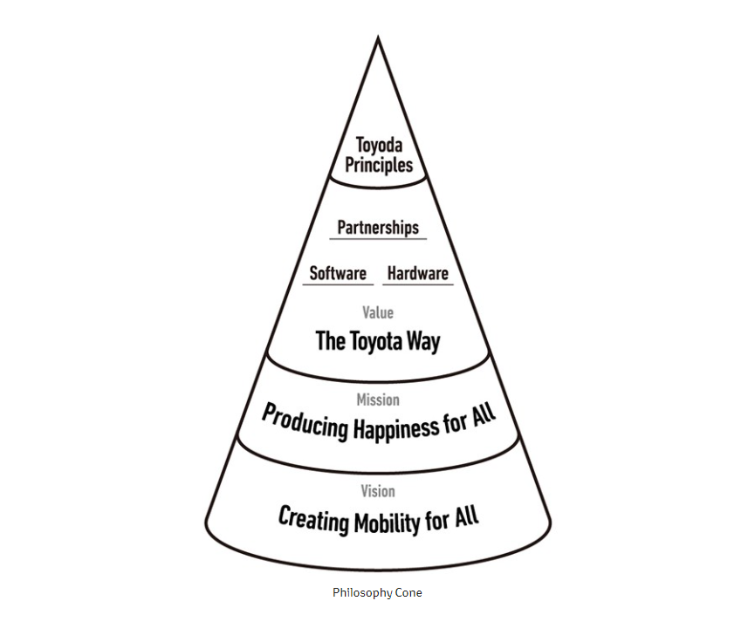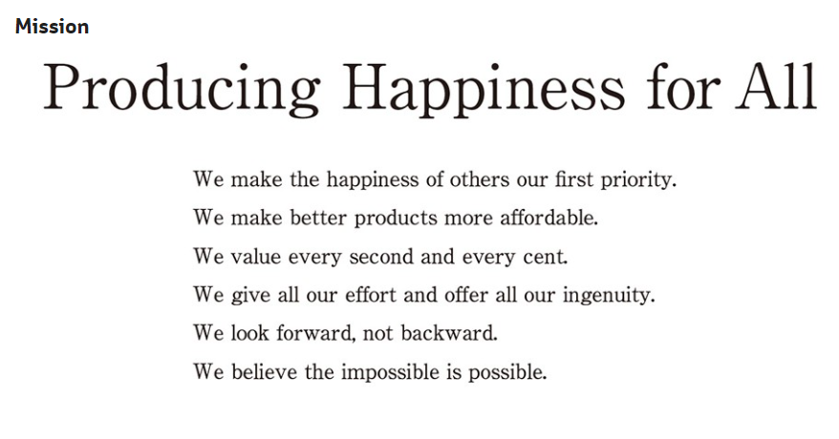
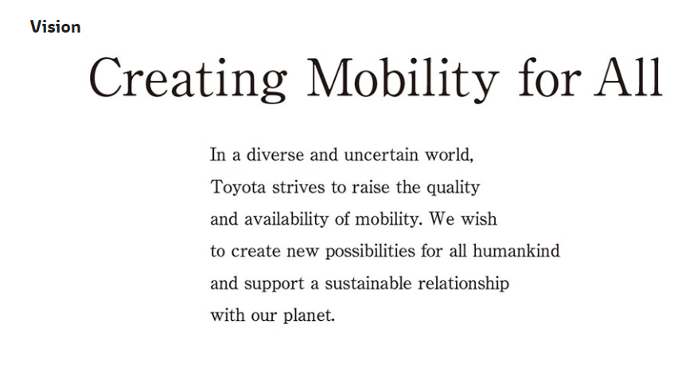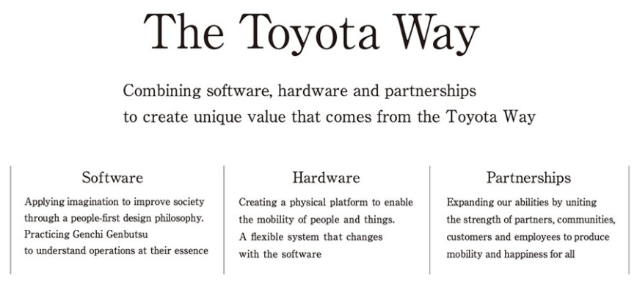

Appendix2: Toyota Code of Conduct 2018
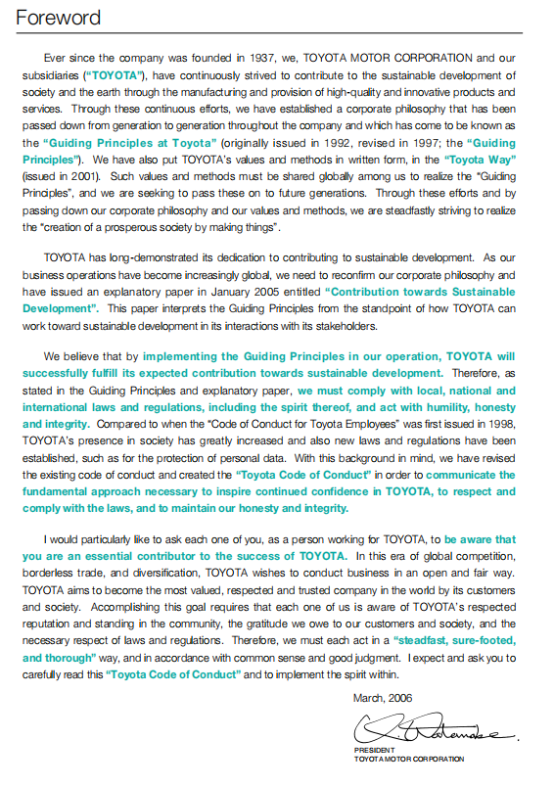
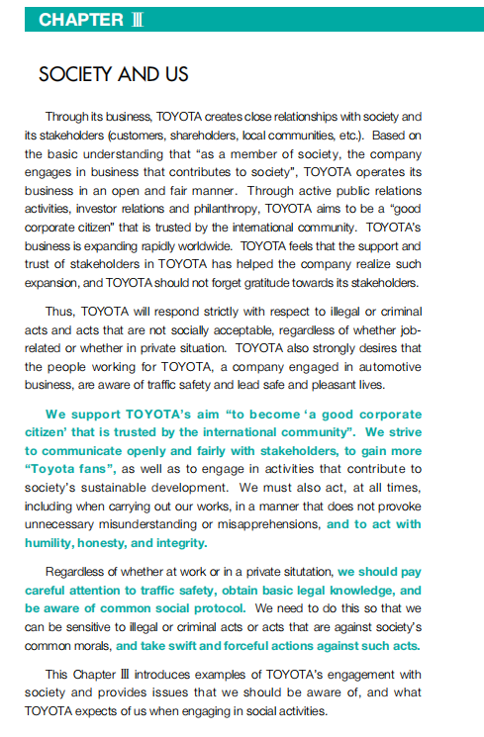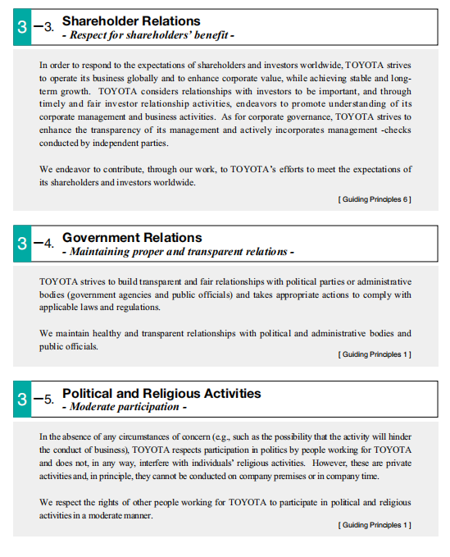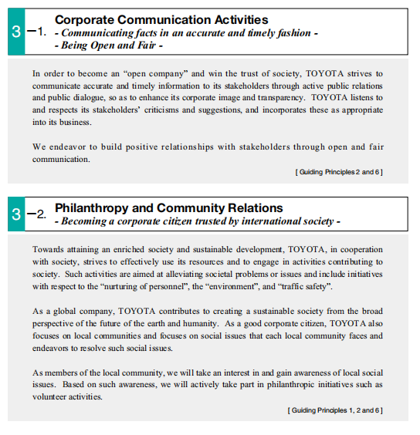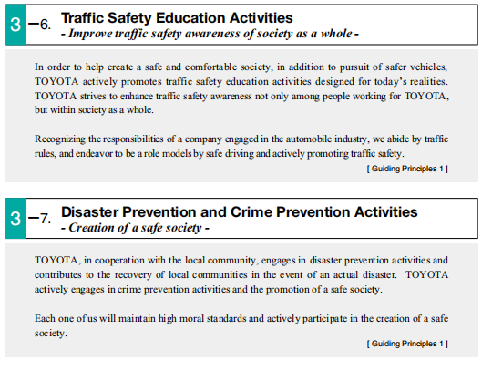

Appendix3: Toyota Human Rights Policy
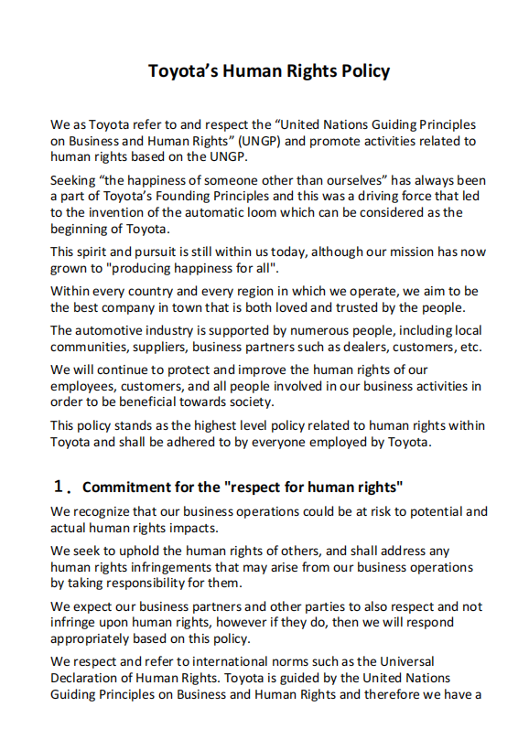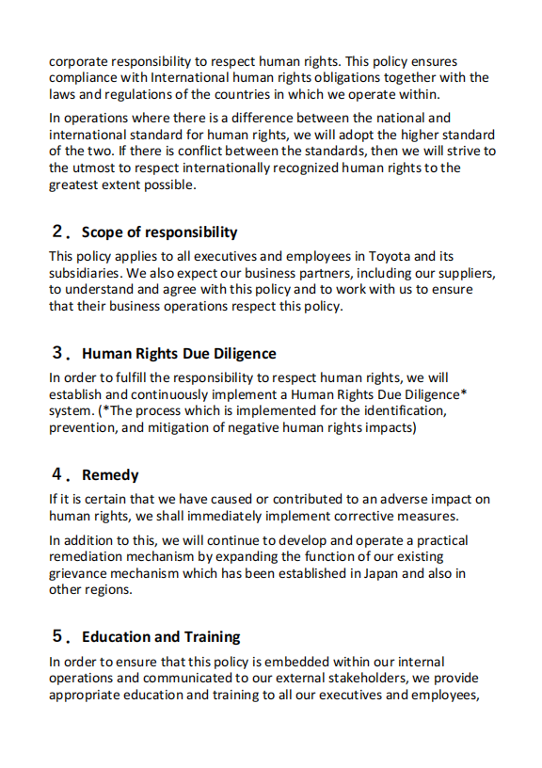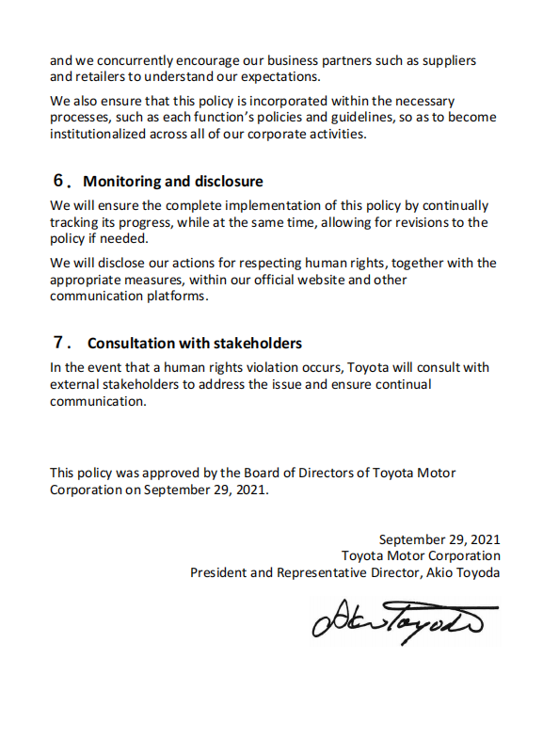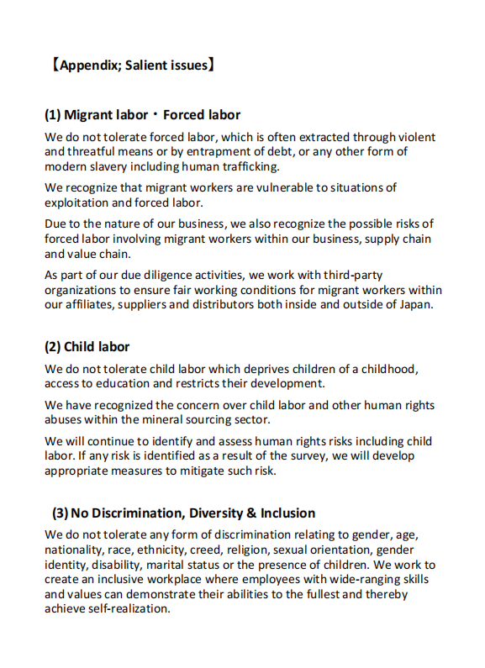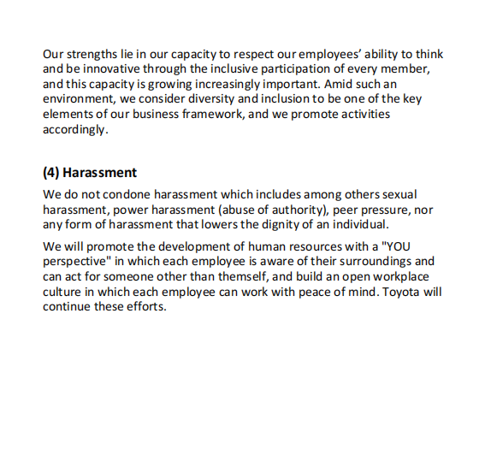

Appendix4: Traffic Safety Activities of Toyota
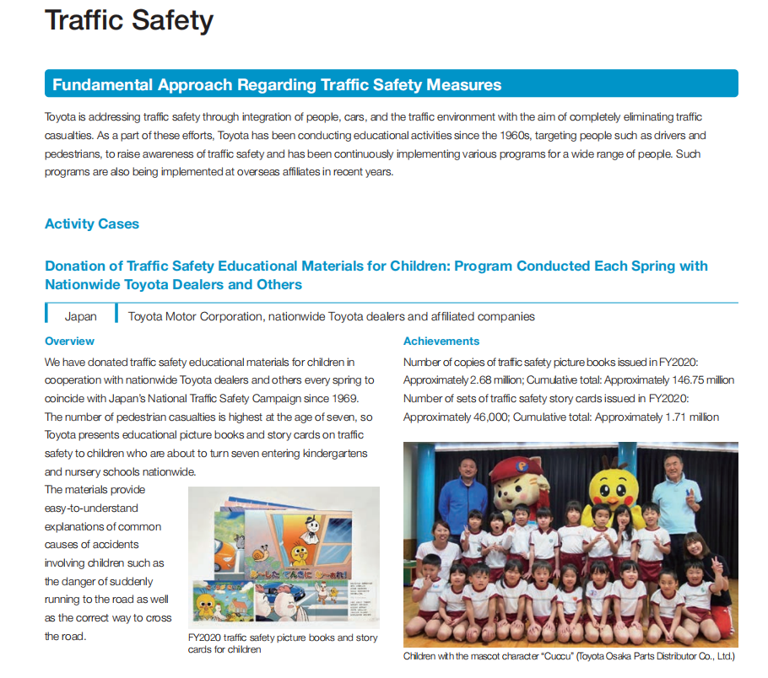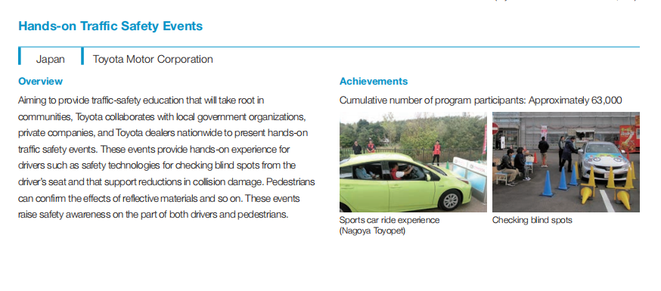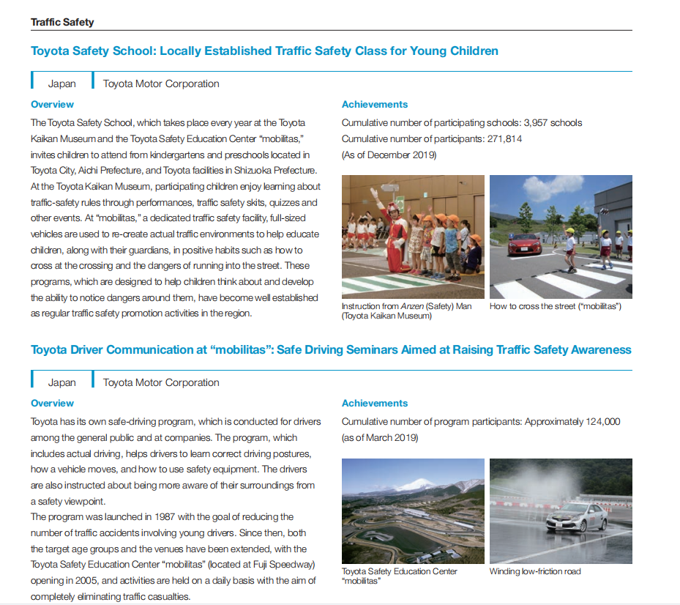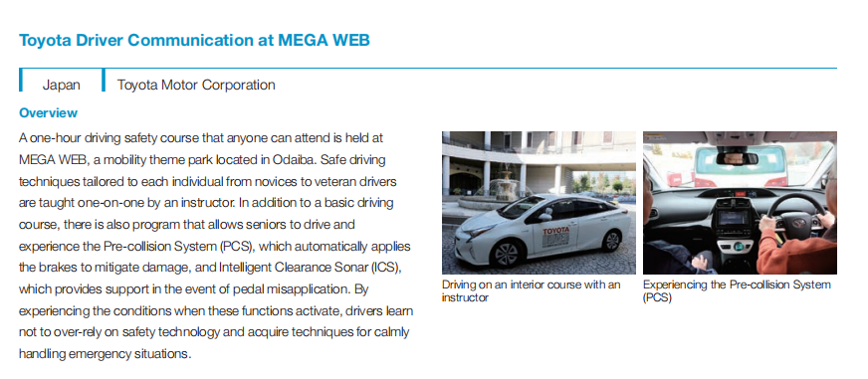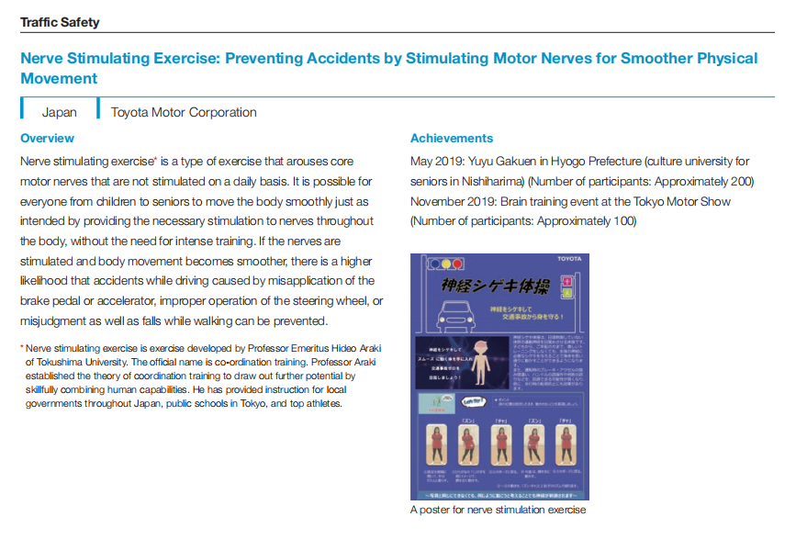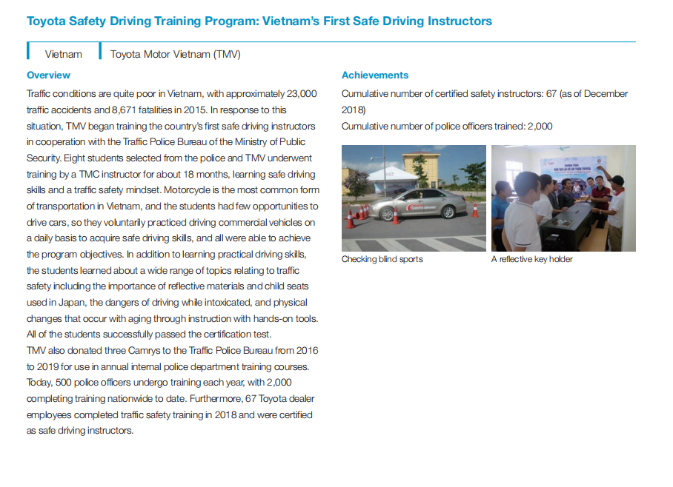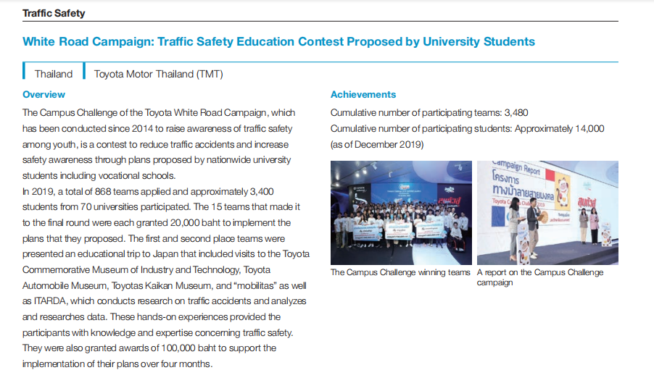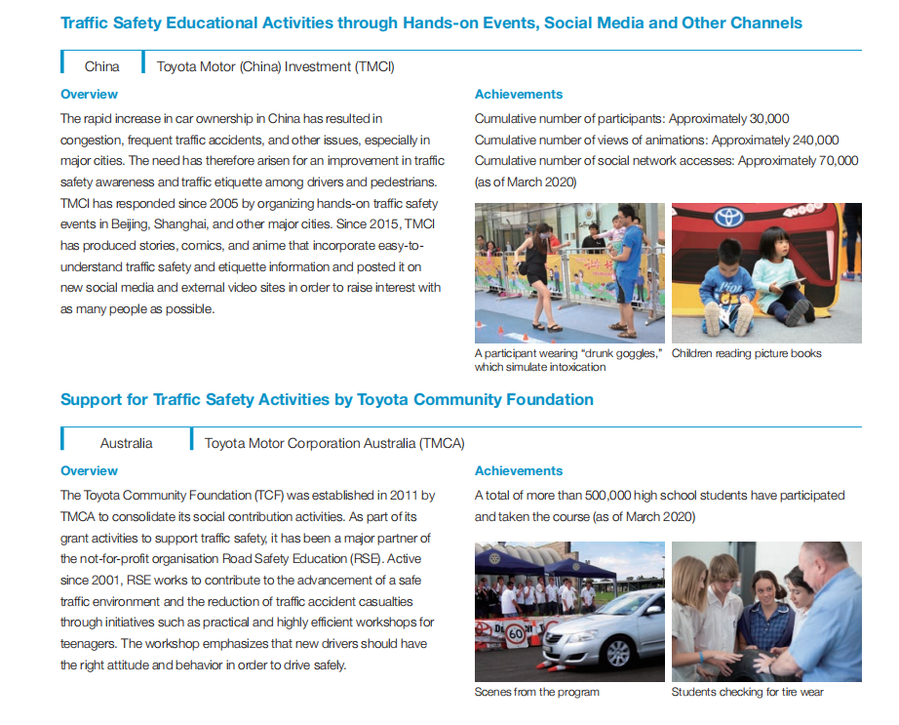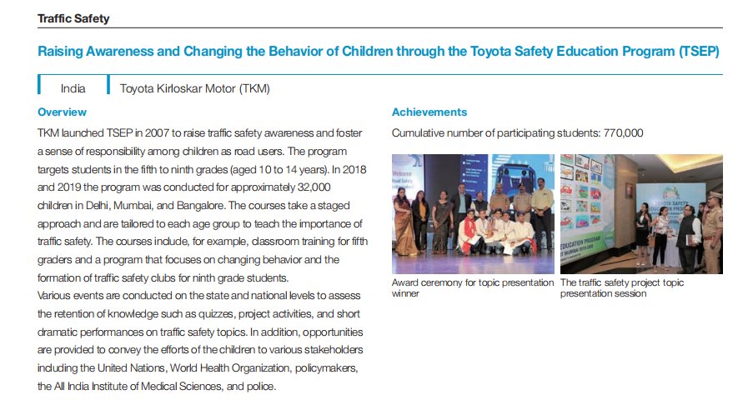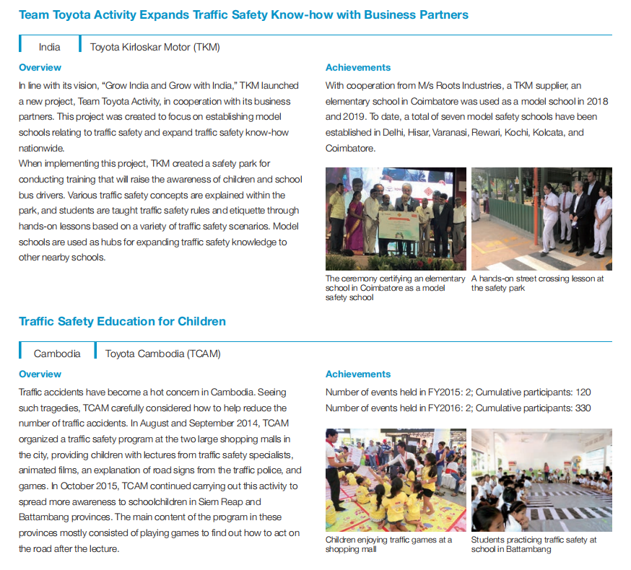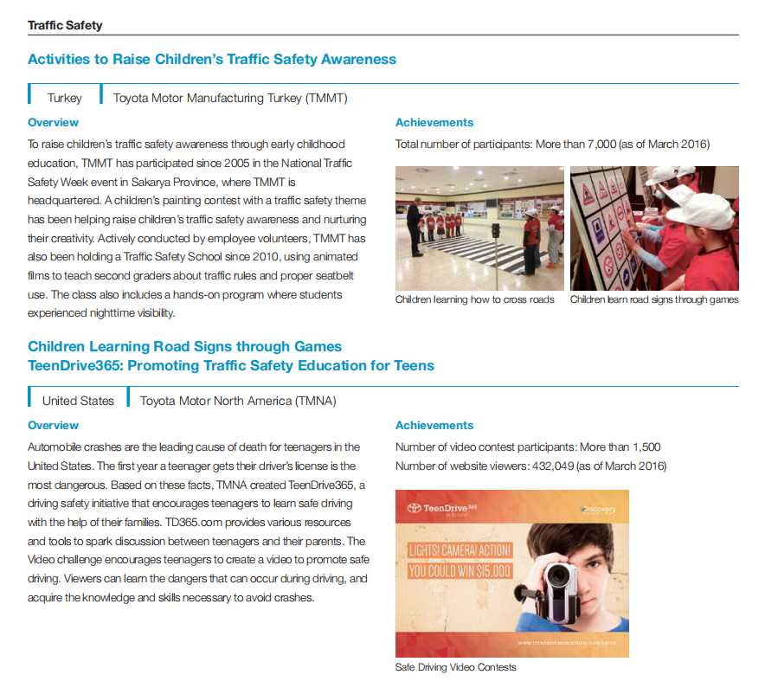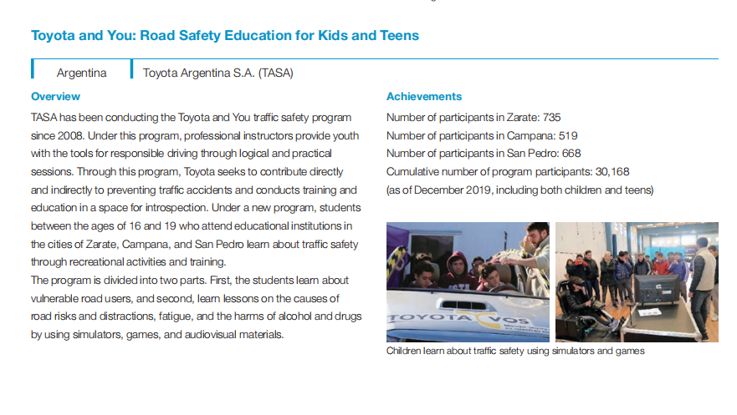

Appendix5: Toyota Environmental Challenge 2050

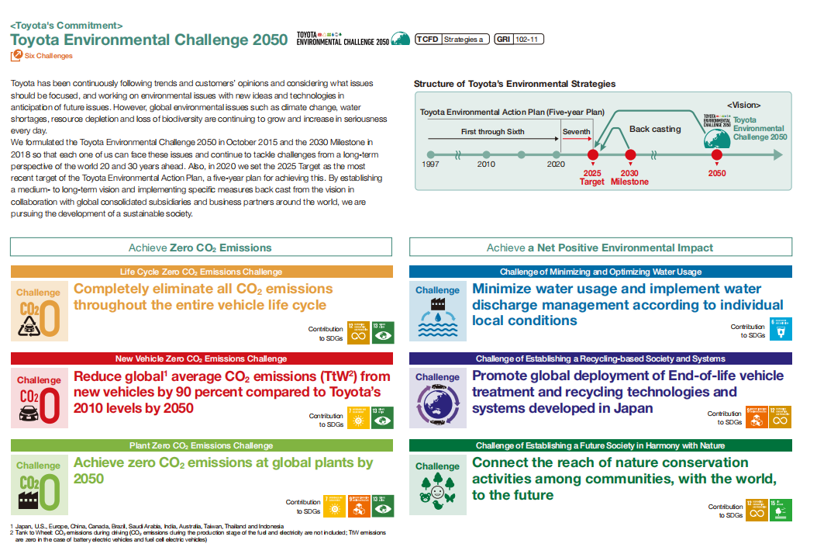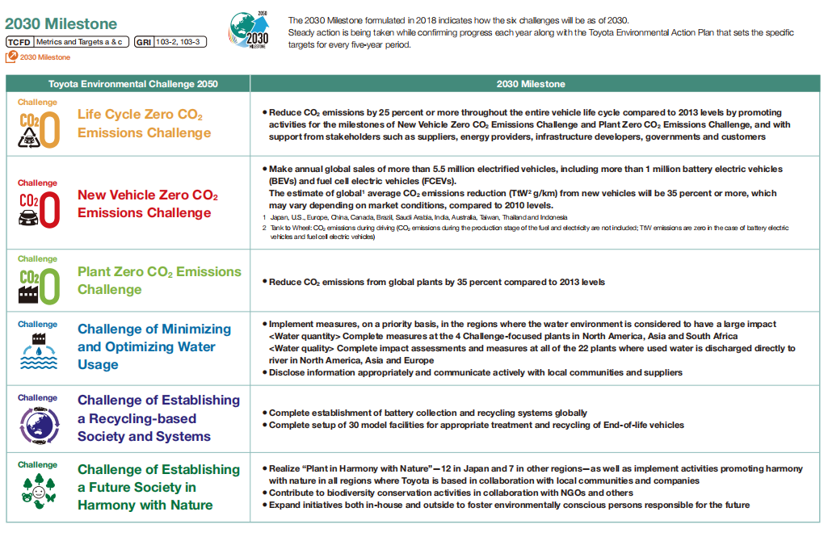

Appendix6: Social Contribution and Disaster Rescue



