Coursework: Business Plan
Student name: Ionel Jerca
Student number:2123373
Date: 29-07-2023

Table of Contents
Business Description / Intellectual Property and Legal Considerations 3
Industry Analysis 3
Porter’s 5 Forces 3
Operations and Management Team Plan 4
Operations Plan 4
Management Team Plan 5
Legal Structure 6
Marketing Plan 6
4ps of Marketing Mix 6
Financial Plan 7
Source and Uses of Funds 7
6 months Cash Budget Forecast 7
Market Research 8
Pestle analysis 8
References 10

Business Description / Intellectual Property and Legal considerations
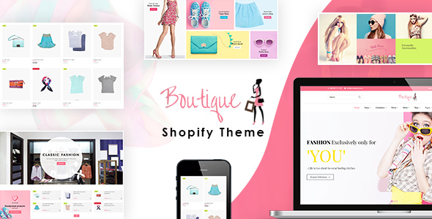
Figure 1: Online fashion boutique business
(Source: Bland and Osterwalder, 2019)
Mercy Trends is an innovative online boutique in the UK that sells fashionable and reasonably priced clothes for women (Bland and Osterwalder, 2019). Their products are official dresses, swimwear, ethnic wear, traditional wear and accessories mainly for female customers. Mercy Trends wants to give fashionable people, especially women, a special shopping experience by providing the latest fashion trends, good materials, and great customer service.
One important part of Mercy Trends’ business model is that it focuses on protecting its ideas and creations. The company knows how important it is to keep its special designs, logos, and brand identity safe. To protect its brand from being copied or fake, the company registers its trademarks. Also, Mercy Trends promises to respect the ideas and products of other designers and manufacturers. They get their products from reliable suppliers and make sure they follow the rules about copyright and licensing.
Mercy Trends follows all the laws and rules that apply to running an online fashion boutique in the UK (Bland and Osterwalder, 2019). This means following the rules that protect customers, keep their personal information safe, and govern online business activities. The company promises to have clear prices, give accurate information about its products, and have fair return policies so that customers can trust them more.
Additionally, Mercy Trends is very committed to safeguarding customer information through strong security measures. It follows the GDPR rules and keeps customer information safe and private.
Mercy Trends is always looking for ways to grow and expand. The company tries to team up with popular fashion brands to make special collections together. This helps the company reach new types of customers and get more people to know its brand. Furthermore, Mercy Trends uses specific marketing tactics like social media, partnering with influencers, and online advertisements to efficiently reach the people they want to connect with.
Mercy Trends is a new company that sells fashionable products and makes sure to protect its original ideas and follow all the legal rules (Bland and Osterwalder, 2019). The company wants to be a respected and well-known player in the UK online fashion industry by providing good quality products, being creative, and making customers happy.

Industry Analysis

Porter’s 5 Forces
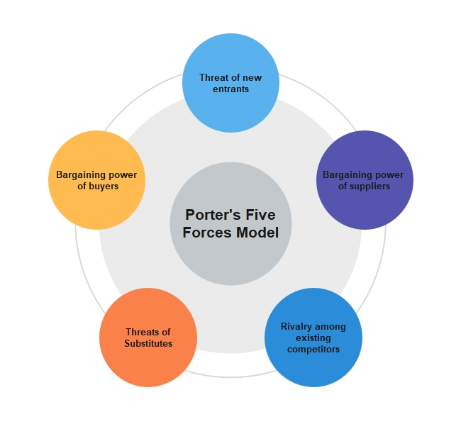
Figure 2: porter’s Five Forces
(Source: Goyal, 2020)
- Competitive Rivalry (High)
The UK’s online fashion industry is very competitive, with many well-known brands already in the market and new ones constantly joining. It can be hard for Mercy Trends to compete with popular brands and established online stores (Goyal, 2020). However, the small shop can stand out by selling one-of-a-kind and fashionable clothes that are specific to a certain group of customers.
- Supplier Power (High)
The success of Mercy Trends relies on how well it gets along with its suppliers. A new boutique store might have some difficulties in getting good prices and deals from suppliers, especially when compared to bigger stores. Creating strong connections with suppliers and making sure to have a variety of suppliers can help reduce this risk.
- Buyer Power (High)
People who buy clothes online have a lot of power because they have many choices and can easily try different websites (Niu and Zhao, 2023). To solve this problem, Mercy Trends can concentrate on giving great customer service, recommending things tailored to each customer, and creating distinct ways of shopping. This will make customers want to keep coming back and decrease the chance of them going to other stores.
- Threat of Substitutes (Moderate)
Online fashion boutiques face competition from both physical stores and other online platforms. Mercy Trends can use its website and online presence to offer customers more convenience, lower prices, and a bigger variety of products. This will help the company stand out from regular stores and other online shopping websites.
- Threat of New Entrants (Low)
The easy access for new people to start their own online fashion businesses makes it likely that more competitors will enter the market (Niu and Zhao, 2023). However, Mercy Trends can gain an advantage over competitors by creating a strong brand, using effective marketing techniques, and earning customer trust and loyalty. Mercy Trends can keep other companies from coming in by always coming up with new ideas and staying on top of what people want.

Operations and Management Team Plan

Figure 3: Operations and Management Plan
(Source: Bortolini et al. 2021)

Operations Plan
- Business Model
Mercy Trends is a company that sells fashion clothes online (Bortolini et al. 2021). The boutique will find fashionable clothes from different suppliers and designers. The goods will be kept in one main warehouse. They will use special systems to keep track of how much stock they have and make sure that orders are delivered quickly.
- Inventory Management
To make sure they have a variety of current items in stock, Mercy Trends will build good connections with manufacturers and suppliers from different countries. The management team will often study and understand what customers like and what is popular in the market to make smart choices when buying things (Cohen et al. 2019). They will regularly check the inventory to make sure they have the right number of items. This will help them avoid having too little or too much stock.
- Website Development and Maintenance
Mercy Trends is planning to put money into creating a website for buying and selling things that is easy to use and look nice (Le et al. 2019). The website will display a list of products, allow customers to order and pay online, and make shopping easy for everyone. The managers will work closely with the people who create websites to make sure that the website works well, is safe, and can be used on different devices.
- Order Fulfilment and Shipping
After getting orders from customers, Mercy Trends will quickly prepare and wrap the products for shipping (Hahn, 2020). The boutique will work with trustworthy shipping companies to make sure that the packages are delivered on time and in a safe way. Using order tracking systems will let customers follow their shipments and improve how clear and satisfied they are.
- Customer Service
Mercy Trends wants to make sure it gives really good customer service so that it stands out from other businesses (Dev et al. 2020). A team of customer service experts will be trained to quickly answer customer questions, solve problems, and offer individual help. The team will use different ways to talk to customers, like email, live chat, and social media. They want to connect with customers and make good relationships.

Management Team Plan
The success of Mercy Trends greatly depends on the knowledge and abilities of its management team (Mansoori and Lackeus, 2020). The group is made up of skilled people with different abilities. The founder of Mercy Trends knows a lot about fashion and enjoys starting their own business. The operations manager has a lot of experience in managing the movement of goods and materials. The person in charge of marketing and branding is experienced in online marketing and creating strong brand images. The IT and website developers are experts in technology and help the team with technical issues. They will be in charge of overseeing the development and maintenance of Mercy Trends’ website for selling things online, making sure it works well, stays safe, and is easy for users to use.

Legal Structure
Mercy Trends will be a company that is privately owned and has limited liability (Blank and Dorf, 2020). This legal structure keeps the founders safe from being personally responsible for any debts or losses, and helps the company to grow in the future. The boutique can bring in people who may invest in it, sell shares, and get more money to help it grow by choosing to become a limited company.

Marketing Plan

4ps of Marketing Mix

Figure 4: 4ps of Marketing Mix
(Source: Rahman and Kuzminov, 2019)
- Product
Mercy Trends will sell official dresses, swimwear, ethnic wear, traditional wear and accessories mainly for female customers online (Rahman and Kuzminov, 2019). The boutique will choose and display a collection of clothes that will attract fashion-forward people especially women looking for trendy and reasonably-priced items. Also, the boutique will focus on selling clothes that are made in an environmentally friendly and socially responsible way in order to attract customers who care about these things.
- Price
Mercy Trends will set prices for its products based on a mix of being affordable for customers and having good value for what they offer. The boutique will research to learn about how much other online fashion stores charge for their products and then set their own prices to be competitive. They will offer special deals, lower prices, and rewards to get customers involved and make them want to buy again.
- Promotion
Promotion is very important for making people aware of the Mercy Trends brand and attracting visitors to their website. The boutique will use different methods on the internet such as using social media, working with popular influencers, creating online material, and making sure their website shows up in search engine results to promote their products (Demirbag-Kaplan and Cavusoglu, 2022). They will use interesting pictures and interesting stories to show what makes this brand special and to connect with the people they want to reach.
- Place
Mercy Trends is an online store that will mainly sell its products through its website. The website will be created to give customers an easy and fun time while shopping. They will try to make the website easier to navigate, work well on mobile devices, and have better security. The boutique will work on being popular on the internet by using social media platforms, and fashion communities online, and partnering with important people who can influence others. Moreover, Mercy Trends will give special importance to providing quick and dependable shipping services to deliver products to customers all over the UK.

Financial Plan
The financial plan for Mercy Trends, a new online boutique in the UK, shows how much money is needed to start the business, where the funding will come from, and a projected budget for the first six months (Eslamibidkoli et al. 2023). It is about making enough money to keep going and getting bigger.

Source and Uses of Funds
- Personal Investment: The entrepreneur who started the business may give their own money to start it.
- Loans: Mercy Trends can consider getting loans from banks or government programs that support new businesses.
- Crowdfunding: The boutique might think about starting a crowdfunding campaign to get more money from people who like and may buy their products.
- Angel Investors or Venture Capitalists: Mercy Trends can talk to angel investors or venture capitalists who want to put their money into the fashion industry (Eslamibidkoli et al. 2023).

6 months Cash Budget Forecast
A cash budget forecast for six months helps determine if Mercy Trends can continue operating financially. It predicts how much money will be received and spent in the next few months, based on the sales income, costs, and when payments will be made. The cash budget helps keep track of how money is flowing in and out of a business to make sure it stays financially stable and can pay its bills.

Month | Cash Inflows | Cash Outflows | Net Cash Flow | Cumulative Cash Flow
Month 1 | £10,500 | £8,500 | £2,500 | £2,500
Month 2 | £12,500 | £10,000 | £3,000 | £5,000
Month 3 | £15,500 | £12,000 | £8,500 | £9,000
Month 4 | £18,500 | £13,000 | £6,000 | £14,500
Month 5 | £20,500 | £14,000 | £,7,000 | £21,000
Month 6 | £22,500 | £15,500 | £8,000 | £28,000

Market Research

Pestle analysis
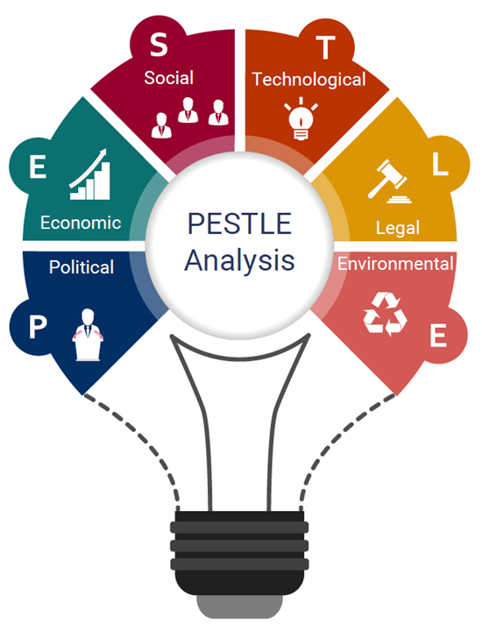
Figure 5: Pestle analysis
(Source: Cavallo et al. 2019)
Political factor
- Mercy Trends must follow rules about online selling, protecting customers, keeping data private, and respecting other people’s ideas (Cavallo et al. 2019).
Economical factor
- The state of the economy, which includes things like how much the country is making, how prices are changing, and how much people are buying can affect how much people can buy and how much they want to buy fashion items.
Social factor
- Social media platforms and fashion influencers have a big impact on how well people know and recognize a brand, how customers connect with a brand, and the ways companies promote their products (Phan, 2021).
Technological factor
- The improvement of online shopping technology allows Mercy Trends to reach more customers and make online shopping better.
- Because more and more people are using smartphones and mobile apps to shop online, it is important for the boutique’s website to work well on mobile devices and have features that are easy to use on mobile.
Legal factor
- Mercy Trends must protect its brand, designs, and trademarks by following the appropriate legal measures. It is really important for businesses to follow the rules about protecting consumers.
Environmental factor
- Mercy Trends needs to think about using environmentally friendly materials, getting their products from ethical sources, and being clear about their supply chain because more and more consumers want sustainable and ethically produced fashion items.
- The boutique needs to evaluate and reduce its carbon footprint by improving how items are transported and packaged, as well as considering environmentally friendly shipping choices.

References
Bland, D.J. and Osterwalder, A., 2019. Testing business ideas: A field guide for rapid experimentation (Vol. 3). John Wiley & Sons.
Blank, S. and Dorf, B., 2020. The startup owner’s manual: The step-by-step guide for building a great company. John Wiley & Sons.
Bortolini, R.F., Nogueira Cortimiglia, M., Danilevicz, A.D.M.F. and Ghezzi, A., 2021. Lean Startup: a comprehensive historical review. Management Decision, 59(8), pp.1765-1783.
Cavallo, A., Ghezzi, A., Dell’Era, C. and Pellizzoni, E., 2019. Fostering digital entrepreneurship from startup to scaleup: The role of venture capital funds and angel groups. Technological Forecasting and Social Change, 145, pp.24-35.
Cohen, S., Fehder, D.C., Hochberg, Y.V. and Murray, F., 2019. The design of startup accelerators. Research Policy, 48(7), pp.1781-1797.
Demirbag-Kaplan, M. and Cavusoglu, L., 2022, June. Reassessing the Marketing Mix Through the Lens of Digitalization. In Advances in Digital Marketing and eCommerce: Third International Conference, 2022 (pp. 36-41). Cham: Springer International Publishing.
Dev, N.K., Shankar, R. and Qaiser, F.H., 2020. Industry 4.0 and circular economy: Operational excellence for sustainable reverse supply chain performance. Resources, Conservation and Recycling, 153, p.104583.
Eslamibidkoli, A., Sadeghi Moghadam, M.R. and Hasangholipour, T., 2023. Designing a strategic financial framework for digital start-ups. Journal of Industrial Engineering and Management Studies, pp.1-10.
Goyal, A., 2020. A critical analysis of Porter’s 5 forces model of competitive advantage. Goyal, A.(2021). A Critical Analysis of Porter’s, 5.
Hahn, G.J., 2020. Industry 4.0: a supply chain innovation perspective. International Journal of Production Research, 58(5), pp.1425-1441.
Le, T.V., Stathopoulos, A., Van Woensel, T. and Ukkusuri, S.V., 2019. Supply, demand, operations, and management of crowd-shipping services: A review and empirical evidence. Transportation Research Part C: Emerging Technologies, 103, pp.83-103.
Mansoori, Y. and Lackeus, M., 2020. Comparing effectuation to discovery-driven planning, prescriptive entrepreneurship, business planning, lean startup, and design thinking. Small Business Economics, 54, pp.791-818.
Niu, B. and Zhao, J., 2023. E-Commerce Industry: A Comprehensive Analysis of its Competitive Advantages. Highlights in Business, Economics and Management, 15, pp.93-98.
Phan, S., 2021. The effect of PESTLE factors on development of e-commerce. International Journal of Data and Network Science, 5(1), pp.37-42.
Rahman, M.M. and Kuzminov, A.N., 2019. Marketing mix as a source of increasing the efficiency of marketing activity. Modern Problems of Scientific Activity, pp.66-68.

