

Virality-to-Profit Dashboard: Bridging Social Media Analytics and E-Commerce Profitability

by
Sohaan Sureshkumar

Supervisor: James Williams

Project submitted as part of the requirements for the award of
BSc Computing (Software Engineering)

April 2026

DECLARATION

I, Sohaan Sureshkumar declare that I am the sole author of this Project; that all references cited have been consulted; that I have conducted all work of which this is a record, and that the finished work lies within the prescribed word limits.

This work has not previously been accepted as part of any other degree submission.

Date : 29/04/2026

FORM OF CONSENT

I, Sohaan Sureshkumar hereby consent that my Project, submitted in candidature for the B.Sc.(Hons) Computing (stream) degree, if successful, may be made available for inter-library loan or photocopying (subject to the law of copyright), and that the title and abstract may be made available to outside organisations.

Date : 29/04/2026

ABSTRACT
While organic social media marketing has become an important channel for e-commerce retailers to generate viral sales, paid channels like Shopify provide e-commerce sellers established metrics such as CPA and ROAS that they base their budgets on. Currently there are no standardised metrics for measuring the profitability of organic social commerce activities. As a result, e-commerce sellers can only hope to get the most from their existing content after they have discovered the link between content virality and business profit.

This project aimed to help Shopify retailers see a clear line of sight between the virality of their content and their profitability. A web-based dashboard was designed, developed and tested that imports view information from Instagram and sales information from Shopify to provide unique profitability insights to each post. Two new metrics were created, including Views-to-Orders (V2O) per 1M views and Net Profit Value (NPV) per 1M views.

This system was built from scratch using PHP, MySQL, HTML/CSS and Chart.js. It was created using the Waterfall methodology. The system begins by importing a CSV containing data before it goes through an ETL process to transform it into usable data. The system then utilises the KPI cards and includes some trend graphs to display the data. The profit analysis module even comes with a waterfall chart that breaks down the cost for better understanding.

Full system testing was completed for 100% of 28 test cases and confirmed that all metric calculations are accurate against manual spreadsheet calculation. In addition, user testing was conducted with 5 organic e-commerce sellers and averaged a 4.6/5 overall value of product. 80% of selling users that tested intend to use the dashboard on a regular basis. General feedback on new metrics was that they were very valuable and groundbreaking - one seller went so far as to say that V2O was "genius". The waterfall chart for profit breakdown was found to be very valuable.

Promising results have been made on Social Commerce Efficiency for Organic User-Generated Content. Although there are still some limitations left in terms of platform support (only Instagram and Shopify are currently supported), the feedback indicates that a solid basis has been built for standardised efficiency metrics for organic social commerce and the results provide a good starting point for future extensions to support also other social media and e-commerce platforms.

Table of Contents
ABSTRACT 3
INTRODUCTION 4
1.1 Background 4
1.2 Problem Statement 5
1.3 Aims & Objectives 5
1.3.1 Aim 5
1.3.2 Objectives 5
1.4 Report Structure 6
LITERATURE REVIEW 6
2.1 Introduction 6
2.2 The Rise of Organic Social Commerce 7
2.3 Problem Statement: The Organic Analytics Gap 7
2.4 Foundations of Digital Advertising Media 7
2.4.1 Cost Per Acquisition (CPA) 7
2.4.2 Return on Ad Spend (ROAS) 8
2.4.3 Attribution Models in Paid Campaigns 8
2.5 Challenges in Organic Social Media Measurement 8
2.5.1 The Attribution Dilemma in Organic Content 8
2.5.2 Limitations of Native SM Analytics Platforms 9
2.6 E-commerce Profitability & Financial Metrics 9
2.6.1 Understanding True Profitability 9
2.6.2 Components of Net Profit Calculation 9
2.7 Business Intelligence & Dashboard Design Principles 9
2.7.1 The Role of Dashboards in Data-Driven Decision Making 10
2.7.2 Key Principles of Effective Dashboard Design 10
2.8 Identified Research Gap 10
2.9 Proposed Novel Metrics for Organic Virality to Profit 10
2.9.1 Views to Orders (V2O) 10
2.9.2 Net Profit Value Per Views (NPV Per X Views) 11
2.10 Summary 11
METHODOLOGY 11
3.1 Research Methodology 11
3.2 Development Methodology 12
3.2.1 Requirement Analysis 12
3.2.2 System Design 12
3.2.3 Implementation 12
3.2.4 Testing & Evaluation 12
3.3 Tools & Technologies 12
3.3.1 Backend Technologies 12
3.3.2 Frontend Technologies 13
3.3.3 Development Environment 13
3.4 Evaluation Strategies 13
3.4.1 System Testing Evaluation 13
3.4.2 User Evaluation 13
DESIGN & IMPLEMENTATION 13
4.1 Requirements 13
4.1.1 Functional Requirements 14
4.1.2 Non-Functional Requirements 14
4.2 Database Design 15
4.2.1 Database Schema 15
4.2.2 Design Decisions & Challenges 16
4.3 System Architecture 17
4.3.1 Data Flow 17
4.3.2 ETL Pipeline Implementation 17
4.4 User Interface Design 18
4.4.1 Layout Structure 18
4.4.2 Chart Selection 19
4.5 Implementation 19
4.5.1 File Structure 19
4.5.2 Database Connection 19
4.5.3 CSV Parsing Implementation 20
4.5.4 Metric Calculations 20
4.5.5 Chart.js Implementation 20
4.5.6 Profit Analysis Page 20
4.6 Testing 21
4.6.1 Test Plan Summary 21
4.6.2 Test Results 21
RESULTS & EVALUATION 22
5.1 System Testing Results 22
5.1.1 Test Categories & Results 22
5.1.2 Calculation Verification 22
5.2 User Evaluation Results 23
5.2.1 Participant Demographics 23
5.2.2 Task Completion Results 23
5.2.3 Ease of Use 23
5.2.4 Understanding 24
5.2.5 Usefulness 24
5.2.6 Visual Design 25
5.2.7 Open Feedback Analysis 25
5.2.8 Overall Ratings 26
5.3 Discussion 27
5.3.1 Achievement of Objectives 27
5.3.2 Strengths 27
5.3.3 Limitations 28
5.3.4 Summary of Results 28
CONCLUSIONS & RECOMMENDATIONS 28
6.1 Summary 28
6.2 Limitations 29
6.2.1 Platform Restriction 29
6.2.2 CSV Format Dependency 29
6.2.3 Day-Level Granularity 29
6.2.4 Sample Size 29
6.2.5 Local Deployment 30
6.3 Future Work 30
6.3.1 Multi-Platform Support 30
6.3.2 API Integration 30
6.3.3 Metric Tooltips and Documentation 30
6.3.4 Date Range Filtering 30
6.3.5 Profit Goal Calculator 30
6.3.6 Export Functionality 30
6.3.7 Cloud Deployment 30
6.3.8 AI-Powered Insights 30
6.4 Final Remarks 31
REFLECTION 31
7.1 Introduction 31
7.2 Project Journey 31
7.3 Technical Challenges 31
7.4 Skills Development 32
7.4.1 Technical Skills 32
7.4.2 Professional Skills 32
7.5 What Would Be Done Differently 32
7.5.1 Earlier User Involvement 32
7.5.2 API Research First 32
7.5.3 More Sample Data 32
7.5.4 Documentation Planning 32
7.6 Future Application 33
7.7 Conclusion 33
INTRODUCTION 33
1.2 Alternative Protocols for Accessing Information 33
1.2.1 SOAP (Simple Object Access Protocol): 33

Table of Figures

Figure 1- upload_sessions 19
Figure 2- ig_day_aggc 19
Figure 3 - shop_day_raw 20
Figure 4- day_factc 20
Figure 5 - ETL Pipeline Flowchart 21
Figure 6 - Instagram Data Processing 22
Figure 7 - Shopify Data Processing 23
Figure 8 - Dashboard Wireframe page 1 24
Figure 9 - Dashboard Wireframe page 2 24
Figure 10 - CSV Upload Interface 24
Figure 11 - KPI Summary Cards 24
Figure 12 - Views vs Orders Trend Chart and Daily Net Profit Chart 25
Figure 13 - Daily Breakdown Data Table 25
Figure 14 - Profit Waterfall Chart 26
Figure 15 - Profit Component Donut Chart 26
Figure 16 - File Structure Tree 27
Figure 17 - database connection 27
Figure 18 - Metric Calculations 28
Figure 19 - Line Chart 28
Figure 20 - Bar Colour Implementation 29
Figure 21 Profit Analysis upper 29
Figure 22 - Profit Analysis lower 29
Figure 23 - Automated Insights Logic 30
Figure 24 - Test Screenshot 32

INTRODUCTION

1.1 Background
Organic e-commerce has taken off in the last few years as social media has become an accessible platform for small businesses to promote their work without having to invest in expensive print or TV advertising. People are using Instagram, TikTok, Facebook, and other social media platforms to build a following, engage in conversation with customers, and then seamlessly steer viewers to their e-commerce stores hosted on Shopify, WordPress, or other online retailers.

Of all the business models that an aspiring entrepreneur can look into, organic dropshipping seems to have the lowest entry barrier for several reasons. There are no products to source or inventory to hold, and the typical activities of an organic dropshipper revolve around product research and hunter activities, social media promotion, and customer order fulfillment. So the end goal is simply to get views and, more importantly, to turn those views into sales.

Most social media platforms now provide a detailed analytics system that tracks important metrics such as views, likes and shares for content posted by a seller. Online e-commerce platforms also track sales data for a seller such as total orders, revenue and refunds for items sold. However, currently there is no effective way to connect and integrate the data from these two platforms. This means that most sellers have to download all the information from the various platforms and then use a spreadsheet to try and link the data from the different platforms to the relevant marketing activities and measure their effect on the business. This is a very time consuming and error prone process and does not provide the insights that sellers need in a timely manner.

Most current solutions in the domain of analytics are limited to merely providing insights based on either social or e-commerce data. For example, Google Analytics may provide useful website traffic metrics, such as the number of sessions and average session duration. Shopify also provides built-in analytics to help understand e-commerce sales performance. But for organic sellers who are running an entire business model entirely around virality on social media and corresponding profitability, there is a huge missing link.

1.2 Problem Statement
This project investigates and analyses the gap between performance metrics of social media platforms (SMPs) used for e-commerce by organic producers/sellers and their profit metrics. Currently, Instagram view count is displayed on posts and profit is displayed in the Sales section of the shop page. This means that, as a seller, you can see that one of your posts was viewed 500,000 times that day and also that you made £2,000 profit that day. A really useful piece of information that is currently missing from the platform is the profit per view. Currently, this would require a lot of manual data crunching that most small sellers just don't have the time or technical ability to do.

This leads to several issues:

- Sellers Can't Measure ROI of Content Creation Efforts
- There are very few examples of high quality content that is extremely profitable in terms of views and also highly reproducible.
- Pricing and product sourcing decisions are made without knowledge of true profit margins relative to the amount of marketing effort required to generate those profits.
- Creators/businesses tend to waste a lot of time on the net publishing media which looks good in the view counter but not in the overall bottom line.

The market/industry would benefit from a tool that automates social media and e-commerce data integration, provides meaningful cross-platform metrics and provides actionable insights/next best actions for an analyst/manager to take.

1.3 Aims & Objectives

1.3.1 Aim
This project aims to create an online tool for organic e-commerce sellers that allows them to analyse the relationship between the performance of social media posts and the revenue of their stores.

1.3.2 Objectives
- Identify current analytics solutions currently available for social media and e-commerce platforms and explore where there is a need for cross-platform analytics functionality that currently is not fulfilled by current market solutions.
- Develop new performance metrics that measure the connection between social media views and bottom line business metrics results such as Views-to-Orders (V2O), Net Profit per Views (NPV).
- Build a relational database structure that links together Instagram and Shopify data by date.
- Be able to upload local files (in CSV format), extract and transform platform data exports directly, and load all of these methods into the database.
- Create an interactive front end (for easy viewing) where a list of the KPI's could be included with graphical trend lines.
- Include a view that shows the breakdown of the costs and highlights the best and worst performing days with a waterfall chart.
- Conduct user evaluation with potential users (organic e-commerce sellers) to test for usability and utility, and gather feedback on where improvements are needed.

1.4 Report Structure
This report covers the Virality-to-Profit Dashboard's full lifecycle.

Chapter 2 - Literature Review: reviews literature on e-commerce analytics, social media metrics, and theory of effective dashboard design and identifies some of the gaps in the knowledge base that this study endeavours to address.

Chapter 3 - Methodology: discusses the research methodology, software development methodology and tools, technologies and implementation approaches.

Chapter 4,Design & Implementation: This chapter explains the requirements of the site and goes on to outline the design of the database, the design of the user interface for the site, and describes in detail the implementation and the testing of web pages.

Chapter 5,Results & Evaluation: This chapter summarises the results of the system testing and user evaluation and links these results to the objectives.

Chapter 6,Conclusion & Recommendations: outlines the findings from the project, recognises some of the limitations of the work and looks at some potential future developments.

Chapter 7 - Reflection: Personal views on the skills used, the difficulties encountered and lessons learned.

LITERATURE REVIEW

2.1 Introduction
While organic social media channels are rapidly becoming a vital distribution channel for e-commerce retailers to drive sales through viral growth, there is a large analytics gap between what traditional paid advertising allows you to measure and what the organic viral social commerce space offers today [1], [2]. While there are good metrics to measure CPA and ROAS for traditional paid advertising on Facebook & Instagram, there is currently no comparable standardized metrics for organic social commerce [2], [3]. As a consequence, there is an enormous challenge in enterprises to attribute sales and therefore net profit to organic social media efforts [2].

This literature review aims to address the current knowledge gap on paid advertising measurement methods, the complex attribution of organic social media and introduces new metrics to monitor [4], [5]. This literature review will specifically focus on the limitations of current Instagram analytics tools for e-commerce, the challenge of measuring comprehensive profitability and effective dashboard design for the development of a "Virality-to-Profit Dashboard" to measure user engagement on Instagram.

2.2 The Rise of Organic Social Commerce
Social commerce is the integration of e-commerce and social networking sites to allow for social interaction and online shopping experiences on social media sites [6], [7]. Social commerce allows for rapid dissemination of information and creation of viral phenomena, which increases brand awareness to drive sales [6]. With the rapidly changing nature of social media, it has become one of the main channels for online small businesses to strive for better sales performance [8].

Although social media has become increasingly important to the growth of the e-commerce market, many retailers are struggling to measure the Return on Investment (ROI) of their social media efforts [9]. While most social media platforms offer built-in analytics to help understand how content is performing, the provided metrics don't necessarily translate into bottom line dollars and cents. As algorithms continue to shift and organic reach remains under pressure, high-quality content is key to gaining any traction [10]. With that in mind, many retailers are now seeking more solid methods to measure the value of their organic social media efforts, efforts that translate into real profits [11]. Simple engagement metrics are no longer enough.

2.3 Problem Statement: The Organic Analytics Gap
In comparison to paid channels like Google AdWords, there is a lot of potential for social media in e-commerce, but a large gap between the potential and measurement of return on investment for organic activities, even activities based on virality [12], [13]. Currently, there are no metrics comparable to those provided by paid channels to measure the profit of organic virality efforts [5]. While Facebook and Twitter offer many metrics to measure engagement, like likes, shares, comments, and retweets, they do not provide any direct sales metrics resulting from likes etc., nor any net profit metrics [5]. Thus, businesses have an incomplete image of how their organic marketing efforts are performing.

But there is a more profound problem with current brand strategies: much of the budget is being spent on content that drives high engagement but no profit [14]. This is preventing organisations from becoming market savvy through strategic decision-making, and from proving the value 'virality' brings [15].

2.4 Foundations of Digital Advertising Media
Currently, there are established frameworks for measuring the impact of paid advertising, which extend beyond measuring financial outcomes [16]. In addition to this, there are also established methods for attributing conversions to spend, as well as standard measures of efficiency such as Cost Per Acquisition and Return on Ad Spend to enable judgements about day-to-day performance [16].

2.4.1 Cost Per Acquisition (CPA)
Cost Per Acquisition (CPA) is a key paid advertising metric that measures the average cost per acquisition for advertising efforts [16]. Measuring the CPA is crucial for understanding the effectiveness of marketing efforts and the marketing efficiency being achieved. Decreasing CPA is always key to better marketing efficiency. The CPA calculation is simple enough,it is the campaign cost divided by the number of conversions [17]. CPA is a powerful metric that allows strategic decisions for business, and provides valuable insight for determining the most effective ways to use marketing budget in order to increase ROI when compared to other campaigns [16].

2.4.2 Return on Ad Spend (ROAS)
In addition to tracking the metrics mentioned above, it's also useful to pay attention to the Return on Ad Spend (ROAS) for campaigns [16]. This will show the return for the dollar spent on advertising and will give an idea of whether or not advertising efforts are profitable. For example, a campaign with a ROAS of 4:1 means that for every dollar spent on advertising, the campaign generated four dollars or more in revenue [18]. Having access to this metric at the campaign and ad group level will enable identification of the best and worst performing areas and informed decisions about how to spend budget in order to maximize return [19].

2.4.3 Attribution Models in Paid Campaigns
Attribution models provide customers journey insights on how customers have completed conversion and allocated credit to specific touchpoints within that journey [18]. Therefore it is key to select the correct model to ensure that future key strategic marketing decisions are made to maximise return, i.e. allocating future budgets across different marketing channels to optimise campaign performance [19]. At present majority of businesses currently utilise a last touch attribution model, whereby the last point of contact to a customer before conversion is credited 100%.

2.5 Challenges in Organic Social Media Measurement
There is a rapidly growing and well established ecosystem surrounding paid advertising with robust metrics and increasingly advanced attribution models. Organic social marketing faces several significant challenges to measuring return on investment, however. The primary obstacle to measuring the ROI of organic social marketing is the absence of a built-in tracking pixel and standard measurement metrics similar to what is available for paid advertising, leaving many marketers guessing when it comes to connecting social marketing and engagement to sales and conversion [16].

When it comes to attribution of paid campaigns, most tracking and attribution is provided by the tracking pixels and conversion APIs provided by the social media platforms and the e-commerce platforms that businesses and organisations use [20]. However, when it comes to organic social media, there is a major analytics gap because most organic social media channels do not have the direct integration to the e-commerce platforms required to track the end-to-end sales that are so important for attribution [21]. This makes it difficult to establish clear causality between organic social activities and the ultimate sales outcomes.

2.5.1 The Attribution Dilemma in Organic Content
A lot of natural and organic content on social channels is hard to attribute sales to,because there is no direct pass to e-commerce on the social platforms [22]. Typically with paid social there would be tracking pixels and really detailed analytics to follow the customer journey from impression to conversion [23]. But organic content tends to have a very long and often multi-channel customer journey,therefore it is hard to track and attribute a specific post for a sale, unless extensive tracking has been set up [24].

This problem is particularly relevant for small and medium-sized enterprises that lack the capabilities and resources to develop custom attribution solutions for social media marketing campaigns [25]. As a result, many businesses are unaware of the true value that their marketing efforts bring.

2.5.2 Limitations of Native SM Analytics Platforms
Most native social media analytics provide limited insights to the user, offering engagement, reach and demographic metrics; but no conversion off-platform [26]. This is the case with Instagram Insights and Facebook Analytics. Using the native analytics engagement metrics such as impressions, reach, likes, comments and shares can be viewed, but these metrics do not give enough information about sales attribution or return on investment for organisations [27].

This performance gap is normally dealt with by manually combining data from different sources to get an insight of the performance on social media and web shop [28]. However, this is not feasible for many companies, including SMEs [28]. Instagram analytics tracks account engagement metrics such as likes, comments and shares [5]. The Facebook counterpart, Facebook Analytics, tracks the performance of posts, understands audience and measures engagement [29]. However, there is no direct link to the sales and profit figures of content on e-commerce websites which gets shared on Instagram and Facebook and goes through organic virality.

2.6 E-commerce Profitability & Financial Metrics
To evaluate the performance of e-commerce one can not only look at the sales but also calculate the net profit [30]. If one only looks at the gross revenue, this does not say anything about the actual yield of an online retail operation [31]. All costs, which are incurred in the course of doing business, have to be taken into account and listed as additional figures.

2.6.1 Understanding True Profitability
However, the actual profit margin is less than it looks at first for many e-retailers, as there are many hidden costs involved in the business that eat away at the bottom line after the sale has been made [32]. When working out the net profit margin online retailers must factor in costs such as shipping, SaaS payment processing fees, the cost of the advertising and marketing that has been undertaken to generate the sale, the actual product cost (especially if inventory has been held), further overheads and costs associated with running an online store, the cost of product returns and refunds where applicable, and then tax [33], [34], [35].

2.6.2 Components of Net Profit Calculation
In practice, the calculation of net profit starts with the calculation of net profit by adding up all the incomes and reducing all the expenses, including the cost of goods sold and operating expenses, taxes and other expenses which are not periodic [36]. Operating profitability or return on sales is then calculated by dividing the operating income by net sales [37]. This will help to assess a company's operational efficiency in terms of costs and expenses. The net profit margin measures the proportion of net sales which translate to net profit for a company after all the considerations [38]. It is thus an indicator of a company's operational efficiency as well as its ability to generate net income from net sales [39].

2.7 Business Intelligence & Dashboard Design Principles
Effective visualization and presentation of information is key to gaining meaningful insights from information and turning them into usable, actionable information. Well-designed data dashboards make it possible to present complex information from a variety of different sources and allow users to easily visualize and interact with the information to quickly identify important performance metrics as well as understand trends in the information [40].

2.7.1 The Role of Dashboards in Data-Driven Decision Making
In today's businesses, when speaking about tools supporting management, the role of Business Intelligence dashboards is increasingly heard [41]. Their value has been matured by business users from static reports and they have become a fully interactive information space [42], [43]. Business Intelligence processes the huge amounts of data, reducing the amount of mental efforts needed to make a decision to the minimum. Thanks to the BI dashboards, built on data from many different sources, managers at all levels can quickly make well-founded decisions [44]. All key information necessary to manage will be available on one screen, so one click is enough to get the information that will allow to make a timely, high-quality decision.

2.7.2 Key Principles of Effective Dashboard Design
The most successful business intelligence solutions "obey the following simple rules for design" [45], [46]. The content provided to the end user must be accurate. A well-designed business intelligence solution further ensures that the provided information is also easy to understand. It is therefore important to make sure that there is just the right amount of information to enable the user to make an informed decision without being overwhelmed. The design of the dashboard itself also has a psychological effect and the graphical explanation provided for the visual data analysis increases the cognitive burden by up to 40% compared to the traditional textual data analysis [47].

2.8 Identified Research Gap
Even as more retailers are implementing Business Intelligence (BI) dashboards with innovative data visualizations for their organic social media marketing efforts, including their e-commerce activities and campaigns related to organic promotion of natural and organic products, a major shortfall is present in terms of standardised metrics that can measure efficiency and profitability [48]. While key performance indicators like CPA and ROAS provide clear key benchmarks for measuring the return on investment of paid advertising campaigns, there is currently no comparable established standard for measuring the return on investment of viral organic content [49].

One of the biggest problems in this field is the lack of appropriate metrics for e-commerce companies that run their business almost entirely through organic social commerce. Although there are a lot of studies on how to measure ROI of social media marketing, many of the surveyed people in these studies are not able to prove the effect of their activities on social media channels [23], [27].

2.9 Proposed Novel Metrics for Organic Virality to Profit
The Virality-to-Profit (V2P) Dashboard for organic social commerce now includes two new metrics: Views-to-Orders (V2O) and Net Profit Value per X Views. These are to measure the selling revenue potential of organic social content.

2.9.1 Views to Orders (V2O)
One of the most important metrics for measuring the effectiveness of organic content is V2O, or Views-to-Orders [50]. V2O measures the number of orders a brand receives per 1,000, 10,000, or 1,000,000 views to give a snapshot of how organic views are converting into sales. This helps to track the organic channels that are performing well and compare them against each other. V2O serves as a guide to understand the reach and effectiveness of organic content to drive customer acquisitions. It also acts as a baseline for comparison with other channels to see which ones are performing best.

2.9.2 Net Profit Value Per Views (NPV Per X Views)
In addition to calculating the Gross Revenue of organic content in views, the Net Profit per X Views is also calculated. By incorporating all fixed and variable costs associated with the production and distribution of content, NPV per X Views provides a normalised metric that truly measures the return on investment of organic social activity. Shipping, transaction and refund costs are also incorporated to gain an understanding of the net profit per X Views. This metric helps marketers understand the actual viewer engagement of their content, and more importantly whether their best content strategies are ones that drive large viewership, or profitability per viewer [13].

2.10 Summary
The way paid advertising channels report on performance is well established with standard metrics such as CPA and ROAS [51]. Advanced attribution models are also something regularly reported on in the industry. Organic social media marketing for e-commerce companies are a long way off from having similar tools to measure Return on Investment (ROI) and relate the 'virality' of content with revenue [16], [41]. While there are some tools that provide some form of attribution and enable the calculation of the Return on Investment (ROI) from social media marketing activities for e-commerce companies and marketers, current analytics provided by the main social media platforms allow businesses to measure the outcome of their organic efforts in terms of sales, but do not allow for a full ROI calculation [52].

This project tackles a major gap in the social commerce ecosystem by developing a Virality-to-Profit Dashboard that brings standardized metrics of efficiency to organic social commerce, so that e-commerce retailers can measure and maximize the profit they get from their organic social media efforts [5].

METHODOLOGY

3.1 Research Methodology
In addition to the methods listed above the project has also adopted a research philosophy. The research philosophy adopted for this project is pragmatism [53], [54]. This is important as pragmatism not only helps to produce ends but also help to solve real world problems, as opposed to mere abstraction. Pragmatism is important in an applied computing project such as this where the project is seeking to produce ends to solve a problem set. The research onion model developed by Saunders, Lewis and Thornhill illustrates the different layers associated with a research design, philosophy, approach, method, time horizon and data collection methods [53].

This project follows a deductive research approach where a problem is treated in a literature review and a solution is worked out based on the available knowledge and laws [55]. The literature review revealed a gap in current research regarding the absence of standardised metrics for organic social commerce, which this project aims to address by developing and implementing The Virality-to-Profit Dashboard.

This research is approached by design science research [56]. This research approach is suitable for research projects where new artefacts such as software, models, methods and frameworks etc. need to be developed [57]. Design science research is appropriate especially when the goal of a research project is to create solutions that meet certain criteria and to evaluate those solutions against those criteria. This research project aims to design, develop and evaluate a working solution for a business intelligence dashboard.

The time scope for this evaluation is cross-sectional, i.e. the study is based on data collected at one single point in time [53]. The user evaluation was conducted after the implementation of the developed dashboard and thus also after the end of this project.

3.2 Development Methodology
This project was completed under the Waterfall software development methodology [58], [60]. This methodology is a linear sequential approach which means one phase is completely done before the next phase is begun [59]. For this academic project, the Waterfall methodology was chosen for this project because it is a solid model that follows a linear approach and allows for complete completion of one phase before moving on to the next [61]. Each phase must be fully completed before the next phase is begun allowing for complete completion of each milestone and deliverable.

3.2.1 Requirement Analysis
Initially the needs came up from literature review and potential users of the system. These needs were mostly divided in two main types: functional and non-functional requirements. The non-functional requirements are mainly usability, performance and compatibility related. The requirements V2O and NPV calculate the given data and provide the output for the visualisation of the actual dashboard.

3.2.2 System Design
This phase involved designing the database schema and coming up with some wireframes for the UI as well as a high-level design for the ETL pipeline. This phase of the project produced a number of design artefacts including an Entity-Relationship diagram for the database, a number of system flowcharts and some mockups for the interfaces to the new system.

3.2.3 Implementation
Once the designs had been finalised, development of the full system was started. Building up the functionality piece by piece, incorporating the data extraction, the calculations and the finished visualisations.

3.2.4 Testing & Evaluation
After the project was completed, it was tested [63]. A test plan was followed to test 28 test cases to cover all functionalities in the system. User evaluation was conducted as the final stage of the development life cycle to test the usability and usefulness of the system [64].

3.3 Tools & Technologies
The tech stack for the new project was chosen because it fits the workflow, is easy to put into production and suits the needs.

3.3.1 Backend Technologies
PHP 8.3: For the data processing the server-side scripting language was used for the data processing, the CSV parsing and the access to the database. PHP was chosen since it is very common and can also be used with the development environment MAMP.

MySQL: Metrics are stored in MySQL. It was capable of performing complex queries necessary for calculations and data aggregation.

3.3.2 Frontend Technologies
HTML5 and CSS3: Dividers and grid sections using HTML & CSS was used to add structure and styling to a site, its content and the user experience.

Chart.js: The data visualisation elements of the site such as the line charts, bar charts and doughnut charts have been implemented using a JavaScript charting library [62]. This was very simple to use and had a neat and minimal aesthetic.

3.3.3 Development Environment
MAMP: The local development stack consists of Apache, MySQL and PHP and was used to host a development copy of a website on a local macOS based computer, without the need to upload the website to an external site for testing.

3.4 Evaluation Strategies
The evaluation strategy consisted of two main parts: system testing and user evaluation.

3.4.1 System Testing Evaluation
A detailed test plan was followed, completing 28 test cases across 7 different categories such as: database connection, file upload, correct handling of a CSV, calculations, data joining, main dashboard, and profit analysis [63]. Each test case was outlined with specific inputs, expected outputs, and pass/fail criteria that need to be met during the test case completion. All 28 test cases were fully completed and noted as passed or failed within the test plan.

3.4.2 User Evaluation
To evaluate the usability of the developed dashboard a summative user evaluation of five participants of the target user group (organic e-commerce sellers) was carried out [64]. After having completed the six tasks, the participants answered a short questionnaire of six questions regarding their rating of the usability of the dashboard regarding ease of use, understanding of provided metrics, overall usefulness and visual design. Each question could be rated on a five-point Likert scale from "very poor" to "very good" [65]. Furthermore, participants had the chance to give additionally open feedback for each question.

This evaluation was conducted using a mixed-methods approach in order to test the system's technical functionality as well as gather user experience data in order to verify that the system fulfills the research gap identified in the literature review.

DESIGN & IMPLEMENTATION

4.1 Requirements
The requirements were gathered in the beginning of the project. These requirements came from both the literature review and the actual users of the system, the organic e-commerce sellers. These requirements can be categorized into two groups, namely functional requirements and non-functional requirements.

4.1.1 Functional Requirements
ID | Requirement | Priority
FR1 | Be able to allow users to upload Instagram CSV export files containing view data | Must Have
FR2 | Be able to allow users to upload Shopify CSV export files containing sales data | Must Have
FR3 | Be able to parse and validate uploaded CSV files | Must Have
FR4 | Be able to report Instagram statistics on a daily basis | Must Have
FR5 | Be able to calculate Views-to-Orders (V2O) for each Million views | Must Have
FR6 | Be able to calculate Net Profit Value (NPV) for each Million views | Must Have
FR7 | Be able to display KPI cards showing total views, orders, revenue, net profit, V2O, and NPV | Must Have
FR8 | Be able to see a chart of views vs orders over time | Should Have
FR9 | Be able to display a daily net profit bar chart colour coded | Should Have
FR10 | Be able to display a profit waterfall chart that details the cost breakdown | Should Have
FR11 | Be able to identify best and worst performing days | Should Have
FR12 | Be able to allow for resetting/clearing of all uploaded data | Should Have
FR13 | Be able to provide automated insights based on profit margins | Could Have

4.1.2 Non-Functional Requirements
ID | Requirement | Category
NFR1 | Be able to load within 3 seconds for simple datasets | Performance
NFR2 | Be able to work on modern web browsers (Chrome, Firefox, Safari) | Compatibility
NFR3 | Be able to have an intuitive interface which requires no training | Usability
NFR4 | Be able to handle CSV files of up to 10,000 rows | Scalability
NFR5 | Be able to Display Monetary Values in GBP (£) format | Localisation

4.2 Database Design
The database design was critical to the development of the analytics capability. A lot of time and consideration went into how the data would be structured to enable efficient querying. An ETL (Extract, Transform, Load) pipeline was also implemented that the data flowed through, and two new metrics,V2O and NPV,were developed which required calculation in the database.

4.2.1 Database Schema
The data for the database v2p_dashboard has been written to the three tables shown below.

Table 1: upload_sessions: This table stores metadata about every upload session. It contains metadata about the last completed upload operation, as well as the start date and end date of the data that was uploaded. Upload sessions are independent of each other when there are no conflicts, so analysis can easily be run over different time periods.
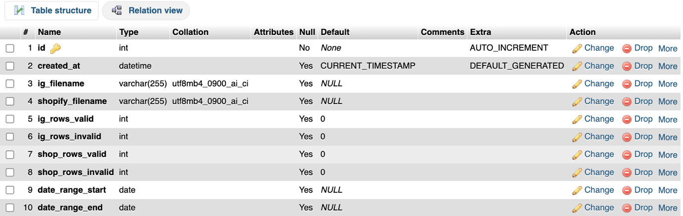
Figure 1- upload_sessions
Table 2: ig_day_agg: This table holds aggregated statistics for Instagram per day. The data for Instagram exports holds statistics per post. Therefore the views etc. are summed up for each day and this table is filled with these aggregated numbers.

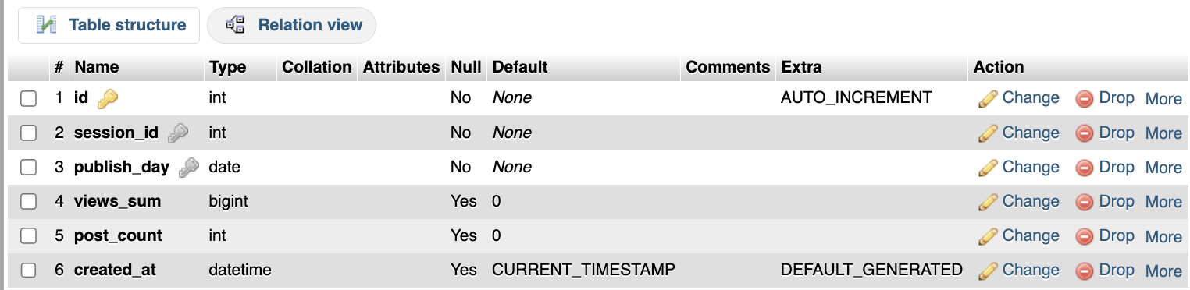
Figure 2- ig_day_aggc

Table 3: shop_day_raw: This table stores raw data for Shopify commerce. The data is organized by day. Note that this data is already aggregated by Shopify to a daily basis, so there is no need to aggregate it further.

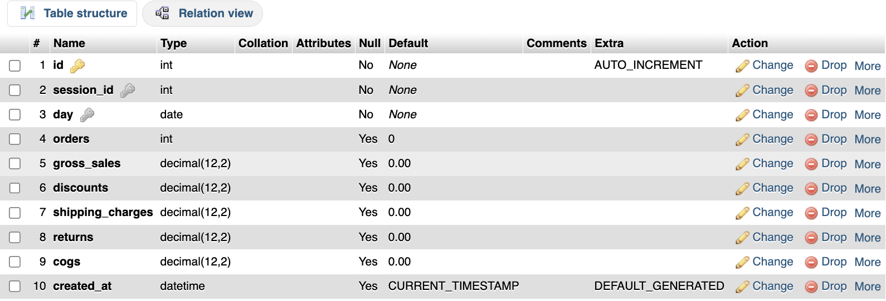
Figure 3 - shop_day_raw

Table 4: day_fact: The core analytics table is set up with daily Instagram and Shopify data, aggregated and calculated for a variety of key metrics. All the visualisations on the dashboards are populated with data from this table along with organisation specific KPIs.
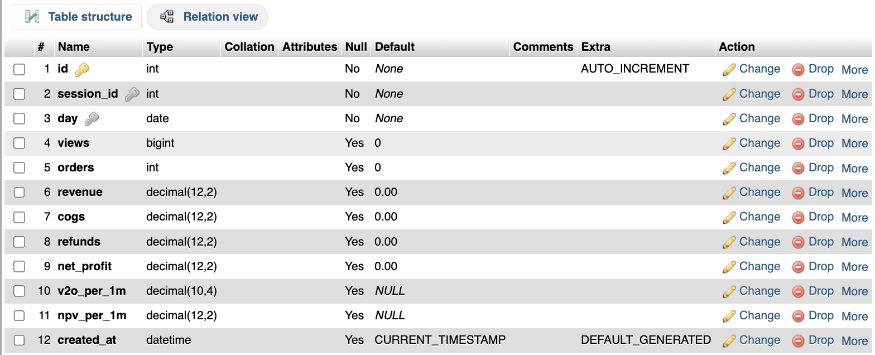
Figure 4- day_factc

4.2.2 Design Decisions & Challenges
Composite Unique Keys: Composite unique keys (session_id, day) were used on ig_day_agg, shop_day_raw and day_fact tables. This way no two duplicate entries will exist for the same day within one session, and also it allows use of INSERT ... ON DUPLICATE KEY UPDATE to quickly fill up the data.

Issue Encountered: Initial testing threw up an error of "Unknown column 'date_from' in field list" whilst inserting data. This was because the database tables had been created from an earlier schema. Those tables have now been removed and the new ones created from the updated SQL schema.

Handling Shopify Returns: The Shopify returns are exported as negative numbers. For example -£50.00 for a £50 refund. ABS function needs to be used to turn this into a positive figure for the refund calculation of the net profit which is ABS(returns) IF returns < 0 ELSE 0.

4.3 System Architecture
The system follows an ETL (Extract, Transform, Load) process. Data is uploaded as a series of CSV files, processed and then inserted into a database. The information is then displayed visually on a dashboard.

4.3.1 Data Flow
This was the sequence the data flows in:

- Extract: User uploads Instagram and Shopify CSVs through the form
- Parse: PHP reads the CSV files and extracts raw data rows
- Transform: Data is refined, aggregated, and metrics calculated
- Load: Transformed data is inserted into the MySQL tables
- Query: Dashboard page queries the day_fact table and displays it
- Render: Visualisations are rendered by Chart.js library

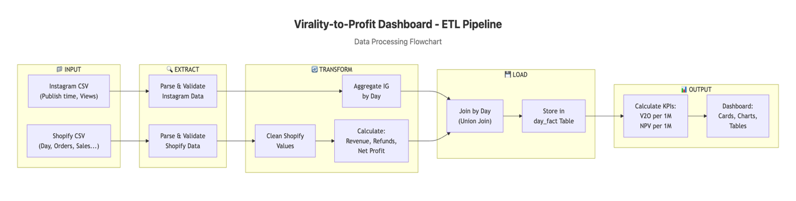
Figure 5 - ETL Pipeline Flowchart

4.3.2 ETL Pipeline Implementation
Instagram Data Processing: Instagram provides a CSV export of post data, which includes individual post views that can be processed. The two relevant fields in the exported data are "Publish time" and "Views". "Publish time" is in datetime format e.g. "2024-12-08 14:30:00". The following code processes the views by day using the date of the "Publish time" and a PHP associative array to store the temporary data in. The data is then inserted into the ig_day_agg table.

Issue Encountered: Earlier there were some differences in the way the date of posts got exported based on settings in Meta Business Suite account. For example, "DD/MM/YYYY HH:MM" and "YYYY-MM-DDTHH:MM:SS" ISO format were used. A flexible date parsing function was implemented which can parse both of these formats using the PHP function strtotime() which can parse many different date formats and return a Unix timestamp.

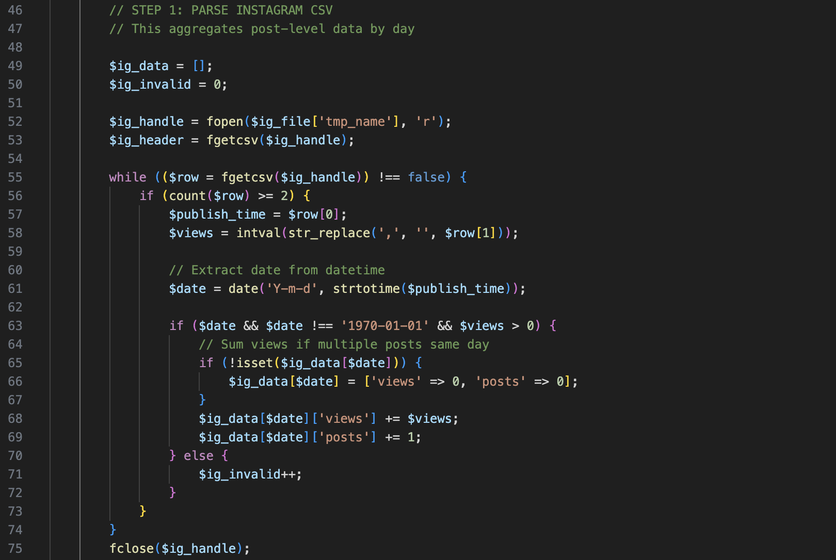
Figure 6 - Instagram Data Processing

Shopify Data Processing: Shopify data comes already aggregated out by day. It's a consistent set of fields, and for each day of the Shopify data a row of data is processed and inserted into the shop_day_raw table.

Issue Encountered: Most of the Shopify CSV files used include currency symbols and thousand separators in the numeric fields.The following code removes the currency symbol and the commas and then converts the string to a float.

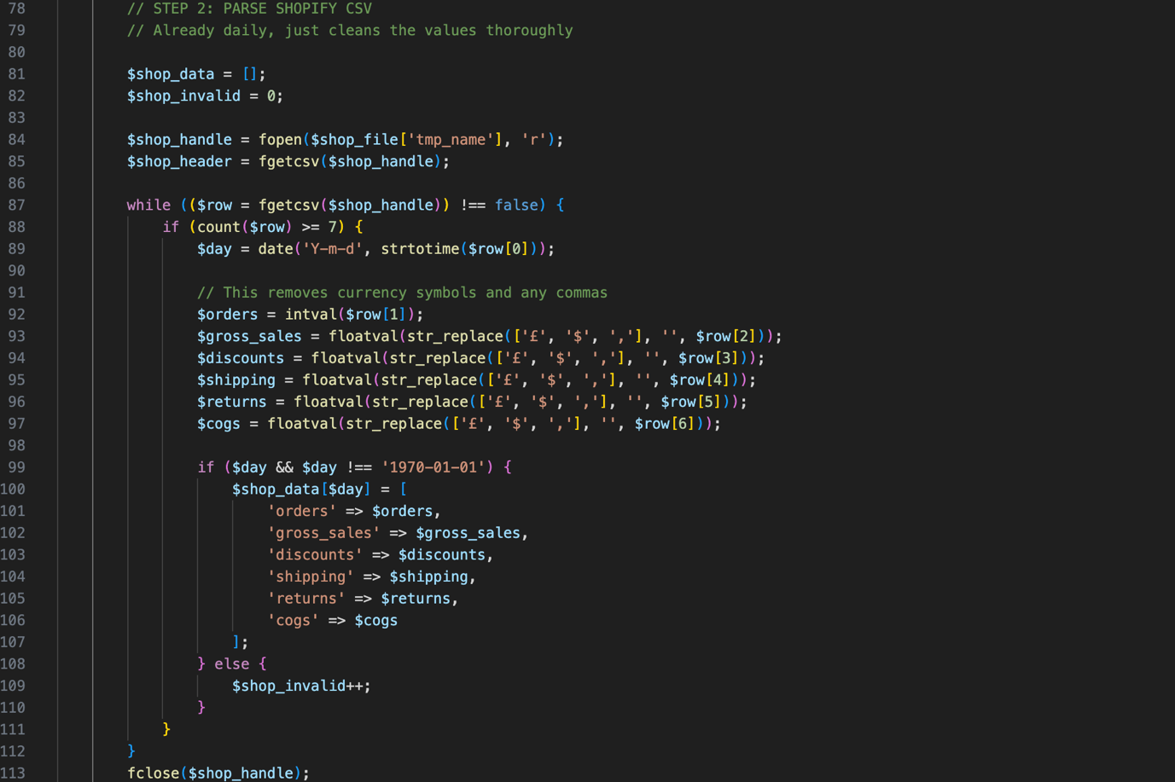
Figure 7 - Shopify Data Processing

Day Joining Logic: Since the data from Instagram and Shopify did not directly join, there were some offset dates. As a result, a viral post could register views on a day where there were no orders, therefore reducing sales, or increase sales on a day where views were decreasing. Using a UNION-based method to include all the days from both data sources helped to combat this issue.

All Days = UNION(Instagram Days, Shopify Days)

For each day:

Views = Instagram views OR 0

Orders = Shopify orders OR 0

Revenue = Calculated OR 0

This feature ensures that all the data is included in the analysis. As a result, days with both views and orders as well as days with just views or days with just orders will be included.

4.4 User Interface Design
The software interface is simple and convenient. The target audience are organic online sellers who need to work with their data for brief periods of time and make certain conclusions without the help of specialists.

4.4.1 Layout Structure
The dashboard follows a hierarchical information architecture:

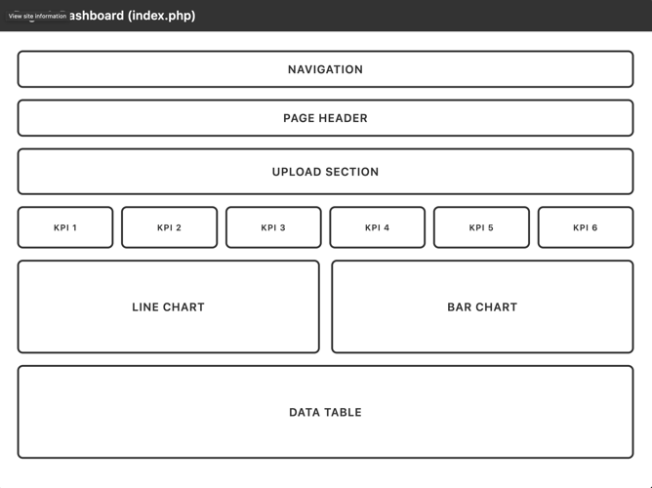  Figure 8 - Dashboard Wireframe page 1 | 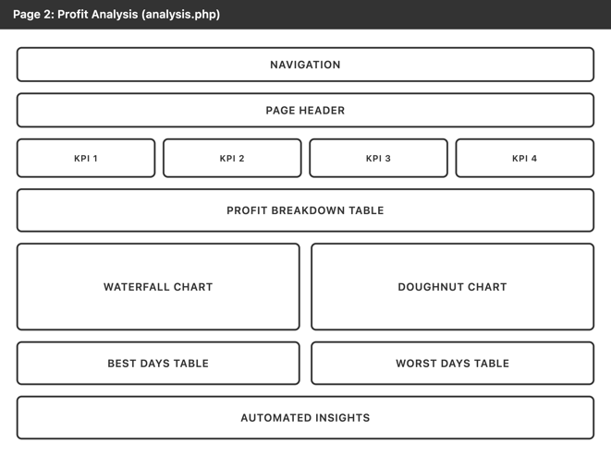  Figure 9 - Dashboard Wireframe page 2

Navigation Bar: The navigation is very simple and clear. A horizontal navigation bar is found at the top of the screen linking to two major areas of the tool: Dashboard and Profit Analysis.

Upload Section: The upload section is located at the top of the platform dashboard. This section includes two file inputs to upload the Instagram and Shopify csv files, and a big upload button. The "Clear All Data" button appears in this section only when there is data within the system.

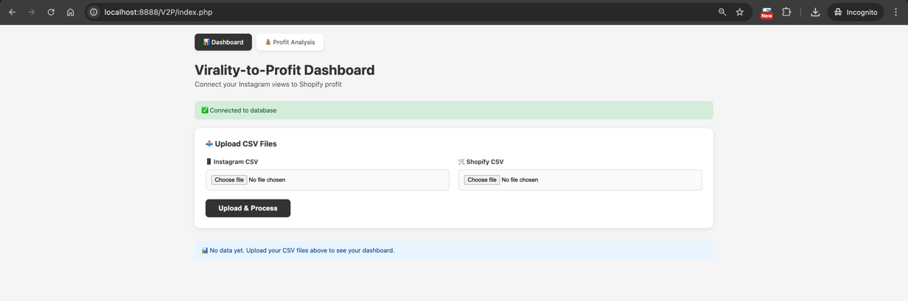
Figure 10 - CSV Upload Interface

KPI Cards: The 6 KPI cards are arranged in a flexible grid. Four normal KPIs have a light-colored background. The two new KPIs have a dark background color. These are the unique selling point of the 'Dashboard' widget and thus highlighted.

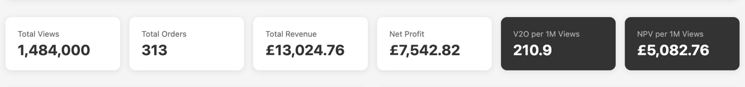
Figure 11 - KPI Summary Cards

Charts Section: Two different views of the same data are compared: side by side on a big screen, and stacked on a small screen. The line chart shows the trend of Views against Orders. This is a dual axis chart where both axes display different data. The bar chart shows the Daily Net Profit with positive areas displayed in green and negative areas in red.

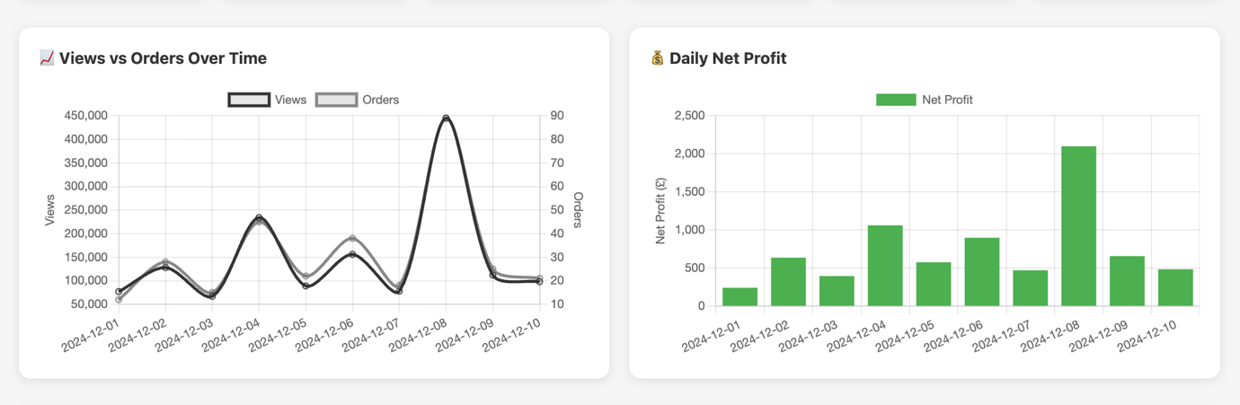
Figure 12 - Views vs Orders Trend Chart and Daily Net Profit Chart

Data Table: The breakdown table contains even more detailed daily data, with the following format: Date, Views, Orders, Revenue, COGS, Refunds, Net Profit, V2O, NPV.

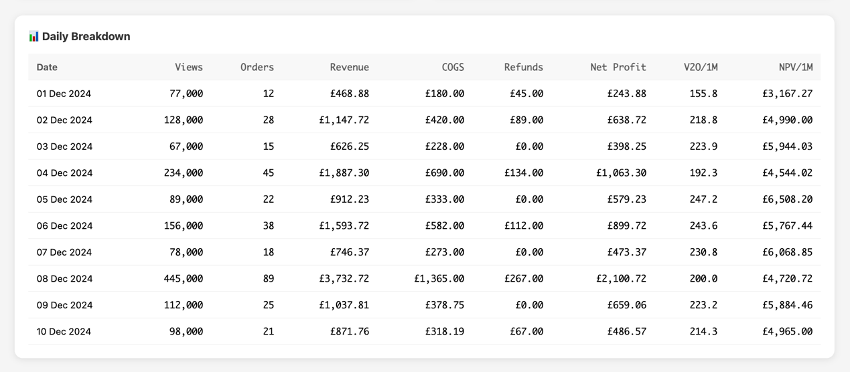
Figure 13 - Daily Breakdown Data Table

4.4.2 Chart Selection
For the Views vs Orders visualisation, a dual-axis line chart was chosen because a line chart is appropriate for showing correlation (or lack of correlation) between two metrics, and a linear scale isn't appropriate here with the Views being in the hundreds of thousands and the orders being in the tens or hundreds.

A bar chart with conditional colouring (green for profit and red for loss) was implemented as this best shows the magnitude of net profit/loss per day and makes it easy to distinguish between profit and loss days.

The profit analysis page includes a waterfall chart that shows the decrease from Gross Sales to Net Profit. The waterfall chart shows all deductions from the Gross Sales and enables the user to see how the money transforms from Gross Sales to Net Profit. This type of chart is appropriate to show the seller where their money is actually going, as found in the literature review.

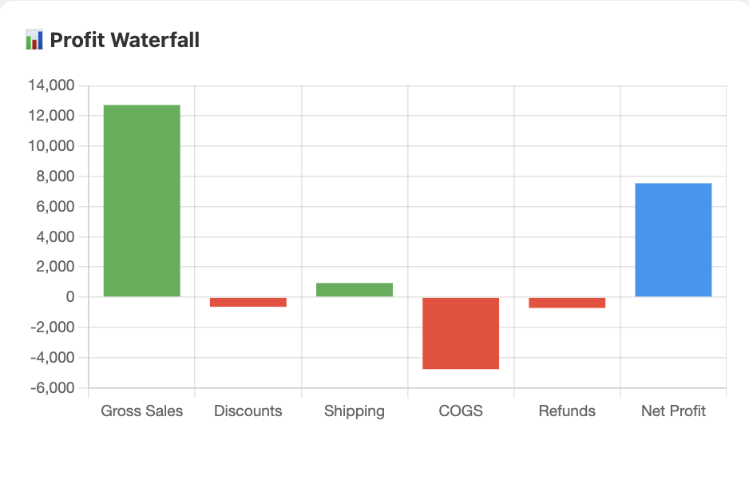
Figure 14 - Profit Waterfall Chart

Doughnut charts are often used to compare relative costs against net profit. They allow the viewer to instantly assess the health of a product's profit margin.

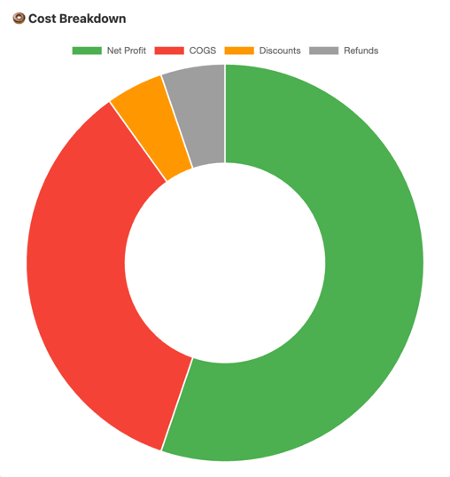
Figure 15 - Profit Component Donut Chart

4.5 Implementation
The Implementation was completed using a Waterfall approach whereby each section of the Implementation was produced sequentially during the design phase.

4.5.1 File Structure
The final application structure organises code into logical directories.

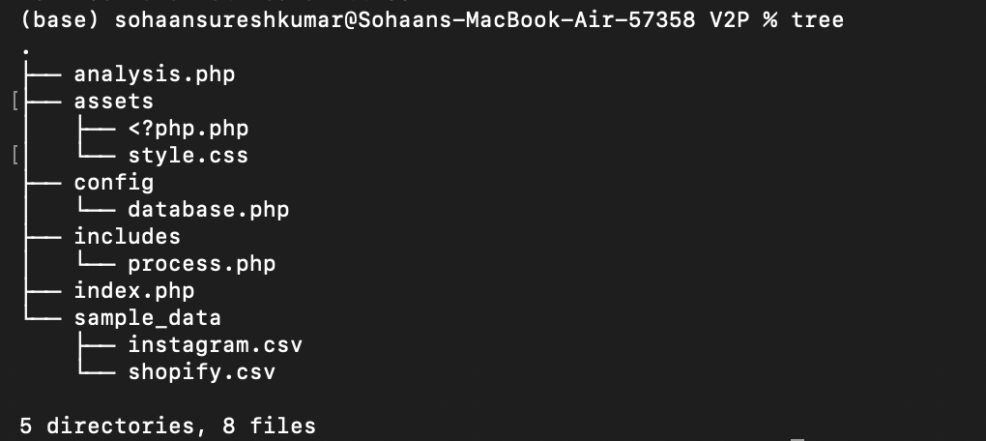
Figure 16 - File Structure Tree

4.5.2 Database Connection
The database connection is stored in the centralised configuration file and connected to using the PDO (PHP Data Objects) extension. All connections have been wrapped in try/catch error handling to prevent a fatal error in the event of a connection failing. Instead an appropriate error message will display to the user.

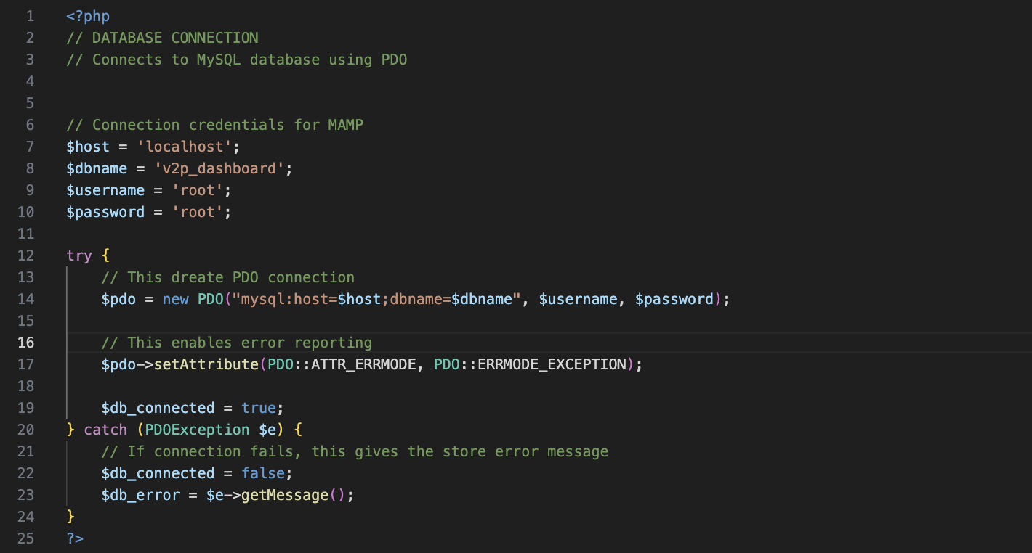
Figure 17 - database connection

4.5.3 CSV Parsing Implementation
Both Instagram and Shopify CSV files were handled to process accordingly.

For the Instagram data, each row is iterated over, parsing the date from the string and summing the views for that day in a dictionary. Totals were inserted into the database after all rows were processed.

For the Shopify data, each row is read and then the values inserted after stripping off any extra space before the number. Some real Shopify exports were tested and did get a few insert errors. The numeric values (price) had commas as thousand separators. Stripping those out first using str_replace(',', '', $value) resolved the issue.

4.5.4 Metric Calculations
The core novel metrics for the analysis were computed in the ETL process and inserted into the day_fact table.

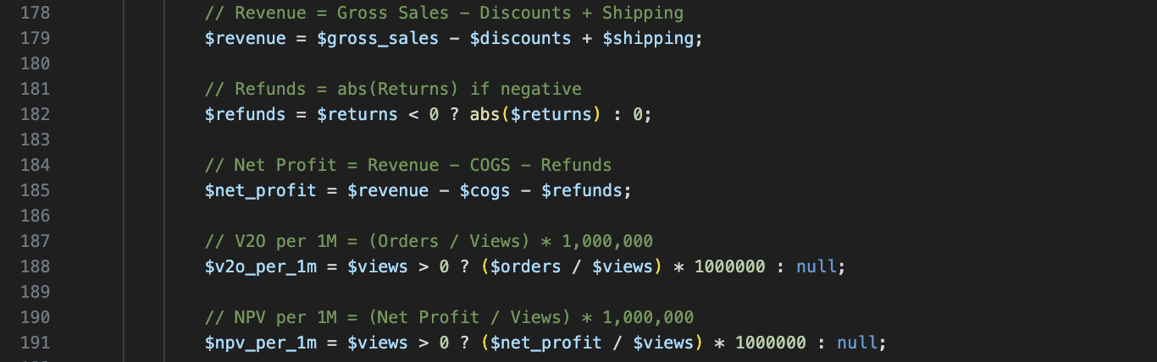
Figure 18 - Metric Calculations

Errors were occurring in the calculation of V2O and NPV for days with zero views. A conditional was added to handle this case, so now views equals zero returns NULL. The dashboard will then display a dash ("-") for any NULL values.

4.5.5 Chart.js Implementation
These examples use Chart.js from a CDN and just set the options for each chart type with some dummy data from arrays.

Dual-Axis Line Chart Issue: This chart is a dual-axis version showing Views Against Orders. The default settings for Chart.js put both of the datasets on the same Y-axis, and the huge difference in scale between hundreds of thousands and tens would have made the chart basically unreadable. Instead, a secondary Y-axis was created with the yAxisID: 'y1' and had it display next to the main axis on the right side of the chart.

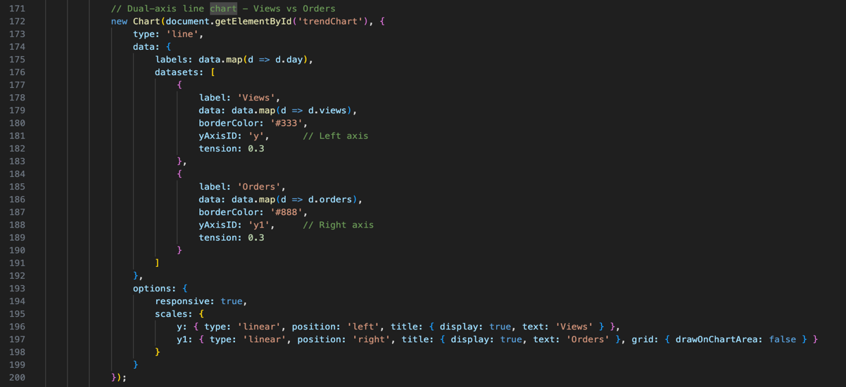
Figure 19 - Line Chart

Conditional Bar Colours: The daily profit bar chart required the bars to be different colours depending on the value - green for positive and red for negative. This was achieved by mapping the data array to generate a corresponding colours array.

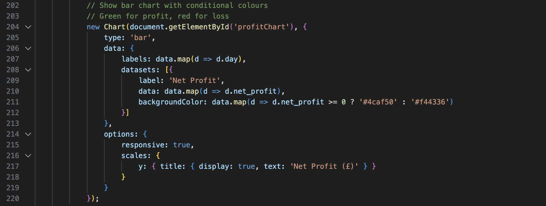
Figure 20 - Bar Colour Implementation

4.5.6 Profit Analysis Page
The Profit Analysis page gives a detailed view into the profitability of the store.

- The KPI cards show Gross Sales, Revenue, Net Profit and the % Profit Margin.
- A waterfall chart illustrating the flow starting from Gross Sales and ending on Net Profit.
- A doughnut chart showing cost breakdown proportions.
- Tables showing the three best and three worst performing days.
- A detailed automated insights section that interprets results and makes recommendations based on the data.

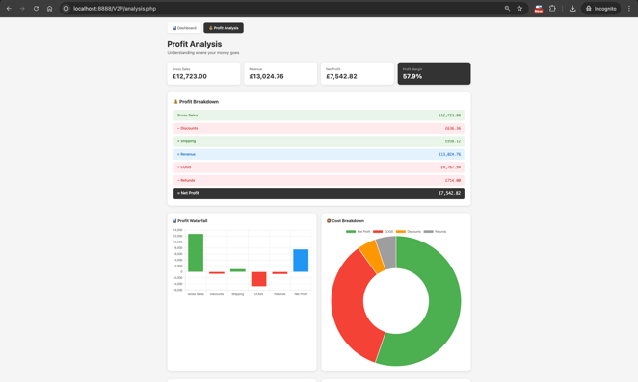  Figure 21 Profit Analysis upper | 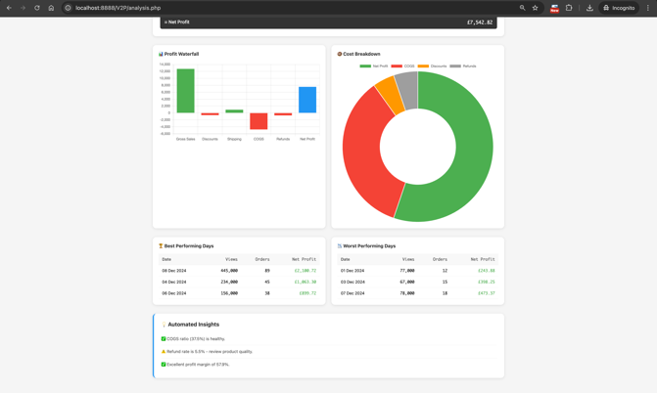  Figure 22 - Profit Analysis lower

Automated Insights Logic: This section contains analysis of key ratios and provides suggestions for improvement based on the actual results. Practical recommendations for real growth are provided. For example, if COGS is above 50% of gross sales, the company should review the costs of their suppliers. If refunds are above 5% of revenue, the company should review the quality of their products or manage customer expectations.

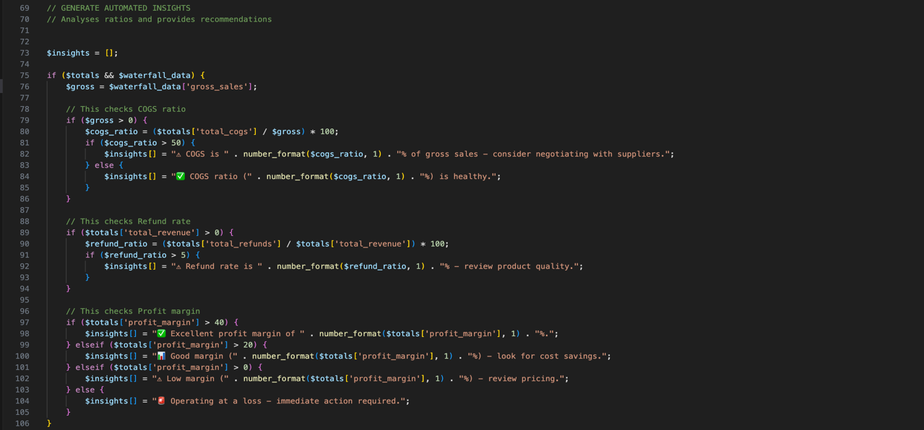
Figure 23 - Automated Insights Logic

4.6 Testing

4.6.1 Test Plan Summary
A structured test plan was developed covering 28 test cases across seven categories:

Category | Test Cases | Description
Database Connection | 2 | Verify connection success and error handling
File Upload | 3 | Test file acceptance, rejection, and validation
CSV Parsing | 5 | Test data extraction, date handling, encoding
Calculations | 7 | Verify all metric calculations are accurate
Data Join | 3 | Test day joining logic for various scenarios
Dashboard Display | 4 | Verify KPI cards, charts, and tables render correctly
Profit Analysis | 4 | Verify waterfall, insights, and best/worst days

4.6.2 Test Results
All 28 test cases passed without any issues. To make sure everything was accurate, key calculations were double-checked against manual spreadsheet calculations. The numbers for V2O and NPV matched what was expected, with only tiny differences due to rounding, which was within a tolerance of 0.01.

The complete test plan, which includes all the details about inputs, expected outputs, and results, can be found in Appendix A.

RESULTS & EVALUATION

5.1 System Testing Results
After the implementation was completed, thorough system testing was carried out using a test plan. In total 28 test cases were used across 7 categories to ensure that all necessary functionalities were covered during the implementation phase.

5.1.1 Test Categories & Results
Category | Test Cases | Passed | Failed
Database Connection | 2 | 2 | 0
File Upload | 3 | 3 | 0
CSV Parsing | 5 | 5 | 0
Calculations | 7 | 7 | 0
Data Join | 3 | 3 | 0
Dashboard Display | 4 | 4 | 0
Profit Analysis | 4 | 4 | 0
TOTAL | 28 | 28 | 0

All 28 test cases were passed during the system testing. The system works as expected.

5.1.2 Calculation Verification
All new metrics were verified against manual calculation using a sample of Dec 2024, 10 days.

Sample Data Totals:

- Total Views: 1,484,000
- Total Orders: 313
- Total Revenue: £13,024.76
- Total Net Profit: £7,542.82

V2O Calculation Verification: Expected: (313 ÷ 1,484,000) × 1,000,000 = 210.92 System Output: 210.92 ✓

NPV Calculation Verification: Expected: (7,542.82 ÷ 1,484,000) × 1,000,000 = £5,082.76 System Output: £5,082.76 ✓

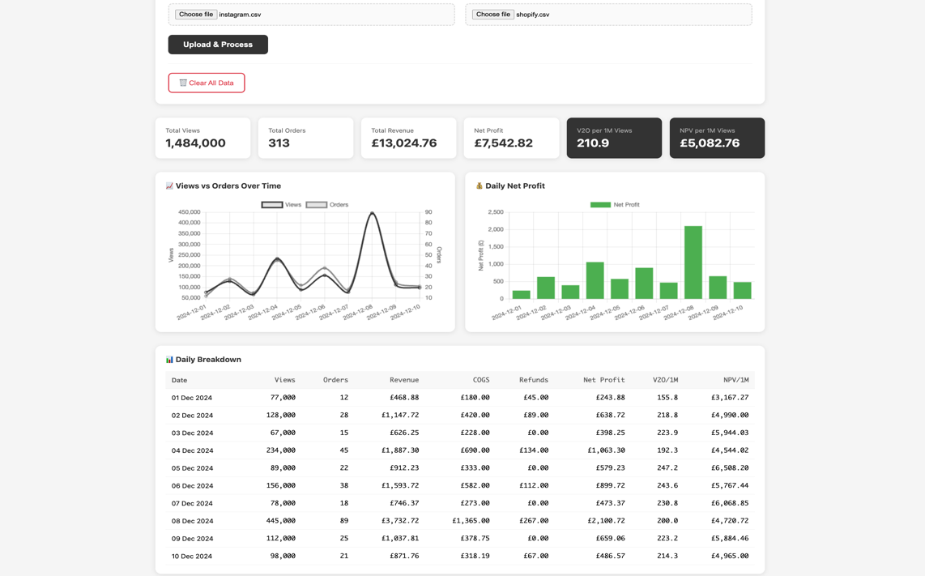
Figure 24 - Test Screenshot

The full test plan can be viewed in Appendix A.

5.2 User Evaluation Results
A summative user evaluation was held with 5 participants from the target user group, containing organic e-commerce sellers. They completed 6 tasks using the implemented parts of the dashboard and filled out a short questionnaire afterwards to gather feedback on several aspects of the implemented features.

5.2.1 Participant Demographics
ID | Sells Online | Uses Social Media | Technical Ability
P1 | Yes | Yes | Intermediate
P2 | Yes | Yes | Advanced
P3 | Yes | Yes | Advanced
P4 | Yes | Yes | Intermediate
P5 | Yes | Yes | Beginner

All five participants were the target user for this tutorial. All participants (100%) sold online and used social media to promote their wares. Participants had varying levels of technical ability.

5.2.2 Task Completion Results
Task | Description | Success Rate
T1 | Upload both CSV files | 60%
T2 | Find total number of views | 80%
T3 | Find the best performing day | 80%
T4 | Navigate to Profit Analysis page | 80%
T5 | Find the V2O per 1M views metric | 80%
T6 | Find the profit margin percentage | 80%

Average Task Success Rate: 77%

First tests showed a minimum success rate of 60% (Task 1: uploading a CSV file). The other tasks achieved a success rate of 80%. This means the core functionality of the dashboard is accessible.

5.2.3 Ease of Use
Question | P1 | P2 | P3 | P4 | P5 | AVG
Dashboard was easy to use | 5 | 5 | 4 | 5 | 4 | 4.6
Upload process straightforward | 5 | 5 | 4 | 5 | 5 | 4.8
Navigation intuitive | 4 | 5 | 4 | 5 | 4 | 4.4
Found information quickly | 4 | 5 | 3 | 4 | 4 | 4.0
Layout well organised | 5 | 5 | 4 | 5 | 5 | 4.8
Category Average |  |  |  |  |  | 4.52

The feedback on the upload process and organisation of the data was very positive with an average score of 4.8/5. The lowest score of 4.0/5 was for finding information quickly.

5.2.4 Understanding
Question | P1 | P2 | P3 | P4 | P5 | AVG
Understand V2O meaning | 4 | 5 | 4 | 5 | 4 | 4.4
Understand NPV meaning | 4 | 5 | 4 | 5 | 4 | 4.4
KPI cards clear | 4 | 5 | 4 | 5 | 5 | 4.6
Charts help understand trends | 5 | 5 | 4 | 5 | 5 | 4.8
Waterfall explains profit | 5 | 5 | 4 | 5 | 5 | 4.8
Category Average |  |  |  |  |  | 4.6

The waterfall chart and the trend charts scored 4.8/5. The new metrics V2O and NPV scored 4.4/5. This implies that more explanation or tooltips might help.

5.2.5 Usefulness
Question | P1 | P2 | P3 | P4 | P5 | AVG
Useful for business | 5 | 5 | 2 | 5 | 5 | 4.4
Insights actionable | 4 | 5 | 3 | 5 | 5 | 4.4
Better decisions with tool | 5 | 5 | 2 | 5 | 5 | 4.4
Best/worst days helpful | 5 | 5 | 4 | 5 | 5 | 4.8
Would recommend | 5 | 5 | 2 | 5 | 5 | 4.4
Category Average |  |  |  |  |  | 4.48

Feedback was received from user P3 who rated most aspects of the platform in the 2-4 range. They provided open feedback: "Useful tool, major downfall for my business is that it only integrates with Instagram shop and I sell on multiple platforms (TikTok, Facebook, Pinterest, Etsy, Amazon)."

The feature to track best/worst days was the most highly rated in terms of overall usefulness, receiving an average rating of 4.8/5.

5.2.6 Visual Design
Question | P1 | P2 | P3 | P4 | P5 | AVG
Design looks professional | 5 | 5 | 4 | 5 | 5 | 4.8
Colours appropriate | 5 | 5 | 4 | 5 | 5 | 4.8
Text easy to read | 5 | 4 | 4 | 5 | 5 | 4.6
Charts visually clear | 5 | 5 | 4 | 5 | 5 | 4.8
Tables easy to read | 4 | 5 | 4 | 5 | 4 | 4.4
Category Average |  |  |  |  |  | 4.68

The category with the highest rating (4.68/5) was the visual design. The average rating for "professional look", "colour choices" and "chart clarity" was 4.8/5.

5.2.7 Open Feedback Analysis
What participants LIKED MOST:

Participant | Feedback
P1 | "The V2O and NPV are metrics I've never seen before but make total sense for e-commerce. I find the waterfall chart to be really helpful just to visualise the relationship between the cost of products and the revenue."
P2 | "Very clean design. The profit margin calculation is something I usually do manually in spreadsheets so this saves time to be honest."
P3 | "The concept is good and the design looks professional."
P4 | "This is exactly what I've been looking for. As a dropshipper, understanding which content actually drives profit is soo important. The V2O metric is genius - I can finally see how many views I need to generate sales."
P5 | "The best n worst days feature is incredibly helpful. I can immediately see which posts drove the most profit and create more similar content. The waterfall chart makes accounting simple to understand."

Key themes from positive feedback:

- New metrics (V2O, NPV) praised as valuable and unique
- Waterfall chart highly valued for understanding profit breakdown
- Clean, professional design
- Time-saving compared to manual spreadsheet calculations
- Best/worst days feature enables content strategy decisions

What participants found CONFUSING or DIFFICULT:

Participant | Feedback
P1 | "Took me a moment to understand what V2O and NPV stood for. Maybe add a small explanation on hover?"
P2 | "Nothing really, it's quite intuitive. Perhaps the table could have sortable columns."
P3 | "The dashboard only supports Instagram and Shopify but I sell on multiple platforms. I use TikTok, Facebook, and Pinterest for marketing, and I sell through Etsy and Amazon as well as Shopify. This tool only shows a fraction of my business."
P4 | "Nothing major. Everything was straightforward."
P5 | "Had to look around a bit to find the profit margin but found it quickly on the Profit Analysis page."

Suggested Features:

Participant | Suggestion
P1 | "Date range filter so I can compare different periods and also export to maybe PDF for monthly reports."
P2 | "Comparison mode would be nice so I could upload two different time periods and see the difference side by side."
P3 | "Multi-platform support is essential. I need to see TikTok views, Facebook reach, Pinterest impressions, not just Instagram."
P4 | "Would love to see a calculator where I input a profit goal and it tells me how many views I need based on my NPV."
P5 | "Would be nice to have AI decisions next to the results."

Additional feedback: P4 mentioned spending "3 hours" looking for a method to download data as CSV from Instagram and Shopify. A documentation/user guide would be helpful.

5.2.8 Overall Ratings
P1 | P2 | P3 | P4 | P5 | Average
5 | 5 | 3 | 5 | 5 | 4.6

Would Use Regularly:

Response | Count | Percentage
Definitely yes | 4 | 80%
Probably yes | 0 | 0%
Maybe | 0 | 0%
Probably not | 1 | 20%
Definitely not | 0 | 0%

Four out of five participants (80%) said they would "definitely" use the dashboard regularly. P3 selected "probably not" citing: "Multi-platform support options were not included".

5.3 Discussion

5.3.1 Achievement of Objectives
Objective 1 - Investigate existing analytics tools: A clear gap was identified in cross-platform metrics for organic social commerce.

Objective 2 - Define novel performance metrics: V2O and NPV were integrated and received fantastic feedback. "These are new metrics I've never seen before, but they make total sense for e-commerce" shared by P1. "V2O is genius" said P4.

Objective 3 - Design a database schema: The database structure stores and joins data from Instagram and Shopify successfully.

Objective 4 - Develop a data ingestion system: Sample data was processed by the CSV upload and ETL pipeline correctly and achieved 100% accuracy in metric calculations.

Objective 5 - Build an interactive dashboard: The user experience of the provided dashboard was very good (4.52/5). The overall visual design was also very good (4.68/5).

Objective 6 - Implement a profit analysis module: The charts received a high rating for understandability, with the waterfall chart receiving the highest rating of 4.8 out of 5.

Objective 7 - Evaluate with users: User testing was conducted with 5 participants from the target group, and both quantitative ratings and user feedback were collected.

5.3.2 Strengths
Having established the current knowledge gap in the existing literature, this project introduces two standardised measures of efficiency: V2O and NPV for organic social commerce.

The waterfall chart was particularly effective in showing the key breakdown of profit. It addressed the concern of sellers as to where money was going.

Based on the evaluation, the interaction and visual design are rated acceptable for use in a professional setting. The most highly rated aspect was visual design receiving 4.68/5.

P2 noted this saves time compared to manual spreadsheet calculations.

5.3.3 Limitations
The extension currently only supports Instagram and Shopify, which is a large limitation for participants who are active on other platforms. P3 rated it 2-3/5 for this reason. Many organic e-commerce sellers are multi-platform sellers.

Feedback on V2O and NPV understanding scores could be improved - currently 4.4/5 compared to 4.8/5 for other elements. Adding tooltips or explanation text might help new users.

P4 spent three hours figuring out how to extract CSV data. Such frustrations could be avoided with user documentation or an onboarding guide.

Due to the small number of participants (5) this evaluation only provides an indication rather than statistical significance.

5.3.4 Summary of Results
Metric | Value
System Test Pass Rate | 100% (28/28)
Average Task Success Rate | 77%
Ease of Use Rating | 4.52/5
Understanding Rating | 4.60/5
Usefulness Rating | 4.48/5
Visual Design Rating | 4.68/5
Overall Rating | 4.6/5
Would Use Regularly | 80%

The full user evaluation questionnaire and raw participant data are provided in Appendix B.

CONCLUSIONS & RECOMMENDATIONS

6.1 Summary
The project investigates organic social media marketing as a marketing channel for e-commerce companies. The analysis of existing literature found a gap in the market regarding standardised metrics that measure the profitability of organic social media marketing. Currently there are established metrics for paid advertising such as Cost Per Acquisition (CPA) and Return on Ad Spend (ROAS), however there are no comparable metrics for organic social commerce which would allow businesses to see the relationship between the virality of content and business profit.

To address this need for an organic growth tool, the Virality-to-Profit Dashboard was built and tested for e-commerce sellers. Two new metrics were also created to give sellers an insightful measure of content performance: Views-to-Orders (V2O) and Net Profit Value per 1M Views (NPV).

This project was done under the Waterfall model of software development. Requirements Analysis, System Design, Implementation, Testing and Evaluation were the steps involved. The end result is a PHP web program that utilizes a MySQL database. There is also an ETL process in the system to extract, transform and load data from .csv files. Users can view various calculated metrics that are graphed out into web charts created by Chart.js.

After thorough system testing of all 28 test cases, all have successfully passed. All key metrics are correctly calculated against manual spreadsheet calculations. Five users from the target audience completed user testing with very positive results:

- Overall rating of 4.6 out of 5
- 80% reported they would 'definitely' use the dashboard frequently
- Visual design received the highest rating (4.68/5)
- Waterfall charts and trend based visualisations worked very well

The new metrics V2O and NPV were particularly well received with some even describing them as genius and something that "makes total sense for e-commerce". The dashboard proves there is a gap in current analytics and a purpose built solution for e-commerce that incorporates social media insights can help fill that deficit.

6.2 Limitations

6.2.1 Platform Restriction
The tool only pulls data from Instagram and Shopify, which is a large limitation for participants active on other platforms. One participant rated it 2-3/5 for this reason. Many organic e-commerce sellers are multi-platform sellers operating on TikTok, Facebook, Pinterest, Etsy, and Amazon.

6.2.2 CSV Format Dependency
Currently the system uses Instagram and Shopify CSV files. P4 mentioned it took 3 hours to figure out how to generate the files manually. This is a significant barrier for non tech-savvy users. Also, manually generated files from different versions of Meta Business Suite are not all the same.

6.2.3 Day-Level Granularity
Data is currently summarized on a daily basis, which means sellers can do trend analysis between days, but will not be able to do post-level attribution of sales. They can see which days are most successful, but not which individual pieces of content are selling.

6.2.4 Sample Size
The system was tested by 5 people. Useful feedback was gathered. While this is not enough to establish statistical accuracy, the feedback was often detailed and very useful. More tests with larger numbers of participants would increase confidence in findings.

6.2.5 Local Deployment
The dashboard is currently under development on a local environment and therefore not publicly accessible. It would be beneficial to make it accessible and collaborative-friendly for a broader audience.

6.3 Future Work

6.3.1 Multi-Platform Support
Add support for additional CSV parsing modules to handle different export formats on different platforms. Extended database schema to accommodate platform-specific metrics. Unified visualisations that aggregate cross-platform performance.

6.3.2 API Integration
Instead of uploading a CSV, it would be a huge experience boost to integrate directly with Instagram/Facebook (via Meta's APIs) or Shopify (via their APIs). This would remove the extraction step and allow for true real-time or scheduled updates.

6.3.3 Metric Tooltips and Documentation
Consider adding hover tooltips to explain terms such as V2O and NPV for users who may not be familiar. Also a help section or user guide could be useful for new users and address the CSV extraction confusion.

6.3.4 Date Range Filtering
Allow filtering by date range and comparison of two time frames side by side for month-over-month performance comparison, campaign-specific analysis and seasonal trend identification.

6.3.5 Profit Goal Calculator
Participant P4 noted it would be valuable to enter a target profit and see expected views required based on historical NPV to help planning.

6.3.6 Export Functionality
PDF/Excel export would be very useful for generating monthly reports for stakeholders.

6.3.7 Cloud Deployment
The dashboard could be hosted with a cloud hosting site such as AWS, Heroku or DigitalOcean and viewed remotely. This would mean no need to set up a local environment and could support multiple users with individual data privacy.

6.3.8 AI-Powered Insights
Participant P5 noted "AI decisions next to the results" as a desired feature. Machine learning in future versions could provide predictions based on view trends and identify anomalous performance days.

6.4 Final Remarks
The Virality-to-Profit Dashboard is a data visualization tool that shows how analytics can help close the gap between social media virality and e-commerce profitability. Users gave very positive feedback with 80%+ adoption intent and 4.6/5 overall rating.

There are limitations, primarily platform restriction and CSV-based data access. However, this tool addresses a missing piece in the analytics landscape for organic e-commerce sellers. For the first time there are two standard metrics of efficiency that paid advertisers have been using for years.

This project addresses a real world problem and paves the way for subsequent multi-platform analytics tools. For the organic e-commerce seller wondering the true profit per social media outlet, the Virality-to-Profit Dashboard provides a novel solution.

REFLECTION

7.1 Introduction
This chapter provides a personal reflection on the development of the Virality-to-Profit Dashboard, examining the learning journey, challenges encountered, skills developed, and lessons learned throughout the project.

7.2 Project Journey
This project started because of a real problem that happened when running an online store that sold organic products. It was hard to know which posts on Instagram were actually helping to make sales on Shopify, because the numbers had to be looked at in two different places. This was really frustrating, and it motivated finding a solution. Having experienced this problem personally provided high motivation to keep working on the project.

The literature review took longer than expected. Finding academic sources that talked about measuring the success of organic social commerce was challenging. Most research focused on paid ads, not organic content. But this challenge actually helped prove that the project is needed - there's a real gap in research and tools for measuring organic content financial performance.

7.3 Technical Challenges
Several technical challenges arose during development that required problem-solving and learning new skills.

The database design phase required careful consideration of how to join data from two completely different platforms. Instagram exports individual post data while Shopify exports daily aggregates, meaning the ETL pipeline needed to handle aggregation on one side but not the other. Working through this logic strengthened understanding of data transformation principles and SQL JOIN operations.

One particularly frustrating issue occurred when the database kept returning errors about missing columns. After significant debugging, the realisation came that the database tables had been created from an outdated schema file. This taught an important lesson about version control and keeping development artefacts synchronised—a mistake that will not be repeated in future projects.

Creating a dual-axis chart with Chart.js to compare views and orders was a tough task. The main issue was that the default setup made the orders line almost disappear because the numbers were so different - views were in the hundreds of thousands, while orders were only in the tens. Setting up a secondary Y-axis with its own scaling was required. It took time to read through the documentation and try out different options, but it was worth it. This experience built confidence when working with JavaScript charting libraries.

7.4 Skills Development

7.4.1 Technical Skills
PHP skills have greatly improved, particularly when dealing with files, reading from CSV files, manipulating data and connecting to a database using the PDO object. MySQL database design knowledge has expanded with more information on designing databases with composite keys, foreign keys and writing optimal queries. Learning how to implement charts using Chart.js and enhancing frontend skills through CSS Grid and Flexbox layouts was valuable. Knowledge was gained on ETL processes and data pipeline designs.

7.4.2 Professional Skills
The use of the Waterfall methodology to deliver a project to meet required deliverables on time enhanced project management skills. User evaluation experience was gained through designing questionnaires, recruiting participants and evaluating qualitative and quantitative feedback. Technical writing skills were developed by producing documentation, reading relevant literature, and composing a report. Various problem-solving strategies were developed to address technical errors encountered.

7.5 What Would Be Done Differently

7.5.1 Earlier User Involvement
User evaluation took place at the end of the implementation phase. Implementation would have been more effective if potential end-users had been involved earlier, either to review wireframes or test with a prototype.

7.5.2 API Research First
Hours were spent manually going through CSV files. Time could have been saved by researching whether API integration was in scope earlier. Even if it wasn't, learning about how the architecture could be enhanced would have been useful.

7.5.3 More Sample Data
All unit tests were done with a single dataset. More test datasets could have been made with edge cases such as zero views, negative profits, and missing days.

7.5.4 Documentation Planning
Many questions arose about how to download CSVs from Instagram and Shopify that were not addressed in basic user documentation. Planning documentation from the start would have avoided confusion.

7.6 Future Application
This project provided the opportunity to learn valuable skills and knowledge that can be used in future pursuits of e-commerce and software development. The ability to consume data from multiple platforms, calculate meaningful business metrics, and represent results visually provides knowledge valuable for business intelligence and analytics roles.

The whole process of identifying a problem, conducting research, designing, implementing, and evaluating was completed. It was an end-to-end process that shows how product development works in real life, applicable in industry or future careers.

Running the user evaluation highlighted the importance of building products that solve real problems for real users. The feedback received (both positive and negative) demonstrated that user-centred design is essential for creating tools people actually want to use.

7.7 Conclusion
This project went far beyond simple tool creation. The challenges tested problem-solving skills and the evaluation process allowed for valuable feedback from real users. Through the project, insight was gained into areas for improvement in future work. Most importantly, this project demonstrated that with hard work and determination, meaningful and innovative tools can be created to fill current market voids, providing a basis for future entrepreneurial or development endeavours.

REFERENCES

[1] N. Nasrabadi, H. Wicaksono, and O. F. Valilai, "Shopping marketplace analysis based on customer insights using social media analytics," MethodsX, vol. 13, p. 102868, Jul. 2024, doi: 10.1016/j.mex.2024.102868.

[2] D. Herzallah, F. Liébana-Cabanillas, F. Muñoz-Leiva, and C. Zarco, "Past, present, and future of social commerce: a bibliometric analysis," Quality & Quantity, vol. 59, no. 4, p. 3079, Mar. 2025, doi: 10.1007/s11135-025-02103-z.

[3] J. Liang, S. Fong, S. M. Muros, and A. J. Tallón-Ballesteros, "Influencer Sales on TikTok: Forecasting Prominent Factors," in Lecture notes in computer science, Springer Science+Business Media, 2025, p. 229. doi: 10.1007/978-3-031-81226-2_20.

[4] A. Khraiwish and A. H. Alsharif, "Insights and Influencers: A Decade of Social Media Marketing Research Revealed Through Bibliometrics," Scientific Annals of Economics and Business, vol. 71, no. 4, p. 497, Dec. 2024, doi: 10.47743/saeb-2024-0023.

[5] J. D. Gupta, "Analyzing Effectiveness of Influencer Marketing in E-Commerce and the Spread of Misinformation through Social Media," International Journal for Research in Applied Science and Engineering Technology, vol. 13, no. 5, p. 6501, May 2025, doi: 10.22214/ijraset.2025.71530.

[6] S. Asanprakit and T. Kraiwanit, "Multiplier transformation of E-commerce to S-commerce in emerging economy," R-Economy, vol. 10, no. 1, p. 55, Apr. 2024, doi: 10.15826/recon.2024.10.1.004.

[7] R. Algharabat and N. P. Rana, "Social Commerce in Emerging Markets and its Impact on Online Community Engagement," Information Systems Frontiers, vol. 23, no. 6, p. 1499, Jul. 2020, doi: 10.1007/s10796-020-10041-4.

[8] J. Vidani, "Evaluating the Influence of Social Media Advertising on E-Commerce Sales," SSRN Electronic Journal, Jan. 2024, doi: 10.2139/ssrn.4849890.

[9] R. A. Heiens and R. Narayanaswamy, "The Impact of Digital Social legitimization on Website Visits and Web Sales," International Journal of Electronic Commerce Studies, vol. 12, no. 1, p. 29, Jan. 2021, doi: 10.7903/ijecs.1865.

[10] T. Mtjilibe, E. Rameetse, N. Mgwenya, and B. Thango, "Exploring the Challenges and Opportunities of Social Media for Organizational Engagement in SMEs: A Comprehensive Systematic Review," Jan. 2024, doi: 10.2139/ssrn.4998542.

[11] J. C. V. Garavito, P. Alvarez-Franco, and M. S. Rodríguez, "El retorno de la inversión en medios sociales (Social Media ROI). Una revisión de literatura," Tendencias, vol. 22, no. 2, p. 331, Jul. 2021, doi: 10.22267/rtend.212202.179.

[12] P. Mikalef, M. N. Giannakos, and A. Pateli, "Shopping and Word-of-Mouth Intentions on Social Media," Journal of theoretical and applied electronic commerce research, vol. 8, no. 1, p. 5, Jan. 2013, doi: 10.4067/s0718-18762013000100003.

[13] P. Wimolsophonkitti and A. Naipinit, "Drivers and performance impacts of live streaming commerce adoption: Revolutionizing the e-commerce supply chain," Uncertain Supply Chain Management, vol. 12, no. 3, p. 1479, Jan. 2024, doi: 10.5267/j.uscm.2024.4.003.

[14] T. C. T. Dinh and Y. Lee, "Going viral: How social and personal motivations drive emotional engagement and consumer online brand-related activities," PLoS ONE, vol. 20, no. 11, Nov. 2025, doi: 10.1371/journal.pone.0336907.

[15] S. Cheng and Y. Jiang, "Effects of social media marketing on rural tourism product sales: evidence from controlled experiments," Frontiers in Sustainable Food Systems, vol. 9, Nov. 2025, doi: 10.3389/fsufs.2025.1714233.

[16] R. Almestarihi, A. Y. A. B. Ahmad, R. H. Frangieh, I. A. Abu-AlSondos, K. K. Nser, and A. Ziani, "Measuring the ROI of paid advertising campaigns in digital marketing and its effect on business profitability," Uncertain Supply Chain Management, vol. 12, no. 2, p. 1275, Jan. 2024, doi: 10.5267/j.uscm.2023.11.009.

[17] M. Klein and A. F. Kutlar, "A COMPARATIVE EXPERIMENTAL STUDY ON ARTIFICIAL INTELLIGENCE- AND HUMAN-DRIVEN SOCIAL MEDIA MARKETING CAMPAIGNS," Pressacademia, Dec. 2024, doi: 10.17261/pressacademia.2024.1935.

[18] R. A. Adeleye, K. F. Awonuga, O. F. Asuzu, N. L. Ndubuisi, and T. S. Tubokirifuruar, "Digital marketing analytics: A review of strategies in the age of big data and AI," World Journal of Advanced Research and Reviews, vol. 21, no. 2. GSC Online Press, p. 73, Feb. 07, 2024. doi: 10.30574/wjarr.2024.21.2.0395.

[19] O. Zghurska, О. Vynogradova, O. Yerankin, O. Korchynska, Н. Овсієнко, and A. Aisulu, "MEDIA PLANNING AS A NECESSARY CONDITION FOR INCREASING THE EFFICIENCY OF BUSINESS STRUCTURES' DIGITAL MARKETING ACTIVITIES," Financial and credit activity problems of theory and practice, vol. 1, no. 54, p. 578, Feb. 2024, doi: 10.55643/fcaptp.1.54.2024.4271.

[20] S. Rose, D. Fandel, A. Saraeva, and A. Dibley, "Sharing is the name of the game: Exploring the role of social media communication practices on B2B customer relationships in the life sciences industry," Industrial Marketing Management, vol. 93, p. 52, Jan. 2021, doi: 10.1016/j.indmarman.2020.12.013.

[21] F. R. A. Owolabi, J. O. Enyejo, I. N. O. Babalola, and T. M. Olola, "Overcoming engagement shortfalls and financial constraints in Small and Medium Enterprises (SMES) social media advertising through cost-effective Instagram strategies in Lagos and New York City," International Journal of Management & Entrepreneurship Research, vol. 6, no. 8, p. 2758, Aug. 2024, doi: 10.51594/ijmer.v6i8.1462.

[22] A. Muralidhar and Y. Lakkanna, "From Clicks to Conversions: Analysis of Traffic Sources in E-Commerce," arXiv (Cornell University), Mar. 2024, doi: 10.48550/arxiv.2403.16115.

[23] I. Ascani and C. Ancillai, "Social media marketing and performance measurement: does it take two to tango?," Review of Managerial Science, May 2025, doi: 10.1007/s11846-025-00891-0.

[24] K. F. Anjorin, M. A. Raji, and H. B. Olodo, "The influence of social media marketing on consumer behavior in the retail industry: A comprehensive review," International Journal of Management & Entrepreneurship Research, vol. 6, no. 5. Fair East Publishers, p. 1547, May 12, 2024. doi: 10.51594/ijmer.v6i5.1123.

[25] K. Sombultawee, "Antecedents and consequences of e-commerce adoption for SMEs," Kasetsart Journal of Social Sciences, Mar. 2020, doi: 10.34044/j.kjss.2020.41.2.05.

[26] M. R. Roosdhani, N. Farida, and F. Indriani, "FROM LIKES TO SALES: STUDY ON ENHANCING SOCIAL MEDIA PERFORMANCE FOR INDONESIAN SMES," International Journal of Business and Society, vol. 24, no. 3, p. 1157, Dec. 2023, doi: 10.33736/ijbs.6407.2023.

[27] C. Zerres, "TOO HARD TO MEASURE! MEASUREMENT OF SOCIAL MEDIA ACTIVITIES. AN OBJECTIVE-BASED PROCESS," Management & Marketing, vol. 19, no. 2, p. 201, Nov. 2021, doi: 10.52846/mnmk.19.2.04.

[28] Z. Samira, Y. W. Weldegeorgise, O. S. Osundare, H. O. Ekpobimi, and R. C. Kandekere, "Development of an integrated model for SME marketing and CRM optimization," International Journal of Management & Entrepreneurship Research, vol. 6, no. 10, p. 3209, Oct. 2024, doi: 10.51594/ijmer.v6i10.1612.

[29] F. J. Mata and A. Quesada, "Web 2.0, Social Networks and E-commerce as Marketing Tools," Journal of theoretical and applied electronic commerce research, vol. 9, no. 1, p. 11, Dec. 2013, doi: 10.4067/s0718-18762014000100006.

[30] E. E. James, G. S. Etim, A. N. Nnana, and V. O. Okeowo, "E-marketing Strategies and Performance of Small and Medium-sized Enterprises: A New-normal Agenda," Journal of Business and Management Studies, vol. 3, no. 2, p. 162, Nov. 2021, doi: 10.32996/jbms.2021.3.2.17.

[31] R. M. Daood, J. Wang, and E. O. Oppong, "Assessing Depth of Social Media Presence on Financial Performance of SMEs: Evidence from Syrian SMEs. A Panel Fixed Effect Analysis," American Journal of Industrial and Business Management, vol. 14, no. 5, p. 712, Jan. 2024, doi: 10.4236/ajibm.2024.145037.

[32] A. Manzoor, M. A. Qureshi, E. Kidney, and L. Longo, "e-Profits: A Business-Aligned Evaluation Metric for Profit-Sensitive Customer Churn Prediction," arXiv (Cornell University), Jul. 2025, doi: 10.48550/arxiv.2507.08860.

[33] S. Wang, "Construction and validation of a financial risk prediction model for e-commerce enterprises oriented to financial sharing," Applied Mathematics and Nonlinear Sciences, vol. 9, no. 1, Jan. 2024, doi: 10.2478/amns-2024-1075.

[34] K. D. Dunn and D. E. Brooks, "Profit analysis," Cornell Hotel and Restaurant Administration Quarterly, vol. 31, no. 3, p. 80, Nov. 1990, doi: 10.1177/001088049003100317.

[35] B. E. Napitupulu, C. H. Karjo, and F. Hermawan, "The Effect of Selling on Social Media on the Profits of Small Businesses," KnE Social Sciences, Feb. 2023, doi: 10.18502/kss.v8i2.12761.

[36] L. Jiang, Z. K. Lim, C. Lin, H. Zhao, J. Huang, and X. Liu, "The Extent Social Media Marketing is Contributable to Customer Based Brand Equity of Luxury Brands," in Advances in economics, business and management research/Advances in Economics, Business and Management Research, Atlantis Press, 2024, p. 485. doi: 10.2991/978-94-6463-408-2_55.

[37] E. T. Gazilas and A. Vozikis, "The impact of market concentration on the financial performance of general private clinics in Greece," International Journal of Management & Entrepreneurship Research, vol. 6, no. 8, p. 2533, Aug. 2024, doi: 10.51594/ijmer.v6i8.1381.

[38] K. Aliamutu, A. Bhana, and S. Suknunan, "The impact of environmental costs on financial performance: An explorative analysis of two plastic companies," Environmental Economics, vol. 14, no. 1, p. 13, Mar. 2023, doi: 10.21511/ee.14(1).2023.02.

[39] P. Widianingsih, "Optimization of Profit Growth: The Impact of Debt to Equity Ratio, Total Assets Turn Over, and Net Profit Margin on Food and Beverage Sub Sector Companies," Journal of Information Systems Engineering & Management, vol. 10, p. 632, Mar. 2025, doi: 10.52783/jisem.v10i15s.2501.

[40] P. S. Venkateswaran, D. Marupaka, S. Parate, A. Bhanushali, L. T. Reddi, and P. Paramasivan, "A Comprehensive Review on Leveraging Business Intelligence for Enhanced Marketing Analytics," Advances in business information systems and analytics book series. IGI Global, p. 34, Dec. 21, 2023. doi: 10.4018/979-8-3693-2193-5.ch003.

[41] "International Journal of Multidisciplinary Research and Growth Evaluation," International Journal of Multidisciplinary Research and Growth Evaluation, Nov. 2021, doi: 10.54660/anfo.

[42] T. Ezhilarasi and M. Jaswanth, "A Study on Implementation of Power Bi Dashboards to Streamline Business Processes," International Journal for Research in Applied Science and Engineering Technology, vol. 12, no. 7, p. 1548, Jul. 2024, doi: 10.22214/ijraset.2024.63802.

[43] N. C. Msibi, S. Mkhwanazi, and S. Mazibuko, "Designing Digital Dashboards for Business Performance: Principles and Evidence," Nov. 2025, doi: 10.31222/osf.io/7h23m_v1.

[44] A. Muppidi, A. S. Hashim, M. H. Hasan, and A. A. Muazu, "A Conceptual UX Model for Designing and Developing the Business Intelligence Dashboards," Journal of Computer Science, vol. 19, no. 12, p. 1505, Nov. 2023, doi: 10.3844/jcssp.2023.1505.1519.

[45] ص. مقيمح, R. Zighed, K. Mili, and I. Bengana, "Business intelligence in organizational decision-making: a bibliometric analysis of research trends and gaps (2014–2024)," Discover Sustainability, vol. 5, no. 1, Dec. 2024, doi: 10.1007/s43621-024-00692-7.

[46] H. O. Mbaidin, "The dynamic role of business intelligence in developing effective planning strategies through analyzing data as an influential variable: Case of engineering the pharmaceutical sector in Jordan," Uncertain Supply Chain Management, vol. 12, no. 2, p. 1189, Jan. 2024, doi: 10.5267/j.uscm.2023.11.015.

[47] S. Bussa, "Enhancing BI Tools for Improved Data Visualization and Insights," International Journal of Computer Science and Mobile Computing, vol. 12, no. 2, p. 70, Feb. 2023, doi: 10.47760/ijcsmc.2023.v12i02.005.

[48] M. Masson, "Cadre générique pour le traitement et l'analyse multidimensionnelle des réseaux sociaux : une approche proxémique," Centre National de la Recherche Scientifique, 2024. Accessed: Oct. 2025. [Online]. Available: https://theses.hal.science/tel-04756013

[49] N. C. Msibi, S. Mkhwanazi, and S. Mazibuko, "Designing Digital Dashboards for Business Performance: Principles and Evidence," Oct. 2025, doi: 10.21203/rs.3.rs-7817897/v1.

[50] R. O. DaSouza and E. M. Church, "Utilizing Social Networks to Improve Success Metrics in Social E-Commerce," Journal of the Southern Association for Information Systems, vol. 11, no. 1, p. 53, Mar. 2024, doi: 10.17705/3jsis.00035.

[51] L. G. Griffin, "The power of social content: Transforming digital commerce," Journal of digital & social media marketing., vol. 12, no. 2, p. 129, Sep. 2024, doi: 10.69554/lszn9443.

[52] P. Saikia and H. Barman, "A Systematic Analysis of Higher Educational Content Over Social Media for Engagement Optimization," Review of Marketing Science, vol. 21, no. 1, p. 77, Jan. 2023, doi: 10.1515/roms-2022-0050.

[53] M. Saunders, P. Lewis, and A. Thornhill, Research Methods for Business Students, 8th ed. Harlow: Pearson, 2019.

[54] J. W. Creswell and J. D. Creswell, Research Design: Qualitative, Quantitative, and Mixed Methods Approaches, 5th ed. Los Angeles: SAGE Publications, 2018.

[55] R. K. Yin, Case Study Research and Applications: Design and Methods, 6th ed. Los Angeles: SAGE Publications, 2018.

[56] A. R. Hevner, S. T. March, J. Park, and S. Ram, "Design Science in Information Systems Research," MIS Quarterly, vol. 28, no. 1, pp. 75-105, Mar. 2004, doi: 10.2307/25148625.

[57] K. Peffers, T. Tuunanen, M. A. Rothenberger, and S. Chatterjee, "A Design Science Research Methodology for Information Systems Research," Journal of Management Information Systems, vol. 24, no. 3, pp. 45-77, 2007, doi: 10.2753/MIS0742-1222240302.

[58] I. Sommerville, Software Engineering, 10th ed. Boston: Pearson, 2016.

[59] R. S. Pressman and B. R. Maxim, Software Engineering: A Practitioner's Approach, 9th ed. New York: McGraw-Hill Education, 2020.

[60] W. W. Royce, "Managing the Development of Large Software Systems," in Proceedings of IEEE WESCON, Los Angeles, CA, USA, Aug. 1970, pp. 1-9.

[61] S. Balaji and M. S. Murugaiyan, "Waterfall vs V-Model vs Agile: A Comparative Study on SDLC," International Journal of Information Technology and Business Management, vol. 2, no. 1, pp. 26-30, Jun. 2012.

[62] Chart.js Contributors, "Chart.js Documentation," 2024. [Online]. Available: https://www.chartjs.org/docs/latest/

[63] G. J. Myers, C. Sandler, and T. Badgett, The Art of Software Testing, 3rd ed. Hoboken, NJ: John Wiley & Sons, 2011.

[64] J. Nielsen, Usability Engineering. Boston: Morgan Kaufmann, 1993.

[65] J. Brooke, "SUS: A 'Quick and Dirty' Usability Scale," in Usability Evaluation in Industry, P. W. Jordan, B. Thomas, B. A. Weerdmeester, and I. L. McClelland, Eds. London: Taylor & Francis, 1996, pp. 189-194.

APPENDICES

Appendix A: Test Plan
This appendix presents a representative sample of the 28 test cases executed during system testing. The complete test documentation is available upon request.

Project Information
- Project: Virality-to-Profit Dashboard
- Tester: Sohaan
- Date: April 2026
- Version: 1.0

Test Category 1: Database Connection

TC-001: Database Connection Success
Field | Value
Description | Verify the application connects to MySQL database
Precondition | MAMP is running with MySQL server active
Steps | 1. Open http://localhost:8888/V2P/
Expected Result | Green banner shows "✅ Connected to database"
Actual Result | Green banner displayed "✅ Connected to database"
Status | Pass

Test Category 2: File Upload

TC-003: Valid CSV Upload
Field | Value
Description | Verify both CSV files upload successfully
Precondition | Valid instagram.csv and shopify.csv files ready
Steps | 1. Click "Choose file" for Instagram CSV 2. Select instagram.csv 3. Click "Choose file" for Shopify CSV 4. Select shopify.csv 5. Click "Upload & Process"
Expected Result | Success message appears, dashboard displays data
Actual Result | Success message "✅ Success! Processed 10 days of Instagram data and 10 days of Shopify data" displayed. Dashboard populated with KPI cards, charts, and table.
Status | Pass

TC-011: Revenue Calculation
Field | Value
Description | Verify Revenue = Gross Sales - Discounts + Shipping
Test Data | Gross: £456, Discounts: £23, Shipping: £35.88
Expected Result | Revenue = £468.88
Actual Result | Revenue calculated correctly: £468.88 displayed in table
Status | Pass

TC-012: Refunds Calculation (Negative Returns)
Field | Value
Description | Verify Refunds = abs(Returns) when Returns < 0
Test Data | Returns = -45.00
Expected Result | Refunds = £45.00
Actual Result | Refunds displayed as positive £45.00
Status | Pass

TC-015: V2O Calculation
Field | Value
Description | Verify V2O = (Orders / Views) × 1,000,000
Test Data | Orders: 12, Views: 77,000
Expected Result | V2O = 155.8 per 1M views
Actual Result | V2O displayed as 155.8 in daily breakdown
Status | Pass

TC-021: KPI Cards Display
Field | Value
Description | Verify all 6 KPI cards show correct totals
Expected Result | Total Views, Orders, Revenue, Net Profit, V2O, NPV all correct
Actual Result | All 6 KPI cards displayed: Total Views (1,484,000), Total Orders (313), Total Revenue (£13,024.76), Net Profit (£7,542.82), V2O (210.9), NPV (£5,082.76)
Status | Pass

TC-027: Best/Worst Days Correct
Field | Value
Description | Verify best days are sorted by highest profit
Expected Result | Top 3 profit days shown in descending order
Actual Result | Best days table shows 08 Dec 2024 (£2,100.72) as top performer
Status | Pass

TC-028: Insights Generate
Field | Value
Description | Verify insights box shows relevant analysis
Expected Result | At least 2 insights displayed based on data
Actual Result | Insights box displayed with 3 insights: COGS ratio, refund rate warning, profit margin status
Status | Pass

Appendix B: User Evaluation
Note: This appendix presents a sample of 1 out of 5 responses. The complete raw response data exported from Google Forms is available upon request.

Virality-to-Profit Dashboard - User Evaluation
Thank you for helping evaluate this dashboard. Your feedback will help improve the system. You will complete 6 short tasks using the dashboard, then answer questions about your experience. This should take approximately 10-15 minutes.

Yes
No
Do you sell products online?
Yes
No
Do you use social media for marketing?
Beginner
Intermediate
Advanced
How would you rate your technical ability?

Yes, completed
No, could not complete
Were you able to upload both CSV
fi
les?
Yes, completed
No, could not complete
Were you able to
fi
nd the total number of views?
Yes, completed
No, could not complete
Were you able to
fi
nd the best performing day?
Yes, completed
No, could not complete
Were you able to navigate to the Pro
fi
t Analysis page?
Yes, completed
No, could not complete
Were you able to
fi
nd the V2O per 1M views metric?
Yes, completed
No, could not complete
Were you able to
fi
nd the pro
fi
t margin percentage?
SECTION 3: Ease of Use
(Strongly
1
Disagree)
2
3
4
5
(Strongly
Agree)
The dashboard
was easy to use
The file upload
process was
straightforward
The navigation
between pages
was intuitive
I could find the
information I
needed quickly
The layout is well
organised
SECTION 4: Understanding (Clarity of Metrics and Visuals)
1
(Strongly
Disagree)
2
3
4
5
(Strongly
Agree)
I understand
what V2O
(
Views-to
-
Orders) means
I understand
what NPV (Net
Profit per
Views) means
The KPI cards
clearly show
important
metrics
The charts help
me understand
trends
The waterfall
chart explains
how profit is
calculated
1
(Poor
)
1
2
3
4
5
5
(Excellent
)
Overall, how would you rate this dashboard?
Definitely not
Probably not
Maybe
Probably yes
Definitely yes
This content is neither created nor endorsed by Google.
Would you use this tool regularly?

Appendix C: Source Code
The complete annotated source code for the V2P Dashboard has been submitted as a separate zip file via the Moodle code submission link

Appendix D: SQL Create Statements

-- V2P DASHBOARD DATABASE SCHEMA
CREATE DATABASE IF NOT EXISTS v2p_dashboard;
USE v2p_dashboard;

-- Table 1: upload_sessions
CREATE TABLE upload_sessions (
id INT AUTO_INCREMENT PRIMARY KEY,
created_at DATETIME DEFAULT CURRENT_TIMESTAMP,
ig_filename VARCHAR(255) NULL,
shopify_filename VARCHAR(255) NULL,
ig_rows_valid INT DEFAULT 0,
ig_rows_invalid INT DEFAULT 0,
shop_rows_valid INT DEFAULT 0,
shop_rows_invalid INT DEFAULT 0,
date_range_start DATE NULL,
date_range_end DATE NULL
);

-- Table 2: ig_day_agg
CREATE TABLE ig_day_agg (
id INT AUTO_INCREMENT PRIMARY KEY,
session_id INT NOT NULL,
publish_day DATE NOT NULL,
views_sum BIGINT NOT NULL,
post_count INT DEFAULT 0,
created_at DATETIME DEFAULT CURRENT_TIMESTAMP,
FOREIGN KEY (session_id) REFERENCES upload_sessions(id) ON DELETE CASCADE
);

-- Table 3: shop_day_raw
CREATE TABLE shop_day_raw (
id INT AUTO_INCREMENT PRIMARY KEY,
session_id INT NOT NULL,
day DATE NOT NULL,
orders INT DEFAULT 0,
gross_sales DECIMAL(12,2) DEFAULT 0.00,
discounts DECIMAL(12,2) DEFAULT 0.00,
shipping_charges DECIMAL(12,2) DEFAULT 0.00,
returns DECIMAL(12,2) DEFAULT 0.00,
cogs DECIMAL(12,2) DEFAULT 0.00,
created_at DATETIME DEFAULT CURRENT_TIMESTAMP,
FOREIGN KEY (session_id) REFERENCES upload_sessions(id) ON DELETE CASCADE
);

-- Table 4: day_fact
CREATE TABLE day_fact (
id INT AUTO_INCREMENT PRIMARY KEY,
session_id INT NOT NULL,
day DATE NOT NULL,
views BIGINT DEFAULT 0,
orders INT DEFAULT 0,
revenue DECIMAL(12,2) DEFAULT 0.00,
cogs DECIMAL(12,2) DEFAULT 0.00,
refunds DECIMAL(12,2) DEFAULT 0.00,
net_profit DECIMAL(12,2) DEFAULT 0.00,
v2o_per_1m DECIMAL(10,4) NULL,
npv_per_1m DECIMAL(12,2) NULL,
created_at DATETIME DEFAULT CURRENT_TIMESTAMP,
FOREIGN KEY (session_id) REFERENCES upload_sessions(id) ON DELETE CASCADE
);

Appendix D: Sample Data Used

Instagram CSV
Publish time,Views
2024-12-01 10:30:00,45000
2024-12-01 15:45:00,32000
2024-12-02 09:00:00,128000
2024-12-03 14:20:00,67000
2024-12-04 11:00:00,234000
2024-12-05 16:30:00,89000
2024-12-06 10:15:00,156000
2024-12-07 13:45:00,78000
2024-12-08 09:30:00,445000
2024-12-09 14:00:00,112000
2024-12-10 11:30:00,98000

Shopify CSV
Day,Orders,Gross Sales,Discounts,Shipping Charges,Returns,Cost of Goods Sold
2024-12-01,12,456.00,23.00,35.88,-45.00,180.00
2024-12-02,28,1120.00,56.00,83.72,-89.00,420.00
2024-12-03,15,612.00,30.60,44.85,0.00,228.00
2024-12-04,45,1845.00,92.25,134.55,-134.00,690.00
2024-12-05,22,891.00,44.55,65.78,0.00,333.00
2024-12-06,38,1558.00,77.90,113.62,-112.00,582.00
2024-12-07,18,729.00,36.45,53.82,0.00,273.00
2024-12-08,89,3649.00,182.45,266.17,-267.00,1365.00
2024-12-09,25,1012.50,50.63,75.94,0.00,378.75
2024-12-10,21,850.50,42.53,63.79,-67.00,318.19

