Sheraton London Park Lane

Module Name: Marketing Essentials
Module Id: BMIH4005
Student name: Rezaul Rabbani
Student ID : 1813391

Introduction:
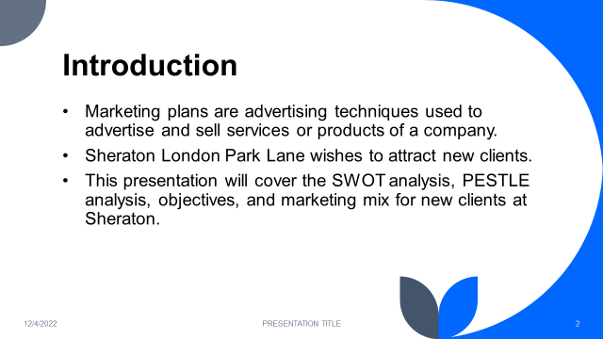

Marketing plans are advertising techniques used to advertise and sell services or products of a company (Hales, 2014). Every company's goal is to increase sales by acquiring new clients. As a result, in the current economic scenario, Sheraton London Park Lane wishes to attract new clients. As a result, they require a marketing strategy. The following marketing strategy is for Sheraton's Chief Marketing Officer. It goes over the SWOT analysis, PESTLE analysis, objectives, and marketing mix for new clients at Sheraton. Undoubtedly, this marketing strategy will assist the marketing officer in identifying various opportunities for recruiting new customers.

Situation analysis:

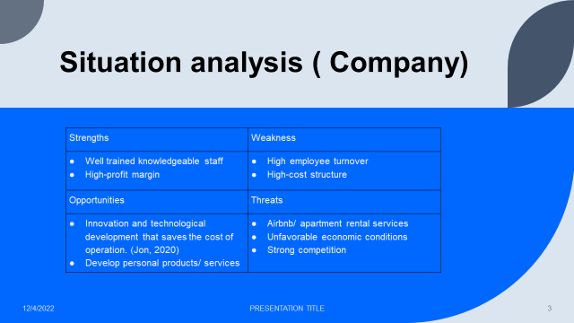

Company:
Strengths | Weakness
- Well trained knowledgeable staff  - High-profit margin | - High employee turnover  - High-cost structure
Opportunities | Threats
- Innovation and technological development that saves the cost of operation. (Jon, 2020)  - Develop personal products/ services | - Airbnb/ apartment rental services  - Unfavorable economic conditions  - Strong competition

Customers: 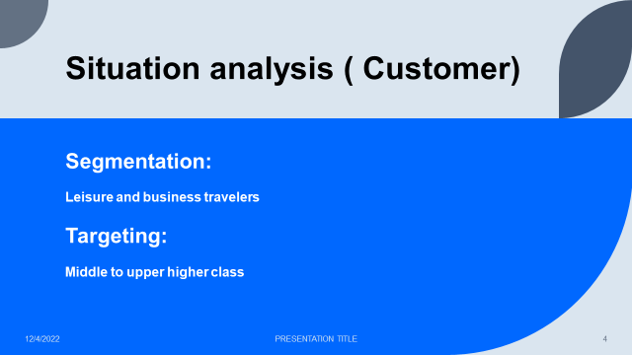
Segmentation:
There are two major segments that Sheraton London Park Lane will be targeting with this new marketing plan: those looking for luxury facilities and those looking for international-level services. (Weinstein, 2020)
Targeting:
To meet the expectations of its target market, the Sheraton London Park Lane focuses on quality control to guarantee that they meet the expectations of its target market, which is the middle-to-upper class.

Competitors: (Using Porter's five models)
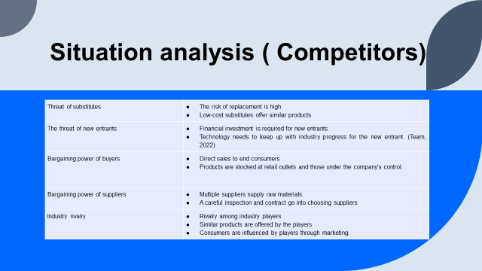
Threat of substitutes | - The risk of replacement is high  - Low-cost substitutes offer similar products
The threat of new entrants | - Financial investment is required for new entrants  - Technology needs to keep up with industry progress for the new entrant. (Team, 2022)
Bargaining power of buyers | - Direct sales to end consumers  - Products are stocked at retail outlets and those under the company's control.
Bargaining power of suppliers | - Multiple suppliers supply raw materials.  - A careful inspection and contract go into choosing suppliers
Industry rivalry | - Rivalry among industry players  - Similar products are offered by the players  - Consumers are influenced by players through marketing.

Collaborations: 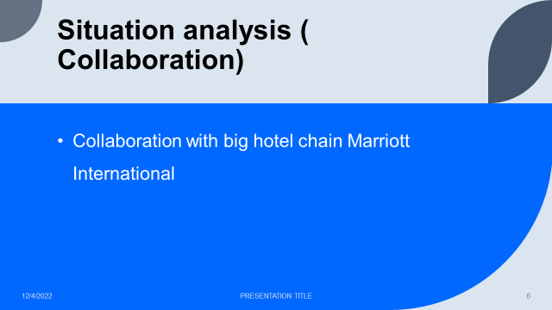
The Sheraton Grande London Park Lane is the first hotel in London to be designated as a Sheraton Grande, the brand's top tier of hotels. Marriott International is a huge chain of hotels affiliated with Sheraton London, so this is an important hotel to be recognized. (Wallis, 2021)

Climate: 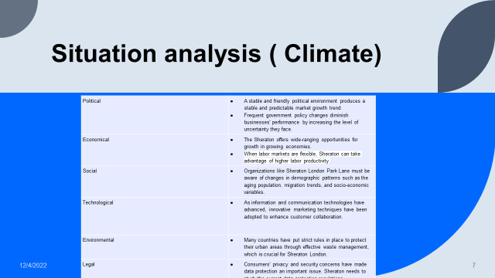
Political | - A stable and friendly political environment produces a stable and predictable market growth trend.  - Frequent government policy changes diminish businesses' performance by increasing the level of uncertainty they face.
Economical | - The Sheraton offers wide-ranging opportunities for growth in growing economies.  - Sheraton can benefit from greater labor productivity when labor markets are open.
Social | - The aging population, migration patterns, and socioeconomic factors are just a few examples of the changing demographic patterns that organizations like Sheraton London Park Lane need to be aware of.
Technological | - As information and communication technologies have advanced, innovative marketing techniques have been adopted to enhance customer collaboration.
Environmental | - Many countries have put strict rules in place to protect their urban areas through effective waste management, which is crucial for Sheraton London.
Legal | - Data protection has become a crucial issue as a result of consumer privacy and security worries. The current laws governing data protection must be studied by Sheraton.

Objectives: 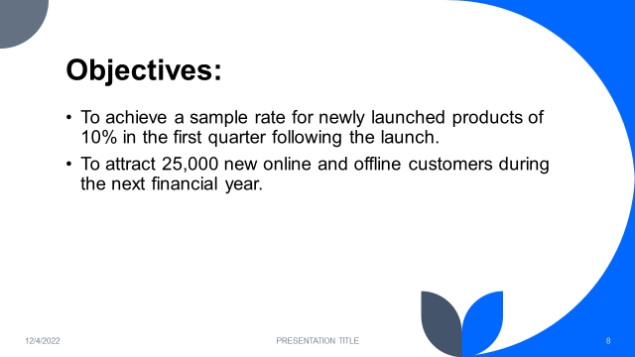

In the first quarter following the launch, 10% sample rates for newly announced products are anticipated at Sheraton London Park Lane. In addition, during the current fiscal year, the consumption rate of currently available products will also rise by 45%. (Ronald, 2018). During the upcoming fiscal year, the company aims to bring in 25,000 new consumers, both online and off. The business anticipates that using email and blogging strategies, website traffic will rise by 505 throughout the first two quarters of the new fiscal year.

Strategy:
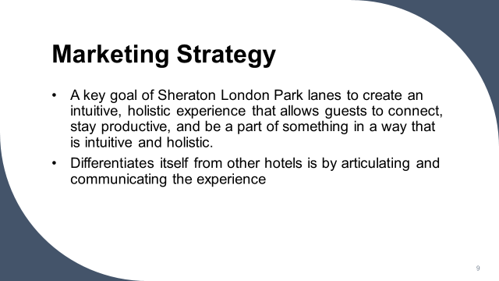
There is no doubt that Sheraton London Park Lane has the world's largest inventory of hotel rooms, and the company intends to continue this advantage for many years to come since they have more hotel rooms under development than any other hotel chain (Petri, 2015). A key goal of Sheraton London Park lanes to create an intuitive, holistic experience that allows guests to connect, stay productive, and be a part of something in a way that is intuitive and holistic. This new design combines the feeling of timelessness with the ambiance of modernity, ensuring that guests will feel at ease and comfortable when relaxing or working in the hotel (Elman ogle Bağırov, 2021). A key way Sheraton London Park Lane differentiates itself from other hotels is by articulating and communicating the experience one will have at the hotel, which will be unlike any other hotel in the area. Moreover, they provide customized services that cater to the specific needs of their target market to reach their target market.

Marketing Mix:
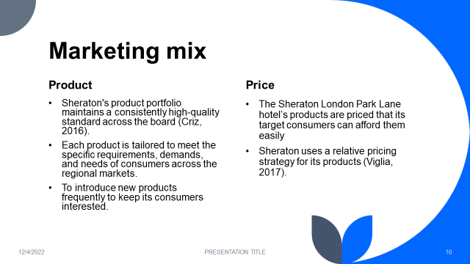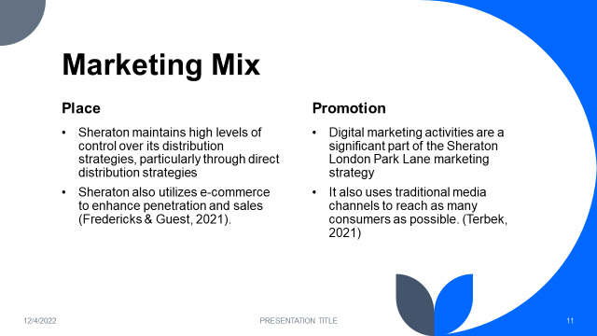
Product:
Sheraton's philosophy is to provide mass-marketed products for all segments of the market that are undifferentiated across the board. Sheraton also offers niche customer groups some selected premium products. Sheraton's product portfolio maintains a consistently high-quality standard across the board (Criz, 2016). Each product is tailored to meet the specific requirements, demands, and needs of consumers across the regional markets. It is important for Sheraton to maintain a high level of innovation in its products and to introduce new products frequently to keep its consumers interested.
Price:
Products at the Sheraton London Park Lane hotel are reasonably priced for their intended customers. The price of Sheraton's products comprises not just the high-quality raw materials and value additions but also the improved customer experience they provide. For its products, Sheraton employs a relative pricing strategy (Viglia, 2017). The business has been able to increase sales and profits thanks to its pricing approach.
Place:
Sheraton maintains tight control over its distribution strategies, particularly through direct distribution strategies, as part of its mission to forge close, emotional, and personal bonds with its customers. Sheraton operates company-operated stores in malls and other locations in addition to its presence in top supermarkets to provide customers with its products. Sheraton also makes use of e-commerce to increase sales and penetration (Fredericks and Guest, 2021). Hotel Sheraton Tower has several important aspects of its marketing mix that will be used in marketing. Along with the distribution strategy utilized in the marketing process, the location of Hotel Sheraton Tower is crucial in luring in new or more clients.
Promotion:
Sheraton London Park Lane has a high budget allocated toward marketing activities. Digital marketing activities are a significant part of the Sheraton London Park Lane marketing strategy, and it has been used to reap high and effective results. Additionally, it enables the Sheraton London Park Lane marketing plan to set a budget. In order to reach as many people as possible, the company also engages in direct consumer involvement by launching trials on the ground and through conventional media channels (Terbek, 2021).

Action:
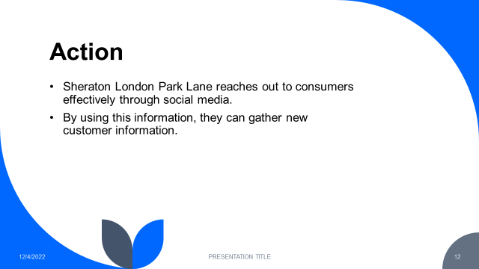
Through social media, Sheraton London Park Lane successfully connects with customers. The business connects with customers, replies to their questions, and takes their comments into account in addition to directly communicating with them. Through digital marketing, it also communicates with consumers and cultivates relationships with them. By using this information, they can gather new customer information. In addition, there are travel agencies that inform Sheraton about reservations, and these agencies may be able to assist Sheraton in making new decisions (Jones, 2021). In addition to providing customer preference regarding their services, agencies can also make demands for the services. Sheraton London Park Lane can utilize this feedback to improve its service quality and attract more customers.

Control: 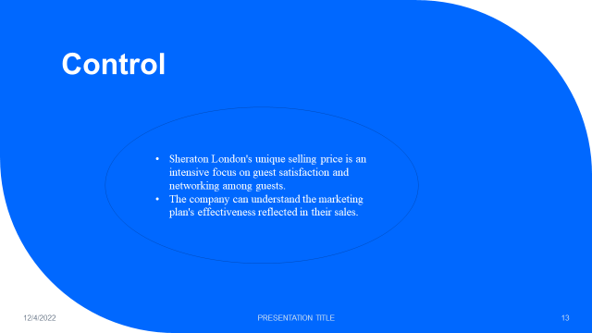
Sheraton London's unique selling price is an intensive focus on guest satisfaction and networking among guests. They always try to give their best to satisfy their customers. The increase in customer interaction in social media with the brand will help to understand how customers react. The marketing manager also takes information from the distribution channel to understand customer attitudes. The company can understand the marketing plan's effectiveness reflected in their sales. The plan will work if their sales increase after the new marketing plan. Eventually, the company can see a change in its profit margin. (Lorries, 2019)

Conclusion: 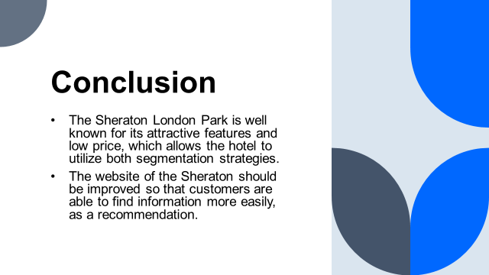
A Sheraton hotel is characterized by a strong culture of quality service that its employees and clients cherish. The Sheraton London Park is well known for its attractive features and low price, which allows the hotel to utilize both segmentation strategies: luxury and upscale, as well as targeting both leisure and business travelers (Olander, 2022). The website of the Sheraton should be improved so that customers are able to find information more easily, and there should also be an easy way for customers to locate the galleries for the Sheraton on the Park, as a recommendation.

References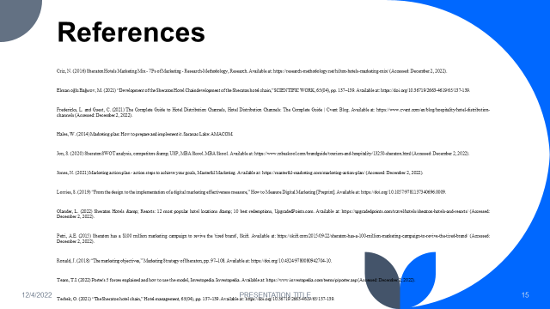
Criz, N. (2016) Sheraton Hotels Marketing Mix - 7Ps of Marketing - Research-Methodology, Research. Available at: https://research-methodology.net/hilton-hotels-marketing-mix/ (Accessed: December 2, 2022).
Elman oğlu Bağırov, M. (2021) “Development of the Sheraton Hotel Chaindevelopment of the Sheraton hotel chain,” SCIENTIFIC WORK, 65(04), pp. 137–139. Available at: https://doi.org/10.36719/2663-4619/65/137-139.
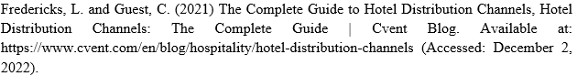
Hales, W. (2014) Marketing plan: How to prepare and implement it. Saranac Lake: AMACOM.
Jones, N. (2021) Marketing action plan - action steps to achieve your goals, Masterful Marketing. Available at: https://masterful-marketing.com/marketing-action-plan/ (Accessed: December 2, 2022).
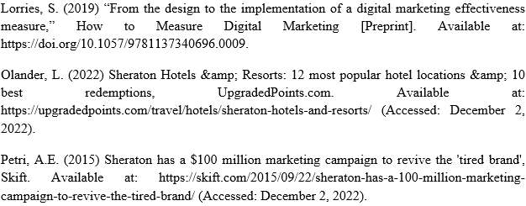
Ronald, J. (2018) “The marketing objectives,” Marketing Strategy of Sheraton, pp. 97–108. Available at: https://doi.org/10.4324/9780080942704-10.
Team, T.I. (2022) Porter's 5 forces explained and how to use the model, Investopedia. Investopedia. Available at: https://www.investopedia.com/terms/p/porter.asp (Accessed: December 2, 2022).
Terbek, O. (2021) “The Sheraton hotel chain,” Hotel management, 65(04), pp. 137–139. Available at: https://doi.org/10.36719/2663-4619/65/137-139.
Viglia, G. (2017) “Case study: Applications for the Hotel Industry,” Pricing, Online Marketing Behavior, and Analytics, pp. 76–86. Available at: https://doi.org/10.1057/9781137413260_7.
Wallis, G. (2021) Sheraton debuts new look at global properties, hotelbusiness.com. Available at: https://hotelbusiness.com/sheraton-debuts-new-look-at-global-properties/ (Accessed: December 2, 2022).
Weinstein, A. (2020) “Segmentation and relationship marketing,” Journal of Segmentation in Marketing, 3(2), pp. 1–3. Available at: https://doi.org/10.1300/j142v03n02_01.

