Module Title: Introducing the Modern Workplace

Assignment Title: ASSESSMENT 1- STRUCTURE AND CULTURE

Student Name:GEANINA-AURORA CHELARU
Student Number: 1916056
Module Lecturer’s Name: DR. JOHN-PAUL OKEKE

Table of Contents
Introduction 2
1. Company overview 2
2. Structure of Tesco 2
3. Culture of Tesco 3
4. Contribution of Tesco’s structure to company success 4
5. Analysing the contribution of Tesco's culture in the development of the firm 4
6. The relationship between structure, culture, people and organisational performance 5
7. Theoretical analysis of structure and culture of Tesco 6
7.1 Hofstede’s Cultural dimension theory (HCD) 6
7.2 Administrative theory 6
Conclusion 7
Reference List 8
Appendix 1: Corporate Steering Wheel followed by Tesco 9

Introduction
Every system has its format of culture and structure that binds the whole system under a single venture. Organisational culture and structure must be correlative in nature and must-have transitional points of view that can mediate wider vision and mission development. This essay is going to discuss the culture and structure within Tesco and the factors based on culture and structures contribution will also be analysed in this study. Apart from that, analysis of the relationship between organisational performances, structure, culture, along with people within Tesco will be done.

Company overview
Tesco is known to be the multinational groceries as well as general merchandiser that has originated in the UK. It is the third-largest retailer in the world, and it has headquartered in Welwyn Garden City, Hertfordshire (Tescoplc.com, 2020). It has been reported that Tesco has gained market venture through laughing its business role and goal based on demand. The company has successfully generated GBP 6391.1 crores (Corporatewatch.org, 2020). It has been found that Tesco has established its market in 13 countries with 450000 employees working throughout the globe. Tesco is also known to have grown its stores in 13 countries of the world. These are numbered to be 6993 with subsidiaries, such as Tesco Mobile, Tesco bank as well as Tesco Ireland.

Structure of Tesco
The system that is developed to drive the strategic outline of the prospective activity formulation that is vested with the prospective goal of the organisation is stated to be the organisational culture. As opined by Ahmady et al. (2016), organisational structure (OS) is also developed to determine the process of information flow between various levels within an organisation. There is a vast list of organisational structure ranging from hierarchical to matrix and divisional and many more. Tesco is one of the well-established largest retail chain markets that has focused on maintaining wider diligence among its business perspective.
The structure of Tesco can be stated to be hierarchical as well as tall, as the organisation has a large base, and there are several layers within the company format. As per the statement of Marik and Varon (2018), the hierarchical structure helps to establish an effective communication path among employees of different departments and divisions of the company. It has been observed that the structure or the whole system of the employees is subdivided into prospective departments that confirm work to be done efficiently and smoothly. It has been reported that Tesco has divided its managerial position into three perspective and prime source known as Top-level and Middle level as well as a lower level.
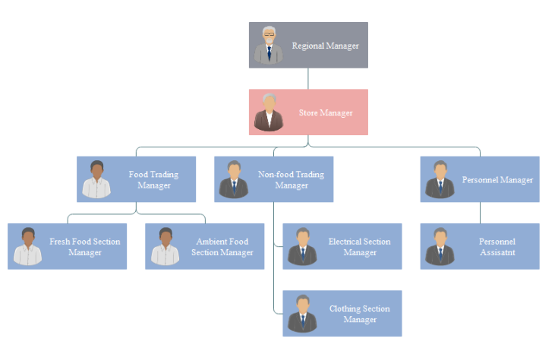
Figure 1: Tesco management structure
(Source: Tescoplc.com, 2020)

Culture of Tesco
Culture of an organisation determines the position of the company within the market and its perseverance. Tesco is a fully employee-owned company, and it is known to be a unique workplace. Based on Joseph and Gaba (2020), the team-oriented culture of ownership within an organisation brings stability as well as fosters the organisation to become innovative and growth-oriented. Tesco is known to have deployed a team-oriented culture that helps it to develop the desire to serve clients with effective solutions and quality of the products. Tesco follows a hierarchical organisational structure, and for that, it has adopted the hierarchy culture that meets its aim to meet the goals it has determined.
This can be observed from its purpose regarding company ventures where it states “Serving Britain's shoppers a little every day" (Tesco-careers.com, 2020). From this purpose, it is clear that Tesco is liable to serve its customer base with diligence and meet every demand of the customers from every perspective. From the analysis, it has also been found that Tesco also focuses on bringing deliberative change to the system by lending its focus on the employees. The little help plan that has been developed by the company states that serving shoppers daily with perspective alignment can bring growth to the firm's integrity.

Contribution of Tesco’s structure to company success
Structure of an organisation is known to have acted potentially to bring effective growth of the system which entitles wider diligence within the system. It has been reported that supermarket giant Tesco has simplified its operational structure that has a wider impact on the 17000 employees (Insidermedia.com, 2020). This particular change may bring a renaissance to the service provider and bring higher efficiency levels to the system. This hierarchical structure has brought high potentiality to the system of manifestation and brought a change in the wider prospectus. It has been claimed by Neubert et al. (2016), that managers are the core role player in driving the wider prevalence and output of the work in the strategic sense that can be effective for the growth of the firm.
The hierarchical structure with three levels of managers has potentially led the company to maintain a strategic responsibility with a prospective approach that can elaborate and bring denomination of business prospectus with a wider prevalence of the customer needs. The prospective need and deliverance of a wider prevailing system within the company entity has made systematic growth of Tesco for its organisational structure. As mentioned by Naranjo-Valencia et al. (2019), the hierarchical structure helps to determine the levels of leadership with specified authority and perspective of responsibility. This tends to have led the managerial perspective of Tesco to be subdivided with the division of responsibility.
The perspective structure has allowed the employees to focus on their specified matter, and this can bring hierarchical structure to bring promotion of the system. It has been observed in 2018 that Tesco announced to simplify its operational structure. This was through the incorporation of changes, such as the role of people manager as well as compliance manager will be removed from the large stores. This would enhance efficiency and provide line managers with accountability to customer experience (Insidermedia.com, 2020). This change has revealed to be a successful one and has provided sustainable motivation to the system.

Analysing the contribution of Tesco's culture in the development of the firm
Inducing the proper culture within the firm can bring effective management of the whole operation leading to systematic growth of the firm. As stated by Arditi et al. (2017), proper integration of culture and deliverance of sustainable culture prevalence can entitle wider and deliberative form of business policy. It has been so reported that the company is employee-oriented and has wider democratic vigilance that has derived the employees from becoming more innovative and full of enthusiasm that can be fruitful for the company. Tesco has deployed an employee stock ownership plan (ESOP) which is known to be developed for the welfare of the personnel (Tescocontrols.com, 2020). This particular attribute has an integrated wide prevalence of the system that can mediate the systematic flow of the prospective venture.
As reported to the retail gazette, Tesco has gained a hike of 34% sales rise in 2019 due to its market prevalence and its prospective potential output (Beugelsdijk and Welzel, 2018). This potential output is possible due to the wider presence and hard work of the employees and their efficiency along with the commitments. This form of dedication among the employees has grown among Tesco employees due to its market presence and deliverance it has adopted to gain wider denomination of business. On the other hand, Ahmady et al. (2016) reported that lack of proper culture could deliver a loss of the market as organisational culture determines the potentiality of the system and its wider presence in strategic format. Thus, it can be stated that systematic presence and susceptible action of Tesco's employee-oriented culture has led to wider success in the current market.

The relationship between structure, culture, people and organisational performance
Structure, culture, people and performance are interrelated attributes of an organisation that bring potential effect to the system. As mentioned by Marik and Varon (2018), organisations must adhere to the policies that can establish a wider role based on its performance of the employees. In Tesco, the structure of the organisation is hierarchical, where there existed three levels of managerial systems. This is linked to the cultural perspective of the company as its structure determines the cultural aspect of the firm. Based on Joseph and Gaba (2020), culture is imbibed through the process of system or manifestation that delivers role and strategic output to the system. Thus, the culture of Tesco is somehow manipulated through its structure, and its culture is vested with hierarchy format.
On the contrary, Neubert et al. (2016) argued that organisation might not have the same prospectus of culture and structure, as it may vary with organisational growth prospectus as well as its perspective alignment with its sub judicious aspect. This may somehow lead to contradicting fact, but culture and structure of Tesco are reliable and is fully contributed to each other's perception. In addition to that, Tesco is an employee-oriented company and is driven by employees, which are revealed from Tesco’s Corporate Steering Wheel (Refer to Appendix 1). As a result, every employee is highly judicious to the prospective decision regarding Tesco. This format has attained value through the inclusion of policies and certain forms of nested attributes which mediate growth within this system. It has been reported that the organisational performance of the firm is the price action and the culture that a company follows (Tesco-careers.com, 2020).
Tesco is known to have highly contributed to the development of the firm through developing effective culture as well as structure to drive growth for the firm. Thus, it can be stated that organisational performance, culture, structure, along with people, makes the company a successful one in the present scenario.

Theoretical analysis of structure and culture of Tesco

7.1 Hofstede’s Cultural dimension theory (HCD)
Hofstede's cultural dimension theory states about the perspective cultural attributes that has prevalence within the organisation itself. As opined by Naranjo-Valencia et al. (2019), HCD is directly contributed with six categories, known as
- Power distance index (PDI)
- Collectivism vs. individualism (IDV)
- Uncertainty avoidance index (UAI)
- Femininity vs. masculinity (MAS)
- Short-term vs. long-term orientation
- Restraint vs. indulgence.
PDI is used to measure the type of management system, and the prospective responsibility and Tesco has a hierarchical system of orientation that provides an opportunity in the participation of the employees in every crucial matter. Thus, profoundly low PDI which is attended to be effective and deliberative. On the other hand, Arditi et al. (2017) stated that the five perspectives of HCD have delivered wider prevalence and are more subjective in analysing the facts. The cultural prospectus is more deliberative, and in Tesco, the five aspects can easily be determined and can bring wider diligence in underlying the core field of the system.

7.2 Administrative theory
The administrative theory states the management perspective of the organisation and its rational prevalence based on perspective structure deployment. As opined by Beugelsdijk and Welzel (2018), this theory is developed to gain subjective viewpoint and is formalised to develop an administrative structure based on a clear vision of deployment. This has entitled wider prevalence and has cooperated to bring effective notation of systematic flow of the whole cognitive approach. The administrative theory states and analyses the core factor associated with the structure of prevalence and reliable approach within a systematic aspect. This is more reversible and more coordinated that has been promulgated to bring effective notation and analysis of the system within Tesco. Tesco follows a hierarchical structure where layers of managers are available that states about the coordinated approach it has developed within a strategic system.

Conclusion
Business structure and culture promotes equally for the better manifestation of business. Thus, it can be concluded that a wider prevalence and analytical figure has its approach which has negotiated and aligned Tesco to gain subjective analysis within the whole system. This has been prevailing a wider role and goal development which has manifested systematic format of view within its specified scenario. The hierarchical structure and culture have led Tesco to gain a much more predictive format of business from strategic sources. This has been countered from the elaborative definition regarding the perspective gain policy of the system in a strategic and versatile manner.

Reference List
Ahmady, G.A., Mehrpour, M. and Nikooravesh, A., (2016). Organisational structure. Procedia-Social and Behavioral Sciences, 230, pp.455-462.
Arditi, D., Nayak, S. and Damci, A., (2017).Effect of organisational culture on delay in construction. International Journal of Project Management, 35(2), pp.136-147.
Beugelsdijk, S. and Welzel, C., (2018). Dimensions and dynamics of national culture: Synthesizing Hofstede with Inglehart. Journal of Cross-Cultural Psychology, 49(10), pp.1469-1505.
Corporatewatch.org. (2020), TESCO COMPANY PROFILE, Available at: https://corporatewatch.org/tesco-company-profile/ [Accessed on: 18/08/2020]
Insidermedia.com. (2020), TESCO TO “SIMPLIFY” STRUCTURE IMPACTING 1,700 STAFF, https://www.insidermedia.com/news/central-and-east/tesco-to-simplify-structure-impacting-1700-staff [Accessed on: 18/08/2020]
Joseph, J. and Gaba, V., (2020). Organisational structure, information processing, and decision-making: A retrospective and road map for research. Academy of Management Annals, 14(1), pp.267-302.
Marik, P. and Varon, J., (2018). The optimal ICU organisational structure. Crit Care Shock, 21(4), pp.148-150.
Naranjo-Valencia, J.C., Jiménez-Jiménez, D. and Sanz-Valle, R., (2019).Organizational culture effect on innovative orientation. Management Decision, 49(1), pp.55-72.’
Neubert, M.J., Hunter, E.M. and Tolentino, R.C., (2016). A servant leader and their stakeholders: When does organisational structure enhance a leader's influence?. The Leadership Quarterly, 27(6), pp.896-910.
Tesco-careers.com. (2020), Our Culture, Available at: https://www.tesco-careers.com/explore-our-world/our-culture/
Tescocontrols.com. (2020), Company Culture, https://tescocontrols.com/about-us/careers/your-career-join-in/company-culture/ [Accessed on: 18/08/2020]
Tescoplc.com. (2020), TESCO Plc, Available at: https://www.tescoplc.com/about/ [Accessed on: 18/08/2020]

Appendix 1: Corporate Steering Wheel followed by Tesco
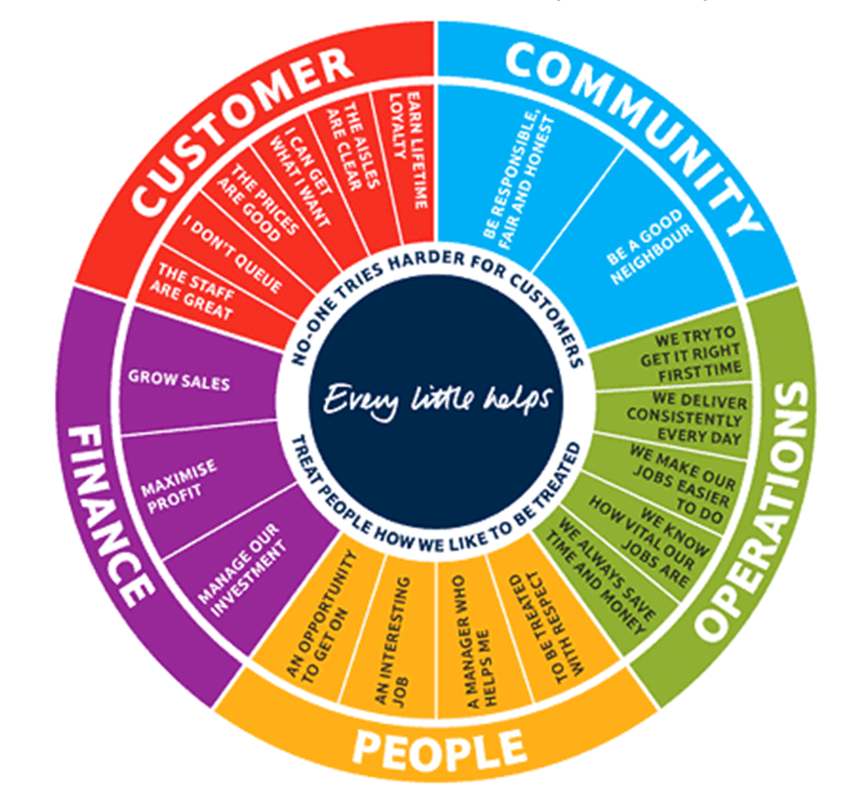
(Source: Tescoplc.com, 2020)

