Title: A Comparison of the Marketing Methods of Two Multinational Hotel Brands
Student Name
Student ID Number
Module Title: Marketing Essentials BMIH4005
Lecturer’s Name:

Table of Contents
1 Introduction 3
2 Main Body 3
3 Conclusion 3
4 References 3
5 Appendices 3

Introduction
The essay mainly aims to present a comparison between two multinational hotel chains, Six Senses and Holiday Inn. Six Senses is a luxury hotel that is associated with IHG Hotels & Resorts family (Six Senses, 2023). Holiday Inn is an affordable hotel brand that offers families, guests and business customers a great place to stay (IHG Hotel & Resorts, 2023). The main focus of the essay will be on the comparison of the marketing strategies and methods of these two hotel brands. In particular, the essay will shed light on the marketing strategies of hotels with the use of situational analysis tools while focusing on SWOT and PESTLE analysis. Moreover, the similarities and dissimilarities between hotels will be identified with the marketing mix, segmentation, targeting, and positioning.

Main Body
With the analysis of the internal and external environment, challenges, possibilities and difference between Six Senses and Holiday Inn is discussed. Considering strength, Six Senses is popular for its luxurious and grand services, like virtual event space, wellness and spa, reconnection with nature experiences, and sustainability stories (Six Senses, 2023a). For Holiday Inn, the approach to keep it smart and simple is the key strength (Holiday Inn, 2023). The hotel is a perfect choice for customers who need an elegant, simple and engaging place to rest. There are almost 3.095 open hotels at Holiday Inn, whereas, Six Senses contains a total of 21 properties all across the world (Six Senses, 2023a). The major weakness of Six Senses is the high price range of services which are undoubtedly expensive for middle-class society. On the other hand, the limited portfolio and services of Holiday Inn are the weakness of the brand. An increase in technology integration is a foremost opportunity for both hotels. For Holiday Inn, it will be beneficial to expand the portfolio range and offer a better experience to the guests. For Six Senses, targeting middle-class society with competitive pricing would be an opportunity as customers will attract towards luxury services if it is offered in an affordable or budget-friendly range. Despite this, fluctuating economic condition causes a significant threat to both the hotels as it directly affects the behaviour and perception of travellers and tourists.
PESTLE analysis is a useful framework for the analysis of the external environment of both hotels. The political tension between Russia and Ukraine has a significant impact on the hospitality industry. The war affects the inbound travel and economic conditions of the country and increases the price of crude oil and food costs, which causes a surge in travel-related costs and cuts down the purchasing power of tourists (Statista, 2023). When talking about economic factors, the graph (referred to appendix I) shows that the inflation rate for the hotels and restaurants in the UK was previously calculated as 10.2%, which surged to 11.1% in 2022, which indicated that the country faced a serious crisis of cost of living (Statista, 2023a). In terms of Value Added Tax, the British government reduced the tax rate to about 5% in the year 2020 (GOV.UK, 2023). This will help the hospitality industry in boosting spending and economic condition as well. Considering social factors, safety concerns and the demands of customers are important for the hospitality industry. Customers are more concerned towards hotel brands which implement sustainable strategies and eco-friendly practices (Abdou et al., 2022). Six Senses exclusively reflects a passion for community, wellness, sustainable design and smiles, which helps the brand to remain competitive in the hotel industry. Contradict to this, Holiday Inn needs to focus on sustainability to attract customers. In regards to technology, hotel brands focus on the use of the latest technologies to give a memorable experience to guests and improve operational efficiency. The use of Artificial Intelligence, Chabot’s, Augmented Reality, Contactless Payment and many more are important considerations for hotel brands in the UK. Despite this, it is important for the hotel industry to follow legal regulations and laws to run the business efficiently. Staffing Hospitality Legislation and Requirements and Hotel Proprietors Act 1956 are the common laws that must be followed by all hotel brands in the UK (England, 2023). In terms of environmental factors, the hotel industry needs to ensure that sustainability criteria are fulfilled, and minimal carbon emissions occur within the activities.
While comparing the marketing mix of both hotels, it is evaluated that Six Senses is a luxurious hotel and, therefore, provides expensive and high-quality services. While on the other hand, Holiday Inn is relatively cheaper than Six Senses and offers meeting rooms, a variety of cuisine and many other services. Ultimately, the customers of Six Senses also belong to wealthy backgrounds and pay much more; this indicates that the pricing of Six Senses is premium (Six Senses, 2021). However, the customers of Holiday Inn prefer to stay at an affordable hotel with good services (Holiday Inn, 2022). Nonetheless, the promotion strategy for both of the hotels is pretty much the same in terms of strategy, as both use digital marketing (Barda, 2022). However, Six Senses does it on a much greater level than Holiday Inn. As for the place, Holiday Inn prefers to operate in residential areas. Nevertheless, considering the size of the business, Six Senses operates in both rural and urban areas (Six Senses, 2023). The target public of Six Senses is the group of people who lives a luxurious lifestyle and has wealthy backgrounds. These people like to use every service of extremely high quality. However, the customers of Holiday Inn like to enjoy their lives in a self-sufficient manner and be happy less, which is enough to complete their needs (Holiday Inn, 2023). In terms of physical evidence, Six Senses focuses on offering a personalised experience that satisfies the wellness and luxurious needs of customers, for which the brand specifically invest in its unique design and services. In comparison, Holiday Inn focuses on giving a consistent view of its hotel design and properties. It can be said the success of Six Senses is because of its unique design and facilities. The last element of the marketing mix is a process that refers to the serviced delivery of both hotels. For Six Sigma, the brand offers personalised and excellent service, whereas the focus of Holiday Inn is to offer efficient services.
To compare the two brands, it is evident that both the hotels target young adults in the 24 to 35 age group, which is the common similarity between the brands. Additionally, there is a small gender gap, as the Holiday Inn tends to draw more women than men. Meanwhile, Six Senses draws more, 51.12% men and 48.88% female (referred to appendix II) (Similar Web, 2023). It is evident that hotels have used specialist strategies to draw in the target market. Analysing the integration of digital tools into hotel operations will reveal positioning tactics. While Six Senses is renowned for its high-end amenities and services but charges more, Holiday Inn offers outstanding service at reasonable rates without promoting the use of digital channels. Social media marketing improves audience engagement, which in turn raises brand awareness. In light of this, YouTube is where Holiday Inn spends the most time, followed closely by Facebook. On the other hand, Six Senses utilises multiple social media marketing platforms quite well (referred to Appendix III). Both brands engage their target market by offering unparalleled services that are catered to their tastes as contemporary customers. Six Senses positions itself as a provider of practical services, including those connected to comfort and well-being. As a result, the business has successfully created a presence on social media sites to broaden its audience and maintain constant two-way communication with its customers. However, by concentrating on price-conscious clients, Holiday Inn has been able to grow its offerings and establish itself as a budget-friendly brand. This has enabled the business to maintain the proper level of quality and service, but the entire investment has been profitable. With the help of perceptual mapping, it is possible to analyse the positions of both hotels. Like, the map shows that Six Senses positioned itself among the competitors that offer high prices along with exceptional and high-quality services (referred to Appendix IV).

Conclusion
With the comparison of both the hotels, it has been concluded that the popularity of Holiday Inn is among the middle-class market, whereas Six Senses is highly demandable by elite-class customers. The pricing strategy of Holiday Inn is affordable, and Six Senses offer services within a premium price range. The focus of Six Senses is to promote sustainability in its services, whereas Holiday Inn lacks in this area. The use of social media is common in Six Senses marketing tactics, but Holiday Inn has more inclination towards direct marketing with customers.

References
Abdou, A.H., Hassan, T.H., Salem, A.E., Albakhit, A.I., Almakhayitah, M.Y. and Salama, W., 2022. The Nexus between Environmentally Sustainable Practices, Green Satisfaction, and Customer Citizenship Behavior in Eco-Friendly Hotels: Social Exchange Theory Perspective. Sustainability, 14(19), p.12791.
Barda, A., 2022. The present and future of loyalty programs in airline and hospitality industry: The Covid Era.
England, K.T., 2023. A Unified Front: The Need for a Comprehensive, Centralized Network for Financial Institutions and Law Enforcement to Collaborate on Anti-Human Trafficking Efforts. North Carolina Banking Institute, 27(1), p.284.
GOV.UK, 2023. Introduction of a new reduced rate of VAT for hospitality, holiday accommodation and attractions [Online] Available at < https://www.gov.uk/government/publications/introduction-of-a-new-reduced-rate-of-vat-for-hospitality-holiday-accommodation-and-attractions/introduction-of-a-new-reduced-rate-of-vat-for-hospitality-holiday-accommodation-and-attractions [Accessed on 26th May 2023].
Holiday Inn 2022 Annual report - investors - InterContinental Hotels Group PLC, InterContinental Hotels Group. Available at: https://www.ihgplc.com/en/investors/annual-report (Accessed: 26 May 2023).
Holiday Inn 2023 Find a Holiday Inn Express Hotel, Holiday Inn Express Hotel Locations Worldwide. Available at: https://www.ihg.com/holidayinnexpress/destinations/us/en/explore (Accessed: 26 May 2023).
Holiday Inn, 2023. Simple, smart travel. [Online] Available at https://www.ihgplc.com/en/our-brands/holiday-inn-express [Accessed on 26th May 2023].
IHG Hotel & Resorts, 2023. Our Brand – Holiday Inn. [Online] Available at < https://www.sixsenses.com/en/about-us> [Accessed on 26th May 2023].
Similar Web, 2023. Competitive Research. [Online] Available at https://www.similarweb.com/website/sixsenses.com/#traffic [Accessed on 26th May 2023].
Six Senses 2021 Annual report launched by Mui – six senses laamu, MUI. Available at: https://coralglass.media/news/2021-annual-report-launched-by-mui-six-senses-laamu (Accessed: 26 May 2023).
Six Senses 2023 Luxury lifestyle resort & hotel locations: Six senses, Luxury Lifestyle Resort & Hotel Locations | Six Senses. Available at: https://www.sixsenses.com/en/resorts (Accessed: 26 May 2023).
Six Senses, 2023. The history of logo. [Online] Available at < https://www.sixsenses.com/en/about-us> [Accessed on 26th May 2023].
Six Senses, 2023a. Sustainability stories [Online] Available at < https://www.sixsenses.com/en/sustainability> [Accessed on 26th May 2023].
Six Senses, 2023b. Hello There [Online] Available at < https://www.sixsenses.com/media/13020/220113_ss_directory_2022_9mb.pdf> [Accessed on 26th May 2023].
Statista, 2023. Impact of inflation on travel and tourism worldwide - statistics & facts [Online] Available at < https://www.statista.com/topics/9662/impact-of-inflation-on-travel-and-tourism-worldwide/#topicOverview> [Accessed on 26th May 2023].
Statista, 2023a. CPI inflation rate for restaurants and hotels in the UK 1989-2023 [Online] Available at < https://www.statista.com/statistics/621993/cpi-restaurants-and-hotels-uk/> [Accessed on 26th May 2023].

Appendices

Appendix I:
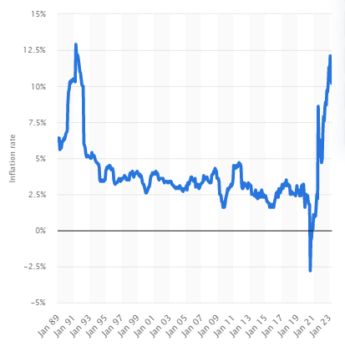
Figure 1: CPI inflation rate for restaurants and hotels in the United Kingdom from January 1989 to April 2023
Appendix II:
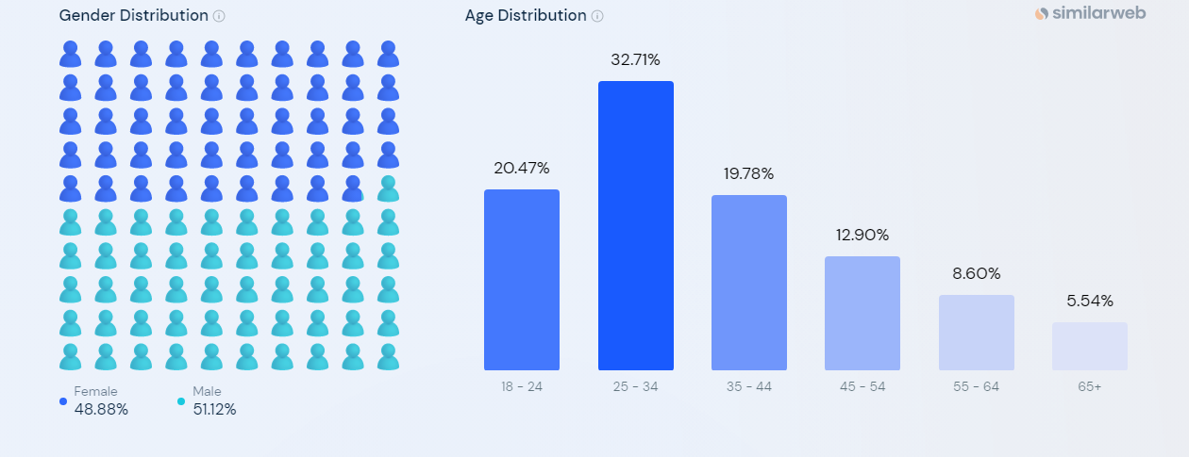
Figure 2: Six Senses
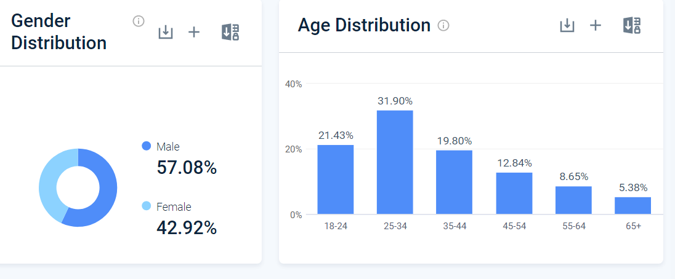
Figure 3: Holiday Inn
Appendix III:
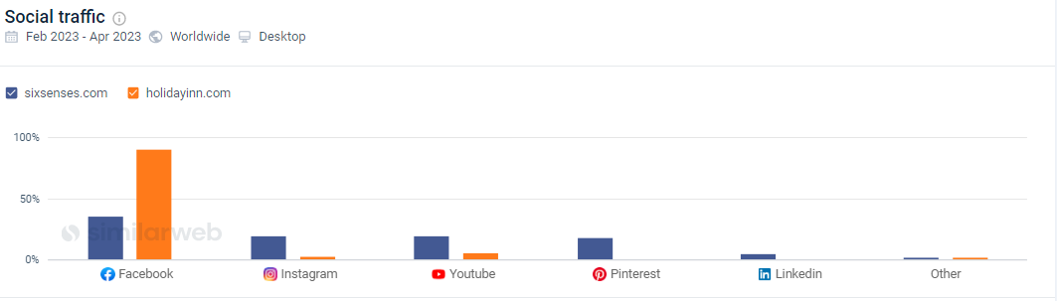
Figure 4: Social Traffic
Appendix IV:
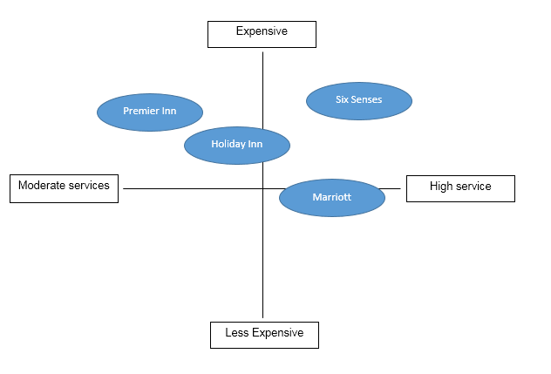
Figure 5: Perceptual Mapping

