Contents

AI Declaration 2
Task 1: Study Timetable 3
Task 2: Using Microsoft 365 Copilot to Explore Study Techniques. 4
Task 3: PowerPoint Poster and Task Four: Voice-Over Presentation 9
Reference List 10

AI Declaration

Basic Acknowledgement format of AI tool use
I acknowledge the use of Microsoft 365 Copilot (windows edition) on 04/09/2026-06/09/2016 and Chat GPT on 10/09/2026 to complete Task 2 in the module ECEY4012. I used the following prompt(s):
- Can you find me two studies techniques I can successfully complete my degree also I might have some ALN needs in which I struggle with certain task and focusing
- Can you give me two study techniques to help build my independent learning while helping me focus with lack of motivation and some ALN please give me references.
- Can you give me two study techniques to help plan and organise my time. I may have some ALN like dyslexia. I prefer breaking areas down into more manageable bite size pieces. Please include references from between 2016 and 2026 where applicable.
I acknowledge the use of ChatGPT on the 15/09/2016 to create an example of a Gantt chart for Task 3 in the module ECEY4012. I used the prompt:
Can you give me an example of a study schedule using a Gantt chart? Give a visual to put into a PowerPoint presentation.

I confirm that I have not presented any AI generated text as my own work. I confirm I have copies of my drafts, notes, and other resources I used before, and after the use of AI tools which I may be asked to provide in evidence.

Task 1: Study timetable
 | Monday |  |  |  | Tuesday |  |  |  |  | Wednesday |  |  |  |  | Thursday |  |  |  |  |  |  | Friday |  |  |  |  |  | Saturday | 1st Saturday of the month |  | Sunday
6am-7am |  | Wake up |  |  |  |  |  | Wake up |  |  |  | Wake up |  |  |  |  |  | Wake up |  |  |  |  |  | Wake up
7am-8am | Preparing for school/Work |  |  |  | Preparing for school/Work |  |  |  |  | Preparing for school/Work |  |  |  |  | Preparing for school/Work |  |  |  |  |  |  | Preparing for school/Work |  |  |  |  |  | Wake up | Wake up |  | Wake up
8am-9am | Breakfast club supervisor |  |  |  | Breakfast club supervisor |  |  |  |  | Breakfast club supervisor |  |  |  |  | Breakfast club supervisor |  |  |  |  |  |  | Breakfast club supervisor |  |  |  |  |  | Assignment writing | Spend Time catching up |  | Spend Time catching up
9am-10am | Nursery, one-to-one support |  |  |  | Nursery, one-to-one support |  |  |  |  | Cleaning House |  |  |  |  | Nursery, one-to-one support |  |  |  |  |  |  | Nursery, one-to-one support |  |  |  |  |  | Assignment writing | Reading for assignment |  | Panto until December
10am-11am | Nursery one-to-one support |  |  |  | Nursery | Lunch |  |  |  | Cleaning House/ Lunch |  |  |  |  | Nursery |  |  |  |  |  | Lunch | Nursery |  |  |  |  | Lunch | Assignment writing | Crochet Club |  | Panto until December
11am-12pm | Lunch |  | Mid-day S |  | Lunch | Mid-day S |  |  |  | Lunch |  |  |  | Mid-day S | Lunch | Mid-day S |  |  |  |  |  | Lunch |  |  |  |  | Mid-day S | Assignment writing | Crochet Club |  | Panto until December
12pm-1pm | Mid-day Supervisor |  |  |  | Mid-day Supervisor |  |  |  |  | Mid-day Supervisor |  |  |  |  | Mid-day Supervisor |  |  |  |  |  |  | Mid-day Supervisor |  |  |  |  |  | Lunch Time | Crochet Club |  | Lunch time
1pm-2pm | Wrap Around LSA |  |  |  | Wrap Around LSA |  |  |  |  | Wrap Around LSA |  |  |  |  | Wrap Around LSA |  |  |  |  |  |  | Wrap Around LSA |  |  |  |  |  | Break time | Crochet Club |  | Assignment writing
2pm-3pm | Wrap Around LSA |  |  |  | Wrap Around LSA |  |  |  |  | Wrap Around LSA |  |  |  |  | Wrap Around LSA |  |  |  |  |  |  | Wrap Around LSA |  |  |  |  |  | Assignment writing | Lunch |  | Assignment writing
3pm-4pm | Wrap Around LSA |  | Travel Time |  | Wrap Around LSA |  |  |  | Travel Time | Wrap Around LSA |  |  | Travel Time |  | Wrap Around LSA |  |  |  | Travel Time |  |  | Wrap Around LSA |  |  | Travel Time |  |  | Assignment writing | Assignment writing |  | Assignment writing
4pm-5pm | Travel Time |  |  |  | Research for assignment |  |  |  |  | Research for assignment |  |  |  |  | Research for assignment |  |  |  |  |  |  | Research for assignment |  |  |  |  |  | Assignment writing | Assignment writing |  | Assignment writing
5pm-6pm | Lecture |  |  |  | Research for assignment |  |  |  |  | Research for assignment |  |  |  |  | Research for assignment |  |  |  |  |  |  | Research for assignment |  |  |  |  |  | Cooking | Assignment writing |  | Cooking
6pm-7pm | Lecture |  |  |  | Cooking/Dinner time |  |  |  |  | Cooking/Dinner time |  |  |  |  | Cooking/Dinner time |  |  |  |  |  |  | Cooking/Dinner time |  |  |  |  |  | Dinner time | Cooking/Dinner time |  | Dinner time
7pm-8pm | Lecture |  |  |  | Dog walk |  |  |  |  | Dog walk |  |  |  |  | Dog walk |  |  |  |  |  |  | Dog walk |  |  |  |  |  | Dog walk | Dog walk |  | Dog walk
8pm-9pm | Travel Time |  |  |  | Tidy up |  | Reading with Ruby |  |  | Tidy up | Reading with Ruby |  |  |  | Tidy up |  | Reading with Ruby |  |  |  |  | Tidy up | Reading with Ruby |  |  |  |  | Cleaning/Tidy up | Cleaning/Tidy up |  | Cleaning/Tidy up
9pm-10pm | Reading relevant texts |  | Bed time |  | Reading relevant texts |  |  | Bed time |  | Reading relevant texts |  |  |  | Bed time | Reading relevant texts |  |  |  |  | Bed time |  | Reading relevant texts |  |  |  | Bed Time |  | Bed Time | Bed Time |  | Bed Time
Key: | Work |  |  |  | Lectures |  |  |  |  | Independent Studies |  |  |  |  | Health and wellbeing |  |  |  |  |  |  | Family Reasonability’s

Task 2: Using Microsoft 365 Copilot to Explore Study Techniques.

Initial prompt into Microsoft 365 copilot.
Prompt one, can you find me two studies techniques I can successfully complete my degree also I might have some ALN needs in which I struggle with certain task and focusing.
1. Active Recall (Practice Testing)
Takeaway: The single most effective learning technique — especially if you struggle to stay engaged or remember information.
Active recall means testing yourself instead of re-reading. Your brain has to work harder, which strengthens memory and keeps you mentally active.
How to use it:
- Study a topic for 20 minutes.
- Close your notes.
- Write down everything you remember.
- Check what you missed and focus your next session on those gaps.
- Use flashcards (Anki, Quizlet) or quick quizzes.
Why it helps with ALN:
- It turns studying into a structured task (no vague “just revise”).
- It keeps your brain engaged, reducing drifting and distraction.
- It gives immediate feedback, which helps motivation.
2. Spaced Repetition (Distributed Practice)
Takeaway: Reviewing material at planned intervals dramatically improves retention and reduces overwhelm.
Instead of cramming, you revisit topics over days and weeks. This strengthens memory right before you forget it.
How to use it:
- Day 1: Learn the topic
- Day 2: Quick 10-minute review
- Day 5: 15-minute review
- Day 12: 20-minute review
- Week before exam: Final review
Apps like Anki automate this so you don’t have to remember the schedule.
Why it helps with ALN:
- Reduces cognitive overload — you do not have to “hold everything in your head.”
- Creates predictable routines, which support executive functioning.
- Breaks studying into small, manageable chunks.
Extra Support for Focus (ALN-friendly strategies)
These are not full techniques, but they make the two above much easier to use:
- Pomodoro (25 minutes work, 5 minutes break) — helps with task initiation and prevents burnout.
- Phone in another room — even a silent phone reduces cognitive capacity.
- Consistent study space — your brain learns “this is where I focus.”
- Ambient or instrumental music — helps block distractions.

- studentnotes.co.uk
- 10 Science-Backed Study Techniques That Actually Work for GCSE & A-Level Success in 2026 | StudentNotes.co.uk
- https://studentnotes.co.uk/blog/10-science-backed-study-techniques-that-actually-work-for-gcse-a-level-success-in-2026

- www.studyvector.co.uk
- Best Revision Techniques for Students 2026 | StudyVector
- https://www.studyvector.co.uk/blog/best-revision-techniques-for-students

- www.promodo.app
- How to Focus While Studying: 10 Proven Strategies | Promodo
- https://www.promodo.app/blog/how-to-focus-while-studying

- The Profs
- 9 Study Tips for People Who Struggle to Concentrate - The Profs
- https://www.theprofs.co.uk/student-resources/revision/9-study-tips-for-people-who-struggle-to-concentra

Refining prompts in Microsoft 365 copilot.
Prompt Four
Can you give me two study techniques to help build my independent learning while helping me focus with lack of motivation and some ALN please give me references.
Prompt Seven
Can you find me relevant research on Metacognitive and self-regulated learning for independent learning for my degree in early years education and care please include your references so I can follow up on my own
Finalising prompts in Chat GPT.
A prompt template was created for every search in Chat GPT.
This included: Give me clear, relevant information that will help me understand the topic and develop my own academic discussion. Prioritise reliable academic sources, including peer-reviewed journal articles, academic books and reputable educational or government sources. Where possible, use recent research. Clearly show which source supports each main point. Provide a full reference list at the end in Harvard referencing style. Include DOI numbers or links to the original source where available so I can check the sources myself. Do not invent or guess references. If you cannot verify a source, clearly tell me. Explain important theories, concepts or terminology in language that is easy to understand. Where appropriate, relate the research to Early Years Education and Care and professional practice. Include different viewpoints or limitations where appropriate rather than presenting one perspective as fact. Help me identify the strongest points that I could investigate further.
Last Prompt
Can you give me two study techniques to help plan and organise my time. I may have some ALN like dyslexia. I prefer breaking areas down into more manageable bite size pieces. Please include references from between 2016 and 2026 where applicable.
The two techniques suggested were the Pomodoro Technique and Back-wards planning.
Pomodoro Technique
The Pomodoro technique breaks down long study sessions into smaller more manageable chunks and includes a short break. Studies have shown that students that use this method maintain longer study sessions while decrease workload and tiredness (Ogut, 2025). This is usually a 25-minute study session followed by a 5-minute rest period. This technique was created by Francesco Cirillo in the second half of the 1980’s (Iyengar, Vaishya and Botchu, 2014). Furthermore, Biwer et al. (2023) concludes that this technique has positive benefits on mental health and overall performance over taking self-regulated breaks. This method is particularly going to help people who struggle concentrating for long periods of time. It will also help people who find large tasks daunting as you can break up the task. Mabalda, Et al (2026) Sates the importance of taking regular breaks to reduce mental fatigue, working memory problems and keeps attention engaged for longer periods of time.

Back-wards planning
For each module/assignment, find the deadline and work backwards what is needed to be done and by when. In this method the student will have to calculate how much time is needed for each task. Once the assignment is completed the student will need to reflect on how long each task took to complete and adjust for further assignments. (Cottrel, 2024). Backwards planning will help with organisational problems and control of workload. It will allow the student to feel more in control of the outcome, (Honeybourne, 2025). Back-wards planning will help students with additional learning needs especially those who need may require visual prompts. (British Dyslexia Association, no date). One technique for this can be using a Gantt chart, Wadhwa (2024).
Where both these techniques help with time management they both have individual benefits. The back-wards planning will allow the student to determine how much time they have to complete the whole assignment where the Pomodoro technique will break down each study session into more manageable segments.
Reflection on using AI
My personal experience of using AI as a research tool has been mixed. Initially I found it challenging to get enough information into Microsoft Copilot and ChatGPT to produce a reliable output.
Some of my first results had unreliable sources where I would click on the links and I would be sent to unavailable sites. I do see the advantages in some research although. The benefits that AI can bring allow you to quickly search thousands of different texts and draw out only applicable information. You can also quickly get AI to summarise text so saves you hours of reading through unnecessary information.
With a little help from my Husband who is experienced working with AI and provides AI training in his company, I have written a background prompt that for every question asked in ChatGPT that I get detailed responses back. I made sure that in the prompt I asked for reliable sources and to give Harvard references. I am aware however am aware that I still need to check sources and not believe every output I get back from AI generated content. I have included information about myself and the degree course that I am doing to ensure that I get information relevant to my course.
AI can also help people who have additional learning needs, it can proofread assignments, check spelling, grammar and punctuation. This aspect will greatly improve my assignment writing as I find this extremely difficult. Again, this must be treated with extreme caution as AI has a habit of trying to change words to sound more academic while you wouldn’t necessarily know what that word means.
Using AI is not only useful to help in academic settings but is also useful in my school setting. If we need to set up a specific skill-based task such as fine motor skills, Chat GPT can find many resources of information on how to develop that skill.
I am also against AI being used in a creative medium such as art and music. I feel that expressive arts are created passionately and with deep meaning. AI generated art takes that away from artists who spend a lot of time coming up with concepts that AI cannot understand.
Using both Microsoft 365 Copilot and ChatGPT has made me really question the morality of using AI in education. I see the advantages, but it must be used ethically and in a limited capacity.

Task 3: PowerPoint Poster and Task Four: Voice-Over Presentation
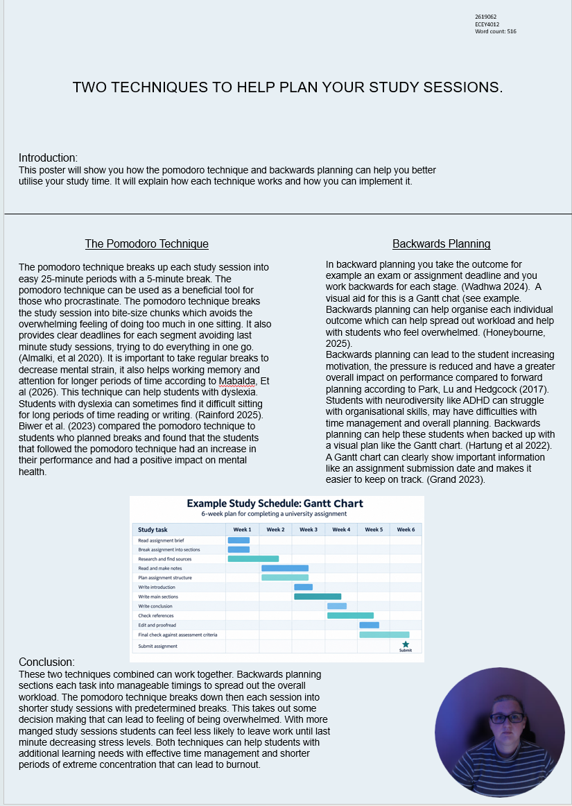

Reference List

Almalki, K., Alharbi, O., Al-Ahmadi, W. and Aljohani, M. (2020) ‘Anti-procrastination online tool for graduate students based on the Pomodoro technique’, in Zaphiris, P. and Ioannou, A. (eds.) *Learning and Collaboration Technologies: Human and Technology Ecosystems*. HCII 2020, Copenhagen, Denmark, 19–24 July. Lecture Notes in Computer Science, 12206, pp. 133–144. Cham: Springer. doi:10.1007/978-3-030-50506-6_10.
Biwer, F., Wiradhany, W., oude Egbrink, M.G.A. and de Bruin, A.B.H. (2023) ‘Understanding effort regulation: Comparing ‘Pomodoro’ breaks and self-regulated breaks’. British Journal of Educational Psychology, 93 (S2), pp. 353-367. Available at: https://doi.org/10.1111/bjep.12593.
British Dyslexia Association (No Date) Adult study skills, Available at: https://www.bdadyslexia.org.uk/advice/adults/in-education/adult-study-skills (Accessed 12 September 2026)
Cottrell, S 2024. The Study Skills Handbook, Bloomsbury Publishing Plc, London. Available from: ProQuest Ebook Central. (accessed: 12 September 2026).
Hartung, C., Canu, W.H., Bodalski, E.A., Neger. E.N., Bridges, R.M., Gleason, L.L., Anzalone, C and Flory K. (2022) ‘A New Organizational and Study Skill Intervention for College Students with ADHD’ Cognitive and Behavioral Practice, 29 (2) pp. 411-424 Available at: https://doi.org/10.1016/j.cbpra.2020.09.005
Honeybourne, V (2025) Finding Joy in Studying: An Autistic and ADHD Guide to Uncovering the Study Skills That Work for You. Philadelphia: Jessica Kingsley Publishers. Available at: https://research-ebsco-com.uwtsd.idm.oclc.org/plink/45c69cd2-d1d0-3bc4-9019-ecb14c6fa3cc (Accessed: 12 September 2026).
Grand, A. (2023) EPQs: writing up your dissertation, Available at: https://www.open.edu/openlearn/epqs-writing-your-dissertation#tab-0-1 (accessed 20 September 2026)
Iyengar, K.P., Vaishya, R. and Botchu, R. (2024) ‘Can we apply Pomodoro Technique in academic publishing?’ Apollo Medicine, 21 (2), pp.176-177. Available at: https://doi.org/10.4103/am.am_193_23.
Mabalda, V.S., Balsomar, F.N.M., Dela Cruz K.C.T., Gaspar, H.S., Huliganga, R.R.D., Velasquez, V.E.D. and Diola, D.D. (2026) ‘Effects of the Pomodoro Technique and Self-Directed Study Breaks on College Students’ Immediate Post-Test Performance’ Psychology and Education: A Multidisciplinary Journal 57 (10), pp. 1327-1335. Available at: DOI:10.70838/pemj.571009

Ogut, E. (2025) ‘Assessing the efficacy of the Pomodoro technique in enhancing anatomy lesson retention during study sessions: a scoping review,’ BMC medical education, 25(1). Available at: https://doi.org/10.1186/s12909-025-08001-0.
Park, J., Lu, F-C. and Hedgcock, W.M. (2017)
Relative effects of forward and backward planning on goal pursuit.
Psychological Science, 28(11), pp.1620–1630.
Available at: DOI:10.1177/0956797617715510.
Rainford, J. (2025) 5 tried-and-tested study tips for dyslexic students. Available at: https://www.open.edu/openlearn/education-development/5-tried-and-tested-study-tips-dyslexic-students (accessed 20 September 2026)
Robles, V.D. (2018) ‘Visualizing Certainty: What the Cultural History of the Gantt Chart Teaches Technical and Professional Communicators about Management’, Technical Communication Quarterly, 27(4), pp. 300–321. Available at: DOI:10.1080/10572252.2018.1520025.

Wadhwa, K. (2024) The Role of Gantt Chart in the Project Management. Master’s Thesis. Vaasa University of applied sciences. Available at: https://www.theseus.fi/handle/10024/865913 (accessed 12 September 2026)

