University of Wales Trinity Saint David
School of Engineering

Design & Analysis of Extended Surfaces
Advanced Thermofluid Mechanics
ACMA6011

Heather Came
2208198
16/09/2026

Abstract

This report investigates the use and design of extended surfaces for heat-transfer applications. Firstly, the development of fins in automotive and microprocessor cooling is reviewed, including recent developments in heat-sink geometry, microchannels and additive manufacturing. The fin optimisation analysis then considers the relationship between finite- and infinite-fin heat transfer and confirms that $mL=2.65$ provides approximately 99% of the ideal infinite-fin heat-transfer rate, making it a practical point of diminishing returns. The same theory is then applied to a 200 mm saucepan handle manufactured from copper, 2024 aluminium alloy, brass and 304 stainless steel. Stainless steel produced the lowest free-end temperature of 29.3°C and the lowest heat loss of 2.67 W. The calculated theoretical optimum lengths were 879 mm, 641 mm, 446 mm and 173 mm respectively. Overall, the results show that good thermal design requires a balance between heat transfer, material properties, safety and practical design constraints rather than simply maximising heat transfer.
Contents

1 Introduction 1
2 Task A – Applications of Extended Surfaces 2
2.1 Historical development of fins in automotive design 2
2.2 Extended surfaces in microprocessor cooling 3
2.3 Recent advances in extended-surface design 4
3 Task B - Fin Optimisation Analysis 6
4 Task C - Saucepan Handle Analysis 9
4.1 Geometry, assumptions and governing equations 9
4.2 Part 1 - Free-end temperature and handling safety 9
4.3 Part 2 - Temperature distribution for the 200 mm handles 10
4.4 Part 3 - Heat loss from the 200 mm handles 11
4.5 Part 4 - Optimum fin length and heat-loss comparison 12
4.6 Part 5 - Optimised temperature distributions and design recommendation 12
5 Conclusion 16
6 References 17
7 Appendix A - Plotting and calculation checks 19

Figure 1 - Evolution of automotive cooling and extended-surface applications adapted from MAHLE Aftermarket GmbH (2021, pp. 6, 9 and 49). 3
Figure 2 - Typical CPU package and heat-sink assembly showing the CPU chip, thermal interface materials, integrated heat spreader and finned heat sink (Wei, 2008, p. 179) 4
Figure 3 - Variation of the finite-fin to infinite-fin heat-transfer ratio with fin parameter mL. 7
Figure 4 - Temperature distribution along the original 200 mm saucepan handles for the four material options. 11
Figure 5 - Temperature distributions along the four saucepan handles at their theoretical optimum lengths ($mL=2.65$). 14

Table 1 - Finite-fin to infinite-fin heat-transfer ratio for selected values of $mL$. 6
Table 2 - Fin parameter and free-end temperature for the four 200 mm saucepan-handle materials. 10
Table 3 - Calculated heat loss from the four 200 mm saucepan handles. 11
Table 4 - Theoretical optimum fin lengths and heat-transfer comparison for the four saucepan-handle materials. 12
Table 5 - Original 200 mm handle distribution data (°C) 20

Introduction

Extended surfaces, or fins, increase the area through which a solid can exchange heat with a surrounding fluid. Their usefulness is therefore not determined by area alone: conduction must first carry energy from the base into the fin before convection can remove it. Fin geometry, thermal conductivity, length, spacing and the external heat-transfer coefficient all interact, so a design that maximises heat transfer is not necessarily the lightest, cheapest or safest design (Bergman et al., 2017). This report reviews extended surfaces in automotive and microprocessor applications, examines the accepted mL design limit and applies the same theory to a saucepan handle made from four metals.

Task A – Applications of Extended Surfaces

Historical development of fins in automotive design

The earliest automotive use of extended surfaces was closely linked to air-cooled internal-combustion engines. Heat produced in the cylinder and head had to pass through the metal wall and then into air, whose convective heat-transfer coefficient is relatively low. Casting ribs or fins directly onto the cylinder and cylinder head increased the external area without requiring a separate coolant circuit. The principle was simple and robust, but performance depended strongly on fin thickness, spacing and the air available between neighbouring fins. Closely packed fins provide more nominal area yet can restrict flow and cause the air temperature to rise through the fin bank; very widely spaced fins have the opposite problem of wasting available envelope volume. Contemporary reviews of air-cooled engine fins still identify material, profile, perforations and spacing as coupled optimisation variables rather than independent choices (Sachar et al., 2023).
The Volkswagen Beetle provides a familiar historical example: Volkswagen records that the series-production design adopted a four-cylinder boxer engine with air cooling (Volkswagen, 2003). In this type of system, the cylinder/head fins form the heat exchanger itself, with vehicle motion or a fan supplying the cooling air. As engine specific power and passenger expectations increased, liquid cooling became dominant because it allowed heat to be collected at the engine, transported by coolant and rejected at a radiator under more controlled conditions (MAHLE Aftermarket GmbH, 2021). The extended surface did not disappear; instead, it moved from the engine exterior to the radiator.
A radiator is an especially effective use of fins because the air side normally presents the larger thermal resistance. Thin aluminium fins are bonded or brazed to coolant tubes so that heat spreads from the tube wall into a much larger air-side area. Over time, simple flat or wavy fins have developed into compact louvered arrangements. Louvers repeatedly interrupt the air-side boundary layer and redirect flow, raising local heat-transfer coefficients, but the gain must be balanced against pressure drop and fan power. Zhang et al. (2022), for example, modelled alternative louver sections for automotive radiators and reported that an airfoil louver could raise Nusselt number by up to 4.9% while reducing pressure difference by up to 16.6% relative to the rectangular form for the cases studied. The same paper also showed why geometry cannot be judged from one metric: reduced fin area can offset an improved local coefficient under some operating conditions.
Modern vehicle thermal management broadens the role of extended surfaces again. Electric vehicles remove the engine cylinder fins but add thermally sensitive batteries, motors, inverters and power electronics. Battery thermal-management systems now use combinations of air, liquid, refrigerant, phase-change media and heat pipes, with compact finned heat exchangers remaining important at the interfaces to ambient air (Maiorino et al., 2024). Across this historical progression, the design objective has shifted from merely preventing engine overheating to controlling temperature uniformity, aerodynamic drag, fan/pump power, package size, mass and manufacturability at the same time. The underlying extended-surface principle, however, is unchanged: additional useful area is beneficial only while conduction can maintain a sufficient temperature difference along that area. The development of automotive cooling systems is illustrated in Figure 1.

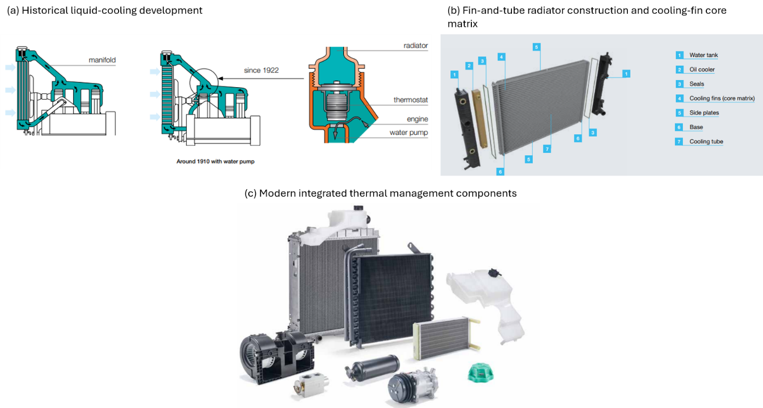
Figure 1 - Evolution of automotive cooling and extended-surface applications adapted from MAHLE Aftermarket GmbH (2021, pp. 6, 9 and 49).

Extended surfaces in microprocessor cooling

Microprocessor cooling applies the same conduction-convection problem at a far smaller scale and at much higher local heat flux. Heat generated in the semiconductor die is conducted through the package and thermal-interface material into a heat spreader or heat-sink base. Parallel plate fins or pin fins then increase the area exposed to air. These main components are shown in Figure 2. Aluminium is common because it combines useful conductivity, low density and low cost, whereas copper is attractive where spreading resistance is critical but adds mass and cost. Forced airflow raises the air-side coefficient, allowing a smaller heat sink for the same load, although fin spacing must still permit adequate flow (Wei, 2008; Zhang, Wang and Yan, 2021).
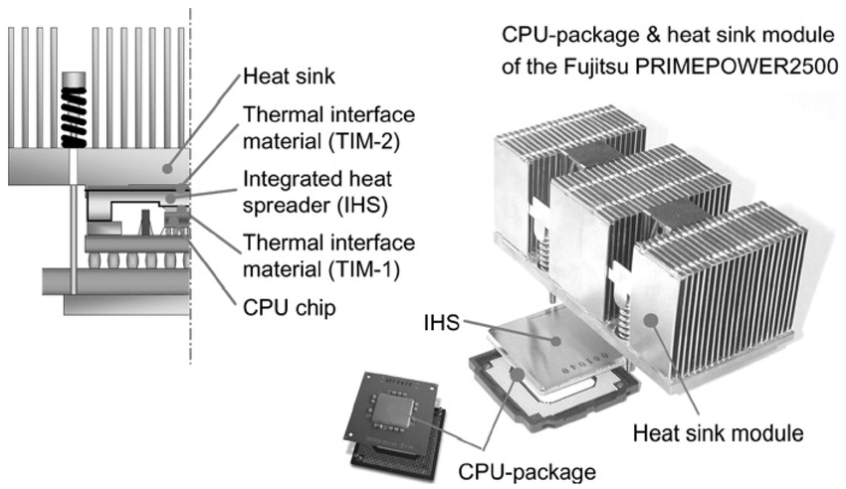
Figure 2 - Typical CPU package and heat-sink assembly showing the CPU chip, thermal interface materials, integrated heat spreader and finned heat sink (Wei, 2008, p. 179)

As chip power density increased, heat pipes and vapour chambers became common partners to the fin stack. They use phase change to spread heat from a small die footprint over a much larger base area, allowing a greater proportion of the fins to operate at an effective temperature difference. The important point is that the heat pipe does not replace the extended surface: it improves heat distribution to the extended surface. Recent reviews therefore treat thermal spreading, fin geometry, airflow and contact resistance as one thermal network rather than isolated components (Zhang, Wang and Yan, 2021; Li and Yang, 2023). At still higher heat fluxes, liquid-cooled microchannel heat sinks place a very large, wetted area close to the heat source. Yu, Li and Cao (2024) identify their high specific surface area, compact size and high heat-transfer coefficient as major advantages, while pumping power, pressure drop, fabrication precision and fouling remain practical constraints.

Recent advances in extended-surface design

The most significant recent change is that fin geometry is no longer limited to shapes that can easily be extruded, stamped or machined. Additive manufacturing can create branching channels, lattice structures and topology-optimised surfaces in a single component. This allows the designer to distribute solid material where it carries heat effectively and to shape fluid passages where they most improve convection. Sun et al. (2024) combined three-dimensional topology optimisation, additive manufacturing and experimental thermohydraulic testing; their optimised heat sinks achieved approximately twice the conductance of the rectangular-fin benchmark used in the study. This is a useful demonstration that more surface area is not automatically the best solution: the optimised designs had lower surface area but improved mixing and boundary-layer disruption.
Triply periodic minimal surface (TPMS) lattices are a further example. Their continuous curved walls provide high area within a compact volume and interconnected passages that can distribute coolant through three dimensions. Chouhan et al. (2026) experimentally and numerically assessed laser-powder-bed-fused aluminium TPMS heat sinks and found superior performance to conventional pin-fin designs of equal volume in the investigated cases. The advantages are high surface-area density, design freedom, compactness and structural integration. The disadvantages are equally important: roughness and manufacturing variation can alter flow, internal passages are harder to inspect or clean, and a thermally excellent geometry can still be unacceptable if it requires excessive pumping power or costly additive manufacture.
Computational fluid dynamics and optimisation algorithms increasingly sit alongside these manufacturing advances. CFD can predict local temperature, recirculation and pressure loss before tooling is committed, while topology and parametric optimisation can search large design spaces. Reviews by Li and Yang (2023) and Rahman et al. (2024) show that current heat-sink research is therefore moving from the question of 'how many fins?' toward multi-objective optimisation of geometry, materials, flow and manufacture. For an engineering design, the perceived advantage of an advanced extended surface should consequently be expressed in system terms - thermal resistance, pressure drop, mass, reliability and cost - rather than heat-transfer rate alone.

Task B - Fin Optimisation Analysis

For a straight fin of uniform cross-section with an adiabatic tip, the finite-fin heat-transfer rate contains the factor tanh(mL). For an ideal infinitely long fin this factor tends to one. With base excess temperature $θ_{b}=T_{b}-T_{∞}$ (Bergman et al., 2017):
q_{f} = √(hPkA_{c}) θ_{b} tanh(mL)
q∞ = √(hPkA_{c}) θ_{b}
q_{f} / q∞ = tanh(mL)
The ratio was evaluated from mL = 0 to 4 in increments of 0.1. The resulting curve rises steeply at first and then asymptotically approaches unity. Representative values are shown below in Table 1 and Figure 3.

Table 1 - Finite-fin to infinite-fin heat-transfer ratio for selected values of $mL$.
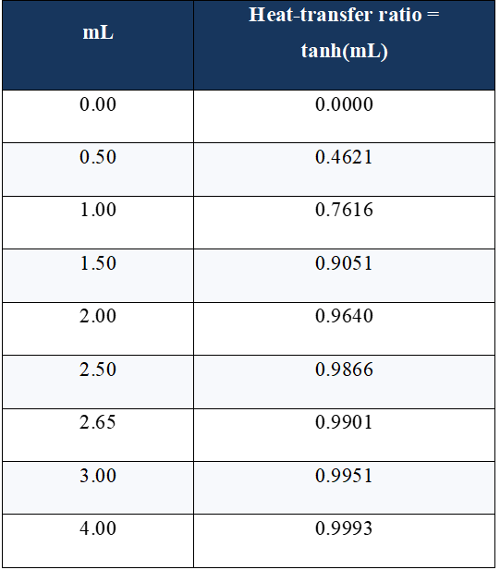
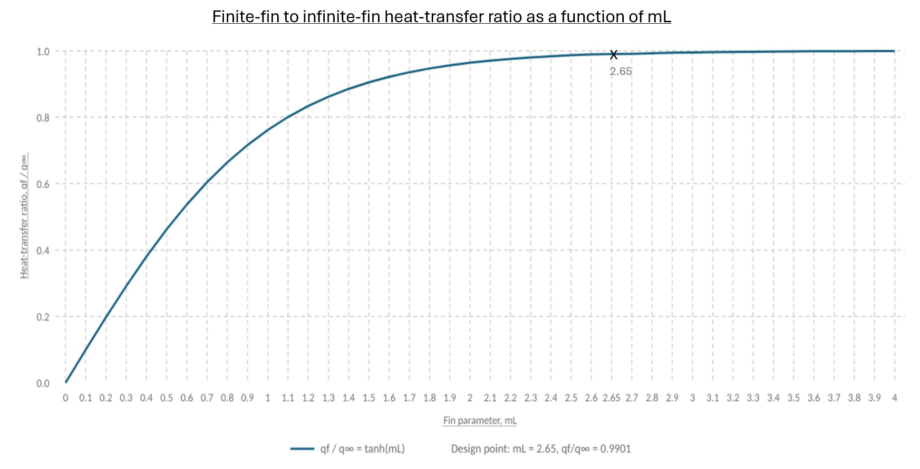
Figure 3 - Variation of the finite-fin to infinite-fin heat-transfer ratio with fin parameter mL.
At mL = 2.65 the finite fin already transfers 0.9901, or 99.01%, of the infinite-fin value. Extending the fin from mL = 2.65 to mL = 4 only raises the ratio to about 0.9993, an absolute gain of roughly 0.92 percentage points. The accepted $mL≈2.65$criterion is therefore not a mathematical maximum, as $tanh⁡\left(mL\right)$continues to increase, but a practical point of diminishing returns. Beyond it, additional material, mass and envelope length purchase less than about one further percent of the idealised infinite-fin heat transfer. This is why mL is a useful design parameter: it combines geometry, material and convection into a dimensionless indicator rather than prescribing one physical length for every fin.

Task C - Saucepan Handle Analysis

Geometry, assumptions and governing equations

The handle is treated as a straight rectangular fin with length 0.200 m, width 0.030 m and thickness 0.005 m. The base is held at the boiling-water temperature of 100 °C, the surrounding air is 22 °C and h = 7.5 W m⁻² K⁻¹. The free end is adiabatic as stated in the brief. The cross-sectional area and exposed perimeter are:

A_{c} = wt = 0.03 × 0.005 = 1.50 × 10⁻⁴ m²
P = 2(w + t) = 2(0.03 + 0.005) = 0.070 m
Standard fin relations are used for each material (Bergman et al., 2017):
m = √(hP / kA_{c})
T(x) = T∞ + (T_{b} - T∞) cosh[m(L - x)] / cosh(mL)
q_{f} = √(hPkA_{c})(T_{b} - T∞) tanh(mL)

These equations assume steady one-dimensional conduction, constant properties and a uniform convection coefficient. Radiation, thermal contact resistance at the pan/handle joint, variations in $h$ and cooling from a hand are neglected. The model is therefore suitable for comparing the four materials, although actual touch temperature and burn risk are not fully represented by a steady-state fin model.
Because $m$is proportional to the square root of $h/k$, the calculated optimum lengths are specific to the stated convection coefficient of 7.5 W m⁻² K⁻¹ and would change if airflow changed. The adiabatic-tip assumption also idealises the real handle end, which would lose some heat by convection.

Part 1 - Free-end temperature and handling safety

As shown in Table 2, the free-end temperatures are 87.7 °C for copper, 79.3 °C for aluminium, 65.5 °C for brass and 29.3 °C for stainless steel. The trend is physically consistent: high-conductivity metals keep a larger proportion of the handle near the 100 °C base temperature, whereas the low conductivity of stainless steel produces a much larger temperature drop along the same 200 mm length. ISO 13732-1:2006 assesses burn risk as a function of both surface material and contact duration and gives specific guidance for uncoated metals; it does not support a single universal safe temperature (ISO, 2006). The results show that the copper, aluminium and brass ends are too hot for normal bare-hand gripping, while the stainless-steel tip at approximately 29 °C is the only one that can be considered reasonably safe for ordinary handling. That judgement applies to the tip: the region closer to the pan remains hotter.

Table 2 - Fin parameter and free-end temperature for the four 200 mm saucepan-handle materials.
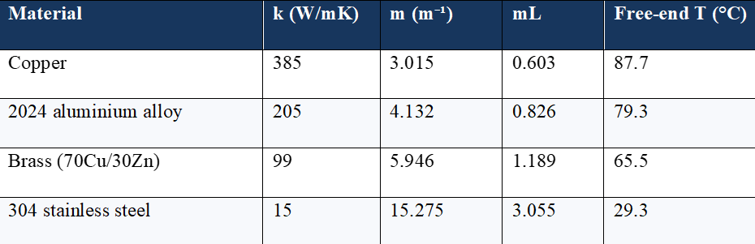

Part 2 - Temperature distribution for the 200 mm handles

The temperature equation was evaluated from x = 0 to 200 mm in 10 mm increments for each material. Copper shows the shallowest gradient and stainless steel the steepest. At x = 0 every curve begins at 100 °C because the same base temperature is imposed; moving away from the pan, the separation between curves grows as conductivity controls how effectively energy is replenished from the base. Brass provides an intermediate response, while stainless steel approaches ambient temperature much more rapidly. Figure 4 shows a plot of the four gradients being compared directly.

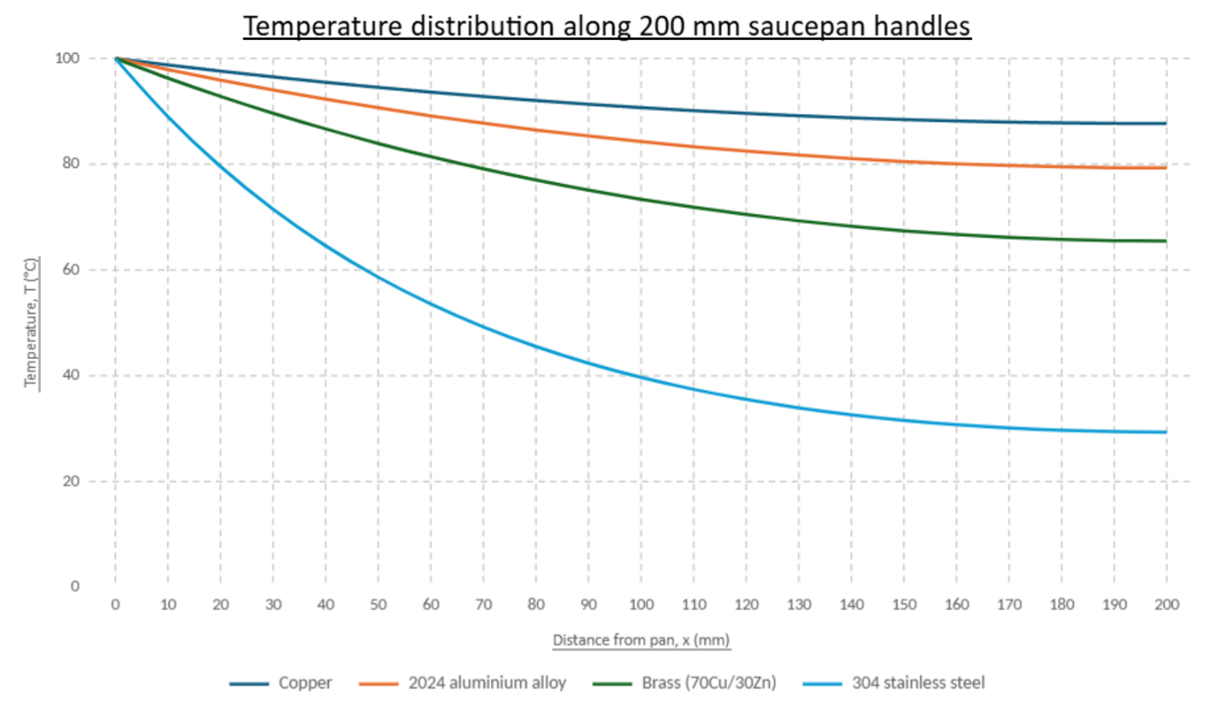
Figure 4 - Temperature distribution along the original 200 mm saucepan handles for the four material options.

Part 3 - Heat loss from the 200 mm handles

Table 3 shows the steady heat losses calculated using the adiabatic-tip expression. Higher conductivity increases heat transfer because more of the fin remains at a higher temperature. For a saucepan handle, however, this is undesirable because the aim is to reduce heat conducted towards the hand.

Table 3 - Calculated heat loss from the four 200 mm saucepan handles.
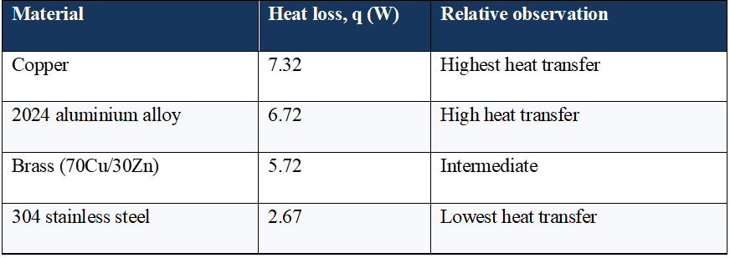

Part 4 - Optimum fin length and heat-loss comparison

Table 4 applies the Task B practical criterion $mL=2.65$, giving $L=2.65/m$. Because m is inversely proportional to √k, the higher-conductivity materials require a longer physical fin to reach the same dimensionless mL. Importantly, a high-k material transports useful heat farther along the fin, so its diminishing-return length occurs farther from the base, not closer.

Table 4 - Theoretical optimum fin lengths and heat-transfer comparison for the four saucepan-handle materials.
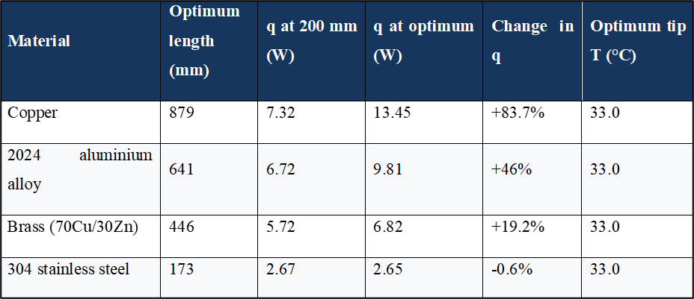

Copper, aluminium and brass are all shorter than their theoretical heat-transfer optimum at 200 mm, so lengthening them to mL = 2.65 increases heat loss by approximately 83.7%, 46.0% and 19.2%, respectively. Stainless steel is already beyond the criterion because its original mL is 3.055. Shortening it from 200 mm to about 173 mm changes heat loss from 2.67 W to 2.65 W - less than a 1% reduction, while removing about 13% of the handle length. This supports the diminishing-return behaviour identified in Task B.

Part 5 - Optimised temperature distributions and design recommendation

When each theoretical optimum is defined using the same $mL$ condition, the calculated free-end temperature is approximately 33.0 °C for every material. The dimensionless temperature profile is also the same when position is normalised by each material’s own length, with only the physical length changing between materials. Copper therefore requires about 879 mm to reach the same dimensionless condition that stainless steel reaches at about 173 mm. This shows that the theoretical optimum relates to fin heat-transfer performance rather than the practical or ergonomic length of a saucepan handle, as shown in Figure 5.

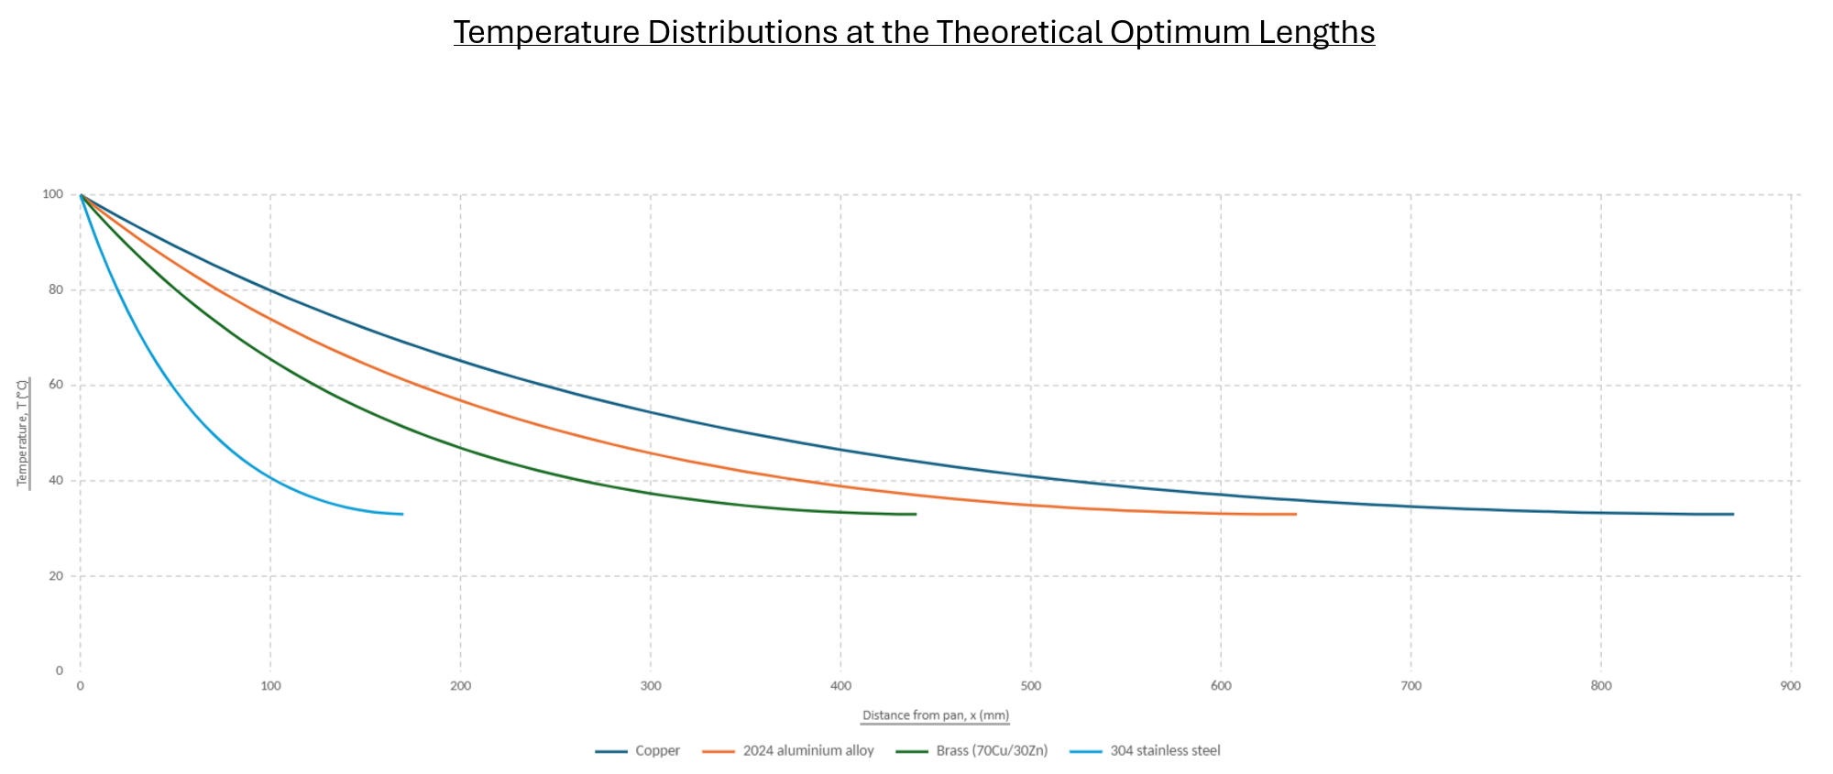
Figure 5 - Temperature distributions along the four saucepan handles at their theoretical optimum lengths ($mL=2.65$).
For an actual saucepan, the mathematically optimum bare-metal lengths for copper, aluminium and brass would be impractical. A handle approaching 0.45–0.88 m would be too long and would add unnecessary mass and leverage, even though the tip temperature would be lower. A more practical design would keep the handle shorter and reduce heat conduction using stainless-steel attachments, a reduced section or a polymer/wood insulating grip. If the material and rectangular cross-section are fixed and the assignment’s fin criterion is used, the theoretical lengths are 879 mm for copper, 641 mm for 2024 aluminium, 446 mm for brass and 173 mm for 304 stainless steel. Of these, stainless steel is the only material with a theoretical optimum close to the original 200 mm handle. A practical recommendation would therefore be around 175–200 mm, with 200 mm producing the lower calculated tip temperature. Supporting calculations and plotting data are provided in Appendix A.

Conclusion

Extended surfaces have remained central to thermal management even as their form has changed from cast engine fins to louvered automotive radiators, processor heat sinks, microchannels and additively manufactured lattices. The Task B analysis shows why fin length should be limited by diminishing returns: at $mL=2.65$, a finite adiabatic-tip fin already delivers about 99% of the infinite-fin heat-transfer rate. Applying the same theory to the saucepan demonstrates the difference between thermal and practical design optimisation. Copper gives the greatest heat loss but an unacceptably hot 200 mm grip, while stainless steel restricts conduction and produces a 29.3 °C tip. Its theoretical optimum length is about 173 mm, close to the existing geometry, whereas the higher-conductivity materials require impractically long handles to reach the same $mL$criterion. Overall, the results show that a good design must balance heat transfer with safety, size, mass and manufacturability.

References

Bergman, T.L., Lavine, A.S., Incropera, F.P. and DeWitt, D.P. (2017) Fundamentals of heat and mass transfer. 8th edn. Hoboken, NJ: John Wiley & Sons.
Chouhan, G., Namdeo, A.K., Guner, A., Essa, K. and Bidare, P. (2026) 'Heat transfer performance of compact TPMS lattice heat sinks via metal additive manufacturing', Progress in Additive Manufacturing, 11, pp. 593-610. doi: 10.1007/s40964-025-01366-0.
ISO (2006) ISO 13732-1:2006 Ergonomics of the thermal environment - Methods for the assessment of human responses to contact with surfaces - Part 1: Hot surfaces. Geneva: International Organization for Standardization.
Li, J. and Yang, L. (2023) 'Recent development of heat sink and related design methods', Energies, 16(20), 7133. doi: 10.3390/en16207133.
MAHLE Aftermarket GmbH (2021) Vehicle cooling: A compact guide for the workshop. Available at: https://www.mahle-aftermarket.com/media/homepage/facelift/media-center/klima/mah-kompaktwissen-ec-fahrzeugkuehlung-en-screen.pdf (Accessed: 16 September 2026).
Maiorino, A., Cilenti, C., Petruzziello, F. and Aprea, C. (2024) 'A review on thermal management of battery packs for electric vehicles', Applied Thermal Engineering, 238, 122035. doi: 10.1016/j.applthermaleng.2023.122035.
Rahman, M.A., Hasnain, S.M.M., Paramasivam, P. and Ayanie, A.G. (2024) 'Advancing thermal management in electronics: a review of innovative heat sink designs and optimization techniques', RSC Advances, 14, pp. 31291-31319. doi: 10.1039/D4RA05845C.
Sachar, S., Parvez, Y., Khurana, T. and Chaubey, H. (2023) 'Heat transfer enhancement of the air-cooled engine fins through geometrical and material analysis: a review', Materials Today: Proceedings. doi: 10.1016/j.matpr.2023.03.447.
Sun, S., Rankouhi, B., Thoma, D.J., Cheadle, M.J., Maples, G.D., Anderson, M.H., Nellis, G. and Qian, X. (2024) 'Topology optimization, additive manufacturing and thermohydraulic testing of heat sinks', International Journal of Heat and Mass Transfer, 224, 125281. doi: 10.1016/j.ijheatmasstransfer.2024.125281.
Volkswagen (2003) VW Beetle through the years. Available at: https://www.volkswagen-newsroom.com/en/the-volkswagen-beetle-a-success-story-2341/vw-beetle-through-the-years-2361 (Accessed: 16 September 2026).
Wei, J. (2008) ‘Challenges in cooling design of CPU packages for high-performance servers’, Heat Transfer Engineering, 29(2), pp. 178–187. doi: 10.1080/01457630701686727.
Yu, Z.-Q., Li, M.-T. and Cao, B.-Y. (2024) 'A comprehensive review on microchannel heat sinks for electronics cooling', International Journal of Extreme Manufacturing, 6(2), 022005. doi: 10.1088/2631-7990/ad12d4.
Zhang, X., Huang, Y., Song, J., Ma, Z., Chen, L. and Li, T. (2022) 'Numerical investigation of the air-side performance of louver fin-and-tube radiators having rectangular, tapered and airfoil section configuration', Energy Reports, 8, pp. 11799-11809. doi: 10.1016/j.egyr.2022.09.050.
Zhang, Z., Wang, X. and Yan, Y. (2021) 'A review of the state-of-the-art in electronic cooling', e-Prime - Advances in Electrical Engineering, Electronics and Energy, 1, 100009. doi: 10.1016/j.prime.2021.100009.

Appendix A - Plotting and calculation checks

Task B plotting formula: For $mL=0.0,0.1,0.2,…,4.0$, the heat-transfer ratio was calculated using $q_{f}/q_{∞}=tanh⁡\left(mL\right)$. The $mL=2.65$point was added separately because it does not fall within the 0.1 increments.
Optimum-length plot endpoints: The calculated optimum lengths were 878.9 mm for copper, 641.3 mm for aluminium, 445.7 mm for brass and 173.5 mm for stainless steel. For each material, its own optimum length was used in the temperature equation, with $x$evaluated at 10 mm increments and at the final exact endpoint. Each theoretical optimum ends at approximately 33.0 °C. Table 5 below gives the temperature-distribution data for the original 200 mm handles.

Table 5 - Original 200 mm handle distribution data (°C)
x (mm) | Copper | 2024 Al | Brass | 304 SS
0 | 100.0 | 100.0 | 100.0 | 100.0
10 | 98.8 | 97.9 | 96.3 | 89.0
20 | 97.6 | 95.9 | 92.8 | 79.6
30 | 96.5 | 94.0 | 89.6 | 71.5
40 | 95.5 | 92.3 | 86.7 | 64.6
50 | 94.5 | 90.7 | 83.9 | 58.6
60 | 93.6 | 89.2 | 81.4 | 53.6
70 | 92.8 | 87.8 | 79.1 | 49.2
80 | 92.0 | 86.5 | 77.0 | 45.5
90 | 91.3 | 85.3 | 75.1 | 42.4
100 | 90.7 | 84.3 | 73.4 | 39.7
110 | 90.1 | 83.3 | 71.8 | 37.4
120 | 89.6 | 82.5 | 70.5 | 35.5
130 | 89.2 | 81.7 | 69.3 | 33.9
140 | 88.8 | 81.1 | 68.3 | 32.6
150 | 88.4 | 80.5 | 67.4 | 31.6
160 | 88.2 | 80.1 | 66.7 | 30.7
170 | 88.0 | 79.7 | 66.2 | 30.1
180 | 87.8 | 79.5 | 65.8 | 29.7
190 | 87.7 | 79.3 | 65.5 | 29.4
200 | 87.7 | 79.3 | 65.5 | 29.3

