LEVEL 4 ASSESMENT
Alin Raducan

[Alin Valentin Raducan] [2522566] Programme: CertHE Computing Skills for Workplace Module Code: ACCA4026 Lecturers: Martin Svejda, Osman Elgawi University Name: University of Wales Trinity Saint David Campus: [Birmingham] Date of Submission: 09/03/26

Homepage
https://sites.google.com/d/1rtWrID2EKiHcwlQ3FJqYP0pGTb_HvdS-/p/1ZXX1B4YUGrJb0eDSRlQTdiN-WQ385HSz/edit
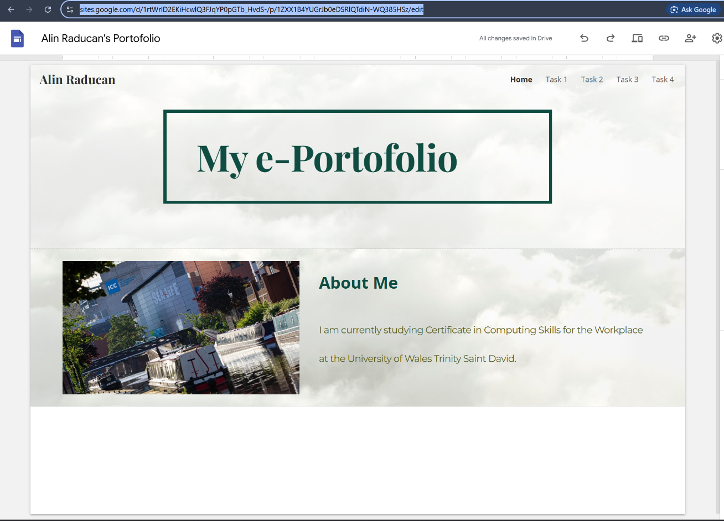

1.
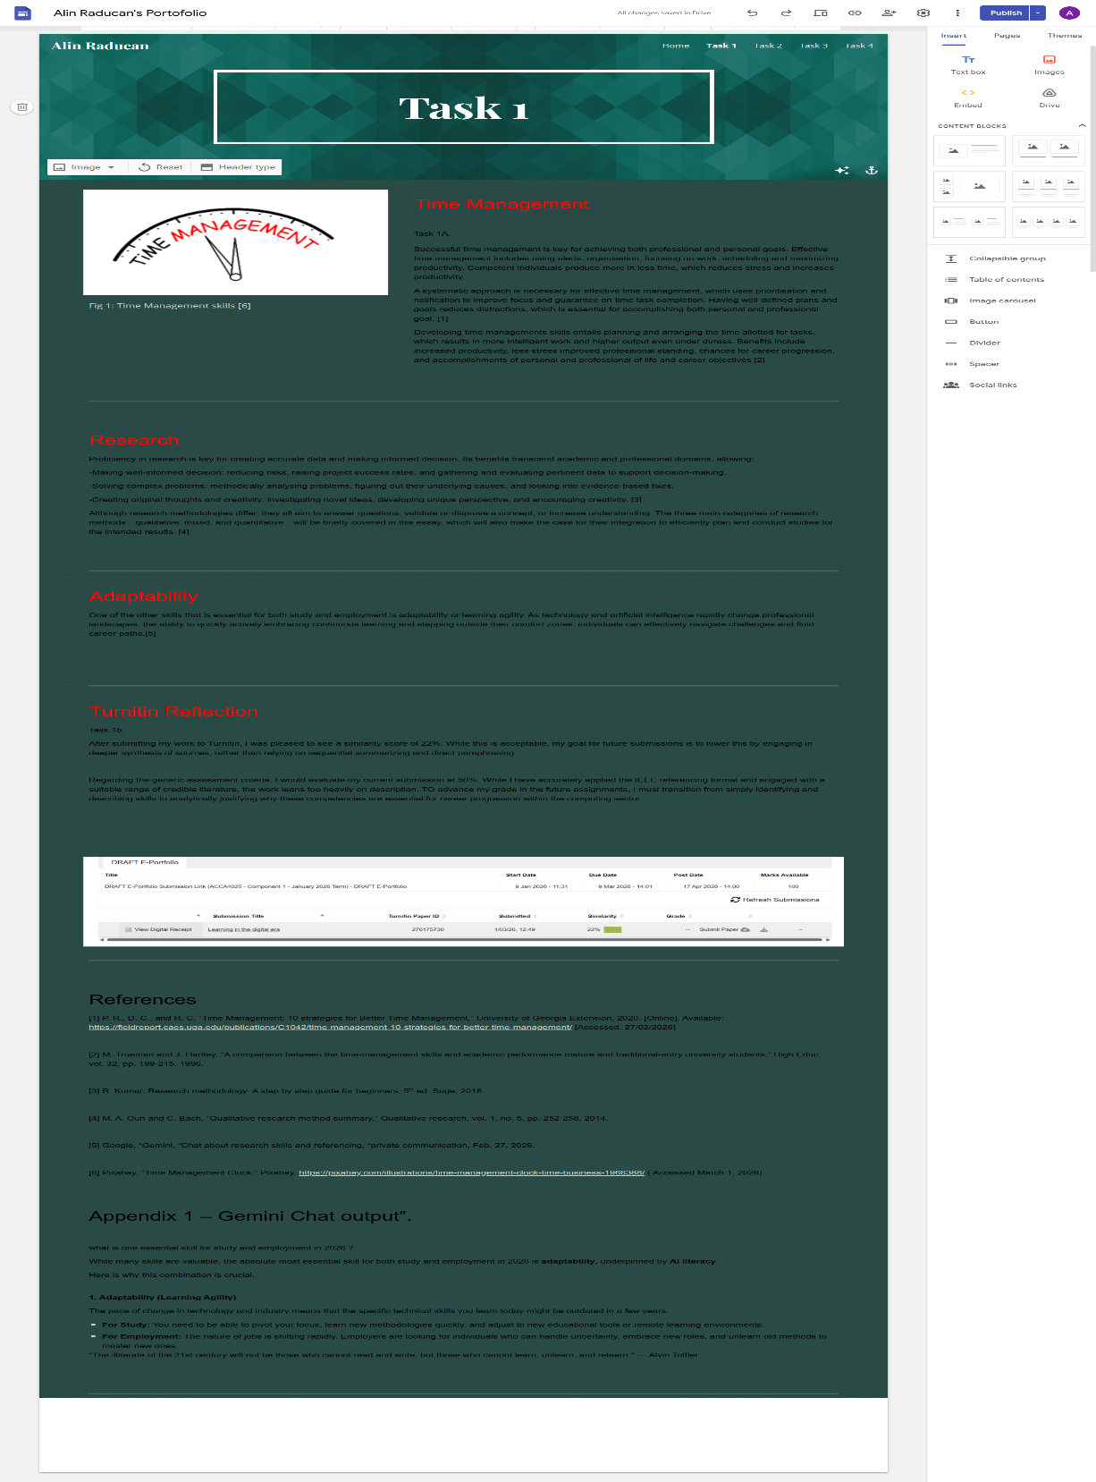

2.
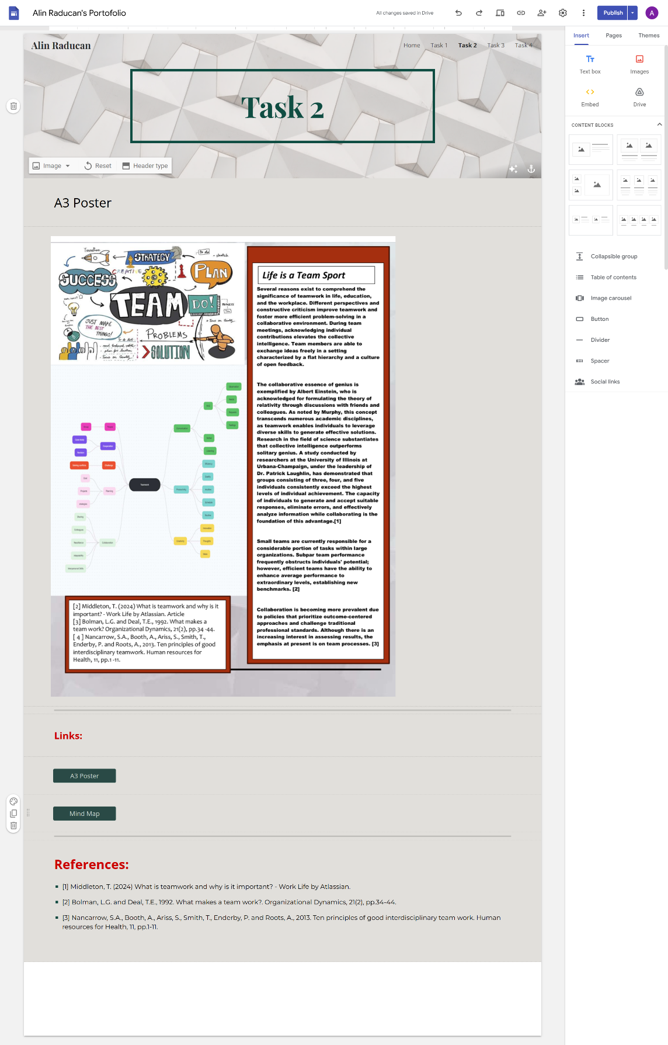

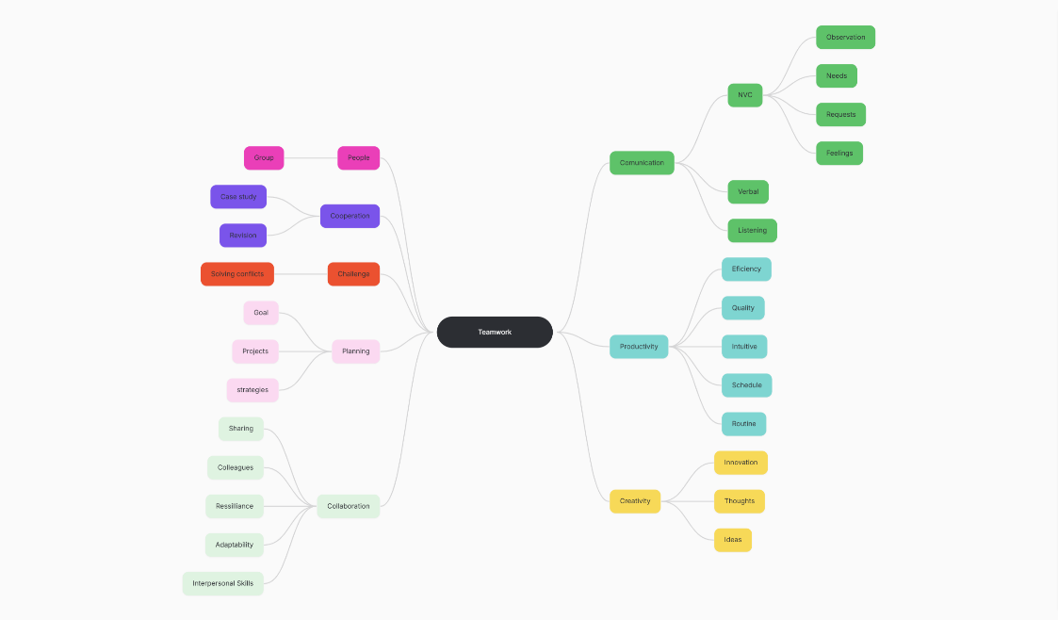
https://atlas.mindmup.com/mind-map-teamwork-feon3c/

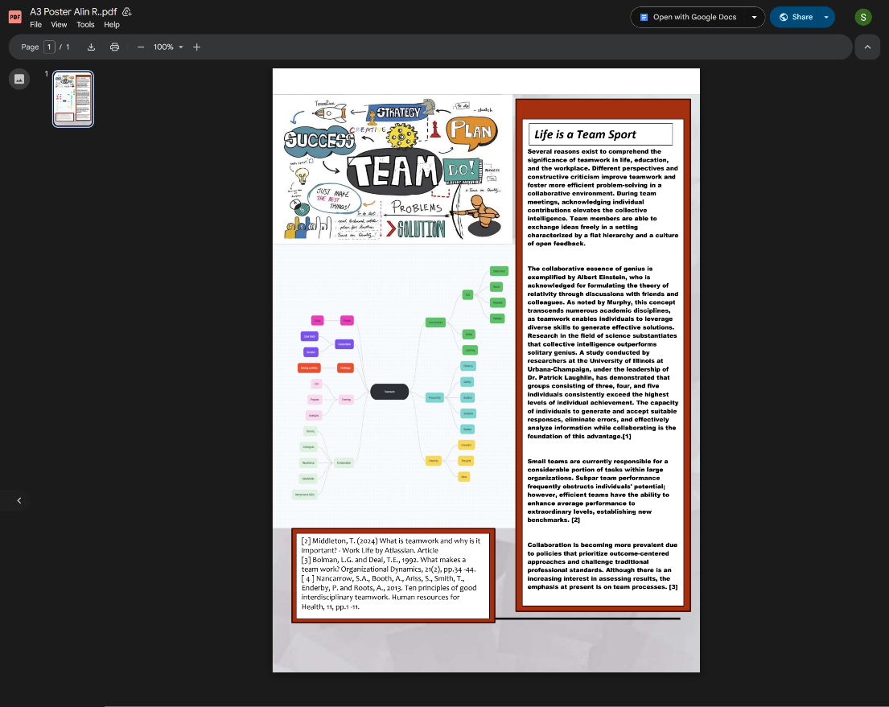
https://drive.google.com/file/d/1QSNzQ0e36n5XHhqLRA0inZ0onNUTrlzd/view

3.

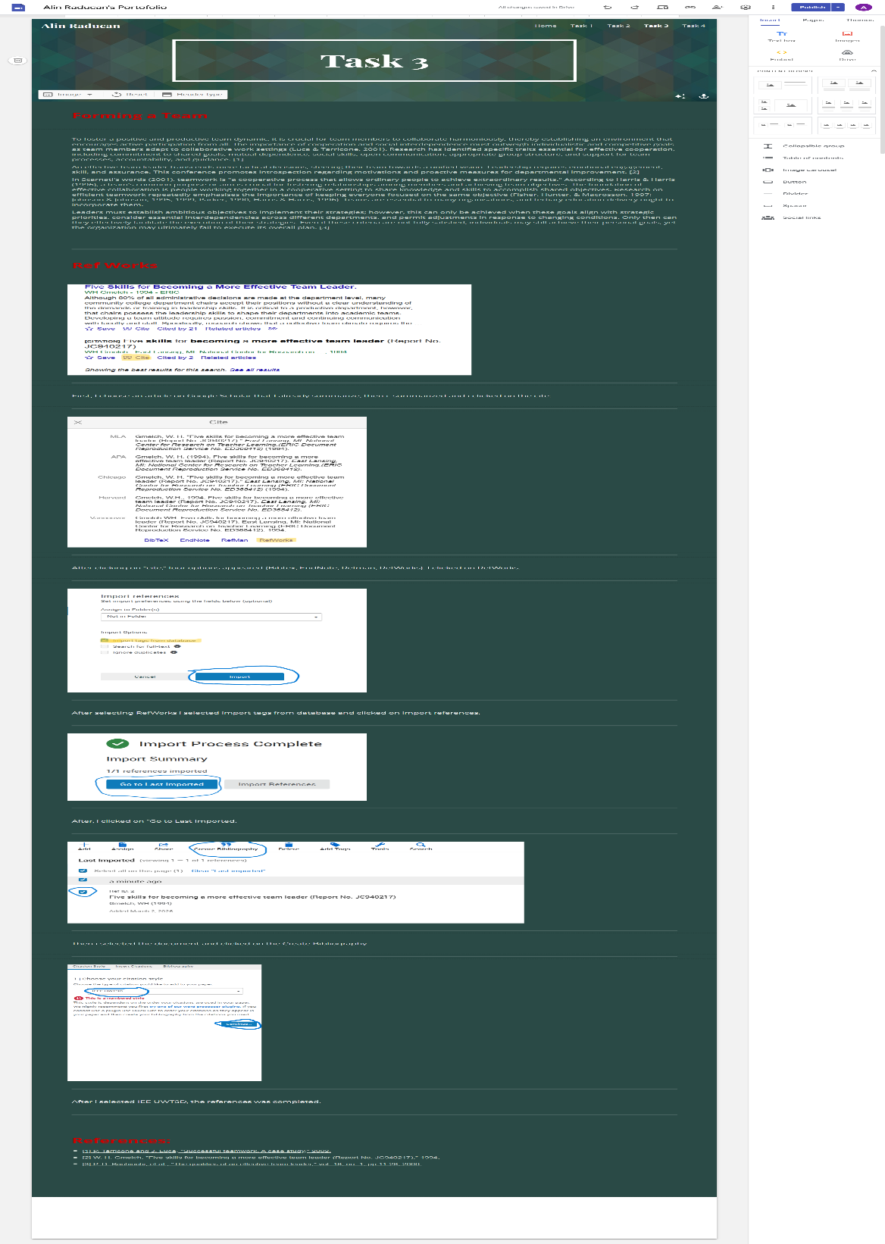

4.
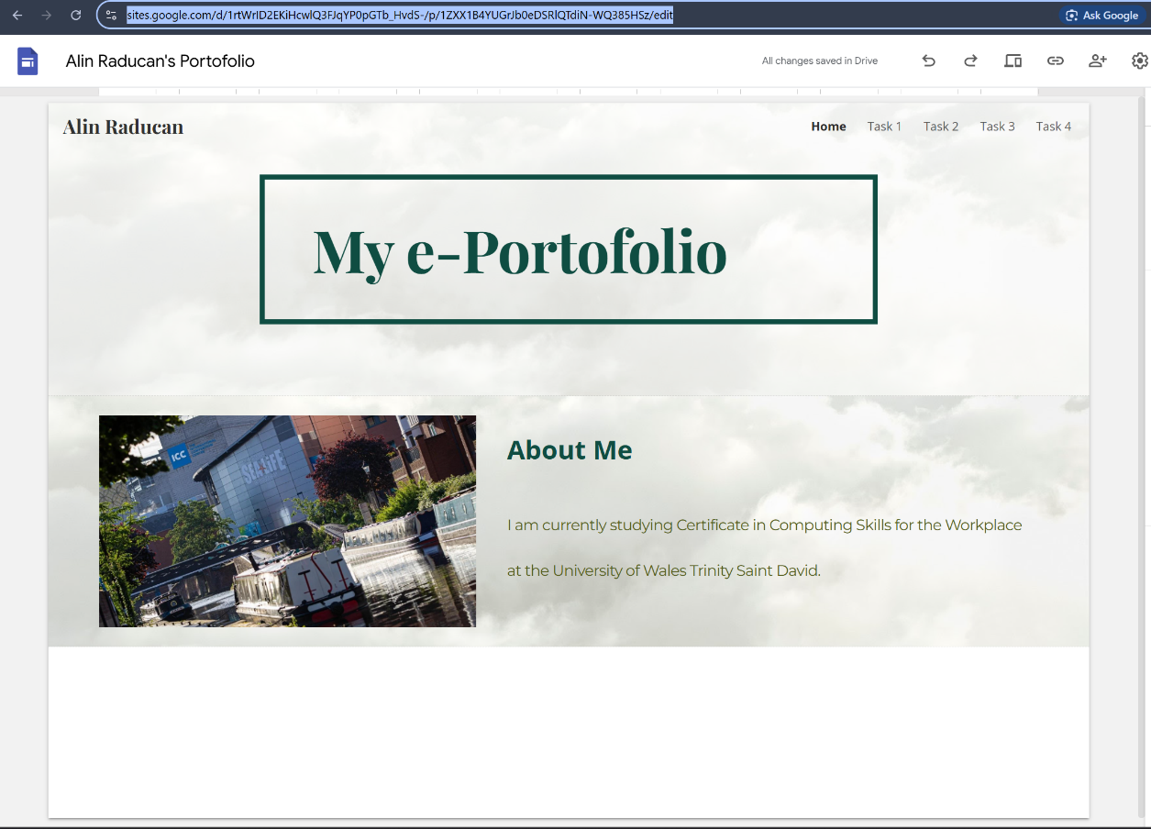

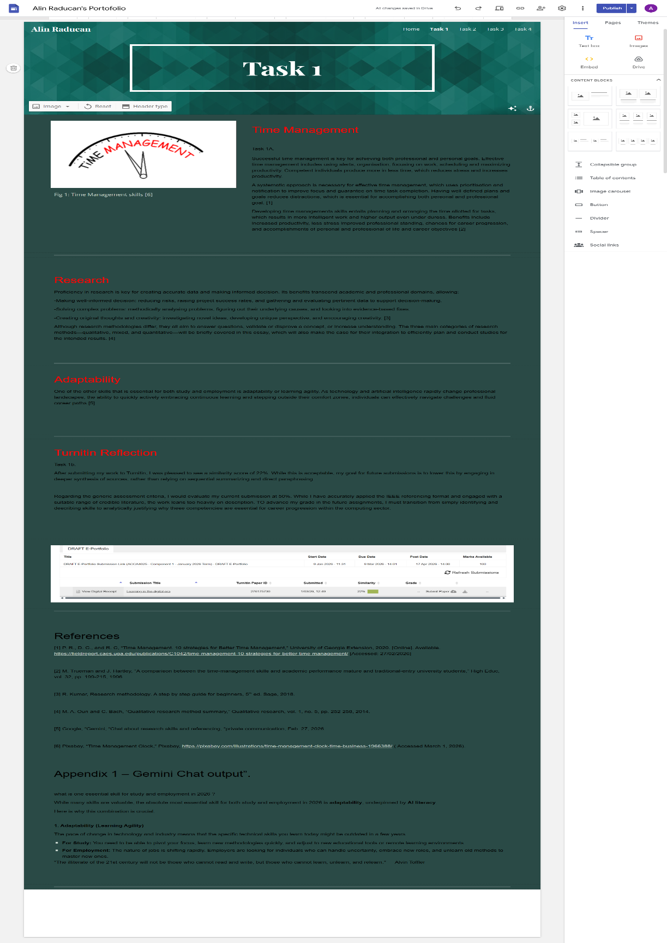

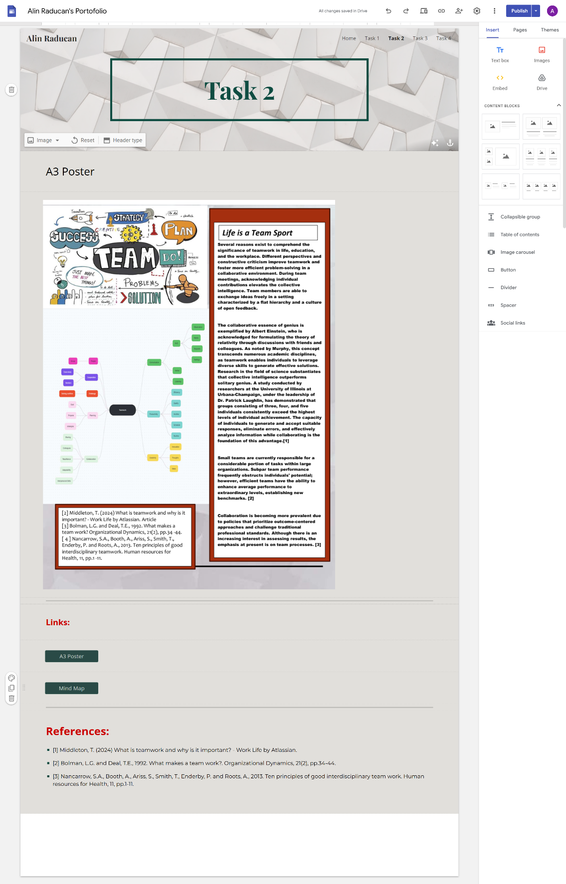

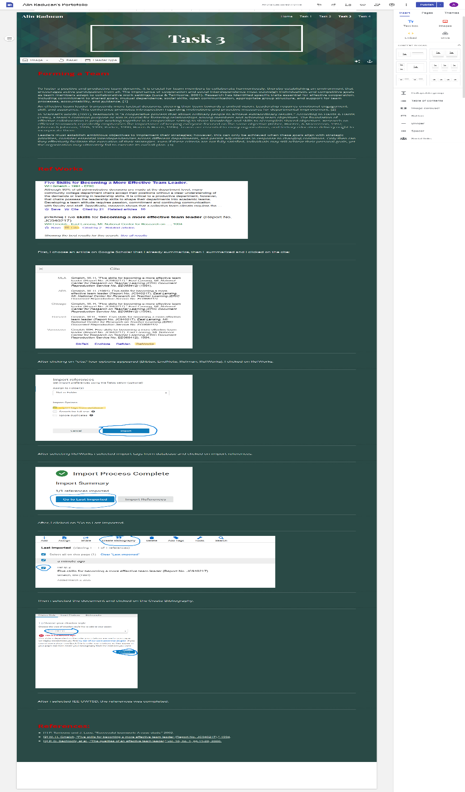

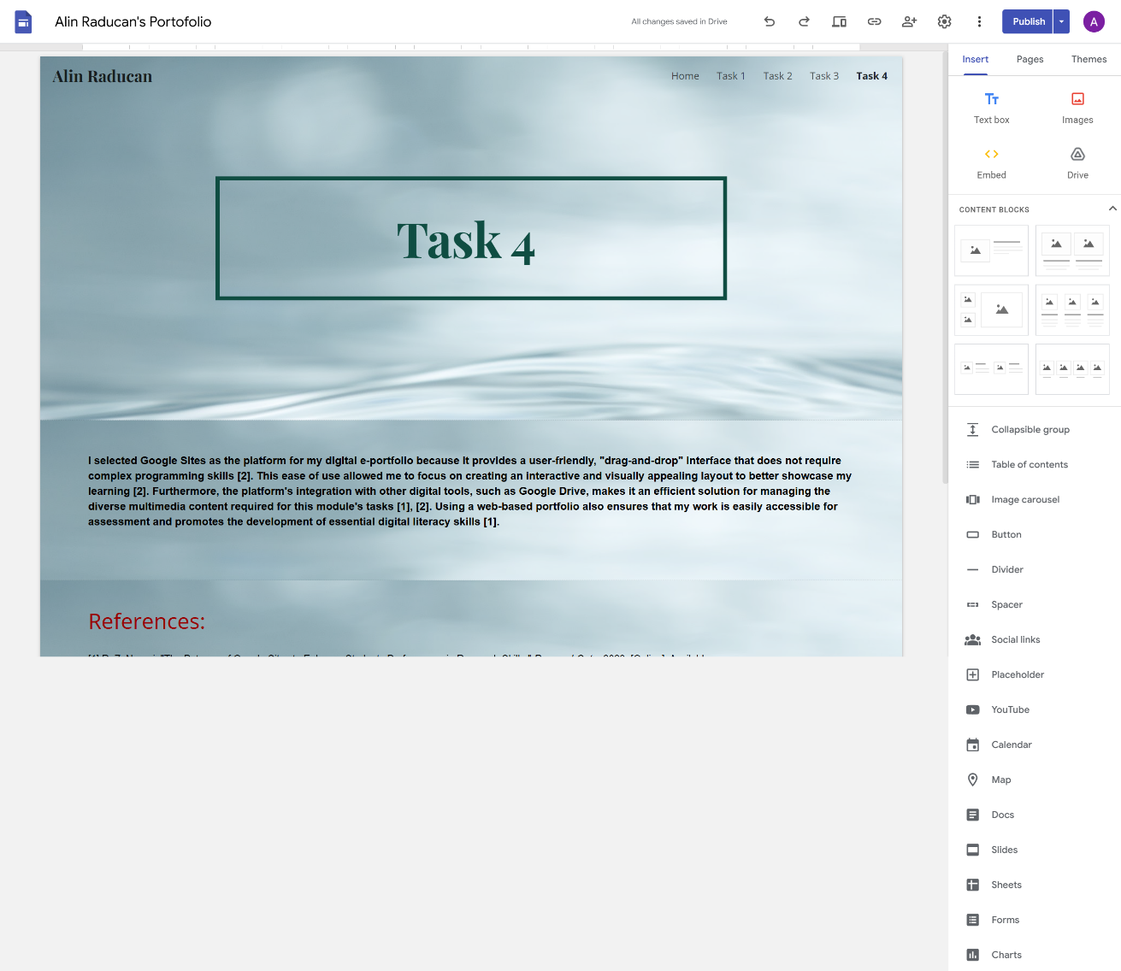

Table of Contents
Homepage 1
Task 1- Written Summary 2
Task 2-Mind Map and Academic Poster 3
Task 3- Automatic Referencing tool. 5
Task 4 – E-portfolio creation and review. 6

