

MODULE CODE/: LCBB4001
ACCOUNTING FUNDAMENTALS
ASSESSMENT TYPE: ASSIGNMENT 1
TEACHER: Rexon Nting
STUDENT: Vasilka Atanasova
ID:1818595​

Table of contents

- Introduction………………………………………………………… 3.
- Task 1………………………………………………………………... 4.
- Task 2 ……………………………………………………………….. 6.
- Task 3………………………………………………………………… 8.
- Task 4……………………………………………………………….. 11.
- Task 5……………………………………………………………….. 13.
- References…………………………………………………………. 15.

Introduction
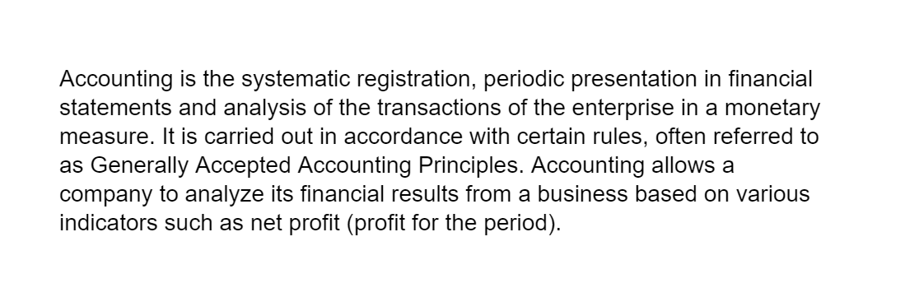


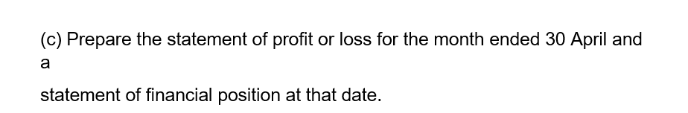


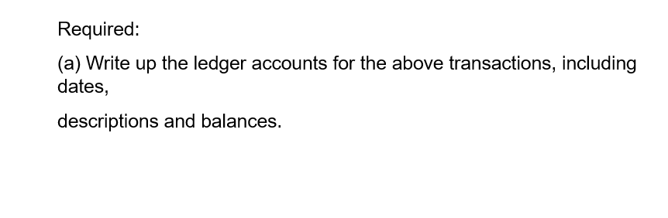
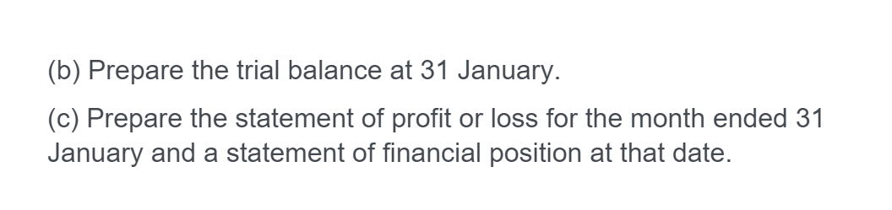

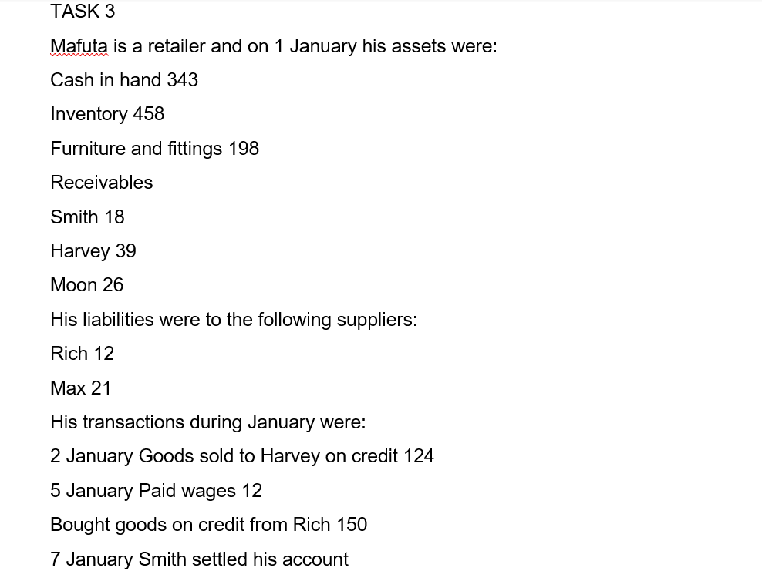

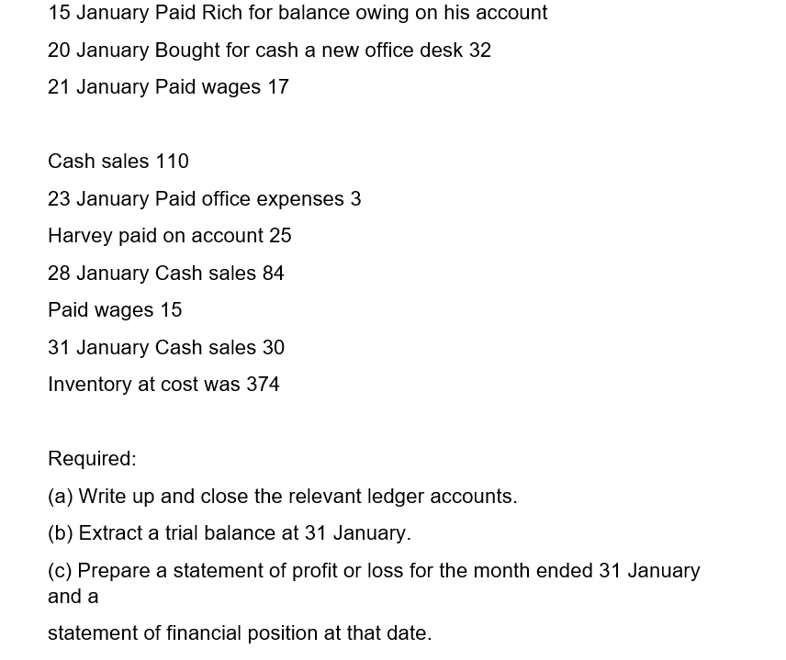


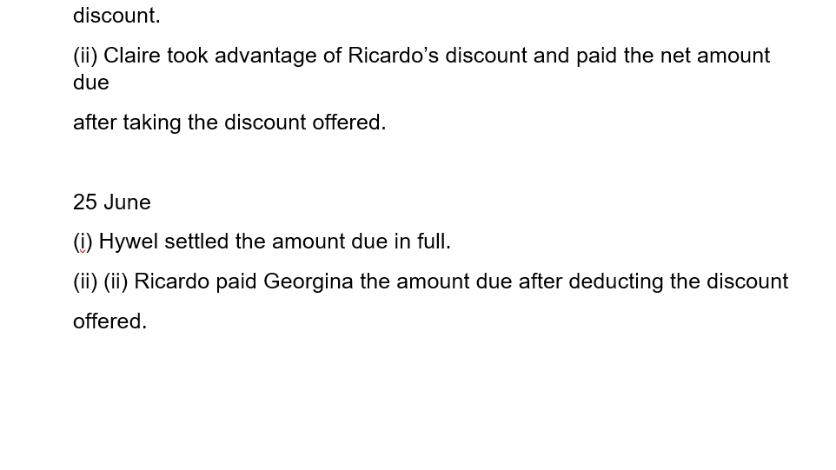
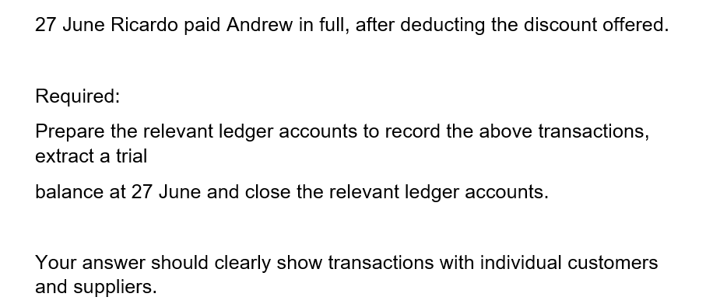

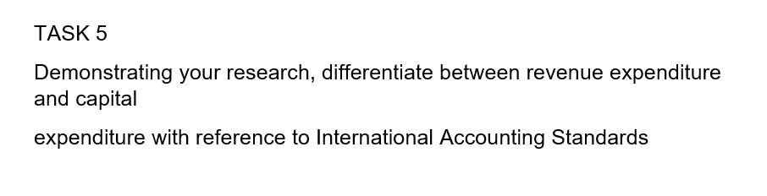

The function of a financial statement is to provide information about the financial position of an entity, where the results of operations and cash flows are. The financial statements also reflect the facts of resource management. To achieve this, the financial statements provide information about the company on assets, liabilities, income and expenses, gains and losses, equity changes in equity and cash flows. The full composition of the financial statements includes - balance sheet statement of income and expenses, statement of contingencies in equity, cash flow statement. Profit and loss statement for the period of profit or loss. The idea is to directly combine income and expenses over a given period and determine the actual financial result of the activity.
Revenue > Expense => Financial Profit
Revenue < Expenses => Result of financial losses
An important point in the preparation of an income statement is that it includes revenue and expenses as they arise.
Drawing up a balance sheet.
Balance - represents the state of the assets and liabilities of an enterprise at a given moment.
Assets are resources that an entity owns and manages, they are current and non-current - fixed assets are used for more than one reporting period.
They are reported in the balance sheet by their carrying amount or acquisition value
- current assets are often used for operational activities.
The liability of the balance sheet provides information on the sources of funds used to finance the enterprise, both own and borrowed funds.
The basic rule is that the size of the assets must be equal to the capital plus the size of the liabilities
Cash Flow Statement - The cash flow statement provides information about cash flows and payments for a specified period, the opening and closing cash balances for that period. This information is the basis for evaluating an entity's ability to operate and generate cash and cash equivalents
Cash is a short-term financial asset in the form of cash. Cash and cash equivalents. Cash and unlimited deposits are available. Cash equivalents are short-term highly liquid investments that can be easily converted into cash equivalents and carry little risk of changes in value.
The statement of equity reflects changes in equity as a result of transactions with owners - an increase in the distribution of dividend capital and more.
The main purpose of financial analysis is to evaluate the development of an entity through the information in the financial statements.
The main forms of reporting used for financial analysis are the balance sheet, the profit and loss statement and the cash flow statement, which provide the necessary information that can be used to determine the level of liquidity, solvency, debt and return.

References



