
How to start a conference call on Skype.

1. In your contacts list, select multiple contacts by holding down the Ctrl key and clicking the names of those who you would like to invite to your conference call so that they are highlighted.
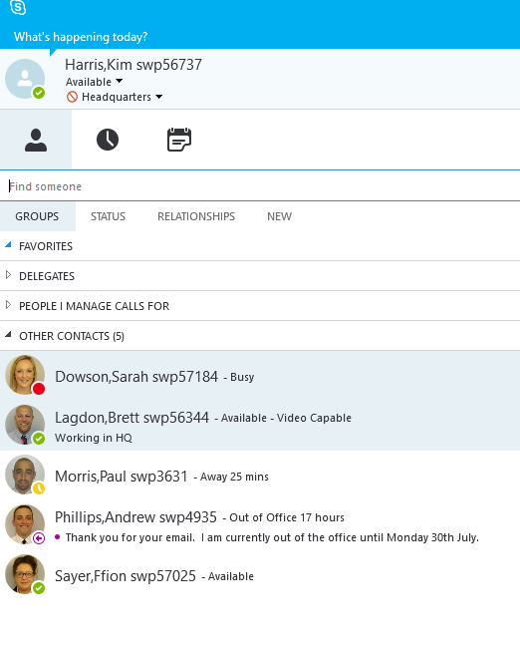


- Right click on any of the selected names then click on Start a conference call and select Skype Call.
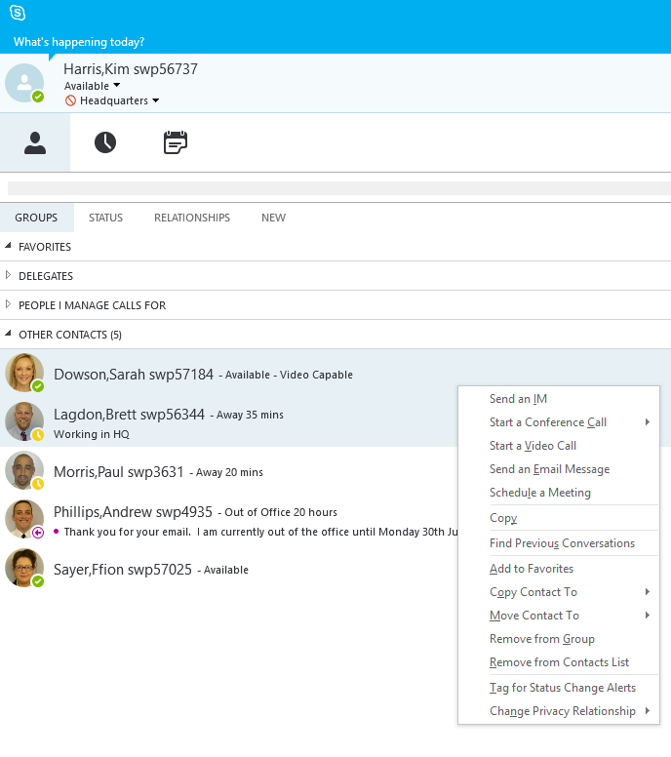

- This will then bring up the below screen while waiting for your contacts to connect.
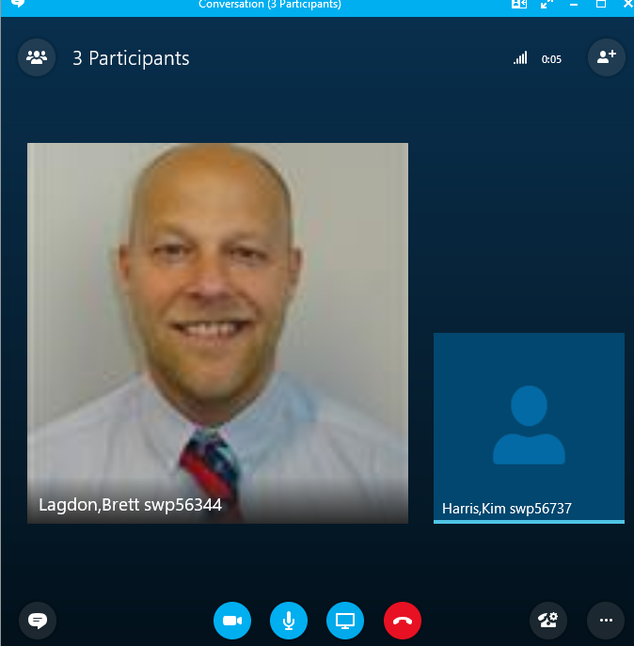

N.B. If you are accepting a conference call then the below image will pop up on your screen. If you are free to chat click on the message to open it. If you are busy, click ‘Ignore’, this will let the person know you are not available and will also close the icon



- You are now connected.
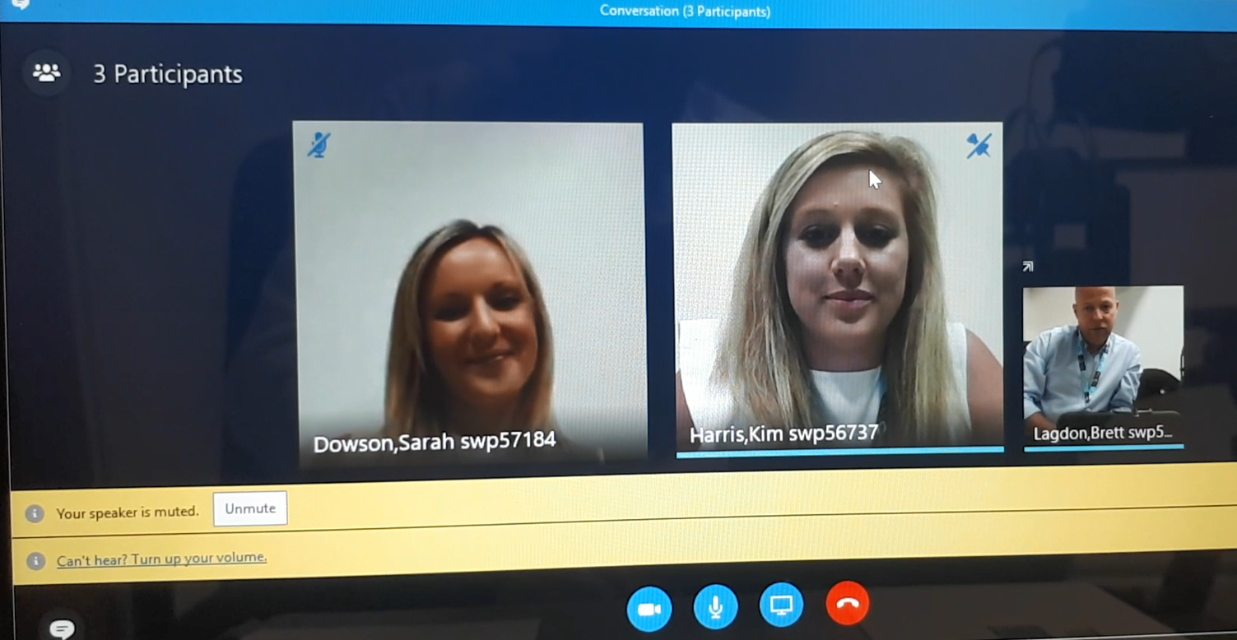

To end the call click on the red phone icon.

