Print Making with Cam 10am – 12.30pm Monday 28th Sept

You have previously printed with the Letter Blocks in Print Making – how can you play with the regularity of the letter order to be playful with your emotive words?

- Rethink the linearity of a word…. Eg

HAP Instead of Happiness
PIN
Ness

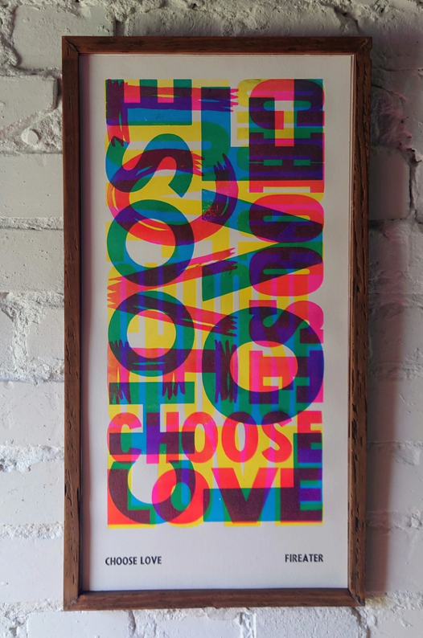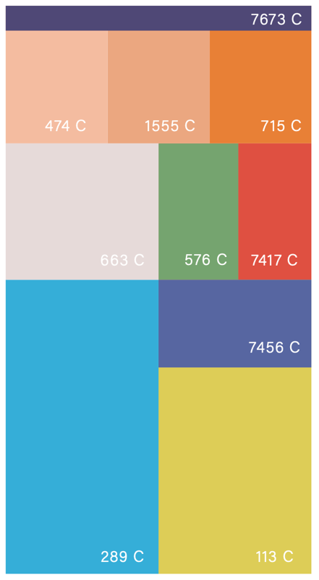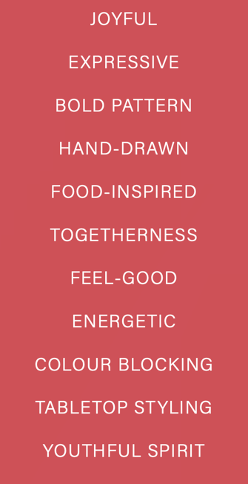
Fireater Press Food is Happiness Palette

- Play with overlaps and Fall on Colour/transparencies and opacities.
- Play with the orientation of the letters – right way/wrong way/upside down/reflected
- Use Coloured grounds or brown paper
- Mix colours according to the Design Group Food is Happiness Colour Palette

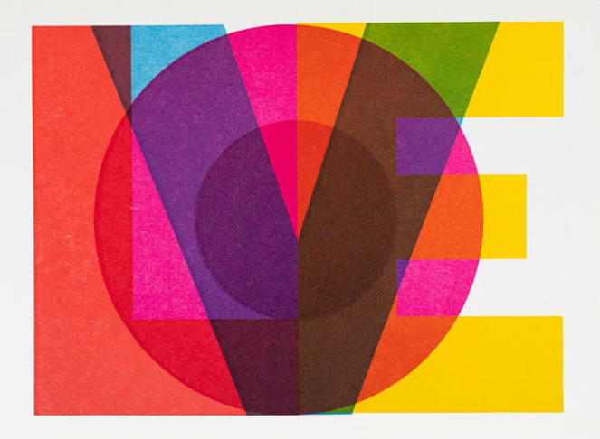
Daisy Chain Gift Co

