Digital Skills and Research Methods

Firih Hashim Suliman
Student ID: 2110796

Table of Contents
Assessment 1 Blog 1
1st Blog Post: About Me 1
References 1
2nd Blog Post: Professional research methods 3
References 3
3rd Blog Post: Collaborative working 4
References 4
4th Blog Post: Data protection & ethics 6
References 6
5th Blog Post: Questionnaire design/importance of primary research 7
References 7
Assessment 2 Report 9
Introduction 9
2. Importance of primary, or market research for businesses 10
3. Analysis of the questionnaire data including graphs/snippets and how the findings can impact/influence your business idea. 11
3.1 Questionnaire for Data collection 11
3.2 Findings and Discussion 14
4. Rationale for how the questionnaire data influenced the website design, including colour theory. 24
5. Discussion around the importance of SEO and how the primary research informs the SEO strategy. 24
Conclusion 25
Reference 26

Table of figures
Figure 1 Customers like to know variation of products and services available in the platform 14
Figure 2 Detailed information is related to trust issue and decision-making of customer. 15
Figure 3 Customers make decision based on available information from review and recommendation of others. 16
Figure 4 Two-way communication is needed for social media marketing. 17
Figure 5 Feedback system influences the customer’s trusts and decision-making. 18
Figure 6 Promotion in social media engages more customers. 19
Figure 7 Website needs to have proper content of product and company for educating the customers. 20
Figure 8 Fast responses from the company help the customers to have positive experience. 21
Figure 9 Social media platform provides option for engagement and satisfaction of customers. 22
Figure 10 Customers make more buying preferences while being engaged and interacted effectively. 23

Assessment 1 Blog

1st Blog Post: About Me
Knowing own mistakes, strengths, abilities, resources and weakness can help the individual to be very cautious of the behaviour and action (Halper et al., 2020). I am currently studying and focusing on my knowledge and academic qualification. In case of discussing myself and my learning, I choose to think in the bigger way. From childhood, I have had the desire to be part of a business field, either starting my own business or being part of a respected organisation. But, options do not come easily. I had to work on myself. As I was talking about childhood, I had the leadership instinct and skills to lead any team. I played with the team and most of the time, I played the position of leader. Also, in academic learning and work, I choose to act as a leader while helping my teammates. Leadership and team management skills can help any individual to gain learning about themselves and help others at work (Park and Millora, 2012). Every student is expected to work on learning from observation, incidents, actions, mistakes and experiences. The experience can help them to develop more knowledge about their past activities and possible future actions to reduce the possible issues (Hodges, 2021). I have ensured to learn from every experience that I get from the academic work and others which have helped me to develop my skills and knowledge for the future. My volunteer work for the local charity has always helped me to value the lives of the people and animals. Every day, I learn something that nobody can give me. All I can say is that people should value the prayers and lives of every creature in the world to make things better. Also, I value learning each day to improve my knowledge and personality from the previous day. A simple change can help one to value their own flaws.

References
Halper, L., Craft, C. and Shi, Y., 2020. Expanding the Student Employment Literature: Investigating the Practice of Reflection in On-Campus Student Employment. Journal of College Student Development, 61(4), pp.516-521.
Hodges, D., 2021. Keep a work journal for reflection and responsibility. Student Affairs Today, 24(3), pp.3-3.
Park, J. and Millora, M., 2012. The Relevance of Reflection: An Empirical Examination of the Role of Reflection in Ethic of Caring, Leadership, and Psychological Well-Being. Journal of College Student Development, 53(2), pp.221-242

2nd Blog Post: Professional research methods
From academic areas to industries, the research is conducted for various purposes. One thing most common that affects the research methods and findings of the paper is the application of the research method (Zikmund et al., 2019). Professional research methods represent different types of research methods used in a professional manner to accomplish the objectives and aim. Based on data type and requirement, the researcher tends to select research philosophy, approach, strategy, data collection method and analysis method. The researcher follows the research onion to get an idea about stages and proper tools relevant to the data type (Mitchell and Jolley, 2013). For quantitative research design, the researcher tends to approach positivism research philosophy, deductive research approach and survey research strategy. A survey research strategy helps the researcher to collect data from respondents which is mostly quantitative in nature. Also. The interview can be used as part of primary research to collect detailed data from the respondents (Schindler, 2022). For the qualitative research design, interpretivism and inductive research approach are approached to select either interview method, case research strategy, or experimental or desk research strategy.
The primary data collection method can be a common professional research method when it comes to the collection of primary and raw data (Zikmund et al., 2019). The primary data collection method is related to survey research and interview methods. On the other hand, the secondary data collection method is approached to get a vast amount of sources and detailed data from the secondary sources (Mitchell and Jolley, 2013). Hence, the desk research strategy can be approached under the secondary data collection method. MS Excel and SPSS are used for the quantitative data analysis. Thematic and basic data analysis tools are approached for qualitative data analysis. In a professional research paper, the researcher has to be careful about ethical consideration and practices.

References
Mitchell, M. and Jolley, J., 2013. Research design explained. Australia: Wadsworth Cengage Learning.
Schindler, P., 2022. Business research methods. New York: McGraw-Hill.
Zikmund, W., Quinlan, C. and Griffin, M., 2019. Business Research Methods. Andover: Cengage.

3rd Blog Post: Collaborative working
Collaborative working represents teamwork, collaboration among the team members and integration of skills and knowledge (O'Neill et al., 2012). In every organisation, from business to the healthcare sector, collaborative working is required to be accepted for better performance. In academic study, students are supposed to value team working skills as some activities are done with group work. The students can learn about teamwork and team working skills and other knowledge (Saffran, 2014). With the help of collaborative working and learning, the students can learn from others while developing observational skills and learning. Hence, the learners are encouraged to value collaborative working in teamwork and performance.
The studies showed that collaborative working has higher benefits for the organisation compared to individual working (Coit et al., 2018). In the case of business, collaborative working can represent the partnership of the businesses for gaining competitive advantages and success in the given markets. In some situations, the organisation can work with other organisations under collaborative working to develop their power and control in the business marketplaces (O'Neill et al., 2012). In the healthcare setting, collaborative working increases patient satisfaction and integrated service and care. Healthcare professionals can see the benefits of collaborative working for managing emergency care, service and treatment (Saffran, 2014). Also, collaborative working can reduce the possible issues and problems. But, collaborative working can increase conflicts among the team members. The poor communication supports for the members, cultural gap and lack of respect for the members can affect the collaborative working and mind-set of the members (Coit et al., 2018). Hence, the individual should share the right information while supporting integration and collaborative working. Also, the organisation should value culture and communication to build up collaborative working.

References
Coit, C., Franzen, M. and Hughes, J., 2018. Build Staff Trust and Teamwork for Best Results. Opflow, 44(8), pp.6-6.
O'Neill, T., Goffin, R. and Gellatly, I., 2012. The Knowledge, Skill, and Ability Requirements for Teamwork: Revisiting the Teamwork-KSA Test's validity. International Journal of Selection and Assessment, 20(1), pp.36-52.
Saffran, J., 2014. Sounds and Meanings Working Together: Word Learning as a Collaborative Effort. Language Learning, 64(s2), pp.106-120.

4th Blog Post: Data protection & ethics
In any research study and method, the researcher has to collect data from the respondents or the secondary sources. Two types of data collection methods are approached collecting data. In each situation, the researcher is liable to others and research practice (Floridi, 2018). Data Protection Act has been followed in the research process to manage privacy and confidentiality. The privacy of the respondents and their given data should not be disclosed or used to harm them or for any other purposes (Fritz, 2022). In the meantime, data protection requires proper confidentiality of data given by the respondents to make things protective and safe for them. In some cases, the respondents are unwilling to give the right information related to business due to fear or any other issues (Kuyumdzhieva, 2019). Hence, the researcher has to manage the data protection and safety of the respondents where they participated in the survey or interview.
The ethical aspects and considerations are related to both primary and secondary research types (Floridi, 2018). In the case of secondary research, plagiarism has to be reduced for credible and reliable research with findings. The researcher has to select relevant tools and methods to collect secondary data and evaluate them for the aim and objectives. The acknowledgement of sources is managed under ethical practice as well (Fritz, 2022). In the case of primary research, the ethical issues are related to the privacy of respondents, less manipulation, less bias and judgment, alternation of data and confidentiality of information. The researcher cannot manipulate or force the respondents to provide particular responses to the questions (Kuyumdzhieva, 2019). Also, the ethical practices are related to the reduction of research errors and sampling errors for the paper. Proper management of ethical aspects and practices can create a valid and professional research paper.

References
Floridi, L., 2018. Soft Ethics and the Governance of the Digital and the General Data Protection Regulation. SSRN Electronic Journal,.
Fritz, Z., 2022. When the frameworks don’t work: data protection, trust and artificial intelligence. Journal of Medical Ethics, 48(4), pp.213-214.
Kuyumdzhieva, A., 2019. General Data Protection Regulation and Horizon 2020 Ethics Review Process: Ethics Compliance under GDPR. Bioethica, 5(1), p.6.

5th Blog Post: Questionnaire design/importance of primary research
To address any issues, conducting research gets priority. In the research method, primary research guarantees raw and fresh data collection as this method allows the researcher to collect up-to-date and relevant information from the sources (Keshavarz and Maze, 2013). Even the information collected from the primary research enables the researcher to have proper information about the accurate trends. The importance of primary research is higher for academic purposes and business. Primary research helps the students to control the method and ownership of data collected for their own research for academic or other purposes (Leppenwell et al., 2013). This happens with the organisation as they can collect raw and fresh data from primary sources and can easily rely on the data. The primary data collected from primary research is more reliable and relatable compared to the secondary research. Moreover, primary research develops more trust in the audiences or researcher than secondary research for their nature (Keshavarz and Maze, 2013). Also, primary research contributes to the development of reliable and accountable data to make decisions based on the findings.
In the primary research, the survey is embraced compared to other processes where the questionnaire method is accepted to collect data (Hassan and Singh, 2012). Questionnaire design represents the procedures and process of designing the questions in the survey instrument to conduct the primary research. Primary research can help the researcher to use questions and to collect responses and reactions from the respondents (Leppenwell et al., 2013). The organisation can get information on the market needs, customer demands, competitor strategy, trends of the market and environment while applying primary research and data collection method. Also, the students are encouraged to perform primary research and use primary data collection methods to get raw data from primary sources and to develop accurate findings for the paper.

References
Hassan, A. and Singh, R., 2012. Respondents versus Informants Method of Data Collection: Implications for Business Research. SSRN Electronic Journal,.
Keshavarz, M. and Maze, R., 2013. Design and Dissensus: Framing and Staging Participation in Design Research. Design Philosophy Papers, 11(1), pp.7-29.
Leppenwell, E., De Lusignan, S., Vicente, M., Michalakidis, G., Krause, P., Thompson, S., McGilchrist, M., Desombre, T., Taweel, A. and Delaney, B., 2013. Developing a survey instrument to assess the readiness of primary care data, genetic and disease registries to conduct linked research: TRANSFoRm International Research Readiness (TIRRE) survey instrument. Informatics in Primary Care, 20(3), p.207.

Assessment 2 Report

Introduction
“Cooking and Food” is a new business start-up working for the cooking items and products for the customers. For the business growth and marketing strategies in the social media platform, this report has been done for conducting market research and developing digital content in the platform to maximize sales and/or publicity for the organization.

2. Importance of primary, or market research for businesses
Any business organisation needs to look at the market trends and issues affecting the business or can affect the business in the future (Marino et al., 2021). The organisation uses primary research or market research to collect raw and fresh data and up-to-date data. These type of data and relevant information from the sources help the business to analyse the accurate trends and to know about the market needs, external business environment, customer demands, and competitor strategy (Taherdoost, 2016). For the new business start-up and market research primary data collection method have been selected which can lead to collection of the raw data related to the business content and promotion. In the meantime, primary research allows the business to innovate new product with the ideas from the markets (Boparai et al., 2019). Hence, the industries tend to approach market research or primary research to address any issue.

3. Analysis of the questionnaire data including graphs/snippets and how the findings can impact/influence your business idea.

3.1 Questionnaire for Data collection
The questions for the data collection method are as follows:
TITLE OF THE RESEARCH: “Promotion and Customer engagement in Social Media Platform.”
Dear participant,
This is a business research project. Ethical issues will be strictly managed.
Thank You
Socio-Demographic Profile of the survey
1. What is your gender?
- Male
- Female
Questionnaire
Close Ended Questions: Please mark the correct answer,
1. Customers like to know variation of products and services available in the platform.
- Strongly Agree
- Agree
- Neutral
- Disagree
- Strongly Disagree
2. Detailed information is related to trust issue and decision-making of customer.
- Strongly Agree
- Agree
- Neutral
- Disagree
- Strongly Disagree
3. Customers make decision based on available information from review and recommendation of others.
- Strongly Agree
- Agree
- Neutral
- Disagree
- Strongly Disagree

4. Two-way communication is needed for social media marketing.
- Strongly Agree
- Agree
- Neutral
- Disagree
- Strongly Disagree
5. Feedback system influences the customer’s trusts and decision-making.
- Strongly Agree
- Agree
- Neutral
- Disagree
- Strongly Disagree
6. Promotion in social media engages more customers
- Strongly Agree
- Agree
- Neutral
- Disagree
- Strongly Disagree
7. Website needs to have proper content of product and company for educating the customers.
- Strongly Agree
- Agree
- Neutral
- Disagree
- Strongly Disagree

8. Fast responses from the company help the customers to have positive experience.
- Strongly Agree
- Agree
- Neutral
- Disagree
- Strongly Disagree
9. Social media platform provides option for engagement and satisfaction of customers.
- Strongly Agree
- Agree
- Neutral
- Disagree
- Strongly Disagree
10. Customers make more buying preferences while being engaged and interacted effectively.
- Strongly Agree
- Agree
- Neutral
- Disagree
- Strongly Disagree

3.2 Findings and Discussion
The data has been collected from 20 respondents and the analysed data is as follows:
1. Customers like to know variation of products and services available in the platform.
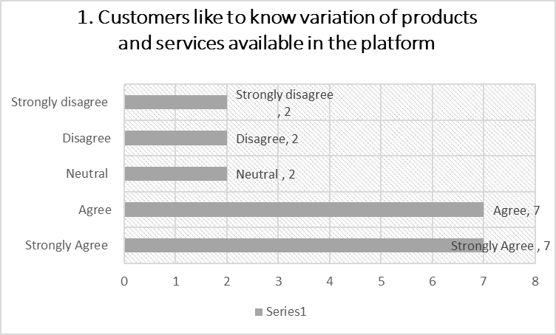
Figure 1 Customers like to know variation of products and services available in the platform
The figure represented that 14 of the respondents have agreed to the fact that Customers like to know variation of products and services available in the platform. 2 of them have been neutral and 4 of them have disagreed to the statement. This statement represents that the customers tend to collect information about various products and services from the platform of the business.

2. Detailed information is related to trust issue and decision-making of customer.
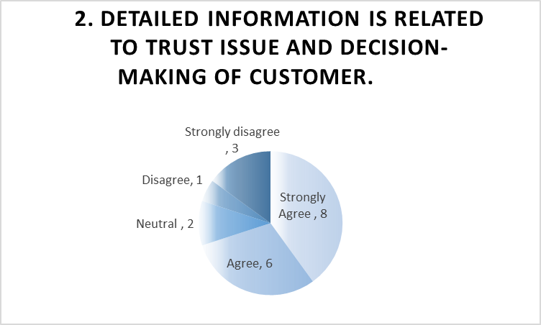
Figure 2 Detailed information is related to trust issue and decision-making of customer.
The figure represented that 14 of the respondents have agreed to the fact detailed information is related to trust issue and decision-making of customer. 2 of them have been neutral and 4 of them have disagreed to the statement. This statement represents that proper information about any products in the platform can make the customers more eager to buy the products.

3. Customers make decision based on available information from review and recommendation of others.
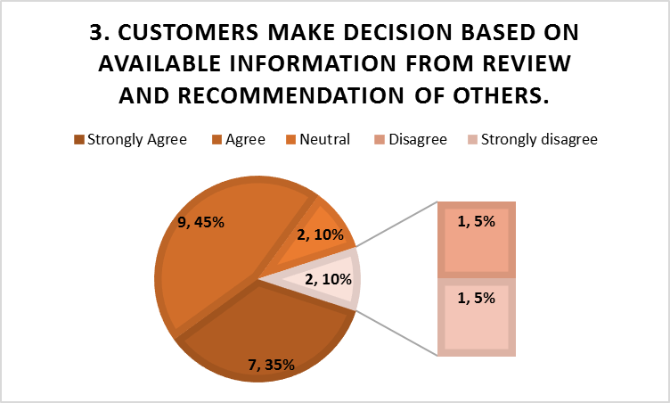
Figure 3 Customers make decision based on available information from review and recommendation of others.
The figure represented that 16 of the respondents have agreed to the fact that customers make decision based on available information from review and recommendation of others. 2 of them have been neutral and 2 of them have disagreed to the statement. The review and recommendations from other have higher impacts on customers for making decision about purchasing the products (Ansong and Boateng, 2019).

4. Two-way communication is needed for social media marketing.
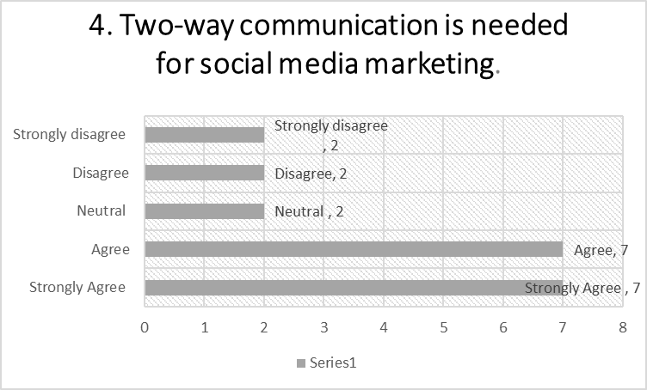
Figure 4 Two-way communication is needed for social media marketing.
In social media marketing, two-way communication is supposed to be built based on customer preferences and demands of the markets (Jawad et al., 2020). The figure represented that 14 of the respondents have agreed to the fact that two-way communication is needed for social media marketing. 2 of them have been neutral and 4 of them have disagreed to the statement.

5. Feedback system influences the customer’s trusts and decision-making.
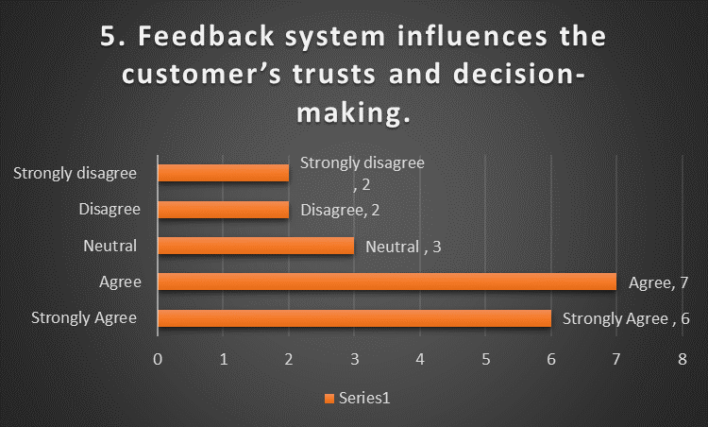
Figure 5 Feedback system influences the customer’s trusts and decision-making.
Feedback process and system of the organisation help the customers to build up their trusts and proper decision-making for the products (Killian and McManus, 2015). The figure represented that 13 of the respondents have agreed to the fact that Feedback system influences the customer’s trusts and decision-making. 3 of them have been neutral and 4 of them have disagreed to the statement.

6. Promotion in social media engages more customers.
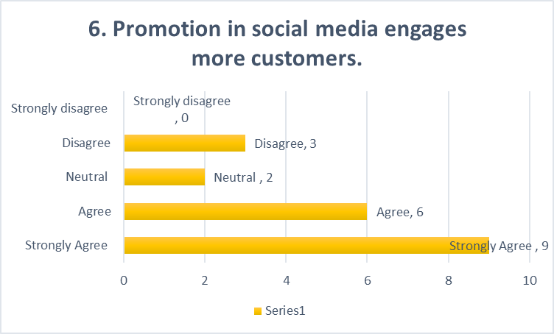
Figure 6 Promotion in social media engages more customers.
The figure represented that 15 of the respondents have agreed to the fact that promotion in social media engages more customers. 2 of them have been neutral and 3 of them have disagreed to the statement. The organisations are using social media marketing and promotion which engage more customers.

7. Website needs to have proper content of product and company for educating the customers.
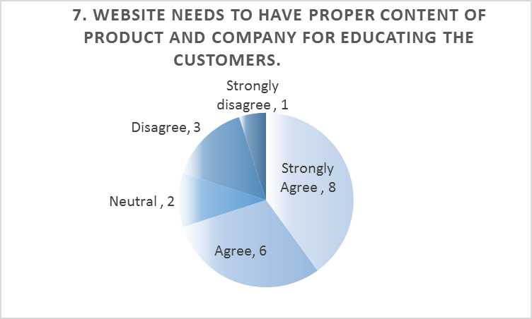
Figure 7 Website needs to have proper content of product and company for educating the customers.
The figure represented that 14 of the respondents have agreed to the fact that website needs to have proper content of product and company for educating the customers. 2 of them have been neutral and 4 of them have disagreed to the statement. The statement represents the organisation has to add proper content in websites for educating the customers about the products.

8. Fast responses from the company help the customers to have positive experience.
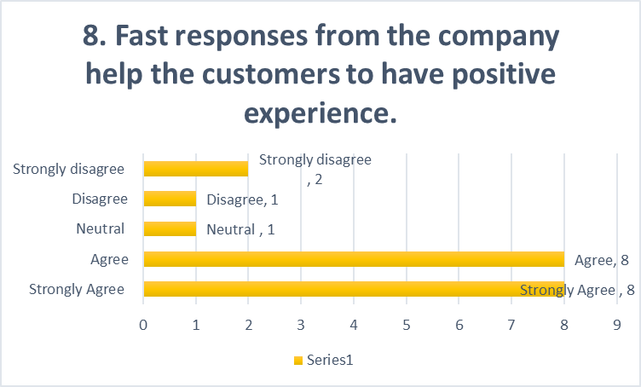
Figure 8 Fast responses from the company help the customers to have positive experience.
The figure represented that 16 of the respondents have agreed to the fact that fast responses from the company help the customers to have positive experience. 1 of them has been neutral and 3 of them have disagreed to the statement. The statement represents the customers demand fast responses from the organisation in social media.

9. Social media platform provides option for engagement and satisfaction of customers.
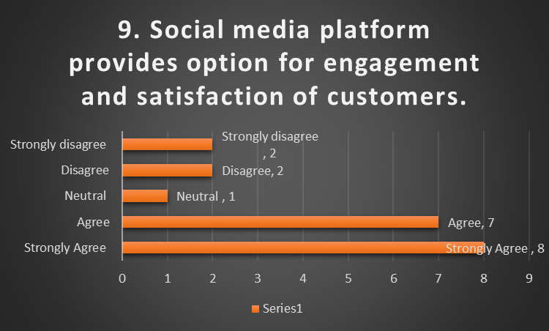
Figure 9 Social media platform provides option for engagement and satisfaction of customers.
The figure represented that 15 of the respondents have agreed to the fact that social media platform provides option for engagement and satisfaction of customers. 1 of them has been neutral and 4 of them have disagreed to the statement. The organisation can engage the customers while influencing them to make purchase decision.

10. Customers make more buying preferences while being engaged and interacted effectively.
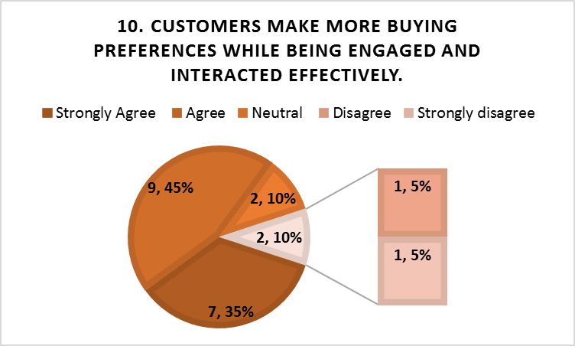
Figure 10 Customers make more buying preferences while being engaged and interacted effectively.
The figure represented that 16 of the respondents have agreed to the fact that customers make more buying preferences while being engaged and interacted effectively. 2 of them have been neutral and 2 of them have disagreed to the statement. The engagement, communication and promotion are more effectively done in social media platform.

4. Rationale for how the questionnaire data influenced the website design, including colour theory.
The data collected from the questionnaire represents the preference, decision, demands and requirement of the customers about the social media and websites. These represent how the customers want to be connected and engaged in the company through the websites. Colour theory represents the body of practical guidance of the combination of the colours and visual effects of a specific colour combination (Zhu et al., 2017). The colour theory represents how one can react to the combination of the colour in the certain situation. Based on questionnaire, the findings represent that proper content and engagement of the customer can have positive reactions of the customers.

5. Discussion around the importance of SEO and how the primary research informs the SEO strategy.
Search Engine Optimization (SEO) is a digital marketing tool which is made up of different factors and elements (Yin et al., 2014). SEO helps the company to make website more visible with more traffic and more opportunities. In any business with digital touch, SEO is valuable tool for brand awareness, positioning the brand and building relationships (Fisenko et al., 2022). In case of new business start-up, SEO can increase ranking and visibility, web traffic, and better visitor experience.
The primary research helps the organisation to develop SEO strategy with large research samples. In the meantime, market research is critical in SEO as the company can make content changes to reflect the customer preferences which are discovered through the primary research (Pramesty and Ariesta, 2021). In case of this new business start-up, the customers want to be connected with proper information of the products. This represents one effective strategy of SEO.

Conclusion
Proper research methods and content in social media can help any organisation to promote and influence the decision-making of the customers. This report has focused on the development of SEO strategy and website design based on findings of the paper.

Reference
Ansong, E. and Boateng, R., 2019. Surviving in the digital era – business models of digital enterprises in a developing economy. Digital Policy, Regulation and Governance, 21(2), pp.164-178.
Boparai, J., Singh, S. and Kathuria, P., 2019. How to Design and Validate A Questionnaire: A Guide. Current Clinical Pharmacology, 13(4), pp.210-215.
Fisenko, T., Baliun, O. and Grigorenko, A., 2022. SEO AS A METHOD OF WEBSITE PROMOTION. Věda a perspektivy, (2 (9).
Jawad, M., Naz, M. and Maroof, Z., 2020. Era of digital revolution: Digital entrepreneurship and digital transformation in emerging economies. BUSINESS STRATEGY &amp; DEVELOPMENT, 4(3), pp.220-228.
Killian, G. and McManus, K., 2015. A marketing communications approach for the digital era: Managerial guidelines for social media integration. Business Horizons, 58(5), pp.539-549.
Marino, M., Lucas, J., Latour, E. and Heintzman, J., 2021. Missing data in primary care research: importance, implications and approaches. Family Practice, 38(2), pp.199-202.
Pramesty, I. and Ariesta, A., 2021. Business Model Canvas for Usability Testing of E-Commerce Website Design Using SEO On-Page Technique. Inform: Jurnal Ilmiah Bidang Teknologi Informasi dan Komunikasi, 6(2), pp.93-102.
Taherdoost, H., 2016. Validity and Reliability of the Research Instrument; How to Test the Validation of a Questionnaire/Survey in a Research. SSRN Electronic Journal,.
Yin, X., Xu, J. and Zhao, X., 2014. For Search Engine Optimization Strategy Analysis of Website Design. Applied Mechanics and Materials, 519-520, pp.383-386.
Zhu, F., Zou, S. and Xu, H., 2017. Launching reverse-innovated product from emerging markets to MNC’s home market: A theoretical framework for MNC’s decisions. International Business Review, 26(1), pp.156-163.

