School of Hospitality & Tourism Management
BA International Hotel Management
BMIH5007
Financial Management for the Hotel Industry
LEVEL 5

FINANCIAL MANAGEMENT FOR THE HOTEL INDUSTRY ASSESSMENT 2

Lecturer: Tristan Hawkins, Kathryn Roberts
Student: 2242685 Olga Brinza
Executive Summary
The income statement analysis of the City Hotel has found that the company has faced financial distress. Their revenue was significantly low in 2023 which declined their profit margin and caused the high debt in the market. The key factors impacting the City Hotel's financial performance include inflation, economic uncertainty, changing market trends, labour shortages and many more. Amid all these issues, the hotel's very survival relies on its strategic readjustments to cope with changing industry scenarios. The City Hotel can improve its operational capacity to face market problems such as rivalry and inflation by increasing operating capacity, marketing, and technological development. Through the scale of costs, digital marketing, and government loans to invest in technology, the hotel can enhance its financial standing and sustainable competitiveness in the hospitality industry.
Contents

Introduction 4
Trends and Patterns in the Hotel's Financial Performance in the past three years 4
Key reasons behind the decline in profitability, taking into consideration real-world events and the current economy. 10
Turnaround strategy to recover the hotel’s financial health and restore its reputation, or the most viable financial outcome for the owner. 12
Risk Management Analysis 13
Risk register and management plan 13
Conclusion 16
Recommendations 16
Reference List 18

Introduction
The hospitality industry is vulnerable to the negative implications of various external developments taking place in the industry (Coles et al., 2021). In the following report, the case study of The City Hotel will be evaluated to identify the underlying trends and patterns in the hotel's financial performance over the years. The City Hotel is a state-of-the-art facility with multiple high-end facilities like an in-house restaurant, bar and central location in a buzzing urban location. It will highlight the key reasons behind such decline of the hotel, followed by a comprehensive turnaround strategy to help the hotel regain financial affluence and performance efficiency.

Trends and Patterns in the Hotel's Financial Performance in the past three years 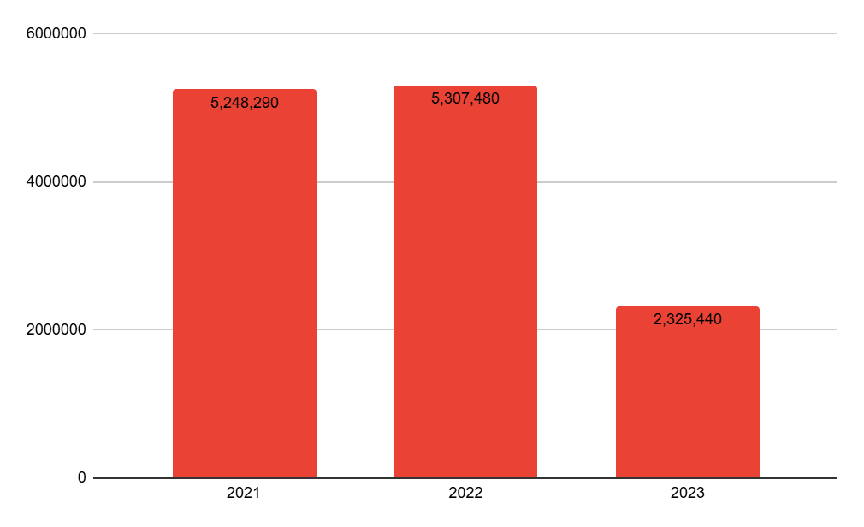
Figure 1: Revenue analysis of City Hotel
(Source: Excel-developed)
The revenue of a company describes the sales within a limited period of time (CFI, 2024). As per the above figure, it has been found that the City Hotel generated a revenue of £2,325,440 in 2023 which was significantly lower than the last two years. In 2021 and 2022 the revenue of the hotel was £5,248,290 and £5,307,480. Thus the hotel City Hotel found a sharp decline in revenues in 2023.
Expenses 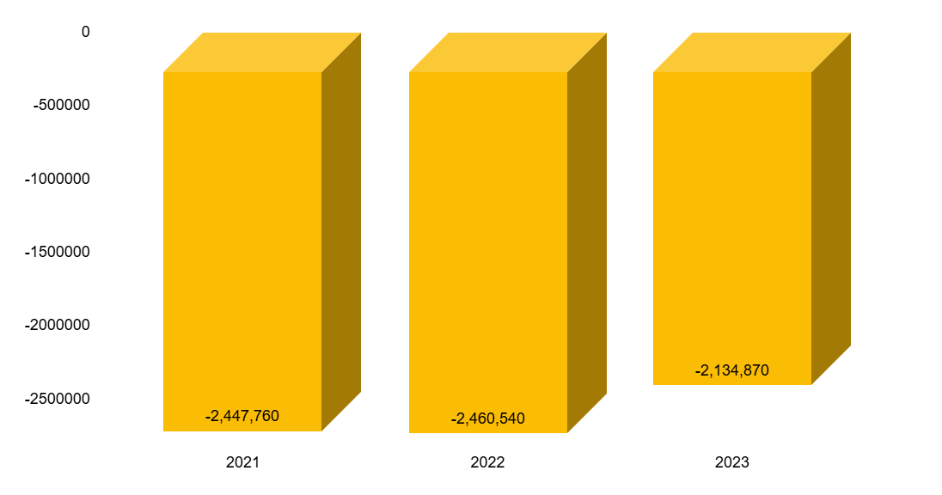

Figure 2: Expenses of City Hotel
(Source: Excel -developed)
Expenses play a crucial role in the income statement, reflecting the company's expenditures across various business activities (CFI, 2024b). According to the figure above, the city's expenditures decreased to -£2,134,870 in 2023, compared to -£2,460,540 in 2022. This decline suggests that the City's economic conditions have influenced a reduction in spending on business operations.

Profitability
- Net Profit Margin
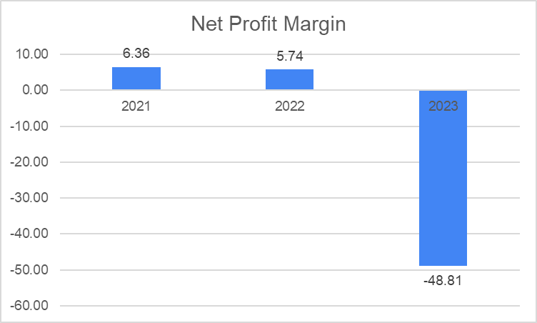
Figure 3: Net Profit Margin of City Hotel
(Source: Excel -developed)
The profitability ratio defines if a company has been earning more than their expenditure within the operational activities. In that case, the net profit ratio of the City Hotel declined to -48.81% in the financial year of 2023. In 2022 this ratio was calculated to be almost 6.36% which was way higher than in 2023. Thus this helped in understanding that City Hotel found that the profit in the business is lowered while expenditure is higher.

- Analysis of Operating Profit Margin

Figure 4: Operating profit margin of City Hotel
(Source: Excel -developed)
According to Mahdi and Khaddafi (2020), the operating profit margin serves as a key indicator of a company's profitability relative to its sales. An analysis of the data reveals that The City Hotel experienced a profit margin of 12.65% in 2021. This figure had a modest increase to 12.71% in 2022, suggesting some progressive performance in profitability during that period. But, in a worrying turn, the profit margin fell to -52.41% in 2023, representing that the hotel not only failed to make a profit but also experienced significant losses. This sudden drop highlights the challenges faced by the company in that fiscal year.

Liquidity
- Current ratio
Year | Current Ratio
2021 | 0.93
2022 | 0.93
2023 | 0.64
Figure 5: Current ratio of the hotel (Source: Excel -developed)
The current ratio defines the ability of a company to pay off its short-term obligation within one year of time period. Within the loss of the capital the City Hotel found that their current ratio declined to 0.64 which was 0.93 in the previous years [Refer to figure 5]. This signifies that a company is only able to pay 0.64 of its short-term obligations in 2023. Hence the City Hotel indeed suffered through the financial crisis during 2023.

- Quick ratio

Figure 6: Quick ratio analysis of City Hotel (Source: Excel-developed)
The ability of a company to pay off its current debts can be defined through the quick ratio analysis of the income statement of a company. In 2021 the quick ratio of City Hotel was 0.95 while in 2022 this ratio stood at 0.92 [Refer to Figure 6]. The analysis of the year 2023 found that the quick ratio declined to 0.62. Therefore, this has been indicating that the company faced issues paying their current debt in the market.

Solvency analysis
- Debt-to-Equity Ratio

Figure 7: Debt-equity ratio(Source: Self-developed)
The debt-equity ratio defines the liabilities and debt of a company against the total equity of stakeholders (Farah, Amin and Pramudianto, 2021). The above (figure 7) provides the analysis that in 2021 the liability and debt of the company against their stakeholder's equity was only 0.83 while in 2023 this reached 0.91. Thus, this has been revealed that the liability and debt of the company were higher than the total equality of stakeholders.

- Debt-to-Assets Ratio

Figure 8: Debt-to-asset ratio(Source: Excel-developed)
As per the above (figure 8) the debt-to-asset ratio in 2023 was 0.23 for the City Hotel, while in 2022 this was 0.19 and in 2021 there was no debt of the company. This has been indicating that company debt against their assets increased in 2023. In this case, this has caused a high risk for the company to seek investment while facing financial loss in a drastic manner.

Key reasons behind the decline in profitability, based on real-world events and the current economy.
The key reasons that might be contributing to the declining financial performance of the City Hotel may be as follows:
- Transforming market dynamics: The UK hospitality industry is witnessing significant transformations in key consumption patterns and consumer preferences with an increasing demand for sustainable and digitalised services (Auditel, 2019). A recent report showed that non-compliance with the prevailing sustainability demands in the industry is a high-risk factor for at least 24% of all UK hospitality establishments (Chemmanur, 2024). The same holds true for The City Hotel which, due to a lack of disposable revenue cannot invest effectively in sustainability initiatives.
- Intensifying competition: Following a remarkable rebound in 2023, the UK hospitality industry is witnessing significant competition, especially in meeting employee requirements, owing to many other sectors seeking a similar skill set, such as retail and healthcare (Allianz, 2024). Competition is also increasing in the industrial sub-sectors such as restaurants, fast food chains, and many more. During such intensifying competition, the City Hotel is struggling to meet its staff requirements, which is evident in declining employee costs from £1,724,760 in 2021 to £1,233,160 in 2023 (refer to the case study).
- Inflation and economic uncertainty: In the UK, prevailing inflationary pressures in 2023 have given rise to the cost of doing business, as operational costs are fast reaching unsustainable rates. During this period, more than 1/3rd of the hospitality establishments in the country faced the threat of business crash, while 96% of these establishments have witnessed a hike in energy expenses (UK Hospitality, 2023). This is one of the key issues impacting the City Hotel as it has simultaneously increased operational costs while reducing consumption demand.
- Labour shortage: According to a recent survey, more than 53% of UK hospitality institutions are found to be suffering from labour shortages, leading to high employee turnover, staff burnout, and a generally low morale predominant in the industry (Axonify, 2024). A key solution for this issue is increased investment in employee training, development, and overall well-being. This issue is likely to impact the operational profitability of the City Hotel as well.
- Technological investment requirement: Technological progress is one of the defining features of the contemporary hospitality industry worldwide. In the UK, technological progress has amended the consumption patterns dominant in the industry, with future guests seeking a more automated and digitalised hospitality experience (Jiwnani, 2024). Although such improvements can help organisations overcome various service experience issues such as staff shortage and high wait times, they require considerable capital investment in technological transformation and modification. This is a major issue for City Hotel as it lacks the necessary resources to introduce required technological innovations.
Can the hotel be saved?

The existing issues impacting the City Hotel are undoubtedly serious, however, the hotel can be saved with the help of strategic realignment. For instance, the hotel may seek to implement energy-efficient systems to reduce its energy costs and also meet the existing market demand for sustainability. Focus on building and maintaining strong online reviews, particularly on platforms like TripAdvisor, Google, and Booking.com, which influence customer decisions. Introducing loyalty programs, personalized experiences, and customer engagement strategies to build a loyal customer base. To tackle staffing challenges, the hotel could focus on enhancing employee skills through training and development programs. Partnering with tech startups that offer creative and budget-friendly solutions tailored for the hospitality sector could help the hotel stay modern and competitive without stretching the finances. Creating a clear path for career advancement within the hotel can help reduce turnover. Staff are more likely to stay if they see growth opportunities.

Turnaround strategy to recover the hotel’s financial health and restore its reputation, or the most viable financial outcome for the owner.

Risk Management Analysis
 | Severity →
Likelihood  ↑ | Measures | 1 Insignificant | 2  Minor | 3  Moderate | 4  Major | 5  Catastrophic
Likelihood  ↑ | 1  Rare | 1 | 2 | 3 | 4 | 5
Likelihood  ↑ | 2  Unlikely | 2 | 4 | 6 | 8 | 10
Likelihood  ↑ | 3  Possible | 3 | 6 Moderate | 9 Moderate | 12  Major | 15
Likelihood  ↑ | 4  Likely | 4 | 8 | 12 | 16 | 20  Catastrophic
Likelihood  ↑ | 5  Certain | 5 | 10 | 15 | 20 | 25
Table 1: Risk Matrix(Source: Self-created)
Risk register and management plan
Risk description | Likelihood | Severity | Impact | Mitigation
Transforming market dynamics | 3 | 3 | 9 | Increase operational efficiency along with keeping a close eye on market developments and modify business plans as needed to become more adaptable and responsive (BDC, 2024).
Intensifying competition | 4 | 5 | 20 | Improve marketing and branding to represent the contemporary, welcoming ambience among customers. The hotel may benefit from focusing on distinctive features to set itself apart from rivals and lessen competition (Sudirjo, 2023).
Inflation and economic uncertainty | 5 | 4 | 20 | To strengthen its financial position, the business may find it advantageous to investigate short-term funding possibilities.
Labour shortage | 2 | 3 | 6 | Hospitality companies may lessen the effects of a labour shortage by putting measures like competitive pay, encouraging diversity in the workforce, adopting technology, and giving flexible work schedules into practice (Eposnow, 2024).
Policies and regulations | 3 | 3 | 9 | Keeping abreast of changes to regulations and The Hotel's corporate environment may efficiently minimise waste and mitigate regulatory compliance by promoting sustainable practices (Barakagira and Paapa, 2024).
Technological investment requirement | 4 | 3 | 12 | Create a staged technology adoption strategy to guarantee improvements happen gradually without taxing resources. The hotel may also invest in technological upgrades for their business by taking out government loans.
Table 2: Risk register and management plan (Source: Self-created)

Conclusion
In conclusion, it can be said that the new challenges of the market dynamics for the City Hotel, the competition, inflation rates as well as the shortage of workers affect the financial performance of City Hotel. But, by following a detailed tactical approach with strategic operational improvements, strategic market targeting, and strategic technological advancement, the hotel can successfully restore its financial status and improve its strategic opportunities. Hedging activities like using government loans to prepare technology improvements and enhance staff skill base will not only improve the present concerns but will also lead to long-term success amid the continuously changing prospects of the hospitality industry.

Recommendations
Recommendation 1: Improve operational efficiency to transform the market dynamics of the business
The City Hotel can operate more efficiently which will be shown by analysing costs and finding potential for improvement. As per the opinion of Landini et al. (2020), In economics, equilibrium theory describes a situation in which the competing agents' opposing goals are balanced, usually demonstrated by the equality of supply and demand, leading to steady levels of output and consumption without interruptions in business dealings.
Applying the concept of equilibrium in the organisation preserves financial stability and enhances organisational performance due to the enhancement of the organisation's operational procedures. Demanding improved terms from suppliers and improving methods in the field of business services can reduce costs. The City Hotel, for instance, must be able to establish patterns of staffing and, through cross-utilization of the workers, enhance flexibility, and satisfaction among the workers. Such a strategy can lower the turnover level and contribute to raising the net profit margin in a hotel by creating a more flexible and enthusiastic staff.
Recommendation 2: Improve marketing and branding to cope with market competition
Businesses may use digital marketing as a platform for one-on-one or individual marketing, which helps the brand stand out from the competition by creating advertising or content that shows consumers that the brand is paying attention to their specific requirements (Digital Catalyst, 2023). For example, The Ritz-Carlton shares stunning pictures and videos of the abundant experiences visitors can anticipate on social media to build a marketing story. Additionally, they interact with their fans by sharing guest images and answering comments (Giraffe Social, 2024).
Here, the City Hotel can source extra value for the consumer by implementing effective social media advertisement that provides an avenue through which consumers can view current images of the hotel as a modern structure that is welcoming to guests. So, in order to become good with few competitors the hotel must focus on its competitive advantages.
Recommendation 3: Borrowing loans from the government and implementing policies for investment in technology and its upgradation
Businesses in the retail, hotel, and leisure industries can get financial assistance for their operating expenses from the Retail, hotel, and Leisure Grant Fund (RHLGF) (GOV UK, 2023). Therefore, borrowing money from the government will help The City Hotel to invest in technology and help in the business path. Moreover, adjustment of operations in terms of cash flow analysis by working on blockchain technology will also help solve the problem of the company in terms of managing operating costs and operational liabilities. Furthermore, it would make strategic sense for the company to review short-term funding to complement the company's financial position. As stated before, there is value in introducing sustainable practices that will likely result in long-term cost savings and may contain the potential of tax credits. With that City Hotel ensures that it reduces the levels of waste that it produces and at the same time is in a position to meet the required legal standards.

Reference List
Allianz, (2024). Travel and Hospitality – Sector report – United Kingdom. Available at: https://www.allianz-trade.com/en_GB/insights/economic-research/travel-and-hospitality-sector-report.html (Accessed: 30 October 2024).
Auditel, (2019). Market Dynamics The Hospitality Sector. Available at: https://auditel.co.uk/wp-content/uploads/Market-Dynamics-Hospitality-WebSpreads.pdf (Accessed: 30 October 2024).
Axonify, (2024). U.K. Hospitality Industry Faces Significant Challenges Amid Labour Shortages and Employee Burnout, Reveals New Survey. Available at: https://axonify.com/en-uk/news/hospitality-survey-2024/ (Accessed: 25 October 2024).
Barakagira, A. and Paapa, C., (2024). ‘Green practices implementation for environmental sustainability by five-star hotels in Kampala, Uganda.’ Environment, Development and Sustainability, 26(4), pp.9421-9437.
BDC, (2024). What is operational efficiency?. Available at: https://www.bdc.ca/en/articles-tools/operations/operational-efficiency/3-critical-factors-operational-efficiency (Accessed: 30 October 2024)
CFI, (2024a). Revenue. Available at: https://corporatefinanceinstitute.com/resources/accounting/revenue/ (Accessed: 25 October 2024) .
CFI, (2024b). Expenses. Available at: https://corporatefinanceinstitute.com/resources/accounting/expenses/ (Accessed: 26 October 2024).
Chemmanur, A., (2024). Sustainability in the hospitality industry. Available at: https://www.deloitte.com/uk/en/Industries/consumer/blogs/sustainability-in-the-hospitality-industry.html (Accessed: 30 October 2024).
Coles, T., Ritchie, B.W. and Wang, J., (2021). ‘Building business resilience to external shocks: Conceptualising the role of social networks to small tourism & hospitality businesses’. Journal of Hospitality and Tourism Management, 48, pp.210-219.
Digital Catalyst, (2023). What Are The Main Advantages And Disadvantages of Digital Marketing?. Available at: https://digitalcatalyst.in/blog/what-are-the-main-advantages-and-disadvantages-of-digital-marketing/ (Accessed: 02 November 2024).
Eposnow, (2024). Labor Shortage in Hospitality Industry: Addressing Challenges. Available at: https://www.eposnow.com/au/resources/labor-shortage-in-hospitality-industry/ (Accessed: 25 October 2024).
Farah, I., Amin, C. and Pramudianto, P., (2021). ‘The Effect of Debt To Asset Ratio, Long Term Debt To Equity Ratio and Time Interest Earned Ratio on Profitability’. Bina Bangsa International Journal of Business and Management, 1(1), pp.68-78.
Forbes, (2024). Navigating The Balance: Growth Vs. Profitability In Business. Available at: https://www.forbes.com/councils/forbesfinancecouncil/2024/03/21/navigating-the-balance-growth-vs-profitability-in-business/ (Accessed: 24 October 2024).
Giraffe Social, (2024). Social Media Strategies for Hotels: Enhancing Online Visibility & Guest Experience. Available at: https://www.giraffesocialmedia.co.uk/social-media-strategies-for-hotels/# (Accessed: 30 October 2024).
GOV UK, (2024). COVID-19 business grant funding schemes: guidance for local authorities. Available at: https://www.gov.uk/government/publications/local-restrictions-support-grants-lrsg-and-additional-restrictions-grant-arg-guidance-for-local-authorities# (Accessed: 02 November 2024).
Jiwnani, L., (2024). The hospitality guest of the future. Available at: https://www.deloitte.com/uk/en/Industries/consumer/blogs/the-hospitality-guest-of-the-future.html (Accessed: 30 October 2024).
Landini, S., Gallegati, M. and Barkley Rosser Jr, J., (2020). ‘Consistency and incompleteness in general equilibrium theory.’ Journal of Evolutionary Economics, 30(1), pp.205-230.
Lee, S., Song, H. J., Yoon, H., Kim, C.-S., & Ham, S., 2024. Resilience of the hospitality industry during crises: A comparison between the 2008 financial crisis and COVID-19. International Journal of Hospitality Management, 116, 103622. Available at: https://doi.org/10.1016/j.ijhm.2023.103622 (Accessed: 02 November 2024).
Mahdi, M. and Khaddafi, M., (2020). ‘The influence of gross profit margin, operating profit margin and net profit margin on the stock price of consumer good industry in the Indonesia stock exchange on 2012-2014’. International Journal of Business, Economics, and Social Development, 1(3), pp.153-163.
Martin, A. (2019). The Practical Guide to Understanding and Raising Hotel Profitability (1st ed.). Routledge. https://doi.org/10.4324/9780429266416 (Accessed 12 November 2024).
Sudirjo, F., (2023). ‘Marketing Strategy in Improving Product Competitiveness in the Global Market.’ Journal of Contemporary Administration and Management (ADMAN), 1(2), pp.63-69.
Toubes, D.R. (2021) Risk, crisis, and disaster management in small and medium-sized tourism enterprises. Edited by D.R. Toubes and N. Araujo-Vila. Hershey, PA: IGI Global. Available at: https://doi.org/10.4018/978-1-7998-6996-2.(Accessed 12 November 2024).
UK Hospitality, (2023). Third of hospitality businesses at risk of going bust due to soaring costs. Available at: https://www.ukhospitality.org.uk/third-of-hospitality-businesses-at-risk-of-going-bust-due-to-soaring-costs/ (Accessed: 25 October 2024).

