Module Assignment Submission
Cover Page

Student Name: | Nadean Kennedy
Student Number: | 1815021
Module No: | BMSK 6006
Module Title: | Developing Emotional Intelligence skills for the workplace

Date submitted: | 19/03/2033
Time submitted: | 23:59
Statement of Confirmation of Authenticity
By the act of making this submission, the student declares that this is the work of the student named above. Where materials have been used from other sources it has been properly acknowledged. If this statement is untrue, the student acknowledges that an assessment offence has been committed. Proven incidents of plagiarism, collusion or cheating can result in a learner being withdrawn from a
qualification.
Attention is drawn to the Plagiarism, Collusion and Cheating Policy and Unfair Practice policies of the University and ILM.
Permission for ILM to use this script
ILM uses learners’ submissions – on an anonymous basis – for assessment standardisation. By submitting, both the centre and the learner agree that ILM may use this script on condition that identifying information is removed. However, if you are unwilling to allow ILM to use this script, please refuse by ticking the box: □

Contents
Introduction 3
Emotional intelligence and its relevance to workforce development and business performance. 3
.1 What is emotional intelligence? 3
.1.1 Daniel Goleman 4
.1.2 Mayo and Salovey’s four branches of emotional intelligence 5
.1.3 Transactional Analysis 6
.1.4 The Learning Cycle – 5e Model 7
.2 The effect of emotions on my own workplace performance using theories of Emotional Intelligence and Mindfulness within Admiral Insurance 9
.2.1 Mindfulness 10
.2.2 Admiral Insurance 10
Conclusion 12
References 13
Appendix A 15
Appendix B 16
Appendix C 17
Appendix D 18
Appendix E 19
Appendix F 20
Appendix G 21
Appendix H 22

Introduction

This report will research emotions and emotional intelligence but looking at different theories and critically evaluating them. This report will look at the relevance of emotional intelligence in the workplace and it s influence on workforce development and business performance. This report will also look at what mindfulness is and its affect within an organisation, also looking at how emotional intelligence affects workplace performance in an individual within a specific organisation. A conclusion will then be drawn up of the report’s findings.

Emotional intelligence and its relevance to workforce development and business performance.

What is emotional intelligence?

As this report is regarding emotion intelligence. A good place to start is by looking at what emotions are. Emotions are closely link to a person’s reaction in a situation. Emotions at times can be a response to any kind event that has taken place within a person’s life and can either have a negative or positive affect on how that person responds or reacts to such event. Salovey and Myer, Daniel Goleman, Steven Covey to name a few, are all leading experts in the field of emotional intelligence. Each have many books explaining their theories on emotional intelligence, how to measure it, and the benefits it has on an individual and how they respond when events occur. Emotional intelligence can be applied to work or home life.
The book Emotional intelligence: key readings of the Mayor and Salovey model, Salovey, P., Brackett, M.A., &Mayer, J.D(2004). Emotions are defined as “Organised responses, Crossing the boundaries of many psychological subsystems, including the physiological, cognitive, motivational, and experimental systems”.
The book mentions that emotions are reactions from the brain and are said to be made up of commonly three and sometimes four (Conscientiousness) main areas, which are:
: Motivation
: Emotion
: Cognition
The more basic motivation for a person would be things such as hunger, thirst, the need for social contact, and sexual desire. Motivation is responsible for making a person carry out tasks to satisfy that need. In a simple form getting a glass of water aiming to quench the person’s thirst or arranging to meet up with friends and family to meet social needs.
Emotions are a signal and a response to a change for the person and the environment that they are in. There are numerous different emotions that a person may experience. For example, a person may experience anger in the event of a threat or an injustice, or when fear arises in response to danger. Emotions can happen immediately or over time and can be due to changes in the persons environment or their perception of themselves. Emotions can differ in different individuals, for example fear can trigger the fight or flight reaction in a person. On the higher end of the emotional scale would include the nicer emotions such as love, joy, humour, playfulness. And on the lower end of the emotional scale, and more likely emotions which would lead to depression in a person would be misery, emptiness, despair, dread.
Refer to Appendix A which includes a periodic table of emotions within humans.
Cognition is the treat that allows the person to learn from an environment and solve a problem amicably, satisfying motives and keeping emotions in a positive state. Cognition would include things such as learning, memory and problem solving. In theory all these aspects however make up emotional intelligence. A person’s emotions and cognition go hand in hand to helping a person become more emotionally intelligent.
The concept of emotional intelligence has been around for a while now as something that is used in jobs, at schools, and in home life on a daily basis but everything starts from somewhere. Referring to a journal article regarding emotional intelligence
Dhani, P., & Sharma, T. (2016); it gives a breakdown of the history of theories within the field. Refer to Appendix B
Emotional intelligence was first theorised back in 1930 by Edward Thorndike but he described it as social intelligence rather than emotional intelligence. This was described as the ability for one to get along with others due to being able to understand the internal state, motives and behaviours of themselves and in others. There have been a number of different theories since then and this report will start by looking at one of the most popular Daniel Goleman.

Daniel Goleman

Daniel Goleman is the most commonly referred to theorist when it comes to emotional intelligence and still gives lectures to companies, universities and other professionals. Although originating from America, Goleman is known internationally and has had a lot of success with a number of books he has released regarding the topic. One of his books out emotional intelligence was the on New York time best sellers list for one and a half years in 1995. This book had 5,000,000 copies printed worldwide in 40 languages and has been named best seller in many countries.
Goleman, D. (2001) Describes how he recognised the rules for the working environment were changing. Employees were no longer being judged by qualification on experience alone, but by how well an individual handles themselves and each other and applies to any and all industries of business. Goleman believes that emotional intelligence is not so much to do with the individual academic abilities but focuses more on the personal qualities such as initiative, empathy, adaptability, and persuasiveness.
Goleman, D. (2012) Speaks on emotional intelligence having four main components but later on introduces a fifth. Goleman explains that, the area in the brain that is used to drive social intelligence and supports emotional intelligence, is the last to mature is shaped by experiences. He believes that teaching children from a young age regularly and systematically the skills of self-awareness, self-management, empathy and socials kills is something that should be encouraged. Since making this YouTube theses skills are used widely in schools around the world. Speaking of an analysis of data at the time that was comprised of lots of data from different schools and children that had been introduced to a program regarding emotional intelligence, to those that were not, Goleman says there was a 10% decrease in such things as antisocial behaviour and class disruption. And an 11% increase in academic achievement. Goleman, D. (2012) suggest a number of different traits a person should have to become more emotionally intelligent. And can be especially affective in a workplace environment.
- Emotional Self Awareness
- Emotional Self Control
- Adaptability
- Achievement Orientation
- Positive Outlook
- Influence
- Coaching and Mentoring
- Empathy
- Conflict Management
- Teamwork
- Organisation Awareness
- Inspirational Leadership
Daniel Goleman says that there are five components to his theory on emotional intelligence. In an article that looks at het different theories of emotional intelligence, Craig, H. (2019) it breaks down the components down as follows:
- Self-Awareness – To become self-aware an individual would need the ability to recognise and understand their emotions, and understand that their actions, mood, and emotion will have an affect on the outcome of a situation. It is the ability to keep track of their emotions and being able to recognise different emotions and able to identify the correct emotion. Self-awareness would be recognising how we feel and what we do are connected.

- Self-management - Self management involves an individual being flexible and being able to express appropriate emotions for the situation or task. Also being able to cope with change and being able to manage conflict. Self-reflection also refers to diffusing difficult or tense situations and being aware that an individual’s actions do affect others and to be able to take e ownership for those actions.

- Social skills – Different social skills include things such as active listening, verbal and nonverbal communication skills, leadership skills, and Developing rapport. An individual would have to be empathetic to situations and be able to understand how others are felling, enabling an individual to be able to respond appropriately to other people based on their emotions.

- Empathy – This would need an individual to understand power dynamics and the influence it has on feelings and behaviour. If an individual perceives a situation correctly it enables to offer another empathy if needed

- Motivation – Motivation in relation to Emotional intelligence is referred to as Intrinsic motivation and is a drive to meet personal needs, and goals, as opposed to instead being motivated by external reward such as money, fame and recognition.

Refer to Appendix C
.1.2 Mayo and Salovey’s four branches of emotional intelligence
As mentioned a little earlier in this report Mayor and Salovey, had already started looking at emotional intelligence before Daniel Goleman. Their theory is based on four components to help an individual become more emotionally intelligent. Their definition of emotional intelligence is “The ability to monitor one’s own and other’s feelings, to discriminate among them, and to use this information to guide one’s thinking and action’s”. They then went on to break this definition down into four suggested abilities that are distinct but relatable.
Perceiving Emotions – To be able to perceive emotions, would be the ability to pick up on and understand emotions either from an individuals facial expressions, pictures, the tone of voice, and even cultural influences. It is also the ability to recognise your own emotions. Identifying the emotion of oneself or others is the first step to being emotionally intelligent.
Using Emotions – would be the second branch of emotional intelligence, and is the ability to use our emotions but in a positive way. Being able to emotionally intelligent means you can use your emotions and moods to best fit the task at hand. For example having an important task to complete in a short amount would be better completed being in a good mood as opposed to being in a bad mood. If the individual is in a bad mood, recognising this and using methods to help put the individual back into a good mood and them completing said task would be a lot more productive.
Understanding Emotions – Understanding emotions is the third branch and is the ability to understand emotional language and understand the complexed relationship among emotions. If an individual understands their emotions, paying attention to redirecting their mood, motivation, flexible planning can help when completing tasks.
Managing Emotions – Managing emotions is tied in with understanding them. Once an individual understands why they are reacting the way they do, enables the individual to find tools to help manage their emotions, especially the more negative emotions one may encounter.
Refer to Appendix D
Adnan, A., & Anila, K. (2016). Completed a study looking at the workplace affect between emotional intelligence and job satisfaction among customer service representatives. The study was conducted on mobile phone reps and bank staff. A number of different theorist were used for this study “The Emotional Intelligence Scale (Wong & Law, 2002), Positive and Negative Affect Schedule (Watson, Clark, & Tellegen, 1988), and job satisfaction subscale of the Michigan Organizational Assessment Questionnaire (Camman, Fichman, Henkins, & Klesh, 1979) has been used for measuring emotional intelligence, negative and positive emotions at work, and job satisfaction, respectively”. The study results showed that emotional intelligence aided the abilities of the customer service reps in regulating their emotions so as to be in a good mood an meet eh needs of their customers. It also enabled them to become aware of their clients feelings and encourage their feelings. This also help increase the attitude of the workforce, becoming more positive. The study showed that positive affectivity and emotional intelligence had a positive affect on job satisfaction. People that enjoy what they do, tend to do it better and this study confirmed this. And mentions that the employees that experienced positive affect from their job, seem to enjoy their job, see value in the job that they are doing, and feel satisfaction at their job. If the employees are happy at their job, they are more likely to give better service when dealing with individuals directly and indirectly involved in the business
Looking at back at the Salovey and Mayer and the Daniel Goleman theories, the main component to both are emotions and being able to regulate them. Giving the ability to deal with a situation appropriately. Being emotionally intelligent within the workplace can be a great tool to help improve work performance and relationships within the organisation. Looking at a workplace environment effective communication for example is one of the main components of running a successful organisation. On a daily basis a company has to communicate. This can be peer to peer, management, projects within the company. And even expand to outside the company such as suppliers, investors, energy suppliers and so on. There are a lot of ways a company has to communicate to be successful. Being emotionally intelligent can help the run of communication run smoother and more effective. There are theories that are aimed to help aid communication such as the theory of transactional analysis.

.1.3 Transactional Analysis

Eric Burn is most famously known for his theory of transactional analysis – Ego States. There are three main states: Parent, Child, and Adult. Burn believed that a lot can be learned about a person by taking the time to study the way in which decisions and communication is basic on an individual’s feelings. An individual’s experiences are already subconsciously stored in the brain from birth and is used as kind of an imprint on how an individual behaves later in life. The ego state an individual adapts whilst dealing with a situation can have a major effect on the outcome but by being emotionally intelligent an induvial is able to identify the ego state of the other person and adapt. This should allow the communication to run smoother and tasks being complete successfully.

Parent – This ego state has two parts, the critical, disciplining, restricting parent. And the helpful, caring, loving parent. A controlling parent would be the one that would discipline or scolded on arriving late home, were as the caring parent would be the type just grateful one was home safe and well. The parent ego is imprinted with a person’s brain and works automatically. It comes from experiences over our lifetime from parents and teachers, especially in one’s early life. A critical parent would use phrases like ‘Right and Wrong’, ‘Good and Bad’, ‘You must Never’. And the caring parent would use phrases such as ‘Oh Dear’, ‘What a Shame’, ‘Don’t Be Afraid’.

Adult – The adult ego state is based on the current, and processes what we are thinking and feeling rationally. This will be based on facts. Actions are sensible and well thought out, unlike the automatic response of the parent and child ego state. The Adult ego state collects information, evaluates it, works out probabilities, tackles and solves problems in a calm and collected manner.

Child – This ego state also has two parts. The nurturing child, that is implosive, instinctive, primitive, undisciplined, and demanding. Then we have the adapted child that obedient, polite, gives rise to guilt, rebellion, and compromise. They can sometimes also be manipulative. These behaviours are adapted as a child and are based on one’s early days experiences and emotions.
India, J. Psychiatry (1996) explains that that there are personal, and interpersonal transactions. Personal is with us internally and interpersonal is communication with others. Communicating in an adult-to-adult state is the best place to be. Adult to Adult is complimentary to each other. So, for example a manager giving a staff member feedback regarding their work, including some criticism, and the recipient replying, ‘Thank you for your feedback, I will take what you said on bored’ and work on how to improve criticisms’. That is a positive interaction, feedback communicated.
Communication has a direct correlation to workplace development, because if an individual is unable to communicate, whether it is manager to employee for example or vice versa, it is unlikely that an induvial that wants to progress and develop their skills will get the opportunity. This can lead to resentment, job diss satisfaction, high turnover and individuals not feeling valued. It is vital for an organisation to have positive workplace relationships to aid performance, and this applies throughout the organisation. An organisations success is affective communication and decision making. Affective communication means everyone is working together to reach a common goal. There are many tools that have been created to help aid workforce development, but without affective methods of communication an organisation would struggle to implement these tools.

.1.4 The Learning Cycle – 5e Model

The 5e learning cycle consists of 5 areas and was developed by the Biological Sciences Curriculum Study and includes the following:
- Engage – Engagement is the beginning stage of the cycle and means being focused on the specific object, problem, situation or event. The Individual needs to be able to focus on the task or activity at hand. Being emotionally intelligent will aid in recognising if the receiver is not engaging and applying methods to help re engage the individual being developed\taught.
- Explore – Once the situation, event, task has been established at the engagement stage, the exploration stage is to then look for solutions and answers to the task at hand. This is where information is gathered and explored. Questions get asked. Without affective communication, the exploration stage could get chaotic and loose structure. It is important to discuss, and communicate findings, and be able to ask questions. Emotional intelligence would help in this stage to deal with different personalities within a group setting, recognising if a person is maybe introvert or struggling and in need of intervention is emotional intelligence.
- Explain – This would be for the teacher\manager to implement their knowledge and expertise of the subject and relay it to the recipient. Communication again is vital as to make sure the recipient has a good understanding of what the teacher/manager is trying to relay.
- Elaborate – There should now be a good understanding of the task, situation etc.
- Evaluate – This would be a follow up stage to maybe test the new knowledge gained. Being the last stage would give the recipient time to reflect on what has been learnt.
Within this cycle communication is imperative for it to work. Affective communication builds relationships, breaks down barriers, helps with engagement and moral, improves teamwork, which all impacts business performance. Being emotionally intelligent allows an individual to recognise the emotions in themselves and others, therefore aiding in the effectiveness of communication and ultimately allowing information to be transferred appropriately.
Duran, L.B & Duran, E. (2004) Use this learning cycle as an approach for inquiry-based science teaching. There are many different learning cycles that can be used but in this review, it mentions that the 5e learning model helped help encourage inquiry practises which is vital within their field of science. “Using a learning cycle approach in the classroom, helps to facilitate inquiry practises because learning cycles focus on constructive principles and emphasize the explanation and investigation, the use of evidence to back up conclusions, and experimental designs”. The conclusion of this report was that incorporating learning cycles to their teaching approaching within the classroom helped to aid the development of enquiry-based science lessons. The report mentions how flexible the 5e model is and how it helps assist curriculum developers and classroom teachers create lessons that illustrate constructive, reform based, best teaching practise. Although this report was based around a science school, it can also be implemented with any other type of organisation to aid workforce development.
All areas of this learning cycle need affective communication to be affective. Being emotionally intelligent allows for affective communication and both lay hand in hand to enable the opportunities for workplace development and encourage individuals to want to develop within the organisation.
Refer to appendix F.
Within Admiral Insurance, within the sales department, each staff member starts of based on a level one authorisation. This mean you are authorised to make a limited amount of decisions relating the insurance policy being set up. Once the individual has passed the probation stage they are offered the opportunity to increase their knowledge and also increase the authority levels they have whilst dealing with a customer. These levels of authority allow the individual to write off amount of money or sign through something that can usually only be done by a manager. The highest level for a salesperson would be level 6. It is not something that and individual has to do, but if completed, give the individual more authorities and encouraging a bigger sense of pride for the individual. It also give the individual the ability to offer better customer service due to less hold time having to refer to management for issues. The company also offer a multi skilled bonus. Again this is not mandatory but if an individual would like to become multi skilled within the department, they can train on other products such as home or van insurance as well as car insurance. This not only expands their knowledge, it allows them further opportunity to better the customer journey by only having to deal with the one person for all their needs. The customer having a positive experience also reflect on the employee, so having the tools to make the customer happy is impowering.
Admiral Insurance (2021) is a page dedicated to workplace development and learning. “At Admiral, we believe that career growth and development is an active, participative process that everybody has the right to enjoy at every stage of their career with us”. They include a number of different programs including:
- Learning and Development - an award-winning dedicated team providing classroom-based learning, webinars and valuable training to staff
- ILM – An accredited qualification from the institute of leadership and management delivered by Admiral Academy.
- Education Sponsorship – Fully or partly funded sponsorship to aid your professional development.
- Opportunities Abroad – to work with a qualified development coach to identify opportunities and support career development and sharing best practice.
- Development Coaching – Opportunities to work with a qualified development coach to identify opportunities, create goals and reflect upon achievements.
- Port of Calls – Spending time in other areas of the business to learn, build relationships and support career development.
- Career Opportunities – Rare and exciting opportunities to work in different areas of the business that are only available to current staff.
- Ilearn – An E learning platform with a wide range of courses and videos covering personal and work based topics.
- Buy a book scheme – Up to two books per month, paid for by Admiral to aid personal and professional development.

.2 The effect of emotions on my own workplace performance using theories of Emotional Intelligence and Mindfulness within Admiral Insurance

This section of the report will start by looking at the results of my own emotional intelligence self-assessment questionnaire. Refer to Appendix G
Results:
Emotional Competency Score.
- Emotional Awareness 34
- Managing Ones Emotions 32
- Self-Motivation 31
- Empathy 34
- Coaching Other’s Emotions 33
Emotional Competency | Definite Strength | Needs Some Development | Needs Substantial Development
Emotional Awareness | 31 or above | 26 - 30 | 25 or below
Managing One’s Emotions | 32 or above | 27 - 31 | 26 or below
Self-Motivation | 31 or above | 27 - 30 | 26 or below
Empathy | 31 or above | 26 - 30 | 25 or below
Coaching Others’ Emotions | 30 or above | 25 - 29 | 24 or below

This questionnaire links to the Daniel Goleman theory of Emotional Intelligence and includes the areas that Goleman suggest are important to become emotionally intelligent. Looking at my results I have seemed to have scored in the higher category for all sections. I believe this Is due to the fact that working at Admiral Insurance. Dealing with customers on a daily basis for the past 13 years at my job has unknowingly helped me gain an understanding of my emotions how it is imperative to be able to regulate them when dealing directly with customers. If a customer has had a bad experience before speaking with me, which could be home life, work, or anything else that may have the customer in a negative mind set, it is my job to be as empathetic, engaged, and aware of the customer, how they are feeling and the emotion that they are expressing at the time. Being emotionally intelligent is important to be able to recognise these emotions and deal with the customer accordingly with coursing any further distress and also resolving their issue.
Looking back to transactional analysis, being able to recognise what ego state the customer is in and adjusting accordingly will help the interaction run smoother. For example, I customer was transferred from another department due to a complaint that had resulted in the customers insurance being cancelled. It was a company error but unfortunately the customer had already been on the phone for 2 hours. By the time the customer had got to myself, she was crying and extremely upset. After reassuring the customer that I will be able to get the situation sorted and in a timely manner, by the ned of the call the customer also insured another vehicle and her home insurance. In this situation I had to start the call in a nurturing parent ego state but end up in and adult to adult situation. Without emotional intelligence, the complaint would have escalated.

.2.1 Mindfulness

Zinn, J.K. (2015) is an audio book called mindfulness for beginners. In this Zinn’s definition of mindfulness is “ paying attention, on purpose in the present moment, as if your life depended on it. Nonjudgmentally”.
He also has many other famous quotes regarding mindfulness that are used regularly to aid stress reduction.
“You can’t stop the waves, but you can learn to surf.”
“Mindfulness practice means that we commit fully in each moment to be present; inviting ourselves to interface with this moment in full awareness, with the intention to embody as best we can an orientation of calmness, mindfulness, and equanimity right here and right now.”
Stress is a major contributor to sickness attrition and turnover within any organisation but having measures in place to help combat this is not only a way to help aid emotional intelligence in oneself and others by being able to regulate emotions but can also improve physical and mental health. Mindfulness can be used to help deal with issues more productively and awareness of this kind can also help individuals recognise signs of stress or anxiety at an early stage. Mindfulness based therapy is recommended by the national institute of health and social care excellence (NICE) as a way to treat less severe depression. NICE also recommend employers make mindfulness available to all employees to support mental wellbeing at work.

.2.2 Admiral Insurance

Admiral insurance was named the best big company in the UK for wellbeing. It is a FTTSE100 company with over 7500 employees across south Wales but also trades internationally in places such as Spain, France Germany and Canada and parts of America. The company has been recognised for its approach to employees well being and also named 5th in the annual list of UK’S 25 best big companies to work for. The company has also been named in Insurances 10 best companies to work for and the 30 best companies to work for in Wales ranking 2nd and 7th respectively
Some of the things Admiral Insurance provide to its staff to help aid mindfulness within the workplace are:
- Annual Leave Holiday Allowance – 33 days annual leave for full time employee plus eight bank holidays.
- Complimentary and discounted alternative therapies – Including discounted or free therapy sessions including stress relief massages, reflexology, Reiki, and Yoga
- Dental Care – A Cigna dental plan is available to help towards the cost of dental check-ups and treatment.
- Career Break – After three years’ service an employee can take up to six months unpaid leave.
- E-care -This is a 24hours service offering information and support over the phone.
- Workplace support – This a team that’s sole job is to offer resources, equipment and support needed to allow staff to perform their role to the best of their ability.
- Free Gym Membership – Various hotels offer free gym access in all sites Admiral sites in Wales.
- Cycle Scheme – Give all staff members the opportunity to purchase a bike and spread the cost of commuting to work. This is a salary-based sacrifice which means that staff make savings on their tax and national insurance.
Refer to Appendix H
All the things that Admiral offer is very important in being ablet to complete my job successfully. As like many jobs working in a call centre environment can be stressful and also having to sometime deal with difficult customers, I know I have the support form Admiral to complete my role Looking back at my self-assessment of my emotional intelligence, self-motivation was my lowest score. As I work a lot from home now self-motivation is very important as I have less interaction physically with my peers, but with what Admiral has to offer around mindfulness is great for me to fall back on when I need motivation or feeling a little stressed, giving me the opportunity to recharge and start again and is accessible regardless of working at home or in the office.

Conclusion

This report has taken a look at emotional intelligence and what emotions are. This report has looked at two theories of emotional intelligence and have concluded that having the ability to manage and control ones emotions is a major factor in becoming emotionally intelligent. This report has shown how varied emotions are and how they play a major part in how we make decisions. This report has shown many layers to being emotionally intelligent and include skills such as communication, self-realisation, empathy, compassion to name a few, and there are many reports and analyses that have been carried out to confirm emotional intelligence is very effective. Not only in a workplace environment but any situation an individual is in. This report has shown that there are different techniques to help aid workplace development and the impact that workplace development had on business performance. Emotional intelligence has no age limit, and is an on going learning process but can be improved. It is also shown how emotional intelligence within an organisation can have a huge positive impact on performance, improve moral, communication, trust, and job satisfaction. This report has also shown how mindfulness techniques are a useful aid in helping improve not only emotional intelligence but has health benefits physically and mentally, from an organisational point of view, a happy works force will do their jobs better and enjoy what they do aiding retention, sickness, and the want to progress with workplace development. This report has showing that organisations such as Admiral insurance are implementing wellbeing and mindfulness at work as it has proven to be affective with the company winning a number of awards accredited to the happiness and wellbeing of the staff within the organisation.

References
Admiral Group PLC. (2021, May 21). Admiral tops UK list of best employers for wellbeing | Admiral Group plc. Admiralgroup.co.uk. https://admiralgroup.co.uk/media/news/admiral-tops-uk-list-best-employers-wellbeing
Admiral Insurance. (2021). Career Growth & Development. Admiral Jobs. https://www.admiraljobs.co.uk/career-growth-development
Admiral Insurance PLC. (2023). Health & Work life balance. Admiral Jobs. https://www.admiraljobs.co.uk/health-work-life-balance
Adnan, A., & Anila, K. (2016). Workplace Affect as Mediator Between Emotional Intelligence and Job Satisfaction Among Customer Service Representatives. In EBSCO Host (pp. Vol.26 (2), Page79–). Uwtsd. https://web-s-ebscohost-com.ezproxy.uwtsd.ac.uk/ehost/pdfviewer/pdfviewer?vid=0&sid=d4fd6f3a-80c0-4958-864e-67d4cbe774bf%40redis
Better, O. P. (2015). Emotional Intelligence by Daniel Goleman ► Animated Book Summary [YouTube Video]. In YouTube. https://www.youtube.com/watch?v=n6MRsGwyMuQ
BSCS. (2006, June 12). The BSCS 5E Instructional Model: Origins and Effectiveness. BSCS Science Learning; BSCS. https://bscs.org/reports/the-bscs-5e-instructional-model-origins-and-effectiveness/
Craig, H. (2019, January 30). The Theories of Emotional Intelligence Explained. PositivePsychology.com. https://positivepsychology.com/emotional-intelligence-theories/
Dhani, P., & Sharma, T. (2016). Emotional Intelligence; History, Models, and Measures. International Journal of Science Technology and Mnagement, 5(7). https://www.researchgate.net/profile/Priyam-Dhani/publication/305815636_EMOTIONAL_INTELLIGENCE_HISTORY_MODELS_AND_MEASURES/links/57a418bc08ae455e85354dbd/EMOTIONAL-INTELLIGENCE-HISTORY-MODELS-AND-MEASURES.pdf
Duran, L. B., & Duran, E. (2004). The 5E Instructional Model: A Learning Cycle Approach for Inquiry-Based Science Teaching. ERIC, 3(2), 49–58. https://files.eric.ed.gov/fulltext/EJ1058007.pdf
Ebsco host. (1992, February 1). The Science of Emotional Intelligence. Current Directions in Psychological Science : a Journal of the American Psychological Society, 14(6), 281–285. Uwtsd.ac.uk; Blackwell Publishers. https://web-s-ebscohost-com.ezproxy.uwtsd.ac.uk/ehost/pdfviewer/pdfviewer?vid=0&sid=8b98d76a-459c-4278-aa54-9b772a167bd1%40redis
Emerald Works ltd. (2002). MindTools | Home. Www.mindtools.com; Mind Tools. https://www.mindtools.com/az10obi/the-5-e-learning-cycle
Goleman, D. (2001). Working With Emotional Intelligence. Mcmillan Audio. https://www.audible.co.uk/webplayer?asin=B004EVP3DU&contentDeliveryType=Unknown&ref_=a_ownedbuybox_cloudplayer&cloudPlayerStartLoadTime=1616756098750&fetchNewPlayQueue=true&overrideLph=false#
Goleman, D. (2012). Daniel Goleman Introduces Emotional Intelligence [YouTube Video]. In Big Think. https://www.youtube.com/watch?v=Y7m9eNoB3NU
Indian J Psychiatry. (1996). Berne E. Principles of transactional analysis. In National Library of Medicine (pp. 154–159). https://www.ncbi.nlm.nih.gov/pmc/articles/PMC2970834/pdf/IJPsy-38-154.pdf
Mayer, J., D, Salovey, P., & Caruso, D., R. (2004). Personal Summery Report. MHS. https://humancapitaltalent.co.za/wp-content/uploads/2018/11/MSCEIT-Personal-Summary-Report.pdf
Media, K. S. (2021). About Daniel Goleman – Daniel Goleman. Daniel Goleman.info; linkedin. https://www.danielgoleman.info/biography/
NHS. (2018, November 20). Mindfulness. Nhs.uk. https://www.nhs.uk/mental-health/self-help/tips-and-support/mindfulness/
Salovey, P., Brackett, M. A., & Mayer, J. D. (2004). Emotional Intelligence: Key Readings on the Mayer and Salovey Model. In Google Books. National Professional Resources Inc./Dude Publishing. https://books.google.co.uk/books?hl=en&lr=&id=YVKmxr_D7yQC&oi=fnd&pg=SL19-PA81&dq=Mayer
Taylor, R. (2013). Chapter 02: Eric Berne’s transactional analysis - ProQuest. Www.proquest.com; UWTSD. https://www.proquest.com/docview/1809568490/C2749147C7294C17PQ/5?accountid=130472
Tiwari, H. (2017, October 8). 30 Best Jon Kabat Zinn Quotes On Mindfulness. BrilliantRead Media. https://www.brilliantread.com/30-best-jon-kabat-zinn-quotes-on-mindfulness/#:~:text=Here%20are%20the%20best%20Quotes%20by%20Jon%20Kabat
Zinn, J. K. (2015, June 6). Mindfulness for beginners. Www.amazon.co.uk; Sounds True. https://www.amazon.co.uk/arya/webplayer?asin=B004F4QWUY&ref=adbl_typ_cloudplayer_dt&useRelativeUrl=true&fetchNewPlayQueue=true&contentDeliveryType=SinglePartBook

Appendix A

Source: A_Periodic_Chart_of_Human_Emotions.jpg (2200×1700) (cenera.ca) Accessed March 2023

Appendix B

HISTORY OF EMOTIONAL INTELLIGENCE
1930s - Edward Thorndike described the concept of social intelligence as the ability to get along with other people by being able to understand the internal states, motives and behaviours of oneself and others.
1940s – David Wechsler developed the concept of non-cognitive intelligence stating that it is essential for success in life intelligence is not complete until we are not able to define its non-cognitive aspects.
1950s – Humanistic Psychologist Abraham Maslow suggested that people can build emotional strength.
1975 - Howard Gardner introduces the concept of multiple Intelligences in his book The Shattered Mind.
1983 - Howard Gardner in his book Frames of Mind introduced Interpersonal and Intrapersonal Intelligence and said it is as important as IQ.
1985 - Wayne Payne used the term emotional intelligence in his doctoral dissertation entitled,' A study of emotion: Developing emotional intelligence; self-integration; relating to fear, pain and desire. ‘(Theory, structure of reality, problem-solving, contraction/expansion, tuning in/coming out/letting go)".
1987 – In an article published in Mensa Magazine, Keith Beasley used the term "emotional quotient." It has been suggested that this is the first published use of the term, although Reuven Bar-On claims to have used the term in an unpublished version of his graduate thesis.
1990 - Psychologists Peter Salovey and John Mayer published their landmark article, ―Emotional Intelligence‖ in the journal Imagination, Cognition, and Personality.
1995 - The concept of EI got popularized after the publication on Daniel Goleman's book ―Emotional Intelligence: Why It can Matter More than IQ.

Source: EMOTIONAL-INTELLIGENCE-HISTORY-MODELS-AND-MEASURES.pdf (researchgate.net) Accessed March 2023

Appendix C

Daniel Goleman’s Five elements of emotional intelligence

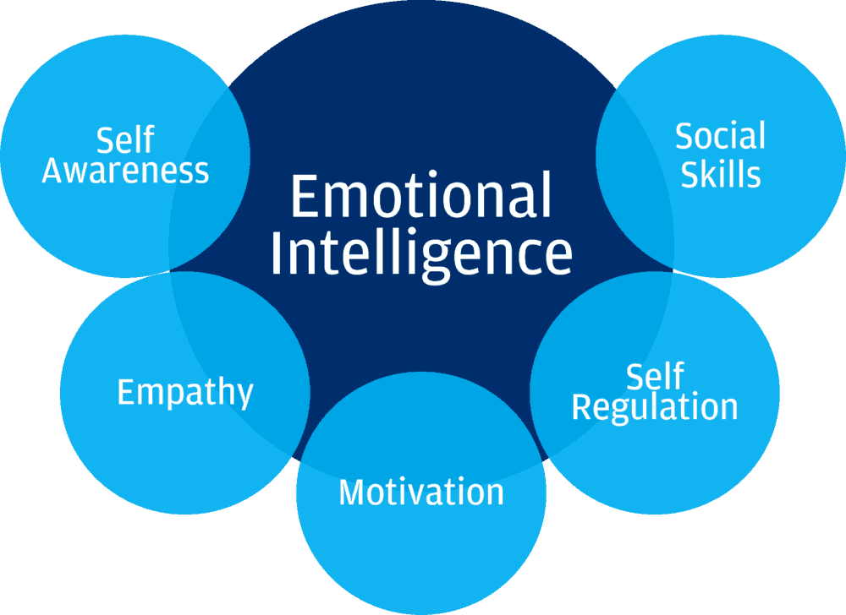

Sourced: 1*ZP3H8ZOtMqlVHzj5DFtLUw.png (1000×728) (medium.com) Accessed March 2023

Appendix D

Mayor and Salovey’s Four Branch Theory
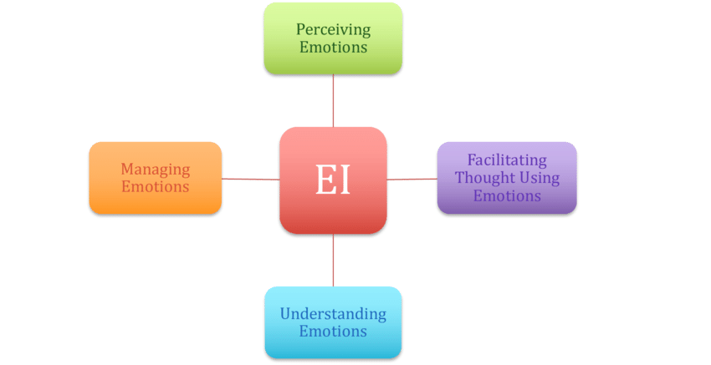

Sourced: The-Mayer-and-Salovey-1997-four-branch-model-of-emotional-intelligence-EI-abilities.png (850×437) (researchgate.net) Accessed March 2023

Appendix E
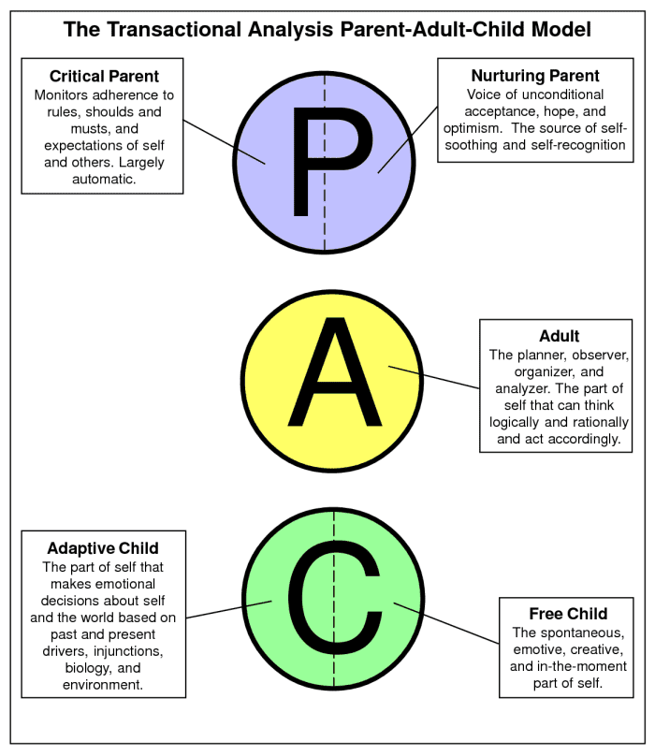
Transactional Analysis. Sourced summary-of-transactional-analysis.png (700×808) (saymedia-content.com) Accessed March 2023

Appendix F

The 5e Learning Cycle. Sourced 5E-Learning-Cycle.png (1024×768) (aasl.org) Accessed March 2023
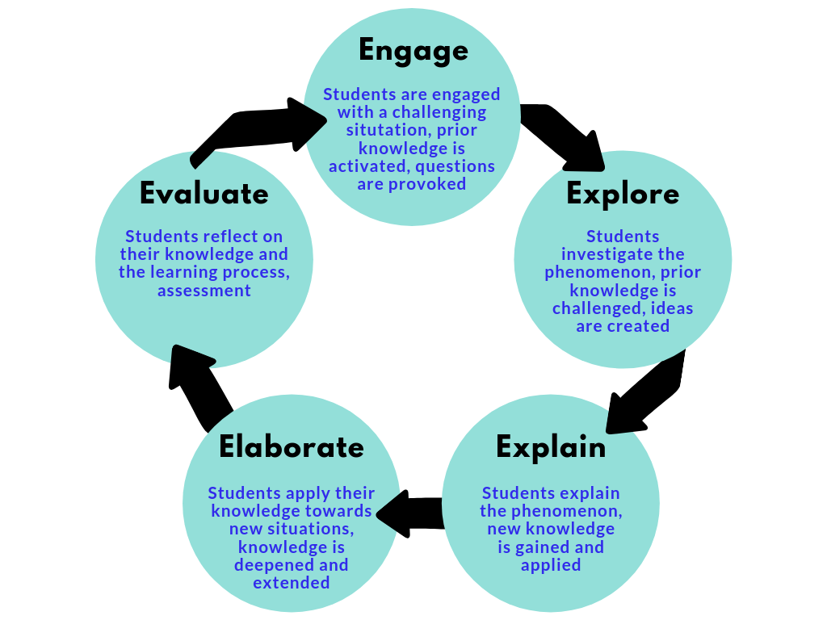

Appendix G

Emotional Intelligence, self-assessment questionnaire. Sourced:https://uowtsd-my.sharepoint.com/personal/1815021_student_uwtsd_ac_uk/Documents/Emotional%20Intelligence%20Self%20assessment%20questionaire%20(002).doc Accessed March 2023

Appendix H
- Annual Leave Holiday Allowance – 20 days annual leave for full time employee plus eight bank holidays.
- Complimentary and discounted alternative therapies – Including discounted or free therapy sessions including stress relief massages, reflexology, Reiki, and Yoga
- Dental Care – A Cigna dental plan is available to help towards the cost of dental check-ups and treatment.
- Career Break – After three years’ service an employee can take up to six months unpaid leave.
- E-care -This is a 24hours service offering information and support over the phone.
- Workplace support – This a team that’s sole job is to offer resources, equipment and support needed to allow staff to perform their role to the best of their ability.
- Free Gym Membership – Various hotels offer free gym access in all sites Admiral sites in Wales.
- Cycle Scheme – Give all staff members the opportunity to purchase a bike and spread the cost of commuting to work. This is a salary-based sacrifice which means that staff make savings on their tax and national insurance.
- Flu Inoculation – Discounted flu jab offers annually.
- Fresh Fruit – on a daily basis for all offices
- Flexible working- This is encouraged as part of the Admiral culture and is for all employees varying depending on their department.
- Independent Financial Advice – This is now via teams again due to covid, but a monthly visit form an independent financial advisor, on many matters including mortgages, savings and investments.
- Paid Leave for Health Appointments – Up to four hours of paid leave to travel to and attend screening appointments.
- Free Eye test – Free eye test and money towards glasses through Admiral partners Specsavers
- Simply Health – Cash plans to cover everyday health care costs, dental trips, opticians cost, physio sessions etc.
- Maternity, Paternity and Adoption Leave – This does include surrogacy.
- Shared Parental Leave – When both parents work at Admiral, they can share the 16 weeks full pay benefit, if only one parent is employed at Admiral paternal leave can still be shared but paid at statutory rate.
- Free sanitary products provide in all female and accessible toilets in all UK offices.

