

Academic Employability Skills

Name: Aissatu Abubacar Soares Bangura
Student ID: 2019279
Module Name: Academic Employability Skills
Module Code: BMSW4001
Lecturer Name: Anita Nan

Table of contents

- Introduction
- Time Management/ Organizing Study
- Paraphrasing
- Online Learning Experience
- Public speaking and giving presentations
- Conclusion
- References

Introduction

In my report, I will use Gibb’s reflective Cycle (1988). I will address and reflect on four topics that, I learned from class Time Management, Paraphrasing, Online Learning Experience, public speaking and giving presentations, and believed will be helpful for me during my academic life and professional life. As it was my first time as a university student and independent student, it was all new. Still, at the end of the Academic employability skills module, I learned how to use those tools future, how useful they will be for life.

Time Management/ Organising Study

Description I usually worked at weekends, and on weekdays I had class and had to take kids to school and coming to cooking and cleaning the house, so I just had time to review the class at night time. It is the time that kids are in bed and are all quiet so I can focus more and read about the points discussed in the class. There is my schedule from Monday to Thursday because on Friday I had to go to bed early. I am working on weekends.
Feelings: In the begging, I was scared, asking myself if I could do this course. It was all new for me, and I couldn't properly manage my time. It was a struggle to be a mother, worker, and study simultaneously, and I couldn't find the best way to set time for everything I had to do.
Evaluation: After a couple of trying to organize my study, finally, I could manage my time. I take time off from social media, I was spending a lot of time on my social media, but then I decide to prioritize my course, realize what's important, take three hours to study or just read and review the last class before the next one. The bad thing, I decided to prioritize my studies, and now I have less time to socialize with my friends and family, but this course is my dream, so I don't want to lose this opportunity.
Analysis: Looking back at my previous situation in this experience, I saw that I had some positives and negatives. I had the opportunity to hear the challenges from people outside of experience, that being in the same situation. I find peoples that told me the first year at university it always struggles. I assist colleagues from the same class in giving up even with no kids, and they couldn't handle it. It was challenging to manage them after those situations felt strength because I could set and manage my time and improved my study. I could organise my time for reflection, personal life, mothered and still have some time with friends I took a good experience from this experience and will apply future.
Conclusion(specific): I concluded that I could prioritize my study at the first instant in my situation and set my goal achievement period. That could save me time and avoid all the stress I had, and I should set up and apply the management techniques and manage my distractions. That is what I could do differently.
Action: My action future would be completely different. In the first moment, I will apply the ten steps to effective time management and avoid distractions.

As a student, only part of your week and year will be formally timetabled. You are responsible for organising most of your study time for yourself. This can be challenging. You will be:
Experience many demands on your time, from study, jobs, family, social life, sports, music, personal interests, shopping, eating, travel, moving across campus.
Must manage competing deadlines, with several assignments to turn around in quick succession or for the same hand-in date.
Spend much of your time in independent study online, both of which can lead to interesting but time-consuming diversions. (Cottrell, 2019)

When you manage your time correctly, more accessible for you will have a successful study. As much as you take your time reading the tasks, assignments briefs, or preparing your exams, you will do well more quickly. I learned to organize my study and manage my time, in my case, it was not easy, because I'm a mother of two kids, worker and now student, is a bit difficult. Still, after I had access to the Stella Cottrell book the study skills handbook, I ready some essential points that I put into my study and it been working, I read the reports from other students on " The Study Skills Handbook."
10 Steps to Effective Time Management
Be Systematic in your time management
Find out your time requirements
Clarify how you use your time currently
Decide how you want to spend your time
Prioritize what is most important
Plan what you will do when
Do it, keeping to your plan
Apply time management techniques
Manage distractions and procrastination
Monitor keep checking it is all working (Cottrell, 2019)

Paraphrasing

Is a group of sentences about a single topic. Together, they explain one of the writer’s main ideas.
Paraphrasing is writing the same information in your own words or ideas. It helps to understand better what you are writing. To paraphrasing, you need to read all the text first to know how to make a change and write in your own words to avoid plagiarism. If necessary, you can change the word grammatically.
does not match the source word for word
involves putting a passage from a source into your own words
changes the words or phrasing of a passage, but retains and fully communicates the original meaning
must be attributed to the original source. (UNSW Sydney 2019)
The techniques used to present the same meaning differently
using synonyms
changing word class (and making any other necessary changes)
changing word order (and making any other necessary changes)

Paraphrasing helping me understand that write an essay is not only copy-paste, but it had also been helping me organize my reports better and make citations and avoid plagiarism in every paragraph even after paraphrasing the text.

Online Learning Experience

I have been a good time having distance learning. It is helpful for me as a mother, learning in our home comfort and anywhere at any time is always the best choice, obviously, but at the same time, I would prefer face-to-face class because I feel like I would be more focused than a online. But it was not bad at all. At the same time, it will be suitable for students studying in the UK to have families in other countries. They probably prefer online learning.

Benefits of online learning

- Flexible Learning time
- Easier to Manage the study time
- Self-motivation that has been demonstrated
- Learn to working with others virtually
- Technical Skills Updates (Miller.K 2019)

Disadvantages of Online Learning
- Isolation may be a result of online learning.
- Self-discipline is required for online learning.
- Instructors Must Complete Additional Training to Teach Online Courses
- Technical Issues Can Affect Online Classes
- More screen time is associated with online learning. ( Vinikas 2021)

For higher education, there are benefits and drawbacks to online learning. However, as technology capabilities have advanced and many of the key concerns of students taking online classes have been addressed, the benefits of attending online classes are beginning to outweigh the drawbacks. (Vinikas, 2021)

Public speaking and giving presentations

Speaking for the public is never easy. I already had group presentations before when I was studying in Portugal. I think it was easier because Portuguese is my first language; I was confident about my presentations because I was in front of colleagues that I came with from primary school, so it wasn't new for me. But in UK, I had never done it before until my first presentation in the first term for Academic Employability Skills. I was the first person to present that day for my teacher Joanna Walsh, my class colleagues, and another Lecture that I never met before. I was so nervous, my mouth was shaking, my hand was sweating, it was difficult for me, but I tried my best, presented without reading, I read a bit it wasn't so well, I learned from those experiences. Otherwise, in this second term, I had another presentation for Effective Team Working. I believe a hundred percent that I did well present without reading and says only essential points.

Public speaking is a soft skill that involves strong communication skills, passion, and the ability to engage an audience. A public speaker is someone who makes a presentation to a gathering of people.
Speaking to a small group of employees to presenting to a big audience at a national conference or event are all examples of presentations. (Doyle, 2019)

Important Public Speaking Skills for Workplace Success
Many vocations require the ability to speak in front of a group, thus candidates with great public speaking skills are in high demand. Although public speaking is rarely, if ever, part of a job description, employers reward energetic and well-prepared presenters, and they are more likely to achieve leadership positions and crucial customer contact responsibilities.
Anyone whose employment requires them to communicate, instruct, or persuade others will perform better if they can talk in public. (Doyle, 2019)

Employers Value Public Speaking Skills for a Variety of Reasons
The art of public speaking is used in a variety of situations, including professional presentations, training events, and motivational speaking, in addition to speeches and public lectures. Consultants, trainers, managers, clergy, salespeople, and instructors, for example, all have reasons to speak in front of others on occasion. (Alison Doyle, Dec 28, 2019)

Steps for success public speaking
- Prepare and practise Physiological responses such as beating hearts and shaking hands are experienced by everyone. Some nerves are beneficial. The rush of adrenaline that causes you to sweat also makes you more attentive and ready to perform at your best.
- Know Who You're Talking To. It's about them, not you, in your speech Consider who your message is meant for before you start writing it, as much as you can about your listeners.
- Organize Your Materials in the Most Efficient Way to Achieve Your Goal.
Make a structure for your speech. Make a list of the topic, overall goal, particular goal, key idea, and main points.
- Keep an eye out for feedback and adjust accordingly.
Maintain your attention on the audience. Keep an eye on their emotions, alter your message, and remain adaptable.
- Allow your personality to shine. In every kind of communication, be yourself and avoid being a talking head.
- Use humour, tell stories, and communicate well. If you include a humorous narrative in your presentation, you will absolutely attract the attention of your audience. A personal touch in a speech is typically appreciated by audiences. That is something that a narrative can give. (North, 2020)

Conclusion

In this study experience at the Academic employability skills module, I had changed my life views, and I learnt many different things that I would take for my future professional life, some bad and some very good. I had the opportunity to improve my knowledge. Before this module, I didn't even know how to organise my study, I didn't remember how to paraphrase and summarising, I did leave the school long ago, so it was like long time refreshing, with this module I learnt things that I will take for life and apply their future, I always been afraid to speak up in public, today I can do it with no fear. I'm glad I could have this opportunity. It changes my life perspective. My attitude and behaviour have changed.

Appendix
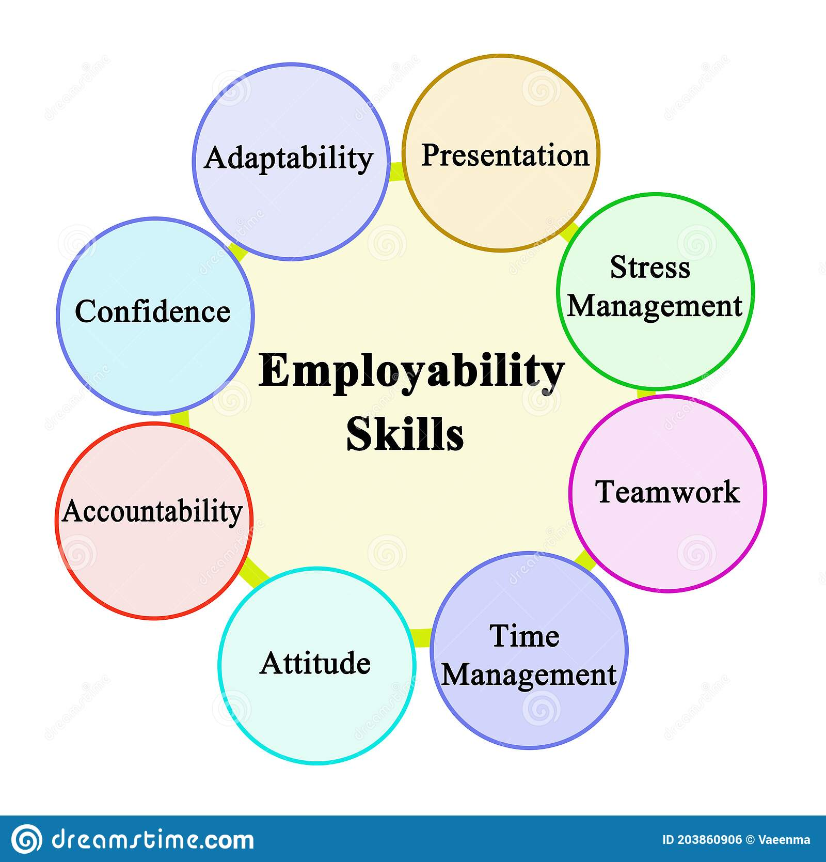(Dreamstime)
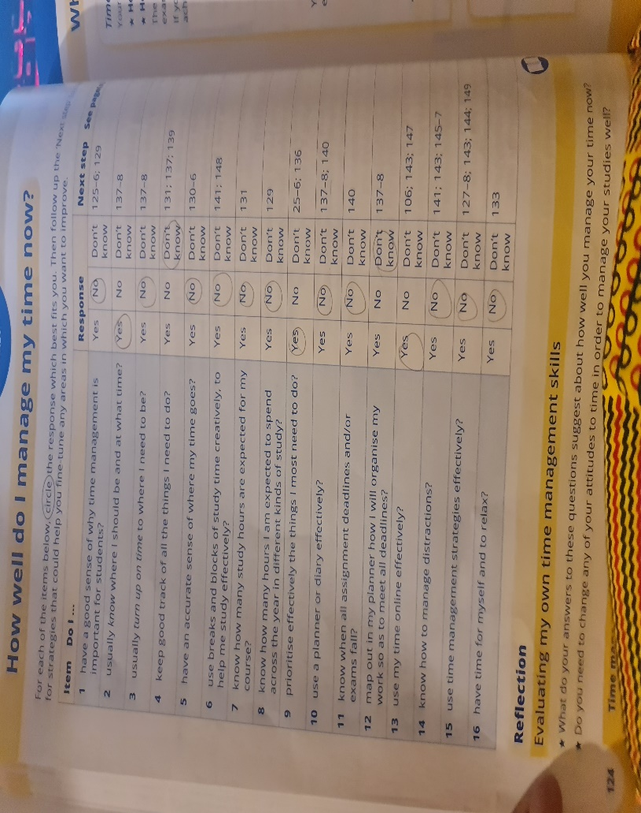

Reference List
- Cottrell. S (2019) The Study Skills Handbook, 5th ed, Book Time management as a student and 10 steps to effective time management. (Accessed 23 Aug 2021)
- UNSW Sydney, (2019) online available at https://student.unsw.edu.au/paraphrasing-summarising-and-quoting (Accessed 23 Aug 2021)
- ULC (2021) Online at https://www.ucl.ac.uk/ioe-writing-centre/reference-effectively-avoid-plagiarism/paraphrasing (Accessed 23 Aug 2021)
- Miller. K Northeastern university, (Sep 2019) Online at https://www.northeastern.edu/graduate/blog/benefits-of-online-learning/ (Accessed 24, Aug 2021)
- Vinikas. I advantage and disadvantages of online learning (2021) online at https://corp.kaltura.com/blog/advantages-disadvantages-online-classes/ (Accessed 24 Aug 2021)
- Johnson. S, (2021) Experience of online learning Online at https://blogs.bath.ac.uk/students/2020/06/26/my-experience-of-online-learning/ (Accessed 24 Aug 2021)
- Doyle A (2019) Speaking skills Online at https://www.thebalancecareers.com/public-speaking-skills-with-examples-2059697 (Accessed 24 Aug 2021)
- Gibbs, G. (1988), (2020) Learning by Doing: A guide to teaching and learning methods online at https://www.ed.ac.uk/reflection/reflectors-toolkit/reflecting-on-experience/gibbs-reflective-cycle (Accessed 24, Aug 2021)

Tools Learnt from the class:
References
Paraphrasing
Summarizing
Time management
Public speaking

