

BA (Hons) Business Management
Student Name: Cristian Florin Oglan
Student Number: 2414409
Module Name and code: Management Accounting for Managers - LCBB5010
Lecturer name: Zainab Atta

Report: A Critical Evaluation of Management Accounting and Strategic Decision-Making for Tesco PLC

Table of Contents
Introduction 3
Main Body 3
Cost Analysis and Business Model 3
Budgeting and Financial Planning 5
Performance Measurement and Decision-Making 6
Sustainability and Ethical Considerations 8
Conclusion and Recommendations 10
References 11

Introduction
Tesco PLC is the UK's leading food retailer and one of Europe's top grocery companies, operating across the UK, the Republic of Ireland, and Central Europe. The company serves millions of customers weekly through a wide network of supermarkets, convenience stores, and online platforms. It also provides wholesale services via Booker, along with retail media, insurance, and financial services. In the 2024/25 fiscal year, Tesco reported revenue of £69.9 billion, reflecting continued growth in market share, profitability, and customer satisfaction, which demonstrates its strategic focus on value and digital innovation (Tesco PLC, 2025).
Management accounting is essential to Tesco's decision-making since it supplies managers with prompt financial and operational data to aid in planning, budgeting, cost management, and performance assessment. In a progressively competitive retail landscape marked by inflation, evolving consumer preferences, and technological advancements, management accounting allows Tesco to efficiently distribute resources, enhance pricing strategies, and ensure enduring profitability while delivering value to customers and shareholders (Drury, 2021; Horngren, Datar and Rajan, 2021).

Main Body

Cost Analysis and Business Model
Tesco PLC employs a multifaceted retail business strategy primarily focused on food sales, while also deriving supplementary revenue from wholesale activities, financial services, retail media, and e-commerce. The principal revenue stream for the Group continues to be derived from the sale of groceries and general products via its vast network of supermarkets, convenience stores, and online platforms throughout the United Kingdom, the Republic of Ireland, and Central Europe. Tesco additionally produces substantial income via Booker, the foremost food distributor in the UK, catering to independent stores, restaurants, and catering enterprises. Complementary enterprises such as Tesco Mobile, Tesco Insurance, Money Services, and Tesco Media and Insight Platform enhance income diversification and diminish dependence on conventional supermarket sales (Tesco PLC, 2025).
Over the past three fiscal years, Tesco has consistently achieved revenue growth in spite of inflationary challenges and evolving consumer expenditure trends. Group revenue rose from £65.76 billion in 2022/23 to £68.19 billion in 2023/24, subsequently escalating to £69.92 billion in 2024/25, illustrating the robustness of Tesco's business model and its capacity to uphold market dominance in the UK grocery industry (Tesco PLC, 2023; Tesco PLC, 2024; Tesco PLC, 2025). The firm's approach of providing attractive pricing via its Clubcard reward initiative, alongside growth in convenience retail and online grocery offerings, has bolstered customer loyalty and enhanced sales figures. Moreover, high-margin endeavours like retail media and financial services have favourably impacted profitability by producing supplementary revenue without significantly escalating inventory expenditures (Tesco PLC, 2025).
Tesco's expense framework includes both fixed and variable expenditures, necessitating proficient management accounting strategies to sustain profitability in a fiercely competitive retail landscape. Fixed expenses encompass property leases, amortisation of retail and distribution facilities, IT infrastructure, pay for permanent personnel, administrative costs, and investments in digital technologies. These expenses tend to be consistent despite temporary variations in sales quantities, necessitating meticulous budgeting and strategic long-term financial planning (Drury, 2021). Tesco has persistently allocated resources towards automation, supply chain innovations, and digital infrastructures, augmenting capital investment while enhancing enduring operational efficacy (Tesco PLC, 2025).
Variable expenses vary in direct correlation to the degree of commercial operations. These encompass merchandise acquisitions, shipping expenses, packaging supplies, temporary workforce, utility usage associated with retail operations, and transaction processing charges. Escalating food commodity prices, energy expenses, and wage inflation in recent years have elevated Tesco's variable operating costs, necessitating a heightened focus on effective procurement and inventory management (Tesco PLC, 2025). The Group tackles these obstacles by forming strategic alliances with suppliers, leveraging economies of scale, and employing advanced inventory management systems that reduce waste while ensuring product availability.
Management accounting methodologies, such as activity-based costing, variance analysis, and cost-volume-profit analysis, allow Tesco to differentiate between fixed and variable expenses and assess the profitability of various items, locations, and distribution avenues. These methodologies facilitate pricing strategies, promotional initiatives, and resource distribution, while guaranteeing that operational expenses correspond with consumer demand and company objectives (Horngren, Datar and Rajan, 2021). As a result, Tesco's varied revenue strategy and stringent cost control consistently establish a robust basis for enduring financial success and prolonged competitive edge.

Budgeting and Financial Planning
Budgeting is an essential element of Tesco PLC's management accounting framework as it allows the organisation to convert strategic goals into operational and financial strategies. As a major food retailer in Europe, Tesco functions within a fiercely competitive landscape marked by variable customer demand, inflationary challenges, and evolving supply chain dynamics. Thus, budgeting facilitates the effective distribution of financial resources, expense management, inventory organisation, and capital investment, all while guaranteeing the company's profitability and competitive pricing. By utilising comprehensive operational and capital budgets, management can estimate sales, oversee spending, assess investment initiatives, and contrast actual outcomes with intended objectives through variance analysis (Drury, 2021).
Tesco implements budgeting in all key company areas, encompassing retail operations, distribution, technology, marketing, and human resources. Operational budgets aid store managers in managing labour expenses, inventory quantities, and overhead expenditures, whereas capital budgets facilitate long-term investments in store renovations, automation, digital systems, and distribution facilities. The Group employs rolling forecasts and scenario analysis to swiftly adapt to fluctuating market conditions, allowing management to modify financial strategies in reaction to inflation, consumer behaviour, and supply chain interruptions (Horngren, Datar and Rajan, 2021).
An analysis of Tesco's most recent financial data reveals that operational costs rose in the 2024/25 fiscal year. Per Google Finance, overall operational expenditures increased from roughly £65.4 billion in 2023/24 to about £67.2 billion in 2024/25, indicating a year-on-year rise of nearly 2.8%. Selling, general, and administrative expenditures rose from roughly £2.02 billion to £2.24 billion, indicating ongoing investment in operational activities and elevated operating expenses. These statistics align with Tesco's 2025 Annual Report, which indicates increased operating expenses due to strategic investments and inflationary cost challenges.
A number of internal administrative choices led to this rise in expenses. Tesco persisted in allocating resources towards digital transformation, online grocery services, data analytics, Clubcard customisation, and supply chain automation to enhance operational efficiency and consumer satisfaction. The organisation augmented its investment in employee compensation, store renovations, and technological infrastructure, while also enhancing security protocols to mitigate inventory losses and bolster operational resilience. Despite the rise in immediate operational expenses due to these initiatives, management anticipates enhancements in productivity, heightened consumer allegiance, and enduring profitability (Tesco PLC, 2025).
External macroeconomic elements also impacted Tesco's financial planning choices. Ongoing food price inflation, escalating energy charges, salary increases, and heightened logistical costs have augmented the operational expenses of supermarkets throughout the United Kingdom and Europe. Moreover, alterations in customer buying patterns prompted Tesco to enhance its value proposition via competitive pricing and Clubcard incentives, so exerting further strain on operating margins. Notwithstanding these obstacles, proficient budgeting allowed Tesco to harmonise expense management with ongoing investment in strategic objectives, fostering revenue expansion and preserving its dominant market stance (Tesco PLC, 2025).
Tesco's budgeting framework exemplifies the critical role of management accounting in reconciling immediate cost control with sustained investment. Through the incorporation of adaptable budgeting, variance examination, and ongoing financial projections, the organisation may adeptly navigate economic volatility while fostering sustainable development and preserving shareholder equity.

Performance Measurement and Decision-Making
Performance measurement constitutes a vital component of Tesco PLC's management accounting framework as it allows managers to assess financial performance, operational effectiveness, and customer results, hence facilitating strategic decision-making. Tesco use a blend of financial and non-financial key performance indicators (KPIs) to assess advancement towards its corporate goals and to guarantee that business choices foster sustainable growth. Management accounting data enables the organisation to juxtapose actual performance against established objectives, discern operational enhancements, and allocate resources with greater efficiency (Drury, 2021).
The table displays five essential performance metrics utilised to evaluate Tesco's operational effectiveness.
Tesco PLC – (KPI) Key Performance Indicators (2024/25)
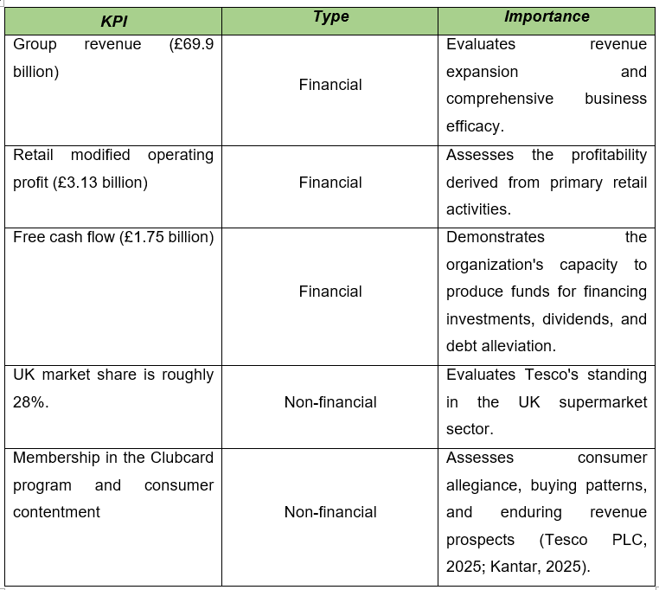
Financial KPIs, such as sales, operating profit, and free cash flow, furnish management with insights into profitability, liquidity, and operational efficacy. Revenue rose from £65.76 billion in 2022/23 to £68.19 billion in 2023/24, ultimately reaching £69.92 billion in 2024/25, while retail adjusted operating profit ascended to £3.13 billion, indicating enhanced operational efficacy despite inflationary challenges (Tesco PLC, 2023; Tesco PLC, 2024; Tesco PLC, 2025). Free cash flow is a crucial metric as it allows Tesco to fund capital expenditures, uphold dividend distributions, and enhance its financial stability without resorting to excessive debt.
Non-financial KPIs hold comparable importance since they furnish insights that financial reporting alone cannot encapsulate. Tesco retains around 28% of the UK grocery sector, sustaining its status as the foremost supermarket chain in the nation (Kantar, 2025). Furthermore, the enhancement of the Clubcard loyalty scheme allows Tesco to scrutinise consumer buying patterns, tailor promotional incentives, and bolster client loyalty. Customer contentment, online interaction, and product accessibility are meticulously observed as they have a direct impact on sustained profitability and brand allegiance (Tesco PLC, 2025).
Performance metrics have impacted numerous significant strategic choices. Initially, robust consumer demand revealed via Clubcard analytics has prompted Tesco to persist in broadening customised pricing and focused promotions, enabling the firm to sustain competitiveness while safeguarding operational margins. Secondly, financial assessments indicating robust cash flow have facilitated ongoing investments in store refurbishment, automation, and online grocery services. These upgrades enhance efficiency and customer satisfaction while decreasing long-term operational expenses. Thirdly, management has persistently executed cost-efficiency strategies throughout distribution and supply chain activities, incorporating automation and data-centric inventory management, in reaction to inflationary pressures and escalating labour expenses (Tesco PLC, 2025).
Moreover, Tesco has bolstered its value-oriented pricing approach by augmenting investments in the Aldi Price Match and Low Everyday Prices initiatives, leveraging consumer and market analytics to address the rising competition from bargain retailers. These tactical choices illustrate how both financial and non-financial management accounting data facilitate sustainable development, operational effectiveness, and enduring competitive superiority (Horngren, Datar and Rajan, 2021).

Sustainability and Ethical Considerations
Sustainability has emerged as a fundamental component of Tesco PLC's corporate strategy and fiscal decision-making. The organisation integrates environmental, social, and governance (ESG) goals into capital investment choices, operational strategies, and risk management to guarantee sustained value generation for shareholders and other stakeholders. Tesco has pledged to attain net-zero emissions in its operations by 2035 and throughout its value chain by 2050, as outlined in its Planet Plan. These obligations affect investment choices for renewable energy, low-emission refrigeration systems, energy-efficient retail outlets, and distribution infrastructures. Through the integration of sustainability into management accounting practices, Tesco can assess the financial yields and ecological consequences of significant investment initiatives, hence facilitating more sustainable resource distribution (Tesco PLC, 2025; Schaltegger and Burritt, 2018).
Management accounting additionally aids Tesco in minimising food waste, advancing packaging sustainability, and optimising supply chain efficiency. Investments in energy-efficient technologies and waste minimisation efforts necessitate substantial upfront costs; yet, these endeavours yield enduring financial advantages via decreased energy usage, diminished waste management expenses, and enhanced operational efficacy. Environmental management accounting allows managers to concurrently assess financial and ecological advantages, facilitating the incorporation of sustainability goals into budgeting and performance assessment (Schaltegger and Burritt, 2018). Moreover, Tesco maintains a collaborative relationship with suppliers to enhance ethical sourcing methods and diminish greenhouse gas emissions across its supply chain, thereby bolstering operational robustness and corporate image (Tesco PLC, 2025).
Ethical factors hold similar significance in Tesco's cost management and pricing approaches. As the foremost food retailer in the UK, Tesco is required to reconcile profitability with its obligation to offer economical items while sustaining equitable partnerships with suppliers. Cost-cutting measures, such as supply chain enhancement and automation, enhance operational efficacy but should not jeopardise product integrity, employee welfare, or supplier equity. The Groceries Supply Code of Practice (GSCOP) mandates that supermarkets engage with suppliers equitably, promoting ethical sourcing and mitigating the likelihood of unjust commercial behaviours (Groceries Code Adjudicator, 2024).
Tesco's pricing approach additionally embodies ethical principles. Initiatives like Aldi Price Match and Low Everyday Prices aim to assist consumers in coping with escalating living expenses while maintaining competitiveness in the UK supermarket sector. Nevertheless, management must guarantee that competitive pricing does not impose undue strain on suppliers or promote unsustainable cost-cutting measures. Thus, proficient management accounting ought to facilitate equitable decision-making by evaluating financial outcomes in conjunction with environmental sustainability, supplier relations, and consumer well-being. This cohesive strategy allows Tesco to attain sustained profitability while preserving stakeholder confidence and endorsing ethical corporate conduct (Seal, Garrison and Noreen, 2022).

Conclusion and Recommendations
The examination reveals that management accounting is essential in facilitating strategic and operational decisions at Tesco PLC. Tesco's varied revenue strategy, efficient cost control, and thorough budgeting framework allow the firm to adeptly adapt to evolving market dynamics while preserving profitability and its dominant status in the UK grocery industry. Financial and non-financial key performance indicators, such as revenue expansion, operational income, free cash flow, market share, and customer allegiance, furnish management with essential insights for assessing performance and informing strategic choices. Moreover, the incorporation of sustainability into financial strategy illustrates Tesco's dedication to generating enduring value via responsible investment, operational efficacy, and ethical business conduct (Tesco PLC, 2025; Drury, 2021).
In accordance with management accounting principles, three suggestions are put forth. Initially, Tesco ought to enhance activity-based costing to refine cost distribution within online retailing and distribution processes. Secondly, the organisation ought to enhance predictive budgeting by augmenting the application of artificial intelligence and sophisticated data analytics to refine demand forecasting and inventory oversight. Ultimately, Tesco ought to incorporate environmental and social performance metrics more comprehensively into management performance assessments to facilitate sustainable decision-making and enhance long-term stakeholder value.

References


