University of Wales Trinity Saint David

School of Engineering



Material Properties, Material Selection, and Manufacturing Processes Suitable for a Piston in an Internal Combustion Engine

Engineering Design and Materials (ACHA4001)
BEng Motorsport Engineering

Franklin Spencer Tim Attwood
2004876
March 2022
Table of Contents
Table of Figures and Tables 2
Figures 2
Tables 2
1 Introduction 3
2 Material Properties 4
2.1 Mechanical Load 4
2.2 Gas Pressure 5
2.3 Thermal Load 6
2.3.1 Thermal Expansion 6
2.3.2 Thermal conductivity 7
2.3.3 Thermal Limits 7
3 Material Selection 9
4 Manufacturing 14
4.1 Production Type 14
4.2 Manufacturing Process 15
5 Conclusion 16
6 References 17

Table of Figures and Tables

Figures
Figure 1 - Basic internal combustion engine components (AuYeung, 2019) 3
Figure 2 – Diagram showing the parts to a piston (Muir, 2017) 3
Figure 3 - Diagram showing the forces acting on a piston (Perera, Rahnejat and Theodossiades, 2007) 4
Figure 4 - Graphs showing cylinder pressure (IMechE, 2013) 5
Figure 5 - Diagram showing cross-section view of piston when cold and at operating temperature 6
Figure 6 - Temperature distribution for a petrol engine (MAHLE GmbH, 2016, p. 6) 8
Figure 7 - Temperature distribution for a diesel engine (MAHLE GmbH, 2016, p. 6) 8

Tables
Table 1 - Thermal and geometric properties from the simulation (Periyasamy, Prithiviraj and Vengatesvaran,2018) 7
Table 2 - Table showing the aluminium alloys MAHLE use (MAHLE GmbH, 2016, p. 64) 9
Table 3 - Table showing the aluminium alloys used by EAA (EAA, 2011, p. 6) 9
Table 4 - Table showing the material properties performance values for the above alloys (MAHLE GmbH, 2016, p. 66-67) 10
Table 5 - Table showing the alloy mechanical properties from EAA (EEA, 2011, p. 6) 11
Table 6 - Table showing the alloy physical properties from EAA (EEA, 2011, p. 6) 11
Table 7 - Table showing required properties for the piston with the aluminium alloys and their specifications 12

Introduction
This report will cover the required material properties for a piston in an internal combustion engine, a suitable range of materials and a final justified decision that meets the required properties. In addition, there will be a discussion on suitable manufacturing processes that could be used to manufacture the piston. A piston in an internal combustion engine is the component which takes the pressure from the controlled burn of air and fuel in the cylinder and transfers the force to the connecting rod. The connecting rod is attached to the crankshaft which converts the up and down motion of the piston and reciprocating action of the connecting rod into a turning motion at the output of the engine. The layout of these components can be seen in figure 1 and the piston terminally in figure 2.
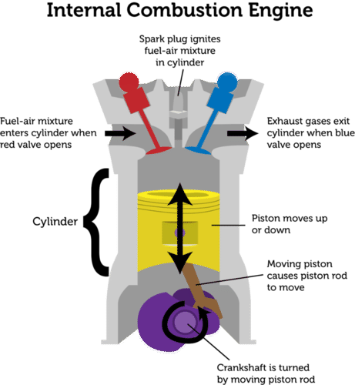
Figure 1 - Basic internal combustion engine components (AuYeung, 2019)
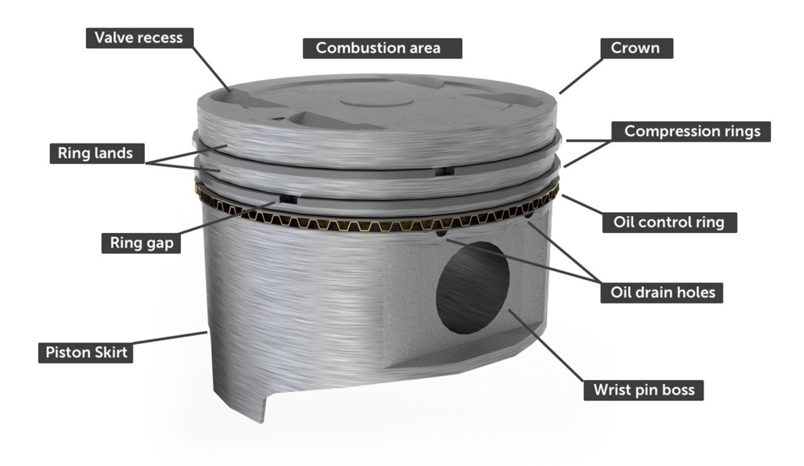
Figure 2 – Diagram showing the parts to a piston (Muir, 2017)

Material Properties

Mechanical Load
When talking about mechanical load it refers to the forces acting on the piston, when the engine is running “the piston is subjected to an equilibrium of gas, inertia and supporting forces. “(MAHLE GmbH, 2016, p. 5). In figure 3 the forces acting on the piston can be seen.

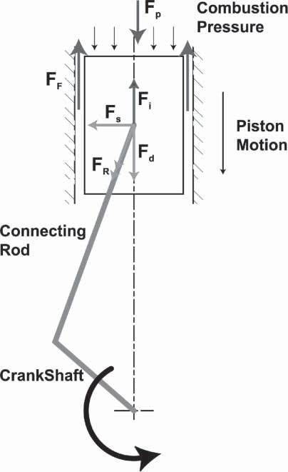
Figure 3 - Diagram showing the forces acting on a piston (Perera, Rahnejat and Theodossiades, 2007)

Gas Pressure
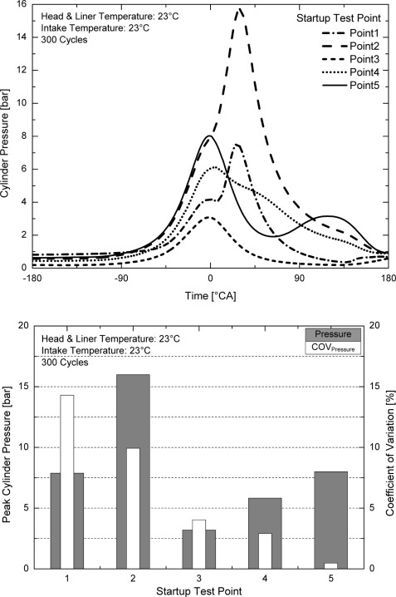
As can be seen in figure 4, when the combustion event takes place in the chamber it generates a large pressure spike which quickly decreases. At peak engine load the maximum cylinder pressure “for a typical passenger vehicle engine will typically be around 120 bar (gasoline) or 180 bar (diesel)” (McNally Institute, 2022) although the SAE (2013) say diesel engines have a maximum cylinder pressure of 180 to 200 bar. In the line graph in figure 4 the cylinder pressure is peaking at 16 bar on point 3 which is the engine in a warmup stage without any external load. MAHLE GmbH (2016) say that an engine at 6,000 rpm with a gas force of 90 bar and a piston diameter of 90mm means that the piston is subjected to about 6 tones worth of load, this occurs 50 times a second. This shows that the material must have good compressive strength and stiffness to ensure the piston does not deform under load. In addition the material must be tough to be able to absorb sudden impacts from the combustion event.
Figure 4 - Graphs showing cylinder pressure (IMechE, 2013)

Thermal Load

Thermal Expansion
As a material is heated it experiences thermal expansion, “the general increase in the volume of a material as its temperature is increased” (Britannica, 2017). Since the crown of the piston is part of the combustion chamber it is the hottest part of the piston and will expand at a greater rate to the skirt of the piston.
To prevent it from expanding to a larger size than the rest of the piston, it is machined to a diameter that is approximately 0.03 to 0.04 of an inch smaller than the skirt area.
(Construction Mechanic Basic, 2003, p. 25)
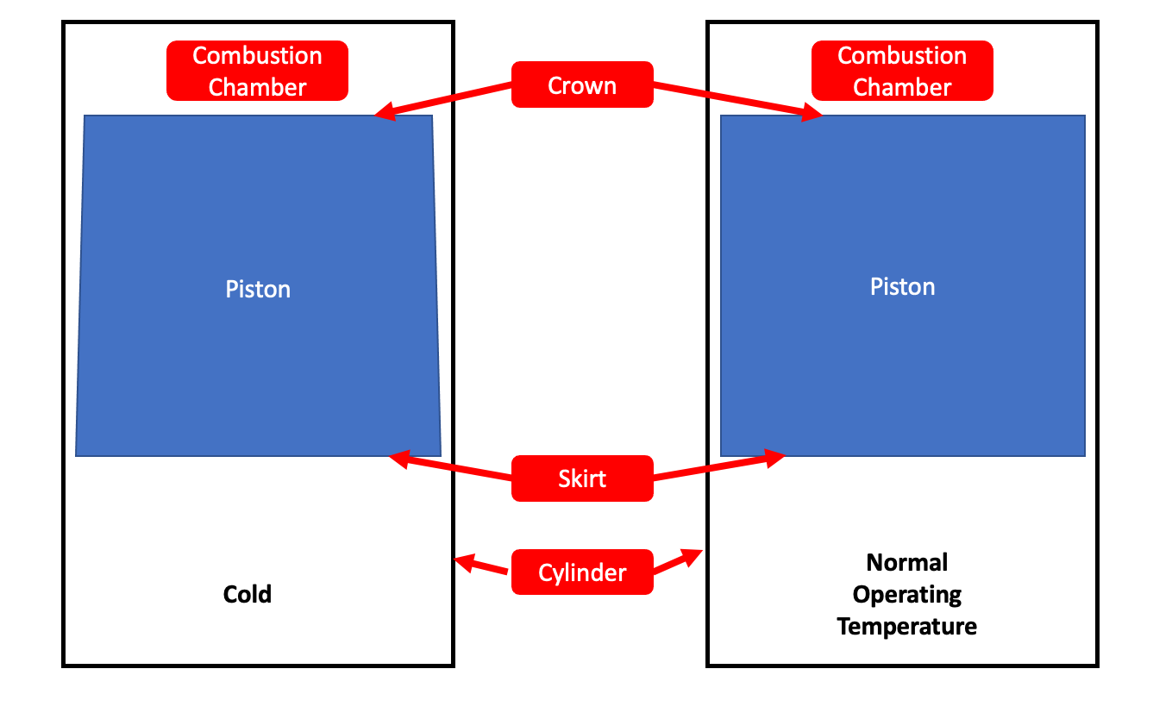
Figure 5 - Diagram showing cross-section view of piston when cold and at operating temperature
As can be seen in figure 5, this means when the piston is cold, a cross section view looks like a trapezium but when the piston gets up to operating temperature the crown expands resulting in the cross-section looking square. From this it is evident that the material selected for a piston must respond well to thermal expansion and contraction. This requires the material to have good elasticity properties and the material must be able to go through this cycle millions of times without fatiguing.

Thermal conductivity
“Thermal conductivity refers to the ability of a given material to conduct/transfer heat” (BYJU’S, 2022) this is a very important property for the pistons material because the piston needs to absorb heat quickly to expand into the correct shape for efficient engine operation. In addition, heat needs to be taken away from it quickly so it can be cooled by the lubricating oil otherwise the piston material may get too hot. As seen in table 1 the simulation from Periyasamy, Prithiviraj and Vengatesvaran (2018) on the aluminium alloy shows a thermal conductivity value of 174.15 W/mK. In an experiment written up by Sharma (2015) they used a piston made form a MSFC-388-T5 alloy in their experimental engine, this alloy had a thermal conductivity value of 136 W/mK.

Table 1 - Thermal and geometric properties from the simulation (Periyasamy, Prithiviraj and Vengatesvaran,2018)
S. No. | Name of the Property | Value
1 | Thermal Conductivity | 174.15 W/mK
2 | Specific Heat | 0.13 J/kgK
3 | Young’s Modulus | 71x10³ Mpa
4 | Poisson’s Ratio | 0.33
5 | Density, Dens | 2.77x10⁻⁶ kg/mm³

Thermal Limits
The thermal limit of a material is the point at which a material starts to change state i.e. changing from a solid to a liquid, obviously a piston starting to melt will cause major engine damage and will no longer operate. The combustion event in an engine generates a lot of heat “even if present only for a short time, can reach levels of over 2,300ºC” (MAHLE GmbH, 2016, p. 5). Although the peak temperature can be over 2,300ºC the event happens so fast there isn’t time for the peak temperature to transfer to the piston. From looking at figure 6 and 7 the maximum temperature experienced by the piston crown is 301ºC for a petrol engine and 375ºC for diesel.
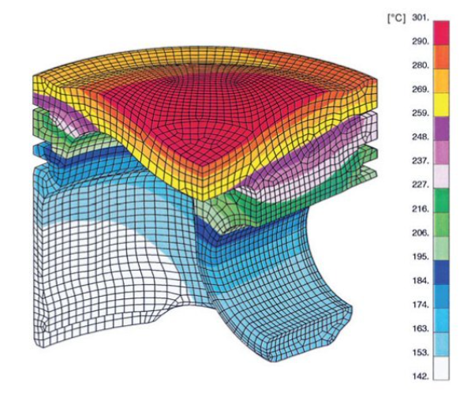
Figure 6 - Temperature distribution for a petrol engine (MAHLE GmbH, 2016, p. 6)
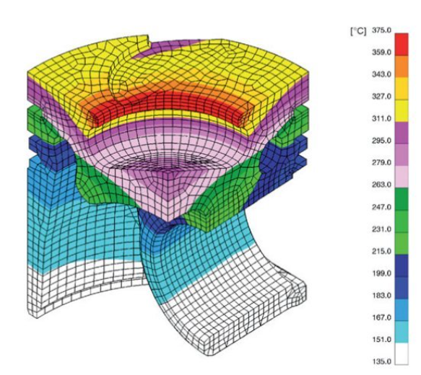
Figure 7 - Temperature distribution for a diesel engine (MAHLE GmbH, 2016, p. 6)

Material Selection
When looking for suitable materials for a piston with the required properties discussed in the previous section, metals are the only option however, pure metals simply do not perform as well as an alloy which is a mix of multiple elements which changes the properties generally making the material perform better.

In the table below (table 2) there are the aluminium alloys used by MAHLE, their material property values will be compared to the material properties values discussed in the previous section.
Table 2 - Table showing the aluminium alloys MAHLE use (MAHLE GmbH, 2016, p. 64)

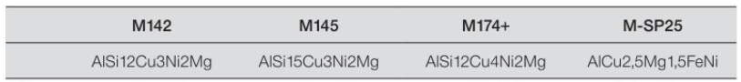

In table 3 there are the alloys recommend by European Aluminium Association (EAA) for a piston in an engine, looking at the chemical make-up however it looks like the alloys listed by the EAA are the same as M124, M138 and M174+ listed by MAHLE. This being the case only the alloys from MAHLE will be looked at.
Table 3 - Table showing the aluminium alloys used by EAA (EAA, 2011, p. 6)
Table 4 - Table showing the material properties performance values for the above alloys (MAHLE GmbH, 2016, p. 66-67)
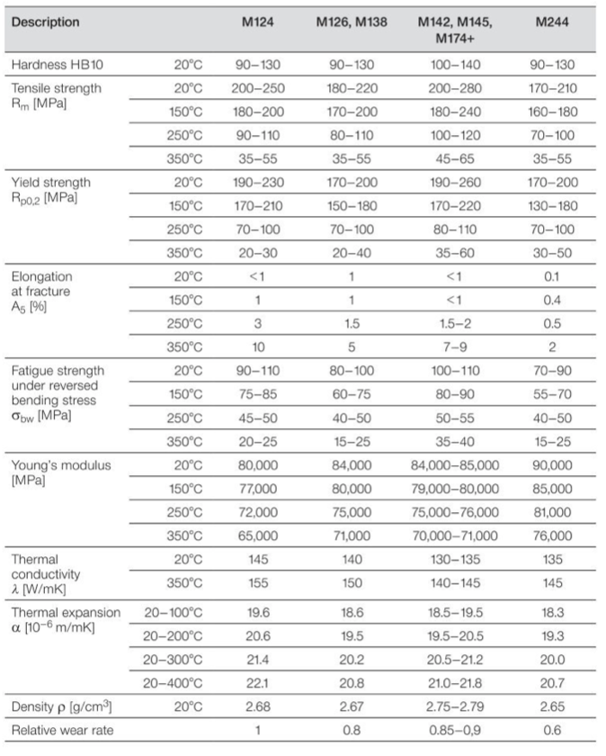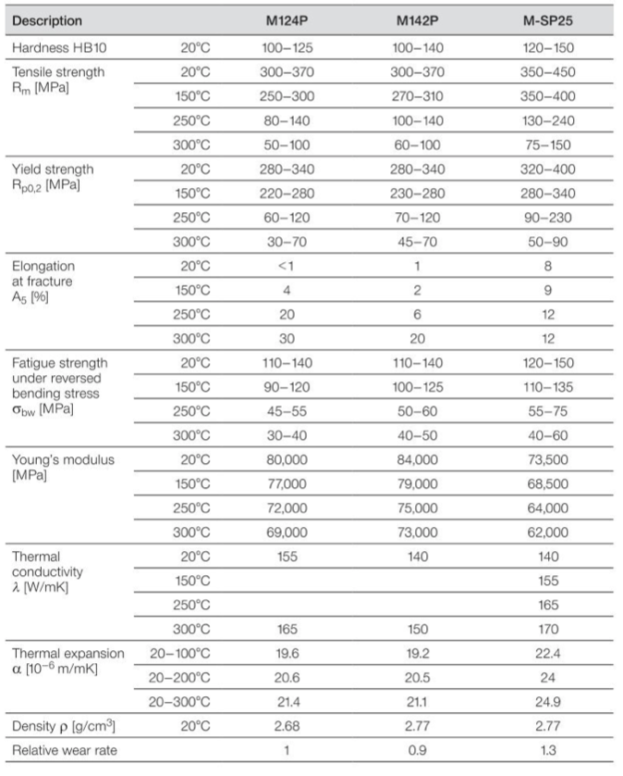

Table 5 - Table showing the alloy mechanical properties from EAA (EEA, 2011, p. 6)
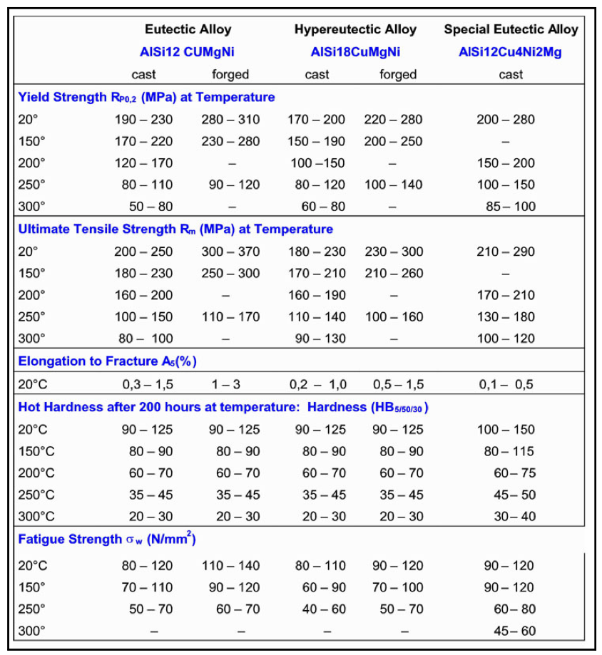
Table 6 - Table showing the alloy physical properties from EAA (EEA, 2011, p. 6)
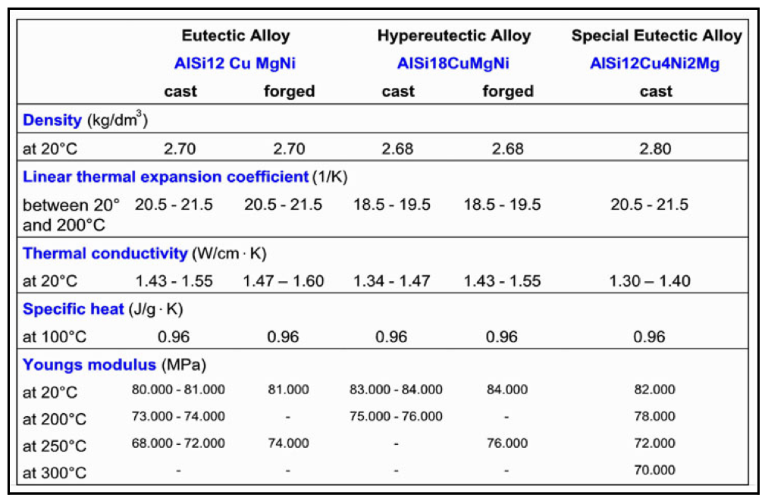

Table 7 - Table showing required properties for the piston with the aluminium alloys and their specifications
Property | M124 | M126 & M138 | M142, M145 & M174+ | M244 | M124P | M142P | M-SP25
Compressive Strength at 350ºC (MPa) | 20 – 30 | 20 – 40 | 35 – 60 | 30 – 50 | 30 – 70 | 45 – 70 | 50 - 90
Tensile Strength at 350ºC (MPa) | 35 - 55 | 35 - 55 | 45 – 65 | 35 - 55 | 50 - 100 | 60 – 100 | 75 - 150
Stiffness
Toughness
Elasticity at 350ºC (%) | 10 | 5 | 7 – 9 | 2 | 30 | 20 | 12
Fatigue Strength at 350ºC (MPa) | 20 – 25 | 15 -25 | 35 - 40 | 15 - 25 | 30 – 40 | 40 – 50 | 40 - 60
Thermal Expansion at 300ºC  (10⁻⁶ m/mK) | 21.4 | 20.2 | 20.5 - 21.2 | 20 | 21.4 | 21.1 | 24.9
Thermal Conductivity at 300ºC  (W/mK) | 155 | 150 | 140 – 145 | 145 | 165 | 150 | 170
Thermal Limit (Melting Point)

Values taken from MAHLE (MAHLE GmbH, 2016)
Proprietary values – could not be found publicly

- For compressive and tensile strength M-SP25 has the highest value meaning it can take the most load which for a diesel, high performance road car or race car would be important because they run much higher combustion pressures.
- The Elasticity value for M124P was the highest which means it will return to its original form once the load has been removed however, if it changes shape too much, while the piston may not be permanently damaged it may not make a good seal in the cylinder, hence losing efficiency.
- Looking at the fatigue strength for M142P and M-SP25 they both perform very well with M-SP25 being able to withstand more pressure therefore the M-SP25 should be able to outlast M142P.
- For thermal expansion a lower value would be better, M244 has the lowest value of 20x10⁻⁶ m/mK whereas M-SP25, which has been the best performing in the previous properties, has the highest expansion of 24.9x10⁻⁶ m/mK. This high expansion rate can be compensated for in the piston design, but it means the engine would be significantly less efficient than M244 in the engine warm up stage. Once the engine is up to temperature however there would be very little difference between M244 and M-SP25 as long the temperature is kept stable.
- Unsurprisingly the thermal conductivity of M-SP25 is the highest at 170 W/mK which explains why M-SP25 has the highest thermal expansion. As mentioned in the previous section a high thermal conductivity value is good for taking heat away from the piston and for getting the material up to operating temperature but if temperature begin to climb momentarily the piston will respond to that heat much quicker than M244.

Overall the aluminium alloy M-SP25 (AlCu2.5Mg1.5FeNi) performs the best in these categories with its only downside shown being thermal expansion as mentioned.

Manufacturing

Production Type
The first step is to see what the scale of manufacturing is:
- Repetitive Manufacturing - A manufacturer uses process types like repetitive manufacturing for repeating production to commit to a production rate.
- Discrete Manufacturing - Like repetitive manufacturing, discrete manufacturing also utilizes an assembly or production line. However, this process type is highly diverse, with a variety of setups and frequent changeovers.
- Job Shop Manufacturing - Unlike the other process types, job shop manufacturing makes use of production areas rather than assembly lines.
- Continuous Process Manufacturing - Similar to repetitive manufacturing is the continuous manufacturing process, which runs 24/7 too.
- Batch Process Manufacturing - The final process shares similarities with discrete and job shop processes. After a batch production run, a manufacturer cleans the equipment to prepare the machinery for the next batch. Batch processes are continuous by nature.

(Katana, 2021)
Looking at this from the perspective of MAHLE, a piston manufacture who supply pistons to automotive and motorsport companies all over the world its clear they would be on a high production rate, this could easily be above 10,000 units a week for one type of piston. This shows that a large batch production of pistons would be suitable due to the high demand from manufactures.

Manufacturing Process
When manufacturing a piston from an aluminium alloy, in this case M-SP25, there are 2 suitable processes:
- Casting – Cast metal is metal that has been heated up past its melting point and poured into a mould, using one of a number of techniques such as gravity or high pressure die casting, to form the shape of your desired product.
- Forging - Forged metal is heated up until it is malleable (not molten) and forced into the desired shape. This is the same process that blacksmiths and ironmongers originally used to create horseshoes, swords, and armour. However, modern methods usually use high pressure stamping, rather than a hammer and anvil.
(MRT Castings, 2017)
Lost foam casting “which is suitable for the production of complex component geometrics of pistons and piston parts from a single casting” (Hanke, Luz and Spermann, 2014) is often the way manufactures make pistons. However, in high power and high stress applications like motorsport the piston can be stressed significantly more and as can be seen in table 5 a forged version of the same alloy can have much more strength which will be able to handle more force. The issue with forging is the cost because it is a longer process and requires more machinery, also some shapes cannot be forged so a piston designed for casting may not be able to be forged so it would require a redesign for the forging process.

Conclusion
In conclusion, a piston in an internal combustion engine is subjected to a lot of different forces which all act on the piston in different directions, the main force of course came from the combustion pressure which equated to about 6 tones of force acting on the piston. The thermal load experienced by the piston it turns out was much lower than the 2,300ºC combustion gas temperature and the temperature on the piston was only about 375ºC for a diesel engine and much less for a petrol engine. Looking at what manufactures use it was very clear that an aluminium alloy was the way to go due to their good property values, the clear winner out of the 8 alloys was M-SP25. The two different manufacturing process that were suitable for a piston were casting and forging, casting is seen to be suitable for most application such as road cars but for high performance engines like what is used in motorsport, forging the material creates a much stronger piston. Therefore, in a motorsport engine forging a piston out of the aluminium alloy M-SP25 would make a very strong piston capable of withstanding large amounts of cylinder pressure and if the engine temperature is kept under control the alloy should perform exceptionally.

References
AuYeung, C. (2019) 15.12 Internal Combustion Engine
[Diagram]
Available at: https://flexbooks.ck12.org/cbook/ck-12-middle-school-physical-science-flexbook-2.0/section/15.12/primary/lesson/internal-combustion-engines-ms-ps/
(Accessed: 16/03/2022)

Britannica (2017) thermal expansion
Available at: https://www.britannica.com/science/thermal-expansion
(Accessed: 18/03/2022)

BYJU’S (2022) Thermal Conductivity
Available at: https://byjus.com/chemistry/thermal-conductivity/
(Accessed: 18/03/2022)

Construction Mechanic Basic (2003)
Volume 01
Texas: Integrated Publishing

European Aluminium Association – EAA (2011) Applications – Power train – Pistons
Available at: https://www.european-aluminium.eu/media/1570/aam-applications-power-train-1-pistons.pdf
(Accessed: 19/03/2022)

Hanke, W., Luz, G. and Spermann, J. (2014) Casting method for producing a piston and pistons for internal combustion engine
KS Kolbenschmidt GmbH
Patent number: DE102014211350A1
Available at: https://patents.google.com/patent/DE102014211350A1/en
(Accessed: 19/03/2022)

Institute of Mechanical Engineers – IMechE (2013) Internal Combustion Engines: Performance, Fuel Economy, and Emissions
[Graph]
London: Woodhead Publishing
Available at: https://www.sciencedirect.com/topics/engineering/cylinder-pressure
(Accessed: 16/03/2022)

Katana (2021) The 5 types of manufacturing processes
Available at: https://katanamrp.com/blog/types-of-manufacturing-processes/
(Accessed: 19/03/2022)

MAHLE GmbH (2016) Pistons and engine testing
2nd Edition
Wiesbaden: Springer Vieweg

McNally Institute (2022) How Much Pressure Is Produced in An Internal Combustion Engine?
Available at: https://www.mcnallyinstitute.com/how-much-pressure-is-produced-in-an-internal-combustion-engine/
(Accessed: 16/03/2022)

MRT Casting (2017) The Difference Between Cast, Forged and Billet
[Blog]
Available at: https://blog.mrt-castings.co.uk/blog/the-difference-between-cast-forged-and-billet
(Accessed: 20/03/2022)

Muir, A (2017) The Engine: Pistons
[Diagram]
Available: https://www.howacarworks.com/pistons
(Accessed: 18/03/2022)

Perera, M.S.M., Rahnejat, H. and Theodossiades, S. (2007) A multi-physics multi-scale approach in engine design analysis
[Diagram]
Available at: https://www.researchgate.net/publication/48352739_A_multi-physics_multi-scale_approach_in_engine_design_analysis
(Accessed: 13/03/2022)

Periyasamy, N., Prithiviraj, N. and Vengatesvaran, K. (2018) Thermal Analysis and Material Optimization of Piston in IC Engine
Available at: http://ijariie.com/AdminUploadPdf/THERMAL_ANALYSIS_AND_MATERIAL_OPTIMIZATION_OF_PISTON_IN_IC_ENGINE_ijariie8215.pdf
(Accessed: 18/03/2022)

SAE International (2013) Investigation of Extreme mean Effective and Maximum Cylinder Pressures in a Passenger Car Diesel Engine
Available at: https://saemobilus.sae.org/content/2013-01-1622/#abstract
(Accessed: 16/03/2022)

Sharma, S.K. (2015) Experimental Thermal Analysis of Diesel Engine Piston and Cylinder Wall
Volume 2015
10 Pages
Available at: https://www.hindawi.com/journals/je/2015/178652/

