ACCOUNTING FUNDAMENTALS
Assessment 1

Name: George Tivga
Student Number: 2024060
Module: Accounting Fundamentals
(LCBB4001)
Module Lector Name: Winifred Soribe
Table of Contents

Introduction …………………………………………………………………………..…… 3
Question 1
a) Financial Statement & Balance Sheet, Kedison PLC, 31 December 2020 ……………… 4
b) Statement of Financial position always balance, Explained …………………………….. 8
Question 2
a) Calculation of 10 financial ratio of the Company Chocco PLC for 2020 and 2019 …… 11
b) Analysis of financial performance and position of Chocco PLC …………………….…. 14
Conclusion ………………………………………………………………………………… 16
References ………………………………………………………………………..….…….. 17

Introduction

Entrepreneurship is a way of living effective while contributing simultaneously to the society and economy of the country. Behind the successful enterprise there are many variables contributing continuously. Among all the elements providing assistance to a successful business accounting is one of the major discourse contributing by providing correct information on income and expenditure (Cole, 2012). The role of accounting in business is directly associated with operation and transaction (Edwards and Mellett, 2017). Accounting fundamentals carries away responsibility involving systematic procedure of financial or accounting data entry, recording, rearranging, categorising, summarising, analysing and reporting. Proper effective practice of accounting fundamentals provides important information regarding financial condition of the organisation which helps management of the organisation to make essential decision for the better of the organisation (Amiram, Bozanic and Rouen, 2014). The assessment prepares Income statement for the Kedison PLC as well as the Balance Sheet for the date of 31st December 2020. The reason why statement of financial position balances is provided in the assessment (Edmister, 2017). Different financial ratios of the company Chocco PLC such as ROCE, ROE and Net profit margin are being analysed and presented to have a projection on financial position of the company. Accounting fundamentals provides information necessary for the assessment of an organisation and functions as a tool to operate business without failure.

QUESTION 1

a) Financial Statement and Balance Sheet, Kedison PLC, 31st December 2020
A business organisation uses accounting as an effective tool to analyse the financial condition of the organisation (Edwards and Mellett, 2017). By proper calculation of financial transection of the company and the income and expenditure analysis management can conclude the present condition of the organisation and predict future condition. Accounting information forecasts various financial situations for the organisation and it help to take vital decision regarding the situation.
The written records of the financial information in a proper form and formula is called financial statement. Financial Statement can be in various form and nature considering the purpose of the information to be extracted from the data. There are different types of financial statement such as Balance Sheet, Income statement and Cash Flow statement (Gilbertson, Lehman and Ross, 2014). There are may reasons behind preparing financial statements. Most common and main reason is to know the financial condition of the organisation and following the financial track of the organisation. Often the financial statement is prepared for the purpose of determining tax and presenting company portfolio to the investors. Financial statements provides overview of asset, liabilities and stockholders equity at a time which gives advantages for the investors to decide whether to invest in the business or not.
The statement of financial position can be introduced in a different name in accounting premises which is balance sheet. Balance sheet is the widely know name for the statement of financial position. This is the type of financial statement that provides information on asset, liabilities and owners equity or organisations equity (Jinjarak, 2014). Balance sheet is prepared in a predetermined date to measure financial condition of the organisation on the given date. Usually the date of preparing the financial position statement is at the end of the year. The formula for the statement of financial position is Asset = (Liabilities + Owner’s Equity). Several steps to follow while preparing the statement of financial position is to locate all the asset of the organisation (Johnson, 2019). Separate listing of liabilities is needed but must not include contingent liabilities (Gilbertson, Lehman and Ross, 2014). Shareholders equity and the total of equity of the organisation must be located and finally in the net asset of the organisation definitely equals to the net liabilities and equity. Type of item included in final position statement are liquid asset, account receivables and inventory. Debt which can be long term or short term, wages payable and dividends payable are the liabilities of the organisation. Shareholders equity and retained earnings also included in the Balance Sheet.
Kedison PLC’s financial statement and the statement of financial position dated 31st December 2020 is presented below:

Financial Statement (Profit & Loss Statement),
Kedison PLC 31st December 2020

Sales 826,650
Unearned sales revenue 980
Total sell 827,630
Cost of sales (578,650)
Gross profit 248,980

Expenses
Administration expenses (30,000)
Director remuneration (5,000)
Distribution costs (28,000)
Preference dividend paid (30,000)
Interest paid (2,000)
Salesman commission (3,000)
Interest on debentures (4,000)
Other expenses 102,000
Profit/(Loss) before taxation 146,980
Corporation tax (68,000)
Profit for the year 78,980

In the profit and loss statement of Kedison PLC for the year ended 31st December 2020 the gross profit is 248,980. Yearend profit of the Kedison PLC is 78,980. The Kedison PLC’s Profit and loss statement presents amount of profit generated by the company by adjusting income and expenditure of the organisation, which is why the statement can be called income statement.

Statement of financial position, Kedison PLC
for the year ended 31 December 2020

Non- Current assets
Plant and equipment 632,730

Current assets
Cash and bank 12,900
Unearned sales revenue 980
Ordinary dividend paid (20,000)
(6,120)

Interest on debentures 4,000
Stock at 31st December 2020 330,600
Debtors 170,125
498,605

Total assets 1,131,335

Current liabilities
Trade creditors 171,335
Corporate tax 68,000

Non- Current liabilities
4% debentures 100,000

Total liabilities 339,355

Net assets 790,980

Equity
£1 ordinary shares 310,000
10% £1 preferences shares 300,000
Retained profit on 1st January 2020 180,980
Total Equity 790,980

Net Asset & Total Equity of the Kedison PLC is 790,980. Balance sheet of the organisation present asset, liabilities and owner’s equity.

Equity statement, Kedison PLC

Particulars
Retrained profit at 1st January 2020 132,000
Profit for the year 260,600
Preference dividend paid (30,000)
180,980

The Statement of Equity is one of the important financial statement for any business organisation. The statement of equity or equity statement is prepared at the predetermined time of the year which is usually the end of the year along with other financial statements (Jinjarak, 2014). Prior focus of the Statement of Equity is to look into any changes of equity of the company.
Financial statements are necessary for any kind of organisation to assess the financial condition of the organisation (Joy Thomas , S.Rabiyathulbasariya, 2017). Financial statements must be prepared every year to maintain financial progress and take crucial and important decision for the organisation.

b) Why does the statement of financial position balance?
Statement of financial position is also known as balance sheet in the world of accounting. Within the given period time financial position statement reports asset, liabilities and owner’s equity (Metcalf and Titard, 2018). The equation of accounting fundamentals is the main pillar of the balance sheet. The accounting fundamentals equation is A = L + OE. In the equation A equals to asset, L equals to Liabilities and OE stands for the Owner’s equity. Balance sheet provides information regarding financial condition of the organisation which is helpful for important financial decisions and viable document for the potential investors.
The statement of Financial Position or balance sheet always balances. One of the reasons behind the statement of financial position balance is the accounting fundamentals equation, which brings the some of the major principles of the accounting (Joy Thomas , S.Rabiyathulbasariya, 2017). Double entry is the one of the accounting principles responsible for the balance of financial position statement. All account balances of the transaction of the organisation gets double entry (Balance Sheet, 2021). The nature of the system always results in balance (Purnomo, 2018). For example, if an organisation decides to buy a machine for 10,000. The 5,000 will be loan and other 5,000 will be cash. After purchasing the machine the asset of the company will be 10,000 and the liability (loan 5,000) and equity (cash 5,000) will be equal to the asset. For better understanding, clear concept on the balance sheet elements is required.

Asset
Asset of the organisation can be current and noncurrent depending on the nature and characteristics of the asset (Ross, 2013). Current asset are the asset that can be converted into cash and viable for one year to cover operational expenses of the organisation. Accounts receivable, Cash and Cash equivalents, marketable securities and inventory are the example of current asset.
Long term investments of the business organisation is considered as the noncurrent asset. Fixed assets also noncurrent assets (Salavei, 2016). In few cases intangible assets such as trademarks is being considered as noncurrent asset for the organisation. Land, Property, plant, equipment, trademarks, goodwill and long term investments are the noncurrent assets.

Liabilities
The liabilities those are due within a year and can be considered short-term liabilities are the current liabilities (Purnomo, 2018). Accounts payable and accrued expenses are the example of current liabilities.
Noncurrent liabilities are the long term debts and obligations of the company. Noncurrent liabilities are the payable amount of money which crosses the boundary of a year (Ross, 2013). Current and noncurrent liabilities are being calculated together to present total liabilities. Long term lease and bonds payable are the example of the noncurrent liabilities.

Shareholders’ Equity
Shareholders’ equity represents the financial health of the organisation. The calculation of shareholders’ equity gives the number organisation will hold after paying all the debts (Salavei, 2016). The net balance of the total asset and total liabilities is the Shareholder’ equity.

Owner’s Equity
The total sum of money a company owes to its owners and investors is the owner’s equity. The owner’s right to the asset of the business is the owner’s equity. Subtraction of all liabilities from the asset gives the sum which is the owner’s equity. The equation of owner’s equity is very basic. Asset – liabilities = Owner’s equity.
In the statement of financial position balance of the all account must be balanced because of the double entry principle and the accounting fundamentals formula of the accounting (Velez-Pareja, 2012). If the Balance Sheet is not balanced it is to be considered that there is a flaw in the entries or amount entered in the statement. If the Statement of the financial position is balanced it gives the assurance of accuracy in the system of accounting.

QUESTION 2

a) Calculate the following ratios for Chocco PLC for 2020 and 2019, showing the formulas and workings:
Chocco PLC is chocolate and confectionary manufacturer situated at the Heart of London, UK (Salavei, 2016). The financial decision of the organisation is crucial and the financial condition of the organisation must be assessed. To understand the financial position of the organisation various financial ration analysis are calculated below:
- The accounting ratio Return of Capital Employed is used in accounting, valuation and finance (Velez-Pareja, 2012). This ratio is used to measure comparative relative profitability of the capital used. The ROCE of Chocco PLC is being calculated below:
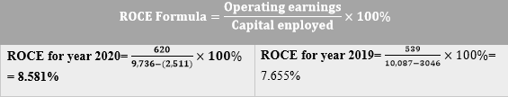
- ROE stands for Return on Equity. Return on Equity can be calculated dividing Net Income by Shareholders’ equity (Salavei, 2016). This ratio measures profitability in relation to equity. ROE is expressed in percentage. The ROE of Chocco PLC is as follows:
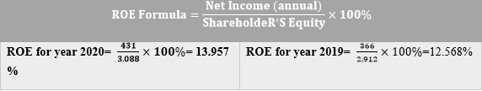
- Earnings per share is expressed shortly as EPS. Earnings per share can be calculated as a company’s profit divided by the weighted average shares outstanding (Ross, 2013). The result of Earnings per share ratio gives the indication of company’s profitability. The calculation of Earnings Per share of the company Chocco PLC is as follows:

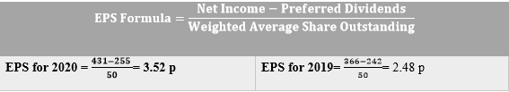
- Net profit Margin of the organisation indicates the amount of net income generated as the percentage of revenue (Purnomo, 2018). The total amount of net income from the total revenue generated by the company in percentage is net profit margin (Financial Ratios, 2021). The Net profit margin of the company Chocco PLC is given below:
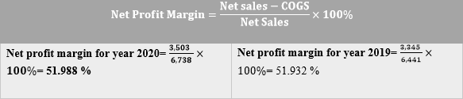
- The asset turnover is the ratio analysis to measure the efficiency of company’s asset in generating revenues or sales (Ross, 2013). The asset turnover ratio for the Chocco PLC is being calculated below for the year of 2019 and 2020:
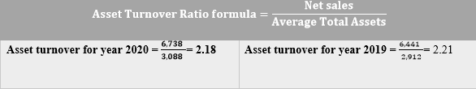
- Stock holding days is the indicator of the sale rate of the company. It is also known as inventory days or inventory outstanding. The inventory outstanding is the number of days stock needs to turn into sales. Chocco PLC’s The stock holding days is calculated below to determine how often the stock of the company is being emptied and refilled:
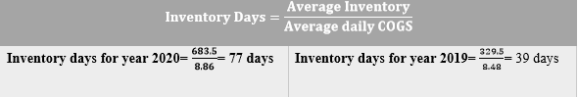
- Debtor’s collection period refers to the average period for collecting debts of the company. Debtor’s collection period of Chocco PLC for the year of 2020 and 2019 is being calculated below:
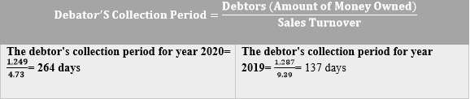
- The Current Ratio of the company compares total assets to the total liabilities of the business organisation (Purnomo, 2018). The current ratio indicates the ability to reduce liabilities and short term obligations within the given period of time. The current ratio considers liabilities with expiration of one year. The current ratio of Chocco PLC for the year of 2020 and 2019 is being calculated here:
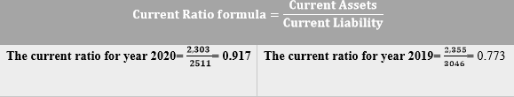
- The type of financial ratio which calculates the financial leverage of the business organisation is known as gearing ratio. Gearing ratio compares few form of owner’s equity to the debt or fund which is borrowed by the company (Amiram, Bozanic and Rouen, 2014). The calculation of gearing ratio of the Chocco PLC for the year 2020 and 2019 is being calculated below:
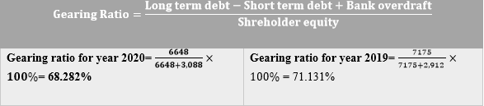
- The ratio which calculates the rate in which a company can repay its outstanding debts. It is the measurement of company’s ability to repay debt interest within a period of time. The interest Coverage ratio for Chocco PLC is calculated below:
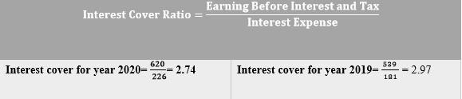
Financial ratio of the organisation indicates financial position and performance (Purnomo, 2018). Effective information using financial ratio analysis tool can give proper decision making scope to acquire progress and set new goals for the business organisation.

- b) Using the information in the financial statements and the ratios you have calculated, comment on the financial performance and position of Chocco plc.
Chocco PLC is a chocolate and confectionary manufacturer situated in London, UK. The business is currently operating worldwide and growing day by day. To understand the financial condition of the company various important financial analysis are made using given information on the company (Amiram, Bozanic and Rouen, 2014). The number gained by implementing the financial analysis formula gives the indications on organisation’s health and financial condition. Analysis of financial performance and position of the Chocco PLC is given below:
- Return of the Capital Employed (ROCE) for the year of 2020 and 2019 of the company Chocco PLC is 8.581% and 7.655% respectively. There is no ideal percentage that indicates the best number of ROCE for any organisation. The ideal percentage of ROCE is varies from the industry to industry. The competitive market ROCE percentage of 10% is considered good (Metcalf and Titard, 2018). The ROCE is increased compared to the year 2019 in 2020. Chocco PLC needs to push forward for the better performance of the business.
- In the year of 2020 the ROE is 13.957% and 2019 ROE is 12.568 for the Chocco PLC. The return of equity for the Chocco plc is increased yet not good. The average of 15% to 20% of ROE is considered good for the business.
- Earnings per Share of the Chocco PLC is 3.52p and 2.48p for the year of 2020 and 2019. Earnings per share of the organisation can be upto 99. In that case the the EPS needs to be increased.
- Net Profit margin of Chocco PLC is 51.988% and 51.932% for the year of 2020 and 2019 respectively (Joy Thomas , S.Rabiyathulbasariya, 2017). Net profit margin of the organisation expresses the net sales of the company. The net profit margin of the Chocco PLC is slightly increased. The profit margin of PLC is excellent.
- Asset Turnover ratio of Chocco PLC is 2.18 and 2.5 for the consecutive year of 2020 and 2019 (Metcalf and Titard, 2018). The present Asset turnover ratio is lesser compared to the previous year’s number. The turnover ratio is double in number which is good for the business.
- The pandemic coronavirus has the impact on the number of stock holding days or inventory days for the Chocco PLC (Metcalf and Titard, 2018). The number of stack holdings days is 77 days and 39 days respectively for the year of 2020 and 2019. The necessary steps regarding online delivery and contactless delivery system can reduce the number of stock holding days and bring it closer to the ideal 5 to 10 days.
- The average debtor’s collection period for the Chocco PLC for the year of 2020 and 2019 is 264 and 137. The collection period of debt must be decreased.
- The present current ratio of the Chocco plc for the year of 2020 and 2019 is 0.917 and 0.773 consecutively. The current ratio is increased but not enough.
- Chocco plc’s gearing ratio is 68.282% and 71.131% for the year of 2020 and 2019. The gearing ratio of Chocco PLC is very good although it decreased compared to previous year.
- Chocco PLC’s Interest cover ratio in the year of 2020 and 2019 is 2.74 and 2.97 respectively. The interest coverage number of the Chocco PLC is healthy.

Financial analysis numbers of the Chocco PLC indicates that the organisation is in good shape and functioning properly (Amiram, Bozanic and Rouen, 2014). However, the financial performance of the organisation is needed a boost to do more good. The numbers indicated that the organisation is have scopes to use assets properly and has drawback in meeting short term obligations of the organisation. The current ratio indicates that the company is capable of paying its existing debts. Again profit margin shows that company is efficient and capable of managing its costs. Return on equity measures a company ability to generate earnings in relation to its shareholders equity. Good working capital shows company’s capability to reimburse its current liabilities with short term assets. We can wrap up that return on equity can produce more revenue.
Conclusion

Financial analysis of the company provides potential information which can be used to take necessary steps for the betterment of the organisation. Fundamentals of accounting enables the uses of proper accounting tools which depicts clear financial picture of any organisation. The proper knowledge about accounting will provide prospect for any individuals and organisation.

References

Amiram, D., Bozanic, Z. and Rouen, E., 2014.
Financial Statement Irregularities:
Evidence from the Distributional Properties of Financial Statement Numbers.
SSRN Electronic Journal, 5(4), pp.122-178.

Cole, W., 2012.
Fundamentals of accounting. 9th ed. New York: Rarebooksclub Com.

Edmister, R., 2017.
An Empirical Test of Financial Ratio Analysis for Small Business Failure Prediction.
The Journal of Financial and Quantitative Analysis, 7(2), p.1477.

Edwards, J. and Mellett, H., 2017.
Introduction to accounting. 3rd ed. London: P. Chapman Pub.

Gilbertson, C., Lehman, M. and Ross, K., 2014.
Fundamentals of accounting. 3rd ed. Mason, Ohio: Thomson/South-Western.

Jinjarak, Y., 2014. Equity prices and financial globalization.
International Review of Financial Analysis, 33(5), pp.49-57.

Joy Thomas , S.Rabiyathulbasariya, J., 2017.
Measuring Financial Performance through Ratio Analysis \"A General Study on The Ratio Analysis Tool to Trigger out Financial Performance\." International Journal of Accounting and Financial Management Research, 7(6), pp.37-44.

Metcalf, R. and Titard, P., 2018.
Introduction to accounting. 6th ed. Philadelphia: Saunders.

Corporate Finance Institute. 2021. Financial Ratios
https://corporatefinanceinstitute.com/resources/knowledge/finance/financial-ratios/
Accessed: 28 August 2021

Investopedia. 2021. Balance Sheet.
https://www.investopedia.com/terms/b/balancesheet.asp
Accessed 28 August 2021

Johnson, W., 2019.
The Cross-Sectional Stability of Financial Ratio Patterns.
The Journal of Financial and Quantitative Analysis, 14(5), p.1035.

Salavei, K., 2016.
Implications of financial statement restatements of different items.
Applied Financial Economics, 20(11), pp.879-890.

Velez-Pareja, I., 2012.
Financial Analysis and Control - Financial Ratio Analysis (Slides).
SSRN Electronic Journal, 5(2), pp.44-62.

