

Programme: MSc Data and Artificial Intelligence
Module: L7 – Advanced Statistical Programming
Module code: ACCA7022
Week 2 Activity
Report Title: Understanding the Role of Statistics in Machine Learning and Data Science
Lecturer: Dr Aliyu Sambo
Student Name: Darpanbhai Raiyani
Student ID: 2534009

Key question: How do statistical methods underpin modern machine learning (ML) and data science (DS) techniques, and where does statistical thinking remain indispensable in an era of automated, large-scale prediction?
Although machine learning is often framed as a discipline distinct from statistics, both fields share the same mathematical foundations of probability and estimation theory. Efron [1] argues that large-scale prediction algorithms such as neural networks, boosting and random forests are best understood as computationally intensive descendants of classical regression, and that the historical divide between “estimation/attribution” (statistics) and “prediction” (ML) is narrowing as both traditions borrow from one another. This convergence is reflected in core ML evaluation practice: techniques such as cross-validation and bootstrapping, both statistical resampling methods, remain the standard means of estimating a model’s generalisation error and quantifying uncertainty in its performance.
Statistical thinking is most visible in feature selection and model validation. Allen, Gan and Zheng [3] show that interpretable ML techniques such as the LASSO rely on statistical concepts of selection consistency and stability to determine which features are genuinely important rather than artefacts of noise, and that rigorous validation — through data-splitting, resampling and formal statistical inference — is essential before a “discovery” made by a model can be trusted. Jung, Jung and Cole [5] illustrate this in practice, combining gradient-boosted feature importance with statistical filtering to build reliable predictive models for materials science, showing that even highly automated ML pipelines depend on statistical criteria to avoid overfitting.
Classical statistical ideas continue to shape modern data science workflows well beyond individual algorithms. Gelman and Vehtari [2] trace how developments such as regularisation, bootstrapping and multilevel modelling — all rooted in twentieth-century statistics — now underlie contemporary ML practice, while Craiu, Gong and Meng [4] describe statistics as providing the essential “senses” (e.g., calibration of uncertainty, robustness) that keep data-driven decision-making disciplined across the wider data science ecosystem.
Overall, the literature converges on a consistent message: machine learning provides powerful predictive tools, but statistics supplies the theoretical grounding, validation logic and uncertainty quantification needed to make those predictions trustworthy.
References
[1] B. Efron, “Prediction, estimation, and attribution,” Journal of the American Statistical Association, vol. 115, no. 530, pp. 636–655, 2020.
[2] A. Gelman and A. Vehtari, “What are the most important statistical ideas of the past 50 years?,” Journal of the American Statistical Association, vol. 116, no. 536, pp. 2087–2097, 2021.
[3] G. I. Allen, L. Gan, and L. Zheng, “Interpretable machine learning for discovery: Statistical challenges and opportunities,” Annual Review of Statistics and Its Application, vol. 11, no. 1, pp. 97–121, 2024.
[4] R. V. Craiu, R. Gong, and X.-L. Meng, “Six statistical senses,” Annual Review of Statistics and Its Application, vol. 10, no. 1, pp. 699–725, 2023.
[5] S. G. Jung, G. Jung, and J. M. Cole, “Gradient boosted and statistical feature selection workflow for materials property predictions,” Journal of Chemical Physics, vol. 159, no. 19, p. 194106, 2023.
Supplementary Visuals (for discussion).
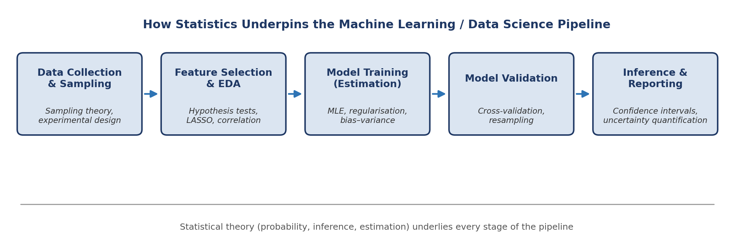
Figure 1. Statistical methods (sampling theory, hypothesis testing, regularisation, cross-validation, uncertainty quantification) support every stage of a typical ML/DS pipeline [1], [3], [5].
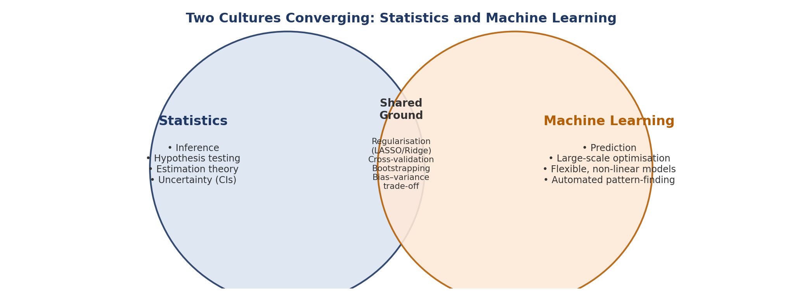
Figure 2. Statistics and machine learning are best viewed as overlapping traditions rather than rivals, converging on shared tools such as regularisation and resampling [1], [2], [4].

