

Employment Relationship

Human Resource Management

M6X01291
Kamila Andrzejewska | P125093 | 31/10/2018

Table of Contents.

- Introduction ………………………………………………………………………………………….….2
  - The Employment relationship theory ………………………………………………..2
- Discussion …………………………………………………………………………………………...2-10
2.1. Understanding Employment Relationship ……………………………………...2-3
Figure 1. The Dimensions of the Employment Relationship …………3
2.2. Maslow’s Theory ………………………………………………………………………….…..3-5
2.3. The Adam’s Equity Theory ………………………………………………………..……..5-6
Figure 2. Inputs, equity, outputs …………………………………………….………5
2.4. Study case …………………………………………………………………………………………….6
2.5. The Herzberg’s Motivators and Hygiene Factors ……………………….………. 7
Figure 3. Factors for satisfaction/ Dissatisfaction ………….……………….7
2.6. Tesco TLC Business HR Strategy……………………………………………….……..7-10
2.6.1. Motivational Theories …………………………………………………………………..……8
Figure 6. Herzberg’s Satisfiers, Hygiene Factors …………………………….8
Figure 5. Maslow’s “Hierarchy of Needs” in use by Tesco ……………….9
2.6.2. Some of the specific Tesco HR Strategies ………………………………………9-10
Figure 6. Tesco’s rewards for hard work ………………………………………….10
- Conclusion ………………………………………………………………………………………….……10-11
- References ………………………………………………………………………………………………..12-

Introduction.
The paper will discuss an argument that are for and against the statement of many commentators who stated that employment relationship is not just an economic transaction but in fact has also social and moral connotations. The theory of employment relationship will be explained in detail. The paper will cover the Adam’s theory, Maslow’s “hierarchy of needs” and Herzberg’s Motivation/ Hygiene theory. The paper will also critically evaluate Tesco’s implications of employment relationship and the different approaches that it adopted to motivate people working at Tesco.

The Employment Relationship Theory.
Employment relationship can be described as “a formal and informal relationship between the employing organization and an employee” (Price, 2004). In everyday life, be it personal or organizational, human beings have to relate themselves to others. The term employment relationship “describes how employers and employees work together” (Armstrong and Taylor, 2014). An interdependency between both employer and employees is an indicator of good employment relationship. Positive employment relationship comes also with a mutual trust. The relationship such as this creates a foundation for employer and employee’s policies, involving development of climate of trust (Armstrong and Tylor, 2014). It also helps to distinguish what the employers need to be aware of when developing and applying Human Resource Management, procedures, policies and human relation processes (Nscpolteksby.ac.id., 2018).
The UK law describes the term employee as “ someone who works under and employment contract” (GOV.UK, 2019). It is assumed that the third party to the employment contract is the employer. The procedure agreements and work rules can also describe what an employment relationship is (Nscpolteksby.ac.id., 2018).
The employment relationship can also be defined “by such means as procedure agreements and work rules” (Armstrong and Taylor, 2014).

Discussion.

Understanding Employment Relationship.

In essence, the employment relationship is a an informal process that can happen at any time when the employer and employees work together (Armstrong and Taylor, 2014). This process is not unique to the human nature, people naturally have to build relationships with each other in their privet and social life’s. The only difference between building relationships in a privet or social life and the employment relationship is that in the working environment people follow by certain, already set rules and standards that are established by the organization. The main initiative is that the employer needs the employee and the employee needs the employer. At workplace the employment relationship is built in order to achieve the co-operation between employer and employees. What makes a strong foundation of the employment relationship is the psychological contract (Nscpolteksby.ac.id., 2018). A positive approach of the management is very crucial, the managers are required to continuously build, develop and nurture relationship with the employees on regular constant basis.

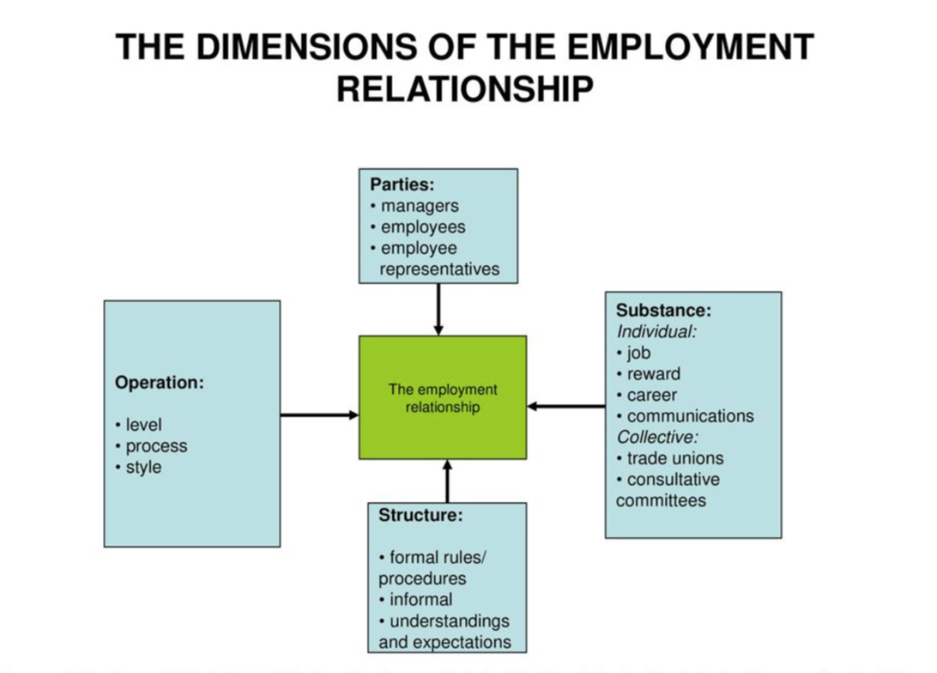
Figure 1. The Dimensions Of The Employment Relationship. Source: (Armstrong and Taylor, 2014).

Maslow’s Theory.
First argument that can be used for the statement which argues that the employment relationship is not just and economic transaction but it also has social and moral connotation is the behavioral science movement on the human relations and human factors approaches which took place in 1950s and 1960s. The movement has delivered theories that have influenced further studies and working environments (Price, 2004). The study was carried out to test the motivation of people to work and how the motivation impacts on the human performance. For instance, the Maslow’s hierarchy of needs, which is five-tire model (divided into three main categories), demonstrated the deficiency and growth needs of employees. The deficiency (D-needs) includes first four levels which are:
- Basic needs;
- Physiological needs (food, water, rest, warmth).
- Safety needs (security, safety).
- Psychological needs;
- Belongingness and love needs (intimate, relationships, friends).
- Esteem needs (prestige and feeling of accomplishment).
- Self-actualization (achieving one’s full potential, including creative activities).
(simplypsychology.org, 2018).
The first level Maslow regards as the deficiency needs because those needs are basic and people are highly motivated into action once those needs have been satisfied. As for the rest four levels Maslow regarded them as the ‘being’ needs. The ‘being’ needs (B-needs) can also be called the growth needs or the higher order needs. Furthermore, those needs deal with the self-actualization and self-development, basically the most a person can be (simplypsychology.org, 2018).
However, the main argument of Maslow’s theory was that individual people must satisfy their lower level of needs that are deficit before they may move on to the higher level of needs. Maslow’s has also stated that those needs don’t necessary have to be satisfied 100% before the emerging of the progress to the higher levels of growth needs. This happens when the deficit need is ‘more or less’ satisfied, so it than just simply disappears and a new need emerges with the silent demand for its satisfaction. The needs for growth never stay at the same level, but it rather continues to grow and becomes even stronger when people get absorbed in it. For instance, when the person deficiency need isn’t satisfied the motivation will be at its peak.
Maslow argues that human needs are organized in a hierarchy:
“It is quite true that man lives by bread alone-when there is no bread. But what happens to man’s desires when there is plenty of bread and when his belly is chronically filled? At once other (and “higher”) needs emerge and these, rather than physiological hungers, dominate the organism. And when these in turn are satisfied, again new (and still “higher”) needs emerge and so on. This is what we mean by saying that the basic human needs are organized into a hierarchy of relative prepotency” (Maslow, 2018).
The hierarchy of needs by Maslow’s has carried and delivered a research on the reasons why people work. Maslow’s has “argued that people satisfied an ascending series of needs from survival, through security to eventual ‘self-actualization” (Price, 2004). Maslow’s research delivers a ‘soft’ approach to management (Price, 2004). This philosopher promoted a theory, that people work for various of reason and the greatest reason according to Maslow’s is that people need to satisfy their needs. Those needs vary from the basic needs, psychological needs to self-fulfillment needs. Abraham Maslow said that “if you only have a hammer, you tend to see every problem as a nail” (brainyquote.com, 2018). He has also argued that people need to satisfy their needs that are in the lower hierarchy before they start to think about satisfying their next need which they never knew or have been focusing on previously.

Adam’s Equity Theory.
The Adam’s Equity Theory was developed in 1963. The theory is focused on different points of views that people have about how they are being treated and how others are being treated compared to them. “To be dealt equitably is to be treated fairly in comparison with another group of people (a reference group) or a relevant other person” (Armstrong and Tylor, 2014). The Adams Equity Theory states that to be treated with equity the employee has to be treated fairly.
The equity usually manifests what is accepted as fair. When the employees feel that are being dealt with unfairly they are more likely to be demotivated and may even quit their job. The opposite to that is when people are feeling that they are fairly treated they prone to be highly motivated.
“ Equity involves feelings and perceptions and it is always a comparative process. It is not synonymous with equality, which would be inequitable if they deserve to be treated differently” (Armstrong and Taylor, 2014). The theory of motivation involves the statement that equity is not the same as equality and that different people deserve a different treatment.

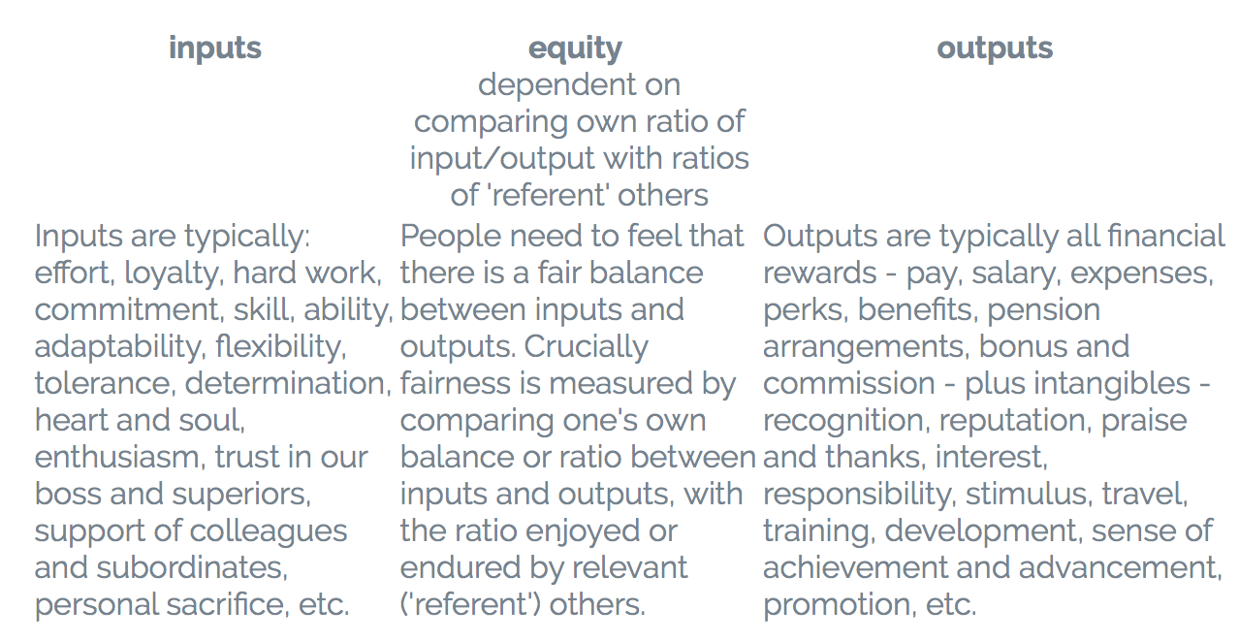
Figure 2. Inputs, Equity, Outputs. Source: (Businessballs.com, 2018).

The theory describes the reasons why and how the employees feel positive and motivated today but if the next day there isn’t any change to their working terms and conditions the motivation and positivity can disappear when the employee sees that their colleague’s reward -to-effort ratio is greater . So, the employees attitude can change depends on the situation they’re at or how they see other collogues being dealt with by the employer, compared to the treatment they receive. The above Figure 2 shows the inputs, outputs and equity. If the employees feel like that they are being fairly rewarded by the outputs then they are most likely to be more happier at work place and the motivation will be higher therefore the input level of employee’s will continue to be the same. However, an employee become demotivated regarding their job and employer, if the employee doesn’t receive an according output compared to the input (Businessballs.com, 2018).
The theory of equity explains that the employer can expect positive outcomes and motivation from the employees when the employer shows that he or she can provide a fair treatment to the employees (Mindtools.com, 2018).
Adam’s Equity theory proves that people get motivated by many outputs. These outputs may vary from financial rewards to recognition, reputation, sense of achievement, promotion and so on. The outputs not necessarily have to be monetary to motivate people to work.

Study case.
In the 1919 the UK National Institute of Industrial Psychology (NIIP) was created by a group of researchers. The NIIP worked together with previously created (1913) Australian Institute of Industrial Psychology (AIIP). The NIIP and the AIIP have proved that people don’t solely get motivated by monetary rewards. These institutes have worked together to research and investigate the conditions of work and have created an employment guidance and techniques (Price, 2014). In Australia the occupational psychologists have carried out a study on fatigue and monotony. The study was organized by the Christchurch branch of the YMCA. The people believed that the fatigue was caused by the toxins that were building up in the blood. Some people thought that those toxins could be neutralized by injection of and antidote into the workers when they would start to feel exhausted and in that way they, the workers, would stop feeling fatigued and work forever. The researchers have proved that the workers don’t only get fatigued because of physiological reasons but it has also psychological side to it. The researchers went on to argue further that the workers could work effectively if the tasks were divided and given out to various of individuals. That is because, different individuals tend to be performing different tasks differently (Price, 2014). Certain people are good at doing certain tasks but may not be as good at performing some other tasks. Some people work more effectively when are given permission to be using their own performance methods. The study also proves the fact that people work for the social relations reasons too. The productivity of people raises when workers are treated as they should be- as human beings. The NIIP research has been mostly on the soft approach however the hard approach couldn’t been avoided when selecting workers to specific jobs.

Herzberg’s Motivators and Hygiene Factors.
In the 1950s and 60s, Frederic Herzberg wondered about the same question many commentators have asked themselves “ What do people want from their jobs? Do they just want a higher salary? Or do they want security, good relationships with co-workers, opportunities for growth and advancement - or something else altogether?” (Mindtools.com, 2018). Herzberg wanted to determine what is the drive for motivation of working people. He has done his study by asking people if they are satisfied or dissatisfied regarding their jobs. He received different reactions from people. But he has discovered that people who feel good about their job gave different reasons from the people who felt bad about their jobs (Mindtools.com, 2018).
The findings of Herzberg Two Factor Theory (Herzberg Motivation – Hygiene Theory) have delivered motivating factors and hygiene factors. These factors are associated with job satisfaction or dissatisfaction which are showed in the Figure 3 below.

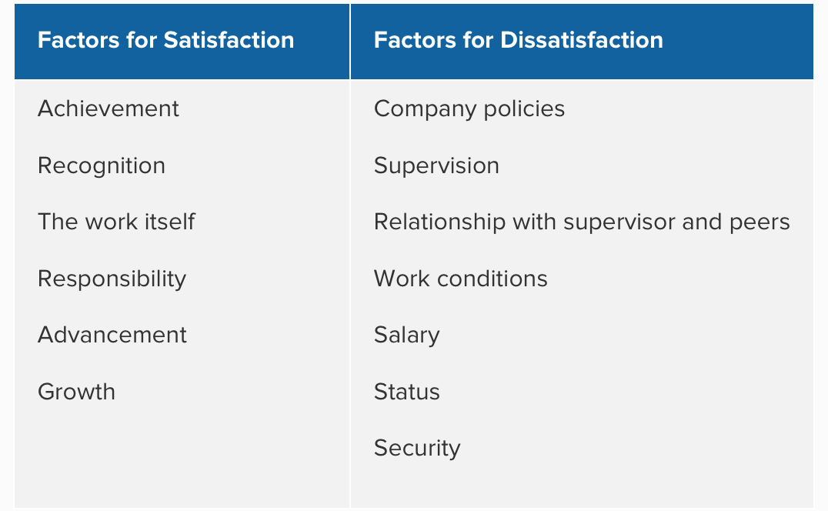
Figure 3. Factors for satisfaction/ Dissatisfaction. Source: (Mindtools.com, 2018).
Herzberg has argued that there are certain factors that motivate people to work. In contrast, the hygiene factors are the ones which create dissatisfaction and demotivate people. Herzberg demonstrated that to motivate an employee certain improvement in the business need to be made and that the employee need to feel fulfilled at working environment (Tesco, 2010).
  - Tesco tlc business HR strategy.
HRS (Human Resource Strategy) is a key aspect in every business achieving success. HRS “indicate what the organization wants to do about its human resource management policies and practices and how they should be integrated with the business strategy and each other. They set aspirations that are expressed as intentions which are then converted into actions” (Armstrong and Tylor, 2014). All organizations cannot apply the same set of strategies because each organization is different and have altered aspirations, and different aims of directions.
Around 440,000 people work for Tesco TLC around the world, Tesco strives to motivate its staff members to give better customer service every day. Tesco’s aim is to give its employees best experience, it can, while working in a friendly and tolerant environment of Tesco (Tescoplc.com., 2018). The net profits of Tesco, as the largest British retailer, is around £3.4 billion. The success of Tesco is an outcome of work of 468,000 employees around the world. To be keeping up with to the customer’s needs and continue its growth, Tesco recognizes its need for staff that is motivated, well trained and flexible (Tesco, 2010). As a part of the culture of Tesco is that every year Tesco invites its employees to take part in Viewpoint, staff satisfaction survey, which allows the staff to express their views on a wide range of aspects of their job. In result of the survey Tesco receives the information from its staff members of what will keep them motivated and strives to provide the right rewards. Amongst the rewards are:
- “ lifestyle break- this offers 4-12 weeks off work and guarantees the job back at the end,
- Career break- this allows staff between 6 months and 5 years away from work with right to return,
- Pension scheme- this award-winning scheme provides clearly defined long term benefits”
(Tesco, 2010)
Tesco takes into consideration that their business heavily depends on two groups of people. Those people that are customers and those who are employees. What Tesco also realizes is that all those people who work for them are unique and have various lifestyles. That’s why Tesco have started to motivating its employees by supporting them with work/life balance and provides rewards for them in the form of “flexible working, free or reduced rate health benefits, discount gym membership, competitive salaries, staff discount, company share options” (Tesco, 2010). By supporting people and providing work/life balance rewards, Tesco employees feel motivated as they feel that they can fulfil their commitments at home while being able to work and balance it all out.

Motivational Theories
Tesco uses two different motivational theories, those theories are well known as Herzberg and Maslow’s theory. As previously explained in the above chapters, the theories of Herzberg and Maslow’s are mainly focusing on rewards in terms of good environment, money, opportunities, fulfilment of ones needs and different policies that allow to motivate people (Tesco, 2010). By focusing on Herzberg Motivation Theory, Tesco motivates its staff by focusing on hygiene factors and allowing satisfiers. The employees get motivated when they get empowered. For instance, Tesco delegates responsibility and gets the employees involved in decision making. Moreover, the employees are able to take part in pay raise discussions or decide which food will go on the restaurants menu (Tesco,2010). The involvement in decision making makes the employees highly more motivated.
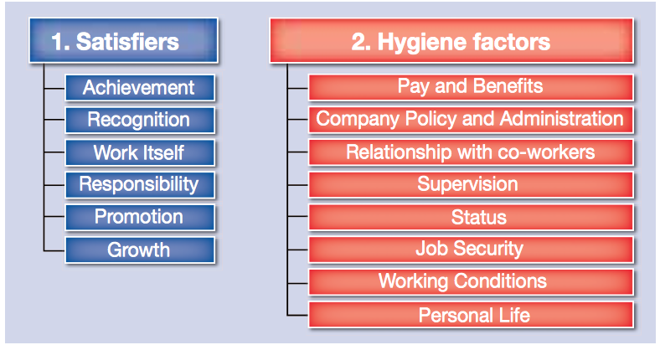
Figure 4. Herzberg Satisfiers, Hygiene factors. Source: (Tesco, 2010).
Using Maslow’s theory has helped Tesco to establish good technique of keeping the employees motivated. Maslow’s theory demonstrates that workers get motivated by various factors.
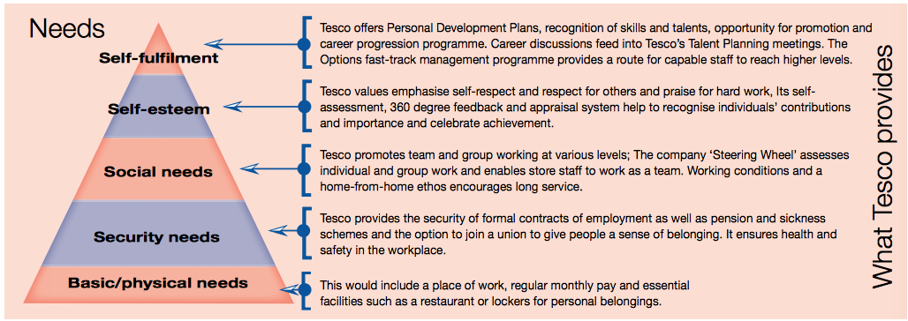
Figure 5. Maslow’s “Hierarchy of needs” in use by Tesco. Source (Tesco, 2010)

Some of the specific Tesco’s HR strategies.
- Employee training – one of the main components of Tesco’s HR. Tesco is investing in training its staff members so that they are supported in developing their careers and skills for the future (Tesco, 2010).
- Reward- Tesco offers rewards through “ flexible working, free or reduced rate health benefits, discount gym membership, competitive salaries, staff discount, company share options” (Tesco, 2010). Tesco’s employee Reward Programme is similar to Taylor’s theory. However, Frederic Taylor believed that employees are motivated only by monetary rewards (Expert Programme Management, 2019). Moreover, Tesco recognizes the fact that there are other existing factors, than money, that motivate people in working and personal environment. Therefore, Tesco supports various lifestyles of individual employees by tailoring specific and targeted benefits. For instance, a person may be motivated by “desire to serve people; others may be to improve personal skills or achieve promotion (Tesco, 2010).
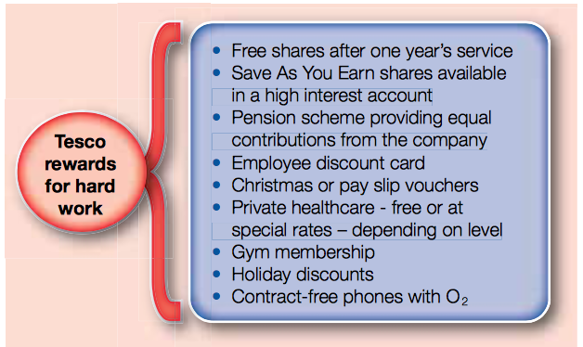
Figure 6. Tesco rewards for hard work. Source: (Tesco, 2010)
- Performance Management- every person working at Tesco is given a set of objectives at the start of the year and has its performance reviewed on annual bases. Moreover, the employees work towards their personal development plan and have career conversations with their line managers (Paton, 2005).
- Talent Management – at Tesco stores “ there is a scheme called Options, which has been designed to give shop staff the skills and experience to develop into managers” (Tesco,2010). Tesco ensures that its staff members who has a talent has an opportunity for success.

Conclusion.
The concept of employment relationship is quite controversial for it doesn’t have a one specific theory for all of the organizations that exists on the market. That is because different people have different ideas regarding how the employment relationship should work in their working environment. The continuous building, developing and nurturing the employee relationships are costly and exhausting however they are very effective in improving efficiency. The paper has demonstrated some essential knowledge about motivational theories which play a key role in good HRM. Maslow’s “hierarchy od needs” have explained the reason behind the question why do people work. Adam’s Theory have showed what motivates and demotivates people to work. Herzberg developed a two factor theory of motivation. The theory have showed that feeling fulfilled at workplace is what truly motivates people.
Tesco recognised that to continue its growth, it must keep their staff members motivated. Tesco does motivates its employees through training, development and by giving the employees appropriate reward and recognition for their achievements. The study has found out about some the Tesco’s HRS. Finally, the paper must conclude that it’s not only monetary rewards that motivates people but it can be various rewards and acknowledgments, recognitions, growth, promotions and different kinds of needs that the individual may have.

  - References

- Armstrong, M. and Taylor, S. (2014). Armstrong's Handbook of Human Resource Management Practice, 13th Edition. 13th ed. London: Kogan Page, pp.5, 26-28, 97, 172-173, 413-416,.

- GOV.UK. (2019). Employment status. [online] Available at: https://www.gov.uk/employment-status/employee [Accessed 23 Apr. 2019].

- Expert Program Management. (2019). Expert Program Management. [online] Available at: https://expertprogrammanagement.com/2018/05/taylors-scientific-management/ [Accessed 20 Apr. 2019].

- Mcleod, S. (2018). Maslow's Hierarchy of Needs. [online] Simply Psychology. Available at: https://www.simplypsychology.org/maslow.html [Accessed 22 Apr. 2019].

- Motivation, A. (2019). Adams' Equity Theory - BusnessBalls.com. [online] Businessballs.com. Available at: https://www.businessballs.com/improving-workplace-performance/adams-equity-theory-on-job-motivation/ [Accessed 22 Apr. 2019].

- Mindtools.com. (2019). Adams' Equity Theory Balancing Employee Inputs and Outputs. [online] Available at: https://www.mindtools.com/pages/article/newLDR_96.htm [Accessed 22 Apr. 2019].

- Nscpolteksby.ac.id. (2018). [online] Available at: https://nscpolteksby.ac.id/ebook/files/Ebook/Business%20Administration/ARMSTRONGS%20HANDBOOK%20OF%20HUMAN%20RESOURCE%20MANAGEMENT%20PRACTICE/15%20-%20The%20Employment%20Relationship.pdf [Accessed 23 Apr. 2019].

- Paton, N. (2005). Supermarket Sweep. Trade Journals, [online] pp.19-23. Available at: https://search.proquest.com/docview/229936819?accountid=130472 [Accessed 19 Apr. 2019].

- Price, A. (2004). Human resource management in a business context. 2nd ed. London: Thomson, pp.13-16,.

- Tescoplc.com. (2018). Serving shoppers a little better ever day. Strategic report.. [online] Available at: https://www.tescoplc.com/media/474794/tesco_2018_strategic_report.pdf [Accessed 19 Apr. 2019].

- Tesco (2010). [online] Is.muni.cz. Available at: https://is.muni.cz/el/1451/podzim2013/np2330/tesco_15_full.pdf [Accessed 19 Apr. 2019].

- Richard, L. (2016). Human Resource Management at Tesco and Sainsbury’s. [online] Perfect Writer UK. Available at: https://perfectwriterukblog.wordpress.com/2016/12/20/human-resource-management-at-tesco-and-sainsburys/ [Accessed 20 Apr. 2019].

