

Effective Team Working and Communication
Module assignment submission

Student Name: | Javier Portaro 1906228  Viktorija Ivanova 1907603  Jhon Salcedo 1909111  Anthony Portaro 1906501  Valentina Mitroi 1906808
Module No. | BMSW4002_LON
Module title: | Effective Team Working and Communication.
Lecture: | Ejiro Esohwode
Date: | 04-05-2020

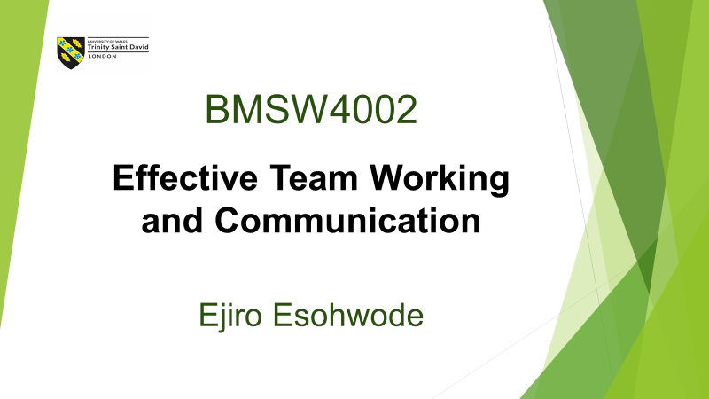
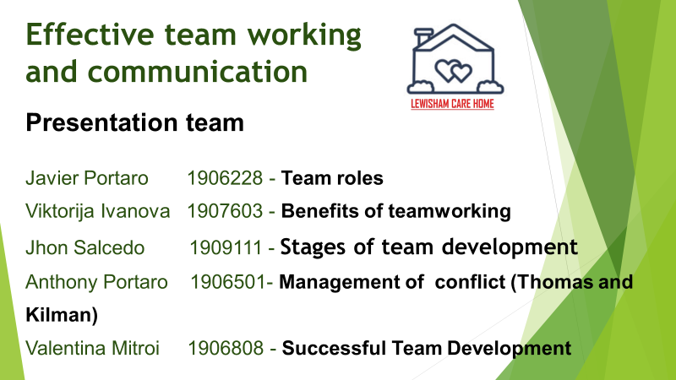

INTORDUCTION
Work in a Care Home is very challenging and responsible. Every member of staff must to be aware and informed about all changes and processes inside. All departments must to cooperate and communicate to be updated. All employees are one unit to achieve the biggest task- satisfy resident’s needs. Therefore, departments are unique teams and is important to understand the main benefits of working together.
BENEFITS OF TEAM WORKING
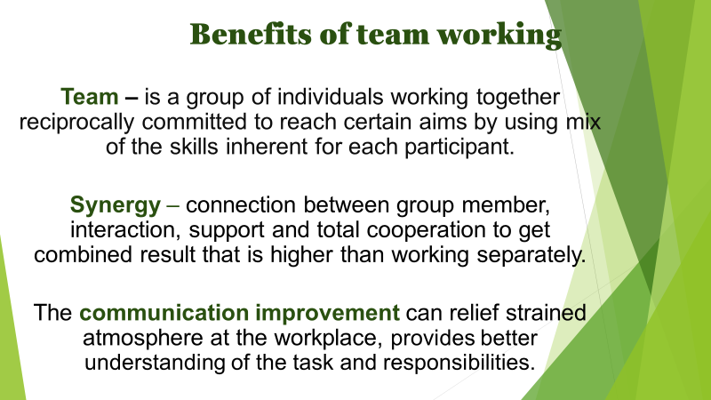

Team – is a group of individuals working together reciprocally committed to reach certain aims by using mix of the skills inherent for each participant (Morgan, 2017). Working as one team means constant communication between members of created team. The communication improvement can relief strained atmosphere at the workplace. The situations can be various, communication provides better understanding of the task, and in case of interest clash good communication can solve the problem to continue work together without misunderstanding and frustration to achieve common goal. Good communication provides one more benefit what is synergy.
Andharad Dalton (2017) defined that synergy is group connection, interaction, support and total cooperation to get combined result that is higher than working separately. It is significant to get group spirit, where the participants can trust each other, do not to be afraid of making mistakes and cooperate to each other.
To work in a team provides support network what means to give help and support to members when needed in case of overload or during difficult and challenging times. It gives opportunity to get advice and lean on each other what reduces stress and confusion at work. And allow to complete the tasks in appropriate way (CIF TRAINING, 2018). In turn when support given and co-workers understand, trust and communicates without the barrier means strong relationships are established, where each of team member feels comfortable.
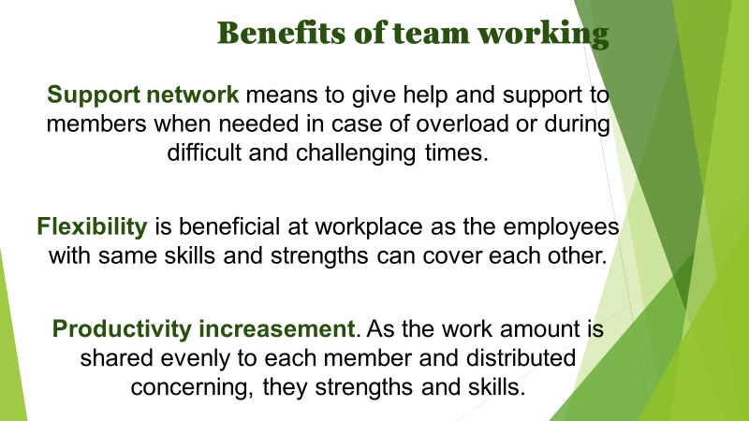
As soon reached synergy and coo-workers collaboration takes a place, the team members became more flexible. Flexibility is beneficial at workplace as the employees with same skills and strengths can cover each other. It means they are able to plan some personal necessary commitments without harming the company’s operation. This type of flexibility provides more calm and friendly atmosphere what improves productivity at workplace (CIF TRAINING, 2018).
Working in a team helps to increase productivity in this case provide, best service on time. As the work amount is shared evenly to each member and distributed concerning, they strengths and skills, the tasks are reached faster and accurately with the high productivity in the result (ProofHub, 2018).
During the work process team members exchange the information what promotes knowledge and skills improvement. And keeps them to be updated at time and place.

STAGES OF TEAM DEVELOPMENT
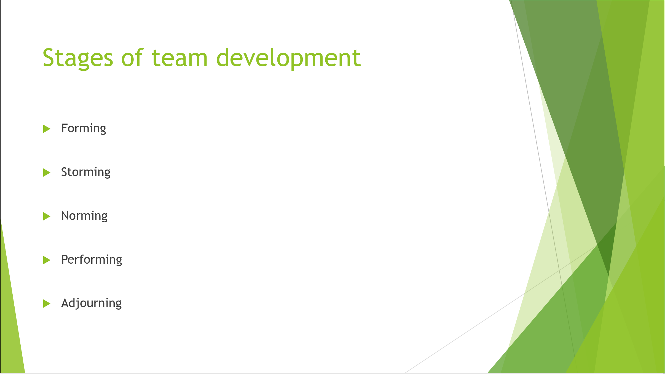
Forming
many people will be concerned and confused about the situation and the other people they worked with because of it at the beginning the participants in this type of company can be between volunteers as workers, the presentation of themselves before the other colleagues and the elderly will be essential to start developing relationships between them, that they feel safe knowing with what types of people will be working in the next days; the ideal is to always maintain a good attitude.

Storming
at this stage many of the workers and volunteers will not feel safe with designated tasks, therefore the ideal to apply it in this for a care home would be to take turns every week between the tasks to be done in this way, they do not stay for a long time in the same position and reduce the possibility of generating conflict either between them and the elderly who live in the care home. older people usually have more problems controlling their feelings.
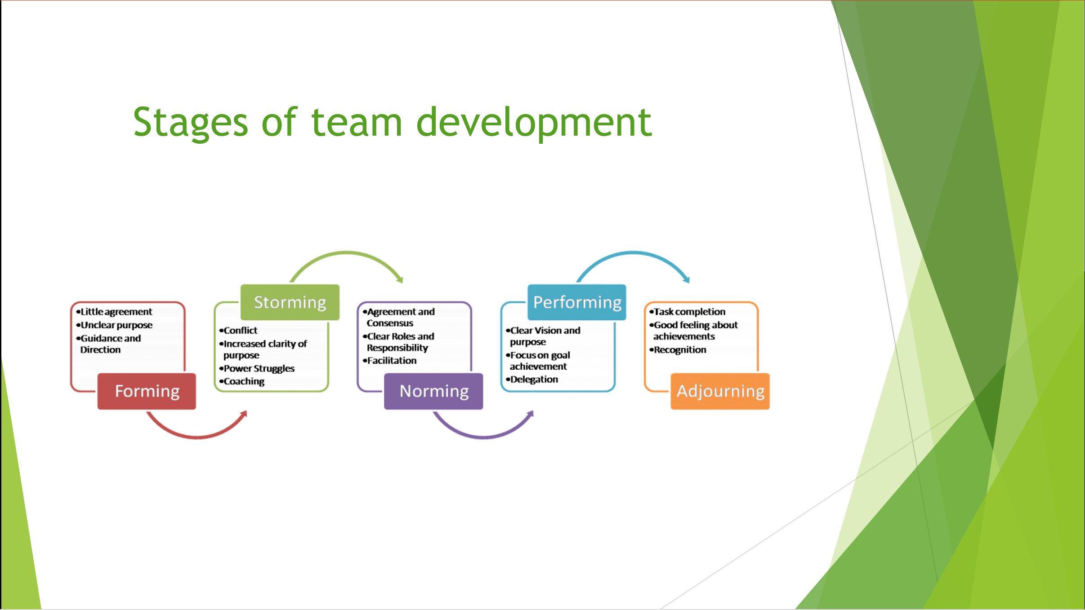
Norming
Once all the personnel are organized and have already found their position in which they feel most comfortable to work, they will proceed to carry out the general norms and specific roles for all so that they are not interrupted with each other to avoid unnecessary delays with unwanted conflicts what if you can listen to are the advice of the other colleagues any help is always welcome to grow as a group, people with whom the elderly feel more comfortable even if they do not like the role should put on your part we must have patience.

Performing
once we have done the previous steps we will reach the end which is the performing they will realize that everyone will be working in good harmony, the problems that may arise with the grandparents can be very difficult but at this time they will work as a group together and they will help each other by making it easier to solve them.
Adjourning
Many of the workers, volunteers and the elderly will feel sad since having managed to achieve a good relationship, the moment of farewell always arrives, leaving feelings of sadness during that moment of celebration that was very important, but the evolution of a team is a process that never ends today you end up with a team but tomorrow you start with a new one
TEAM ROLES
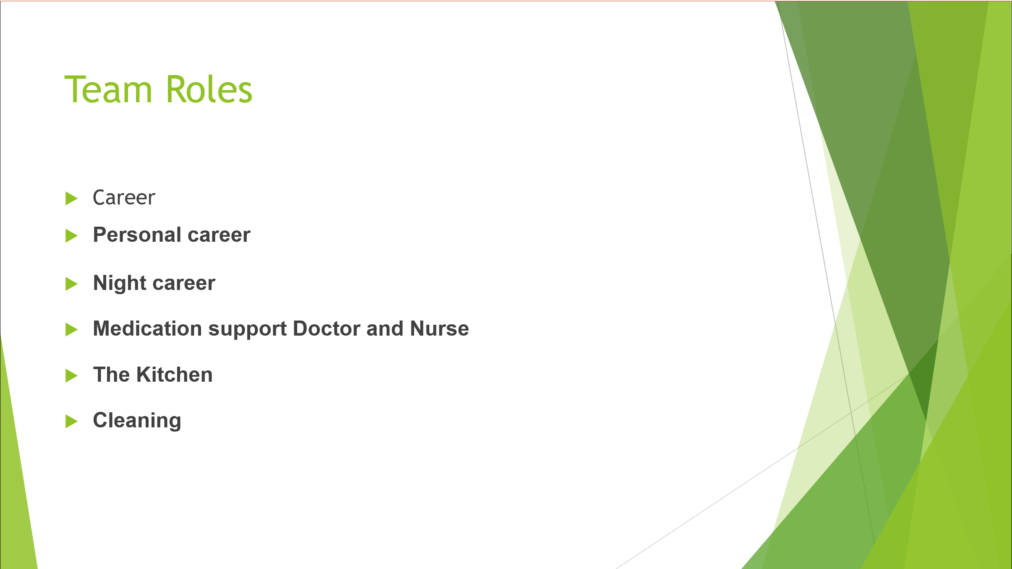
Personal career
The person in charge of providing the daily care of the guest attending to their food, showers, walks and any other need.
Night career
The person in charge of providing care and monitoring at night in case the guest had any health problem. They usually work in fewer numbers because the main job is to monitor sleep and some assistance that arises during the shift.
Medication support Doctor and Nurse
In this case, the doctor is in charge of following up on chronic cases and attending to problems that arise from the guests. The nurses are in charge of providing the required medications in their hours in adequate amounts and coordinate with the caregivers any special situation of any guest.
The Kitchen
One of the most important areas together with the caregivers, since they are in charge of handling the food taking into account some special diet, allergies and health conditions for the guests. This area has a Chef and assistants.
Cleaning
One of the key areas to maintain the cleanliness of the entire complex.They have to have good coordination and teamwork to carry out their tasks in the best way optimizing the time of their work shifts to be able to carry out all the cleaning tasks in time, with the indicated material and processes.
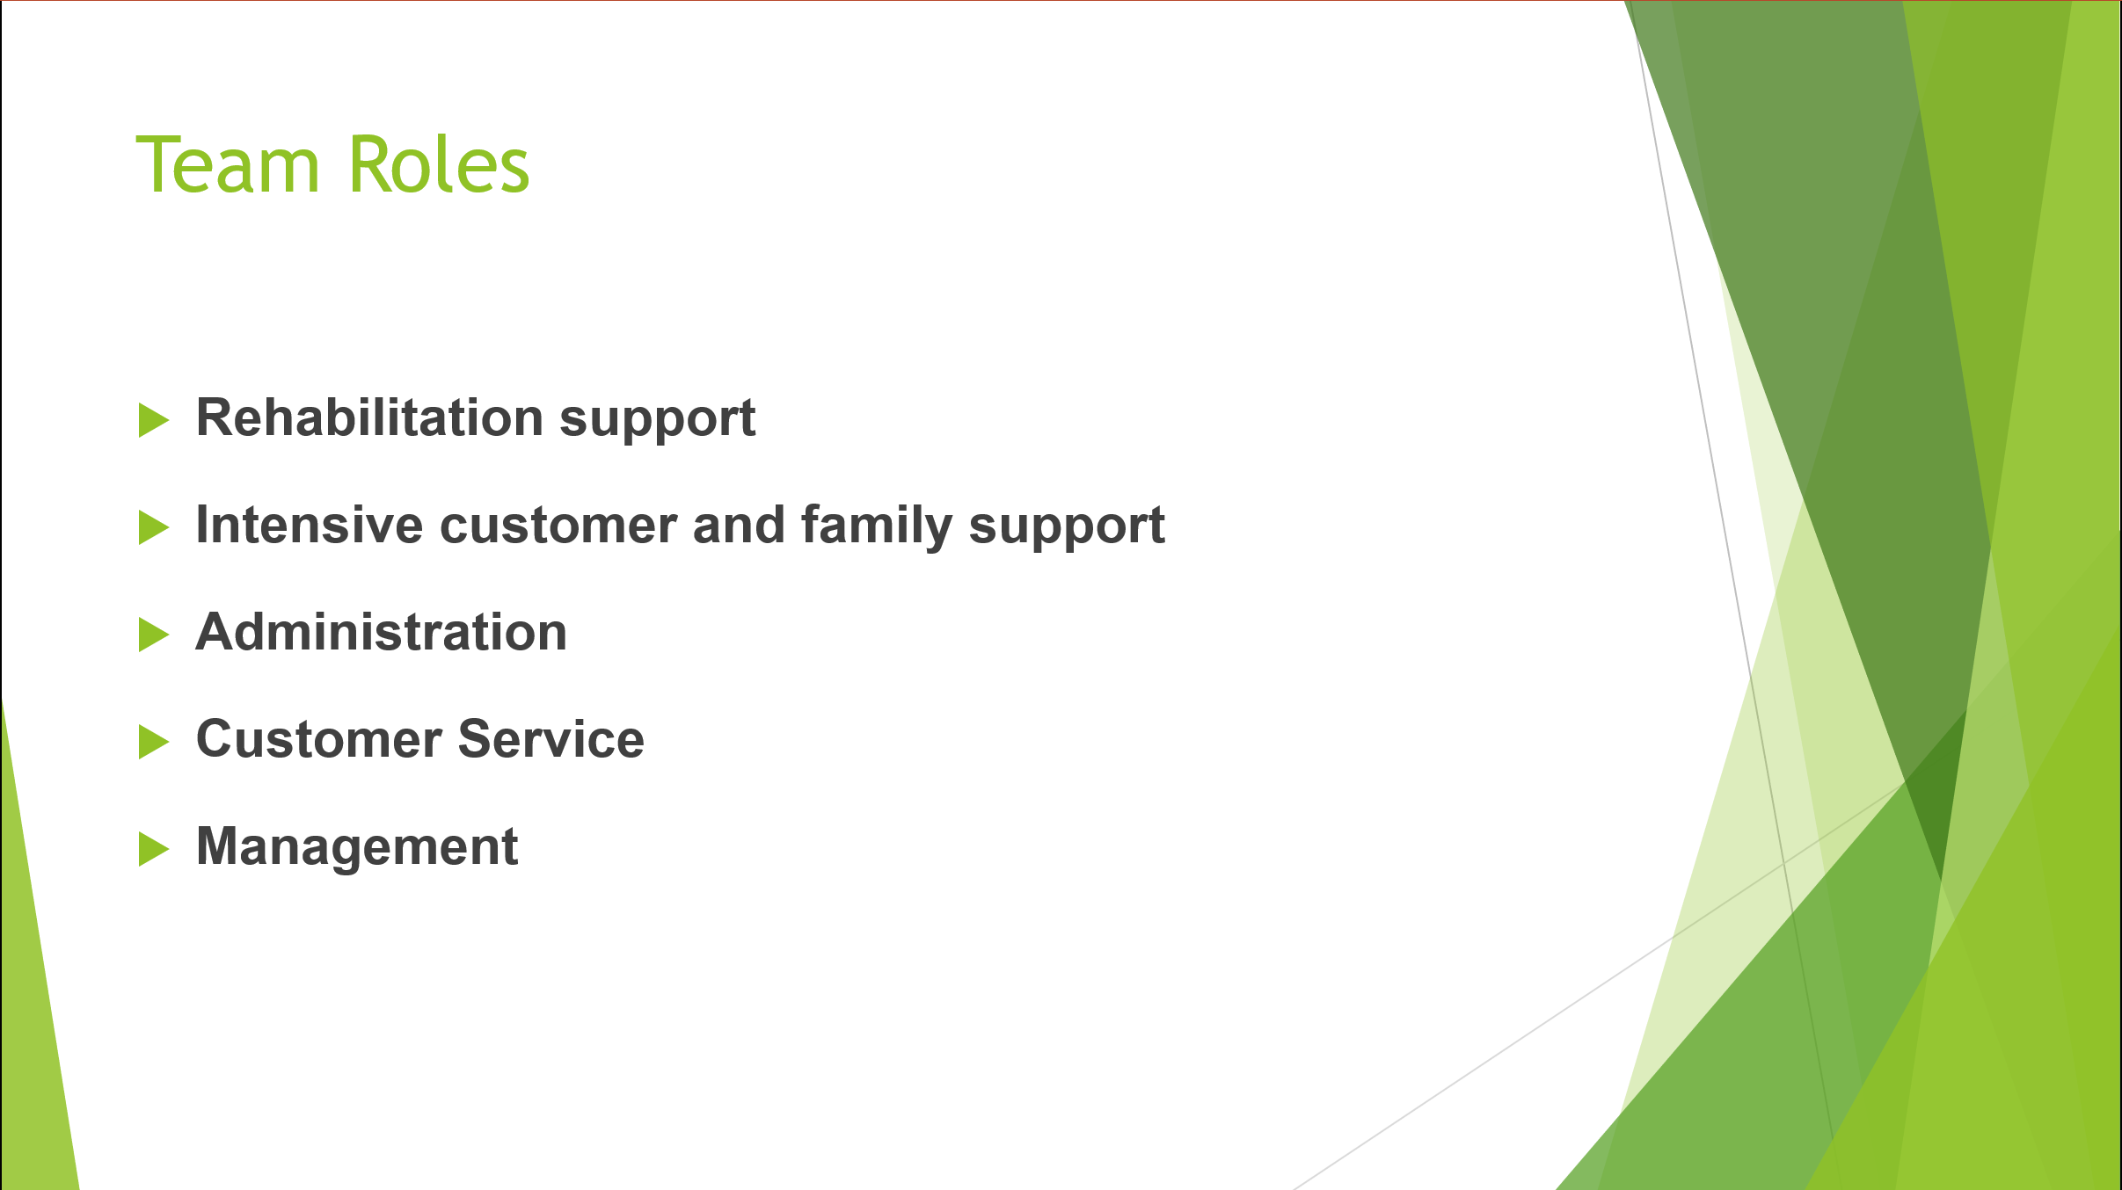

Rehabilitation support
Following an operation or accident we can help you to regain your skills, confidence and independence. We can assist with exercises (under the guidance of your physiotherapist), help you move around your home safely and advise on equipment and adaption aids that could aid your recovery.
Intensive customer and family support
Unfortunately, there are times in life where a bit of tender loving care is needed for the whole family. This is when a much-loved family member or partner has an on-going debilitating illness or becomes terminally ill. Our care teams are especially trained to support both the person and the family to preserve relationships and enable those special moments to still take place.
Administration
They are the people and the area in charge of handling guest documentation issues, such as the admiration of new people whether they are patients or part of the staff.
They have to maintain meticulous control of business documentation to keep everything in order

Customer Service
This area is very important since it is responsible for handling any situation in which any guest has a complaint or observation of the services we provide. The relatives of the guests can also attend to complaints and suggestion. Whether they answer emails, calls and attention in person.
Management
Perhaps one of the most important areas of the company since they are in charge of managing everything from personnel, food and suppliers, along with the annual planning of budgets and work plans.
As well as the commercial strategy to get more guests. They are usually old staff with a lot of experience in the area, together with studies of business and team management.
MANAGING CONFLICT (Thomas and Kilman)

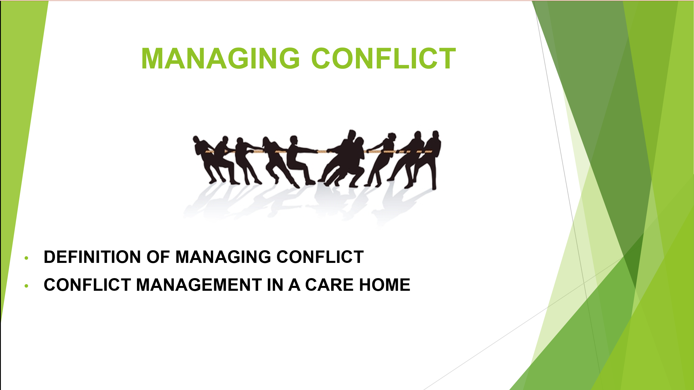
Definition and why is important
Conflict management means a series of thoughts and ideas designed to control and thus be able to reduce negative conflicts and improve positive results for all parties involved in the conflict.
Conflict management in a care home
Working in a nursing home can be an amazing, rewarding and enriching experience.
Many of the people who decide to work in this type of care for the elderly are because they worry and want to mark the before and after in the life of the people in their care. They are great people who take care of and help improve people's lives on a daily basis.

IMPORTANCE OF TEAMWORK TO MANAGIN CONFLICTS
A team combines people who work together and cooperate to achieve their goals. To manage conflicts and reduce them, the best way is to work as a team and mediate a solution between all of us to achieve the objective. From the team leader to the last worker.

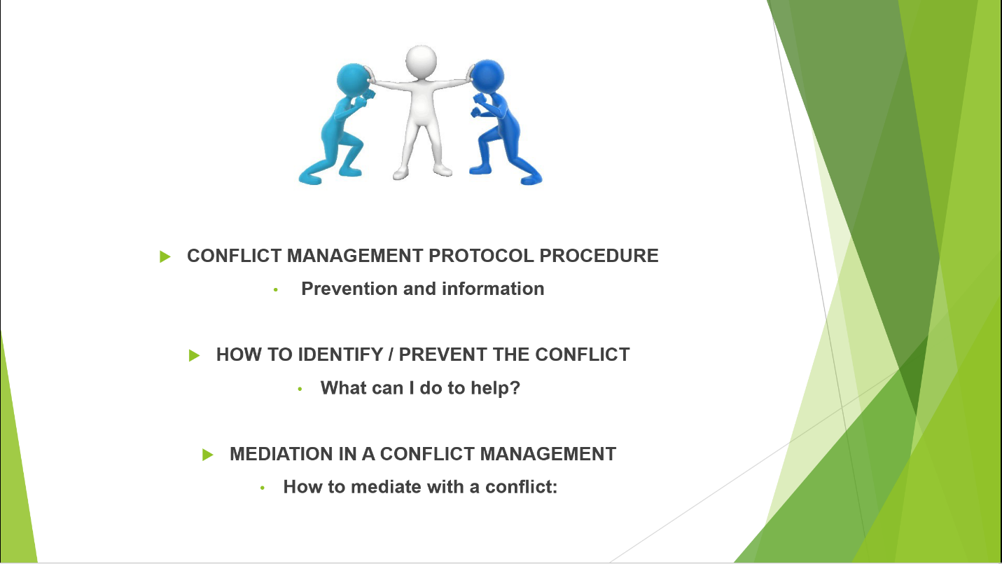
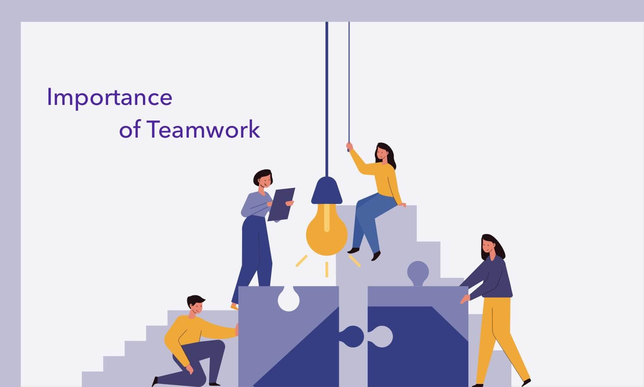
CONFLICT MANAGEMENT PROTOCOL PROCEDURE
Prevention and information
- Inform about the rules and standards of coexistence in the residence.
- Regulation: Communication between residence staff, family members and residents. For common inquiries about the operation, daily care was provided, as well as care at the residence.
- The procedure we provide for complaints and claims: it is sent to the customer service department, as well as we have a suggestion box.
- Resident's Obligations Manual.
- Good practices manual
MEDIATION IN A CONFLICT MANAGING
How to mediation with a conflict:
- When the centre’s employees meet and communication is also carried out between the centre’s workers and residents.
- Facilitate agreements between the people involved
Be neutral in the mediation process.
- Establishment of a consensual solution
- Apply the solution and control the results.
- Mediation action in a conflict situation.
HOW TO IDENTIFY THE CONFLICT
What can I do to help?
- Identify and recognize the reasons for the conflicts.
- Try to limit as much as possible and explain the conflict.
- Propose solutions and alternatives considering their consequences and the possibility of carrying them out. Put the solution into practice - Evaluate the results
- Increase and promote respect, as well as trust between the parties.

INCIDENT BOOK HOME CARE
- A book where we put all the incidents that occurred during the day.
Incidents that occurred and were recorded during the previous day are discussed between the central office and all staff to resolve all incidents and any conflicts

SUCCESSFUL TEAM DEVELOPMENT
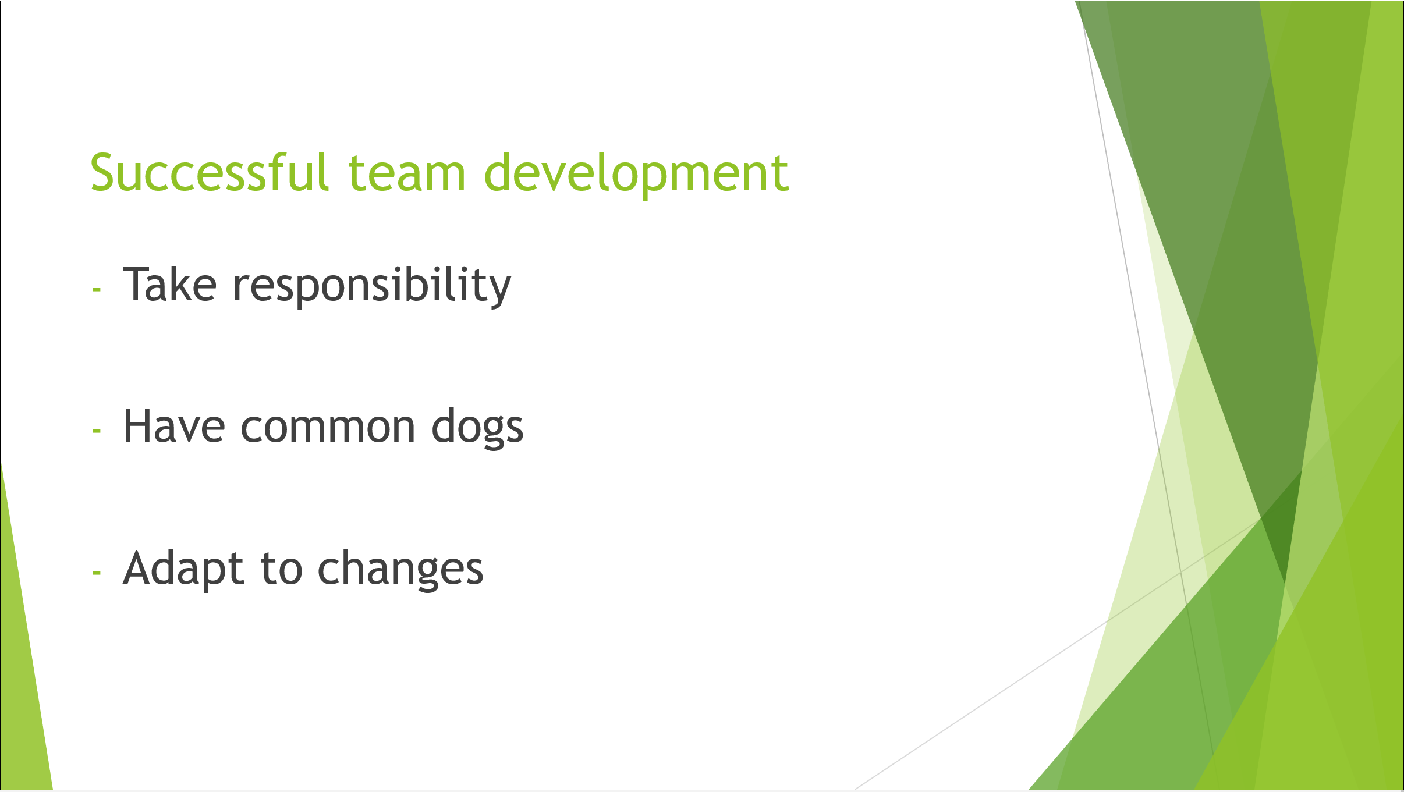

Good communication, trust and teamwork are the key elements for great results, and a care home for the elderly is no different.
In order to achieve the best results when it comes to teamwork there are a few steps that must be followed.
Taking responsibility is a crucial step in order for a team to function as each and every member plays a very important part regarding the end goal, in this case it’s necessary for everyone to do their part as in a team each member counts on the other. So, everyone needs to play their part and perform their tasks in order for the group to achieve success.
Having a common goal (in this case caring for the elderly) is another relevant step in order for the team to succeed, considering that a common goal brings unity. Even if they have different jobs like cleaning or cooking for the elderly, the workers still have the same goal which is making sure that the old people are cared for at the best of their capacity.
Another element for successful team development is being able to adapt to change. New equipment can be implemented in order to make caring for the elderly easier so the employees need to be able to adapt and learn how to use equipment necessary as that may not only make their lives easier but they can be dangerous when used wrong.
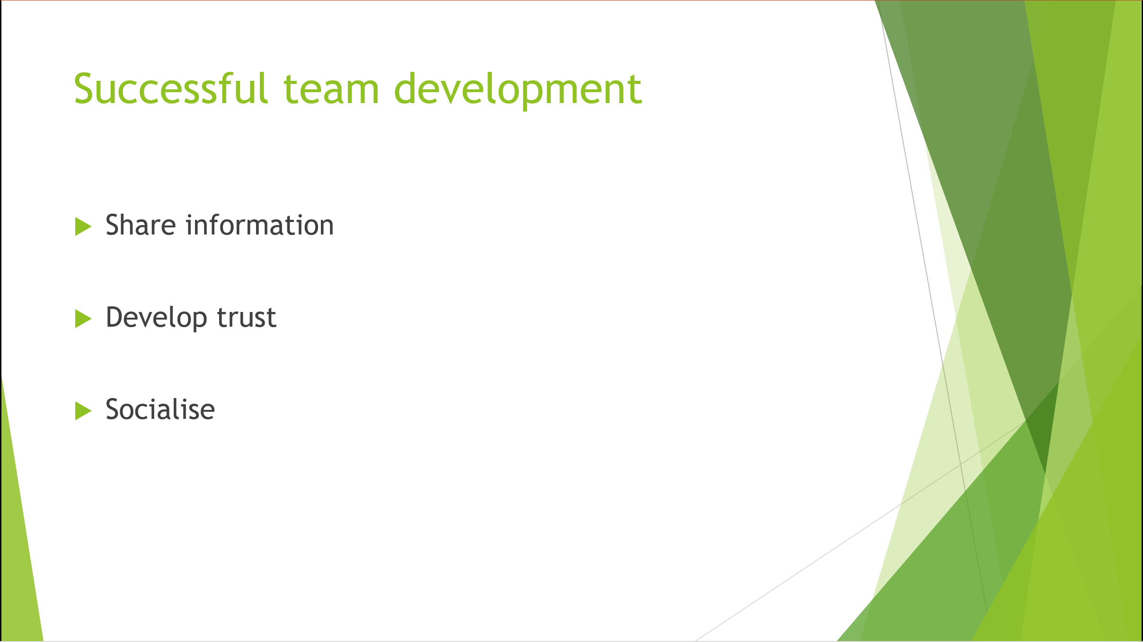

Sharing information is another key element. Because even if the jobs are different, they still intertwine and every part needs to work properly as if it doesn’t it can affect the other parts and, in the end, the whole team.
Develop trust is vital for a functional team as co-workers need to be able to count on each other so the team can work as a whole. Not trusting your teammates can be damaging for the end success the team is trying to achieve. Having the same goal people need to be capable to rely and trust each other that they will do their job as well as possible so that their lack of performance doesn’t affect the other parts of the group. Without trust it’s impossible for the team to work as a whole and it may affect its performance.
And the last but not the least key element is socialising as people need to bound and form interpersonal relationships so they can perform better at work. Socialising outside builds trust and a deeper understanding of the individual which leads to a better work relationship.
CONCLUSION
In this assessment we wanted to touch on all the different aspects related to teamwork in a nursing home.
All the different areas have to work in synergy to achieve the objective of maintaining the well-being of the guests from the cleaning staff and the management, all very important parts of the company. Also one of the main objectives is that the family members are sure and calm that their elders are well cared for and in good hands.

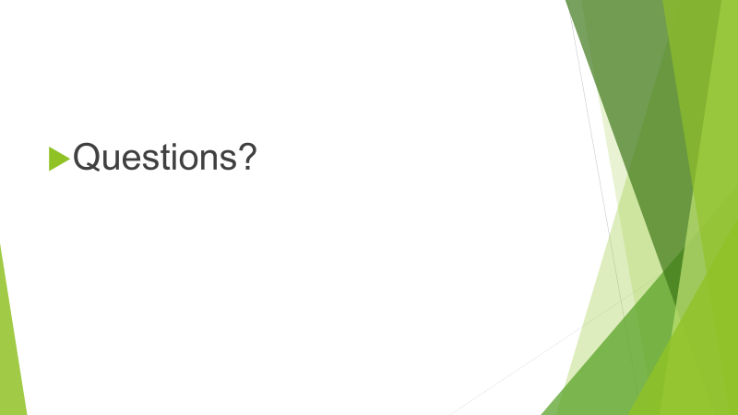
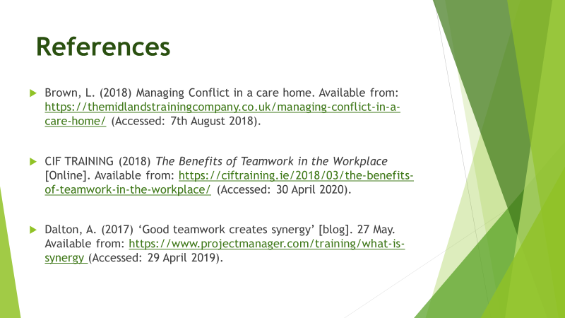

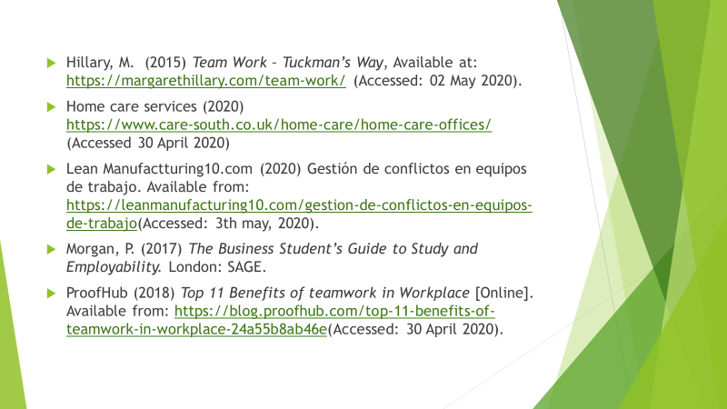
Brown, L. (2018) Managing Conflict in a care home. Available from: https://themidlandstrainingcompany.co.uk/managing-conflict-in-a-care-home/ (Accessed: 7th August 2018).
CIF TRAINING (2018) The Benefits of Teamwork in the Workplace [Online]. Available from: https://ciftraining.ie/2018/03/the-benefits-of-teamwork-in-the-workplace/ (Accessed: 30 April 2020).
Dalton, A. (2017) ‘Good teamwork creates synergy’ [blog]. 27 May. Available from: https://www.projectmanager.com/training/what-is-synergy (Accessed: 29 April 2019).
Hillary, M. (2015) Team Work – Tuckman’s Way, Available at: https://margarethillary.com/team-work/ (Accessed: 02 May 2020).
Home care services (2020)
https://www.care-south.co.uk/home-care/home-care-offices/ (Accessed 30 April 2020)
Lean Manufactturing10.com (2020) Gestión de conflictos en equipos de trabajo. Available from: https://leanmanufacturing10.com/gestion-de-conflictos-en-equipos-de-trabajo(Accessed: 3th may, 2020).
Morgan, P. (2017) The Business Student’s Guide to Study and Employability. London: SAGE.
ProofHub (2018) Top 11 Benefits of teamwork in Workplace [Online]. Available from: https://blog.proofhub.com/top-11-benefits-of-teamwork-in-workplace-24a55b8ab46e(Accessed: 30 April 2020).

