Task 1: Locating Sources
Identify and locate three different sources (a report, a journal article, and a website) related to the question
“What employability skills do business graduates need to succeed in the modern workplace?”
Show how you used keywords, search terms, and Boolean operators to find them, and explain how you know which type of source each one is and why it is appropriate for the research question.

Source Type & Why It Is Appropriate | URL/DOI | What search engine did you use? Google/Online Library/Library AI Assistant | Keywords/Boolean Operators Used
Journel article | The power of an integrated business and Liberal arts curriculum: Students need multidisciplinary skill sets to succeed in modern life and workplaces  Machtley, Ronald K  Professional Media Group LLC; University business, 2018-02, Vol.21 (2), p.52 | Library | Quatations

Task 2: Evaluating Information (CRAAP Test)
Your colleague has forwarded you a source from a peer reviewed journal, and they are not sure whether it is appropriate to use and has asked for your help. Your task is to evaluate the source by using the CRAAP Test to assess its appropriateness.
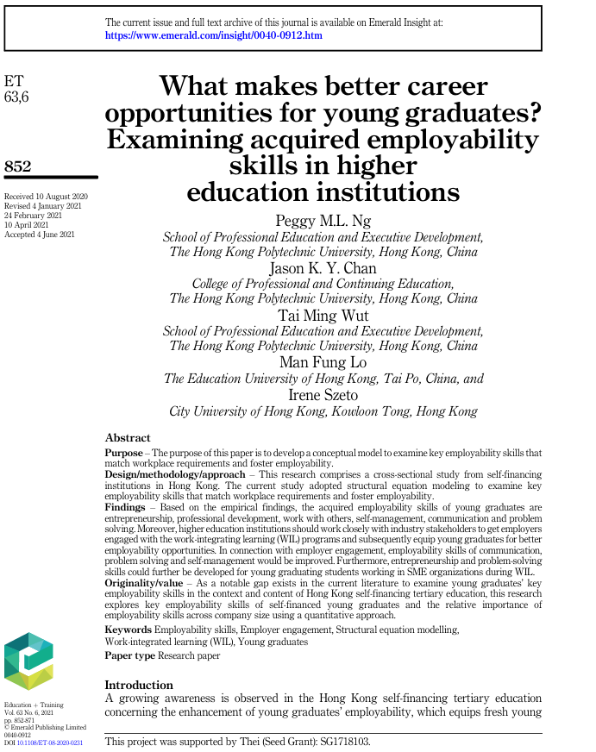

CRAAP Test
Currency | 4th Jan 2021 24th Feb 2021  10th April 2021
Relevance | Better understanding
Authority | Peggy ML  Jason K Y Chan  Ty ming wut  Man fung lo  Irene szeto
Accuracy | School of professional education
Purpose | The purpose of this paper is to develope key skills for a modern work place

Task 3: Source Analysis
Your manager has provided you with a short extract from a source and has asked you to analyse the source by Identifying one strength, one weakness, and providing a brief explanation of the strength and weakness identified.
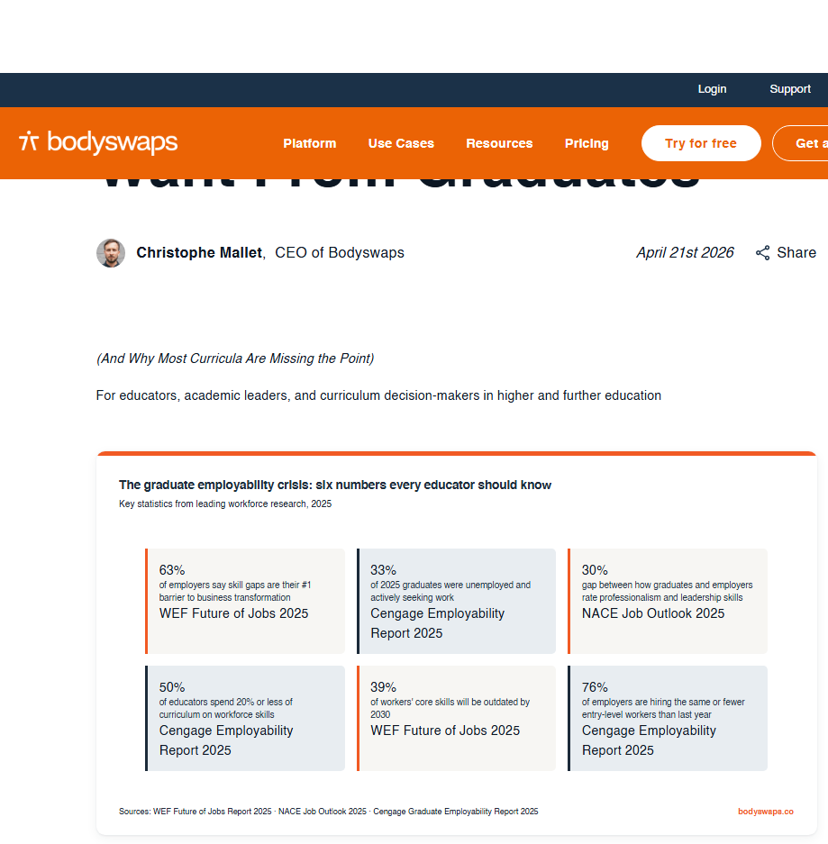
.

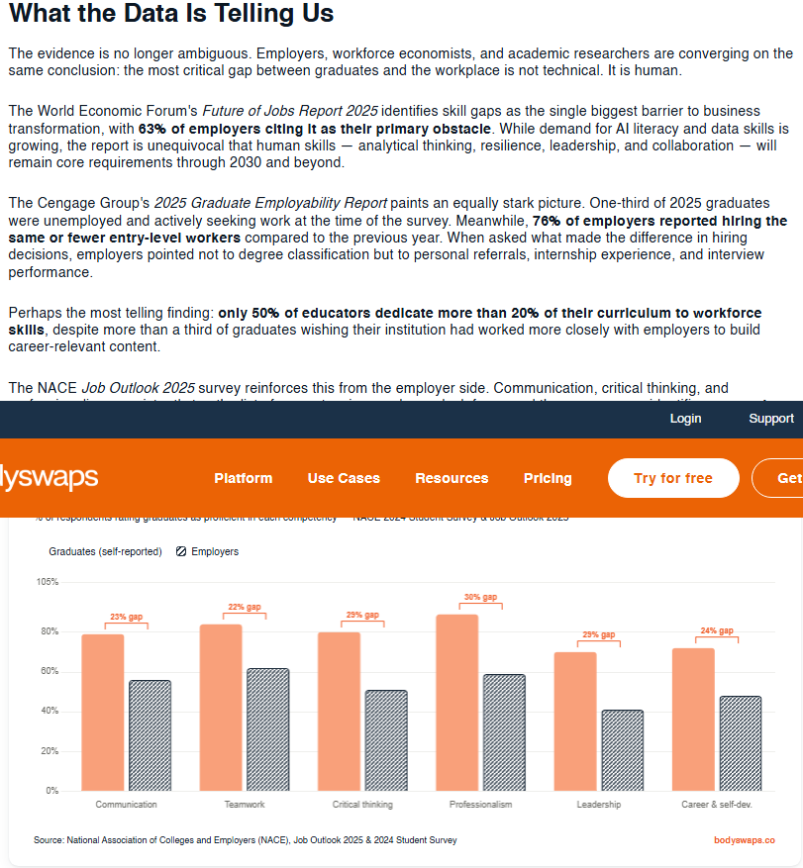

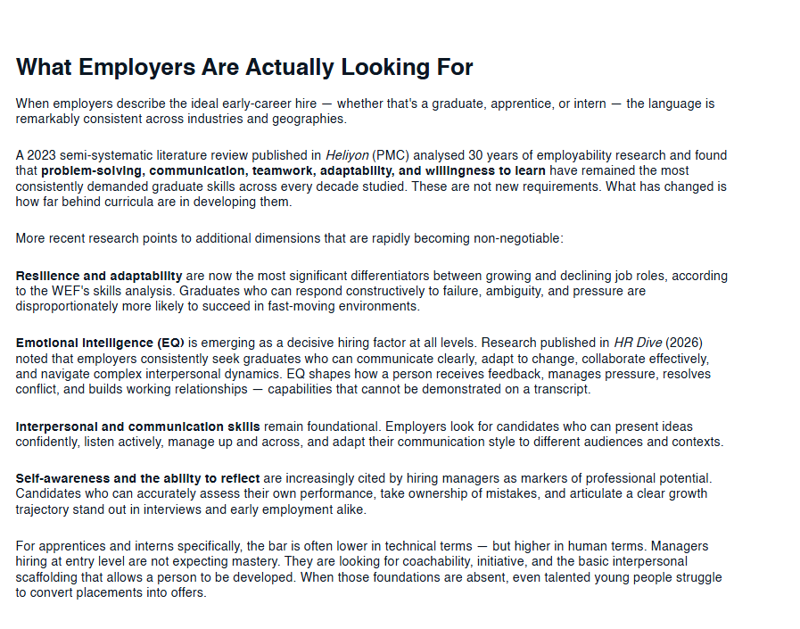

Please click the link, if you wish to read the article online.
What Employers Actually Want From Graduates

Strength of the Source:
The strength is problem solving communication team work adapditbilty

Weakness of the Source:

Only 50% put there dedicate 20% of there curriculum in a work force

