Population Health and Digital Health Promotion

Andreea Lupu
1906519

Lecturer Diola Bijout
LCHS7007

Contents
Introduction 4
Provide evidence about promotion of health. 6
Advantages 6
Disadvantage/ shortfalls 6
Address the shortfalls 6
References 8

Table of Figures

￼
￼
￼

Introduction

According to WHO(2023), at this current moment in time Dementia is number seven in the lead for reasons of death, as well as a major reason for death within people on a world-wide level.
Dementia, mainly Alzheimer’s specifically has reached a level in which makes it be seen as a public health burden due to how large of an issue It has actually become.
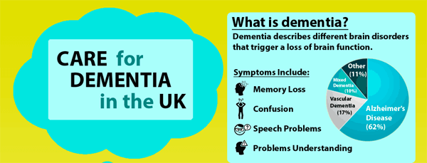
Figure 1 https://th.bing.com/th/id/R.e8a9432180e6456aa8044a78b5092f1f?rik=O5VNgxFB%2b0IHug&riu=http%3a%2f%2finfographicplaza.com%2fwp-content%2fuploads%2fCare-for-Dementia-in-the-UK-Infographic-plaza-small.png&ehk=WSbo3LJX62zGj%2bV%2f4RykU2y%2bmiurf%2fHcXnR3kTTK

Part A.

According to dementiastatistics.org (2023), there currently is a number of 944 thousand people within the United Kingdom that suffer from dementia, furthermore they have specified that one in every three people develop dementia within their time of being alive.

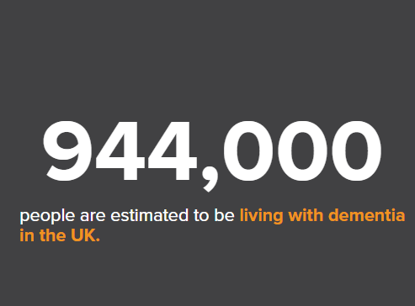

The chosen piece of technology being developed by Cascade3D, which is a technologically advanced company that oversees electronic ways of healthcare, like their connected care devices that promotes the ability to live at home and be independent for as long as possible when suffering from something like dementia, due to the increasing costs of care homes and also private health care, something like this product would be very advantaging for the families in charge.

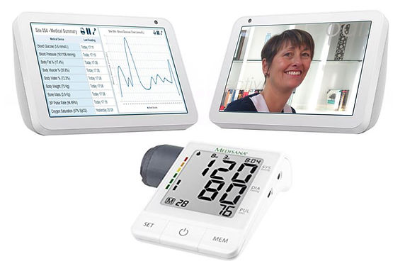
The product advertises using motion and temperature sensors which would be implemented throughout a household to monitor the person’s behaviour and the activities that they get up to, so in cases like the more advanced stages of dementia the people suffering from it might have a tendency to try and open the main door and leave the house in the middle of the night which would trigger the motion sensor and instantly alert the family of the user or even authorities if no one from the family is able to get there in time to maintain the safety of the user.
Figure 2 https://static.wixstatic.com/media/ee17f7_c4f02b2dd4754e5b840255e6c3b82924~mv2.jpg/v1/fill/w_572,h_375,al_c,q_80,usm_0.66_1.00_0.01,enc_auto/Cascade3dAlexaEchoShow_JPG.jpg

Figure 3 https://static.wixstatic.com/media/ee17f7_c4f02b2dd4754e5b840255e6c3b82924~mv2.jpg/v1/fill/w_572,h_375,al_c,q_80,usm_0.66_1.00_0.01,enc_auto/Cascade3dAlexaEchoShow_JPG.jpg

Evidence about promotion of health.
According to Arsene, C. (2019) in 2016 more than half of the hospitals globally introduced and started using a larger number than three devices to do with connected care, also around sixty percent of the organisations involved within healthcare introduced these devices connected to technological healthcare which is seen as a large technological advancement in healthcare and is set to change how the healthcare provided to the elderly or anyone requiring it as a whole for the better.

Advantages
The main advantages of the system are as follow, the user has the ability to continue living at home and is not required to enter the system of being sent off into a care home, which is also very expensive in comparison. Another major advantage is for the family of the person using the system having a much better sense of relief due to having notifications sent to their pocket about the movements of the person using the system, the safety of knowing when something is wrong, and help is needed from them or healthcare professionals.

Disadvantage/ shortfalls
A Large disadvantage there could be encountered is something like a network outage, if the internet that the user goes down the equipment would go dead as far as reading up on works.
Another shortfall that could be encountered would be along the lines of a power outage, which would again send the system into closing due to there not being any electricity.

Address the shortfalls

To address the shortfall found, something like the use of a sim card can be used to keep the devices connected to a separate network that is which is unlikely to go down like the Three mobile broadband.
When it comes to the electrical side of things, and finding a solution which would keep the system up and running even in the event of a power outage, the best idea is to have the system running on an independent generator system which could kick on wen the electricity goes out to ensure the system never fails. (Enshaeifar et al., 2018)

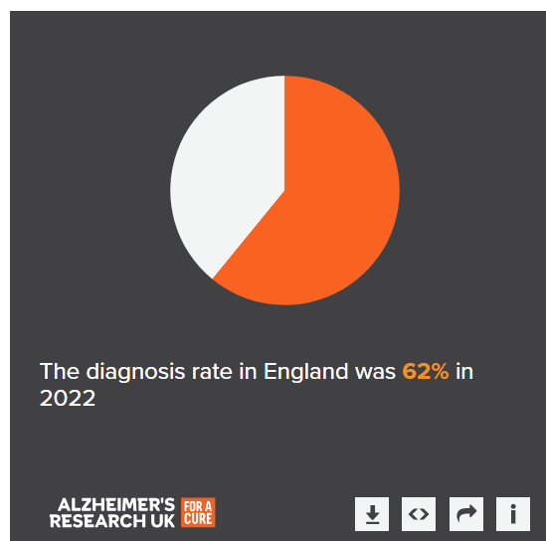
Blog 2
Figure 4 England Dementia Diagnosis Rate

From the research done, It has been confirmed via statistics that Dementia is an ongoing global problem, due to more and more people developing what is currently a very difficult to treat health problem. The reason for which this a massive concern is that as seen through the statistics of AlzheimersresearchUK (2022) which clearly show that there is close to one million of people that are living with dementia within the UK, within 2022 the diagnosis rate of dementia overall was seen to be up in the sixty percents which is envisioned to only rise and did not seem to be slowing down at all.

Another statistic through which it could be easily seen as to how bad Dementia is affecting people, is the estimated costs it has inflicted on the UK as a whole which is shown in Figure 5. The estimated costs within 2021 are shown to have hit a number over 20 billion pounds which is astonishing in itself.
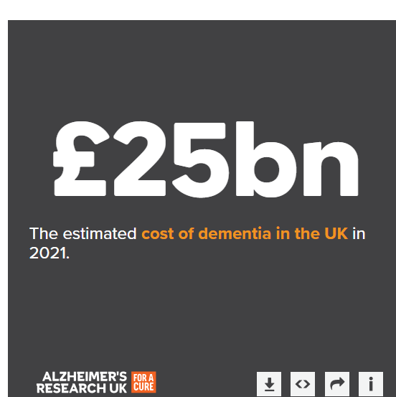
Figure 5 Estimated costs of Dementia in the UK

Part B:
Diabeties has been descriebed and defined as a chronic diseas, that can be developed when the pancreas function is affected and will not produce sufficient insulin, or potentially the human body is unable to have use the insulin produced by itself.The hormone that regulates blood glucose is called insulin. WHO(2020).
Diabeties has been the leading motive of 1.5 milion deaths,worldwide, from which 48% from this deaths were due to developed diabities prior the age of 70 years old. WHO(2020).
According to Diabities UK(2022), the statistics for the UK are showing that 4.3 milion citizens are currently living with this diagnose of a type 2 diabieties.

Althoug there are currently so muche devices on the market to sustain people living with diabities,
the product I would like to improve for the better is already out there in many people’s homes and is already being a major help within the homes of diabities not just in the UK, but all around the world.
The product I will be looking at advancing even further is called Amazon Alexa and can be seen for reference in Figure 6. The large variety of different physical devices would be perfect when it comes to introducing a new function into what is already there.
The idea for the improvement is to create a system that uses AI to be there for the user that was diagnosed with diabetes of any kind, an artificial intelligence software would be able to offer assistance personally tendered to them at any hour of the day and night, any day.
For example to be programed and at breackfast time to remind checking blood sugar before eating, and to advise a healthie breackfast by offering a menu that would make the person prepare it instead of something unhealthy.
Alexa to be programed through AI, to become a real partner on sustaining all the way a person living with diabieties.

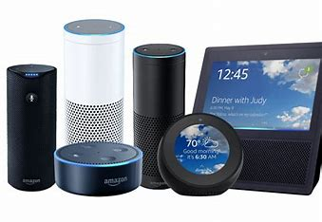

Figure 6 Amazon Alexa Products
As it can be seen in Figure 6, there is a wide range of Amazon Alexa products already out on the market which would be perfect for the proposed upgrade of AI, the devices already use a personal assistant called Alexa and would be more than capable to use a more developed artificial intelligence that can personally tend to the user in the case of suffering from diabetes.

The idea behind the Alexa that can help people suffering from diabetes is to use Artificial Intelligence in the form of Alexa that people are able to configure to help them with things like knowing when to take there insulin or any other medication as well as reminding them to eat something when necessary or before they take their insulin, as well as always having emergency services on stand-by in case any help is needed. (Thomas and Bond, 2014)
The AI will also be able to use sensors and microphones to establish a pattern and routine within the day to day life of the user to anticipate what their schedule looks like in regard to eating, resting or doing activities. Having emergency services just one call away that can be accessed via phone or by speaking through Alexa makes it much more safe for people with diabetes to remain in their homes without needing as much support. (LeRouge et al., 2013)
Adress to shortfalls,
(Jansons et al., 2022) in this quantittive study has been shown through research that some barriers are associated with making use of technology and especially Alexa device, in delivering and potetially monitoring hme based program, for older adults category living alone and diagnosed with diabetes.Further interventions are required to intervene on reducing to reduce potential technical errors, furthur interventions are required, by completing regular feedback.
With the literature that has been reviewed for this blog, we have seen that the technologies that have been developed in the latest years, people that have been diagnosed with diabetes will have a better chance to manage their long term diseas, to receive tailored support, and to prevent long-time waiting face to face appointments with the health professionals.

References
Alzheimer's research UK (n.d.). Dementia Statistics Hub | Alzheimer’s Research UK. [online] Dementia Statistics Hub. Available at: https://dementiastatistics.org/.
‌
Arsene, C. (2020) 20 statistics that prove connected health is the next big thing in Healthcare, Bit Rebels. Available at: https://bitrebels.com/technology/20-statistics-prove-connected-health-next-big-thing-healthcare/ [Accessed: 31 July
Basatneh, R., Najafi, B. and Armstrong, D.G. (2018). Health Sensors, Smart Home Devices, and the Internet of Medical Things: An Opportunity for Dramatic Improvement in Care for the Lower Extremity Complications of Diabetes. Journal of Diabetes Science and Technology, 12(3), pp.577–586. doi:https://doi.org/10.1177/1932296818768618.
‌
2023]
Batchelor, R., Bobrowicz, A., Mackenzie, R. and Milne, A. (2012). Challenges of ethical and legal responsibilities when technologies’ uses and users change: social networking sites, decision-making capacity and dementia. Ethics and Information Technology, 14(2), pp.99–108. doi:https://doi.org/10.1007/s10676-012-9286-x.
‌

cascade3d. (n.d.). Connected Care. [online] Available at: https://www.cascade3d.com/connected-care [Accessed 31 Jul. 2023].

Diabetes. (n.d.). Amazon sets type 2 diabetes management Alexa challenge. [online] Available at: https://www.diabetes.co.uk/news/2017/apr/amazon-sets-type-2-diabetes-management-alexa-challenge-97378420.html [Accessed 31 Jul. 2023].
‌

Enshaeifar, S., Zoha, A., Markides, A., Skillman, S., Acton, S.T., Elsaleh, T., Hassanpour, M., Ahrabian, A., Kenny, M., Klein, S., Rostill, H., Nilforooshan, R. and Barnaghi, P. (2018). Health management and pattern analysis of daily living activities of people with dementia using in-home sensors and machine learning techniques. PLOS ONE, 13(5), p.e0195605. doi:https://doi.org/10.1371/journal.pone.0195605.

Jansons, P., Fyfe, J., Via, J.D., Daly, R.M., Gvozdenko, E. and Scott, D. (2022). Barriers and enablers for older adults participating in a home-based pragmatic exercise program delivered and monitored by Amazon Alexa: a qualitative study. BMC Geriatrics, 22(1). doi:https://doi.org/10.1186/s12877-022-02963-2.
‌

LeRouge, C., Ma, J., Sneha, S. and Tolle, K. (2013). User profiles and personas in the design and development of consumer health technologies. International Journal of Medical Informatics, 82(11), pp.e251–e268. doi:https://doi.org/10.1016/j.ijmedinf.2011.03.006.

Matthew-Maich, N., Harris, L., Ploeg, J., Markle-Reid, M., Valaitis, R., Ibrahim, S., Gafni, A. and Isaacs, S. (2016). Designing, Implementing, and Evaluating Mobile Health Technologies for Managing Chronic Conditions in Older Adults: A Scoping Review. JMIR mHealth and uHealth, [online] 4(2), p.e29. doi:https://doi.org/10.2196/mhealth.5127.
‌

Neal, D., van den Berg, F., Planting, C., Ettema, T., Dijkstra, K., Finnema, E. and Dröes, R.-M. (2021). Can Use of Digital Technologies by People with Dementia Improve Self-Management and Social Participation? A Systematic Review of Effect Studies. Journal of Clinical Medicine, 10(4), p.604. doi:https://doi.org/10.3390/jcm10040604.
‌
NHS digital (2022). Recorded Dementia Diagnoses, January 2022. [online] NHS Digital. Available at: https://digital.nhs.uk/data-and-information/publications/statistical/recorded-dementia-diagnoses/january-2022.
Rai, H.K., Kernaghan, D., Schoonmade, L., Egan, K. and Pot, A.M. (2022). Digital Technologies to Prevent Social Isolation and Loneliness in Dementia: A Systematic Review. Journal of Alzheimer’s Disease, pp.1–16. doi:https://doi.org/10.3233/jad-220438.
‌
Rostill, H., Nilforooshan, R., Morgan, A., Barnaghi, P., Ream, E. and Chrysanthaki, T. (2018). Technology integrated health management for dementia. British Journal of Community Nursing, 23(10), pp.502–508. doi:https://doi.org/10.12968/bjcn.2018.23.10.502.

‌ Surrey County Council, W.P. (n.d.). Technology enabled care: Surrey Connected Care. [online] www.surreycc.gov.uk. Available at: https://www.surreycc.gov.uk/adults/care-and-support/equipment-and-technology/connected-care [Accessed 31 Jul. 2023].
‌
Thomas, J.G. and Bond, D.S. (2014). Review of Innovations in Digital Health Technology to Promote Weight Control. Current Diabetes Reports, 14(5). doi:https://doi.org/10.1007/s11892-014-0485-1.
‌

