3.3 Implementing Lewin’s framework

Lewin’s framework
1940s Kurt Lewin developed his Change management model known as Unfreeze – Change – Refreeze (Mind Tools, 2020). The three possible ways to implement change were at the individual member of staff level, through the organisation’s structures and systems and through the organisational climate. Lewin’s theory is important as he acknowledged the important role of individual workers and that they may be resistant to change. He also pointed out that effective leadership can affect the process of change. Lewin suggested that attitude is important as it can lead to change in behaviour (Sharma, 2006).

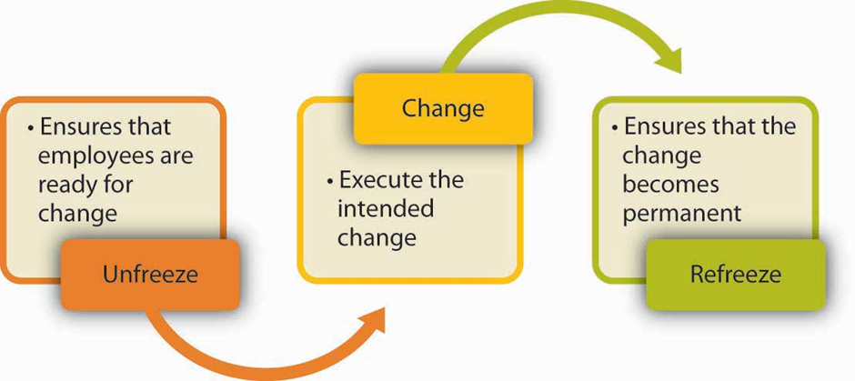

Lewin’s Three-Stage Process of Change (from Carpenter, Bauer, and Erdogan, 2009)
Lewin’s three-stage process of bringing about change can be seen in how M&S brought about change in order to implement Plan A. According to Grayson (2011), the Plan A strategy was led by the CEO and overseen by the Board, who initiated with targets and timescales and delegated responsibility to key staff, therefore implementing change at staff and structural level. Plan A was integrated into all business functions and staff were trained in the strategy which helped to bring about change through the organisational culture, which already treated staff well, and was generous in its community support (Grayson, 2011).
In terms of Lewin’s three-stage model, in relation to M&S’s Plan strategy, these are:
Unfreezing:
Grayson (2011) describes the initial move to incorporate high environmental and social standards across the business as a response to the hostile bid to take over M&S by Philip Green. The re-appointment of Stuart Rose to fight off the bid was the starting point for a move from philanthropy and community, which had been a feature of M&S from the start, to the strategic emphasis on raising social and environmental standards. So despite an existing culture of fairness and corporate responsibility, the change in emphasis instigated by Rose initiated the unfreezing and had the added benefit of attracting consumers who were increasingly aware of environmental concerns and social responsibility.
The hostile take-over bid by Philp Green assisted the cause and helped employees to be ready for the changes brought about by Plan A. Globalisation and the reduction in M&S’s market share also prepared the employees for the Plan A changes, as there was a need for M&S to be seen again as a generous employer and responsible business (Grayson, 2011). However, as Lewin emphasises the importance of changing attitudes in order to change behaviour, the training on Plan A introduced in M&S was a key factor of the unfreezing process. Induction training still includes coverage of Plan A so that staff are aware right from when they start as employees of the importance of sustainability within the organisation. Plan A is also covered in technical training (Wills, 2011). The Guardian newspaper gave M&S the Sustainable Business Award in 2011, recognising that the company embedded Plan A throughout communication with staff, in ‘newsletters, posters, the staff magazine, e-mail updates, breakfast debates, team debriefs and an intranet site with videos, carbon footprint calculator, a car sharing tool and blog for staff to ask questions and share eco hints and tips’ (Wills, 2011). M&S also provided a programme of speakers on sustainability for staff training and set up a website for staff to check hourly energy usage in stores. All staff were offered a day’s paid leave to work with a charity, helping them to engae with the community (Wills, 2011).
M&S’s engagement of employees was important if Plan A was to be successful, so as well as training, each of the 650 shops had a Plan A champion whose job, on top of their existing role, was to promote Plan A in each store (Grayson, 2011). As described by Wills (2011), these champions encourage colleagues to reduce paper and electricity usage and to recover waste. Each store is ranked monthly on how it is meeting Plan A targets, with the champions promoting competitiveness between the various shops. The champions attend special team days to discuss Plan A and share ideas and several have since joined the M&S management development programme, where they can continue to promote Plan A.
Change: The changes were implemented in six key ways, according to Grayson (2011). These were:
1) Leading from the top: The leadership of the company with initiation of Plan A by Stuart Rose and then subsequently the commitment of CEO Marc Bolland, the appointment of Richard Gilles as Plan A director and ensuring that the top executives had responsibility for meeting Plan A targets in their areas. For example, Paul Willgoss introduced environmental improvements in packaging and food ingredients and Krishan Hundal introduced improvements in suppliers’ factories and living wage initiatives. Senior executives’ bonuses were partly paid according to whether they had delivered on their Plan A key performance indicators (Grayson, 2011).
2) Governance and oversight: The setting up of the ‘how we do business’ committee, which meets monthly, and the membership being made up of senior executives, ensures that implementation of Plan A happens. The main board reviews Plan A every six months and threats to Plan A are considered to be risks regarding M&S’s reputation and commercial success (Grayson, 2011).
3) Public commitment: M&S benefitted commercially from their commitment to sustainability and their customers approved of this new environmental emphasis. Competitors were also improving their own performance in this area so M&S needed to demonstrate leadership to consumers, as they did by extending Plan A in 2015 with the stated aim of becoming the world’s most sustainable retailer (Grayson, 2011).
4) Integration into operations and strategic business units: moving from a situation where environmental and social commitments were added onto existing business operations and run by the Corporate Responsibility function, Plan A required each part of the organisation to change (Grayson, 2011). This included requiring that Human Resources introduced a well-being website and workshops on healthy eating. New shops were expected to be constructed to be environmentally sustainable, new packaging, refrigeration and logistics projects were introduced and purchasing staff have tasked suppliers with changing their ways of working to fit with Plan A goals (Grayson, 2011).
5) Engaging the value chain: Early on during the implementation of Plan A, M&S established an online Knowledge Exchange for its suppliers in order for higher sustainability standards to be introduced. It therefore engaged suppliers and took them along in the Plan A initiative. It also carried out market research to find out what customers’ views on sustainability were. It engaged in choice editing by limited the supply of eggs in its food halls to free-range only and only using free range eggs in prepared food. M&S also decided to sell only fair-trade tea and coffee and introduced charges for plastic carrier bags ahead of the UK Government’s legislation on this (Grayson, 2011).
6) Making it ‘everybody’s business’: M&S continued with the Plan A champions and kept them updated on how their store was performing under Plan A. M&S also allowed employees to try out some Plan A innovations before customers, such as the loft insulation service, which meant that 10,000 employees received free loft insulation (Grayson, 2011).
Refreeze: The refreezing phase in Lewin’s model is concerned with ensuring that the change is permanent. Plan A was originally launched in 2007 and consisted on 100 initiatives to be fulfilled by March 2012, but these were added to subsequently so that in 2010 there were 180 initiatives to be fulfilled by 2015 (Morgan, 2015). Subsequently, in 2014 they instigated Plan A 202 and in 2018 M&S launched its new Plan A phase, declaring it would reduce carbon emissions by 80% and become a zero-waste business by 2025 (Mace, 2017). The new initiatives are represented on the following graphic:
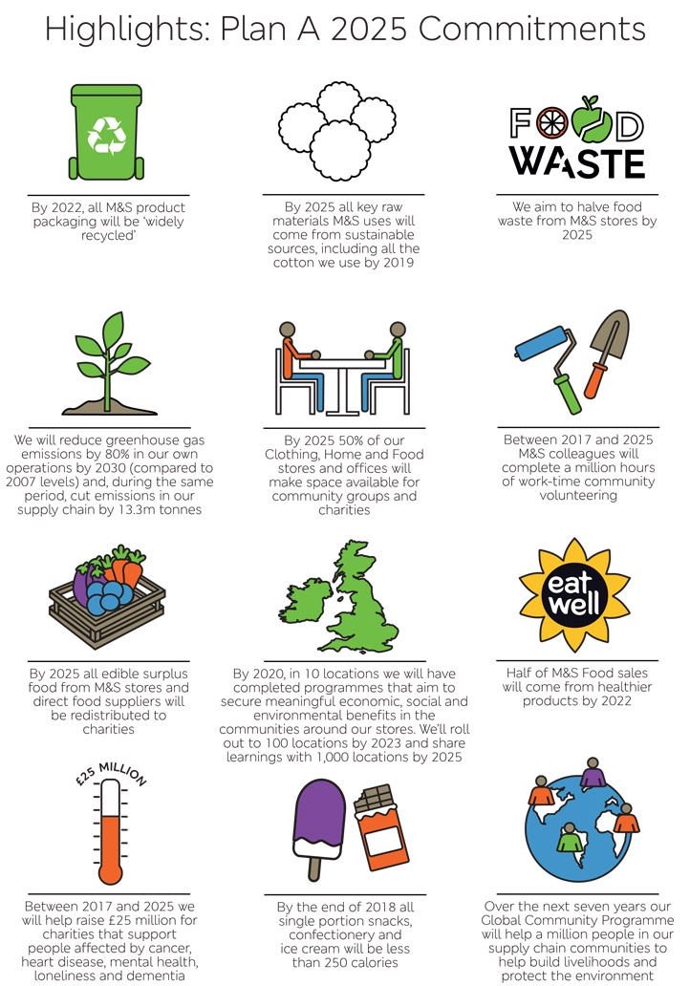
(Mace, 2017)
This demonstrates that the refreezing process is ongoing and that M&S is ‘adapting its sustainability initiatives over time, through learning from its results, within a strong, transparent and coherent framework’ (Morgan, 2015, p. 24)
M&S reports on its progress with Plan A every year, therefore making it a key performance indicator which shareholders and employees have to take responsibility for.
The three stages of Lewin’s model are useful for gaining an understanding of how M&S prepared for, initiated and embedded Plan A, though as from the discussion above, it is clear that there is some overlap between the different stages. The key to M&S’s successful change management in Plan A was ensuring that rather than adding the initiative onto processes, it made sure that employees and customers were on board with the idea, therefore ensuring the organisational climate was welcoming to the idea, and that processes were changed throughout the business. Importantly, Plan A’s goals have changed over time to adapt to environmental and social pressures, ensuring that the company is ‘leading the way’ on ‘all the big challenges – supply chain, climate, food waste, living wage, human rights, packaging, community investment’, according to the chair of Plan A’s advisory board, Jonathan Porritt (Mace, 2017).

References
Grayson, D. (2011) ‘Embedding Corporate Responsibility and Sustainability Marks and Spencer’. Journal of Management Development 30:10, 1017-1026.[Online] Available at: https://dspace.lib.cranfield.ac.uk/index.jsp. (Accessed 13th June 2020).

Mace, M. (2017) ‘Plan A 2025: M&S updates flagship initiative to “embrace a sustainable future”’ Edie [Online] Available at: https://www.edie.net/news/7/Plan-A-2025--M-S-updates-flagship-initiative-to--embrace-a-sustainable-future-/. [Accessed 14th June 2020].
Mind tools, (2020). Lewin’s Change Management Model. [Online] Available at: https://www.mindtools.com/pages/article/newPPM_94.htm. [Accessed 27th March 2020].
Morgan, E (2015) '”Plan A”: analysing business model innovation for sustainable consumption in mass-market clothes retailing. Journal of Corporate Citizenship, 57, 73 -98. [Online] Available at: https://doi.org/10.9774/GLEAF.4700.2015.ma.00007. (Accessed 13th June 2020).

Sharma, R.R. (2006) Change Management Concepts and Applications. New Delhi: Tata McGraw Hill.
Wills, J. (2011) ‘M&S - wholly embracing staff in plan to become the world's most sustainable retailer’ The Guardian, 26.5.11 [Online] Available at: https://www.theguardian.com/sustainable-business/staff-plan-worlds-sustainable-retailer (Accessed 18th June 2020).

