Understanding Performance Management
On the job training record

Discuss your organisation’s current approach to performance management with your manager and whether or not changes are required as a result of remote working or other implications of the pandemic.

Hywel Dda Health Board’s current approach to performance management
Hywel Dda University Health Board’s current approach to performance management aligns with that of Armstrong’s (2006) model of performance management.
The Performance Appraisal and Personal Development Plan Policy (Hywel Dda, 2021) outlines the process for ensuring that staff have clear performance objectives with agreed development plans.
The policy sets out the requirement for staff to have at least one annual performance appraisal development review. The process is based on an ongoing cycle of learning:
- Reviewing how individuals are performing against the requirements of their role and identifying any development needs;
- Agreeing a Personal Development Plan, detailing the learning and development to take place within an agreed timeframe, and the date of the next review;
- Undertaking the learning and development identified, and;
- Evaluating the learning and development and reflecting on how it has been applied to work.

Changes required as a result of the pandemic
Whilst the policy has very recently been reviewed, it doesn’t reflect the impact of the pandemic in terms of how we measure performance. Discussion with my line manager has identified a number of key areas that the Health Board will need to consider as we move forward with a hybrid approach in terms of our work location.
- Pre-pandemic, staff were used to working in traditional ways i.e. co-located in the workplace, working in well-established organisation systems and cultures. With the move to more home working, we need to consider the impact that the increased independence and isolation has on performance and how we can maintain the same standard of drive and innovation. Are people are less likely to collaborate using Teams than they would face to face. Organisations need to find a way of setting SMART objectives to monitor performance around innovation to ensure that that doesn’t cease. With the likely continuation of home working, McKendrick (2020) refers to research that suggests that ‘the process of innovation needs rethinking’.
- Does working from home put individuals more risk of making mistakes due to a loss of concentration as a result of exposure to more non work-related interruptions at home e.g. caring responsibilities, deliveries? This requires further research as a brief review of articles on the internet has not identified any evidence to support this; conversely, articles seem to suggest working from home increases productivity as that staff are experiencing less interruption than they might in the office (NI Business Info, n.d.).
- Does working from home provide less staff with limited direct access to line managers, putting more junior staff at risk of making isolated decisions due to their reluctance in disturbing their line manager to seek advice? In terms of performance management, what are the implications if a wrong decision is made?
- With more flexible working, we need to consider what we are measuring progress against –i.e. a move away from measuring inputs (i.e. hours worked) and more a focus on outputs (i.e. what is being delivered).
- How does overall well-being impact performance when people are not always on site? We need to think about setting objectives around demonstrating how teams are kept motivated, engaged and managed remotely. Health and well-being are critical to engagement and performance and help to ‘prevent stress and create positive working environments where individuals and organisations can thrive’ (CIPD, 2021).

Discuss your development needs with your line manager as a result of the above, using the CIPD Profession Map as a basis for your discussion. Consider whether or not your skills in this area require improvement (for example delivering training on the topic/coaching line managers).
One of the ten professional behaviours in the CIPD 2013 Profession Map focuses on performance and reward. A self-assessment undertaken against this behaviour indicates that my knowledge and skills in this area are emerging.

Figure 1 – CIPD 2013 Profession Map
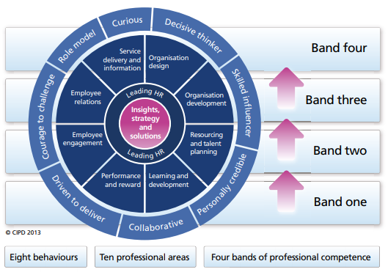
Whilst many of the development actions in the 2013 CIPD Profession Map focus on reward, in the context of the above discussion my development needs have been identified as follows:
- Regular CPD activity to research and read up on current thinking around performance management of remote teams;
- Develop my skills to maximise the functionality of MS Teams to ensure it is being used as a communication and engagement tool e.g. use collaborative channels to engage with teams.
- Think about how I bring together the team. Currently individuals work quite independently, both in terms of different sites and on different business areas, and a third new member of staff is due to be recruited into another business area; all three of which form part of my remit.
- Seek feedback on what their triggers for motivation and drive. These conversations will link in to reward systems and the intervention that may impact on individual performance, including learning and development, coaching and mentoring, team-building, culture and management style (Rees and Tymon, 2016).

References
Armstrong, M (2006) Performance Management: Key Strategies and Practical Guidelines. 3rd edn. London: Kogan Page
CIPD. 2013 Profession Map. Available at CIPD Profession Map. (Accessed: 25th August 2021)
CIPD (2021) Well-being at Work. Available at Wellbeing at Work | Factsheets | CIPD. (Accessed: 25th August 2021)
Hywel Dda University Health Board (2021) The Performance Appraisal and Personal Development Plan Policy. Available at https://hduhb.nhs.wales/about-us/governance-arrangements/policies-and-written-control-documents/policies/performance-appraisal-and-personal-development-plan-padr-policy/. (Accessed: 25th August 2021)
McKendrick, J (2020) Work from home fallout: productivity up, innovation down. Available at Work From Home Fallout: Productivity Up, Innovation Down (forbes.com). (Accessed: 25th August 2021)
NI Business Info (n.d.) Employees working from home: advantages and disadvantages of employees working from home. Available at Advantages and disadvantages of employees working at home | nibusinessinfo.co.uk. (Accessed: 25th August 2021)
Rees, G and Tymon, A (2016) ‘Performance Management, Motivation and Reward’ in Rees, G and French, R (ed) Leading, managing and developing people. 5th edn. London: CIPD

