

GreenBite Healthy Meal Prep & Lunch Delivery
Task 1: Business Plan Development

Student name: Ion Dodon
Student ID.: 2315140
Lecture: Balendran Kandasamy
Contents
Element 1: Business Idea, Products/Services, Objectives and USP 3
Element 2: Business Environment and Competitor Analysis 6
Element 3: 4Ps, Market Segmentation and Marketing Strategies 8
Element 4: Financial Planning 12
Reference List 14

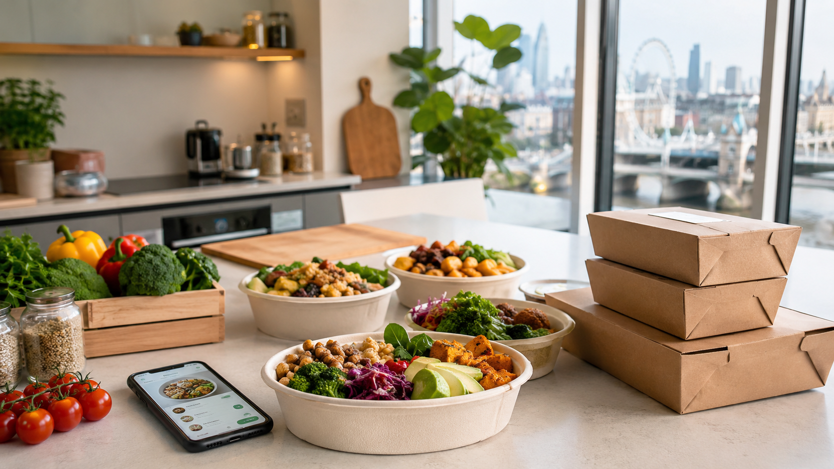
Figure 1. GreenBite concept image: prepared healthy meals and digital ordering (OpenAI, 2026).

Element 1: Business Idea, Products/Services, Objectives and USP

GreenBite is a proposed healthy meal-preparation and lunch delivery company based in London. It is aimed mainly at university students, young professionals and hybrid workers who want convenient meals but do not always have the time or energy to cook. Many people in these groups would like to eat more nutritious food, yet they often depend on expensive takeaways, supermarket meal deals or processed convenience products. This may be because they are busy, unsure how to plan balanced meals or unable to compare nutritional information when ordering food. GreenBite intends to address this problem by providing fresh, ready-to-eat lunches that can be ordered online and delivered within selected local areas during busy working weeks and demanding university schedules.
The concept has been designed as a realistic small-scale start-up rather than an immediate city-wide operation. GreenBite would begin with one rented commercial kitchen, a carefully controlled menu and a limited number of London delivery zones. Starting at this level would allow the company to test demand, monitor costs and improve its systems before expanding. It would also reduce the financial and operational risks of opening a large restaurant or attempting to serve the whole of London from the beginning.
GreenBite’s range would include plant-focused meal bowls, higher-protein bowls, wraps and healthy snack boxes. The weekly menu would contain six core meals and two seasonal options. Rotating the choices would provide variety for regular customers without making the menu difficult to manage. A smaller range would also make it easier to buy ingredients accurately, control stock, maintain quality and reduce waste. Meals would use vegetables, wholegrains, beans, lentils and other pulses, together with lean sources of protein. Each product would display clear nutritional and allergen information, allowing customers to make informed choices. This approach reflects the NHS Eatwell Guide’s general principle of achieving a balanced diet across the week.
Alongside individual orders, GreenBite would offer subscription packages for customers who regularly need weekday lunches. Buyers could select bundles of either three or five meals per week, helping them organise their food spending and plan ahead. Subscriptions would also give the company more predictable demand, improve production planning and encourage repeat purchases. GreenBite would deliberately avoid a large restaurant-style menu because its main priorities would be reliable service, affordable prices and consistent quality.
In its first six months, GreenBite would focus on confirming demand, building a loyal customer base and keeping operations stable. A key sales target would be to supply at least 4,800 meals during this period. The company would also aim to gain 300 repeat customers, as regular purchasing would show that the meals, prices and delivery experience meet expectations. Another objective would be to achieve an average customer rating of at least 4.5 out of 5. Reviews and feedback would help the business identify successful products and resolve service problems quickly.
GreenBite would also seek partnerships with at least two nearby universities, offices or co-working spaces. These arrangements could provide access to groups of customers who regularly need convenient lunches and might support collection points, promotional activities or workplace deliveries. The business would aim to keep food waste below 8% of prepared stock through pre-orders, close sales monitoring and weekly menu planning. Limiting waste would lower costs while supporting the company’s environmental aims.
In the longer term, GreenBite plans to become a recognised healthy lunch brand in selected areas of London. After establishing the first kitchen, the company would aim to open a second micro-kitchen and gradually widen its delivery coverage. It would also introduce corporate lunch plans for small businesses and teams seeking reliable, healthier workplace meals. Within three years, GreenBite intends to sell 1,500 meals each week, employ a small kitchen and delivery coordination team, and create a structured menu-development process. Customer feedback, sales information and seasonal ingredient availability would guide future recipe decisions.
GreenBite’s main unique selling point is affordable, nutritious food combined with local delivery and transparent nutritional information. Recipe-box businesses such as Gousto and Mindful Chef support healthier home eating, but their customers must still prepare and cook the meals. Delivery platforms such as Deliveroo and Uber Eats provide speed and choice, although price, nutritional quality and value vary between restaurants. GreenBite would position itself between these alternatives. Its meals would require no preparation, offer a healthier option than many takeaways, cost less than many premium delivered lunches and be easy to organise through subscriptions. This combination of convenience, affordability, nutrition and reliability would give GreenBite a clear position within London’s competitive food delivery market.

Element 2: Business Environment and Competitor Analysis

A SWOT analysis is useful because it links GreenBite’s internal capabilities to its external market conditions. It also shows where the business must manage risks before launch.

SWOT area | Key points | Implications for GreenBite
Strengths | Focused menu, clear healthy positioning, local delivery, direct online ordering. | A narrow offer should simplify operations, improve quality control and make the brand easy to understand.
Weaknesses | Low brand awareness, limited finance, small delivery area and dependence on early reviews. | GreenBite must launch carefully, collect feedback and avoid overspending before demand is proven.
Opportunities | Health, convenience and eating-at-home trends are important to UK meal choices (AHDB, 2025). | The business can position itself as a convenient routine for lunch rather than an occasional treat.
Threats | Strong competitors, food inflation, delivery costs, hygiene requirements and price-sensitive customers. | Pricing, waste control and supplier relationships must be managed tightly.

Table 1. SWOT analysis for GreenBite.

GreenBite’s main direct competitors are Mindful Chef and Gousto. Mindful Chef provides health-oriented recipe boxes and meal kits across the UK, making it a relevant competitor for customers who want nutritious meals at home (Mindful Chef, 2026). One of its main advantages is its established reputation as a health-focused brand. However, compared with GreenBite, its main limitation is that customers must still spend time preparing and cooking the meals themselves.
Gousto is another direct competitor because it delivers recipe boxes and offers customers a wide selection of meals each week. The company advertises more than 175 weekly recipes, giving customers considerable variety and flexibility (Gousto, 2026). Its large scale, strong brand awareness and extensive menu are significant strengths. Nevertheless, Gousto is mainly designed around home cooking, evening meals and family dining, whereas GreenBite would focus specifically on ready-to-eat lunches for students, professionals and hybrid workers.
GreenBite would also face competition from several indirect competitors, particularly food delivery platforms and convenient high-street lunch providers. Deliveroo presents itself as a hyperlocal marketplace that connects customers with restaurants, supermarkets and delivery riders. It therefore competes strongly in terms of speed, accessibility and convenience (Deliveroo, 2026). Uber Eats operates through a similar model, allowing customers to order takeaway food and meals from a wide range of local businesses (Uber Eats, 2026).
Although these platforms provide customers with extensive choice and rapid delivery, the nutritional value and overall quality of meals can differ greatly between restaurants. Customers may also have to pay service and delivery charges, making the final cost higher than expected. As a result, convenience does not always guarantee affordability or healthy food choices.
Pret A Manger and supermarket meal deals are additional indirect competitors because they are widely available, familiar and easy to purchase. Pret A Manger offers freshly prepared sandwiches, snacks, salads and drinks, making it a popular option for people seeking a quick lunch during the working day (Pret A Manger, 2026). Supermarket meal deals may be even more competitive on price and are easily accessible in many London locations.
GreenBite is unlikely to compete successfully with every rival solely on price, especially against discounted supermarket meal deals. Instead, it would need to differentiate itself by providing clear nutritional information, convenient subscription packages and meals designed to support healthier eating habits. Its competitive advantage would come from helping customers build a consistent and nutritious lunchtime routine rather than simply offering a one-off convenient meal.
Competitor | Type | Strength | Weakness/gap GreenBite can exploit
Mindful Chef | Direct | Strong healthy-eating positioning. | Requires cooking and is less useful for immediate lunch.
Gousto | Direct | Large menu choice and strong brand awareness. | Broad recipe-box model; less local and still requires cooking.
Deliveroo/Uber Eats | Indirect | Fast delivery and wide restaurant choice. | Total cost and health quality vary significantly.
Pret/meal deals | Indirect | Convenient, familiar and available on high streets. | Less personalised nutrition and weaker subscription planning.

Table 2. Competitor analysis summary.

Element 3: 4Ps, Market Segmentation and Marketing Strategies

GreenBite’s market segmentation strategy uses four main categories: demographic, geographic, psychographic and behavioural factors. Combining these forms of segmentation will help the business identify customers most likely to value its products. The primary demographic market will be people aged between 18 and 35, especially university students, recent graduates and professionals beginning their careers. Individuals in this group often have busy schedules, are confident using digital services and regularly buy products online. However, many also have limited disposable income and must balance convenience with affordability.
A secondary demographic group will include health-conscious employees aged between 35 and 50. These customers may have greater spending power and are likely to value dependable lunch options during the working week. Some may purchase meals individually, while others could use workplace or corporate lunch packages. This group may be especially interested in consistent quality, visible nutritional information and meals that can be ordered in advance for office days.
Geographically, GreenBite will initially concentrate on East and Central London. Priority will be given to neighbourhoods with universities, offices, co-working spaces and gyms. Limiting the launch to a smaller delivery area will make operations easier to control. It should also support shorter delivery times, lower transport costs and more consistent food quality. After demand has been tested and the delivery process has become reliable, GreenBite can consider expanding into other London zones.
Psychographic segmentation is important because GreenBite customers will not simply be purchasing lunch. They will also be buying convenience, greater control over their diet and the feeling that they are making a healthier choice. The ideal customer wants to feel organised, productive and health-conscious but may not have enough time to shop, prepare ingredients or cook. GreenBite will therefore position itself as a service that helps customers maintain healthier routines without creating additional work.
Behavioural segmentation will focus on purchasing habits and frequency. The most valuable customers will be people who already buy lunch several times each week and are willing to consider a subscription. These individuals have an existing need and may be easier to convert than customers who normally prepare every meal at home. GreenBite’s representative customer persona is Maya, a 24-year-old graduate employee who travels into London three days a week and studies online in the evenings. She wants a lunch that looks attractive, is filling and can be ordered quickly. She also expects calorie and allergen details to be clearly displayed, with the full ordering process taking less than two minutes.
GreenBite’s product strategy will focus on ready-to-eat bowls, wraps and snack boxes. Each main meal will include vegetables, fibre-rich carbohydrates and a suitable protein source. This structure supports the brand’s healthy positioning while ensuring that meals are satisfying enough for lunch. Labels will clearly display calories, protein, allergens and whether an item is vegetarian or vegan. This will allow customers to compare choices quickly and make decisions.
Where financially practical, the company will use recyclable or compostable packaging. This will strengthen the brand’s responsible image, although packaging must remain affordable for a small start-up. A rotating weekly menu will give customers variety without forcing the business to manage an unnecessarily large product range. Customer reviews, sales figures and direct feedback will determine which meals remain as core products and which should be improved or replaced.
GreenBite will use an affordable value-based pricing strategy. Standard meals will begin at £7.50, while premium protein options will cost around £8.95. Subscription packages will lower the price per meal, with proposed bundles of three lunches for £21 and five for £34. These prices are higher than a basic supermarket meal deal but should remain below many takeaway lunches ordered through delivery applications once service and delivery charges are added. This supports GreenBite’s intended position as a healthy, convenient and affordable service.
Promotional discounts will be used carefully. Introductory offers may encourage customers to try the service, but frequent reductions could weaken the brand or encourage people to order only when a discount is available. Promotions should therefore support first purchases, referrals and subscription trials rather than become the company’s main pricing strategy.
GreenBite will sell mainly through its own mobile-friendly website. Direct ordering will reduce reliance on third-party platforms, which often charge commission and restrict access to customer data. The company will also create selected collection points at partner universities, gyms and co-working locations. Deliveries in the first service area will use bicycles or e-bikes. Collection points can reduce delivery costs, improve convenience and increase brand visibility in places customers regularly visit for work, exercise or study.
Promotion will combine social media, partnerships, referrals and product sampling. Instagram and TikTok content will include short preparation videos, weekly menu announcements and customer testimonials. Partnerships with university societies, gyms, office managers and co-working spaces will create opportunities for tasting events and targeted discount codes. A referral programme will give both the existing customer and the new buyer a small saving. Promotional communication will concentrate on the audience’s problem: wanting a healthy lunch without having time to prepare it.
Online marketing will be important to attracting and retaining customers. Search engine optimisation will target phrases such as “healthy lunch delivery London,” “meal prep for students” and “office lunch bowls.” Paid social advertising will start with small budgets and be assessed through cost per order. Email campaigns will promote weekly menus, subscription reminders and loyalty rewards. A digital stamp card will encourage repeat purchases by offering a discounted meal or free snack after eight meals. Customers will also be encouraged to post lunch photographs and tag GreenBite, generating user-created content and building trust through social proof.
However, GreenBite should not rely entirely on online visibility. A start-up can spend heavily on advertising without producing repeat sales. Marketing should therefore be measured through conversion rate, repeat order rate, average order value and customer acquisition cost. Likes and views alone do not demonstrate success. If a campaign attracts attention but produces few orders, the budget should move towards sampling, workplace partnerships or university promotions that place the product directly in front of target customers.



Figure 2. Target customer context: students and young professionals eating in a café/workspace setting

Element 4: Financial Planning
The financial plan uses cautious assumptions for a small local launch. Start-up costs are estimated at £14,500. This includes kitchen deposit and setup, basic equipment, initial ingredients and packaging, a simple website/order system, branding, hygiene training, insurance and contingency. The approach avoids heavy spending on a shopfront before demand has been proven.

Start-up cost item | Estimated cost (£)
Kitchen deposit and setup | 4,000
Equipment and utensils | 3,000
Initial ingredients and packaging | 1,500
Website/order system | 1,500
Branding and launch marketing | 2,000
Insurance, licences and hygiene training | 1,000
Working capital contingency | 1,500
Total | 14,500

Table 3. Estimated start-up costs.
Monthly operating costs include ingredients, packaging, part-time kitchen labour, delivery, rent, utilities, software, insurance and marketing. Sales are expected to grow gradually as awareness increases. The forecast assumes an average selling price of £7.90 and an average variable cost of £3.50 per meal.

Month | Meals sold | Revenue (£) | Variable costs (£) | Fixed costs (£) | Profit/loss (£)
1 | 400 | 3,160 | 1,400 | 3,900 | -2,140
2 | 550 | 4,345 | 1,925 | 4,100 | -1,680
3 | 700 | 5,530 | 2,450 | 4,300 | -1,220
4 | 900 | 7,110 | 3,150 | 4,600 | -640
5 | 1,050 | 8,295 | 3,675 | 5,000 | -380
6 | 1,200 | 9,480 | 4,200 | 5,100 | 180
Total | 4,800 | 37,920 | 16,800 | 27,000 | -5,880

Table 4. Six-month operating forecast.
The forecast shows total six-month revenue of £37,920 and a small monthly profit by month six. However, the business does not recover the initial start-up investment within six months. Break-even on monthly operations is expected around month six, while full recovery of start-up costs is more likely between months 11 and 14 if sales continue to grow and fixed costs remain controlled. This is a realistic outcome because food start-ups often need time to build repeat purchasing and efficient operations.
Funding will come from £8,000 personal savings, a £4,000 family loan and a £2,500 grant or enterprise support fund. This mix is selected because it reduces dependence on high-interest commercial borrowing. A UK Start Up Loan could also be considered because the government-backed scheme offers £500 to £25,000 for starting or growing a business (Gov.uk, 2026). However, loans create repayment pressure and require a credit check, so GreenBite should only borrow if early sales evidence supports growth. The key financial risks are lower-than-expected sales, food price increases and overspending on marketing. These risks will be managed through pre-orders, weekly cost reviews and gradual expansion rather than opening a permanent shop immediately.
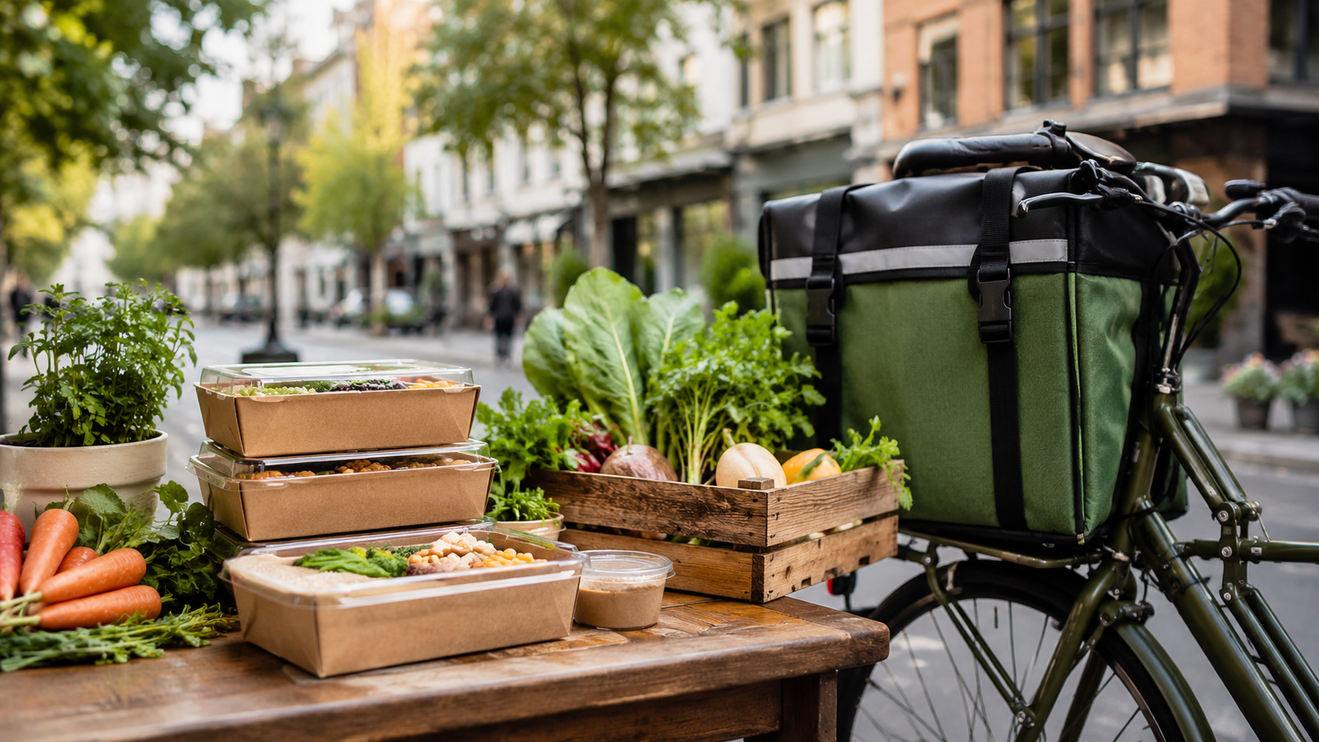

Figure 3. Local delivery and fresh ingredients concept image for GreenBite

Reference List

- AHDB (2025) ‘Consumer cooking trends: Healthy and convenient meals on the rise’. Available at: https://ahdb.org.uk/news/consumer-insight-consumer-cooking-trends-healthy-and-convenient-meals-on-the-rise (Accessed: 20 June 2026).
- Deliveroo (2026) ‘About us’. Available at: https://deliveroo.co.uk/about-us (Accessed: 20 June 2026).
- Gousto (2026) ‘Recipe boxes from Gousto: The UK’s best food box for choice’. Available at: https://www.gousto.co.uk/food-box (Accessed: 20 June 2026).
- GOV.UK (2026) ‘Apply for a Start Up Loan for your business’. Available at: https://www.gov.uk/apply-start-up-loan (Accessed: 20 June 2026).
- Kotler, P., Armstrong, G., Harris, L. and He, H. (2019) Principles of marketing. 8th European edn. Harlow: Pearson.
- Mindful Chef (2026) ‘Healthy recipe boxes and meal kits delivered UK’. Available at: https://www.mindfulchef.com/ (Accessed: 20 June 2026).
- NHS (2026) ‘The Eatwell Guide’. Available at: https://www.nhs.uk/live-well/eat-well/food-guidelines-and-food-labels/the-eatwell-guide/ (Accessed: 20 June 2026).
- OpenAI (2026) Concept images generated for the GreenBite business plan using DALL-E [AI-generated images]. Generated 20 June 2026.
- Pret A Manger (2026) ‘Coffee, fresh sandwiches, snacks and drinks menu’. Available at: https://www.pret.co.uk/en-GB/our-menu (Accessed: 20 June 2026).
- Start Up Loans (2026) ‘Start Up Business Loans’. Available at: https://www.startuploans.co.uk/ (Accessed: 20 June 2026).
- Uber Eats (2026) ‘Food delivery and takeaway’. Available at: https://www.ubereats.com/gb (Accessed: 20 June 2026).

