Daniel Bennett

Database Design (The book Store)

Contents
Introduction 2
Initial Design 2
Books 3
Users 3
Orders 3
Order Line 4
Supplier 4
Relationships 5
Forms / Menus 5
Queries and reports 7
References 7

Introduction
In this document the author will detail the steps and features used to create a database system for “The City Book Store”. The author used a combination of MS Access, VBA and SQL to complete this task.

Initial Design
For the initial design, the author used a software called lucid chart to create an entity relationship diagram. This helps lay the foundation of a good database and ensures that integrity can be kept throughout the course of its use. Below is said diagram:
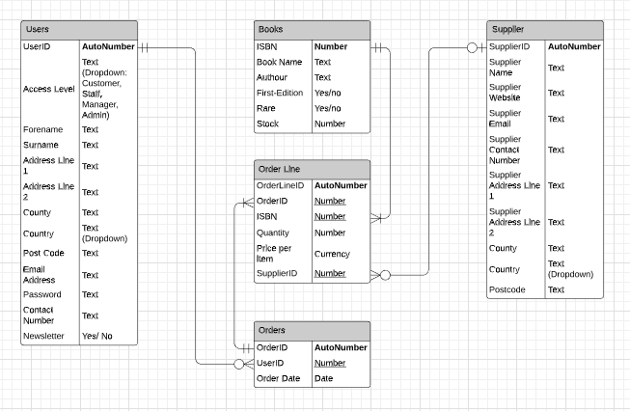
Once this was completed, the author went ahead and created the groundwork for what would be the database to come. The first items that needed to be added were the tables for the database. Below is an image of them.
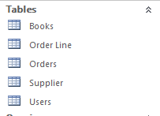
Each table has a different purpose which will be described in the following sections.

Books
The books table contains all the books that the store will be dealing with. Every time a new book is added, or stocks need to be updated this is the table that will store that information.
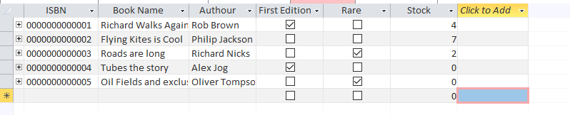
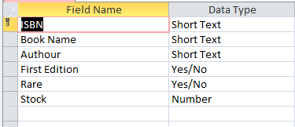

Users
The users table will contain all the users of the database. This table contains all the shipping information and details about each customer and staff member.
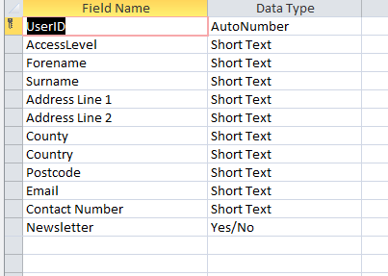

Orders
The orders table contains every order that a person will place with the store. This includes the purchasing and selling of stock.

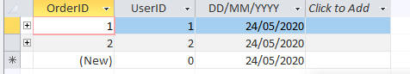
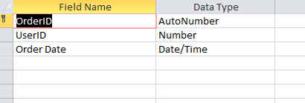

Order Line
Order line goes hand in hand with the order table. Each order contains many Order lines which contain the actual individual sales for that order. This helps make an effective system and allows for multiple items per order.
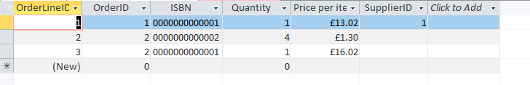
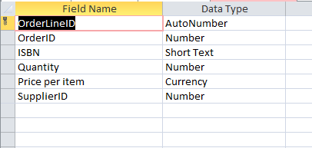

Supplier
The supplier table contains all the information required for each of the suppliers that the company will use. This includes location and contact details.
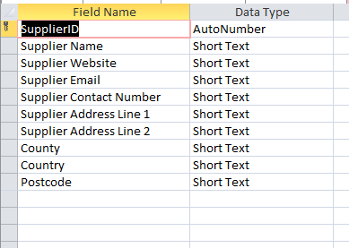

Relationships
The next step was to create relationships between the data in the tables, this way the database would function correctly, and data would maintain integrity.
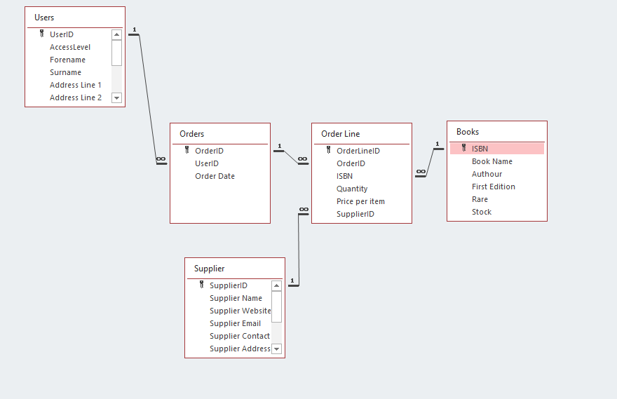

Forms / Menus
The next step was to create a series of forms, which would make the front-end of the database and allow for easier use with less training. The menus are as follows:
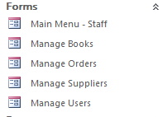
When the program first opens, the user will be greeted with the for Main Menu – Staff. This acts as a hub for all the other forms.
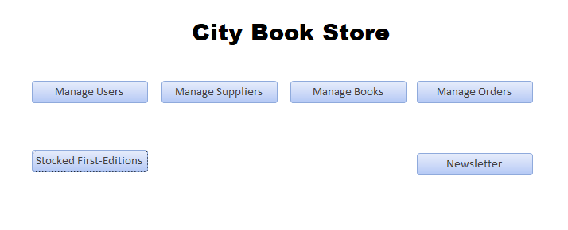
By clicking the “Manage Users” button you are brought to the form which is used to manage the users in the database.
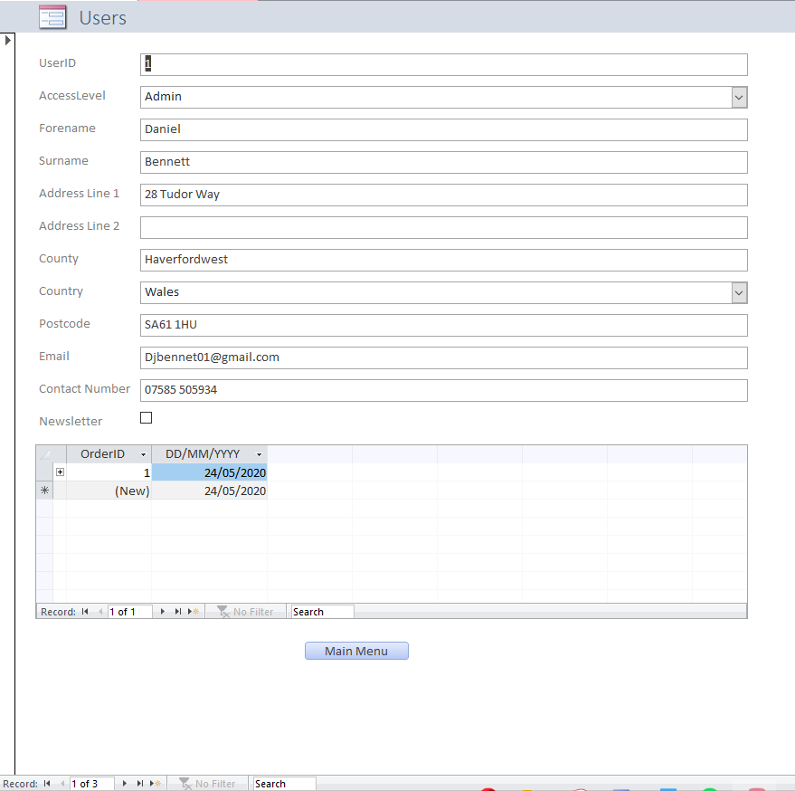
This form allows the user to browse all the customers and search for them specifically with their UserID. This report will also show the users how many orders the customer has had in the past. The page can also be used to create more customers or staff.

Queries and reports
The final section created is with regards to queries and reports, these search the tables for specific information to show the user. The two queries/reports with this database show the user the first-edition books in stock and the newsletter.
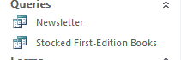
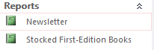
The newsletter is the best example of the reports. It shows the users all the rare and first edition books in stock, this is achieved through the use of specific SQL to retrieve the correct results.
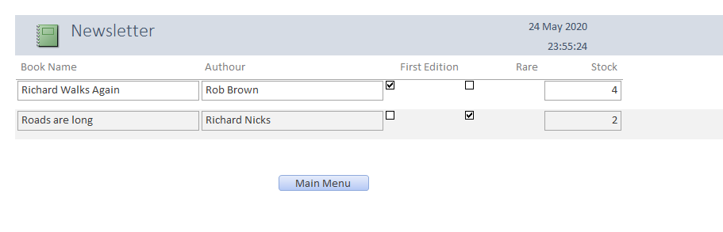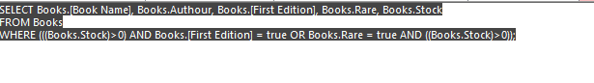

All knowledge for this database was learnt through the very good study material the Access Bible, it was very helpful in building the database and it couldn’t have been done without it.

References
[1]R. Alexander and D. Kusleika, Access 2016 Bible. Indianapolis: Wiley, 2016.

