
Hilton hotel Group
Case Study


Student name: Alina Bud
Student ID: 2213954
Module Name and Code: Management & Organisational Behaviour, BMIH5004
Lecturer Name: Julia Ault

EXECUTIVE SUMMARY
Organizations must consider new factors due to globalization when formulating strategies, including political instability, international trade disputes, fluctuating exchange rates, and foreign cultures. Companies must manage complexity, ambiguity, diversity, and learning to succeed. This case study analyses the hospitality industry organization Hilton Hotel Group, a leader in its field. The study describes Hilton's structure, culture, objectives, recent change initiatives, and strategic direction.
Hilton is a commercial hospitality organization that provides necessities to guests while fostering a hospitable environment. The company has a significant global presence, with 22 brands, approximately 7,300 properties, and over 1.1 million rooms in 123 countries. Hilton has been recognized as a top employer and sustainability leader.
Hilton's organizational structure, hierarchical and divisional, is a testament to its inclusive culture. It consists of ownership, management, franchise, and timeshare divisions, all working together to understand and appreciate international cultures. Senior leadership actively funds diversity initiatives, fostering a sense of belonging for all. Hilton's goals, unveiled in 2018, include doubling its social impact investment and reducing its environmental footprint by half by 2030. The Travel with Purpose initiative promotes social and environmental transformation in its operations, supplier chain, and communities. One recent change initiative was the creation of the Canopy by Hilton brand, which targets younger customers. The first Canopy hotel opened in Reykjavik, Iceland, after three years of development based on interviews with 9,000 people. The hotel offers an appealing experience for millennials while maintaining the fundamentals of hospitality. Hilton's business strategy is not just about service differentiation, but about pioneering quality, high standards, and IT system integration. The company's 2023 annual report showcases its innovative strategies for performance, global presence, and successful brands. Hilton's system is not just about delivering solutions, but about driving earnings and efficiency through cutting-edge technology, guest loyalty, leading innovation, and exceptional guest experiences.
In conclusion, Hilton's performance advantage results from its integrated approach to cutting-edge technologies and inspired solutions, which has been recognized through numerous awards. The company's focus on hospitality, innovation, and sustainability contributes to its success in the hospitality industry.
Contents
EXECUTIVE SUMMARY 1
INTRODUCTION 3
MAIN BODY (1600) 3
Hospitality organisation 3
Company overview 4
Organisation structure 6
Organisation culture 7
Organisation goal 7
Recent change initiatives, their impact and how well these were managed 8
The organisation’s strategic direction 9
CONCLUSION 11
REFERENCE LIST 13

INTRODUCTION

Organisations must transport people, ideas, goods, and information globally because of globalisation to satisfy regional demands. When formulating a strategy, they must include fresh and crucial components such as unpredictable political circumstances, discordant international trade disputes, unpredictable exchange rates, and overseas cultures. They must be more knowledgeable than ever about competing with people worldwide and doing business. However, due to globalisation, companies must become more adept at managing complexity, ambiguity, diversity, and learning. The circumstance that each organisation's specific ingredients were diverse indicates that various elements, including the organisation's strategy, culture, structure, and internal and external environments, are crucial (Armstrong, 2012). In this context, this case study is based on the analysis of the hospitality industry organisation of the Hilton Hotel Group, a leader in the field. For this case study to be as complete as possible, the organisation, in general, will be described, and then its structure, culture and objectives will be analysed. Another analysed chapter is recent change initiatives, their impact and how well these were managed, where the decision to inaugurate a new Canopy by Hilton brand is explained, and finally, the strategic direction that the organisation relies on to be so efficient and successful.

MAIN BODY (1600)

Hospitality organisation
While the organisationsdiffer significantly from one another, they also have many commonalities. Clear goals and objectives are essential for every organisation as they will dictate the type of inputs to be used, the sequence of actions to produce desired results, and the achievement of organizational objectives. The system's effectiveness and the impact of its operations on the environment are evaluated based on how healthy goals and objectives are met. While general guidelines and recommendations apply to all organizations, variations in their nature, purposes, goals, and external factors draw attention to the unique relationship between individuals and organizations. This facilitates the examination of alternative organizational structures and management styles, operational procedures, leadership philosophies, and employee motivations and behaviour in various context (Mullins, 2019).
The commercial hospitality organisation needs to be hospitable to its guests despite selling its products and services, as explained in Figure 1. From insights into the usual processes of hotel industry involving to contemporary hospitality organisations, hospitality can be explained as
- Providing necessities such as food, drink, and a place to sleep to those who are not family members.
- rewarding hosts who show extravagant hospitality to guests with increased social standing and
- A trade that benefits both the host and the visitor (Mullins, 2013).

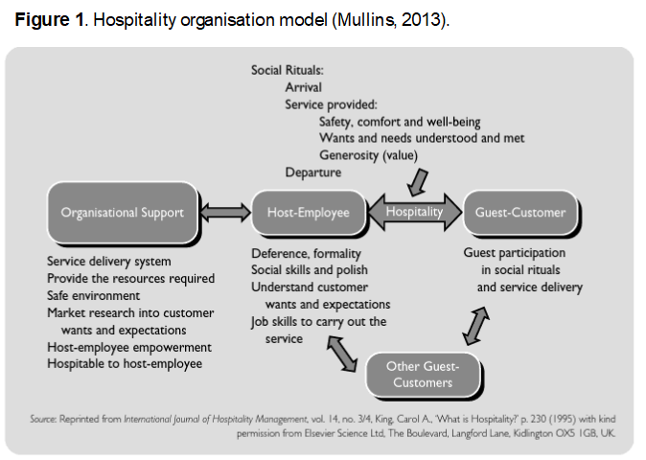

Company overview
Hilton holds a significant position worldwide, boasting 22 elite brands, about 7,300 establishments, and over 1.1 million rooms in 123 countries and territories. Hilton was rated number one on Fortune's list of the 100 Best Companies to Work For and has been recognized as a global leader on the Dow Jones Sustainability Indices for six consecutive years. The more than 165 million members of Hilton Honors, the renowned guest loyalty program, can accrue Points for hotel stays and activities when they make direct bookings with the hotel. Using the free Hilton Honors app, guests may use their cell phones to book their stay, select their room, check-in, and use a digital key to unlock their door and check out. (Hospitality Net, 2024). Hilton has introduced several first-in-industry technical innovations to enhance the visitor experience, including automated complimentary room upgrades, digital key sharing, and confirmed booking of linked rooms (Hantuli, 2016). The Code of Conduit, Figure 2, contains the vision, mission, and values. These are the standards that the company operates by and must not deviate from in any circumstances, and they apply to all team members (Hilton, 2024).
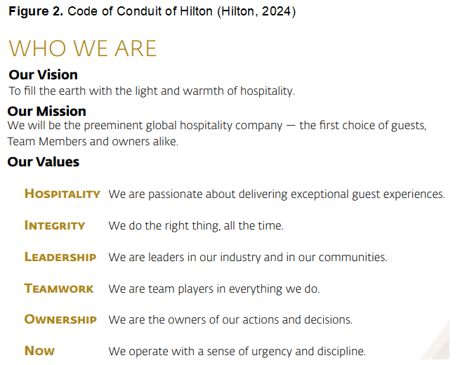

Organisation structure
The structure of an organisation into work groups, as well as the authority and reporting connections that bind individuals and groups together, are known as its organisational structure. Structure helps distinguish distinct identities for various teams or work groups and significantly impacts how well people and groups communicate. An organisation's structure is meant to organise and allocate work among its members to maximise their ability to accomplish the organisation's goals and objectives. The four factors that affect structure are the business climate, organization size, strategy, and technology. These aspects influence the degree of specialization and spans of control, the proper approach to mechanistic or organic structuring, the proper degree of centralization and decentralization, and functionalization and divisionalization. Determining the influences on structure and the effects that structure has on people and an organization's success is challenging from the perspective of organizational behaviour (Brooks, 2018).
As per Dudovski (2016), Hilton's organisational structure is hierarchical because of its enormous scale, which includes several brands and millions of customers worldwide. The organisation is divided into the resulting divisions: ownership division, management and franchise division, and timeshare division. Additionally, the Hilton organisational structure can also be characterized as divisional. One example of an organisational structure for one of the Hilton hotels is presented in figure 3.
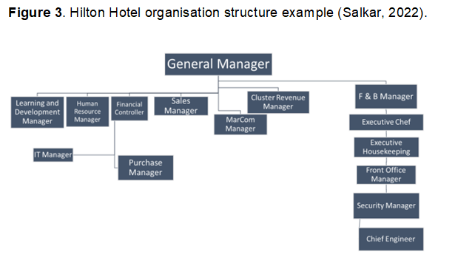

Organisation culture
Besides structures, cultures play an essential role in an organisation. The influence of characteristics like main value directions, behaviour, or social construction on insights, attitudes, styles of personal collaboration, and personality patterns offers a perception on culture that concentrate on a particular aspect and its influence on attitudes and behaviour. However, most perspectives ignore the impact of the surrounding context in which cultural activities appear. Every culture has an environment that shapes it and affects how it develops. Some context-related elements can influence a culture's traits. This may lead to misunderstanding since apparent variations in consumer values, attitudes, or consumption may be due to context rather than culture. Figure 4 depicts the general relationship between setting and culture (Nakata, 2009). In the context of the hospitality sector, Hilton Hotel Group aims to comprehend the distinct international cultures to guarantee that every Team Member is acknowledged and appreciated. Senior leadership is therefore dedicated to funding initiatives that support diversity, like inclusion training and events honouring many cultures and practices. To strengthen relationships, employee volunteerism, and give initiatives in the areas in which operates (Gay, 2016).
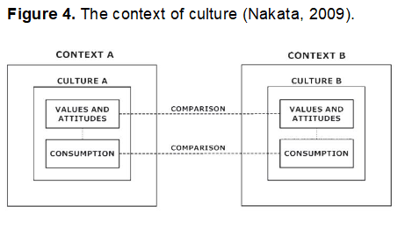

Organisation goal
Hilton unveiled its Travel with Purpose 2030 goals in May 2018, figure 5. In a global declaration, Hilton pledged to double its social impact investment and lower its environmental footprint in half. The introduction of Hilton's 2030 goals offers measurable objectives to assist the company in fulfilling its mission to advance the United Nations' Sustainable Development Agenda. Hilton has pledged to reinvent sustainable travel with its initiative, Travel with Purpose. Hilton promotes social and environmental transformation in our communities, supplier chain, and operations. Hilton is dedicated to promoting a positive social and environmental impact in each market it serves through its Travel with Purpose initiative (Hospitality On, 2023).
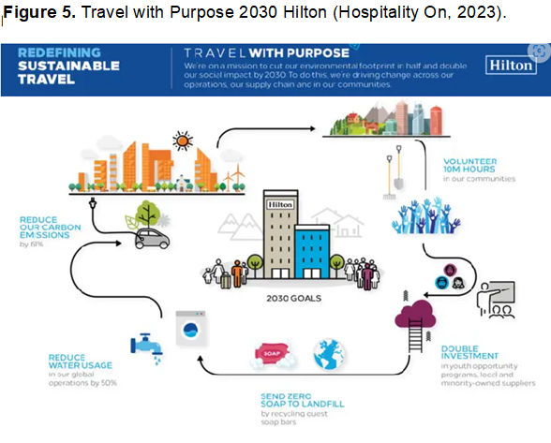

Recent change initiatives, their impact and how well these were managed
One of the recent projects of the hotel group was to create a hotel that would attract a younger group of millennial customers. The development of this hotel was based on the reviews of 9000 people interviewed about their preferences when deciding to book a hotel, such as rooms, prices, and other vital factors. Initially, groups of young people from their primary market were interviewed: Americans, British and English, and later Australians, and Germans. Tasteful after three years of development, Hilton Group opened the first Hilton Canopy hotel in Reykjavik according to the preferences of young people (Marcus, 2015). The critical thing to remember is that while millennials' needs are essentially the same as those of previous generations—they care about warm showers, comfy beds, and round-the-clock check-in—certain minor adjustments can make businesses more appealing to millennials for leisure and business travel. Here, two distinct strategies have demonstrated that hotels can appeal to millennials, and their needs are not significantly different. Offering an "experience" is valuable but not always necessary. Occasionally, making little adjustments to locations, cuisine, and stylish lobby areas can be sufficient to attract new customers. Companies prioritising creating an utterly novel hotel experience over mastering the fundamentals of hospitality will likely fail since their offerings may not be memorable or recurring. Hilton has significantly improved the room to cater to the target age group (Market Line, 2018). Therefore, the development team's concept has been so successful that the website of Canopy (2024) shows that now 40 properties are open for business today, with more 30 under development spanning 18 nations and territories. Canopy by Hilton, Hilton's lifestyle brand, is a spot where guests can unwind and rejuvenate. It provides straightforward guest-directed service, cosy places, and well-considered local options. Every hotel offers a novel take on hospitality and the visitor experience while also being a seamless extension of the community in which it is located.
Thus, we can say that this initiative to attract younger customers was put into practice after the decline in this sector was analysed. One of the disturbing factors was Airbnb, which offers cheaper alternatives, more options, and local offers. To solve this problem, Hilton developed Canopy by Hilton, which offers, in addition to the perfect locations for adventure and relaxation, the comfort and cleanliness of the room, the possibility to accumulate points for the Hilton Honors program, partnerships with different companies, digitalization embracing technological innovations, and the possibility for clients to organize meetings and events (Chen, Ye, Zhang and Tang, 2019).

The organisation’s strategic direction
Strategies could aim for expansion, renewal, or stability. Growth strategies aim to cover more markets or provide more items. It is probably stable when a company offers the same products and services to virtually the same customer base. Renewal usually occurs following a challenging period and requires significant organizational changes to accomplish the required turnaround (Boddy, 2017).
Hilton's business strategy can be characterized as service differentiation that prioritizes quality, upholds the highest standards, and integrates IT systems into several service delivery aspects. Hilton world wide’s most notable vulnerabilities include its more than billion-dollar debt, excessive reliance on the US market, and massive scale, which limits its flexibility (Business Research Methodology, 2016). Thus, the 2023 annual report from Stories from Hilton (2024) presents the strategies that lead to performance, global presence, and successful brands, figure 6. Award-winning brands are the first step towards enabling to serve any costumer, everywhere in the globe, for any time during their stay. Excellent items and dependable, kind service keep customers happy and loyal, and an emphasis on loyalty, product, and service results in an industry-leading RevPAR premium. Hotel owners receive substantial financial returns due to their continued investment in expanding our brands. This further investment fuels Hilton's solid global expansion and impressive pipeline. Ultimately, Hilton experiences significant financial profitability due to the reinforcing nature of these efforts.
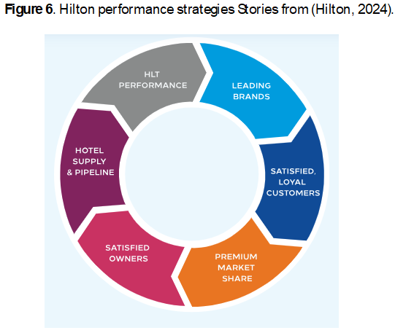

CONCLUSION
In Conclusion, Hilton's organisational performance advantage now consists of an incorporated approach of cutting-edge technologies and inspired solutions working together to increase income and control expenses without sacrificing quality. One of the leading hospitality firm, Hilton, delivers the power of scale, access, reputation, and innovation to create the Hilton performance advantage. Their system delivers cutting-edge solutions to continuously drive earnings and efficiency, offering vital resources throughout their portfolio of businesses. By increasing guest loyalty, share of wallet, and leading innovation, this technology can simplify on-site staff's focus on providing an exceptional guest experience (Teras, 2011). Thus, we can say that the Hilton Hotel Group organization has become hospitable through this, and it is also recognized due to the hundreds of awards received. Fortune World's Most Admired Companies, Great Place to Work, and Dow Jones Sustainability Indices are just a few that can be mentioned (The Hotel Group, 2024).

REFERENCE LIST
Armstrong, M. (2012) Armstrong's handbook of management and leadership [electronic resource]: developing effective people skills for better leadership and management, 3rd edn., London: Kogan Page. Available at: Armstrong's handbook of management and leadership [electronic resource] : developing effective people skills for better leadership and management (exlibrisgroup.com) (Accessed at: 16th May 2024).
Boddy, D. (2017) Management: an introduction, 7th edn, Harlow: Pearson. Available at: Management [electronic resource] : an introduction (exlibrisgroup.com) (Accessed at: 20th May 2024).
Brooks, I. (2018) Organisational behaviour: individuals, groups and organisation, 5th edn, Harlow: Pearson. Available at: Organisational behaviour : individuals, groups and organisation (exlibrisgroup.com) (Accessed at: 16th May 2024).
Business Research Methodology (2016) Hilton Worldwide Holdings Inc. Report. Available at: Hilton Worldwide Holdings Inc. Report - Research-Methodology (Accessed 23rd May 2024).
Canopy by Hilton (2024) Locations. Available at: Canopy by Hilton – Say Hello to Canopy. (Accessed at: 15th May 2024).
Chen, A., Ye, R., Zhang, W., and Tang, Y. (2019) ‘Strategies for Hilton (HLT) to expand growth, SlideShare. Available at: Strategies for Hilton Worldwide (HLT) to Expend Growth | PPT (slideshare.net) (Accessed at: 15th May 2024).
Dudovskiy, J. (2016) Hilton Organizational Structure, Business Research Methodology. Available at: Hilton Organizational Structure - Research-Methodology (Accessed at: 17th May 2024).
Gay, W. (2016) '4 Things Companies Can Learn from Hilton's Award-Winning Culture', Forbes. Available at: 4 Things Companies Can Learn From Hilton's Award-Winning Culture (forbes.com) (Accessed 23rd May 2024).
Hantuli, L. (2016) ‘An Analysis of Hotel Loyalty Programs: A Case Study of the Hilton Honors Loyalty Program’, California State Polytechnic University. Available at: An Analysis of Hotel Loyalty Programs: A Case Study of the Hilton HHonors Loyalty Program | ScholarWorks (calstate.edu) (Accessed 23rd May 2024).
Hilton (2024) Code of Conduct. Available at: HW-Code-Of-Conduct-OCT2015-L26.pdf (hilton.com) (Accessed at: 26th May 2024).
Hospitality Net (2024) Hilton. Available at: Hilton (hospitalitynet.org) (Accessed 23rd May 2024).
Hospitality On (2023) Worldwide Hospitality Awards. Available at: Hilton Travel with Purpose 2030 Goals - English | Hospitality ON (hospitality-on.com) (Accessed 23rd May 2024).
Marcus, L. (2015) 'Hilton's New Hotels Cater to the Young and Restless', Conde Nast Traveler. Available at: Hilton's New Hotels Cater to the Young and Restless | Condé Nast Traveler (cntraveler.com) (Accessed at: 15th May 2024).
Market Line (2018) The Future of Travel and Tourism: Technology is driving significant change and growth is on the horizon. Available at: The Future of Travel and Tourism: Technology is driving significant change and growth is on the horizon (uwtsd.ac.uk) (Accessed at: 15th May 2024).
Mullins, L. J. (2013) Hospitality management and organisational behaviour, 5th edn, Harlow: Pearson. Available at: Hospitality management and organisational behaviour (exlibrisgroup.com) (Accessed at: 16th May 2024).
Mullins, L. J. (2019) Organisational behaviour in the workplace, 12th edn, Harlow: Pearson Education Limited, Available at: Organisational behaviour in the workplace (exlibrisgroup.com) (Accessed at: 15th May 2024).
Nakata, C. (2009) Beyond Hofstede: culture frameworks for global marketing and management, 1st edn, UK: Imprint Palgrave Macmillan. Available at: Beyond Hofstede [electronic resource] : Culture Frameworks for Global Marketing and Management (exlibrisgroup.com) (Accessed 23rd May 2024).
Salkar, V. (2022), Hilton Goa Resort, Goa University. Available at: 1.3.4-Salkar-Varshali-Ramnath.pdf (unigoa.ac.in) (Accessed at: 16th May 2024).
Stories from Hilton (2024) 2023 Hilton Year in Review. Available at: Hilton 2023 Year in Review | 2023 Annual Report | Hilton News (Accessed at: 23rd May 2024).
Teras, M. (2011) 'The evolution of Marketing capability and alliance portfolio: Case of Hilton Worldwide', Tallinn School of Economics and Business Administration, thesis. Available at: (Microsoft Word - Magistrit\366\366 21.11.2011.docx) (Accessed at: 23rd May 2024).
The Hotel Group (2024) Awards & Accolades. Available at: Awards & Accolades - The Hotel Group (Accessed at: 26th May 2024).

