Jack Holland (P149473)
Website Development
Module Tutor: Mike Dacey
Advanced Web Development
Assignment 2
Contents
1. MVC 3
2. Page and Front Controllers 5
2.1 Page Controller 5
2.2 Front Controller 5
3. Template Pattern 6
4. Symfony 6
4.1 ORM Tool Support 6
4.2 Testing 6
4.3 Server Side Templates 7
4.4 REST Web Services 7
4.4 NoSQL Support 7
5. Testing 8
6. Bibliography 12

MVC
MVC is a design pattern which separates the application, business logic and presentation. MVC stands for Model View Controller.
The model contains the business logic and application data. It is often used to perform data validation and storing data. Data is typically stored in a database or JSON/XML file.
The controller deals with users requests, if a user requests the page “/index.php?cart” the controller will route the user to the shopping cart page.
The view then deals with what to present to the user, this is often in HTML with PHP included for dynamic aspects of the page.
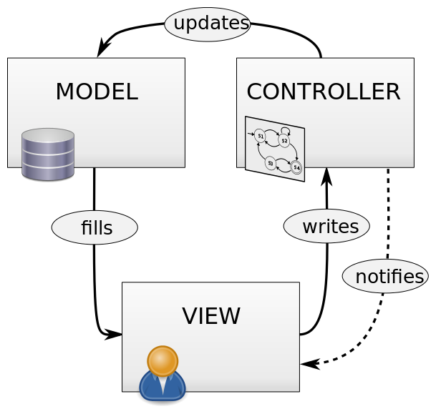
Figure 1 MVC Diagram [1]
Displaying Specific Views
Certain websites require different web pages to be displayed for specific users. For example, a University website may need separate web pages for students and lecturers.
This can be done by creating different views for each user group. Then inside the MVC Controller business logic can be applied to display different views.
Security
In PHP and MVC the biggest security risk is CSRF (Cross site request forgery). CSRF tricks a web browser into executing unwanted actions. [2]
Once a CSRF attack is successful the attacker can steal data and potentially money from the web application.
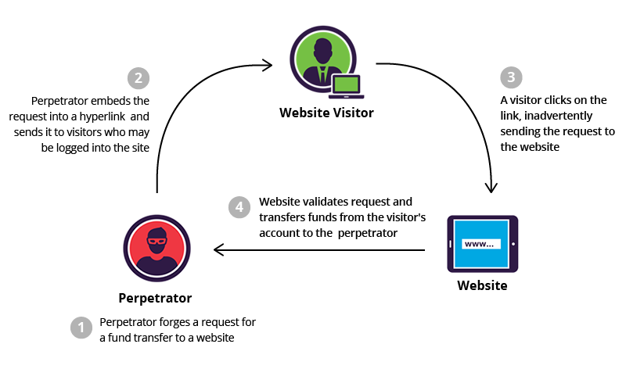
Figure 2 - CSRF Diagram [2]

Page and Front Controllers
The Page and Front controllers are design patterns used within MVC. They allow for separation, which is a key principle of MVC. Fowler says as soon as there is nonvisual logic, separation should be applied.[3]

Page Controller
The page controller design pattern creates one single file, it is then used to display a view to the user. The page controller is responsible for processing the view and model, it extracts information from the web servers request and performs an action on the model. It can also deliver a view to the browser based on the information.
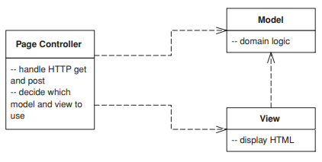
Figure 3 How the Page Controller works [3]
The Page Controller is responsible for the following:[3]
- Decoding a URL and extracting any form data
- Create and invoke any model objects
- Decide on which view to display and forward any information to the model

2.2 Front Controller
The front controller handles all the requests on a website, it is separated into two parts. The web handler and command hierarchy. The web handler is the class that receives requests from the web server and then decides where to route the user.
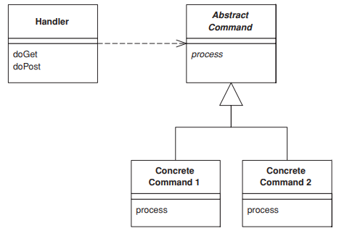
Figure 4 How the Front Controller works [3]

Template Pattern
The template design pattern defines the outline of an algorithm inside of an operation. It allows the developer to defer some steps into sub classes. The template design pattern allows steps to be redefined without the original structure being changed.
Advantages:[4]
- There is no code duplication in the template design pattern
- Code can be reused as inheritance is used and not composition
- The design pattern is flexible as sub classes can be used to implement steps in the algorithm

Symfony
Symfony is a MVC framework built using PHP, it is free to purchase and was first released in October 2005. The purpose of Symfony is to speed up the creation and maintenance of web applications and to stop repetitive programming tasks[5].
Symfony has a bunch of features that allow developers to create web applications easier. They are:
- Easy to install on most platforms
- Database engine support (MySQL and SQL Server)
- Simple to use but can be developed to create complex projects
- Follows web practises and implements design patterns
- Can be used at a personal or enterprise level
- Easy to maintain
- Easy to extend and is compatible with other vendor libraries
Popular websites that use the Symfony framework areSpotify, Dailymotion, Trivago, National Geographic Travel and Visit Barcelona[6].

ORM Tool Support
There isn’t a ORM tool built into Symfony, but it does have integration for a third-party tool called Doctrine[7]. The Doctrine library can be installed using Composer.
Doctrine is a set of PHP libraries which focuses on providing functionality, it is most known for their object-relational mapper (ORM).
Once the ORM is setup and configured, a database can be generated and built using the console and configuration migrations.

Testing
Symfony has a library called PHPUnit built into the framework, PHPUnit allows developers to create unit tests and then perform them[8]. Within Unit testing, classes are known as units. The program can automatically test each unit or it can perform a test on chosen classes.
Functional tests are used to check the integration of different layers of the application. The developer has to create a workflow for the program to complete.

Server Side Templates
A server side template lets web developers automatically generate custom web pages. Server side templates use static web page elements such as a footer, header and navigation but incorporates dynamic elements such as usernames and user details.
Server side templates are typically used in MVC frameworks such as Symfony, Laravel and CakePHP. They allow developers to quickly create pages without having to re-write static code.
Symfony has built its own server side template called Twig. The benefits Twig has over other server side templates are[9]:
- Twig will compile the templates into optimised PHP code, making it fast for the web server.
- It is security focused, with a sandbox mode to test untrusted code.
- The system is flexible, with a dynamic scripting language (DSL) that can be modified to add custom tags and filters.
Server side templates have custom syntax, for example. The code below will do the same as PHP but is easier to write.
Code:
PHP Code:
<?php echo htmlspecialchars($var, ENT_QUOTES, 'UTF-8') ?>

Twig Syntax:
{{ var|escape }}

4.4 REST Web Services
Like the ORM tool, there is no official Symfony support for REST web services. But there is a bundle (similar to plugin) called FOSRestBundle. This allows developers to create and use REST web services.
The FOSRestBundle can automatically generate routes for the web service, this will make the developers time easier.

NoSQL Support
Doctrine has a bundle for MongoDB, this is the most popular alternative to NoSQL. It allows developers to incorporate NoSQL databases to their web services easily.
Symfony also has support for XML and JSON databases using bundles.

Testing
Scenario
The web application for the practical side of this assignment is called “The Music Shop”. The purpose of the web application is to list the albums on sale at the store in Swansea. Customers can browse the current albums and send a contact us message to the shop.
The albums and contact us messages are stored on a MySQL database.
Homepage
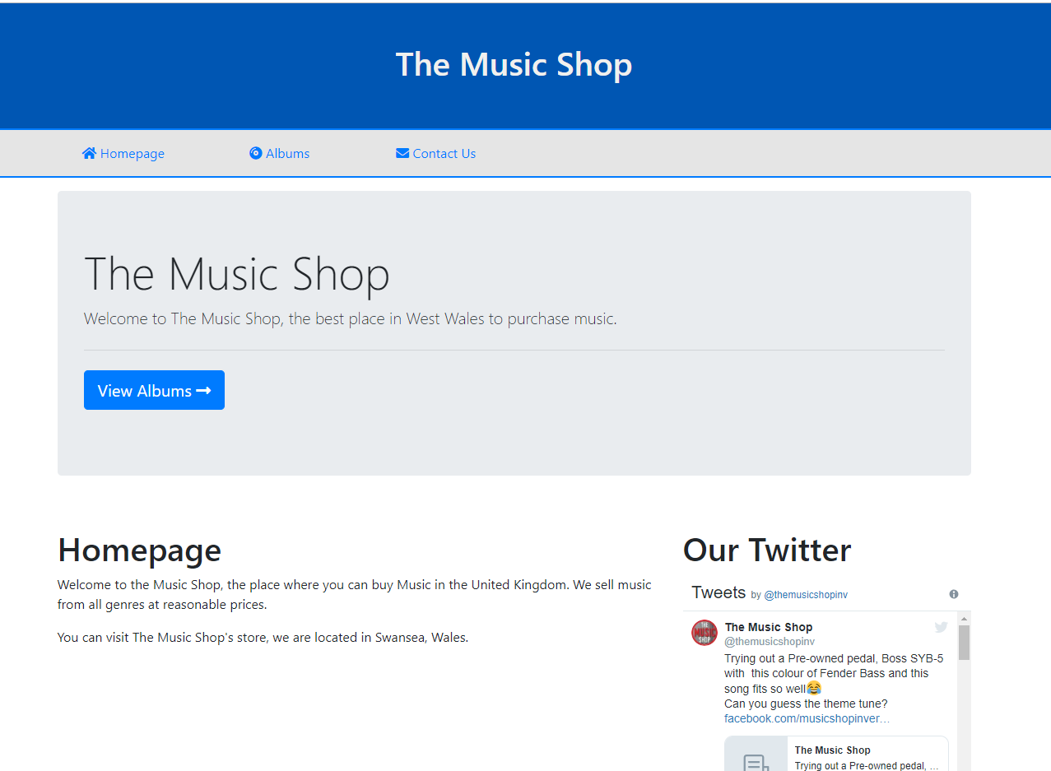
The view used for this is “DefaultView”, it is used as an index view for the web application. If the web application was to be improved further, a 404 (file not found) page could be added instead as currently a PHP error message is shown.

Albums
The second page of the web application is an album list, it displays every album in the stores catalogue.
Testing every album displays
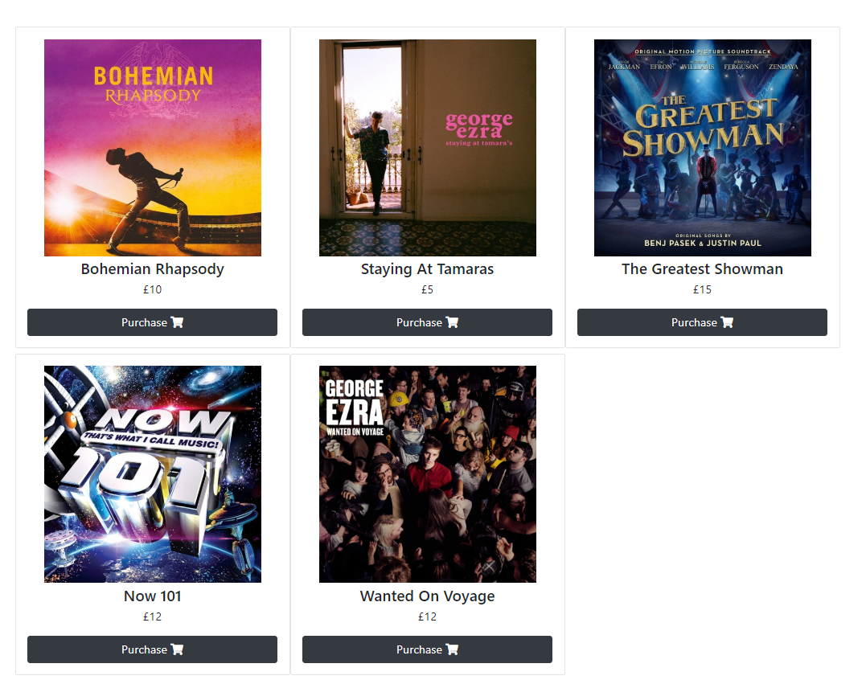
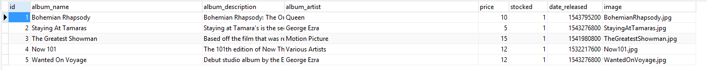
This shows every album being loaded and displayed by the web application.

Detailed Album View
Attached to every “Purchase” button is a form with a hidden input, the value for the hidden input is the ID of each album. Once the button is pressed, the form is submitted using POST and the specific album is retrieved from the database using its WHERE clause.
Displaying detailed albums
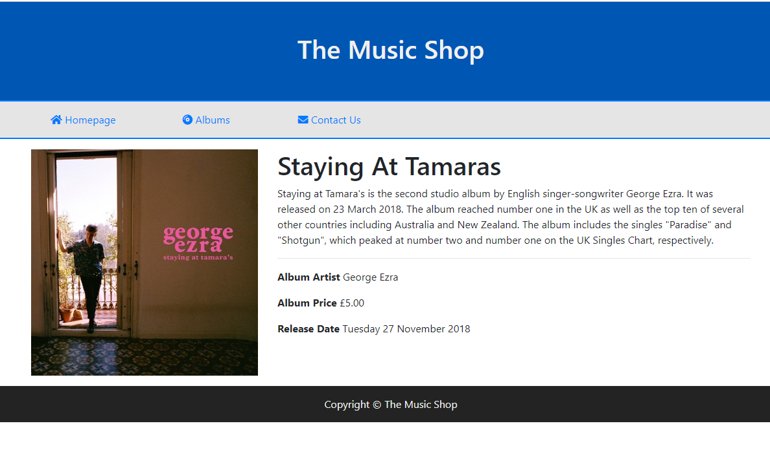
The screenshot above shows a specific album being retrieved from the database.

Contact Us
The contact us form lets customers send a message to the web master. It is a form that sends the details to a database using POST.
Testing message is sent
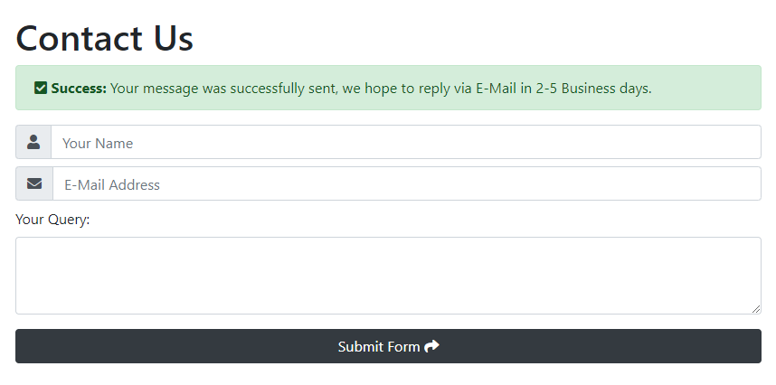
The database entry shows the message was successfully entered into the database.
An improvement for this form could be to add SQL injection prevention, another improvement could add form validation.

Bibliography
[1] “File:MVC Diagram (Model-View-Controller).svg - Wikimedia Commons.” [Online]. Available: https://commons.wikimedia.org/wiki/File:MVC_Diagram_(Model-View-Controller).svg. [Accessed: 02-Apr-2019].
[2] “What is CSRF | Cross Site Request Forgery Example | Incapsula.” .
[3] M. Fowler, Patterns of Enterprise Application Architecture, vol. 1, 1 vols. Addison Wesley, 2002.
[4] “The advantages and disadvantages of the Template Method pattern - Learning Python Design Patterns - Second Edition [Book].” [Online]. Available: https://www.oreilly.com/library/view/learning-python-design/9781785888038/ch08s05.html. [Accessed: 02-Apr-2019].
[5] “Symfony, High Performance PHP Framework for Web Development.” [Online]. Available: https://symfony.com/. [Accessed: 02-Apr-2019].
[6] “Brands That Love Symfony: The Most Popular Symfony Projects,” EtonDigital, 19-Oct-2017. [Online]. Available: https://www.etondigital.com/popular-symfony-projects/. [Accessed: 02-Apr-2019].
[7] “Databases and the Doctrine ORM (Symfony Docs).” [Online]. Available: https://symfony.com/doc/current/doctrine.html. [Accessed: 02-Apr-2019].
[8] “Testing (Symfony Docs).” [Online]. Available: https://symfony.com/doc/current/testing.html. [Accessed: 02-Apr-2019].
[9] “Home - Twig - The flexible, fast, and secure PHP template engine.” [Online]. Available: https://twig.symfony.com/. [Accessed: 02-Apr-2019].

