Sara John – Davies (1910200)

Essential Concepts and Principles of Modelling and Analysing data

Contents
Executive Summary 2
Spreadsheet models 3
Data Analytics 4
Stages of Modelling 5
Data Visualisation 6
Categories of Data 7
Value of spreadsheets 8
Conclusion 9
Bibliography 10

Executive Summary

During this report I will be discussing the importance of spreadsheets and why I think they are important to use to illustrate and construct findings in a numerical, and numerical visual professional standard. I will be going through my own assignment 1 spreadsheets and discussing what formulas I used and why I thought this was appropriate to use. I will be discussing the importance of data analytics, data visualisation and then will be summarising all my findings in this report into a short conclusion at the end.
Whilst reading this report. You will find a contents page, and from this you will see that every new subject of matter will start on a different page. I will also be producing the reader with a reference page of all my findings on the very last page of the report.
Also whilst reading this report you will lean more about myself as a member of the Finance team at First Milk Cheese Company and how spreadsheets have managed to help me in my work life as well as helping me achieve in my academic life.

Spreadsheet models

A spreadsheet is used to be able to summarise information from multiple sources in one central place. In financial circumstances a spreadsheet would be there to be able to help show other members of the team the ‘bigger picture.’ A spreadsheet will give a more specific view that is both precise and well structed. When creating a spreadsheet, it is important to be able to know who is going to be reading the spreadsheet this way it means that this will make the creators job easier as they will know whether to use simple or longer formulas. When creating a formula, it is important to ensure that you ‘Consider alternate software tools such as databases, statistics packages, financial modelling systems, mathematical programming languages’ – (Phillip L. Bewig – July 28, 2005) when creating a spreadsheet you should ‘lay out your spreadsheet as determined by the needs of your problem. – (Phillip L. Bewig – July 28, 2005)
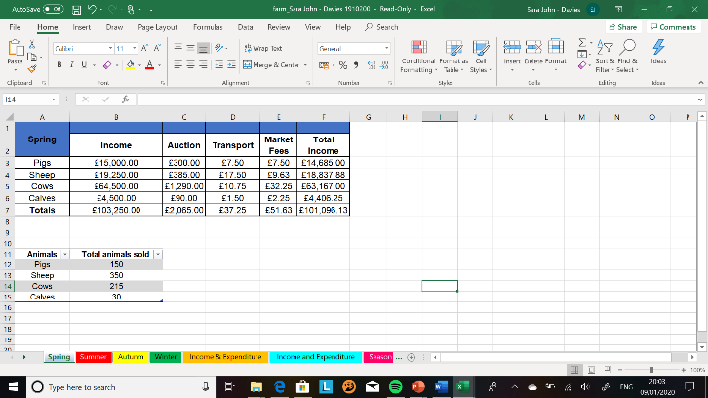
During my time completing the tasks for scenario one and scenario two in assignment one. I created two spreadsheets, first one on Dragon Trading Accounts and the second on a farm livestock and the money which he will make out of this. The spreadsheet I will be discussing in this report is going to be scenario two – farm.
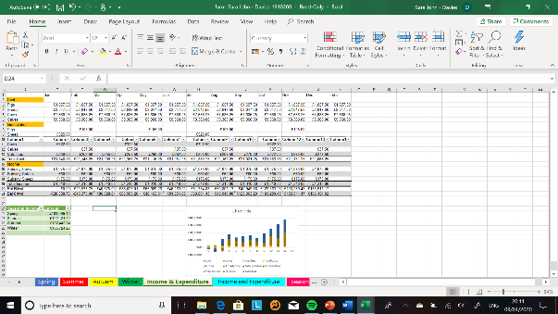
I was given a sheet of data to conduct in an appropriate spreadsheet. So, as you can see in the print screen of the spreadsheet provided. I have taken the income, auction, transport, market fees and total income. This is done for each season so the farmer knows what income he will be expecting and what he is going to be earning from each specific animal in what season.
The next print screen shows the income and expenditure table for the year for the farm. This shows the seasonal income, the income and the inoculation for the animals on the farm.

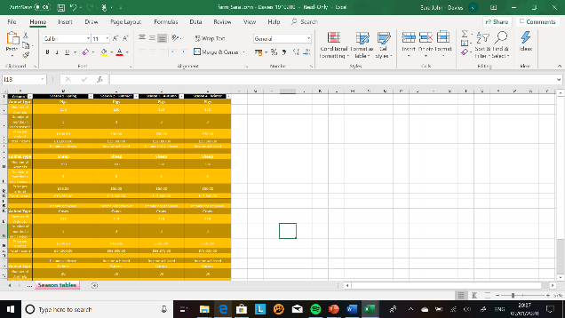
On the last screen shot you will find that I have produced a table for all of the seasons combined and what findings I have found with my formulas to be able to provide the farmer with what particular animals are providing him with the highest income and what animals is potentially going to end up making him a loss.

Data Analytics

Data analytics is the use of:
- Data
- Information technology
- Statistical analysis
- Quantitative methods
- Math and computer-based models.
There are many different types of applications these include;
Pricing – this includes setting prices for consumer and other goods, the governments contracts and maintenance contracts.
Customer segmentation – this includes being able to identify and target key customer groups in several industries effectively.
Merchandising – this is determining particular brands to buy quantities and allocations.
Location - Find the best location for certain equipment and also being able to find where it would be suitable to service industrial equipment.
Social Media – This is being able to understand trends, customer perceptions, marketing and also being able to be design certain parts of the business. (Evans, 2014)
Data analytics is important because it is the process of inspecting, transformation the cleaning of data to discover a goal within it. There are many benefits to do with data analytics.
It encourages smart decision in business as it give companies the power to make accurate decisions that could leverage businesses. Not only does data analytics provide useful data, it also allows companies to make decisions faster and a lot more efficiently than before. (Goewey, 2015)
In modern time a customer can be easily led to go somewhere else for a better deal or simply because that’s where their friend or family member went and they had a good experience so that’s where the other customer wants to go also. So with this approach to shopping becoming the normal way. So, this is why businesses are not protecting themselves with analytics so that they will be able to them ‘innovate and pre-empt their products according to the consumers needs are preferences. (Goewey, 2015)
Lastly, efficiency is improving since the advent of business analytics, Having the ability to gather a large amount of data at a fast pace and also to be able to present it in a visually appealing way businesses are now able to formulate decisions to help achieve specific goals.

Stages of Modelling
During my time of creating the spreadsheets I managed to use a wide range of formulas. To be able to make sure that I can extended my skills and knowledge of Microsoft Excel. In this section I am going to be demonstrating some of the skills which I have learned.
- Sum
In the Dragon Trading spreadsheet. I had to conduct an =sum formula to be able calculate the total sales. This is the formula which I used =SUM(F2:F902)
- Average
In the Dragon Trading spreadsheet. I had to use an =average formula to be able to calculate the average. The formula for averaging which I used in the Dragon Trading spreadsheet was =AVERAGE (F2:F902)
- IF
In the Dragon Trading spreadsheet, I had to use an IF statement formula to determine if a number was over a certain number then the spreadsheet would enter ‘YES’ The formula which I used in the Dragon Trading spreadsheet was, =IF(B2="y","needs check","") So, for this formula was to be effective and work correctly then, if the selected cell in this formula B2 has a Y or No in, if it had a Y in then the IF formulated cell would have Needs check automatically entered in. But, if B2 was to say N then the IF formulated cell would not have anything in the cell it would stay blank.
- LOOK UP
I haven’t personally used a LOOK UP table in either of the spreadsheets. LOOK UP tables is a named table which are used with VLOOKUP function to find any data within the spreadsheet. A LOOKUP table is perfect for when there is a large amount of data in the selected spreadsheet.
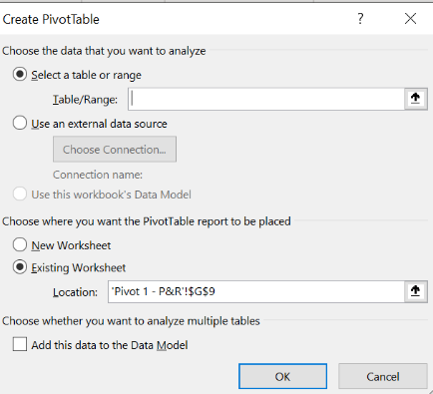
- PIVOT TABLE
Row Labels | Sum of Profit
Dyfed | 45154.05
Gwent | 82431.6
Powys | 51895.94
South Glamorgan | 16868.55
Grand Total | 196350.14
This is the pivot table which I used in my Dragon Trading spreadsheet, the way which I made this Pivot table is you go the ‘INSERT’ tab then you will find a ‘PIVOT TABLE’ function button. This is the table which you will be presented with to be complete. This is the information which will be in your PIVOT TABLE and also the more information which is entered into the table means the PIVOT TABLE will be full of information.

Data Visualisation

Data Visualisation is the representation of information in the form of a char, diagram, graph or picture. In the 21st century data visualisation is becoming more and more common as technology is the main focus of the majority of jobs now. At least the majority of society will see some form of data visualisation every day. Data visualisations are created when communication, data science and design art are all mixed together. If a data visualisation is completed correctly then this means that they will provide insights into complicated sets of data and make them more interesting and potentially easier to read.
It is important to include data visualisation in pieces of work this way it will make the reader engrossed in the piece of work and they will be able to learn more from the visualisation on the page and not just a page full of numbers which to some people would put them off straight away. (INFOGRAM, 2020)
Data visualisation improves decision-making, provides business staff with better analysis capabilities that reduce reliance on IT professionals, and improves collaboration and information sharing. (Evans, 2014)
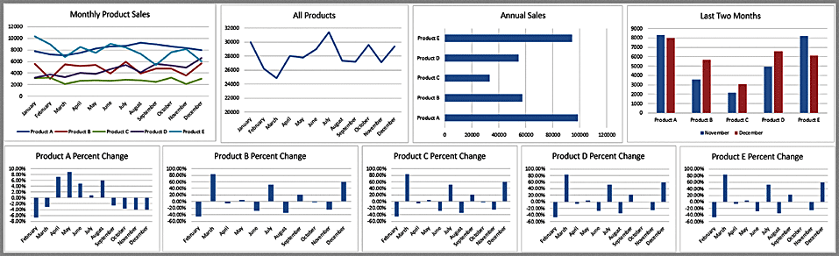
There are many different types of data visualisation, here are two examples which are commonly used.
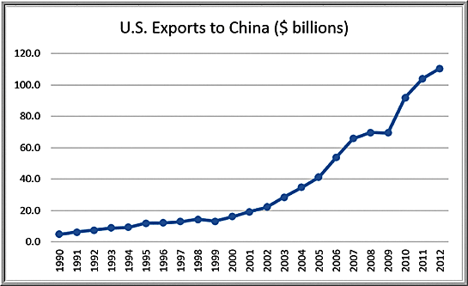
DASHBOARDS – A dashboard is a visual of key business measures. Dashboards provide important summaries.
LINE CHARTS – Line charts are the best way to be able to visually appealing display data of a long period of time.

In my spreadsheet with the farms income I completed a Income and Expenditure graph. In this bar graph I thought this was the clearest way to demonstrate visually on how well or how poorly the farm is doing according to the Income and their expenditure.

Categories of Data
There are two different types of categories of data;
Fundamental data – A fundamental analysis is a method of measuring a ‘security’s intrinsic value by examining related economic and financial factors.’ The end goal when using Fundamental data analysis is to be able to arrive at a final number with the investors can come with a security current price in order to see if the price is undervalued or overvalued.
“The problem with defining the word fundamentals is that it can cover anything related to the economic well-being of a company. They obviously include numbers like revenue and profit, but they can also include anything from a company's market share to the quality of its management.” – (Seagal, 2019)

Value of spreadsheets
For many businesses there is so much paperwork that it would take them so much longer to complete any task if it wasn’t for modern day technology. But thankfully, computers and other technology have made the workplace and homelives a lot more efficient and reliable.
In the home life, if someone had school work, then they can jump onto a spreadsheet on the computer and conduct a high quality spreadsheet and this would not take far as long as it would if they were to sit down and handwrite and hand draw all of the data visualisation to be able to back up the handwritten work.
In the workplace, spreadsheets make everyone’s jobs so much quicker and also a lot more simpler. So, for example my place of work is First Milk Cheese Factory. So, we have UK sites, over seas customers and if we didn’t have spreadsheets to fall back we would be spending so much money on flights, car trips and postage all because we would’ve have to go out to the certain area go and present our findings for that month, and pray that the paperwork doesn’t get ruined, lost or stolen. But, because in the 21st century we are able to present and share our spreadsheets all from our screens. So, because of spreadsheets we are able to share spreadsheets with how ever many people we want to, we can use them for templates and even use them to pay peoples wages. Spreadsheets have certainly made my work life a whole lot quicker and easier for everyone.

Conclusion

The findings of this report is that I am now able to complete spreadsheets and understand them and the background to them without needing a lot of assistance. As you can see from my definitions and examples throughout my report. One of my favourite parts of the report was being able to research into the history of spreadsheets and how far we have come to be able to go from pen and paper to know having complex spreadsheets which also include data visualisations.

In the spreadsheets which I competed in the assignment 1. These were both complex spreadsheets, but the amount of time which I saved creating these and not having to create them on paper. It has made me understand on how to be able to complete such a high standard spreadsheet. This is also something which I have been able to bring into my workplace as I was looking for a way to make all of the formulas, I have to use in my Finance role at First Milk Cheese Company. After studying Data Analytics, it has made me want to go into a career path in this field.

Bibliography
Bewig, P. L. (July 28 2005 ). How Do You Know If Your Spreadsheet is Right? 1-2.
Evans, J. R. (2014). Business Analytics . Cincinnati : Pearson .
Goewey, B. (2015, August 21). 5 benefits of using Business Analytics . Retrieved from Data Mensional : https://www.datamensional.com/5-benefits-of-using-business-analytics/
INFOGRAM. (2020). what is data visualisation? Retrieved from infogram: https://infogram.com/page/data-visualization
Seagal, A. G. (2019, October 14). Fundamental Analysis. Retrieved from Investopedia: https://www.investopedia.com/terms/f/fundamentalanalysis.asp

