Student Name: Andreea Ursu  Student ID: 2227582  Module Title:  Module Code:BMIH5003  Lecturer:  Date:09.02.2024 | 
ASSIGNMENT 1: PORTFOLIO
(4 Components)

Component 1: Professional Reflection (500 words +/- 10%)

Weighting: 25%
I work in a hotel restaurant as a food and beverage employee. A guest from a different country asks me about the ingredients of a specific dish on the menu. Due to a language barrier, I struggle to understand the guest's accent and questions, and end up providing incomplete or inaccurate information about the dish. This leads to a cultural misunderstanding and the guest feels dissatisfied with the service.

Reflection and Action Plan:
Cultural misunderstandings in this scenario can occur due to language barriers and differences in communication styles. In this situation, I realize that I need to develop certain skills and behaviours to prevent such misunderstandings in the future.
Firstly, I need to improve my active listening skills, especially when there is a language barrier. It's essential to focus on understanding the guest's words, even if their accent or pronunciation is different from what I'm accustomed to. This will involve patience, attentiveness, and the willingness to ask clarifying questions to ensure that I fully comprehend the guest's needs and inquiries.

Furthermore, enhancing my language skills is crucial. I should dedicate time to learn basic phrases and food-related vocabulary in the languages commonly spoken by hotel guests, especially if there is a significant number of guests from a particular cultural background. This will enable me to communicate more effectively and accurately with a wider range of guests, reducing the likelihood of misunderstandings.

Additionally, I need to educate myself about the dietary preferences and cultural considerations of guests from diverse backgrounds. Understanding common dietary restrictions, preferences, and taboos in different cultures will allow me to provide more informed and culturally sensitive information to guests, especially when discussing menu items and ingredients.

Moreover, developing cultural sensitivity and awareness is important. I should make an effort to familiarize myself with the customs and communication norms of guests from various cultural backgrounds. This may involve researching and learning about different cultural customs, greetings, and communication styles to ensure that I can interact with guests in a respectful and culturally appropriate manner.

Lastly, seeking feedback and guidance from colleagues or supervisors who have experience in serving a diverse clientele is essential. Their insights and advice can provide me with valuable strategies for improving my cross-cultural communication skills and navigating potential language or cultural barriers effectively.

References:
DoveMed. (n.d.). Language Barrier: Understanding its Impact, Challenges, and Strategies for Effective Communication. [online] Available at: https://www.dovemed.com/health-topics/focused-health-topics/language-barrier-understanding-its-impact-challenges-and-strategies-effective-communication.
Fisic, I. (2022). How to overcome cultural and language barriers in the workplace. [online] Clockify Blog. Available at: https://clockify.me/blog/managing-teams/cultural-and-language-barriers-at-work/.
Kim, E. and Mattila, A. (2011). The Impact of Language Barrier & Cultural Differences on Restaurant Experiences: A Grounded Theory Approach. [online] undefined. Available at: https://www.semanticscholar.org/paper/The-Impact-of-Language-Barrier-%26-Cultural-on-A-Kim-Mattila/dd98a5c137505b89be93f08c929bd0836305c439.
Naseer Alomari, P.D. (2023). Cross-Cultural Miscommunication. open.library.okstate.edu. [online] Available at: https://open.library.okstate.edu/interculturalcommunication/chapter/persuasion-across-cultures/.
ramw.org. (n.d.). Breaking down language barriers in foodservice | Restaurant Association of Metropolitan Washington. [online] Available at: https://ramw.org/blog/breaking-down-language-barriers-foodservice [Accessed 9 Feb. 2024].
The Rail. (n.d.). How to Overcome Language Barriers in Your Restaurant? [online] Available at: https://www.therail.media/stories/2019/8/30/barriers-to-communication-how-to-overcome-language-barriers-in-your-restaurant.

Component 2: Training Plan (500 words +/- 10%)

Weighting: 25%

Training Plan: Cross-Cultural Communication and Sensitivity for Marriott Staff

Objective:
The primary objective of this training program is to equip Marriott staff with the necessary skills and knowledge to effectively communicate and interact with guests from diverse cultural backgrounds, thereby minimizing the potential for cultural misunderstandings and ensuring exceptional guest experiences.

Training Modules:

1. Cultural Awareness and Sensitivity:
- Understanding the importance of cultural diversity in the hospitality industry.
- Exploring common cultural norms, customs, and communication styles of key guest demographics.
- Discussing the impact of cultural misunderstandings on guest satisfaction and the hotel's reputation.
- Promoting a culture of respect, empathy, and inclusivity within the hotel's workforce.

2. Active Listening and Verbal Communication:
- Techniques for attentive and active listening in cross-cultural interactions, especially in the presence of language barriers or accents.
- Strategies for effective verbal communication with guests from diverse linguistic backgrounds.
- Role-playing exercises to practice clear, concise, and culturally sensitive communication.

3. Language Skills Development:
- Basic language training in commonly spoken languages by the hotel's guests, tailored to the specific cultural demographics of the hotel's clientele.
- Introduction to essential phrases, greetings, and food-related vocabulary in target languages.
- Resources for self-study and ongoing language skill development.

4. Understanding Dietary Preferences and Taboos:
- Education on common dietary restrictions, preferences, and taboos in different cultures, and their implications for food and beverage service.
- Guidelines for providing accurate and culturally sensitive information about menu items and ingredients.
- Case studies and discussions on handling guest inquiries about food in a culturally informed manner.

5. Conflict Resolution and Feedback:
- Techniques for resolving cultural misunderstandings with empathy and professionalism.
- Creating an environment where both guests and employees feel comfortable providing feedback on cultural interactions.
- Role-playing scenarios to practice responding to feedback and addressing cultural misunderstandings in real time.

Training Delivery and Implementation:

1. In-person Workshops:
- Conduct interactive workshops led by cultural competency trainers and language professionals to facilitate experiential learning and skill development.

2. E-Learning Modules:
- Develop e-learning modules on cultural awareness, language basics, and communication skills, providing employees with convenient access to training materials.

3. Multilingual Resources:
- Provide multilingual resources such as quick reference guides and digital language tools to support language skill development and cross-cultural communication.

4. Role-playing and Simulation Exercises:
- Incorporate role-playing and simulation exercises in training sessions to practice cross-cultural communication and interpersonal skills in realistic scenarios.

5. Ongoing Support and Refresher Courses:
- Offer ongoing support through cultural sensitivity mentors and refresher courses to reinforce skills and provide additional guidance as employees interact with diverse guests.

Evaluation and Assessment:

1. Pre- and Post-Training Assessments:
- Administer pre-training assessments to gauge employees' existing knowledge and confidence in cross-cultural communication.
- Conduct post-training assessments to measure improvements in knowledge, skills, and attitudes toward cultural sensitivity.

2. Guest Feedback Analysis:
- Regularly analyse guest feedback related to cultural interactions to identify trends or areas for further improvement.

3. Supervisor Observations:
- Encourage supervisors to provide constructive feedback and observations on employees' application of cross-cultural communication skills in real-world situations.

By implementing this comprehensive training plan, Marriott staff will be equipped with the necessary skills and cultural competence to navigate cross-cultural interactions effectively, ultimately enhancing the guest experience and strengthening the hotel's reputation as a welcoming and culturally sensitive establishment.

References:

Iguchi, Y. (2018). Understanding cultural differences in hospitality - Insights. [online] Insights. Available at: https://insights.ehotelier.com/insights/2017/03/17/understanding-cultural-differences-hospitality/.
pos.toasttab.com. (n.d.). How to Communicate Effectively as a Restaurant Team - On the Line | Toast POS. [online] Available at: https://pos.toasttab.com/blog/on-the-line/how-to-communicate-effectively-as-a-restaurant-team.
Rebecca (2023). Build a Skill: Essential Communication Techniques for Restaurant Workers. [online] Poached. Available at: https://blog.poachedjobs.com/2023/09/19/restaurant-worker/career-advancement/communication-techniques/ [Accessed 9 Feb. 2024].
Wegner, A. (2023). Why Language Learning Is a Must in the Hotel Industry. [online] Babbel for Business. Available at: https://www.babbelforbusiness.com/us/blog/why-babbel-is-a-must-in-the-hotel-amp-hospitality-industry/#language-training-specifically-made-for-the-hotel-industry [Accessed 9 Feb. 2024].
www.helloglobo.com. (n.d.). Understanding Cultural Awareness, Sensitivity & Competence. [online] Available at: https://www.helloglobo.com/blog/understanding-cultural-awareness-sensitivity-competence.
www.linkedin.com. (n.d.). Breaking Down Language Barriers: Enhancing Communication in the Multinational Hospitality Industry. [online] Available at: https://www.linkedin.com/pulse/breaking-down-language-barriers-enhancing-hospitality-fajal-luckhman.

Component 3: Student Self-Reflection (500 words +/- 10%)

Weighting: 25%
I have chosen the Gibbs Reflective Cycle as a model to critically reflect on my understanding of the importance of cultural awareness within the hospitality industry.

1. Description:
Initially, when I began exploring the concept of cultural awareness in the hospitality industry, my understanding was primarily rooted in the idea of offering polite and respectful service to guests from different cultural backgrounds. My perception was fairly surface-level, focusing on surface-level aspects such as greeting customs, dietary preferences, and basic communication.

2. Feelings:
As I delved deeper into the subject , I started to feel a sense of empathy and curiosity about the diverse cultural experiences that guests bring with them. I realized that cultural awareness goes far beyond simply avoiding offense; it is about creating an environment where every guest feels genuinely welcomed and understood.

3. Evaluation:
Over time, my understanding of cultural awareness in hospitality has evolved significantly. I learned that cultural sensitivity is not just a "nice-to-have" skill, but an essential component of delivering exceptional guest experiences. For example, I discovered that a simple awareness of religious holidays and observances can significantly impact a guest's perception of their stay. Additionally, through studying guest feedback, I witnessed firsthand the tangible impact of cultural misunderstandings on guest satisfaction and loyalty.

4. Analysis:
As I gained more insight into the complexities of cultural interactions within the hospitality industry, I also recognized the broader societal implications of cultural awareness. Understanding and respecting different cultures fosters a sense of inclusivity and belonging, not only for guests but also for the hotel's workforce. I realized that a culturally competent staff contributes to an overall positive and welcoming atmosphere within the hotel.

5. Conclusion:
My experience has highlighted the utmost importance of cultural awareness in the hospitality industry. It is no longer merely about avoiding cultural missteps; it is about actively engaging with and celebrating diverse cultural experiences to create an environment of genuine inclusivity and respect. For instance, I have come to appreciate the impact of small gestures, such as displaying cultural decor or offering authentic cuisine options, in making guests feel valued and understood.

6. Action Plan:
Moving forward, I am committed to continuously expanding my cultural knowledge and encouraging others to do the same. This means seeking out opportunities for further education on various cultural customs and traditions, as well as advocating for ongoing cultural sensitivity training within the hospitality industry. I aim to actively promote a culture of inclusivity and respect, as I firmly believe that this is the cornerstone of exceptional guest experiences.

References:

Reference list
Main, P. (2023). Gibbs’ Reflective Cycle. [online] Structural Learning. Available at: https://www.structural-learning.com/post/gibbs-reflective-cycle.
Mind Tools (2022). Gibbs Reflective Cycle. [online] www.mindtools.com. Available at: https://www.mindtools.com/ano9qiu/gibbs-reflective-cycle.
www.helloglobo.com. (n.d.). Understanding Cultural Awareness, Sensitivity & Competence. [online] Available at: https://www.helloglobo.com/blog/understanding-cultural-awareness-sensitivity-competence.

Component 4: Training Presentation (6 Slides)

Weighting: 25%
[Introduction slide, e.g. assignment title, student name/ID, module title/code, date, hotel 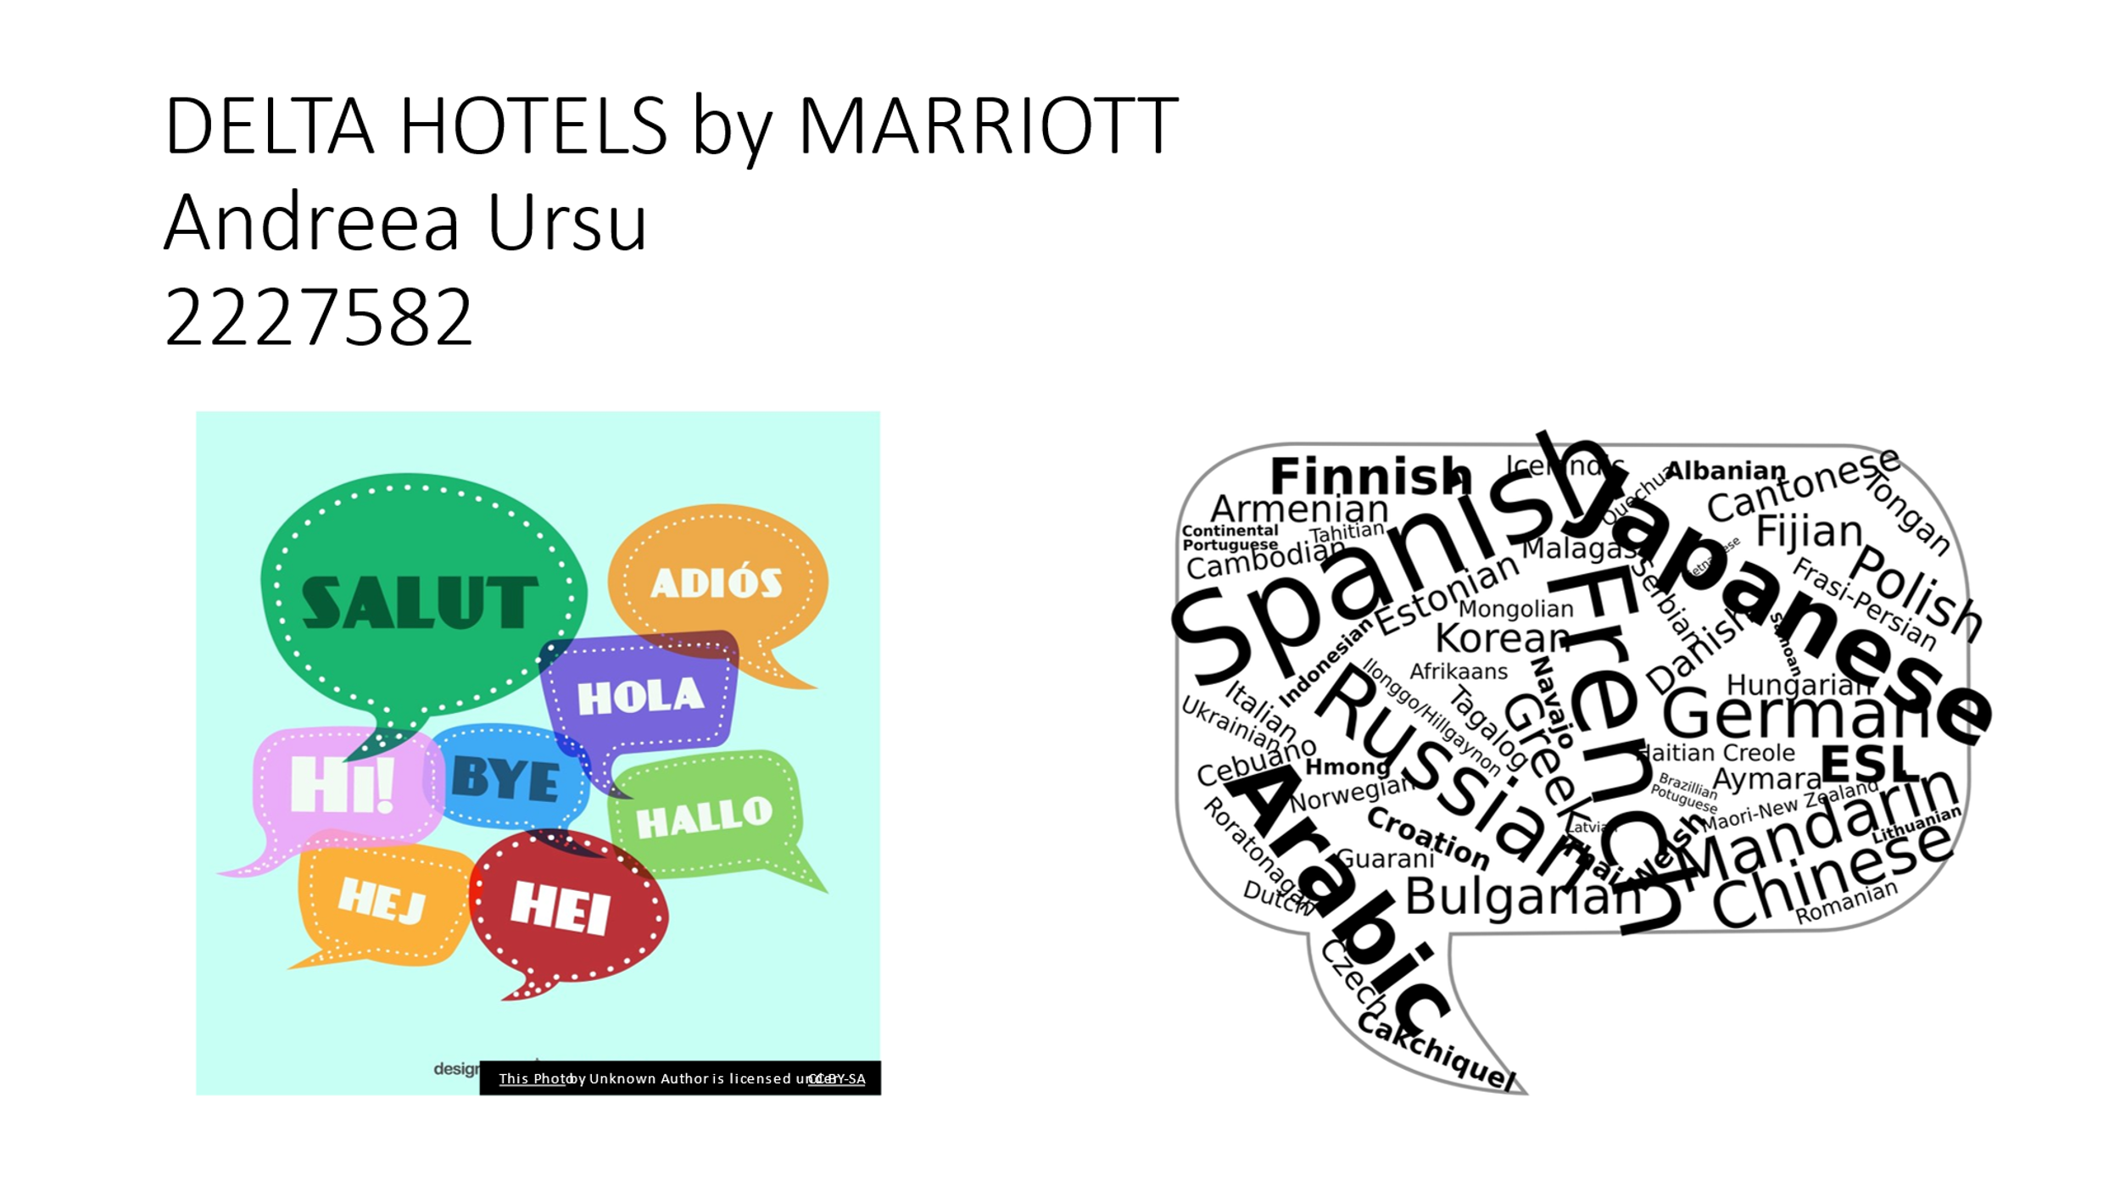 logo]
[Content Slide 1] 

[Content Slide 2]
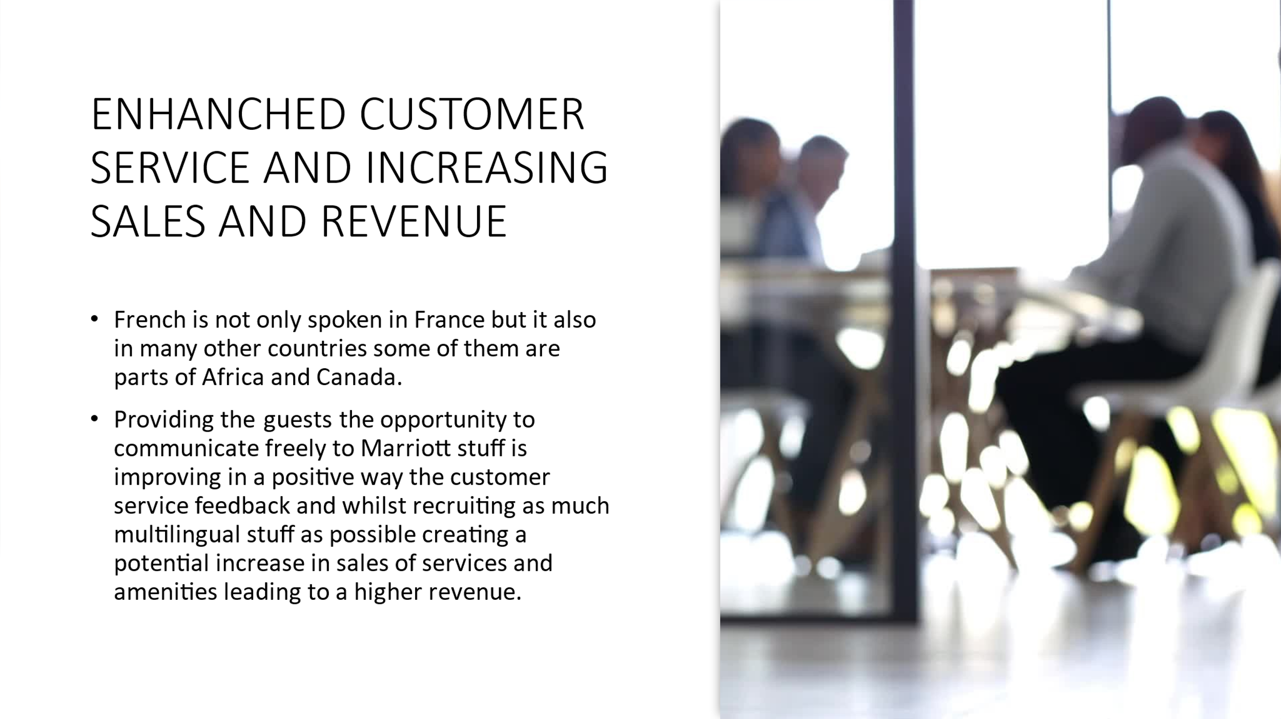
[Content Slide 3] 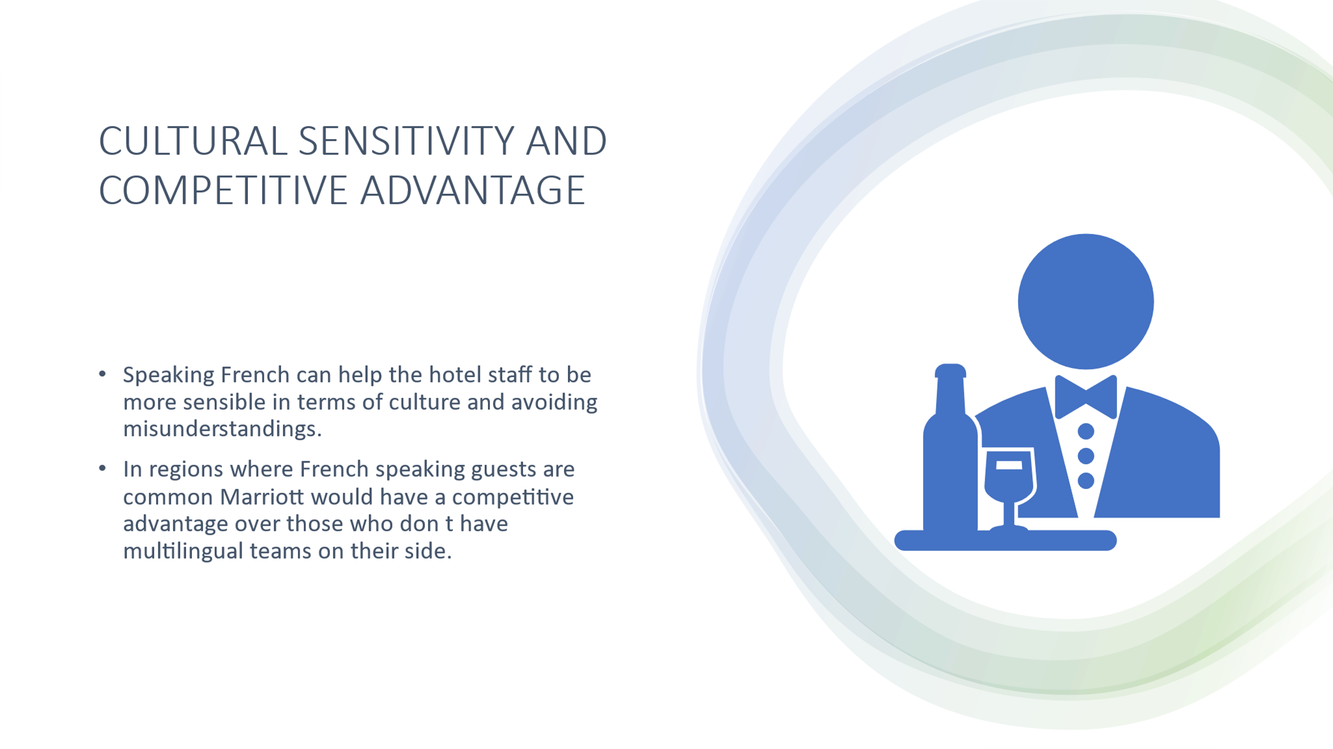

[Content Slide 4]
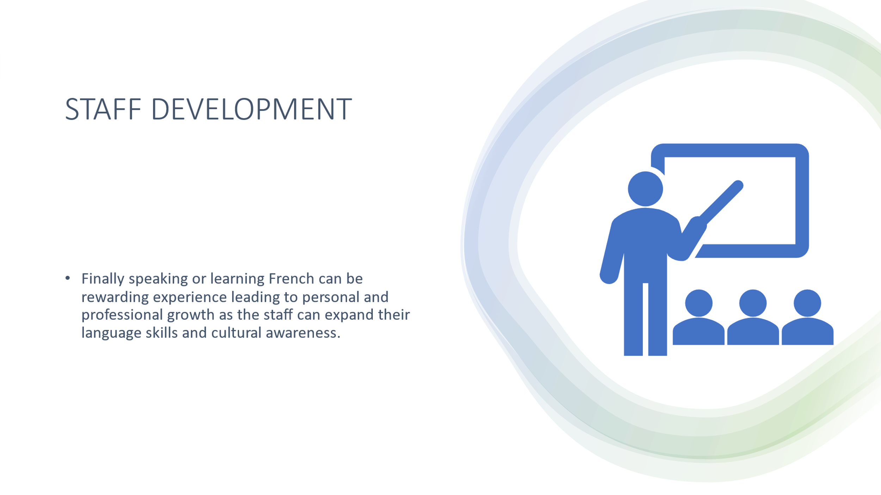
[Content Slide 5] 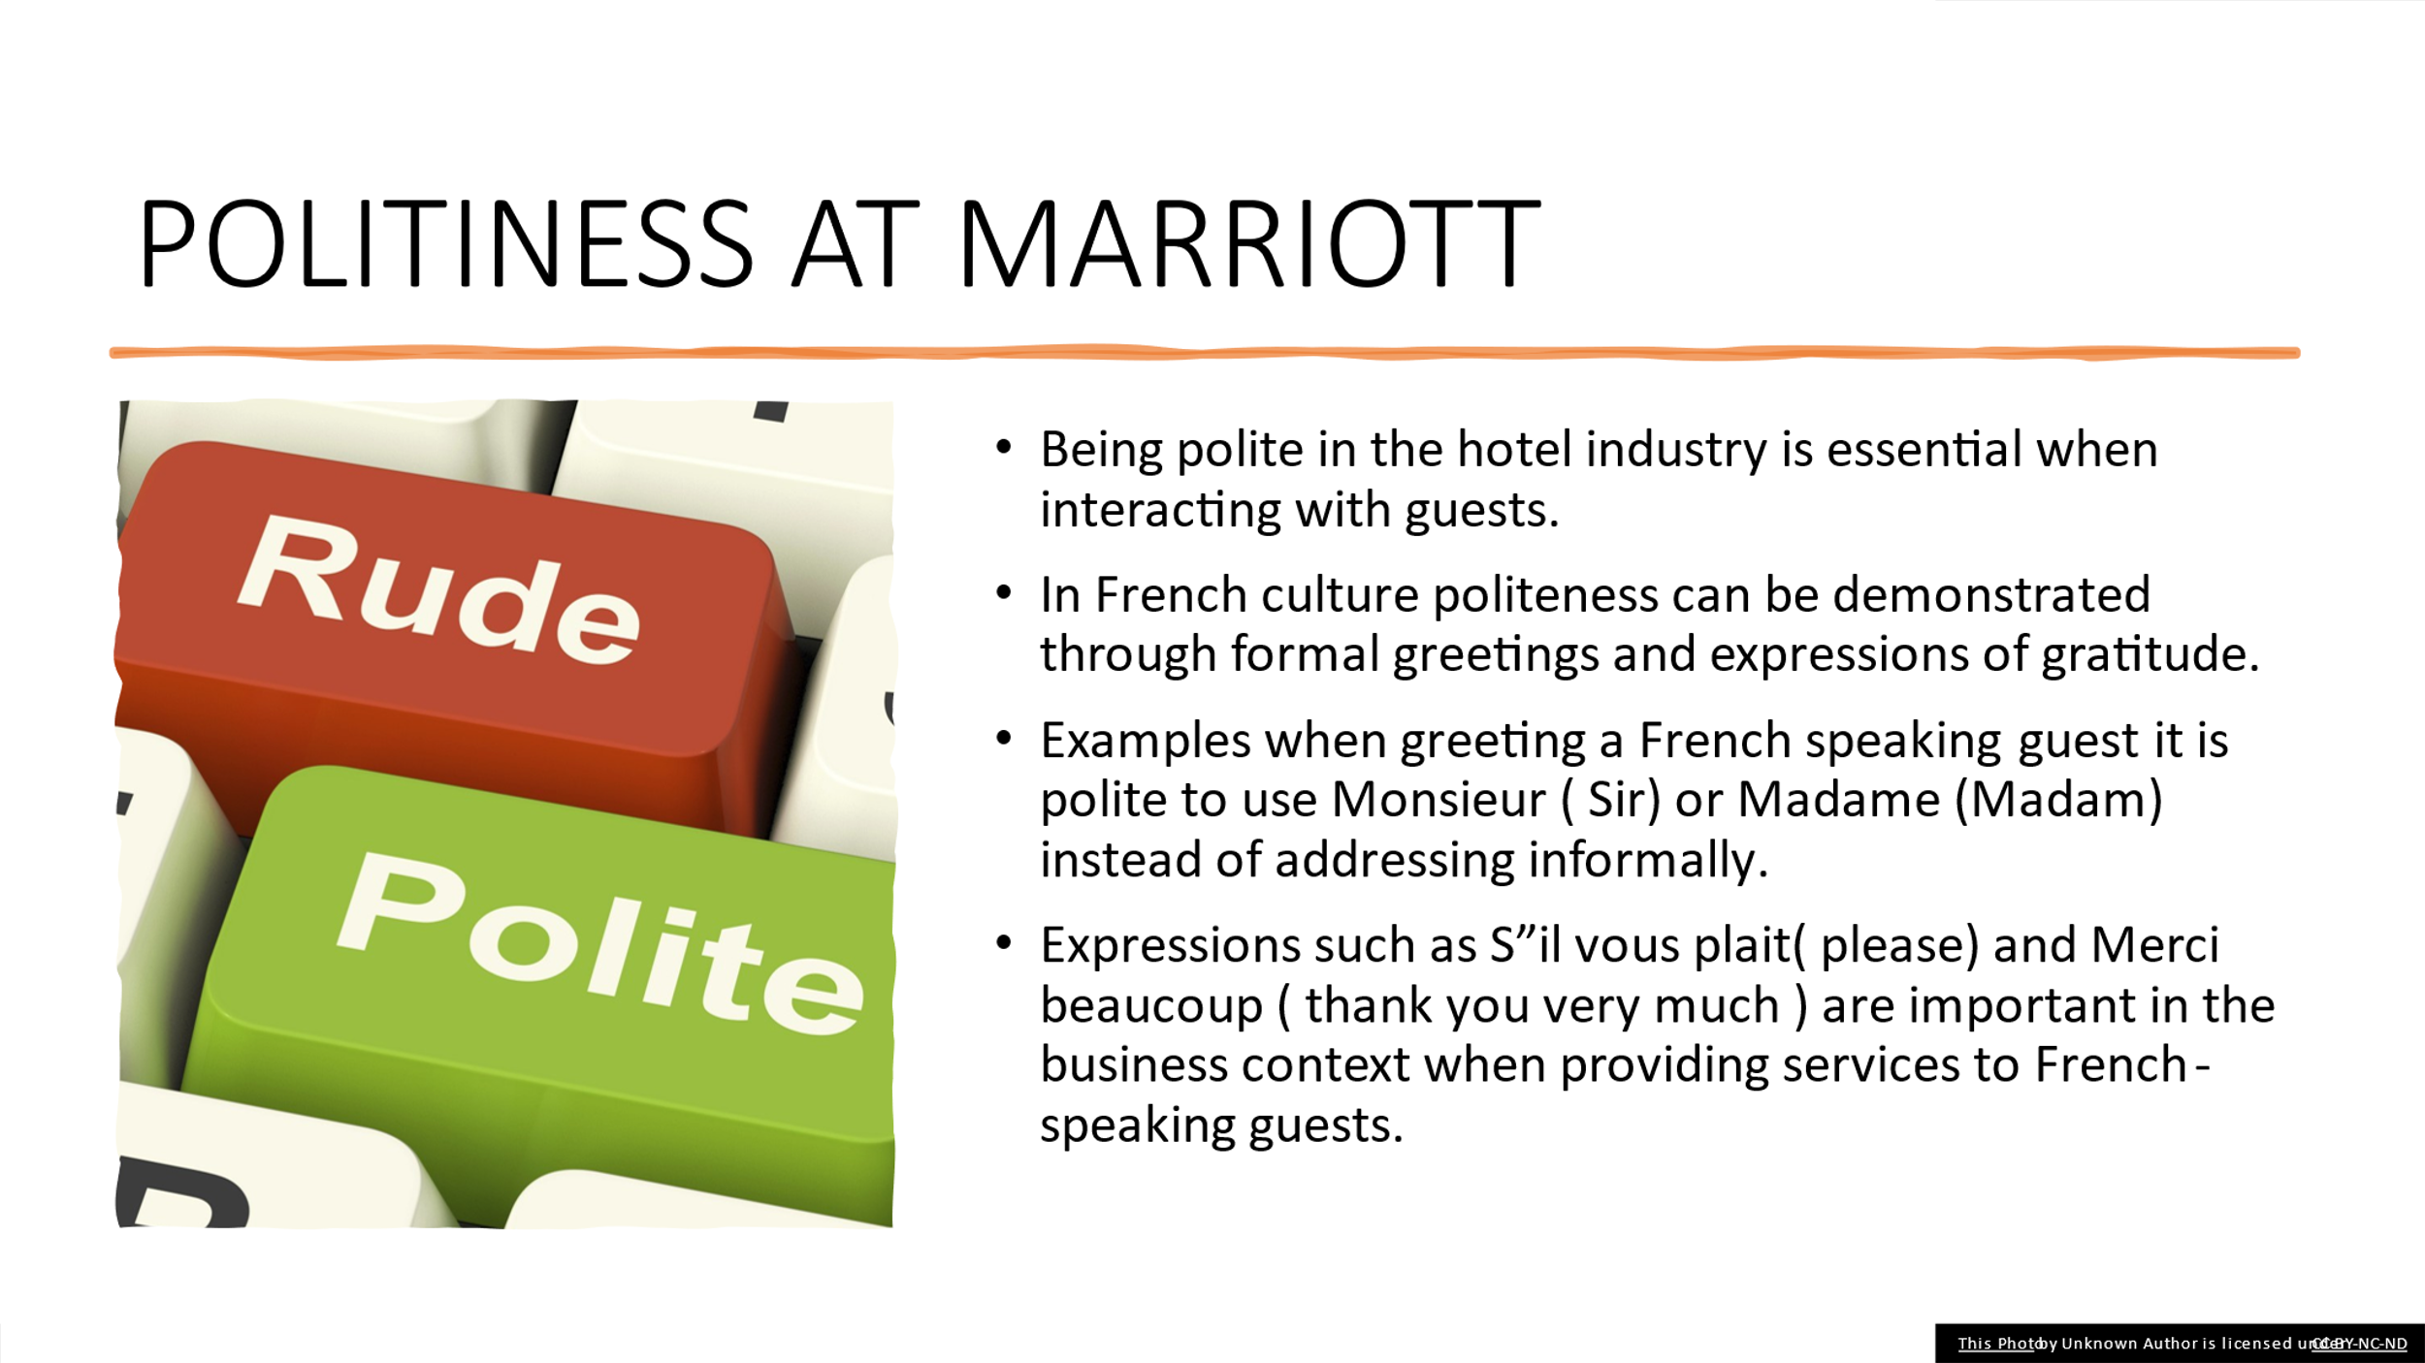
References (no screenshots):

- Anon, (2022). Opportunities in Hospitality with Your Language Skills. [online] Available at: https://www.languagetesting.com/blog/exploring-a-world-of-opportunities-in-the-hospitality-sector-with-your-language-skills/ [Accessed 6 Feb. 2024].
- Hospitality Search International. (n.d.). Benefits of Being Multilingual. [online] Available at: https://hospitalitysearch.co.uk/benefits-of-being-multilingual/.
- hospitalityinsights.ehl.edu. (n.d.). The best languages to learn for business and the hospitality industry. [online] Available at: https://hospitalityinsights.ehl.edu/languages-to-learn-for-business.
- Les Roches (2022). Diversity in Hospitality Industry. [online] Les Roches. Available at: https://lesroches.edu/blog/diversity-hospitality-industry/.
- Lingoda (2019). French Speaking Countries List | Lingoda Live Language Education Online. [online] Lingoda. Available at: https://www.lingoda.com/en/content/french-speaking-countries/
- www.elac.edu. (n.d.). Benefits of Multilingualism | ELAC. [online] Available at: https://www.elac.edu/academic-services/academic-labs/language-lab/benefits.
- www.memrise.com. (n.d.). Polite Expressions in French - Memrise lesson. [online] Available at: https://www.memrise.com/en-us/learn-french/french-course/461/basics/51542/polite-expressions [Accessed 6 Feb. 2024].

